Task 3.3 – Simulated Suspicious Activity Analysis

- Objective
Analyze a simulated log sequence to identify a full suspicious activity pattern, going beyond individual failed-login counts to trace an entire attack timeline from initial access attempt through to potential compromise.

- Source Log

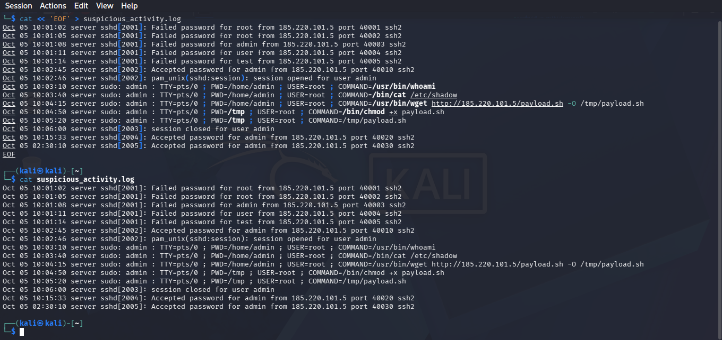

- Timeline Analysis

Stage 1: Brute-Force Login Attempts (10:01:02 - 10:01:14)
Five rapid failed login attempts from a single source IP (185.220.101.5), cycling through common usernames (root, admin, user, test) within 12 seconds. This rapid, multi-username pattern is a strong indicator of an automated credential-guessing tool rather than a human typing manually.

Stage 2: Successful Login (10:02:45)
The same IP successfully authenticated as "admin" less than 90 seconds after the failed attempts began - suggesting either a weak/guessed password or a credential obtained elsewhere (e.g. a prior data breach) being tested here.

Stage 3: Reconnaissance (10:03:10)
Immediately after gaining access, the attacker ran "whoami" - a basic reconnaissance command used to confirm current user identity and permissions, a very common first step after gaining shell access.

Stage 4: Sensitive File Access Attempt (10:03:40)
The attacker attempted to read /etc/shadow (the system's password hash file) using sudo. This is a clear privilege escalation/credential-harvesting attempt - reading this file would allow offline password cracking of every account on the system.

Stage 5: Malicious Payload Download & Execution (10:04:15 - 10:05:20)
The attacker downloaded a file named "payload.sh" directly from their own IP address, made it executable with chmod +x, and ran it. This sequence - download, chmod, execute - is a textbook malware deployment pattern, commonly used to install backdoors, cryptominers, or further attack tooling.

Stage 6: Repeated/Off-Hours Access (10:15:33 and 02:30:10)
The same account logged in again shortly after, and then again at 2:30 AM - an unusual hour for legitimate admin activity, suggesting either a persistent backdoor/scheduled access by the attacker, or a compromised account being used outside normal business hours.

- Overall Pattern Identified
This is not an isolated event but a complete attack chain:
Brute-force -> Initial Access -> Reconnaissance -> Privilege Escalation Attempt -> Malware Deployment -> Persistent/Repeated Access.
Each stage on its own might look like routine activity (a login, a file download, a scheduled task), but viewed together in sequence from a single source IP within a tight timeframe, the pattern clearly indicates a successful compromise rather than normal administrative behavior.

- Recommended Response
- Immediately disable or reset the "admin" account password
- Block source IP 185.220.101.5 at the firewall
- Review and remove /tmp/payload.sh and investigate what it executed
- Audit all commands run during the compromised session for further damage (data
exfiltration, additional backdoors)
- Review logs for the same IP/account pattern across other systems in the network, in case this wasn't an isolated incident
- Enforce multi-factor authentication (MFA) to prevent single-password
compromises from leading to full access in future

