Task 2.3 – Authentication & Session Weakness Analysis

Target: OWASP Juice Shop (localhost:3000)

- Finding 1: Weak Authentication (SQL Injection Bypass)
As found in Task 2.2, the login form was vulnerable to SQL injection using
' OR 1=1--, allowing full authentication bypass without valid credentials.
This confirms a critical authentication weakness at the login layer itself.

- Finding 2: Insecure Session Cookie Configuration
Inspected the session token cookie via Firefox DevTools (Storage > Cookies).
The app uses a JWT (JSON Web Token) stored in a cookie named "token".

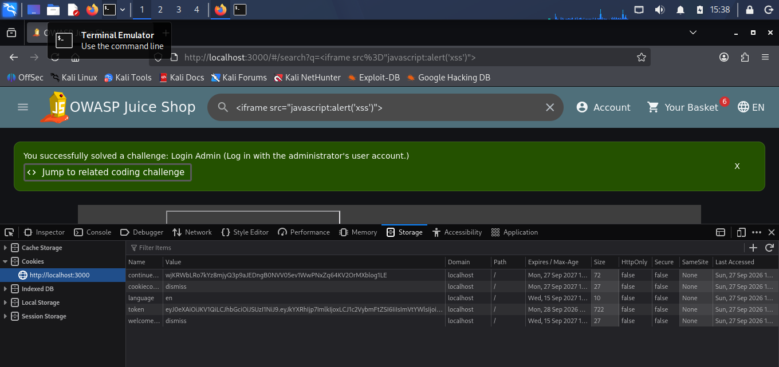

Key issues observed:
- HttpOnly: false - this means JavaScript can read the cookie's value.
Combined with the XSS vulnerability found in Task 2.2, an attacker could
potentially inject a script that steals this token and hijacks the user's
session.
- Secure: false - the cookie isn't restricted to HTTPS-only connections, so
it could be intercepted if sent over an unencrypted connection.
- SameSite: None - this reduces protection against Cross-Site Request Forgery
(CSRF), since the cookie can be sent along with cross-origin requests.

- Finding 3: Input Validation Weaknesses
The search field renders certain HTML tags (like <iframe>) without proper
sanitization, as shown in Task 2.2's XSS test, confirming insufficient input
validation on user-supplied data before rendering it back to the page.

Why this matters together
These three findings aren't isolated - they compound each other. The XSS
vulnerability becomes far more dangerous specifically because HttpOnly is
false, since it means the same script injection that pops an alert box could
just as easily be rewritten to exfiltrate the session token to an attacker's
server, leading to full account takeover even without needing the SQL
injection bypass.

Recommendation
- Set HttpOnly and Secure flags to true on session cookies
- Set SameSite to "Strict" or "Lax" to reduce CSRF risk
- Sanitize all user input before rendering it in the DOM (fixes both the XSS
and reinforces defense-in-depth even if other layers fail)

