Task 1.4 – Basic Security Assessment

- Objective
Perform a basic security assessment of a controlled local lab environment
(OWASP Juice Shop running via Docker on localhost) using nmap.

- Methodology
Used `nmap -sV -p 3000 localhost` to perform a version-detection scan on the
target port where Juice Shop is hosted.

- Findings
- Port 3000/tcp was found “open”, running a Node.js-based web service.
- Service banner grabbing revealed the response headers and HTML metadata,
confirming the running application as “OWASP Juice Shop” (an intentionally
vulnerable web app maintained by Bjoern Kimminich and OWASP contributors).
- Response headers exposed information such as: Content-Type, Server timing,
Access-Control-Allow-Origin set to wildcard (`*`), and allowed HTTP methods
(GET, HEAD, PUT, PATCH, POST, DELETE).

- Security Observations
- “Open CORS policy” (`Access-Control-Allow-Origin: `) — while acceptable
for a deliberately vulnerable practice app, in a production environment this
would allow any external domain to make requests to the API, a potential
security risk.
- “Verbose service banners” — the scan easily revealed the exact application
and its underlying framework. In a real-world assessment, this kind of
information disclosure helps attackers fingerprint the target and search for
known vulnerabilities specific to that software version.
- “Multiple HTTP methods allowed” (including PUT, PATCH, DELETE) — if not
properly authenticated/restricted, these could allow unauthorized data
modification.

- Conclusion
This basic assessment confirms the target is reachable and identifiable via
standard scanning techniques. It reinforces why minimizing exposed information
(banners, permissive headers) is an important part of hardening — even though
this target is intentionally vulnerable for learning purposes.

- Screenshot

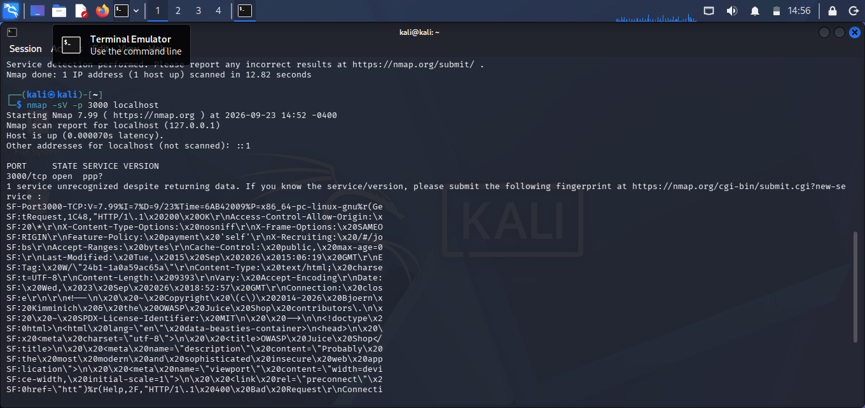
1.4.1 Nmap_scan

