Task 3.1 – Security Log Study

- Objective
Study a sample security log (SSH authentication log) and identify common
Indicators of Compromise (IOCs).

- Dataset
Used a real-world sample Linux authentication log (sourced from the LogHub
public dataset, a collection of real system logs used for security research
and training).

- Analysis performed
Ran a series of command-line searches to extract patterns from the log:
- Counted total authentication failures: grep -c "authentication failure" auth.log
- Identified source IPs with repeated failures: extracted via grep -oP 'rhost=\K[^ ]+'
- Identified most-targeted usernames: extracted via grep -oP 'user=\K[^ ]+'

- Findings (Indicators of Compromise)
1. High volume of authentication failures
Total of 490 failed authentication attempts recorded in the log - an
abnormally high number for a short time window, strongly suggesting
automated brute-force activity rather than genuine user error.

2. Concentrated attack from a single source IP
The IP 150.183.249.110 alone accounted for 80 failed login attempts, by far
the most of any single source - a clear sign of a dedicated brute-force
attempt from one attacker.

3. Distributed attack pattern (possible botnet)
Beyond the top IP, over 30 additional distinct IPs/hostnames were found
making repeated failed login attempts (ranging from 1 to 23 failures each),
many resolving to residential ISP or consumer broadband hostnames (e.g.
dsl/adsl/cable domains). This pattern is consistent with a distributed
brute-force attack, possibly from a botnet of compromised home devices.

4. Privileged account targeting
The username "root" was targeted 351 times - by far the most common target,
confirming attackers were specifically trying to gain the highest level of
system access rather than a regular user account.

5. Default/weak account probing
Secondary targets included "guest" (17 attempts) and "test" (4 attempts) -
common default account names that automated attack tools typically try,
further confirming this was scripted/automated rather than a manual,
targeted attack.

- Conclusion
This log analysis demonstrates classic brute-force attack indicators: a high
volume of failed logins, multiple distinct source IPs, and targeting of both
privileged (root) and default/weak accounts. In a real SOC environment, this
pattern would trigger an automated alert, and appropriate responses would
include IP blocking/rate-limiting, enforcing account lockout policies, and
disabling default accounts like "guest" and "test" entirely.

- Evidence
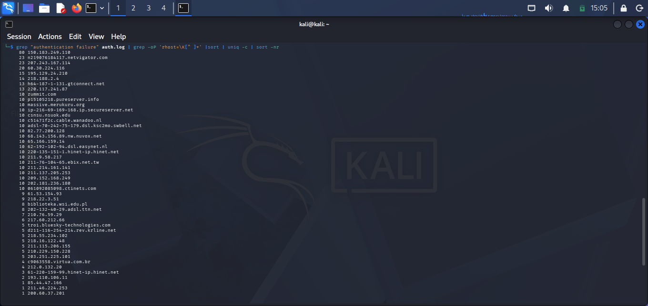
3.1.1 Rhost Breakdown

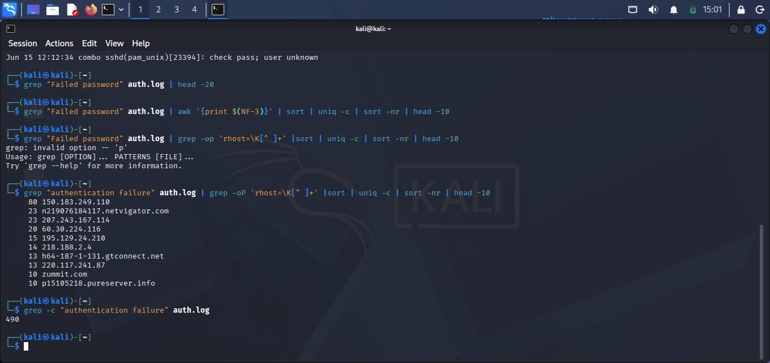
3.1.2 Total Failure Count
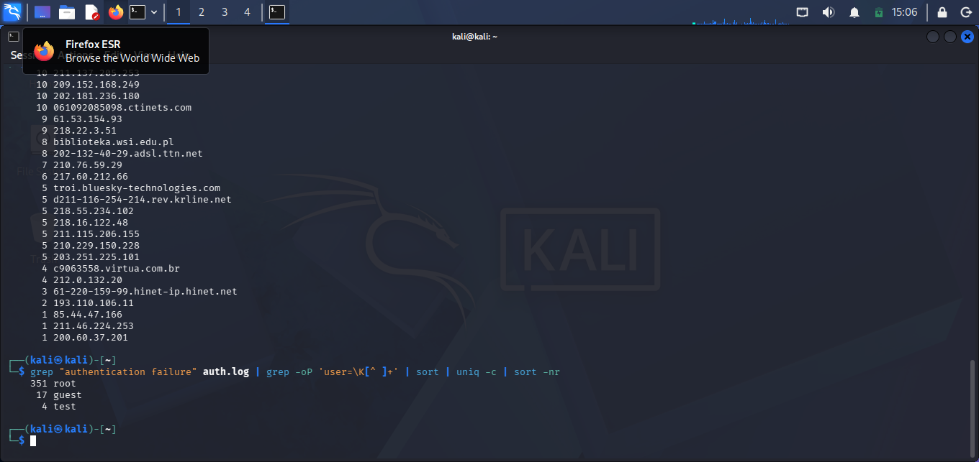
3.1.3 Username Breakdown

