**READING STM32F401RE INTERNAL TEMPERATURE SENSOR VALUE USIND ADC**

1. Create a project -> click on the board selector -> select the NUCLEO f401RE board

2. go to Analog drop down -> select ADC1 -> click temp sensor channel

3. go to parameter settings -> set the following parameters

* Clock prescalar = PCLK2 divide by 4
* Resolution = 12 bits
* Continuous conversion mode = enabled
* DMA contin. Requests = enabled
* Rank->sampling time = 112 cycles

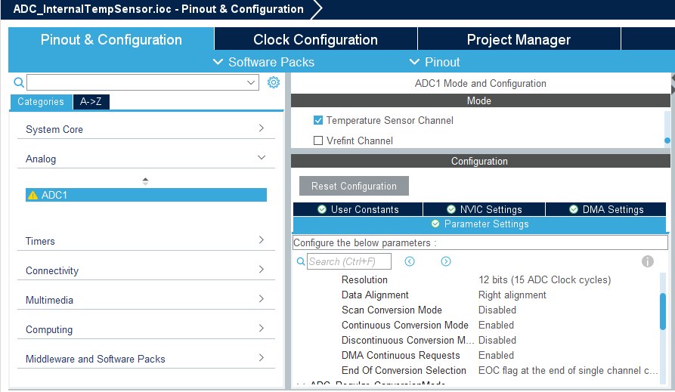

4. add the ADC1 in DMA settings

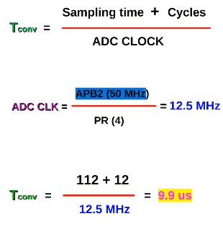

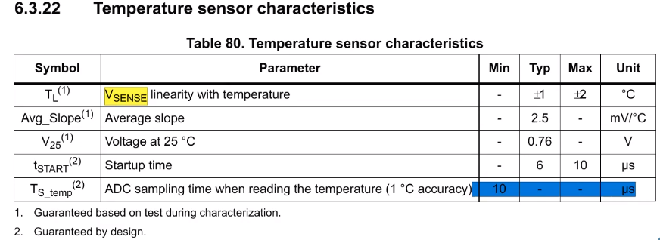

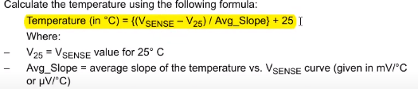

5. go to clock configuration -> set the AHB2 peripheral clock to 50 MHz

6. generate the code

7.debug the code AND observe the value of the temp variable by adding it to the live expressions

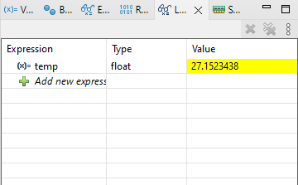

CODE:

/* USER CODE BEGIN Header */

/**

******************************************************************************

* @file : main.c

* @brief : Main program body

******************************************************************************

* @attention

*

* Copyright (c) 2024 STMicroelectronics.

* All rights reserved.

*

* This software is licensed under terms that can be found in the LICENSE file

* In the root directory of this software component.

* If no LICENSE file comes with this software, it is provided AS-IS.

*

******************************************************************************

*/

/* USER CODE END Header */

/* Includes ------------------------------------------------------------------*/

**#include** "main.h"

/* Private includes ----------------------------------------------------------*/

/* USER CODE BEGIN Includes */

**#include** <stdio.h>

**#include** <string.h>

/* USER CODE END Includes */

/* Private typedef -----------------------------------------------------------*/

/* USER CODE BEGIN PTD */

/* USER CODE END PTD */

/* Private define ------------------------------------------------------------*/

/* USER CODE BEGIN PD */

/* USER CODE END PD */

/* Private macro -------------------------------------------------------------*/

/* USER CODE BEGIN PM */

/* USER CODE END PM */

/* Private variables ---------------------------------------------------------*/

ADC_HandleTypeDef hadc1;

DMA_HandleTypeDef hdma_adc1;

UART_HandleTypeDef huart2;

/* USER CODE BEGIN PV */

/* USER CODE END PV */

/* Private function prototypes -----------------------------------------------*/

**void** **SystemClock_Config**(**void**);

**static** **void** **MX_GPIO_Init**(**void**);

**static** **void** **MX_DMA_Init**(**void**);

**static** **void** **MX_USART2_UART_Init**(**void**);

**static** **void** **MX_ADC1_Init**(**void**);

/* USER CODE BEGIN PFP */

/* USER CODE END PFP */

/* Private user code ---------------------------------------------------------*/

/* USER CODE BEGIN 0 */

**#define** Avg_slope 0.0025 //V/C

**#define** V25 0.76 //V

**#define** VSENSE 3.3/4096 //12bit res

uint32_t ADC_VAL = 0;

**float** temp = 0;

**char** buf[20];

**void** **HAL_ADC_ConvCpltCallback**(ADC_HandleTypeDef* hadc1)

{

temp = ((VSENSE*ADC_VAL - V25) / Avg_slope) + 25;

}

/* USER CODE END 0 */

/**

* @brief The application entry point.

* @retval int

*/

**int** **main**(**void**)

{

/* USER CODE BEGIN 1 */

/* USER CODE END 1 */

/* MCU Configuration--------------------------------------------------------*/

/* Reset of all peripherals, Initializes the Flash interface and the Systick. */

HAL_Init();

/* USER CODE BEGIN Init */

/* USER CODE END Init */

/* Configure the system clock */

SystemClock_Config();

/* USER CODE BEGIN SysInit */

/* USER CODE END SysInit */

/* Initialize all configured peripherals */

MX_GPIO_Init();

MX_DMA_Init();

MX_USART2_UART_Init();

MX_ADC1_Init();

/* USER CODE BEGIN 2 */

HAL_ADC_Start_DMA(&hadc1, &ADC_VAL, 1);

/* USER CODE END 2 */

/* Infinite loop */

/* USER CODE BEGIN WHILE */

**while** (1)

{

/* USER CODE END WHILE */

/* USER CODE BEGIN 3 */

}

/* USER CODE END 3 */

}

/**

* @brief System Clock Configuration

* @retval None

*/

**void** **SystemClock_Config**(**void**)

{

RCC_OscInitTypeDef RCC_OscInitStruct = {0};

RCC_ClkInitTypeDef RCC_ClkInitStruct = {0};

/** Configure the main internal regulator output voltage

*/

__HAL_RCC_PWR_CLK_ENABLE();

__HAL_PWR_VOLTAGESCALING_CONFIG(PWR_REGULATOR_VOLTAGE_SCALE2);

/** Initializes the RCC Oscillators according to the specified parameters

* in the RCC_OscInitTypeDef structure.

*/

RCC_OscInitStruct.OscillatorType = RCC_OSCILLATORTYPE_HSE;

RCC_OscInitStruct.HSEState = RCC_HSE_ON;

RCC_OscInitStruct.PLL.PLLState = RCC_PLL_ON;

RCC_OscInitStruct.PLL.PLLSource = RCC_PLLSOURCE_HSE;

RCC_OscInitStruct.PLL.PLLM = 4;

RCC_OscInitStruct.PLL.PLLN = 50;

RCC_OscInitStruct.PLL.PLLP = RCC_PLLP_DIV2;

RCC_OscInitStruct.PLL.PLLQ = 7;

**if** (HAL_RCC_OscConfig(&RCC_OscInitStruct) != *HAL_OK*)

{

Error_Handler();

}

/** Initializes the CPU, AHB and APB buses clocks

*/

RCC_ClkInitStruct.ClockType = RCC_CLOCKTYPE_HCLK|RCC_CLOCKTYPE_SYSCLK

|RCC_CLOCKTYPE_PCLK1|RCC_CLOCKTYPE_PCLK2;

RCC_ClkInitStruct.SYSCLKSource = RCC_SYSCLKSOURCE_PLLCLK;

RCC_ClkInitStruct.AHBCLKDivider = RCC_SYSCLK_DIV1;

RCC_ClkInitStruct.APB1CLKDivider = RCC_HCLK_DIV2;

RCC_ClkInitStruct.APB2CLKDivider = RCC_HCLK_DIV1;

**if** (HAL_RCC_ClockConfig(&RCC_ClkInitStruct, FLASH_LATENCY_1) != *HAL_OK*)

{

Error_Handler();

}

}

/**

* @brief ADC1 Initialization Function

* @param None

* @retval None

*/

**static** **void** **MX_ADC1_Init**(**void**)

{

/* USER CODE BEGIN ADC1_Init 0 */

/* USER CODE END ADC1_Init 0 */

ADC_ChannelConfTypeDef sConfig = {0};

/* USER CODE BEGIN ADC1_Init 1 */

/* USER CODE END ADC1_Init 1 */

/** Configure the global features of the ADC (Clock, Resolution, Data Alignment and number of conversion)

*/

hadc1.Instance = ADC1;

hadc1.Init.ClockPrescaler = ADC_CLOCK_SYNC_PCLK_DIV4;

hadc1.Init.Resolution = ADC_RESOLUTION_12B;

hadc1.Init.ScanConvMode = *DISABLE*;

hadc1.Init.ContinuousConvMode = *ENABLE*;

hadc1.Init.DiscontinuousConvMode = *DISABLE*;

hadc1.Init.ExternalTrigConvEdge = ADC_EXTERNALTRIGCONVEDGE_NONE;

hadc1.Init.ExternalTrigConv = ADC_SOFTWARE_START;

hadc1.Init.DataAlign = ADC_DATAALIGN_RIGHT;

hadc1.Init.NbrOfConversion = 1;

hadc1.Init.DMAContinuousRequests = *ENABLE*;

hadc1.Init.EOCSelection = ADC_EOC_SINGLE_CONV;

**if** (HAL_ADC_Init(&hadc1) != *HAL_OK*)

{

Error_Handler();

}

/** Configure for the selected ADC regular channel its corresponding rank in the sequencer and its sample time.

*/

sConfig.Channel = ADC_CHANNEL_TEMPSENSOR;

sConfig.Rank = 1;

sConfig.SamplingTime = ADC_SAMPLETIME_112CYCLES;

**if** (HAL_ADC_ConfigChannel(&hadc1, &sConfig) != *HAL_OK*)

{

Error_Handler();

}

/* USER CODE BEGIN ADC1_Init 2 */

/* USER CODE END ADC1_Init 2 */

}

/**

* @brief USART2 Initialization Function

* @param None

* @retval None

*/

**static** **void** **MX_USART2_UART_Init**(**void**)

{

/* USER CODE BEGIN USART2_Init 0 */

/* USER CODE END USART2_Init 0 */

/* USER CODE BEGIN USART2_Init 1 */

/* USER CODE END USART2_Init 1 */

huart2.Instance = USART2;

huart2.Init.BaudRate = 115200;

huart2.Init.WordLength = UART_WORDLENGTH_8B;

huart2.Init.StopBits = UART_STOPBITS_1;

huart2.Init.Parity = UART_PARITY_NONE;

huart2.Init.Mode = UART_MODE_TX_RX;

huart2.Init.HwFlowCtl = UART_HWCONTROL_NONE;

huart2.Init.OverSampling = UART_OVERSAMPLING_16;

**if** (HAL_UART_Init(&huart2) != *HAL_OK*)

{

Error_Handler();

}

/* USER CODE BEGIN USART2_Init 2 */

/* USER CODE END USART2_Init 2 */

}

/**

* Enable DMA controller clock

*/

**static** **void** **MX_DMA_Init**(**void**)

{

/* DMA controller clock enable */

__HAL_RCC_DMA2_CLK_ENABLE();

/* DMA interrupt init */

/* DMA2_Stream0_IRQn interrupt configuration */

HAL_NVIC_SetPriority(*DMA2_Stream0_IRQn*, 0, 0);

HAL_NVIC_EnableIRQ(*DMA2_Stream0_IRQn*);

}

/**

* @brief GPIO Initialization Function

* @param None

* @retval None

*/

**static** **void** **MX_GPIO_Init**(**void**)

{

GPIO_InitTypeDef GPIO_InitStruct = {0};

/* USER CODE BEGIN MX_GPIO_Init_1 */

/* USER CODE END MX_GPIO_Init_1 */

/* GPIO Ports Clock Enable */

__HAL_RCC_GPIOC_CLK_ENABLE();

__HAL_RCC_GPIOH_CLK_ENABLE();

__HAL_RCC_GPIOA_CLK_ENABLE();

__HAL_RCC_GPIOB_CLK_ENABLE();

/*Configure GPIO pin Output Level */

HAL_GPIO_WritePin(LD2_GPIO_Port, LD2_Pin, *GPIO_PIN_RESET*);

/*Configure GPIO pin : B1_Pin */

GPIO_InitStruct.Pin = B1_Pin;

GPIO_InitStruct.Mode = GPIO_MODE_IT_FALLING;

GPIO_InitStruct.Pull = GPIO_NOPULL;

HAL_GPIO_Init(B1_GPIO_Port, &GPIO_InitStruct);

/*Configure GPIO pin : LD2_Pin */

GPIO_InitStruct.Pin = LD2_Pin;

GPIO_InitStruct.Mode = GPIO_MODE_OUTPUT_PP;

GPIO_InitStruct.Pull = GPIO_NOPULL;

GPIO_InitStruct.Speed = GPIO_SPEED_FREQ_LOW;

HAL_GPIO_Init(LD2_GPIO_Port, &GPIO_InitStruct);

/* USER CODE BEGIN MX_GPIO_Init_2 */

/* USER CODE END MX_GPIO_Init_2 */

}

/* USER CODE BEGIN 4 */

/* USER CODE END 4 */

/**

* @brief This function is executed in case of error occurrence.

* @retval None

*/

**void** **Error_Handler**(**void**)

{

/* USER CODE BEGIN Error_Handler_Debug */

/* User can add his own implementation to report the HAL error return state */

__disable_irq();

**while** (1)

{

}

/* USER CODE END Error_Handler_Debug */

}

**#ifdef** USE_FULL_ASSERT

/**

* @brief Reports the name of the source file and the source line number

* where the assert_param error has occurred.

* @param file: pointer to the source file name

* @param line: assert_param error line source number

* @retval None

*/

**void** assert_failed(uint8_t *file, uint32_t line)

{

/* USER CODE BEGIN 6 */

/* User can add his own implementation to report the file name and line number,

ex: printf("Wrong parameters value: file %s on line %d\r\n", file, line) */

/* USER CODE END 6 */

}

**#endif** /* USE_FULL_ASSERT */