Plugin docs basic template

# Contents

1. Installation
2. Pre Configuration Steps
3. Configuration

PayPal Payments Advanced is a gateway that allows you to seamlessly integrate credit card processing into your checkout without needing an SSL certificate, this greatly simplifies PCI compliance. This product combines a Merchant Account and Payment Gateway into one cost-effective solution.

* Low cost
* Seamless integration
* Easier PCI compliance and no SSL needed
  + If you want them to stay onsite (Layout C), and not get “Mixed Content” warnings it is advised to have an SSL. An SSL can also give the user a greater feeling of trust in the site.
* Combines Merchant Account and Payment Gateway

# Installation

* Unzip and upload the plugin’s folder to your /wp-content/plugins/ directory
* Activate the extension through the ‘Plugins’ menu in WordPress
* Open the settings page for Jigoshop and go to the “PayPal Advanced Payments” Section.
* Configure your PayPal Advanced settings. See below for details.

**Pre Configuration steps:**

# *Signing up for PayPal Payments Advanced*

* Go to their [signup page](https://www.paypal.com/webapps/mpp/paypal-payments-advanced) and follow the instructions for submitting an application

***Signing up for a Test Account***

* This follows the same process to set up a full account (above), just stop short of submitting payment
* Create a PayPal Sandbox account <https://developer.paypal.com/> , create a new sandboxed merchant account and a sandboxed personal account. (save the email and details outputted for later reference)

# Configuration

## Jigoshop Configuration

* Enable the Gateway from the Jigoshop>>Settings>>Payment Gateways.
  + Note that the Gateway is only visible on the frontend when enabled and the required gateway credentials (LoginID, Reseller ID, and Password) have been entered.

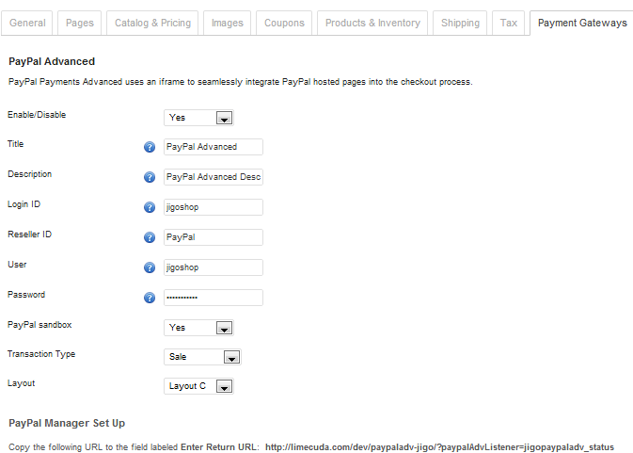

* Input settings to match those set in your PayPal Advanced account.
* Ensure that you select PayPal Sandbox as “No”, if you are using Live Account.
* Authorization or Sale – (sometimes referred to as Authorize & Capture)
  + If you have it set to **“Authorization”**, the payment will be authorized but not completed, you would need to manually “Capture”
  + If it is set to **“Sale”** then it will also capture the payment  *(this is the usual and recommended setting)*

## PayPal Manager Configuration

This service uses PayPal Manager, sign in at [https://manager.paypal.com](https://manager.paypal.com/)

* It is recommended to set up another PayPal Manager user for use with your account as you may be prompted monthly to change the root user account and would then have to change it in Jigoshop settings as well

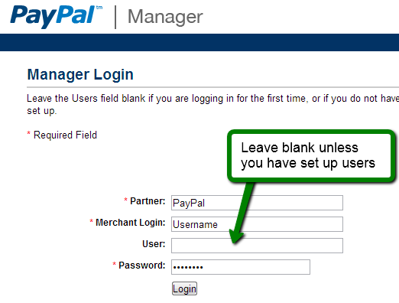

### Step 1: Setup

* The Error URL needs to be copied over from the Jigoshop settings
* Copy over the Return URL that is outputted (bottom of the Jigoshop PayPal Advanced settings page) to PayPal Manager
  + Note: if you are using SSL (https), your Return URL must also use https NOT http
* The Return URL Method must be set to Post

### Step 2: Customize

* Preferably layout should be set to “C” as it keeps your customers on-site. If you use layouts A or B it will redirect to PayPal, let them pay, and then redirect them back to the site.
* On PayPal Manager->Service Settings->Set Up:
  + You need to have “Payment Confirmation->On My Website” checked, you will need to use the Return URL
* PayPal Manager->Service Settings->Set Up: “Enable Secure Token” must be set to “Yes”.

**Note:** If you choose Layout C you should have an [SSL certificate](http://wcdocs.woothemes.com/user-guide/getting-started/ssl-and-https/) installed so as to avoid “Mixed Content” warnings to the user when they visit this page in the checkout (enable “Force SSL on checkout” in Jigoshop >> Settings >> General Tab). If you do not have SSL, if may be better to use an alternate Layout and briefly redirect them offsite.

* Return URL: This is the URL customers return to if they click the return link post-order completion