|  |  |  |
| --- | --- | --- |
| **Model Summary** | | |
| Specifications | Growing Method | CRT |
| Dependent Variable | wheat class |
| Independent Variables | area A, perimeter P, compactness C = 4*pi*A/P^2, length of kernel, width of kernel, asymmetry coefficient, length of kernel groove |
| Validation | Cross Validation |
| Maximum Tree Depth | 20 |
| Minimum Cases in Parent Node | 35 |
| Minimum Cases in Child Node | 17 |
| Results | Independent Variables Included | length of kernel groove, perimeter P, length of kernel, area A, width of kernel, compactness C = 4*pi*A/P^2, asymmetry coefficient |
| Number of Nodes | 5 |
| Number of Terminal Nodes | 3 |
| Depth | 2 |

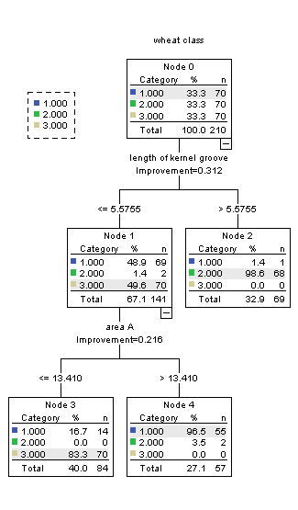

|  |  |  |
| --- | --- | --- |
| **Risk** | | |
| Method | Estimate | Std. Error |
| Resubstitution | .081 | .019 |
| Cross-Validation | .100 | .021 |
| Growing Method: CRT  Dependent Variable: wheat class | | |

|  |  |  |  |  |  |  |
| --- | --- | --- | --- | --- | --- | --- |
| **Classification** | | | | | | |
| Observed | | Predicted | | | | |
| 1 | 2 | 3 | | Percent Correct |
| 1 | | 55 | 1 | 14 | | 78.6% |
| 2 | | 2 | 68 | 0 | | 97.1% |
| 3 | | 0 | 0 | 70 | | 100.0% |
| Overall Percentage | | 27.1% | 32.9% | 40.0% | | 91.9% |
| Growing Method: CRT  Dependent Variable: wheat class | | | | | | |
| **Model Summary** | | | | | | | |
| Specifications | Growing Method | | | | CRT | | |
| Dependent Variable | | | | wheat class | | |
| Independent Variables | | | | area A, perimeter P, compactness C = 4*pi*A/P^2, length of kernel, width of kernel, asymmetry coefficient, length of kernel groove | | |
| Validation | | | | Cross Validation | | |
| Maximum Tree Depth | | | | 20 | | |
| Minimum Cases in Parent Node | | | | 25 | | |
| Minimum Cases in Child Node | | | | 12 | | |
| Results | Independent Variables Included | | | | length of kernel groove, perimeter P, length of kernel, area A, width of kernel, compactness C = 4*pi*A/P^2, asymmetry coefficient | | |
| Number of Nodes | | | | 5 | | |
| Number of Terminal Nodes | | | | 3 | | |
| Depth | | | | 2 | | |



|  |  |  |
| --- | --- | --- |
| **Risk** | | |
| Method | Estimate | Std. Error |
| Resubstitution | .081 | .019 |
| Cross-Validation | .133 | .023 |
| Growing Method: CRT  Dependent Variable: wheat class | | |

|  |  |  |  |  |
| --- | --- | --- | --- | --- |
| **Classification** | | | | |
| Observed | Predicted | | | |
| 1 | 2 | 3 | Percent Correct |
| 1 | 55 | 1 | 14 | 78.6% |
| 2 | 2 | 68 | 0 | 97.1% |
| 3 | 0 | 0 | 70 | 100.0% |
| Overall Percentage | 27.1% | 32.9% | 40.0% | 91.9% |
| Growing Method: CRT  Dependent Variable: wheat class | | | | |

|  |  |  |
| --- | --- | --- |
| **Model Summary** | | |
| Specifications | Growing Method | CRT |
| Dependent Variable | wheat class |
| Independent Variables | area A, perimeter P, compactness C = 4*pi*A/P^2, length of kernel, width of kernel, asymmetry coefficient, length of kernel groove |
| Validation | Cross Validation |
| Maximum Tree Depth | 20 |
| Minimum Cases in Parent Node | 20 |
| Minimum Cases in Child Node | 10 |
| Results | Independent Variables Included | length of kernel groove, perimeter P, length of kernel, area A, width of kernel, compactness C = 4*pi*A/P^2, asymmetry coefficient |
| Number of Nodes | 5 |
| Number of Terminal Nodes | 3 |
| Depth | 2 |



|  |  |  |
| --- | --- | --- |
| **Risk** | | |
| Method | Estimate | Std. Error |
| Resubstitution | .081 | .019 |
| Cross-Validation | .100 | .021 |
| Growing Method: CRT  Dependent Variable: wheat class | | |

|  |  |  |  |  |
| --- | --- | --- | --- | --- |
| **Classification** | | | | |
| Observed | Predicted | | | |
| 1 | 2 | 3 | Percent Correct |
| 1 | 55 | 1 | 14 | 78.6% |
| 2 | 2 | 68 | 0 | 97.1% |
| 3 | 0 | 0 | 70 | 100.0% |
| Overall Percentage | 27.1% | 32.9% | 40.0% | 91.9% |
| Growing Method: CRT  Dependent Variable: wheat class | | | | |

|  |  |  |
| --- | --- | --- |
| **Model Summary** | | |
| Specifications | Growing Method | CRT |
| Dependent Variable | wheat class |
| Independent Variables | area A, perimeter P, compactness C = 4*pi*A/P^2, length of kernel, width of kernel, asymmetry coefficient, length of kernel groove |
| Validation | Cross Validation |
| Maximum Tree Depth | 20 |
| Minimum Cases in Parent Node | 18 |
| Minimum Cases in Child Node | 9 |
| Results | Independent Variables Included | length of kernel groove, perimeter P, length of kernel, area A, width of kernel, compactness C = 4*pi*A/P^2, asymmetry coefficient |
| Number of Nodes | 5 |
| Number of Terminal Nodes | 3 |
| Depth | 2 |



|  |  |  |
| --- | --- | --- |
| **Risk** | | |
| Method | Estimate | Std. Error |
| Resubstitution | .081 | .019 |
| Cross-Validation | .114 | .022 |
| Growing Method: CRT  Dependent Variable: wheat class | | |

|  |  |  |  |  |
| --- | --- | --- | --- | --- |
| **Classification** | | | | |
| Observed | Predicted | | | |
| 1 | 2 | 3 | Percent Correct |
| 1 | 55 | 1 | 14 | 78.6% |
| 2 | 2 | 68 | 0 | 97.1% |
| 3 | 0 | 0 | 70 | 100.0% |
| Overall Percentage | 27.1% | 32.9% | 40.0% | 91.9% |
| Growing Method: CRT  Dependent Variable: wheat class | | | | |

|  |  |  |
| --- | --- | --- |
| **Model Summary** | | |
| Specifications | Growing Method | CRT |
| Dependent Variable | wheat class |
| Independent Variables | area A, perimeter P, compactness C = 4*pi*A/P^2, length of kernel, width of kernel, asymmetry coefficient, length of kernel groove |
| Validation | Cross Validation |
| Maximum Tree Depth | 20 |
| Minimum Cases in Parent Node | 17 |
| Minimum Cases in Child Node | 8 |
| Results | Independent Variables Included | length of kernel groove, perimeter P, length of kernel, area A, width of kernel, compactness C = 4*pi*A/P^2, asymmetry coefficient |
| Number of Nodes | 9 |
| Number of Terminal Nodes | 5 |
| Depth | 4 |

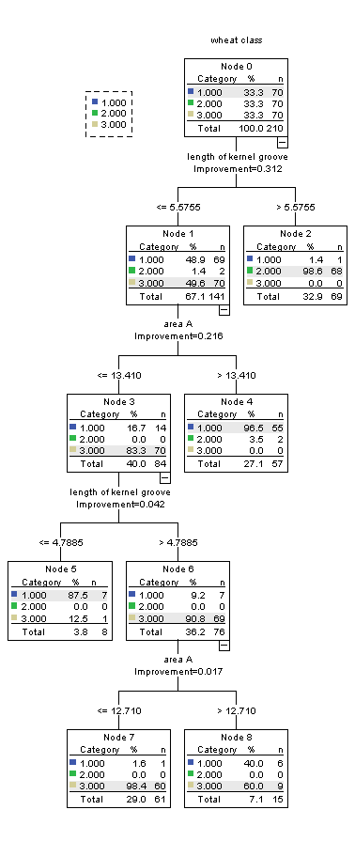

|  |  |  |
| --- | --- | --- |
| **Risk** | | |
| Method | Estimate | Std. Error |
| Resubstitution | .052 | .015 |
| Cross-Validation | .110 | .022 |
| Growing Method: CRT  Dependent Variable: wheat class | | |

|  |  |  |  |  |
| --- | --- | --- | --- | --- |
| **Classification** | | | | |
| Observed | Predicted | | | |
| 1 | 2 | 3 | Percent Correct |
| 1 | 62 | 1 | 7 | 88.6% |
| 2 | 2 | 68 | 0 | 97.1% |
| 3 | 1 | 0 | 69 | 98.6% |
| Overall Percentage | 31.0% | 32.9% | 36.2% | 94.8% |
| Growing Method: CRT  Dependent Variable: wheat class | | | | |

|  |  |  |
| --- | --- | --- |
| **Model Summary** | | |
| Specifications | Growing Method | CRT |
| Dependent Variable | wheat class |
| Independent Variables | area A, perimeter P, compactness C = 4*pi*A/P^2, length of kernel, width of kernel, asymmetry coefficient, length of kernel groove |
| Validation | Cross Validation |
| Maximum Tree Depth | 20 |
| Minimum Cases in Parent Node | 15 |
| Minimum Cases in Child Node | 7 |
| Results | Independent Variables Included | length of kernel groove, perimeter P, length of kernel, area A, width of kernel, compactness C = 4*pi*A/P^2, asymmetry coefficient |
| Number of Nodes | 11 |
| Number of Terminal Nodes | 6 |
| Depth | 5 |

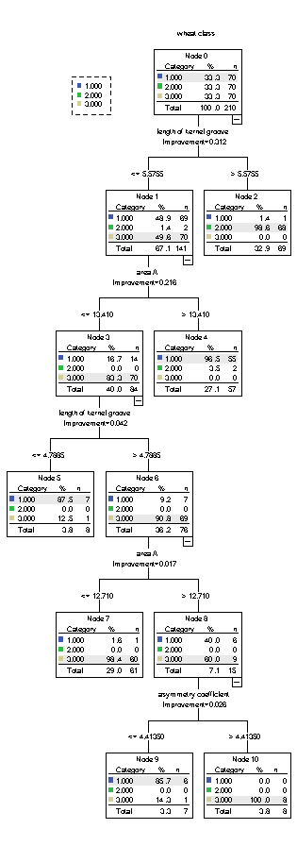

|  |  |  |
| --- | --- | --- |
| **Risk** | | |
| Method | Estimate | Std. Error |
| Resubstitution | .029 | .011 |
| Cross-Validation | .076 | .018 |
| Growing Method: CRT  Dependent Variable: wheat class | | |

|  |  |  |
| --- | --- | --- |
| **Independent Variable Importance** | | |
| Independent Variable | Importance | Normalized Importance |
| area A | .499 | 100.0% |
| perimeter P | .484 | 97.0% |
| width of kernel | .426 | 85.4% |
| length of kernel | .395 | 79.1% |
| length of kernel groove | .381 | 76.3% |
| asymmetry coefficient | .200 | 40.0% |
| compactness C = 4*pi*A/P^2 | .175 | 35.0% |
| Growing Method: CRT  Dependent Variable: wheat class | | |

|  |  |  |
| --- | --- | --- |
| **Model Summary** | | |
| Specifications | Growing Method | CRT |
| Dependent Variable | wheat class |
| Independent Variables | area A, perimeter P, compactness C = 4*pi*A/P^2, length of kernel, width of kernel, asymmetry coefficient, length of kernel groove |
| Validation | Cross Validation |
| Maximum Tree Depth | 20 |
| Minimum Cases in Parent Node | 14 |
| Minimum Cases in Child Node | 7 |
| Results | Independent Variables Included | length of kernel groove, perimeter P, length of kernel, area A, width of kernel, compactness C = 4*pi*A/P^2, asymmetry coefficient |
| Number of Nodes | 11 |
| Number of Terminal Nodes | 6 |
| Depth | 5 |



|  |  |  |
| --- | --- | --- |
| **Risk** | | |
| Method | Estimate | Std. Error |
| Resubstitution | .029 | .011 |
| Cross-Validation | .095 | .020 |
| Growing Method: CRT  Dependent Variable: wheat class | | |

|  |  |  |  |  |
| --- | --- | --- | --- | --- |
| **Classification** | | | | |
| Observed | Predicted | | | |
| 1 | 2 | 3 | Percent Correct |
| 1 | 68 | 1 | 1 | 97.1% |
| 2 | 2 | 68 | 0 | 97.1% |
| 3 | 2 | 0 | 68 | 97.1% |
| Overall Percentage | 34.3% | 32.9% | 32.9% | 97.1% |
| Growing Method: CRT  Dependent Variable: wheat class | | | | |

|  |  |  |
| --- | --- | --- |
| **Model Summary** | | |
| Specifications | Growing Method | CRT |
| Dependent Variable | wheat class |
| Independent Variables | area A, perimeter P, compactness C = 4*pi*A/P^2, length of kernel, width of kernel, asymmetry coefficient, length of kernel groove |
| Validation | Cross Validation |
| Maximum Tree Depth | 20 |
| Minimum Cases in Parent Node | 12 |
| Minimum Cases in Child Node | 6 |
| Results | Independent Variables Included | length of kernel groove, perimeter P, length of kernel, area A, width of kernel, compactness C = 4*pi*A/P^2, asymmetry coefficient |
| Number of Nodes | 13 |
| Number of Terminal Nodes | 7 |
| Depth | 5 |

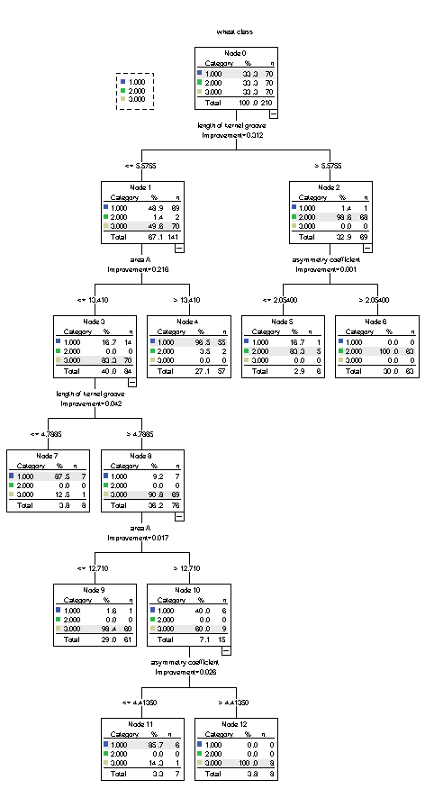

|  |  |  |
| --- | --- | --- |
| **Risk** | | |
| Method | Estimate | Std. Error |
| Resubstitution | .029 | .011 |
| Cross-Validation | .124 | .023 |
| Growing Method: CRT  Dependent Variable: wheat class | | |

|  |  |  |  |  |
| --- | --- | --- | --- | --- |
| **Classification** | | | | |
| Observed | Predicted | | | |
| 1 | 2 | 3 | Percent Correct |
| 1 | 68 | 1 | 1 | 97.1% |
| 2 | 2 | 68 | 0 | 97.1% |
| 3 | 2 | 0 | 68 | 97.1% |
| Overall Percentage | 34.3% | 32.9% | 32.9% | 97.1% |
| Growing Method: CRT  Dependent Variable: wheat class | | | | |

|  |  |  |
| --- | --- | --- |
| **Model Summary** | | |
| Specifications | Growing Method | CRT |
| Dependent Variable | wheat class |
| Independent Variables | area A, perimeter P, compactness C = 4*pi*A/P^2, length of kernel, width of kernel, asymmetry coefficient, length of kernel groove |
| Validation | Cross Validation |
| Maximum Tree Depth | 20 |
| Minimum Cases in Parent Node | 10 |
| Minimum Cases in Child Node | 5 |
| Results | Independent Variables Included | length of kernel groove, perimeter P, length of kernel, area A, width of kernel, compactness C = 4*pi*A/P^2, asymmetry coefficient |
| Number of Nodes | 13 |
| Number of Terminal Nodes | 7 |
| Depth | 5 |



|  |  |  |
| --- | --- | --- |
| **Risk** | | |
| Method | Estimate | Std. Error |
| Resubstitution | .029 | .011 |
| Cross-Validation | .090 | .020 |
| Growing Method: CRT  Dependent Variable: wheat class | | |

|  |  |  |  |  |
| --- | --- | --- | --- | --- |
| **Classification** | | | | |
| Observed | Predicted | | | |
| 1 | 2 | 3 | Percent Correct |
| 1 | 68 | 1 | 1 | 97.1% |
| 2 | 2 | 68 | 0 | 97.1% |
| 3 | 2 | 0 | 68 | 97.1% |
| Overall Percentage | 34.3% | 32.9% | 32.9% | 97.1% |
| Growing Method: CRT  Dependent Variable: wheat class | | | | |