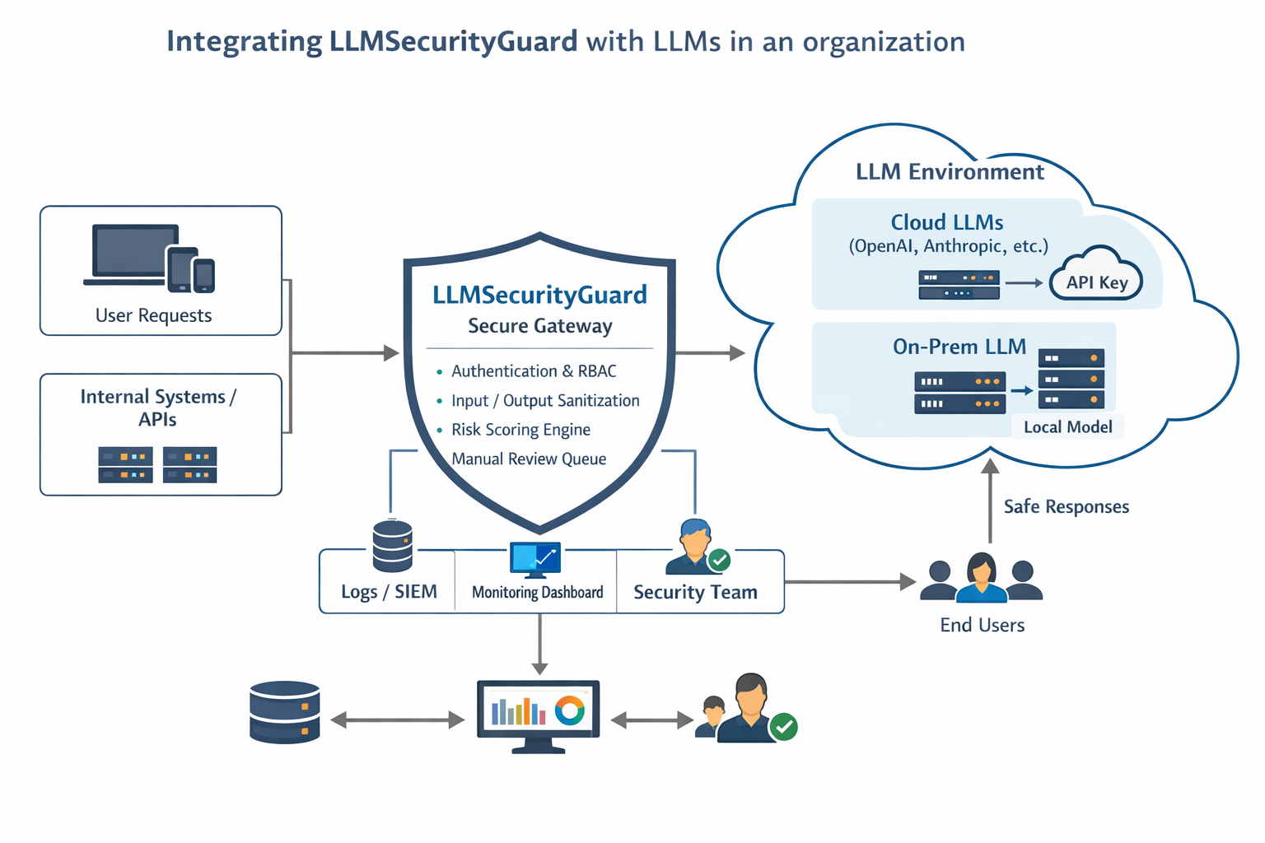

LLMSecurityGuard is designed as a Zero-Trust AI Gateway that sits between enterprise applications and Large Language Models (LLMs).
Architecture Overview
- Client Layer
User-facing apps, internal tools, or backend services send prompts to LLMSecurityGuard instead of directly calling an LLM.
- Security Gateway Layer (Core System)
This layer enforces:
- Authentication & Role-Based Access Control (RBAC)
- HMAC-based context signing (MCP-style integrity checks)
- Nonce validation to prevent replay attacks
- Input sanitization & NLP-based risk scoring
- Manual review routing for high-risk prompts
- Output sanitization before response delivery
- LLM Provider Layer
The gateway forwards validated requests to:
- Cloud-based LLM providers (OpenAI, Anthropic, etc.)
- On-premise LLM deployments
- Local testing models
- Monitoring & Governance Layer
All interactions are logged and can integrate with:
- SIEM platforms
- Security Operations Centers (SOC)
- Audit/compliance workflows
This layered architecture enables secure, compliant, and observable enterprise LLM deployments.
How Would You Scale This in Production?
A. Stateless API + Horizontal Scaling
Deploy LLMSecurityGuard behind a load balancer.
Make the API stateless so multiple instances can run in parallel.
Use:
- Docker containers
- Kubernetes or ECS
- Auto-scaling groups
B. Replace In-Memory Components
Current version uses:
- In-memory nonce tracking
- JSON file manual review queue
Production version should use:
- Redis for nonce storage
- PostgreSQL for logs and manual review queue
- Centralized logging (ELK / Splunk / Datadog)
C. Distributed Rate Limiting
Move rate limiting to:
- Redis-backed limiter
- API Gateway (e.g., Kong, AWS API Gateway)
D. Async Processing
Manual review queue and logging should be:
- Background tasks (Celery / RabbitMQ / Kafka)
- Non-blocking to prevent API latency
E. Observability
Add:
- Prometheus metrics
- Health endpoints
- Request latency tracking
- Risk score analytics dashboard
F. Enterprise Authentication
Replace static tokens with:
- OAuth2
- JWT
- SSO integration (Okta, Azure AD)

How LLM Security Guard Integration Works
Think of LLMSecurityGuard as a secure control layer between users and the organization’s LLM.
It acts like an AI firewall + governance gateway.

Step-by-Step Flow

1️⃣ User / Internal System Sends Request
Requests can come from:
- Web applications
- Internal APIs
- Employees using AI tools
- Automated backend services
Instead of calling the LLM directly, they call:
➡ LLMSecurityGuard API

2️⃣ Authentication & RBAC
The gateway first checks:
- Is the user authorized?
- What role do they have?
- Are they allowed to use this model?
This prevents:
- Unauthorized access
- Privilege escalation
- Internal misuse

3️⃣ MCP Signatures & Nonces
Before processing:
- The prompt must have a valid HMAC signature
- Nonce must be unique
- Timestamp must be valid
This prevents:
- Replay attacks
- Tampering
- Fake requests
This ensures context integrity.

4️⃣ Input Sanitization & Risk Scoring
The prompt is analyzed:
- Dangerous commands detected?
- Sensitive keywords?
- Prompt injection patterns?
- PII detected via NLP?
A risk score is generated.

5️⃣ Risk-Based Decision

✅ Low Risk
→ Sent to the LLM
→ Output sanitized
→ Returned to user

⚠ Medium Risk
→ Logged
→ Allowed but monitored

🚨 High Risk
→ Sent to Manual Review Queue
→ Security team reviews before approval
This is enterprise-grade governance.

6️⃣ LLM Environment (Right Side of Diagram)
The gateway can forward requests to:

☁ Cloud LLMs
- OpenAI
- Anthropic
- Others
Using secured API keys.
OR

🏢 On-Prem LLMs
- Internal models
- Local inference servers
- Private infrastructure
The gateway abstracts this — so organizations can switch models without changing security policy.

7️⃣ Output Sanitization
Before returning response:
- Remove sensitive patterns
- Prevent data leakage
- Filter unsafe content
This protects against:
- Model hallucinations
- Accidental exposure
- Prompt injection chaining

8️⃣ Logging & Monitoring
Everything is logged:
- User ID
- Risk score
- Timestamp
- Provider used
- Decision (allowed / manual review)
Logs can integrate with:
- SIEM tools
- SOC monitoring
- Audit systems
This enables:
- Compliance (SOC2, ISO27001)
- Forensics
- Incident response

9️⃣ Manual Review & Dashboard
High-risk prompts:
- Stored in queue
- Reviewed by security team
- Approved or rejected
This creates:
- Human-in-the-loop AI governance
- True enterprise readiness

