Mini-Project Report:

ASM-FSM Implementing Algorithms in Hardware

exercise 1:

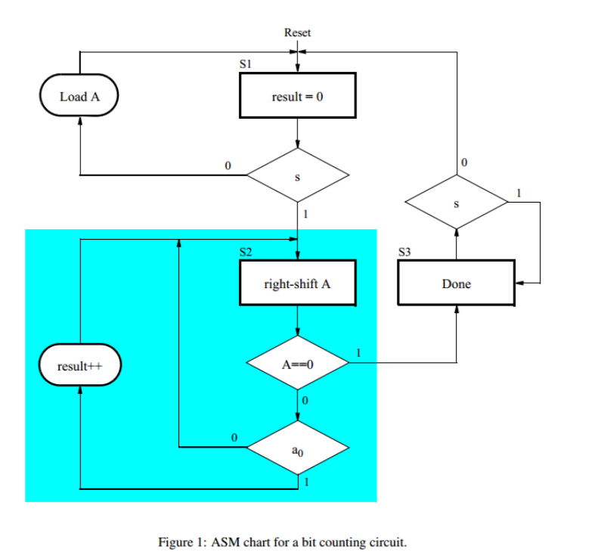

Here is testbench for exercise 1:

