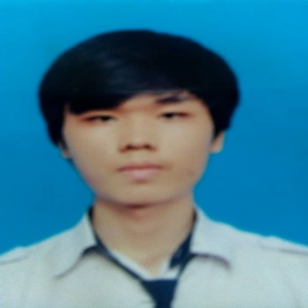

HTML, CSS, Bootstrap

GIT, Agile Scrum

Major: Infeormation Security

GPA: 2.36

**Posts and Telecommunications Institute of Technology**

Project: Image steganography

Technology: Java, LSB

Task: Developer

**Subject: Internship**

**07/2018-08/2018**

Project: School managerment

Technology: Android and fire base

Task: Developer

**Subject: Mobile programming**

**03/2018-05/2018**

**2014 - Now**

Seeking a dynamic, professional, open and focused human development environment.

Raise knowledge, gain practical experience in work. Learn skills to handle work quickly.

Improve myself, advance to higher positions in my career

Contribute to the development of the company.

**CAREER GOAL**

**EDUCATION**

JAVA

OS: Windows, Kali Linux, Ubuntu

Angular

.Net/C#

Android

SQL

Team Work

English

**SKILLS**

Project: Online test

Technology: Angular, ASP.Net core Web API, MS SQL Server

Task: Design database, Front end

**ISC – Quang Trung – Internship**

**07/2018- Now**

**WORK EXPERIENCE**

Male

09 460 38 253

locnqt@gmail.com

18/03/1996

77/10 Ngô Gia Tự, ward 2, district 10, Hồ Chí Minh, Việt Nam

**Address:**

**Gender:**

**Phone:**

**Email:**

**Date Of Birth:**

**Nguyễn Quang Tuấn Lộc**

*Web Developer*

**CONTACT**