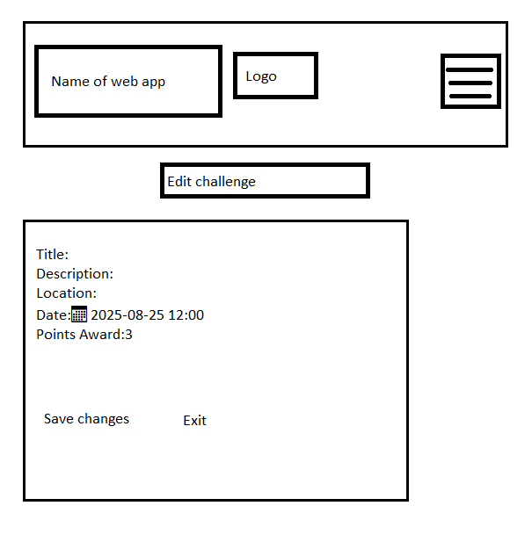Edit Challenge

Gamekeeper Dashboard  
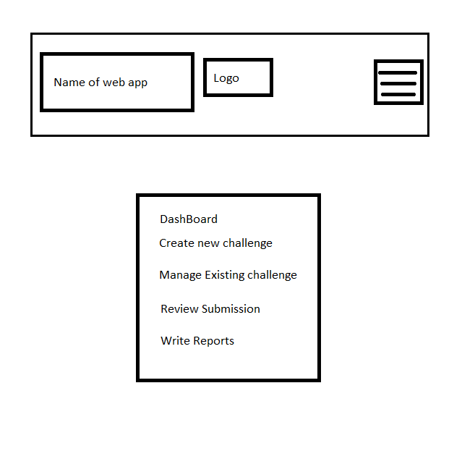

Leaderboard

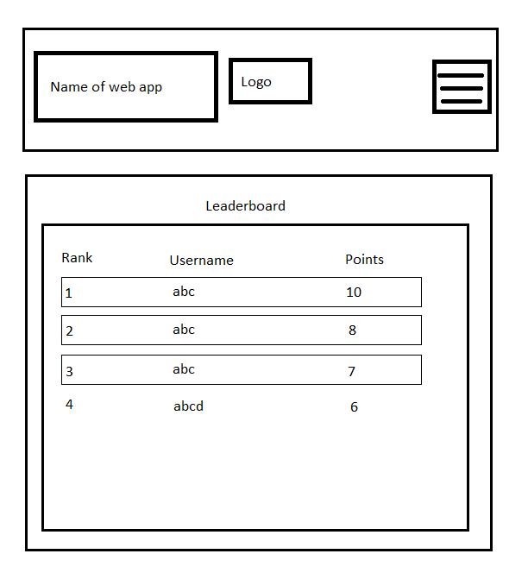

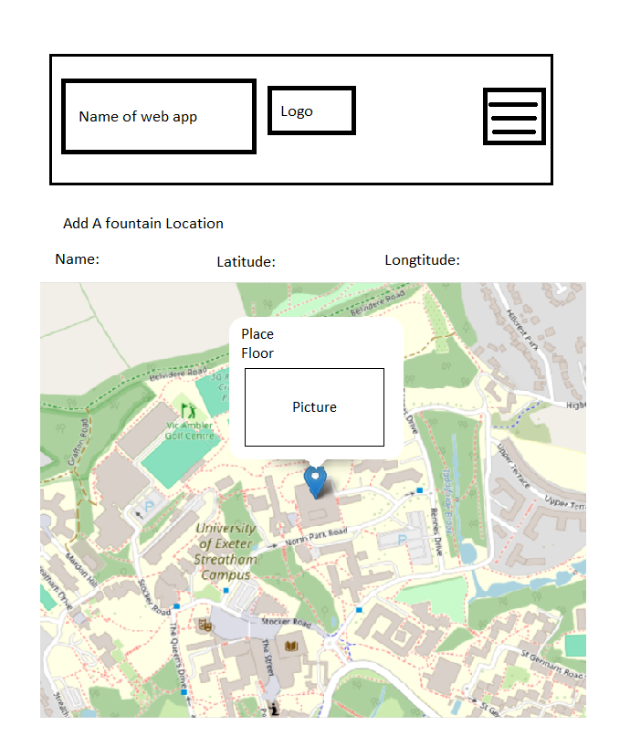GameKeeper Map

MAP

Login

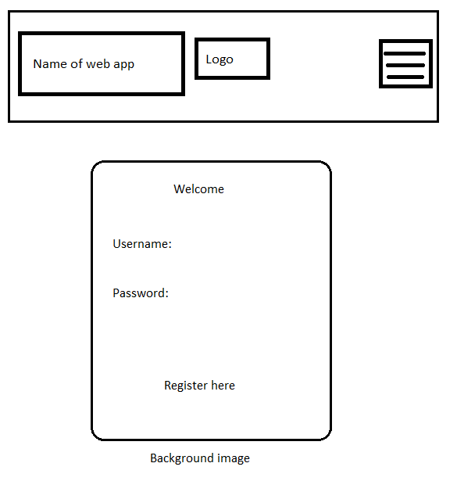

QR CODE SCAN

REGISTER

STUDENT DASHBOARD

Drop down menu

SETTINGS

