|  |
| --- |
| Web Technologies |

|  |
| --- |
| Ryan Spurrier  Candidate number: 40581939  Date: 19/04/2024 |

|  |  |
| --- | --- |
|  |  |

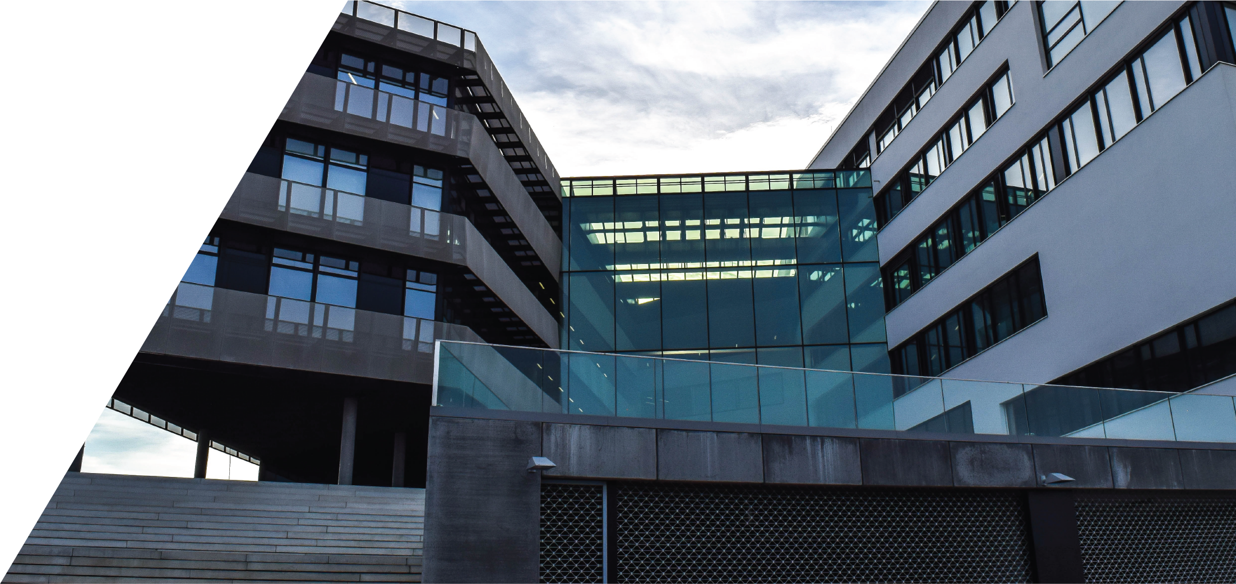

### Website URL –

<https://locomotion1286.github.io/>

### Differences from the design to the main product

There are a couple of differences that can be seen on my main website in comparison to the design ideas, on the pages I was hoping to have the image of the planet that the current page was about was to be displayed on the right hand side of the page and to be quite large, however when it came to coding this it became very tricky, I tried all sorts of techniques, fixing it to the right hand side of the page, even tried to specifically find the X and Y coordinates of the page to place it there, and I still had problems even when I was trying that. So, I had to rethink my ideas quickly. What I went for instead was just the image of the planet at the bottom of the page.

Another difference that can be noticed instantly is that at the bottom of the page I have added a small footer to the page, it is just a simple copy right statement at the bottom of the page. But I felt at the time that I was finishing the first page, after looking at it there was something missing and I could not work out what it was. So, all I did was find a website quickly and have a quick scroll through it to see what was missing, and on the website, there was a footer on the page that I was missing.

When it came to the satellite page, I decided to change the layout of the page, I also went for a different idea when it came to the information, I decided to go for a couple of different satellites and what they do when they are in space, rather than saying what the different types of satellites are. Also, instead of having one image of a satellite I had an image of each of the satellites.

Also, I had a slightly different drop-down menu, in the design there are three lines in a horizontal format. However, when I came to programming this, I had a few issues trying to code it, so instead I just opted to go for a normal drop-down menu with all of the other pages.

I was supposed to have a space station page as well, however when I was trying to code this page with all of the images of the space station and trying to have the set information, this became very tricky, one of the biggest issues I faced was trying to get the images in the correct location, I had that issue a lot when it came to coding this page, so after some research and a little bit more time I believe I could have implemented that knowledge into the website.

On the astronomer page, I wanted to have a slightly different layout, however once again I was having issues with the coding of the page, when it came to putting the text on a certain part of the page and then trying to add an image next to it, it was like it just wasn’t having it. So, I had to change the design of the page, it still holds the same information just slightly different.

### Different features and new knowledge

With the skills that I now possess after doing some research I believe that I could improve my website. One of the features I wish I had more time to look into was API’s I had the code I believe of the API; I had the key and the link to the API. However, I was still missing something, and I was not too sure what it was that I was missing, I believe that having this on my website would have really just added that little bit extra to the website.

Another feature that I wish I had was a little bit more of a unique design approach, I wish I had stars in the background of the website, just to add that little bit more to the website. All these little features are what differs a thorough website to an excellent website.

Another feature on which I added was scalability, so when the device is opened on a different device with different screen dimensions that the website looks the same on each device. However, when you open the website on a different device the website looks completely different, and it does not look the same. This is something that has really annoyed me and when I am trying to fix the issue it just created more issues, so I left it to how it was. With a bit of research into how to fix the issue I think that I could have figured out how to scale the images and the text on the screen so that if the user was to open up the website on a different device with a different resolution it wouldn’t look out of place.

### Challenges and achievements

There were many challenges that I faced when it came to coding this website, as I am not too familiar with coding a website, I remember I had done it once in college however that was over 4 years ago, so, I had to restart again. However, once I started coding and getting things wrong and then finding a solution for the issues, a lot of the stuff that I had learn at college came back to me and I was able to get a lot of the coding done in a couple of days. One of the challenges I faced was definitely fixing all the errors, when I done a rough template for each page there was a lot of errors when I coded it, so I had to go back around and try and fix all of the issues. I wish that I had done one page and then completed that and then moved onto the next page, so that one was completed at a time meaning that I wouldn’t have to go back and change that page at all unless I added maybe a different heading that I needed to add to the drop-down menu but that was it.

One of the challenges I faced when I was making the website was towards the end when I went to add the API to the home page, I left this till last as I tried to do it when I was coding the home page however I got a stumped so I left it so that it could be done at the end of the website, however after sitting down and watching a couple of videos on YouTube and asking my fellow classmates I was still a bit stuck on how to do it. I tried to write a bit of code, I felt like I was there when I had the code however, I still felt like I was missing something particularly important. This really annoyed me because that was the feature that I was really looking forward to having on my website.