

**Name:** Bui Dinh Loc Tho

**DOB:** 27/01/1995

**Address:** Thủ Đức, HCMC

**Phone:** +84962953207

**Skype:**

buidinhloctho1995

**Email:** [buidinhloctho1995@gmail.com](mailto:buidinhloctho1995@gmail.com)

**Blog:** <http://loctho95.blogspot.com/>

**Github:** <https://github.com/loctho1995>

**EDUCATION**

Student of third year in University of Infomation Technology.

**SKILLS**

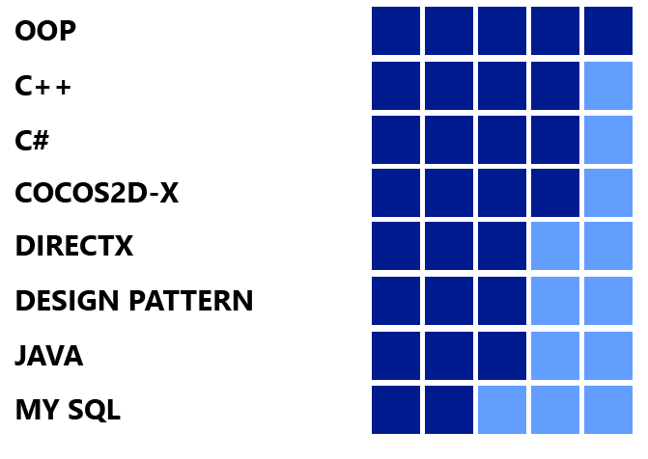

- Can work well by my own initiative and as a part of a team.

- Can self-learning and researching quicker.

- Can read and understand English documents.

- Not good at complex math and logic, but I am going to improve it.

- Sometime work hard like a crazy machine sometime so lazy, but I always finish assigned work before deadline.

**WORK EXPERIENCES**

- Indie game developer for 2 years and work on android and windows phone platform with self-publishing.

- Have ability to work with third party framework and engine: Cocos2d-x, DirectX, Box2D, Chipmunks, XNA, Monogame, XAML, Java Swing, Tiledmap editor, Facebook SDK.

- Have ability to work with multi language: C++, C#, Java and made game by each language.

**GAME TEST MEMORY**



**Name:** Bui Dinh Loc Tho

**DOB:** 27/01/1995

**Address:** Thủ Đức, HCMC

**Phone:** +84962953207

**Skype:**

buidinhloctho1995

**Email:** [buidinhloctho1995@gmail.com](mailto:buidinhloctho1995@gmail.com)

**Blog:** <http://loctho95.blogspot.com/>

**Github:** <https://github.com/loctho1995>

**PROJECTS**

**AT SCHOOL**

**GAME CONTRA**

Like game contra con NES. It was made by DirectX9.

* **Technical:** DirectX9, HLSL
* **Download:** <https://goo.gl/l5AJKO>

**GAME TETRIS**

Game play is the same with Tetris game on NES with higher graphics. Game has 3 levels: Easy, Normal, Difficult and support save the score, sounds and graphics.

* **Technical:** Java JFrame.
* **Download:** <https://goo.gl/1hWKzn>

**GAME MONSTER ATTACK**

Game category is Defense, your mission is touching on screen to attack the monsters and don’t let they move to your defense area.

* **Technical:** C++, C# XAML, Java, Cocos2d-x chipmunks.
* **Download:** <https://goo.gl/Nr5DKt>

**SOFTWARE STUDENT MANAGEMENT**

Software is used for managing information of students, teachers, classes.

* **Technical:** Three layers architecture, ADO.NET, Linq, User control.
* **Download:** <https://goo.gl/qmoKTw>

**PAINT**

Software is the same with Paint in windows, allow to save/load image and edit like: brush, geometry, marquee,…

* **Technical:** C#, User Control, Flood Fill.
* **Download:** <https://goo.gl/PNxEol>



**Name:** Bui Dinh Loc Tho

**DOB:** 27/01/1995

**Address:** Thủ Đức, HCMC

**Phone:** +84962953207

**Skype:**

buidinhloctho1995

**Email:** [buidinhloctho1995@gmail.com](mailto:buidinhloctho1995@gmail.com)

**Blog:** <http://loctho95.blogspot.com/>

**Github:** <https://github.com/loctho1995>

**PERSONAL PROJECTS**

**GAME TEST MEMORY**

Game helps player to improve their memory. Game play is showing a list of numbers with different location on the screen and player must tap on number with game rule like: tap to the smallest number to biggest number or reverse.

* **Technical:** Cocos2d-x C++, C# XAML, Java.
* **Download**
  + **Android:** <https://goo.gl/ocsiWa>
  + **Windows phone:** <http://goo.gl/WRNSZp>

**GAME SWEET VALENTINE**

A kind of Match - 3 game with one state. Game was published on valentine day so game symbols are pearls of love.

* **Technical:** Cocos2d-x C++, C# XAML, Java.
* **Download**
  + **Android:** <https://goo.gl/fkqSJs>
  + **Windows phone:** <http://goo.gl/BJV1Th>

**GAME QUICK TAP**

Game category is Casual game. Game have 2 pads, your mission is press on a block of under pad the same with above pad, level will increase and difficult will increase like: Rotate above pad each 90 degree, spinning above pad or cells. Game has 3 modes: Time Attack, Perfect and Training.

* **Technical:** C# XNA, Monogame, XAML.
* **Download:** <http://goo.gl/wXtLLQ>

**BIEN SO XE APPLICATION:**

The Application helps people search local license plate by number or by province. Support feedback to report errors or provide information. Application got above 50k downloaded on Windows phone.

* **Technical:** C# XAML (Windows phone), Java (android).
* **Download**
  + **Android:** <https://goo.gl/2wgbSl>
  + **Windows phone:** <http://goo.gl/PWhHYw>



**Name:** Bui Dinh Loc Tho

**DOB:** 27/01/1995

**Address:** Thủ Đức, HCMC

**Phone:** +84962953207

**Skype:**

buidinhloctho1995

**Email:** [buidinhloctho1995@gmail.com](mailto:buidinhloctho1995@gmail.com)

**Blog:** <http://loctho95.blogspot.com/>

**Github:** <https://github.com/loctho1995>

**NHAC NHO APPLICATION**

The Application helps users add their note or something they want to remind in the future, application will remind with sound and notification.

* **Technical:** C# XAML.
* **Download WP:** <http://goo.gl/eMw9bg>

**HOBBIES**

- Research game engines, tutorials, and make a demo.

- Reading news, listening to music, watching E-sport Game or movie.

- Play Game, watch E-Sport events.

- Write blog, tutorials, game experiences, share own knowledge.

**PRIZES**

- Top 50 mobiles game, Bluebird Award contest.