**WORKSHEET 16**

**Lecture on Fixed Point, Multiplication & Floating Point**

|  |
| --- |
| PART 1. Fixed point representation |

* 1. Using as inspiration the representation of fractional values in the decimal world (e.g. 2.53), how could you represent fractions in binary?

|  |
| --- |
|  |

1.2.

When using U(4,4), what is the decimal representation of the fixed-point binary number 10111010?

|  |
| --- |
|  |

When using U(6,2), what is the decimal representation of the fixed-point binary number 10111010?

|  |
| --- |
|  |

When using U(8,0), what is the decimal representation of the fixed-point binary number 10111010?

|  |
| --- |
|  |

1.3 Using 3-bit binary words, calculate the two’s complement of the following numbers:

|  |  |  |  |  |  |  |  |  |
| --- | --- | --- | --- | --- | --- | --- | --- | --- |
| X | 0 | 1 | 2 | 3 | -4 | -3 | -2 | -1 |
| Two’s complement |  |  |  |  |  |  |  |  |

1.4. Using the pseudocode given to convert from decimal to two’s complement and vice versa, do the following:

1. Convert the decimal number 18 into its two’s complement representation
2. Convert the decimal number -27 into its two’s complement representation
3. Convert the two’s complement number 01010101 to its decimal representation
4. Convert the two’s complement number 11010101 to its decimal representation

|  |
| --- |
| PART 2. Multiplication |

1. For the following incomplete figure, what multiplication technique is used? (Divide-and-Conquer Multiplication or Divide-and-Conquer Karatsuba Multiplication)

|  |
| --- |
|  |

Complete the missing numbers:

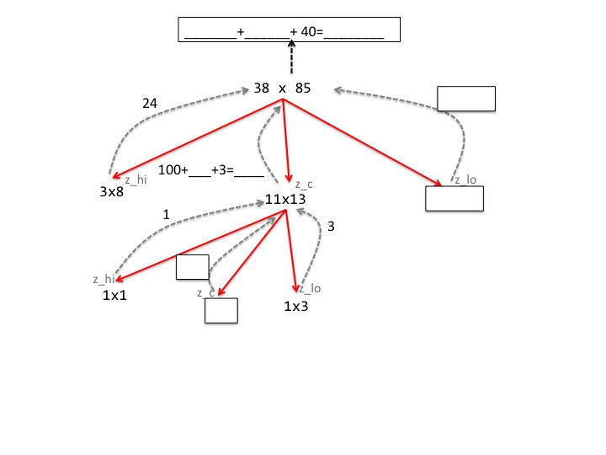

|  |
| --- |
| PART 3. Floating Point Representation |

1. Write the binary number that represents the number 12.75

|  |
| --- |
|  |

1. Write the previous binary number in scientific notation in base 2 (as with base 10, you register how many position you “move” the point and that is the exponent)

|  |
| --- |
|  |

1. Write this number is single-precision IEEE 754 format:

sign bit (1 bit):

exponent bits (8 bits):

mantissa bits (23 bits):

Whole number in IEEE 754 format (grouping the bits in sets of 4 makes reading easier)

|  |
| --- |
|  |

Now, please write it in hexadecimal notation:

|  |
| --- |
|  |