ALGORITHMS & DATA STRUCTURES
ADDITIONAL INFORMATION FOR LAB 18: TRIES
WEEK OF 18TH MARCH 2019

- USAGE

Let’s first understand how the methods and attributes you are going to implement are going to be used.

The following lines of code create a new trie, insert the strings “one” and “two” on it and then query about whether the strings “ones” and “two” are present in the trie (the first query should return false and the second one true).

JAVA CODERS
Trie t = new Trie();
t.insert("one");
t.insert("two");
t.query("ones");
t.query("two");

C++ CODERS
Trie *t = new Trie();
t->insert("one");
t->insert("two");
t->query("ones");
t->query("two");

- ABSTRACT MODEL

At the very beginning the trie is nothing but an array of 27 NULL elements, as shown in Figure 1.

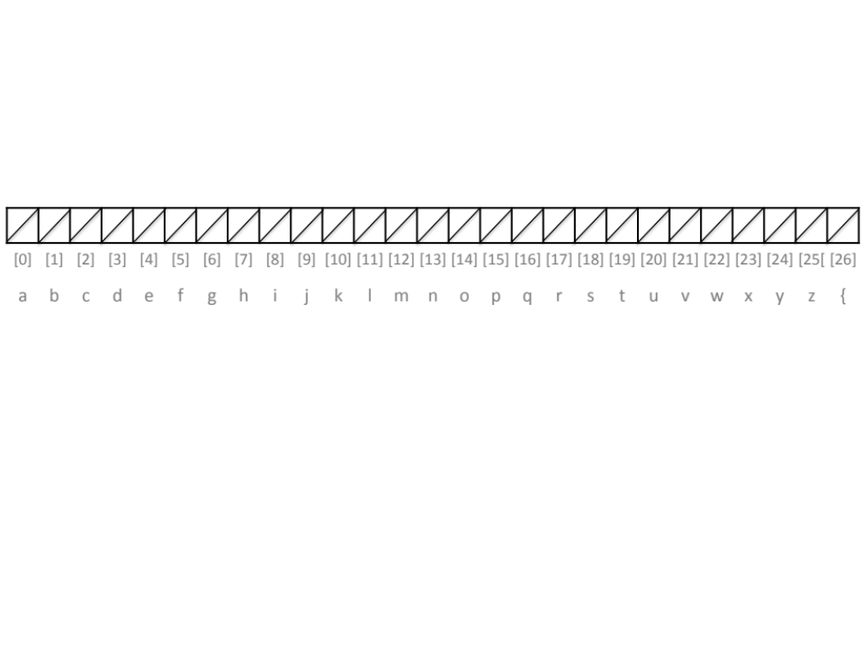

Figure 1. An empty trie

The letters at the very bottom of Figure 1 show the correspondence between the position in the array and the letter this position is “representing”. For example, letter p is “represented” by position [15] in the array.

Now, let’s assume the string “it” is going to be inserted into the trie. Then, the first thing to do is checking whether the position corresponding to letter ‘i’ is already “open”/used in the trie. To do so, we check the content of position 8 (which is the position “representing” letter i). This position is NULL, which means that there is no string starting with the letter i in the trie yet. So, we need to “open” this position. To do so, we make that position to point to a new NULL array, as shown in Figure 2.

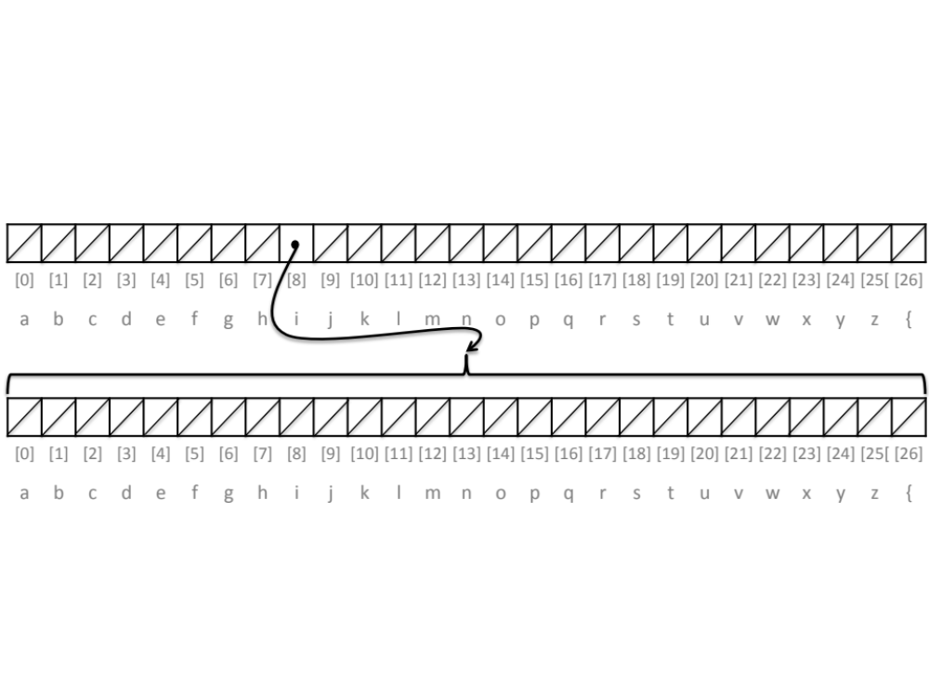
Figure 2. A trie with letter i inserted at level 1 (root is at level 0)

The next step is checking whether letter ‘t’ is stored in the trie after letter ‘i’. So, we check position 19 (corresponding to the letter ‘t’) on the second array (the array at the bottom of Figure 2). As this position is NULL, this means that letter ‘t’ is not in the trie. So, we “open” this letter by making position 19 to point to a NULL array, as shown in Figure 3.

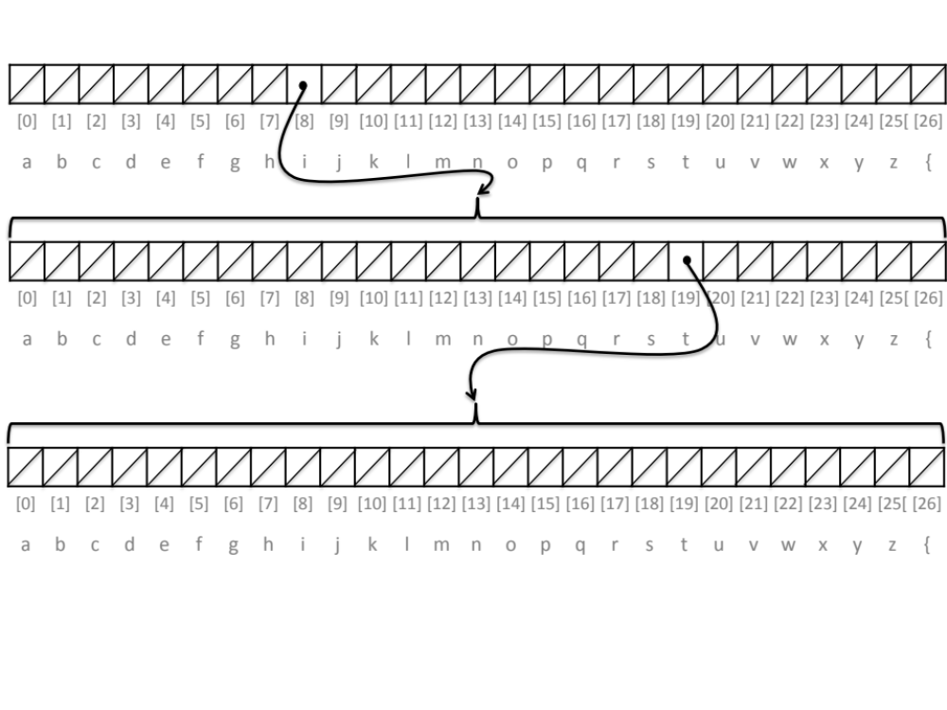
Figure 2. A trie with letter i inserted at level 1 (root is at level 0) and letter t at level 2 (as a child of letter i)
Finally, we have to insert the symbol ‘{‘ as a marker for the end of the word. This is equivalent to inserting such symbol. To do so, we “open” position 26 in the last level of the trie by making this position to point to an NULL array, as shown in Figure 4.

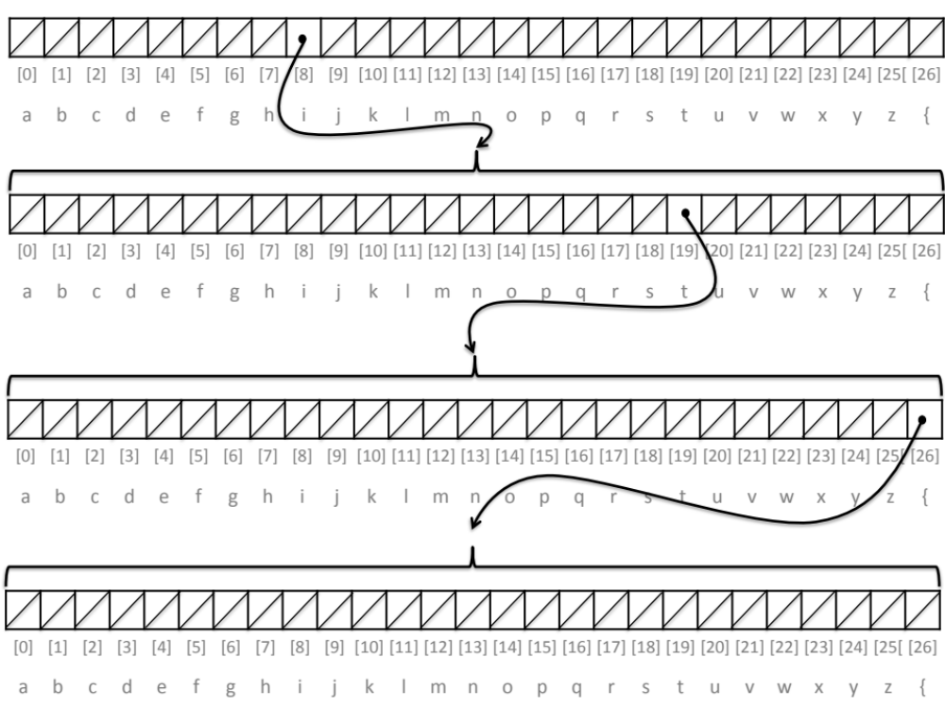
Figure 4. Trie storing the word “it”

- PUBLIC VARIABLES

children: this variable is an array of 27 elements.

JAVA CODERS
Each element of the array is of type Trie. In Java, you declare an array of elements of type Trie as follows:

public Trie[] children;

Please, note that you are just declaring the variable children, You have not allocated memory space to it. That is something you need to do before starting to use the variable to store data.

C++ CODERS
In C++ , each element f the array is a pointer to a Trie type. Thus, the array of type Trie is declared as:

Trie **children;

This type of declaration can be also understood as Trie *children[].

3. CONSTRUCTORS

The constructor initialises the NULL array children. When calling the constructor, remember to allocate memory space to the array children.

In Java you call new and allocate 27 spaces of Trie type to the variable children:

children = new Trie[27];

In C++ you call new and allocate 27 spaces of “pointer to Trie” type to the variable children:

this -> children = new Trie* [27];

- METHODS

C++: void Trie::insert(std::string s)
Java: public void insert(String s)

This method receives a string and insert it, character by character, recursively into the trie. The method has to take care of 3 situations:

- When the string is empty: in that case a new empty trie must be assigned to the position 26 of the array (corresponding to the character ‘{‘ signalling the end of a word). This is performed in lines 2-3 in the pseudo-code shown below.
- When the next character to insert has not been already inserted in the trie: in this case, you must first create a new Trie in the position of the character (lines 6-8 in the pseudo-code shown below) and then call function INSERT again (recursive call) using as an input the rest of the string (line 9 in the pseudo-code shown below)
- When the next character to insert is already in the tree: in this case you only have to call the function INSERT again (recursion) using as an input the rest of the string line 9 in the pseudo-code shown below)

The pseudo-code for this function is as follows:

1. | function INSERT(s)
2. | if s.length()=0 then
3. | children[26]=new Trie()
4. | else
5. | index=s[0]-‘a’
6. | if children[index]= NULL then
7. | children[index]=new Trie()
8. | end if
9. | children[index]=insert(s[1]…s[s.length()-1])
10. | end if
11. | end function

Line 5 identifies the index where the next node has to be inserted (letter ‘a’ is converted to number 0, letter ‘b’ to number 1 and so on until character ‘{‘ is converted to number 26; in the same fashion you used for the Big Integers Lab). s[i] refers to the i-th character of string s (entered as input to the function INSERT).

C++: bool Trie::query(std::string s)
Java: public boolean query(String s)

The input of this method is string s. The method must return false is string s is not stored in the trie, true if it is. Analogously to the method INSERT, the method QUERY must consider 3 cases:

- When string s is empty: if position 26 in children is null, return false. Otherwise, return true (lines 2-7 in pseudo-code below).
- When the first character of string s is stored in the trie: in that case, the function QUERY must be called again (recursive call) using as an input the rest of the string (line 13 in the pseudo-code shown below). In that way, the following characters of the string are checked.
- When the first character of s is not stored in the trie: in that case, the function must immediately return false (lines 10-11 in the pseudo-code below).

The pseudo-code for this function is as follows:

1. | function QUERY(s)
2. | if s.length()=0 then
3. | if children[26]=NULL then
4. | children[index]=false
5. | else
6. | return true
7. | end if
8. | else
9. | index=s[0]-‘a’
10. | if children[index]= NULL then
11. | return false
12. | else
13. | return children[index].query(s[1]…s[s.length()-1])
14. | end if
15. | end function

