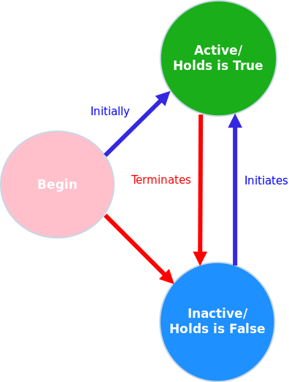
Event/Temporal Calculus

- On begin, a fluent can be activated with: initially(fluent_name), but by default, all defined fluents are inactive when starting. A fluent is defined with fluent(fluent_name)
- If active, a fluent can be terminated with an event, becoming inactive
- If inactive, a fluent can be initiated with an event, becoming active
- Events that trigger initiate or terminate are defined with event(event_name) and called with happens(event_name, timestamp)
- Initiates and terminates define which event initiates or terminates a fluent:
  - initiates(event_name, fluent_name, timestamp)
  - terminates(event_name, fluent_name, timestamp)
- HoldsAt(fluent_name, timestamp), allows to check if a fluent is active or inactive at a given timestamp

