Day 1 Exercise
Follow the steps in order. Take your time.
- Install the Claude Code extension in VS Code and sign in. Then open this folder in VS Code.
- Run the app. Follow the steps in README.md.
- Learn about models and prices. A "token" is a small piece of text (about 4 letters). Claude reads and writes text in tokens, and you pay per token. Open https://www.anthropic.com/pricing and https://docs.claude.com/en/docs/about-claude/models/overview. Fill in this table:
Model | Price per 1M input tokens | Price per 1M output tokens | When would you use it?
Haiku | $0.10(Prompts ≤ 100K tokens)  $0.50(Prompts > 100K tokens) | $0.50(Prompts ≤ 100K tokens)  $2.50(Prompts > 100K tokens) | Cost efficient simple tasks  Less complex  Pricing based on the size of the input prompt
Sonnet | $2 | $10 | High-performance than Haiku  Medium complex reasoning needed
Opus | $4 | $20 | enterprise work  Higher cost  when Complex reasoning needed
- In Claude Code, type /model. See which model you are on. Switch to a different one once.

- Ask Claude: "Explain how this app works in 5 bullet points." Then type /context. "Context" is everything Claude can see right now in this chat. Write down what is using space. Then type /cost (or /usage if you use a subscription). Write down what you see.

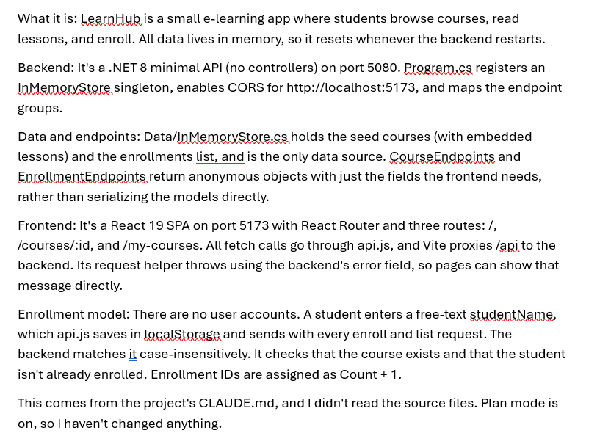
- Ask Claude one question about the code, for example "Where are courses stored?". Open the file it names and check that the answer is right.
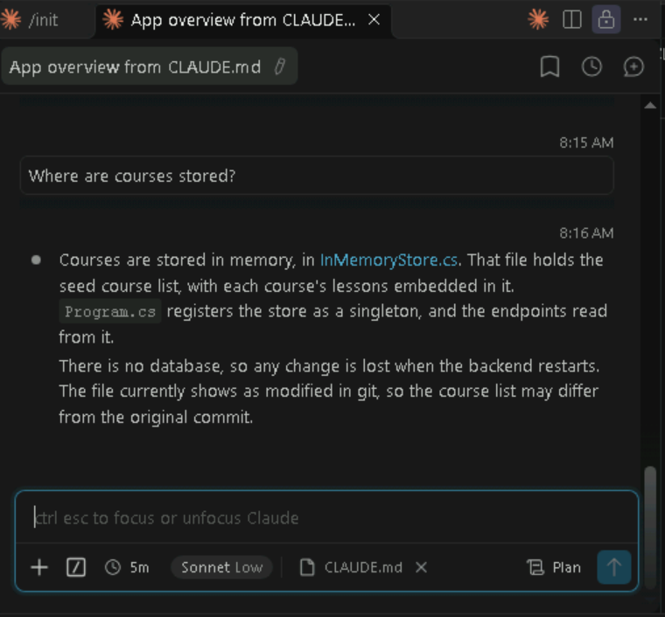
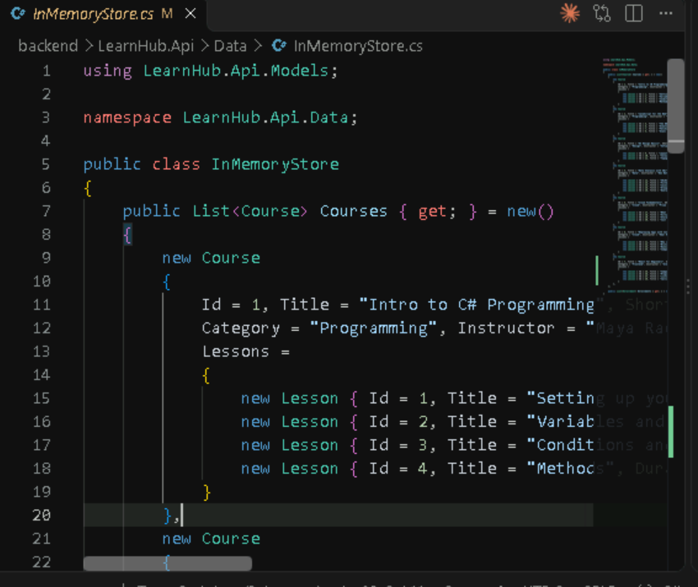
- Bonus: type /help. List 3 commands that look interesting to you.
What to bring to Day 2: your filled table and one thing that surprised you.
Concept about the context window.
The claude can help in identifying the files with respect of the functionality using the chat

