

**Software Requirements Specification (SRS) for ELITE ESTATE ROYCE**

**Sir Moazzam Ali Shah**

**Group Members:**

1. **Khubaib Lodhi (K21-4596)**
2. **Aahil Ashiq (K21-4549)**
3. **Khuzaima Ahsan (K21-3328)**

**Table Of Contents:**

1. **Introduction**
   1. Purpose------------------------------------------------------- 06
   2. Document Convention------------------------------------ 06
   3. Intended Audience and Reading Suggestion-------- 06
   4. Product Scope----------------------------------------------- 06
   5. Reference----------------------------------------------------- 07
2. **Overall Description**

2.1. Product Perspectives---------------------------------------- 08 2.2. Product Functions-------------------------------------------- 08

2.2.1. User registration

2.2.2. Property search and submission

2.2.3. Installment calculator

2.2.4. Admin panel for system management

2.2.5. Contact and feedback management

2.2.6. Property types categorization

2.2.7. Ownership document verification

2.2.8. Map integration

2.2.9. Private chat

2.2.10. Star ratings and filtering

2.2.11. Notifications

2.3. User Classes and Characteristics-------------------------- 18

2.3.1. Buyers

2.3.2. Sellers

2.3.3. Administrators

2.4. Operating Environment------------------------------------- 20 2.5. Design Implementation and Constraints--------------- 22

2.5.1. Corporate Policies

2.5.2. Hardware Limitations

2.5.3. Software Interfaces with MySQL

2.5.4. Communication Protocols

2.5.5. Security Considerations

**3. External Interface Requirements**

3.1. User Interface------------------------------------------------ 24

3.1.1. Contact Frame in Front Window

3.1.2. Navbar with Login Button

3.1.3. 3D Interface with Scroll

3.1.4. Discover Button and Search Bar

3.1.5. Property Listings and Functionalities

3.1.6. Interface Consistency and Standards

3.1.7. Separate User Interface Specification

3.2. Hardware Interface----------------------------------------- 26 3.3. Software Interface------------------------------------------ 27

**4. System Features**

4.1. User Registration------------------------------------------- 28

4.1.1 Description and Priority

4.1.2 Stimulus/Response Sequences

4.1.3 Functional Requirements

4.2. Property Search--------------------------------------------- 28

4.2.1 Priority

4.2.2 Stimulus

4.2.3 Functional Requirements

4.3. Property Submission--------------------------------------- 30

4.3.1 Priority

4.3.2 Stimulus

4.3.3 Functional Requirements

4.4. Contact And Feedback Management------------------- 33

4.4.1 System Detail

4.4.2 Stimulus

4.4.3 Functional Requirements

4.5. Private Chat---------------------------------------------------- 37

4.5.1 Priority

4.5.2 Stimulus

4.5.3 Functional Requirements

**5. Other Functional Requirements**

5.1. Performance Requirements----------------------------- 40

5.1.1 Response Time

5.2. Safety Requirements-------------------------------------- 40 5.3. Security Requirements----------------------------------- 41 5.4. Software Quality Attributes----------------------------- 41

5.4.1 Usability

5.5. Business Rules---------------------------------------------- 41

5.5.1 User Property Submission

5.5.2 Property Submission Requirements

**6** .**Diagrams**

6.1. Activity Diagram-------------------------------------------- 42

6.2. Class Diagram----------------------------------------------- 44

6.3. Sequence Diagram------------------------------------------ 45

6.4. Use Case Diagram------------------------------------------ 46

6.5. Deployment Diagram-------------------------------------- 46

6.6. Component Diagram-------------------------------------- 47

6.7. Communication Diagram-------------------------------- 48

6.7.1. For User Registration------------------------------- 48

6.7.2. For Property Search--------------------------------- 48

6.7.3. For Submission--------------------------------------- 49

6.7.4. For Feedback----------------------------------------- 50

**7. Other Requirements**

7.1. Legal And Regulatory Requirement------------------- 50

7.1.1 Data Protection and Privacy----------------------- 51

7.1.2 User Consent------------------------------------------ 51

1. **Introduction**

**1.1 Purpose**

This SRS defines the software requirements for ELITE ESTATE ROYCE, an online real estate portal for all gated housing societies in pakistan. It outlines the features, functions, and constraints of the system.

**1.2 Document Conventions**

Standard documentation conventions are followed. Priority levels for requirements are defined as High, Medium, or Low.

* 1. **Intended Audience and Reading Suggestions**

This document is intended for developers, project managers, marketing staff, users, testers, real-estate tycoons, market leaders and documentation writers. It is organized to provide an overview for all readers, with a suggested reading sequence.

**1.4 Product Scope**

ELITE ESTATE ROYCE is envisioned as a robust platform encompassing a multitude of features to enhance the user experience in real estate dealings. There is renewed strength in the construction industry in Pakistan these days. Every now and then, one hears the building of a new society. Every society wants a platform to market its plots. We plan to provide a platform to these societies and all other existing strong societies. The system includes, but is not limited to, user registration, property search, submission, an installment calculator, an admin panel, contact and feedback management, property categorization, ownership document verification, map integration, private chat, star ratings and notifications

**1.5 References**

https://t4tutorials.com/use-cases-description-of-real-estate-management-system-project/

https://creately.com/diagram/example/ick4k1g71/real-estate-system-class-diagram

https://www.freeprojectz.com/uml-diagram/property-management-system-component-diagram

https://conceptdraw.com/a629c3/preview--UML%20deployment%20diagram%20-%20Real%20estate%20transactions

https://creately.com/diagram/example/i6d6leyc1/real-estate-system-sequence-diaram-classic

https://www.researchgate.net/figure/Model-of-communication-for-a-real-estate-transaction_fig1_339025952

https://creately.com/diagram/example/ipox40242/real-estate-system-activity-diagram-classic

https://documents.gresb.com/generated_files/real_estate/2023/real_estate/reference_guide/complete.html

https://www.visual-paradigm.com/

https://www.lucidchart.com/blog/

**2. Overall Description**

**2.1 Product Perspective**

ELITE ESTATE ROYCE is a self-contained online real estate portal. It interacts with users, property databases, and external communication channels. A high-level diagram illustrating major components and interfaces is provided in the vision and scope document.

**2.2 Product Functions**

**2.2.1 User registration**

User registration is a critical component of a real estate portal, serving as the gateway for users to access various features and services. A well-designed registration process enhances user experience, ensures security, and facilitates personalized interactions. Here's a detailed breakdown of the user registration process for a real estate portal:

**User Information:**

Basic Details: Collect essential information such as full name, email address, and phone number. These details will serve as the primary means of communication and user identification.

Password: Implement a secure password policy, requiring users to create a strong password for account protection.

**Verification Mechanism:**

Email Verification: Send a verification link to the user's email address to confirm its authenticity. This step ensures that the provided email is valid and that the user has control over the account.

Plus, there would be an option to create an account through Google, Facebook or some other global intercessor app.

**2.2.2 Property search and submission**

Implementing an effective and user-friendly property search functionality is crucial for a real estate portal. Here's a detailed guide on how it can be designed and implemented:

**Prominence:**

Place the search bar prominently on the homepage to make it easily accessible.

**Detailed Property Listings:**

Provide comprehensive property details, including high-quality images, property features, floor plans, and contact information for the listing agent.By incorporating these features into your property search functionality, you can create a powerful tool that meets the diverse needs of users searching for real estate on your portal.

**2.2.3 Installment calculator**

Implementing an installment calculator is a valuable tool for a real estate portal, especially for users interested in financing options. Here's a guide on creating an installment calculator.Calculation

**Monthly Installment:**

Display the calculated monthly installment based on the entered loan amount, interest rate, loan term, and down payment.

**Total Interest Paid:**

Show the total interest paid over the life of the loan.

**Total Repayment Amount:**

Display the total amount repaid, including both the principal and interest.

**Save Calculations:**

Allow users to save their calculated results for future reference or comparison.

**Share Results:**

Include options for users to share the results via email.By incorporating these features into your installment calculator, you can offer a valuable tool that helps users assess the financial aspects of purchasing real estate and contributes to a more informed decision-making process.

**2.2.4 Admin panel for system management**

Designing an efficient and user-friendly admin panel for system management is essential for the smooth operation and maintenance of a real estate portal. Below is a guide on key features and functionalities that should be included in the admin panel

**User Management:**

Define different user roles (e.g., admin, moderator, customer support) with specific permissions.

Allow administrators to create new user accounts and deactivate or suspend accounts as needed.

**Property Management:**

Enable administrators to review and approve or reject property listings before they are published on the portal.

Provide the ability to delete or hide listings that violate policies or are no longer relevant.

By incorporating these features into the admin panel, you can ensure effective management, monitoring, and maintenance of your real estate portal, leading to a seamless user experience for both administrators and end-users.

**2.2.5 Contact and feedback management**

Effective contact and feedback management are crucial components of a real estate portal, fostering positive interactions with users and addressing their inquiries or concerns promptly. Below is a guide on how to implement these features:

**Contact Forms:**

Implement user-friendly contact forms for general inquiries, support requests, and partnership inquiries.

Include fields for name, email address, subject, message, and possibly a category dropdown (e.g., sales, technical support).

**User Feedback Forms:**

Create feedback forms to gather user opinions on the portal's usability, features, and overall experience.

Include open-ended questions to encourage detailed feedback.By incorporating these contact and feedback management features into your real estate portal, you can build a stronger connection with users, improve the overall user experience, and drive ongoing enhancements to your platform.

**2.2.6 Property types categorization:**

The Property Types categorization feature in the system serves to enhance user experience and streamline property search functionalities. By systematically organizing properties into distinct types, including apartments, houses, buildings, flats, villas, and offices, and further differentiating them by sale or rental options, the system aims to provide users with a structured and efficient means of browsing and locating properties that align with their specific needs and preferences. This categorization feature facilitates a more intuitive and user-friendly interface, allowing users to quickly identify and explore properties that match their desired criteria, ultimately enhancing the overall usability and effectiveness of the property management system.

**2.2.7 Ownership document verification:**

**Ownership Documents Submission**

The system shall provide a feature allowing property sellers to submit ownership documents, power of attorney, CNIC, and other pertinent documents for verification purposes. The submission process should be secure and user-friendly.

**Document Verification**

Upon document submission, the system shall facilitate the verification process through a team of agencies and specialists. The administrator will assign a star rating based on the completeness and authenticity of the provided documents.

**2.2.8 Map integration:**

The system shall integrate a mapping functionality to display the location of the property. This feature will enhance the user experience by providing a visual representation of the property's geographical position.

**Map Interaction**

Users should be able to interact with the map, zoom in and out, and view additional details related to the property location.

**External Map Integration**

The system shall provide users with the option to open the property location in external map applications such as Google Maps or the default map application on their device. This feature aims to offer users a seamless transition between the application's map interface and their preferred external mapping tools. The external map configuration should be compatible with major mapping applications and ecosystems. Plus, there should be a setting to directly open the location on the default map application.

**2.2.9 Private chat:**

The system shall include a private chat option to facilitate direct communication between property sellers and potential buyers.

**User Authentication**

Users engaging in private chats must be authenticated, ensuring a secure and trustworthy communication channel.

**Account Verification**

To initiate a private chat, users must have verified accounts. Verification may involve email confirmation, mobile number verification, or other secure methods to establish user identity.

**Notification System**

The system should incorporate a robust notification system to alert users of new messages, ensuring timely and efficient communication.

**Privacy Settings**

Users shall have comprehensive control over their privacy settings within the private chat feature.

**Visibility Controls**

Users can set their online status (online, offline, away) and control the visibility of their last seen status to enhance privacy.

**Block and Report Functionality**

A blocking mechanism shall be implemented, allowing users to block and report others in case of inappropriate behavior. The system shall provide a mechanism for reviewing and addressing reported incidents.

**Content Moderation**

The private chat feature shall include content moderation to prevent the exchange of inappropriate or offensive content. Messages violating community guidelines shall be flagged and appropriate actions taken.

**File Attachment**

Users shall be able to exchange files within the private chat, including but not limited to property documents, images, and other relevant files.

**2.2.10 Star ratings and filtering:**

Implementing star rating and filtering features in a real estate portal enhances user experience by providing valuable insights and making property search more efficient. Here's a guide on how to integrate star ratings and filtering into your portal.

**User Reviews and Ratings:**

Allow users to leave reviews and assign star ratings to properties they have interacted with. Display average ratings for each property based on user feedback.

Show star ratings prominently on property listings to catch the attention of potential buyers or renters.

Display individual ratings for each society to provide a comprehensive overview. This would help buyers choose reliable housing communities.

**Verification-Based Star Rating System:**

The administrator will assess and assign a star rating to plots upon the submission of ownership documents. A dedicated team of agencies and specialists will thoroughly verify the documents, and the administrator will then allocate a star rating. Properties with incomplete ownership documents will automatically receive a lower rating. While this rating won't filter the results, it serves as an indicator for buyers, highlighting the potential risk associated with the property.

**Filtering Options:**

Integrate filtering options on the property search page to enable users to refine results based on star ratings.

Implement sorting options that allow users to order search results by overall rating or specific rating categories.

Provide options for ascending and descending order.

**2.2.11 Notifications:**

Implementing a notification system and property recommendation feature can significantly enhance user engagement and satisfaction on a real estate portal. Below is a guide on how to integrate these features effectively:

**Custom Setting:**

Allow users to customize their notification preferences, specifying the types of notifications they want to receive (e.g., property updates, messages, system announcements).

**Push Notifications:**

Implement push notifications for mobile users to provide real-time updates on new property listings, messages, and relevant activities.Email Notifications:

Send email notifications for important updates, such as new property matches, messages from agents, or changes in property status

**2.3 User Classes and Characteristics**

**2.3.1 Buyers**

Buyers are individuals or entities interested in purchasing or renting real estate properties through the Elite Estate Royce portal. Characteristics of buyers include:

**User Registration:**

Buyers can create accounts to access personalized features such as property saving, notifications, and private chat.

**Property Search:**

Buyers can search for properties based on various criteria, including location, type, and pricing.

**Installment Calculator:**

Buyers have the ability to use the installment calculator to estimate total payments over specified periods.

**Private Chat:**

Buyers can communicate directly with property sellers for inquiries and negotiations.

**Notification:**

Buyers will receive notifications about new property listings, updates, and responses to inquiries.

**2.3.2 Sellers**

Sellers refer to individuals or entities listing their real estate properties for sale or rent on the Elite Estate Royce portal. Characteristics of sellers include:

**Property Submission:**

Sellers can submit detailed property information, including ownership documents, pricing, images, and features.

**Ownership Documents:**

Sellers are required to provide ownership documents, power of attorney, CNIC, and other essential documents for verification.

**Private Chat:**

Sellers can engage in private communication with potential buyers for discussions and negotiations.

**Star Rating:**

Sellers will receive a star rating based on document verification, enhancing transparency for potential buyers.

**Notification:**

Sellers will be notified of inquiries, messages, and updates related to their listed properties.

**2.3.3 Administrators:**

Administrators have comprehensive control over the Elite Estate Royce portal, managing users, properties, and overall system functionality. Characteristics of administrators include:

**Admin Panel:** Administrators can oversee and manage users, states, cities, and property listings.

Contact and Feedback Management: Administrators handle user inquiries and feedback, ensuring effective communication.

**Star Rating:** Administrators verify ownership documents and assign star ratings for property sellers to indicate reliability.

**Notification:** Administrators receive notifications about user feedback, reported issues, and critical system updates.

**Recommendation:** Administrators may provide property recommendations to potential investors based on their preferences.

**2.4 Operating Environment**

The Elite Estate Royce system is designed to operate seamlessly on standard web browsers, ensuring compatibility with both desktop and mobile devices. The operating environment includes the following specifications:

**Web Browsers:**

The system is optimized for popular and standard web browsers, such as Google Chrome, Mozilla Firefox, Microsoft Edge, and Safari. Users can access the portal using these browsers to ensure a consistent and reliable experience.

**Desktop Devices:**

The system is compatible with desktop devices, including personal computers and laptops running various operating systems such as Windows, macOS, and Linux. Users can access the full range of features and functionalities on their desktop devices.

**Mobile Devices:**

The system is responsive and adapted for mobile devices, supporting smartphones and tablets across different platforms, including iOS and Android. The user interface is designed to provide an optimal viewing and interaction experience on smaller screens.

**Internet Connection:**

A stable internet connection is essential for accessing and using the Elite Estate Royce portal. Users should have reliable internet connectivity to ensure smooth navigation, property searches, and real-time interactions.

**Device Specifications:**

The system is designed to accommodate a range of device specifications, considering variations in screen sizes, resolutions, and processing power. The user interface is responsive, adjusting to different device characteristics for a user-friendly experience.

**Security Protocols:**

The operating environment prioritizes security, employing standard encryption protocols (such as HTTPS) to secure data transmission between users and the system. Additionally, user authentication and authorization mechanisms ensure secure access to personal accounts and sensitive information.

**Browser Settings:**

Users are advised to enable JavaScript and maintain updated browser versions for optimal performance and compatibility with the Elite Estate Royce system.

**2.5 Design and Implementation Constraints**

**2.5.1 Corporate Policies**

The Elite Estate Royce system must adhere to existing corporate policies governing data privacy, user rights, and ethical business practices. Compliance with these policies ensures the responsible handling of user data, transparent communication, and ethical considerations in all aspects of system design and implementation.

**2.5.2 Hardware Limitations**

The system's performance may be subject to hardware limitations, especially on older devices with limited processing power and memory. While efforts are made to optimize the system for various specifications, users on outdated hardware may experience reduced performance or limitations in accessing certain features.

**2.5.3 Software Interfaces with MySQL**

The system relies on MySQL as the primary database management system. Any changes or updates to MySQL, including version releases and patches, must be carefully assessed and validated for compatibility. Ensuring seamless integration with MySQL is crucial for maintaining data consistency, reliability, and system stability.

**2.5.4 Communication Protocols**

Communication protocols, including data transmission and messaging between users, must align with industry standards for security and efficiency. The system employs HTTPS to encrypt data during transmission, mitigating the risk of unauthorized access and ensuring the confidentiality and integrity of user interactions.

**2.5.5 Security Considerations**

Security considerations are paramount in the design and implementation of the Elite Estate Royce system. Measures include robust user authentication, secure handling of sensitive data, and continuous monitoring for potential vulnerabilities. Regular security audits and updates are essential to address emerging threats and maintain a secure environment for user interactions and data storage.

**3. External Interface Requirements**

**3.1 User Interfaces**

**3.1.1 Contact Frame in Front Window**

In the front window of the Elite Estate Royce portal, a prominent contact frame will be featured. This frame will display GitHub links for the development team members along with their pictures, fostering transparency and providing users with direct access to the team's profiles. This element aims to establish a connection between users and the development team, promoting accountability and trust.

**3.1.2 Navbar with Login Button**

The website's navigation bar (navbar) will prominently include a login button, facilitating user access to personalized features. This button serves as a gateway for both buyers and sellers to log in, ensuring a secure and personalized experience tailored to individual user profiles.

**3.1.3 3D Interface with Scroll**

A dynamic 3D interface will enhance the user experience as they scroll down the window. This visually engaging element will showcase 3D pictures of buildings, providing an immersive and captivating introduction to the available real estate properties. The 3D interface aims to create a modern and interactive browsing experience, capturing the attention of users from the moment they enter the website.

**3.1.4 Discover Button and Search Bar**

Following the 3D interface, a "Discover" button will be strategically placed, guiding users to a dedicated window for property exploration. This window will feature an intuitive search bar, allowing users to input preferences such as location, property type, and pricing. The search functionality is designed to streamline the property discovery process, enhancing user convenience and satisfaction.

**3.1.5 Property Listings and Functionalities**

Within the property discovery window, users will encounter a comprehensive display of houses and properties. The layout will prioritize clear property information, including images, pricing, features, and ownership details. Various functionalities, such as the Installment Calculator, Private Chat, Star Rating, and Notification options, will be seamlessly integrated into the property listings. This cohesive design ensures that users can efficiently navigate and interact with properties of interest.

**3.1.6 Interface Consistency and Standards**

Throughout the user interfaces, consistency will be maintained in terms of design elements, color schemes, and navigation patterns. Standard buttons for actions like "Chat," "Calculate Installments," and "Submit Property" will appear uniformly across relevant sections, providing users with an intuitive and user-friendly experience. Error messages will follow established display standards, ensuring clarity and ease of understanding in case of user input errors.

**3.1.7 Separate User Interface Specification**

For a more detailed breakdown of the user interface design, including specific screen layouts, GUI standards, and interaction details, a separate User Interface Specification document will be created. This document will delve into the specifics of each interface element, offering a comprehensive guide for developers and designers involved in the implementation phase.

**3.2 Hardware Interfaces**

The Elite Estate Royce system is designed to be compatible with standard hardware configurations found in desktop computers, laptops, and mobile devices. There are no specific hardware requirements, ensuring accessibility across various devices with different screen sizes and resolutions.

**3.3 Software Interfaces**

**MySQL Database:** The system interfaces with the MySQL database using SQL queries to store and retrieve data related to users, properties, and transactions.

**Web Browsers:** Elite Estate Royce is compatible with common web browsers such as Google Chrome, Mozilla Firefox, Microsoft Edge, and Safari, providing a consistent user experience.

**JavaScript, HTML, CSS:** The user interfaces leverage JavaScript for dynamic interactions, HTML for structure, and CSS for styling, ensuring a responsive and visually appealing design.

**GitHub:** GitHub is used for version control and collaborative development, allowing the team to coordinate efforts and maintain a centralized code repository.

**External APIs:** The system may integrate with external APIs for additional features such as mapping and notification services, enhancing overall functionality.

The versatile software interfaces enable seamless interactions, while the absence of specific hardware dependencies ensures broad accessibility across different devices and platforms.

**4. System Features**

**4.1 User Registration**

**4.1.1 Description and Priority**

Users can create and customize profiles. Priority: High.

**4.1.2 Stimulus/Response Sequences**

- User clicks on "Register."

- System prompts for user details.

- User provides details and submits.

- System creates a user profile.

**4.1.3 Functional Requirements**

- REQ-1: The system shall provide a user registration form.

- REQ-2: The system shall validate user input for registration.

**4.2 Property Search**

**System Description:**

The Property Search feature in the system enables clients to search for properties based on various criteria, providing a user-friendly and efficient way to find relevant real estate listings. Users can access detailed information about each property, including its name, location, pricing, features, images, and floor plans.

**4.2.1 Priority:**

High Priority –

This feature is critical for the core functionality of the real estate portal, as it directly addresses the primary user need of finding and exploring properties.

**4.2.2 Stimulus:**

Users initiate property searches by entering specific criteria such as state, which stimulates the system to retrieve and display relevant property listings.

**Response:**

The system responds by displaying a list of properties that match the search criteria, showing essential details like property name, location, pricing, features, images, and floor plans.

**4.2.3 Functional Requirements:**

**1. User Authentication:**

Users must be authenticated to access the Property Search feature to ensure personalized results and track user interactions.

1. **Search Criteria:**

Users can search for properties based on criteria such as state. The system must validate and process user input for accurate results.

**3. Property Data Retrieval:**

The system should fetch property data from the database based on the user's search criteria, ensuring relevant and up-to-date information.

**4. Display Property Listings:**

The system should present a visually appealing and informative display of property listings, including property name, location, pricing, features, images, and floor plans.

**5. Filter and Sorting Options:**

Users should have the ability to filter and sort search results based on different parameters (e.g., price range, features) for a customized experience.

**6. Property Detail View:**

Users can click on a specific property to view detailed information, including additional images, features, floor plans, and any other relevant details.

**4.3 Property Submission**

**System Description:**

The Property Submission feature allows property sellers to submit their properties for sale or rent, providing comprehensive details such as property name, location, pricing, features, images, and floor plans.

**4.3.1 Priority:**

High Priority - This feature is essential for the growth and sustainability of the real estate portal, enabling property sellers to contribute to the platform.

**4.3.2 Stimulus:**

User Interaction: Property sellers initiate the property submission process by entering detailed information about their property.

**Response:**

Property Listing Creation: The system responds by creating a new property listing based on the information provided by the property seller.

**4.3.3 Functional Requirements**

**1. User Authentication:**

Users must be authenticated to access the Property Search feature to ensure personalized results and track user interactions.

1. **Property Details Form:**

The system should provide property sellers with a form to input detailed information about their property, including name, location, pricing, features, images, and floor plans**.**

1. **Data Validation :**

Property must be authenticated through ownership documents to access the Property Search feature to ensure personalized results and track user interactions.

**Submission Confirmation:**

Upon successful submission, property sellers should receive a confirmation message, and the newly submitted property should be added to the database for public viewing.

**Property Edit and Update:**

Property sellers should have the ability to edit and update their property listings, allowing them to make changes or add additional information.

**Submission Status Tracking:**

Property sellers should be able to track the status of their property submissions, including whether the property is under review, approved, or rejected.

**Communication Channel:**

The system should facilitate communication between property sellers and potential buyers, allowing inquiries and negotiations.

**4.4 Contact and Feedback Management:**

**4.4.1 System Detail:**

The Contact and Feedback Management system serves as a vital component within the real estate portal, enabling users to interact with the web administrator seamlessly. It includes features such as a user authentication mechanism, dedicated contact and feedback forms, data validation procedures, submission confirmations, an administrative interface, user notifications, and analytics capabilities.

**Priority:**

High Priority - This system feature holds high importance as it establishes a direct line of communication between users and the web administrator. It enhances user engagement, gathers valuable feedback, and fosters a collaborative environment for continuous improvement.

**4.4.2 Stimulus:**

Users initiate the contact and feedback process by navigating to the respective sections on the real estate portal. Interaction occurs through the completion and submission of dedicated contact and feedback forms.

**Response:**

Upon user interaction with the Contact and Feedback Management feature, the system responds by first prompting user authentication to ensure secure communication. It facilitates the submission of information through intuitive contact and feedback forms, rigorously validating the entered data for accuracy and security. Following successful submissions, the system issues prompt confirmation messages to users, assuring them that their messages have been received and are being processed. For the web administrator, the system provides a dedicated interface to efficiently manage and respond to incoming feedback. Users are kept informed through timely notifications, fostering transparency and user engagement. The system establishes an effective communication channel between users and the web administrator, and it responds to the administrator's needs by offering analytics for data-driven decision-making, contributing to the continual improvement of the real estate portal.

**4.4.3 Functional Requirements**

**1. User Authentication:**

Users must undergo authentication to access the Contact and Feedback Management feature, ensuring that only authorized users can contact the web administrator and provide feedback.

**2.Contact Form:**

The system should include a user-friendly contact form that allows users to send messages to the web administrator. The form should capture essential details, such as name, email address, and a message field.

1. **Feedback Submission:**

Description: Users should have the ability to provide feedback through a dedicated form. This form should capture user opinions, suggestions, or concerns, enhancing user engagement and promoting continuous improvement.

1. **Data Validation:**

Description: The system must perform thorough data validation on the information submitted through the contact and feedback forms. This ensures the accuracy and reliability of the data and prevents misuse or security vulnerabilities.

1. **Submission Confirmation:**

Upon successful submission of the contact or feedback form, users should receive a confirmation message. This acknowledgment assures users that their messages have been successfully transmitted and encourages further engagement.

1. **Feedback Management Interface:**

The web administrator should have a dedicated interface to manage incoming feedback. This includes the ability to view, respond to, and categorize feedback for appropriate follow-up actions.

1. **User Notifications:**

Users should receive timely notifications about the status of their submitted feedback. This could include acknowledgment of receipt, updates on the resolution process, or any additional information relevant to their feedback.

1. **Communication Channel:**

The system should facilitate efficient communication between users and the web administrator. Users may expect responses or clarifications regarding their feedback, and the communication channel should support this interaction seamlessly.

1. **Feedback Analytics:**

Description: The system should provide analytics and reporting features to the web administrator, offering insights into the nature and trends of user feedback. This information can aid in making data-driven decisions to enhance the platform.

**4.5 Private Chat**

**System Detail:**

The Private Chat feature facilitates direct communication between sellers and buyers within the real estate portal. It provides a secure and personalized space for users to engage in one-on-one conversations.

**4.5.1 Priority:**

Medium Priority

- While not the core functionality, Private Chat enhances user experience by fostering direct communication, aiding negotiation, and building trust between buyers and sellers.

**4.5.2 Stimulus:**

Users initiate private chat sessions when interested in a property, allowing seamless communication between the buyer and seller.

**Response:**

**1. Chat Interface Activation:**

Upon a user request to initiate a private chat, the system responds by activating a dedicated chat interface, creating a secure space for real-time communication.

**2. User Notification:**

The system responds by sending notifications to both the buyer and seller, indicating that a private chat has been initiated and is ready for use.

**3. Real-time Messaging:**

As users engage in the private chat, the system responds in real-time, ensuring prompt message delivery and fostering effective communication.

**4.5.3 Functional Requirements:**

**1. Chat Initiation:**

Users should be able to initiate private chats from property listings, providing a direct channel for communication.

**2. User Authentication:**

Private chat functionality requires user authentication to ensure that only legitimate users can participate in secure conversations.

**3. Real-time Messaging:**

The system should support real-time messaging, allowing instant communication between the buyer and seller.

**4. Notification System:**

The system must include a notification system to alert users when a new message is received, ensuring timely responses.

**5. Chat History:**

Users should have access to a chat history, enabling them to review previous conversations and maintain a record of communications.

**6. Security Measures:**

The private chat feature should implement security measures to protect user privacy and sensitive information shared during conversations.

**7. User Status Indicators:**

The system should display status indicators (online, offline) to inform users of the availability of the chat participants.

The Private Chat feature augments the real estate portal by providing a dedicated space for secure and direct communication between buyers and sellers. It ensures real-time messaging, user authentication, and notification systems for an enhanced user experience.

**5. Other Nonfunctional Requirements**

**5.1 Performance Requirements**

**5.1.1 Response Time**:

The system shall respond within 2 seconds under normal load conditions. Additionally:

**Page Load Times:**

Individual page load times should be optimized, aiming for an average load time of 3 seconds or less.

**Transaction Speed:**

Transaction processing, including property submissions and payments, should be completed within 5 seconds.

**5.2 Safety Requirements**

**Buffer:**

There should be a temporary storage of data. In case a sudden app shutdown occurs, the user’s data should not be lost.

**Account Recovery:**

A secure account recovery mechanism shall be in place to assist users in case of forgotten passwords or compromised accounts.

**5.3 Security Requirements**

Data Encryption: User data must be encrypted during transmission. No third party involvement should be there when the user is using the website and any other website should not have access to user data traffic.

The system should authenticate the user before signing him in to the system. This should be done through a password or linked to other ecosystems like Google, Microsoft or Facebook.

**5.4 Software Quality Attributes**

**5.4.1 Usability:**

The interface should be intuitive and user-friendly, with considerations for accessibility and responsiveness on various devices. Plus, The app shall work on different environments for user’s ease

**Feedback Mechanism:** Users should have the ability to provide feedback on the system's usability, allowing for continuous improvement.

**5.5 Business Rules**

**5.5.1 User Property Submission:**

Only registered users can submit properties. This rule ensures that property submissions are associated with authenticated users, contributing to accountability and traceability.

**5.5.2 Property Submission Requirements:**

Property submissions should include mandatory details such as ownership documents, pricing, and property features to maintain a standardized and comprehensive listing.

**6. Diagrams**

**6.1 Activity Diagram:**

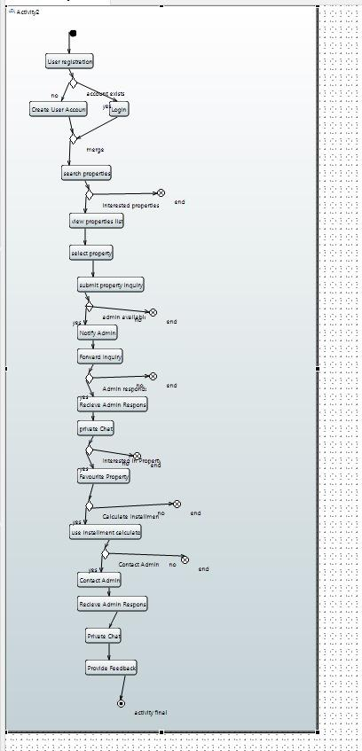

**6.2 Class Diagram:**

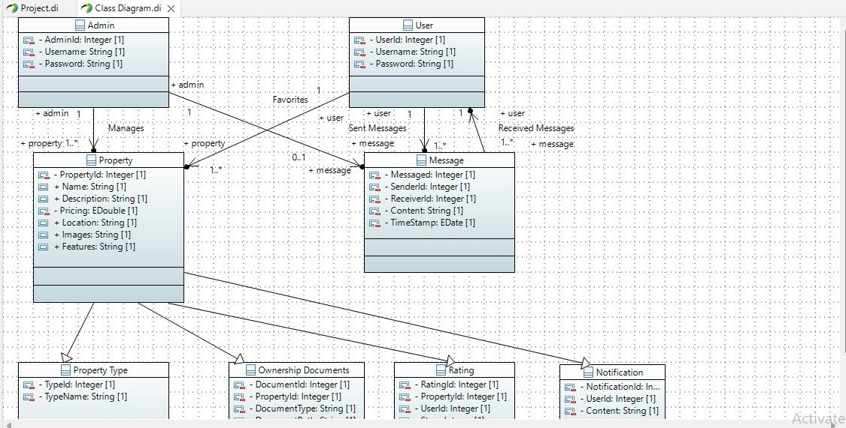

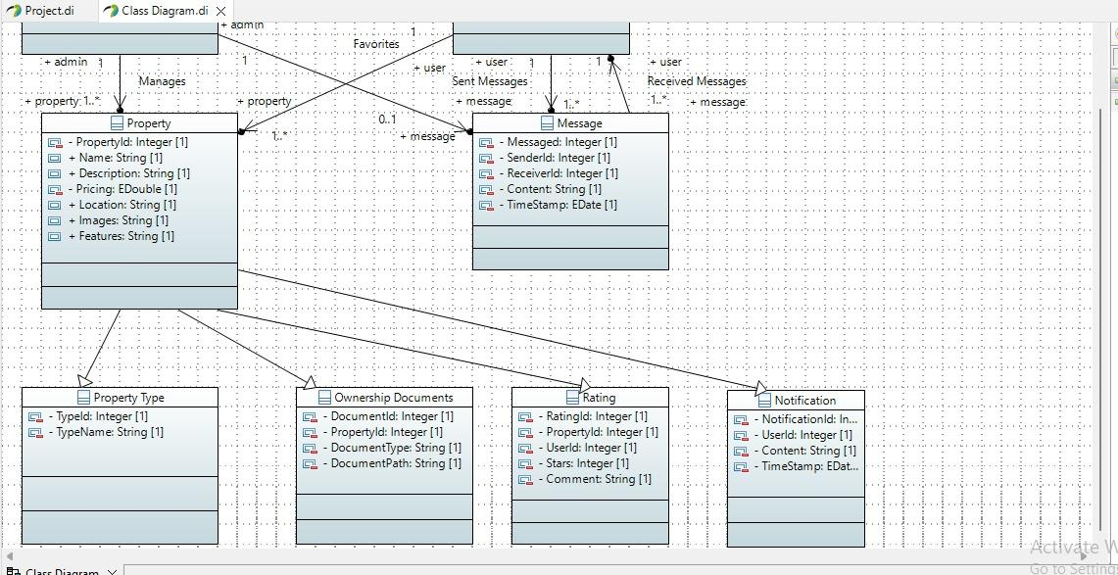

**6.3 Sequence Diagram:**

**6.4 Use Case Diagram:**

**6.5 Deployment Diagram:**

**6.6 Component Diagram:**

**6.7 Communication Diagram:**

**6.7.1 For User Registration:**

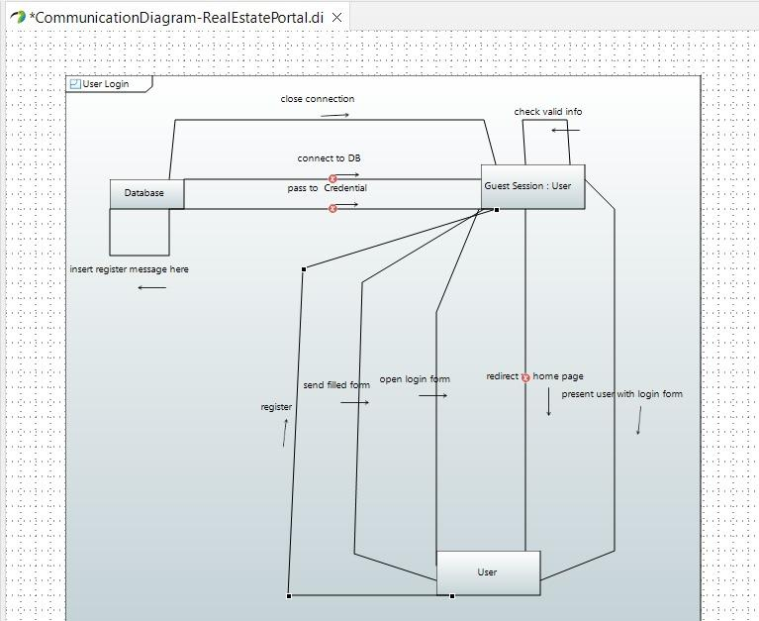

**6.7.3 For Submission:**

**6.7.4 For Feedback:**

**7. Other Requirements**

**7.1 Legal and Regulatory Requirements**

**7.1.1 Data Protection and Privacy:**

The system shall comply with data protection and privacy regulations, ensuring that user data is handled in accordance with legal requirements. This includes adherence to laws such as GDPR or local data protection laws.

**7.1.2 User Consent:**

Users shall be provided with clear and transparent consent mechanisms regarding data collection and usage.