Pocket Dimensions:
Exploring Fractals Portfolio

Lorenzo D. Moon
Dr. David Ely
CS-429 Exploring Fractals
Date TBD

Abstract
Words
Table of Contents
Abstract 2
Recursion 4
Specific Design 4
Mathematics 4
Code 4
External Links 4
L-System 5
Specific Design 5
Mathematics 5
Code 5
External Links 5
Iterative Function System 6
Specific Design 6
Mathematics 6
Code 6
External Links 6
Complex Number 7
Specific Design 7
Mathematics 7
Code 7
External Links 7
The Fifth One 8
Specific Design 8
Mathematics 8
Code 8
External Links 8
Download 9
Playdate 9
Windows, MacOS, or Linux 9
Git Repository 9
References 10

Recursion

Koch Curve
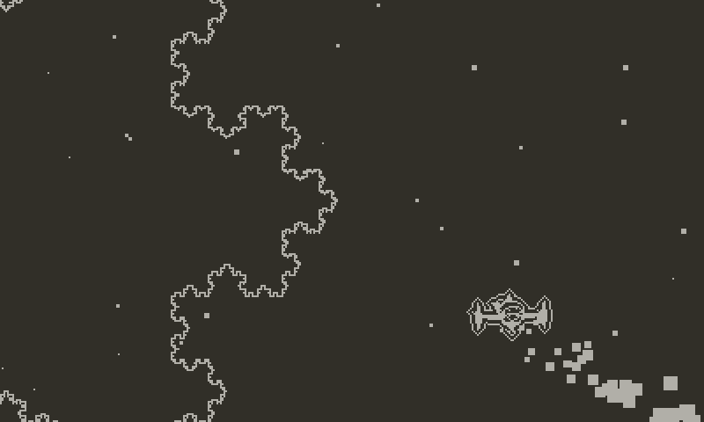
First described by Helge von Koch in 1904,
It was later known as the fracture at the edge of the Universe!

Mathematics
The Math Stuff

Code
SQRT3_OVER_2 = 0.86602540378

function RenderKoch(x1, y1, x5, y5, depth)
if depth == 0 then
DrawLine(x1, y1, x5, y5)
return
End

local p2x = Lerp(x1, x5, 1/3)
local p2y = Lerp(y1, y5, 1/3)

local p4x = Lerp(x1, x5, 2/3)
local p4y = Lerp(y1, y5, 2/3)

local p3x = Lerp(x1, x5, 1/2) + (SQRT_3_OVER_2 * (p4y - p2y))
local p3y = Lerp(y1, y5, 1/2) - (SQRT_3_OVER_2 * (p4x - p2x))

RenderKoch(x1, y1, p2x, p2y, depth - 1)
RenderKoch(p2x, p2y, p3x, p3y, depth - 1)
RenderKoch(p3x, p3y, p4x, p4y, depth - 1)
RenderKoch(p4x, p4y, x5, y5, depth - 1)
end

function Lerp(a, b, t)
return a + (b - a) * t
end

External Links
Links

L-System

Specific Design
Image
Subtitle of the Image

Mathematics
The Math Stuff

Code
Words

External Links
Links

Iterative Function System

Specific Design
Image
Subtitle of the Image

Mathematics
The Math Stuff

Code
Words

External Links
Links

Complex Number

Specific Design
Image
Subtitle of the Image

Mathematics
The Math Stuff

Code
Words

External Links
Links

The Fifth One

Specific Design
Image
Subtitle of the Image

Mathematics
The Math Stuff

Code
Words

External Links
Links

Download

Playdate
Instructions

Windows, MacOS, or Linux
Instructions

Git Repository
Blep

References
Playdate SDK - https://play.date/dev/
Inside Playdate SDK Documentation - https://sdk.play.date/2.7.1/Inside%20Playdate.html
Koch Snowflake - https://en.wikipedia.org/wiki/Koch_snowflake
L-Systems - https://en.wikipedia.org/wiki/L-system

