Pocket Dimensions:
Exploring Fractals Portfolio

Lorenzo D. Moon
Dr. David Ely
CS-429 Exploring Fractals
Date TBD

Abstract
Words
Table of Contents
Abstract 2
Recursion 4
Koch Curve 4
History 4
Mathematics 4
L-System 5
Specific Design 5
History 5
Mathematics 5
Iterative Function System 6
Specific Design 6
History 6
Mathematics 6
Complex Number 7
Specific Design 7
History 7
Mathematics 7
The Fifth One 8
Specific Design 8
History 8
Mathematics 8
The Code 9
Code for Recursion – Koch Curve 9
Code for L-System – Dragon Curve 9
Code for Iterative Function System – Ferns 9
Code for Complex Numbers - Mandlebrot 9
Code for Fifth One – Something with Wire frames? 9
Download 10
Playdate 10
Windows, MacOS, or Linux 10
Git Repository 10
References 11

Recursion

Koch Curve
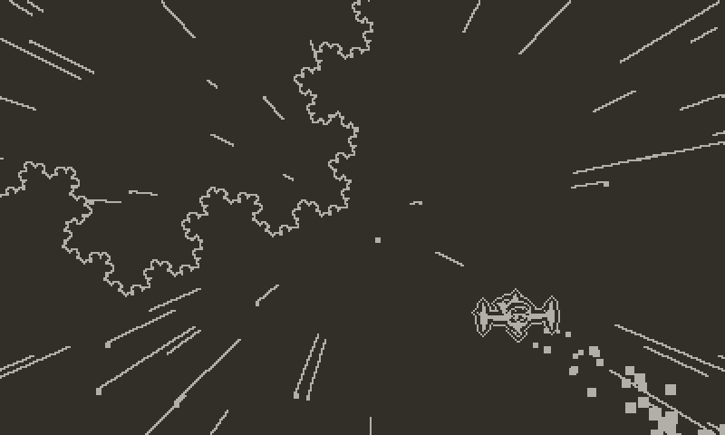
First described by Helge von Koch in 1904,
It was later known as the fracture at the edge of the Universe!

History
The history words

Mathematics
The Math Words

L-System

Dragon Curve
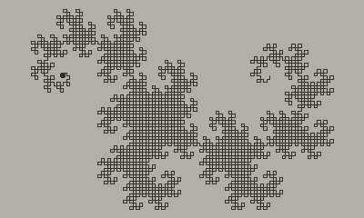
You can lead a Turtle to water but you can’t make him draw. Or… Maybe you can.
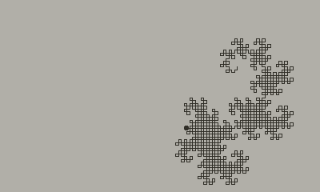

History
The history words

Mathematics
The Math Words

Iterative Function System

Specific Design
Image
Subtitle of the Image

History
The history words

Mathematics
The Math Words

Complex Number

Specific Design
Image
Subtitle of the Image

History
The history words

Mathematics
The Math Words

The Fifth One

Specific Design
Image
Subtitle of the Image

History
The history words

Mathematics
The Math Words

The Code

Code for Recursion – Koch Curve
Code

Code for L-System – Dragon Curve
Code

Code for Iterative Function System – Ferns
Code

Code for Complex Numbers - Mandlebrot
Code

Code for Fifth One – Something with Wire frames?
Code

Download

Playdate
Instructions

Windows, MacOS, or Linux
Instructions

Git Repository
Blep

References
Playdate SDK - https://play.date/dev/
Inside Playdate SDK Documentation - https://sdk.play.date/2.7.1/Inside%20Playdate.html
Koch Snowflake - https://en.wikipedia.org/wiki/Koch_snowflake
L-Systems - https://en.wikipedia.org/wiki/L-system

