8.4 CONSTRUCTING OPERATIONAL PROFILES

An important question before actual OPs are constructed is whether a single OP would be enough or multiple OPs have to be constructed. The decision should be based on the homogeneity or similarity of product usages by different customers: If there are no fundamental differences, one OP would be appropriate. However, if qualitative or substantial differences exist, then one OP for each individual group of customers would be appropriate. The basic assumption is that one OP would be sufficient to capture the usage scenarios and probabilities for all the customers within a group. Sometimes, a mixed strategy might be meaningful, to develop separate OPs for individual groups, and then the combined OP can be used to provide an overall picture of the product’s use by all customers. We next examine the generic methods for OP construction and some proven procedures that have been successfully used in industry.

8.4.1 Generic methods and participants
There are three generic methods for information gathering and OP construction: actually measurement of usage at customer installations, survey of target customers, and usage estimation based on expert opinions. For existing software products, the most precise way to obtain customer usage scenarios and associated probabilities is through actual measurement of the in-field operations at the customer installations. Actual measurement provides ultimate accuracy but also faces various limitations, including:
- For new products or new applications, there won’t be in-field customer installations. Therefore, actual measurement would not be possible. One way to bridge this gap is to use measurement from similar products or earlier versions of the product for different applications, and then make certain adjustment to the measurement results to obtain the OP for the new products or new applications. However, this adjustment would be difficult and would involve a substantial amount of subjective judgment. Therefore, other approaches to for OP construction might be preferable.
- Even if there are in-field customer installations for existing products or earlier versions of new product releases, the actual usage information and the environment may contain a substantial amount of business sensitive and proprietary data. Therefore, the customers would not be willing to share the data with the software development organizations. In fact, this situation covers most of the commercial products and the business relations between software development organizations and their customers. One way to overcome this is through some voluntary participation of selected customers, similar to beta testing.
Alternatively, instead of measuring at the customers’ sites, a few customers could be invited in, to run their applications on the new versions of software products before product release, such as in the ECI (early customer involvement) program by IBM, through which information was collected to build OPs (Lu and Tian, 1993a). However, both these types of remedial solutions suffer from their own limitations, primary in the late availability of such OPs and the doubtful representativeness of the information collected.
In addition to the above difficulties and limitations, actual measurements are also expensive to implement. Consequently, various other ways have been suggested, primarily customer surveys to obtain information from the customers directly and expert opinions to obtain customer usage information indirectly. Both of these ways of information gathering can be carried out much earlier in the software development process, typically in the requirement analysis stage. They are even applicable for brand new products, to get information about the “intended” customer usage by surveying potential customers or obtaining expert opinions. In addition, these techniques are typically much simpler and cheaper to implement than actual measurement.
Customer surveys can provide more objective and potentially more accurate information regarding a product’s usage than expert opinions that are indirect information about product use by customers. For different products and market segments, such surveys may be implemented differently. For example, for products with a single customer or limited number of customers, such as many defense-related software products whose customers are typically the government(s) or government branches, the survey might be more manageable. However, for commercial products and other mass-market products, such as commercial database products or operating systems for PCs, the massive user population requires careful.

8.4.2 OP development procedure: Musa-1
In Musa’s top-down approach (Musa, 199’3) or Musa- 1 procedure, one OP is developed for each homogeneous group of users or operations by following five basic steps below: planning to reduce the survey cost while maintaining result accuracy. Another problem we have to deal with in using customer surveys is that the accuracy of the information obtained is largely affected by the product knowledge of the individuals who complete the survey. The main advantages of using expert opinions to construct OPs are the ready availability of these mostly internal experts and the much lower cost. Therefore, many of the rough OPs can be obtained this way, which can be cross-validated later on when customer survey and measurement information is obtained. Other information sources include many of the existing product and system documentations, such as architectural and design documents, technical memos, and documents of understanding with customers and partners, as well as product specifications and relevant standards. From these information sources, high level structures, major components, interconnections among these components, as well as rough usage frequency and importance information, can be easily obtained by some product experts or with consultation with such experts.
Musa suggested that the operational profile should be developed by a combination of system engineers, high-level designers, and test planners, with strong participation from product planning and marketing functions (Musa, 1993; Musa, 1998). The involvement of customers is implicitly assumed here as a primary source of information. If we consider the test planners as the coordinator of OP construction activities and the testing team as the main user of the OPs, we can then consider the other parties above as representing experts whose opinions are used in the process for OP construction. Each party bring unique expertise to OP construction, as follows:
Planning and marketing personnel are the primary contact with customers, and their involvement would ensure that customers’ concerns and their perspectives are reflected in the resulting OPs. 1nitiall:y product requirements are also gathered by these people, which may as well contain various OP related information. Gathering of such information could also be a part of requirement gathering.
System engineers are responsible for the overall product requirement and specification, including high-level functions and features to be implemented in the product. Therefore, their participation would ensure a comprehensive system view of the resulting OPs.
High-level designers are responsible to produce high-level product designs based on product specifications. Their participation would help map the external functions or features expected by customers into internal product components, modules, or sub-systems that are tested.
On the other hand, the large software systems usually involve many customers who use the software products differently under different environments or settings. It would be highly unlikely that all the information about the operations can be obtained and organized in one step. Consequently, some procedural support is usually needed for such situations. In what follows, we will describe two such procedures developed by Musa: a top-down procedure with multiple profiles refined along the way labeled as Musa-1 (Musa, 1993) and a single profile procedure labeled as Musa-2 (Musa, 1998).

8.4.2 OP development procedure: Musa-1
In Musa’s top-down approach (Musa, 199’3) or Musa- 1 procedure, one OP is developed for each homogeneous group of users or operations by following five basic steps below:
Table1 A sample customer profile
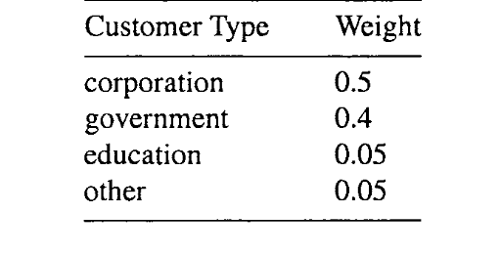
1. Find the customerprofile by defining a complete set of customer categories weighted per a usage factor.
2. Establish the userprofile by defining user types weighted in relation to the customer groups and relative usage rates.
3. Dejine the system modes and related projile by identifying the sets of operations commonly used together and obtaining their related weights.
4. Determine the functional profile by identifying individual (high-level) functions and obtaining their related weights based on analysis of the system modes and environmental variables.
5. Determine the operational profile by refining high-level functions into detailed operations and obtaining their usage probabilities.
Notice that in this top-down approach, each step results in a profile in progressively more detail, culminating in the final operational profile. The focus is on the external users and their usage of the software systems. And the general view is that these users are affiliated with large organizations or are authorized to use certain software products; while each customer represents an organization.
The main difference between a customer and a user is that the former is responsible for the acquisition of the software products, while the latter uses them. For example, a database product could be targeted toward corporate, governmental, educational, and other large organizations as potential customers. In this case, both the number of customers in each category, as well as their importance to the software vendors, can be captured in this customer profile. The resulting customer profile would be in the form of pairs of customer types and associated probabilities or weighting factors, such as in Table1.
Within each customer group or type, there are different user groups, frequently with some similar user groups across different customers. For example, in the example above with database product for large organizations, there may be end users, database administrators (dba), application programmers, third party contractors. The usage probabilities by these user types or their weights within each customer type can be determined first, and then the weighted sums give us the overall user profile, as illustrated in Table2. Notice that the customer types (ctype) are abbreviated in Table2, with “com”, “gov”, “edu”, and “etc” for corporate, governmental, educational, and other organizations respectively. Notice that some user types are absent from some customer types, such as third party contractors are represented in governmental and educational organizations but not in corporate and other organizations. When a user type is missing, it is indicated in Table 8.6 by a “-”, and its weight is interpreted as 0. The customer profile (or weights by customer types) is used to determine the overall user profile. For example the weight for end users is calculated as:
Table2 A sample user profile
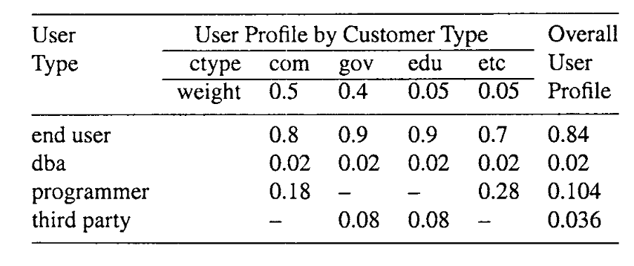
0.8 *0.5 (com) + 0.9 *0.4 (gov) + 0.9 * 0.05 (edu) + 0.7 *0.05 (etc) = 0.84.
The computation for the next three steps, system mode definition and profile, functional profile, and operational profile, follows essentially the same procedure as that for user profile: Individual profiles are obtained first, and then the weights from the previous step are used to calculate the overall profile for this step as the weighted sums of the individual profiles. Therefore, we will omit numerical examples in describing the next three steps.
System modes are associated with different sets of functions or operations that are commonly used together within a mode. For example, the differences of normal operation mode and maintenance mode for many systems are significant, and each mode can be associated with its own functions and operations. In this case, various system maintenance functions, such as some backup and patching functions, are only applied under system maintenance mode but not under normal operations.
The last two steps, functional profile and operational profile, are essentially the same except granularity differences and sometimes implementation status differences. System functions are high-level tasks of the projected system in the requirement, which can be mapped to various lower-level operations in the implemented system. The function list can be created from various sources, such as system requirement, prototypes, previous release, user manual, etc., and then consolidated. The functional profile can then be derived, followed by the operational profile.
One of the decisions to be made for functional and operational profiles is to use explicit or implicit profiles. An explicit profile is similar to that in Table1and in examples we used so far: the alternatives are disjoint and the weights (or probabilities) for them add up to 1. These explicit profiles usually correspond to end-to-end operational sequences and their associated probabilities. However, for many systems, staged or repeated selections, independent of each other, of operational units may be more meaningful to the users.
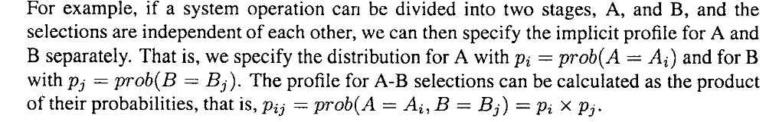
8.4.3 OP development procedure: Musa-2
The above development procedure for OPs is suitable for large software systems, where there are potentially many customers or users involved and their usage situations can be quite diverse. Consequently, successive] profiles are used, with one for each of the 5 steps, culminating into the final OP. However, for smaller products or ones with more homogeneous user population, one profile would probably be enough. The primary areas of procedure support needed might be in the specific information source identification and data collection. Another OP construction procedure also proposed by Musa (Musa, 1998) and labeled Musa-2 in this book, is suitable for such situations. One OP is constructed for each operational mode, similar to the system mode in Musa-1 above, because testing is typically performed under a specific operational mode instead of being in mixed modes.
There are also 5 generic steps:
1. Identify initiators of operations: These initiators include human users as well as other software, hardware, network, etc. The human users will be the primary information sources themselves. However, for non-human users, people who are familiar with them, or sometimes existing documents and recorded data can be information sources.
2. Determine tabular or graphical representation: In fact, this representation used by Musa here goes beyond simple representation to determine the type of OP will be constructed, as we will elaborate later.
3. Operations lists: First, individual operations lists can be obtained from identified initiators of these operations. Then, these lists can be consolidated into a comprehensive list. For example, from the original lists {A, B, C} and {B, D}, we can obtain a consolidate list {A, B, C, D}. Sometimes, some adjustments are also made to ensure proper granularity for the comprehensive list, particularly when the initial lists are based on different levels of granularity.
4. Determine the occurrence rate (per hour): Actual measurement is typically used to obtain data about the occurrence rate or frequency for individual operations in the above consolidated operations list and tabulated. This tabulation may be affected by the type of OPs used, as we will elaborate later.
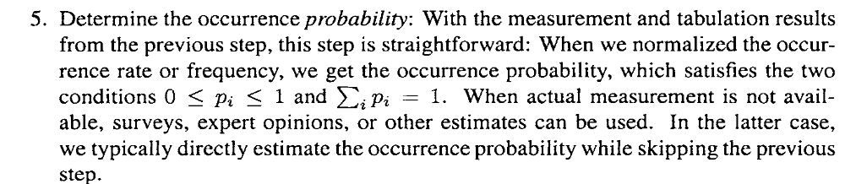
The tabular representation is similar to the explicit OP in Musa-1, such as Table1 above. Such OPs can also be represented graphically as histograms, such as in Figure1, which is not what is referred to as graphical representation by Musa. The measurement and tabulation in step 4 are carried out for each item in the consolidated operations list, and these results are normalized by dividing them by the total occurrences in step 5.
The graphical representation used in Musa-2 actually correspond to a tree-structured OP that somewhat resembles (but it is not exactly the same) the implicit OP in Musa-1 above.
In this type of OPs, the complete operational sequence can be divided into fixed number of stages, with fixed number of choices for each stage. When we combine these stages, it gives us a tree, much like a decision tree, but with occurrence rates and probabilities attached to each tree branch. Therefore, a complete end-to-end operation would be a path in the tree from the root node to one of the leaf nodes, and the path probability is the product of its individual branch probabilities. This is best illustrated through an example in Figure1 for web usage by a group of users modeled as a two-stage process:
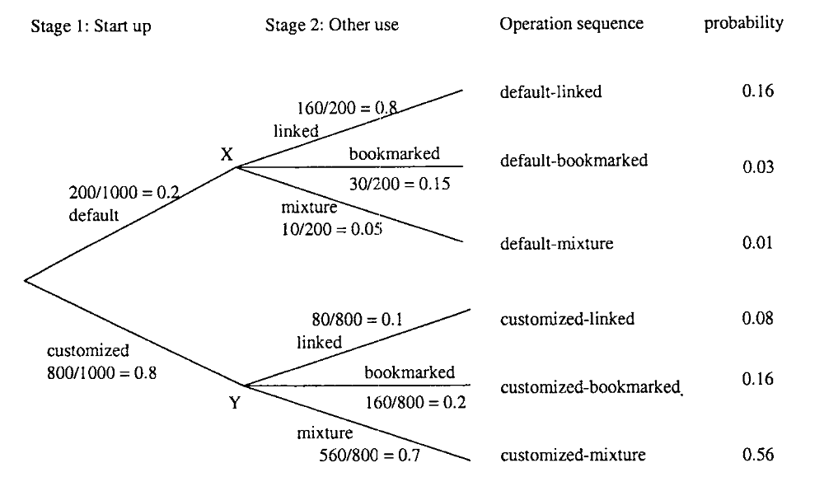
Figure1 A tree-structured or graphical operational profile
- Stage 1. Starting the browser with two choices: either on the default starting page or a customized starting page.
- Stage 2. All subsequent usage is modeled as one stage, with three choices: following links in visited pages, following bookmarked pages, or a mixture of the two.
Occurrences of specific usage choices at each stage are also tabulated separately, thus resulting in different probability distributions at points X and Y in Figure1. In other words, the probability distributions at later stages in such trees can be different, depending on different earlier choices. However, if implicit OPs in Musa-1 are used, the probability distributions at points X and Y would be the same. Consequently, the tree-structured graphical OPs in Musa-2 are more powerful in representing different usage situation than implicit OPs in Musa- 1. Explicit OPs in Musa- 1 and tabular OPs in Musa-2 are the same, and can both be treated as degenerated multi-stage OPs when there is only one stage.

