Open aws account

Select EC2 instance

Click on launch instance

Select ubuntu os

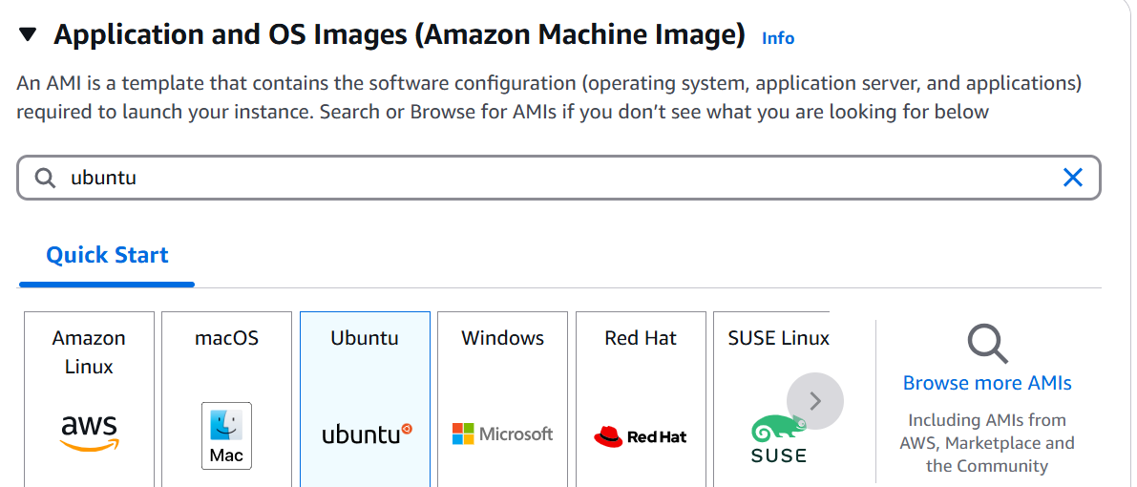

Select ubuntu free tier as amazoin image

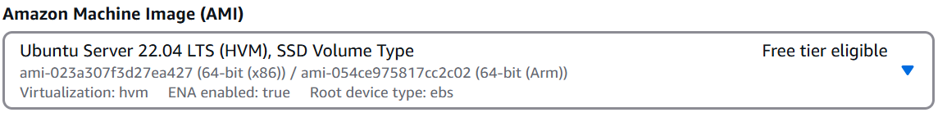

Select instance type t2.micro

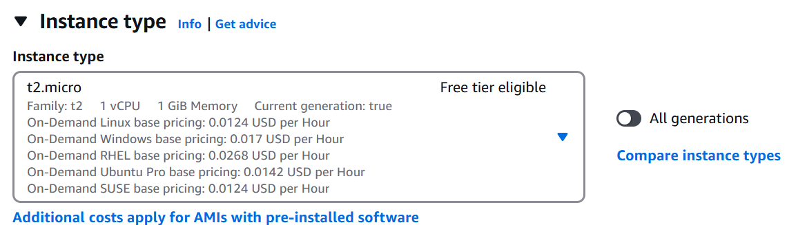

Create key pair

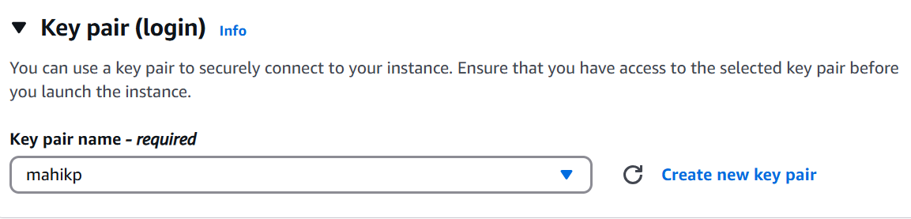

Network add the below rule

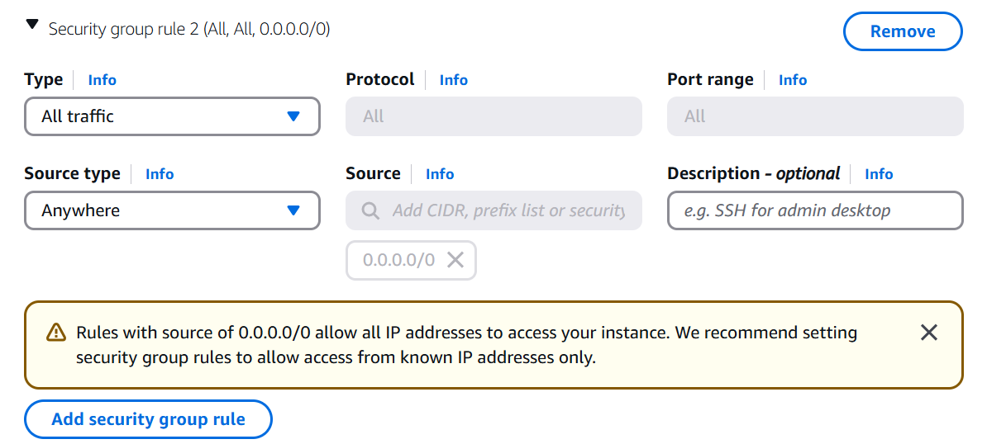

Goto the .pem file location from there open gitbash (before you need to download and install gitbash in your computer)

Goto aws click on the connect take the ssh id copy and paste in the gitbash

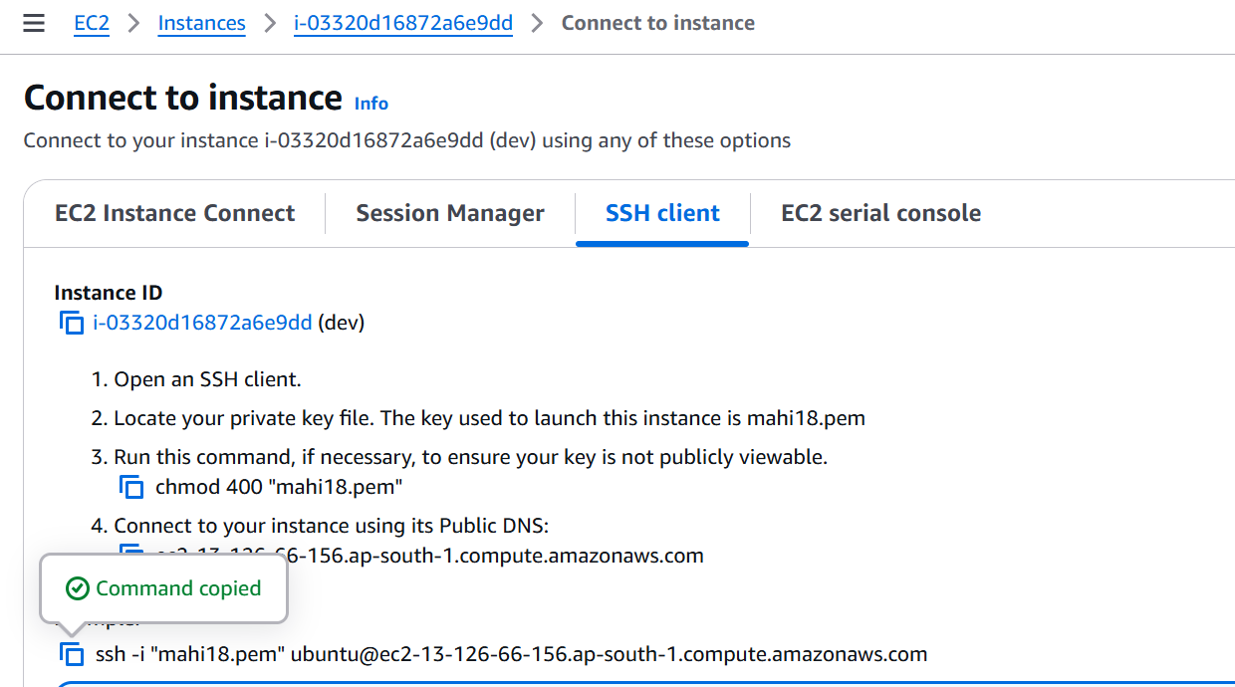

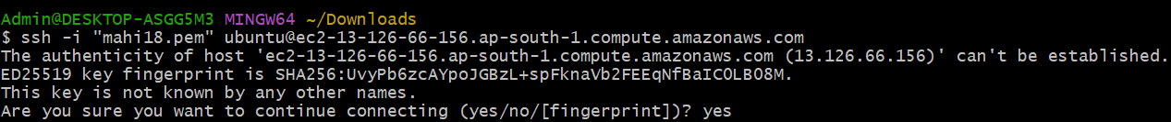

Now u need to install jenkins

First u need to update the apt repository

$ sudo apt update

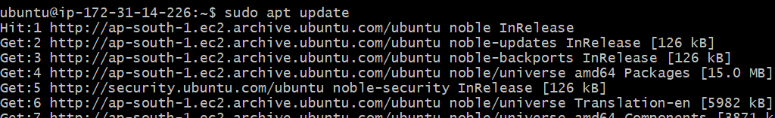

Install java

Sudo apt install openjdk-21-jdk -y

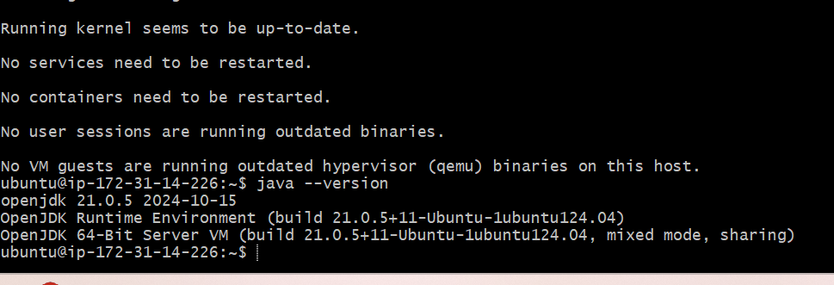

U need to install git and maven and check it

Sudo apt-get install -y git maven

git --version

mvn --version

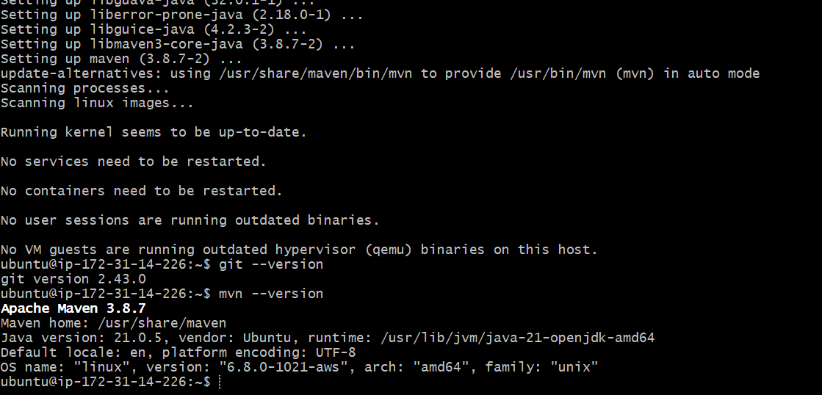

Open jenkin.io ([Download and deploy](https://www.jenkins.io/download/)) in browsedr and select the generic java package(.war)

Copy and paste link addrest

$wget linkaddress

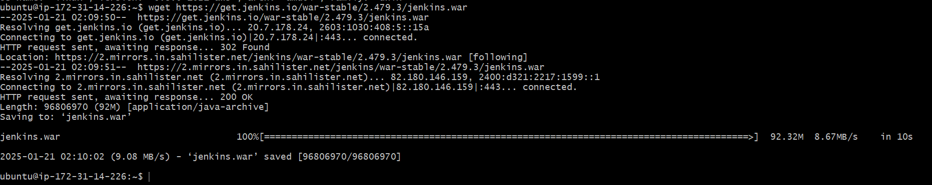

Start the jenkins services

$ java -jar jenkins.war

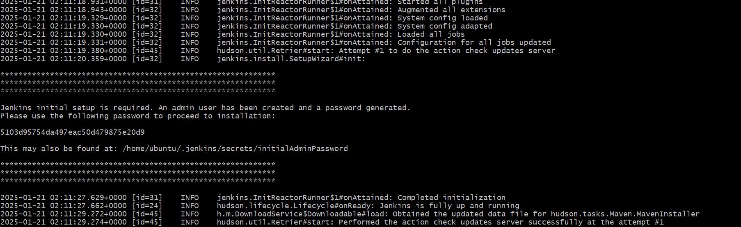

How can we access the jenkin

Take the public ip of dev server

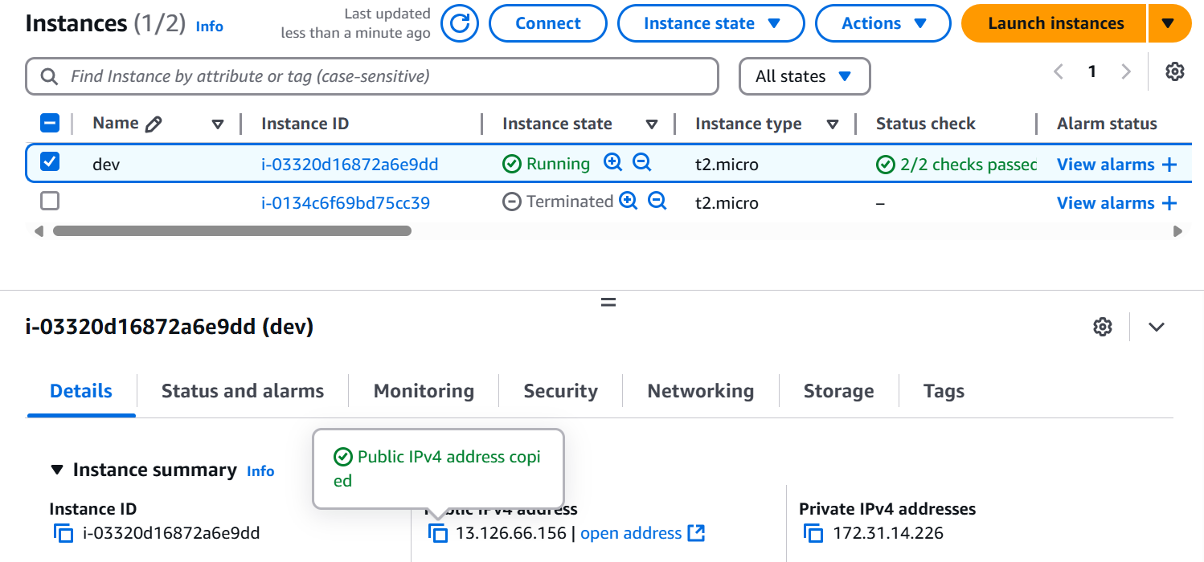

Copy and paste in the browser add 8080 as port number

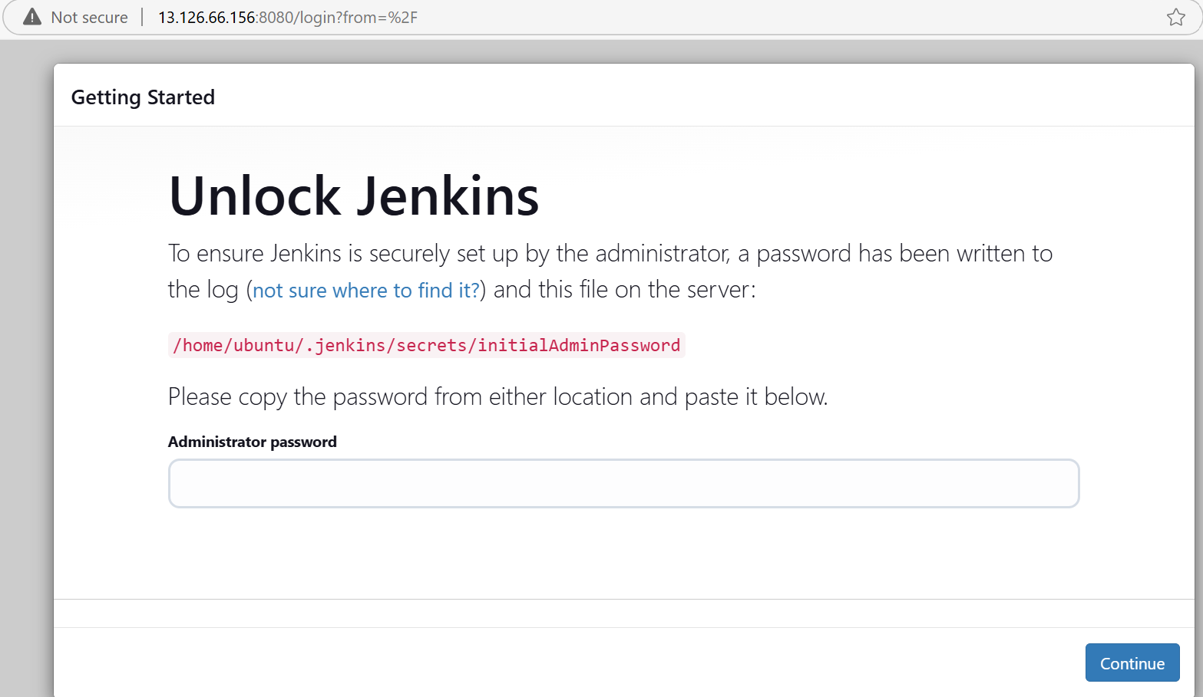

Unlock the jenkins with password which is present in the gitbash

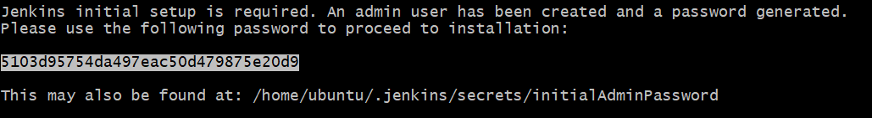

Select the install suggested pluggins

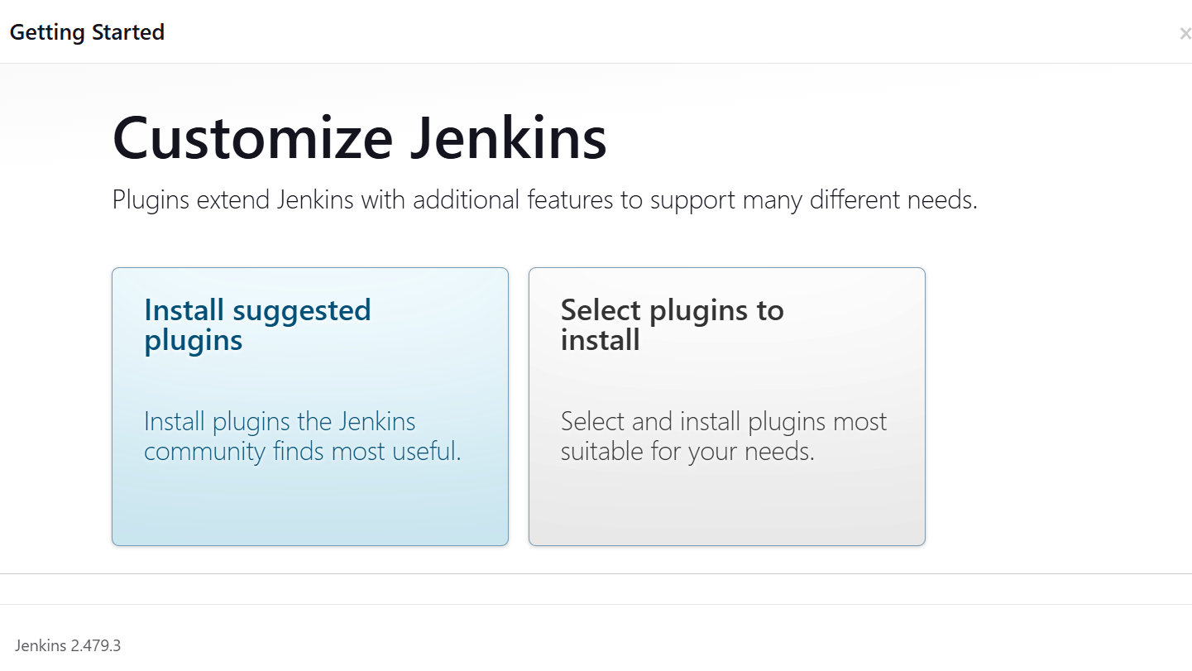

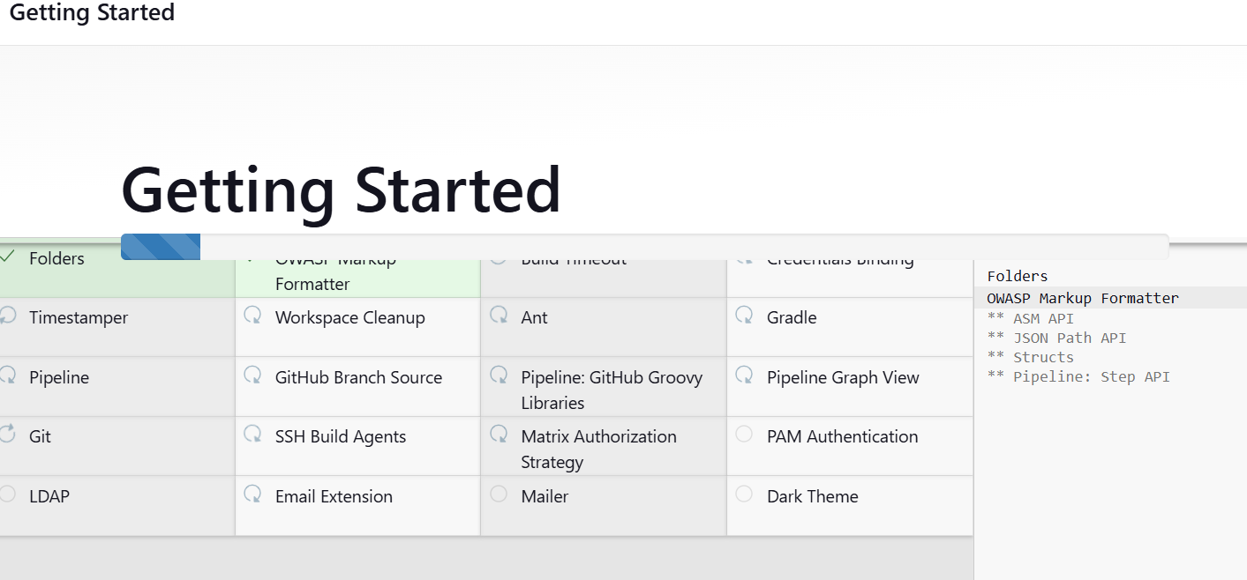

You can give all admin

Click on save and continue

Click on save and finish

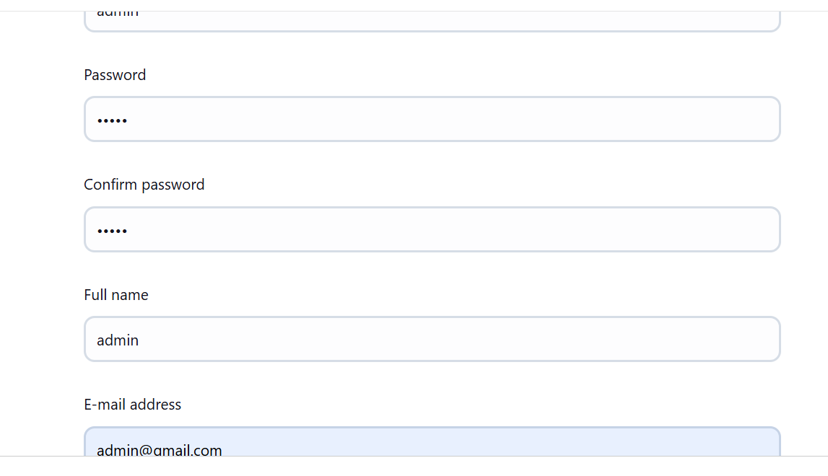

Your jenkins is ready

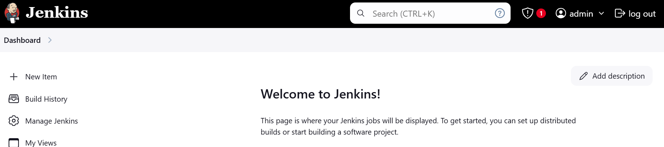

Note: don’t close the jenkins server