Open the websit : Jira | Issue & Project Tracking Software | Atlassian

Signup with google account-- click on google
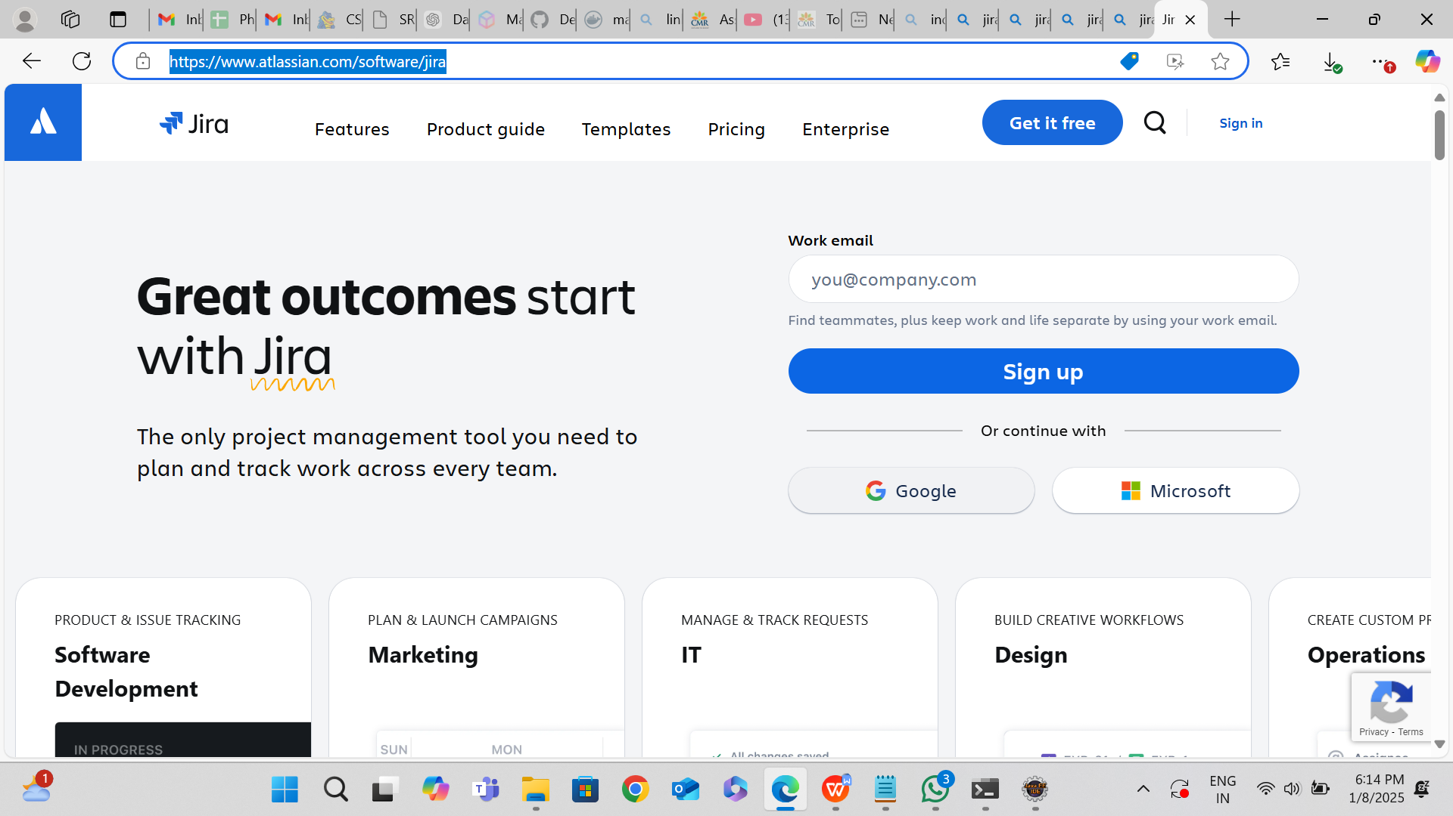

Seletct your gmail id:
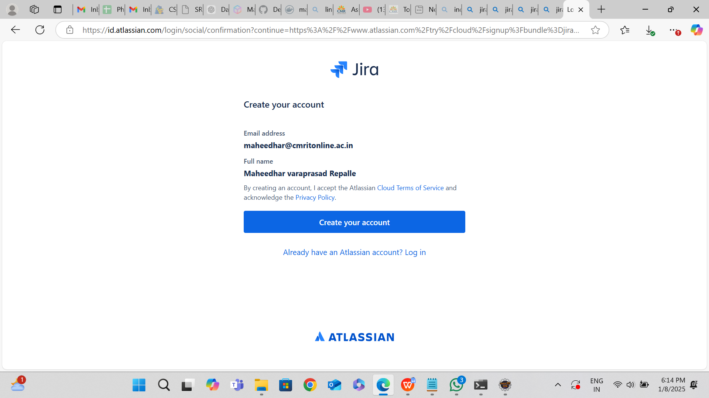

Click on create account

NAME YOUR SITE AND CLICK ON CONTINUE

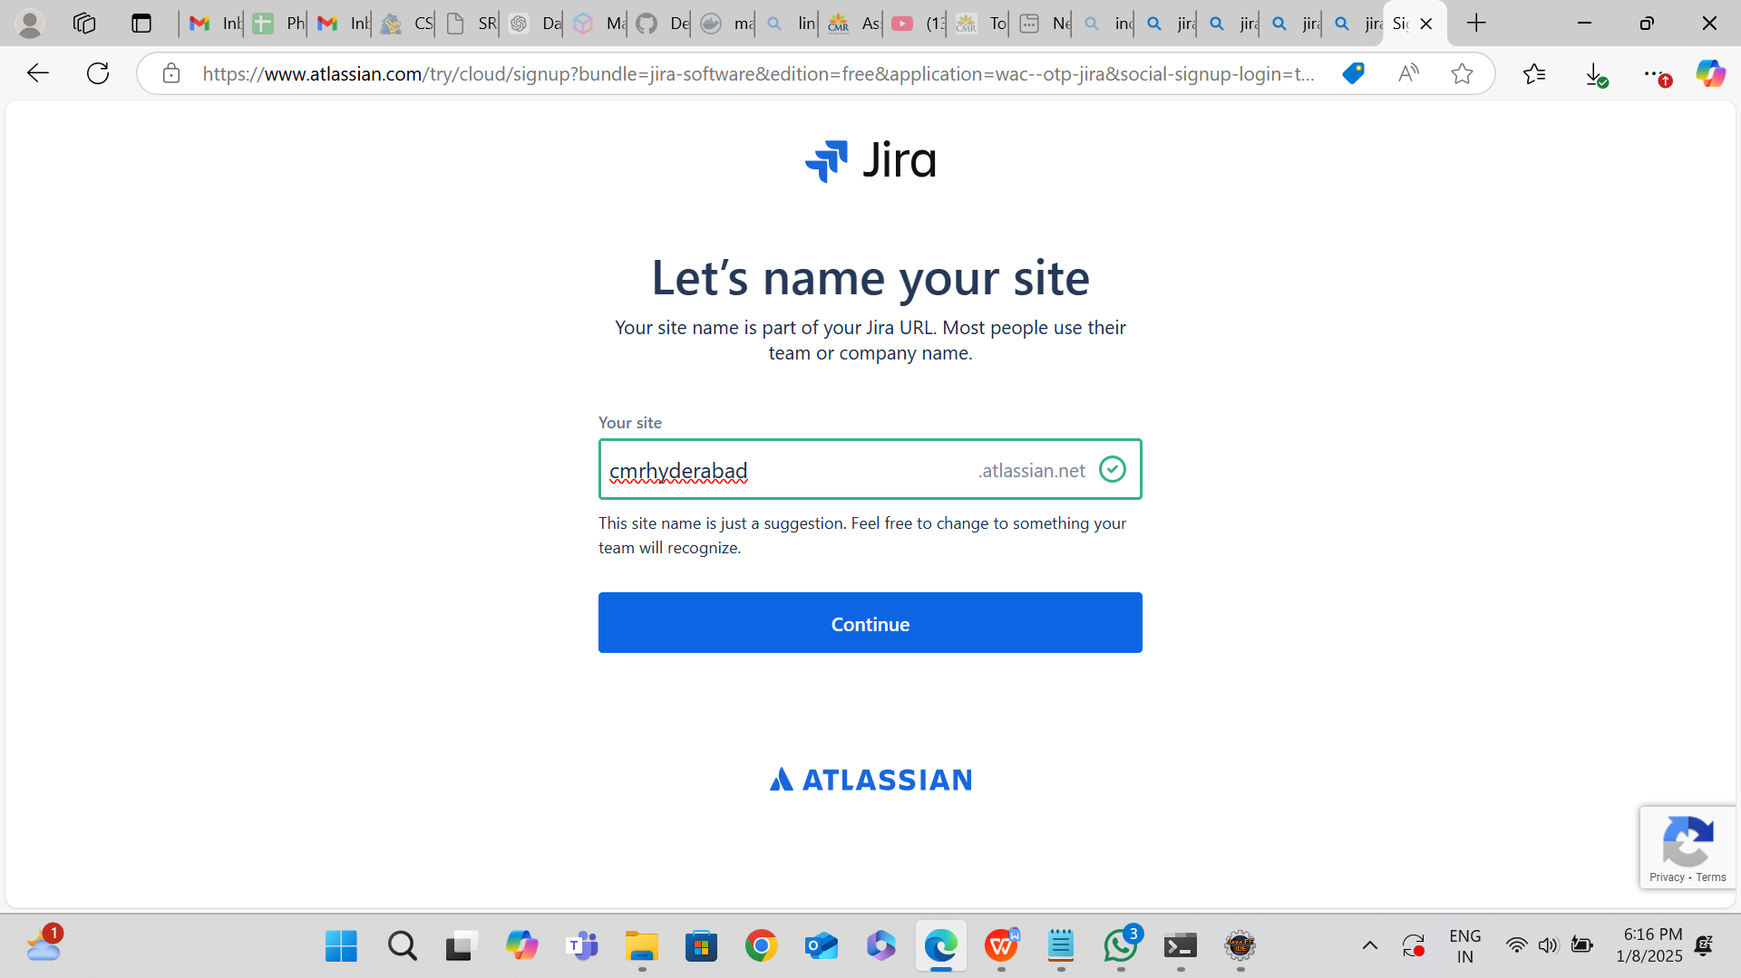

CHOOSE SCRUM:

NAME YOUR PROJECT:
