**Exp-12**

**Install Django and setup a virtual environment.**

Step1: Open command prompt, check version of python

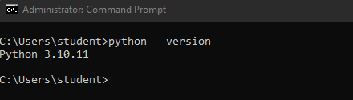

It is suggested to have a dedicated virtual environment for each Django project, and one way to manage a virtual environment is [venv](https://docs.python.org/3/tutorial/venv.html" \t "_blank), which is included in Python.

The name of the virtual environment is your choice, in this tutorial we will call it myworld.

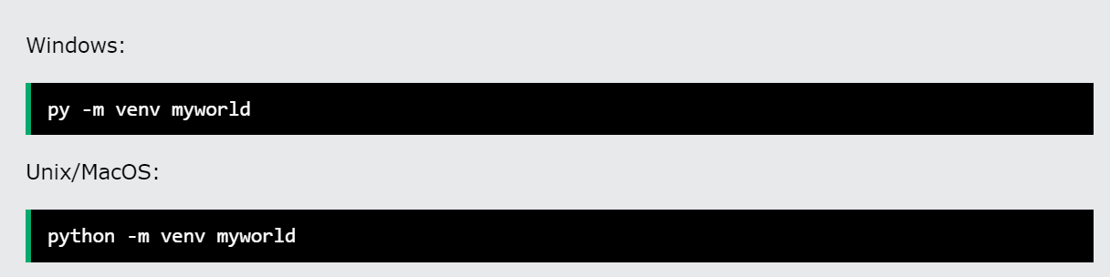Type the following in the command prompt, remember to navigate to where you want to create your project:

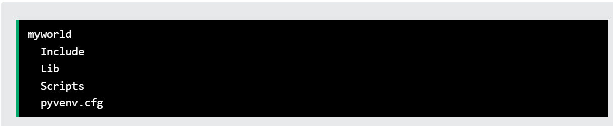This will set up a virtual environment, and create a folder named "myworld" with subfolders and files, like this:

Then you have to activate the environment, by typing this command:

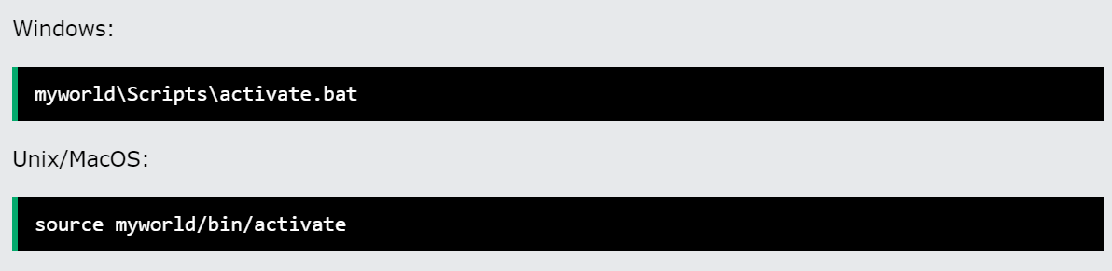

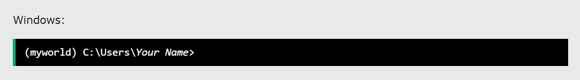Once the environment is activated, you will see this result in the command prompt:

## Install Django:

## Django is installed using pip, with this command:

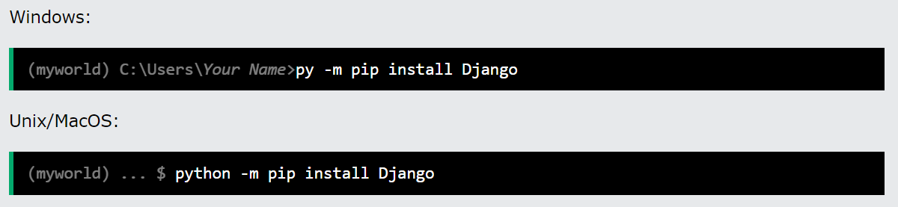

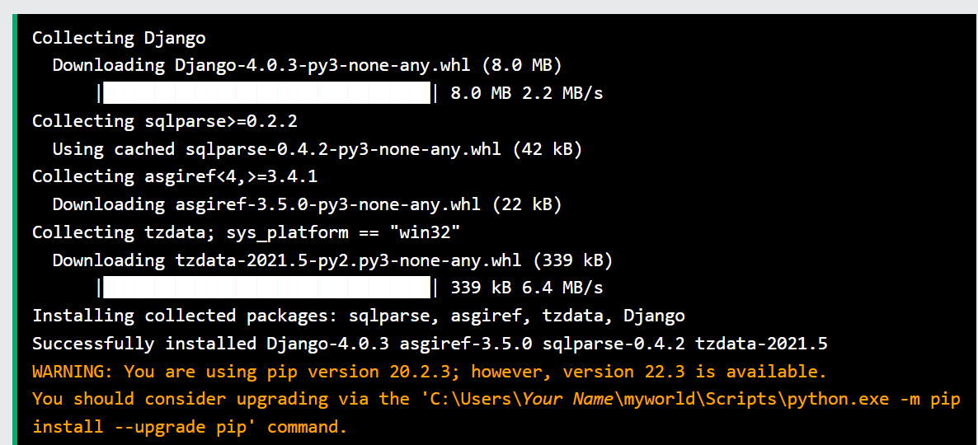Which will give a result that looks like this (at least on my Windows machine):

## **Check Django Version:**



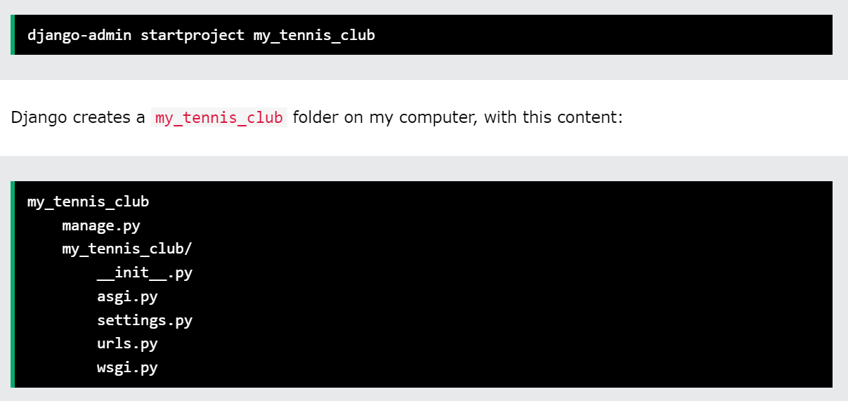

## My First Project:

Once you have come up with a suitable name for your Django project, like mine: my\_tennis\_club, navigate to where in the file system you want to store the code (in the virtual environment), I will navigate to the myworld folder, and run this command in the command prompt:

## Run the Django Project

Now that you have a Django project, you can run it, and see what it looks like in a browser.

Navigate to the /my\_tennis\_club folder and execute this command in the command prompt:

py manage.py runserver

Which will produce this result:

Watching for file changes with StatReloader  
Performing system checks...  
  
System check identified no issues (0 silenced).  
  
You have 18 unapplied migration(s). Your project may not work properly until you apply the migrations for app(s): admin, auth, contenttypes, sessions.  
Run 'python manage.py migrate' to apply them.  
October 27, 2022 - 13:03:14  
Django version 4.1.2, using settings 'my\_tennis\_club.settings'  
Starting development server at http://127.0.0.1:8000/  
Quit the server with CTRL-BREAK.

Open a new browser window and type [127.0.0.1:8000](http://127.0.0.1:8000/) in the address bar.

**Output:-**

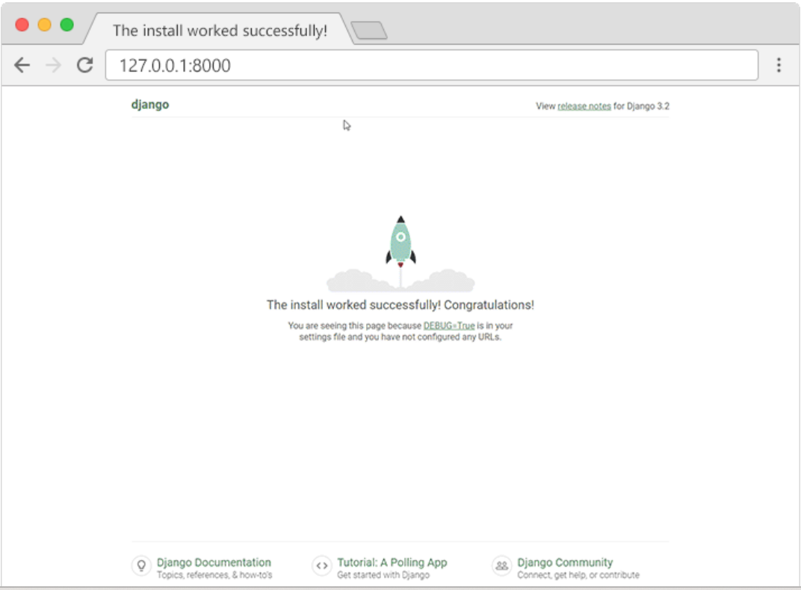

**VIVA QUESTIONS:**

### 1. ****How do I create a virtual environment using venv in Python?****

Ans: You can create a virtual environment using the following command: python -m venv <environment\_name>. Replace <environment\_name> with the desired name for your virtual environment.

### 2. ****Do I need to install venv separately?****

Ans: No, venv is included in the Python standard library for versions 3.3 and above, so there’s no need to install it separately.

### 3. ****How do I activate a virtual environment?****

On Windows, use <environment\_name>\Scripts\activate. On Unix or MacOS, use source <environment\_name>/bin/activate.

### 4. What is Django?

Django is a Full-stack web development framework that facilitates the creation and maintenance of high-quality Dynamic pages while also encouraging rapid development and a clean, pragmatic style. Django makes it easier to automate repeated operations, resulting in a more efficient development process with fewer lines of code.

### 5. ****How do you create a Django project?****

We can create a Django project with the help of the following command

django-admin startproject projectname