Sommaire
Machine Learning Explainability 3
1. Use Cases for Model Insights 3
1.1 COURS 3
What Types of Insights Are Possible 3
Why Are These Insights Valuable 3
Debugging 3
Informing Feature Engineering 4
Directing Future Data Collection 4
Informing Human Decision-Making 4
Building Trust 4
2. Permutation importance 5
2.1 COURS 5
How It Works 5
Code Example 8
Interpreting Permutation Importances 9
2.2 EXERCICES 11
Intro 11
Question 1 12
Question 2 12
Question 3 13
Question 4 14
Question 5 15
Question 6 16
3. Partial plots 18
3.1 COURS 18
Partial Dependence Plots 18
How it Works 19
Code Example 20
2D Partial Dependence Plots 25
3.2 EXERCICES 29
Set Up 29
Question 1 31
Question 2 36
Question 4 40
Question 5 43
Question 6 44
Question 7 46
4. SHAP Values 48
4.1 COURS 48
Introduction 48
How They Work 48
Code to Calculate SHAP Values 50
4.2 EXERCICES 54
Set Up 54
The Scenario 54
Your Code Library 55
Step 1 56
Step 2 58
Step 3 60
Step 4 62
Step 5 63
5. Advanced Uses of SHAP Values 65
5.1 COURS 65
Recap 65
SHAP Values Review 65
Summary Plots 66
Summary Plots in Code 68
SHAP Dependence Contribution Plots 70
Dependence Contribution Plots in Code 73
5.2 EXERCICES 75
Set Up 75
Question 1 76
Question 2 77
Question 3 78
Question 4 79
Question 5 80
Question 6 81
Congratulations 84

Machine Learning Explainability
Extract human-understandable insights from any machine learning model.

1. Use Cases for Model Insights

1.1 COURS

What Types of Insights Are Possible
Many people say machine learning models are "black boxes", in the sense that they can make good predictions but you can't understand the logic behind those predictions. This statement is true in the sense that most data scientists don't know how to extract insights from models yet.
However, this micro-course will teach you techniques to extract the following insights from sophisticated machine learning models.
- What features in the data did the model think are most important?
- For any single prediction from a model, how did each feature in the data affect that particular prediction?
- How does each feature affect the model's predictions in a big-picture sense (what is its typical effect when considered over a large number of possible predictions)?

Why Are These Insights Valuable
These insights have many uses, including
- Debugging
- Informing feature engineering
- Directing future data collection
- Informing human decision-making
- Building Trust

Debugging
The world has a lot of unreliable, disorganized and generally dirty data. You add a potential source of errors as you write preprocessing code. Add in the potential for target leakage, and it is the norm rather than the exception to have errors at some point in a real data science project.
Given the frequency and potentially disastrous consequences of bugs, debugging is one of the most valuable skills in data science. Understanding the patterns a model is finding will help you identify when those are at odds with your knowledge of the real world, and this is typically the first step in tracking down bugs.

Informing Feature Engineering
Feature engineering is usually the most effective way to improve model accuracy. Feature engineering usually involves repeatedly creating new features using transformations of your raw data or features you have previously created.
Sometimes you can go through this process using nothing but intuition about the underlying topic. But you'll need more direction when you have 100s of raw features or when you lack background knowledge about the topic you are working on.
A Kaggle competition to predict loan defaults gives an extreme example. This competition had 100s of raw features. For privacy reasons, the features had names like f1, f2, f3 rather than common English names. This simulated a scenario where you have little intuition about the raw data.
One competitor found that the difference between two of the features, specificallyf527 - f528, created a very powerful new feature. Models including that difference as a feature were far better than models without it. But how might you think of creating this variable when you start with hundreds of variables?
The techniques you'll learn in this micro-course would make it transparent that f527 and f528 are important features, and that their role is tightly entangled. This will direct you to consider transformations of these two variables, and likely find the "golden feature" of f527 - f528.
As an increasing number of datasets start with 100s or 1000s of raw features, this approach is becoming increasingly important.

Directing Future Data Collection
You have no control over datasets you download online. But many businesses and organizations using data science have opportunities to expand what types of data they collect. Collecting new types of data can be expensive or inconvenient, so they only want to do this if they know it will be worthwhile. Model-based insights give you a good understanding of the value of features you currently have, which will help you reason about what new values may be most helpful.

Informing Human Decision-Making
Some decisions are made automatically by models. Amazon doesn't have humans (or elves) scurry to decide what to show you whenever you go to their website. But many important decisions are made by humans. For these decisions, insights can be more valuable than predictions.

Building Trust
Many people won't assume they can trust your model for important decisions without verifying some basic facts. This is a smart precaution given the frequency of data errors. In practice, showing insights that fit their general understanding of the problem will help build trust, even among people with little deep knowledge of data science.

2. Permutation importance

2.1 COURS

One of the most basic questions we might ask of a model is: What features have the biggest impact on predictions?
This concept is called feature importance.
There are multiple ways to measure feature importance. Some approaches answer subtly different versions of the question above. Other approaches have documented shortcomings.
In this lesson, we'll focus on permutation importance. Compared to most other approaches, permutation importance is:
- fast to calculate,
- widely used and understood, and
- consistent with properties we would want a feature importance measure to have.

L'une des questions les plus fondamentales que l'on puisse poser à un modèle est la suivante : Quelles sont les caractéristiques qui ont le plus d'impact sur les prévisions ?
Ce concept s'appelle l'importance des caractéristiques.
Il existe de multiples façons de mesurer l'importance d'une caractéristique. Certaines approches répondent à des versions subtilement différentes de la question ci-dessus. D'autres approches présentent des lacunes documentées.
Dans cette leçon, nous allons nous concentrer sur l'importance de la permutation. Par rapport à la plupart des autres approches, l'importance de la permutation est :
rapide à calculer,
largement utilisé et compris, et
en accord avec les propriétés que nous voudrions voir figurer dans une mesure d'importance.

How It Works
Permutation importance uses models differently than anything you've seen so far, and many people find it confusing at first. So we'll start with an example to make it more concrete.
Consider data with the following format:

L'importance de la permutation utilise les modèles différemment de tout ce que vous avez vu jusqu'à présent, et beaucoup de gens trouvent cela déroutant au début. Nous allons donc commencer par un exemple pour le rendre plus concret.

Considérons les données sous le format suivant :

We want to predict a person's height when they become 20 years old, using data that is available at age 10.
Our data includes useful features (height at age 10), features with little predictive power (socks owned), as well as some other features we won't focus on in this explanation.
Permutation importance is calculated after a model has been fitted. So we won't change the model or change what predictions we'd get for a given value of height, sock-count, etc.
Instead we will ask the following question: If I randomly shuffle a single column of the validation data, leaving the target and all other columns in place, how would that affect the accuracy of predictions in that now-shuffled data?

Nous voulons prédire la taille d'une personne lorsqu'elle aura 20 ans, en utilisant des données disponibles à l'âge de 10 ans.
Nos données comprennent des caractéristiques utiles (taille à 10 ans), des caractéristiques ayant peu de pouvoir prédictif (chaussettes possédées), ainsi que d'autres caractéristiques sur lesquelles nous ne nous attarderons pas dans cette explication.
L'importance de la permutation est calculée après l'ajustement d'un modèle. Nous ne changerons donc pas le modèle ni les prédictions que nous obtiendrions pour une valeur donnée de la taille, du nombre de chaussettes, etc.
Nous poserons plutôt la question suivante : Si je mélange aléatoirement une seule colonne des données de validation, en laissant la cible et toutes les autres colonnes en place, comment cela affecterait-il la précision des prédictions dans ces données maintenant mélangées ?

Randomly re-ordering a single column should cause less accurate predictions, since the resulting data no longer corresponds to anything observed in the real world. Model accuracy especially suffers if we shuffle a column that the model relied on heavily for predictions. In this case, shuffling height at age 10 would cause terrible predictions. If we shuffled socks owned instead, the resulting predictions wouldn't suffer nearly as much.
With this insight, the process is as follows:
- Get a trained model.
- Shuffle the values in a single column, make predictions using the resulting dataset. Use these predictions and the true target values to calculate how much the loss function suffered from shuffling. That performance deterioration measures the importance of the variable you just shuffled.
- Return the data to the original order (undoing the shuffle from step 2). Now repeat step 2 with the next column in the dataset, until you have calculated the importance of each column.

Le réordonnancement aléatoire d'une seule colonne devrait entraîner des prévisions moins précises, car les données résultantes ne correspondent plus à rien de ce qui est observé dans le monde réel. La précision du modèle souffre particulièrement si l'on remanie une colonne sur laquelle le modèle s'appuyait fortement pour ses prédictions. Dans ce cas, le fait de mélanger la hauteur à l'âge de 10 ans entraînerait des prédictions terribles. Si l'on mélangeait plutôt les chaussettes possédées, les prédictions qui en résulteraient ne souffriraient pas autant.
Avec cette idée, le processus est le suivant :
Obtenir un modèle formé.
Mélangez les valeurs dans une seule colonne, faites des prédictions en utilisant l'ensemble de données résultant. Utilisez ces prédictions et les véritables valeurs cibles pour calculer dans quelle mesure la fonction de perte a souffert du brassage. Cette détérioration des performances mesure l'importance de la variable que vous venez de mélanger.
Remettez les données dans l'ordre initial (en annulant le brassage de l'étape 2). Répétez maintenant l'étape 2 avec la colonne suivante dans l'ensemble de données, jusqu'à ce que vous ayez calculé l'importance de chaque colonne.

Code Example
Our example will use a model that predicts whether a soccer/football team will have the "Man of the Game" winner based on the team's statistics. The "Man of the Game" award is given to the best player in the game. Model-building isn't our current focus, so the cell below loads the data and builds a rudimentary model.

Exemple de code
Notre exemple utilisera un modèle qui prédit si une équipe de foot/football aura le gagnant "Homme du jeu" en fonction des statistiques de l'équipe. Le prix "Homme du jeu" est attribué au meilleur joueur du jeu. La construction de modèles n'est pas notre objectif actuel, aussi la cellule ci-dessous charge les données et construit un modèle rudimentaire.

In [1]:
import numpy as np
import pandas as pd
from sklearn.model_selection import train_test_split
from sklearn.ensemble import RandomForestClassifier

data = pd.read_csv('../input/fifa-2018-match-statistics/FIFA 2018 Statistics.csv')
y = (data['Man of the Match'] == "Yes") # Convert from string "Yes"/"No" to binary
feature_names = [i for i in data.columns if data[i].dtype in [np.int64]]
X = data[feature_names]
train_X, val_X, train_y, val_y = train_test_split(X, y, random_state=1)
my_model = RandomForestClassifier(n_estimators=100,
random_state=0).fit(train_X, train_y)
Here is how to calculate and show importances with the eli5 library:
In [2]:
import eli5
from eli5.sklearn import PermutationImportance

perm = PermutationImportance(my_model, random_state=1).fit(val_X, val_y)
eli5.show_weights(perm, feature_names = val_X.columns.tolist())
/opt/conda/lib/python3.7/site-packages/sklearn/utils/deprecation.py:143: FutureWarning: The sklearn.metrics.scorer module is deprecated in version 0.22 and will be removed in version 0.24. The corresponding classes / functions should instead be imported from sklearn.metrics. Anything that cannot be imported from sklearn.metrics is now part of the private API.
warnings.warn(message, FutureWarning)
/opt/conda/lib/python3.7/site-packages/sklearn/utils/deprecation.py:143: FutureWarning: The sklearn.feature_selection.base module is deprecated in version 0.22 and will be removed in version 0.24. The corresponding classes / functions should instead be imported from sklearn.feature_selection. Anything that cannot be imported from sklearn.feature_selection is now part of the private API.
warnings.warn(message, FutureWarning)
Out[2]:
Weight | Feature
0.1750 ± 0.0848 | Goal Scored
0.0500 ± 0.0637 | Distance Covered (Kms)
0.0437 ± 0.0637 | Yellow Card
0.0187 ± 0.0500 | Off-Target
0.0187 ± 0.0637 | Free Kicks
0.0187 ± 0.0637 | Fouls Committed
0.0125 ± 0.0637 | Pass Accuracy %
0.0125 ± 0.0306 | Blocked
0.0063 ± 0.0612 | Saves
0.0063 ± 0.0250 | Ball Possession %
0 ± 0.0000 | Red
0 ± 0.0000 | Yellow & Red
0.0000 ± 0.0559 | On-Target
-0.0063 ± 0.0729 | Offsides
-0.0063 ± 0.0919 | Corners
-0.0063 ± 0.0250 | Goals in PSO
-0.0187 ± 0.0306 | Attempts
-0.0500 ± 0.0637 | Passes

Interpreting Permutation Importances
The values towards the top are the most important features, and those towards the bottom matter least.
The first number in each row shows how much model performance decreased with a random shuffling (in this case, using "accuracy" as the performance metric).
Like most things in data science, there is some randomness to the exact performance change from a shuffling a column. We measure the amount of randomness in our permutation importance calculation by repeating the process with multiple shuffles. The number after the ± measures how performance varied from one-reshuffling to the next.
You'll occasionally see negative values for permutation importances. In those cases, the predictions on the shuffled (or noisy) data happened to be more accurate than the real data. This happens when the feature didn't matter (should have had an importance close to 0), but random chance caused the predictions on shuffled data to be more accurate. This is more common with small datasets, like the one in this example, because there is more room for luck/chance.
In our example, the most important feature was Goals scored. That seems sensible. Soccer fans may have some intuition about whether the orderings of other variables are surprising or not.

Interprétation des importances de la permutation
Les valeurs vers le haut sont les plus importantes, et celles vers le bas importent le moins.

Le premier chiffre de chaque rangée indique dans quelle mesure la performance du modèle a diminué avec un brassage aléatoire (dans ce cas, en utilisant la "précision" comme mesure de la performance).

Comme dans la plupart des domaines de la science des données, le changement de performance exact d'une colonne est aléatoire. Nous mesurons le degré d'aléa dans notre calcul de l'importance de la permutation en répétant le processus avec plusieurs brassages. Le nombre qui suit le ± mesure la variation des performances d'un brassage à l'autre.

Vous verrez parfois des valeurs négatives pour les importances de permutation. Dans ce cas, les prédictions sur les données mélangées (ou bruitées) se sont avérées plus précises que les données réelles. Cela se produit lorsque la caractéristique n'avait pas d'importance (elle aurait dû avoir une importance proche de 0), mais que le hasard a fait que les prédictions sur les données mélangées étaient plus précises. Cette situation est plus courante avec les petits ensembles de données, comme celui de cet exemple, car il y a plus de place pour la chance/le hasard.

Dans notre exemple, la caractéristique la plus importante est le nombre de buts marqués. Cela semble raisonnable. Les fans de football peuvent avoir une certaine intuition quant à savoir si l'ordre des autres variables est surprenant ou non.

2.2 EXERCICES

Intro
You will think about and calculate permutation importance with a sample of data from the Taxi Fare Prediction competition.
We won't focus on data exploration or model building for now. You can just run the cell below to
- Load the data
- Divide the data into training and validation
- Build a model that predicts taxi fares
- Print a few rows for you to review

# Loading data, dividing, modeling and EDA below
import pandas as pd
from sklearn.ensemble import RandomForestRegressor
from sklearn.linear_model import LinearRegression
from sklearn.model_selection import train_test_split

data = pd.read_csv('../input/new-york-city-taxi-fare-prediction/train.csv', nrows=50000)

# Remove data with extreme outlier coordinates or negative fares
data = data.query('pickup_latitude > 40.7 and pickup_latitude < 40.8 and ' +
'dropoff_latitude > 40.7 and dropoff_latitude < 40.8 and ' +
'pickup_longitude > -74 and pickup_longitude < -73.9 and ' +
'dropoff_longitude > -74 and dropoff_longitude < -73.9 and ' +
'fare_amount > 0'
)

y = data.fare_amount

base_features = ['pickup_longitude',
'pickup_latitude',
'dropoff_longitude',
'dropoff_latitude',
'passenger_count']

X = data[base_features]

train_X, val_X, train_y, val_y = train_test_split(X, y, random_state=1)
first_model = RandomForestRegressor(n_estimators=30, random_state=1).fit(train_X, train_y)

# Environment Set-Up for feedback system.
from learntools.core import binder
binder.bind(globals())
from learntools.ml_explainability.ex2 import *
print("Setup Complete")

# show data
print("Data sample:")
data.head()

Question 1
The first model uses the following features
- pickup_longitude
- pickup_latitude
- dropoff_longitude
- dropoff_latitude
- passenger_count
Before running any code... which variables seem potentially useful for predicting taxi fares? Do you think permutation importance will necessarily identify these features as important?
Once you've thought about it, run q_1.solution() below to see how you might think about this before running the code.
Solution: It would be helpful to know whether New York City taxis vary prices based on how many passengers they have. Most places do not change fares based on numbers of passengers. If you assume New York City is the same, then only the top 4 features listed should matter. At first glance, it seems all of those should matter equally.

Solution :
Il serait utile de savoir si les taxis de la ville de New York font varier les prix en fonction du nombre de passagers qu'ils ont.
La plupart des endroits ne changent pas les tarifs en fonction du nombre de passagers.
Si vous supposez que la ville de New York est la même, seules les quatre caractéristiques les plus importantes devraient compter.
À première vue, il semble que toutes ces caractéristiques devraient avoir la même importance.

Question 2
Create a PermutationImportance object called perm to show the importances from first_model. Fit it with the appropriate data and show the weights.
For your convenience, the code from the tutorial has been copied into a comment in this code cell.

import eli5
from eli5.sklearn import PermutationImportance

perm = PermutationImportance(first_model, random_state=1).fit(val_X, val_y)

# Check your answer
q_2.check()

# uncomment the following line to visualize your results
eli5.show_weights(perm, feature_names = val_X.columns.tolist())
Nice job!: Note that these scores can vary slightly from one run to the next. But the big picture findings will stay the same each time
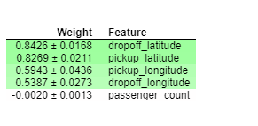
Hint: The only thing you need to change is the first argument to PermutationImportance(). Find the right model name in the code above
Solution:

import eli5
from eli5.sklearn import PermutationImportance

perm = PermutationImportance(first_model, random_state=1).fit(val_X, val_y)
eli5.show_weights(perm, feature_names = base_features)

Question 3
Before seeing these results, we might have expected each of the 4 directional features to be equally important.
But, on average, the latitude features matter more than the longititude features. Can you come up with any hypotheses for this?
After you've thought about it, check here for some possible explanations:

Solution:
1. Travel might tend to have greater latitude distances than longitude distances. If the longitudes values were generally closer together, shuffling them wouldn't matter as much.
2. Different parts of the city might have different pricing rules (e.g. price per mile), and pricing rules could vary more by latitude than longitude.
3. Tolls might be greater on roads going North<->South (changing latitude) than on roads going East <-> West (changing longitude). Thus latitude would have a larger effect on the prediction because it captures the amount of the tolls.

Solution :

1. Les voyages peuvent avoir tendance à avoir des distances en latitude plus grandes que les distances en longitude. Si les valeurs des longitudes étaient généralement plus proches, les mélanger n'aurait pas autant d'importance.
2. Différentes parties de la ville pourraient avoir des règles de tarification différentes (par exemple, le prix par kilomètre), et les règles de tarification pourraient varier davantage en fonction de la latitude que de la longitude.
3. Les péages pourraient être plus élevés sur les routes allant vers le nord <-> sud (changement de latitude) que sur les routes allant vers l'est <-> ouest (changement de longitude). La latitude aurait donc un effet plus important sur la prévision car elle saisit le montant des péages.

Question 4
Without detailed knowledge of New York City, it's difficult to rule out most hypotheses about why latitude features matter more than longitude.
A good next step is to disentangle the effect of being in certain parts of the city from the effect of total distance traveled.
The code below creates new features for longitudinal and latitudinal distance. It then builds a model that adds these new features to those you already had.
Fill in two lines of code to calculate and show the importance weights with this new set of features. As usual, you can uncomment lines below to check your code, see a hint or get the solution.

Sans une connaissance détaillée de la ville de New York, il est difficile d'écarter la plupart des hypothèses sur la raison pour laquelle les caractéristiques de la latitude sont plus importantes que la longitude.

Une bonne étape suivante consiste à démêler l'effet de la présence dans certaines parties de la ville de l'effet de la distance totale parcourue.

Le code ci-dessous crée de nouvelles caractéristiques pour la distance longitudinale et la latitude. Il construit ensuite un modèle qui ajoute ces nouvelles caractéristiques à celles que vous aviez déjà.

Remplissez deux lignes de code pour calculer et montrer les poids d'importance avec ce nouvel ensemble de caractéristiques. Comme d'habitude, vous pouvez décommenter les lignes ci-dessous pour vérifier votre code, voir un indice ou obtenir la solution.

# create new features
data['abs_lon_change'] = abs(data.dropoff_longitude - data.pickup_longitude)
data['abs_lat_change'] = abs(data.dropoff_latitude - data.pickup_latitude)

features_2 = ['pickup_longitude',
'pickup_latitude',
'dropoff_longitude',
'dropoff_latitude',
'abs_lat_change',
'abs_lon_change']

X = data[features_2]
new_train_X, new_val_X, new_train_y, new_val_y = train_test_split(X, y, random_state=1)
second_model = RandomForestRegressor(n_estimators=30, random_state=1).fit(new_train_X, new_train_y)

# Create a PermutationImportance object on second_model and fit it to new_val_X and new_val_y
# Use a random_state of 1 for reproducible results that match the expected solution.
perm2 = PermutationImportance(second_model, random_state=8).fit(new_val_X, new_val_y)

# show the weights for the permutation importance you just calculated
eli5.show_weights(perm2, feature_names = features_2)

Correct
How would you interpret these importance scores? Distance traveled seems far more important than any location effects.
But the location still affects model predictions, and dropoff location now matters slightly more than pickup location. Do you have any hypotheses for why this might be? The techniques in the next lessons will help you` dive into this more.

Comment interpréteriez-vous ces notes d'importance ? La distance parcourue semble bien plus importante que les effets de localisation.

Mais le lieu affecte toujours les prédictions du modèle, et le lieu de chute a maintenant un peu plus d'importance que le lieu de ramassage. Avez-vous des hypothèses sur les raisons de cette situation ? Les techniques des prochaines leçons vous aideront à vous plonger davantage dans cette question.

Question 5
A colleague observes that the values for abs_lon_change and abs_lat_change are pretty small (all values are between -0.1 and 0.1), whereas other variables have larger values. Do you think this could explain why those coordinates had larger permutation importance values in this case?
Consider an alternative where you created and used a feature that was 100X as large for these features, and used that larger feature for training and importance calculations. Would this change the outputted permutaiton importance values?
Why or why not?
After you have thought about your answer, either try this experiment or look up the answer in the cell below.

Question 5
Un collègue observe que les valeurs de abs_lon_change et abs_lat_change sont assez faibles (toutes les valeurs sont comprises entre -0,1 et 0,1), alors que d'autres variables ont des valeurs plus importantes. Pensez-vous que cela pourrait expliquer pourquoi ces coordonnées ont des valeurs plus importantes de permutation dans ce cas ?

Envisagez une autre solution dans laquelle vous avez créé et utilisé une caractéristique 100 fois plus grande pour ces caractéristiques, et avez utilisé cette caractéristique plus grande pour l'entraînement et les calculs d'importance. Cela changerait-il les valeurs d'importance de permutation produites ?

Pourquoi ou pourquoi pas ?

Après avoir réfléchi à votre réponse, essayez cette expérience ou cherchez la réponse dans la cellule ci-dessous.

Solution: The scale of features does not affect permutation importance per se. The only reason that rescaling a feature would affect PI is indirectly, if rescaling helped or hurt the ability of the particular learning method we're using to make use of that feature. That won't happen with tree based models, like the Random Forest used here. If you are familiar with Ridge Regression, you might be able to think of how that would be affected. That said, the absolute change features are have high importance because they capture total distance traveled, which is the primary determinant of taxi fares...It is not an artifact of the feature magnitude.

Solution : L'échelle des caractéristiques n'affecte pas l'importance de la permutation en tant que telle. La seule raison pour laquelle le changement d'échelle d'une fonction affecterait l'IP est indirecte, si le changement d'échelle a aidé ou nui à la capacité de la méthode d'apprentissage particulière que nous utilisons pour utiliser cette fonction. Cela n'arrivera pas avec les modèles basés sur des arbres, comme le Random Forest utilisé ici. Si vous connaissez bien la régression de crête, vous pouvez peut-être imaginer comment elle serait affectée. Cela dit, les caractéristiques absolues de changement ont une grande importance car elles saisissent la distance totale parcourue, qui est le principal déterminant des tarifs de taxi... Ce n'est pas un artefact de l'ampleur de la caractéristique.

Question 6
You've seen that the feature importance for latitudinal distance is greater than the importance of longitudinal distance. From this, can we conclude whether travelling a fixed latitudinal distance tends to be more expensive than traveling the same longitudinal distance?
Why or why not? Check your answer below.

Question 6
Vous avez vu que l'importance de la caractéristique pour la distance latitudinale est plus grande que l'importance de la distance longitudinale. Peut-on en conclure que le fait de parcourir une distance latitudinale fixe tend à être plus coûteux que de parcourir la même distance longitudinale ?

Pourquoi ou pourquoi pas ? Vérifiez votre réponse ci-dessous.
Solution: We cannot tell from the permutation importance results whether traveling a fixed latitudinal distance is more or less expensive than traveling the same longitudinal distance. Possible reasons latitude feature are more important than longitude features
1. latitudinal distances in the dataset tend to be larger
2. it is more expensive to travel a fixed latitudinal distance
3. Both of the above
If abs_lon_change values were very small, longitues could be less important to the model even if the cost per mile of travel in that direction were high.

Solution : Nous ne pouvons pas dire, à partir des résultats de l'importance de la permutation, si le fait de parcourir une distance latitudinale fixe est plus ou moins coûteux que de parcourir la même distance longitudinale. Raisons possibles pour lesquelles les caractéristiques de la latitude sont plus importantes que celles de la longitude

1. les distances latitudinales dans l'ensemble de données ont tendance à être plus grandes
2. il est plus coûteux de parcourir une distance latitudinale fixe
3. Ces deux éléments
Si les valeurs de abs_lon_change étaient très faibles, les longitues pourraient être moins importantes pour le modèle, même si le coût par kilomètre de déplacement dans cette direction était élevé.

3. Partial plots

3.1 COURS

Partial Dependence Plots
While feature importance shows what variables most affect predictions, partial dependence plots show how a feature affects predictions.
This is useful to answer questions like:
- Controlling for all other house features, what impact do longitude and latitude have on home prices? To restate this, how would similarly sized houses be priced in different areas?
- Are predicted health differences between two groups due to differences in their diets, or due to some other factor?
If you are familiar with linear or logistic regression models, partial dependence plots can be interpreted similarly to the coefficients in those models. Though, partial dependence plots on sophisticated models can capture more complex patterns than coefficients from simple models. If you aren't familiar with linear or logistic regressions, don't worry about this comparison.
We will show a couple examples, explain the interpretation of these plots, and then review the code to create these plots.

Alors que l'importance d'une caractéristique montre quelles sont les variables qui affectent le plus les prédictions, les graphiques de dépendance partielle montrent comment une caractéristique affecte les prédictions.

Ceci est utile pour répondre à des questions comme :
En tenant compte de toutes les autres caractéristiques de la maison, quel est l'impact de la longitude et de la latitude sur le prix des maisons ? Pour reformuler cela, comment des maisons de taille similaire seraient-elles tarifées dans différentes régions ?
Les différences de santé prévues entre deux groupes sont-elles dues à des différences dans leur régime alimentaire ou à un autre facteur ?
Si vous connaissez les modèles de régression linéaire ou logistique, les graphiques de dépendance partielle peuvent être interprétés de la même manière que les coefficients de ces modèles. Cependant, les diagrammes de dépendance partielle des modèles sophistiqués peuvent saisir des modèles plus complexes que les coefficients des modèles simples. Si vous n'êtes pas familier avec les régressions linéaires ou logistiques, ne vous inquiétez pas de cette comparaison.
Nous allons vous montrer quelques exemples, expliquer l'interprétation de ces tracés, puis passer en revue le code pour créer ces tracés.

How it Works
Like permutation importance, partial dependence plots are calculated after a model has been fit. The model is fit on real data that has not been artificially manipulated in any way.
In our soccer example, teams may differ in many ways. How many passes they made, shots they took, goals they scored, etc. At first glance, it seems difficult to disentangle the effect of these features.
To see how partial plots separate out the effect of each feature, we start by considering a single row of data. For example, that row of data might represent a team that had the ball 50% of the time, made 100 passes, took 10 shots and scored 1 goal.
We will use the fitted model to predict our outcome (probability their player won "man of the match"). But we repeatedly alter the value for one variable to make a series of predictions. We could predict the outcome if the team had the ball only 40% of the time. We then predict with them having the ball 50% of the time. Then predict again for 60%. And so on. We trace out predicted outcomes (on the vertical axis) as we move from small values of ball possession to large values (on the horizontal axis).
In this description, we used only a single row of data. Interactions between features may cause the plot for a single row to be atypical. So, we repeat that mental experiment with multiple rows from the original dataset, and we plot the average predicted outcome on the vertical axis.

Tout comme l'importance de la permutation, les parcelles de dépendance partielle sont calculées après qu'un modèle ait été ajusté. Le modèle est ajusté sur des données réelles qui n'ont été artificiellement manipulées d'aucune façon.

Dans notre exemple de football, les équipes peuvent différer de bien des façons. Le nombre de passes qu'elles ont faites, de tirs qu'elles ont effectués, de buts qu'elles ont marqués, etc. À première vue, il semble difficile de démêler l'effet de ces caractéristiques.

Pour voir comment les tracés partiels séparent l'effet de chaque caractéristique, nous commençons par considérer une seule ligne de données. Par exemple, cette ligne de données peut représenter une équipe qui a eu le ballon 50% du temps, a fait 100 passes, a tiré 10 fois et a marqué 1 but.

Nous utiliserons le modèle ajusté pour prédire notre résultat (probabilité que leur joueur gagne le titre d'"homme du match"). Mais nous modifions régulièrement la valeur d'une variable pour faire une série de prédictions. Nous pourrions prédire le résultat si l'équipe n'avait le ballon que 40 % du temps. Nous prédisons ensuite si l'équipe a le ballon dans 50% des cas. Puis nous faisons de nouveau une prédiction pour 60 %. Et ainsi de suite. Nous traçons les résultats prédits (sur l'axe vertical) en passant de petites valeurs de possession de balle à de grandes valeurs (sur l'axe horizontal).

Dans cette description, nous n'avons utilisé qu'une seule ligne de données. Les interactions entre les caractéristiques peuvent rendre le tracé d'une seule ligne atypique. Nous répétons donc cette expérience mentale avec plusieurs lignes de l'ensemble de données original, et nous traçons le résultat moyen prévu sur l'axe vertical.

Code Example
Model building isn't our focus, so we won't focus on the data exploration or model building code.
In [1]:
import numpy as np
import pandas as pd
from sklearn.model_selection import train_test_split
from sklearn.ensemble import RandomForestClassifier
from sklearn.tree import DecisionTreeClassifier

data = pd.read_csv('../input/fifa-2018-match-statistics/FIFA 2018 Statistics.csv')
y = (data['Man of the Match'] == "Yes") # Convert from string "Yes"/"No" to binary
feature_names = [i for i in data.columns if data[i].dtype in [np.int64]]
X = data[feature_names]
train_X, val_X, train_y, val_y = train_test_split(X, y, random_state=1)
tree_model = DecisionTreeClassifier(random_state=0, max_depth=5, min_samples_split=5).fit(train_X, train_y)
Our first example uses a decision tree, which you can see below. In practice, you'll use more sophistated models for real-world applications.
In [2]:
from sklearn import tree
import graphviz

tree_graph = tree.export_graphviz(tree_model, out_file=None, feature_names=feature_names)
graphviz.Source(tree_graph)
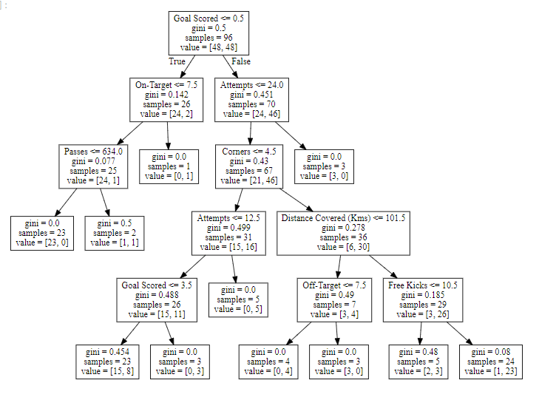
As guidance to read the tree:
- Leaves with children show their splitting criterion on the top
- The pair of values at the bottom show the count of False values and True values for the target respectively, of data points in that node of the tree.

Comme guide pour lire l'arbre :

Les feuilles avec les enfants montrent leur critère de division en haut
La paire de valeurs en bas montre le nombre de valeurs fausses et de valeurs vraies pour la cible respectivement, des points de données dans ce nœud de l'arbre.

Here is the code to create the Partial Dependence Plot using the PDPBox library.
In [3]:
from matplotlib import pyplot as plt
from pdpbox import pdp, get_dataset, info_plots

# Create the data that we will plot
pdp_goals = pdp.pdp_isolate(model=tree_model, dataset=val_X, model_features=feature_names, feature='Goal Scored')

# plot it
pdp.pdp_plot(pdp_goals, 'Goal Scored')
plt.show()

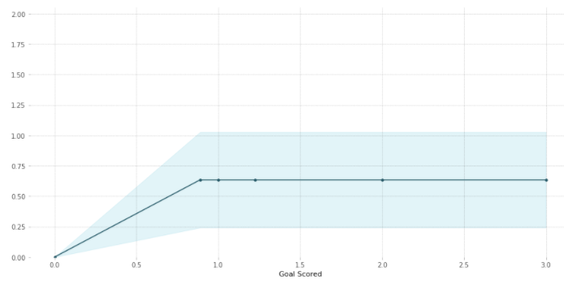
A few items are worth pointing out as you interpret this plot
- The y axis is interpreted as change in the prediction from what it would be predicted at the baseline or leftmost value.
- A blue shaded area indicates level of confidence
From this particular graph, we see that scoring a goal substantially increases your chances of winning "Man of The Match." But extra goals beyond that appear to have little impact on predictions.
Here is another example plot:
Quelques éléments méritent d'être soulignés dans l'interprétation de cette intrigue

L'axe des y est interprété comme un changement dans la prédiction par rapport à ce qui serait prédit à la ligne de base ou à la valeur la plus à gauche.
Une zone ombrée en bleu indique le niveau de confiance
Ce graphique montre qu'en marquant un but, vous augmentez considérablement vos chances de gagner le titre d'"Homme du match". Mais des buts supplémentaires au-delà de cette limite semblent avoir peu d'impact sur les pronostics.

Voici un autre exemple de graphique :
In [4]:
feature_to_plot = 'Distance Covered (Kms)'
pdp_dist = pdp.pdp_isolate(model=tree_model, dataset=val_X, model_features=feature_names, feature=feature_to_plot)

pdp.pdp_plot(pdp_dist, feature_to_plot)
plt.show()
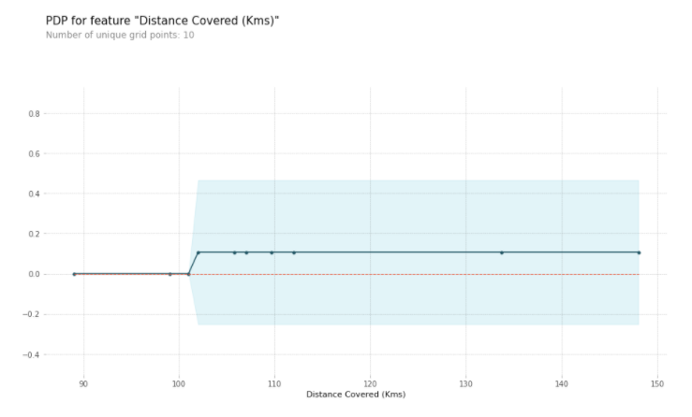
This graph seems too simple to represent reality. But that's because the model is so simple. You should be able to see from the decision tree above that this is representing exactly the model's structure.
You can easily compare the structure or implications of different models. Here is the same plot with a Random Forest model.

Ce graphique semble trop simple pour représenter la réalité. Mais c'est parce que le modèle est si simple. L'arbre de décision ci-dessus devrait vous permettre de voir qu'il représente exactement la structure du modèle.

Vous pouvez facilement comparer la structure ou les implications de différents modèles. Voici la même parcelle avec un modèle de Random Forest.
In [5]:
# Build Random Forest model
rf_model = RandomForestClassifier(random_state=0).fit(train_X, train_y)

pdp_dist = pdp.pdp_isolate(model=rf_model, dataset=val_X, model_features=feature_names, feature=feature_to_plot)

pdp.pdp_plot(pdp_dist, feature_to_plot)
plt.show()

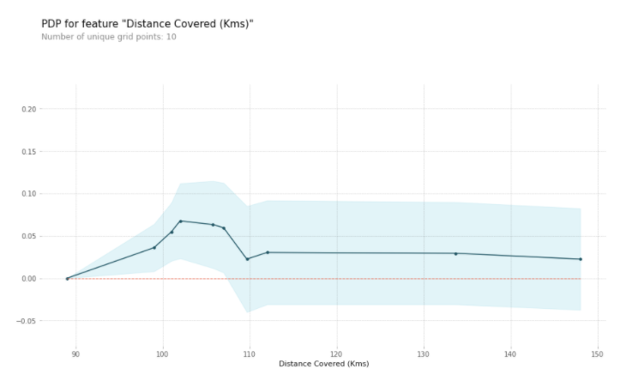
This model thinks you are more likely to win Man of the Match if your players run a total of 100km over the course of the game. Though running much more causes lower predictions.
In general, the smooth shape of this curve seems more plausible than the step function from the Decision Tree model. Though this dataset is small enough that we would be careful in how we interpret any model.

Ce modèle pense que vous avez plus de chances de gagner le titre d'Homme du match si vos joueurs courent un total de 100 km au cours du jeu. Bien que courir beaucoup plus entraîne des prédictions plus faibles.

En général, la forme lisse de cette courbe semble plus plausible que la fonction de pas du modèle de l'arbre de décision. Bien que cet ensemble de données soit suffisamment petit pour que nous soyons prudents dans l'interprétation de n'importe quel modèle.

2D Partial Dependence Plots
If you are curious about interactions between features, 2D partial dependence plots are also useful. An example may clarify this.
We will again use the Decision Tree model for this graph. It will create an extremely simple plot, but you should be able to match what you see in the plot to the tree itself.

Graphiques de dépendance partielle en 2D
Si vous êtes curieux de connaître les interactions entre les caractéristiques, les diagrammes de dépendance partielle en 2D sont également utiles. Un exemple peut vous éclairer sur ce point.

Nous utiliserons à nouveau le modèle de l'arbre de décision pour ce graphique. Il créera un tracé extrêmement simple, mais vous devriez pouvoir faire correspondre ce que vous voyez dans le tracé à l'arbre lui-même.
In [6]:
# Similar to previous PDP plot except we use pdp_interact instead of pdp_isolate and pdp_interact_plot instead of pdp_isolate_plot
features_to_plot = ['Goal Scored', 'Distance Covered (Kms)']
inter1 = pdp.pdp_interact(model=tree_model, dataset=val_X, model_features=feature_names, features=features_to_plot)

pdp.pdp_interact_plot(pdp_interact_out=inter1, feature_names=features_to_plot, plot_type='contour')
plt.show()
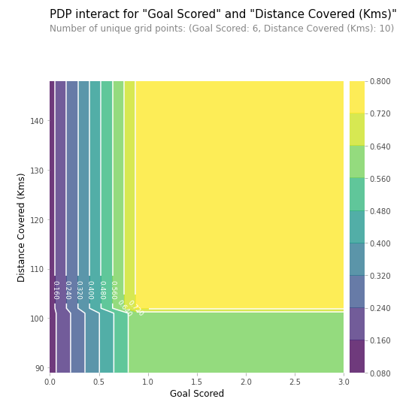
This graph shows predictions for any combination of Goals Scored and Distance covered.
For example, we see the highest predictions when a team scores at least 1 goal and they run a total distance close to 100km. If they score 0 goals, distance covered doesn't matter. Can you see this by tracing through the decision tree with 0 goals?
But distance can impact predictions if they score goals. Make sure you can see this from the 2D partial dependence plot. Can you see this pattern in the decision tree too?

Ce graphique montre les prévisions pour toute combinaison de buts marqués et de distance parcourue.

Par exemple, nous voyons les prévisions les plus élevées lorsqu'une équipe marque au moins 1 but et qu'elle parcourt une distance totale proche de 100 km. Si elle marque 0 but, la distance parcourue n'a pas d'importance. Pouvez-vous le constater en parcourant l'arbre de décision avec 0 but ?

Mais la distance peut avoir un impact sur les prédictions si l'équipe marque des buts. Assurez-vous que vous pouvez le voir à partir du diagramme de dépendance partielle en 2D. Pouvez-vous également voir ce schéma dans l'arbre de décision ?

3.2 EXERCICES

Set Up
Today you will create partial dependence plots and practice building insights with data from the Taxi Fare Prediction competition.
We have again provided code to do the basic loading, review and model-building. Run the cell below to set everything up:

Mise en place
Aujourd'hui, vous allez créer des parcelles de dépendance partielle et vous exercer à construire des aperçus avec les données du concours de prédiction des tarifs de taxi.

Nous avons à nouveau fourni le code pour effectuer le chargement de base, l'examen et la construction du modèle. Exécutez la cellule ci-dessous pour tout mettre en place :

import pandas as pd
from sklearn.ensemble import RandomForestRegressor
from sklearn.linear_model import LinearRegression
from sklearn.model_selection import train_test_split

# Environment Set-Up for feedback system.
from learntools.core import binder
binder.bind(globals())
from learntools.ml_explainability.ex3 import *
print("Setup Complete")

# Data manipulation code below here
data = pd.read_csv('../input/new-york-city-taxi-fare-prediction/train.csv', nrows=50000)

# Remove data with extreme outlier coordinates or negative fares
data = data.query('pickup_latitude > 40.7 and pickup_latitude < 40.8 and ' +
'dropoff_latitude > 40.7 and dropoff_latitude < 40.8 and ' +
'pickup_longitude > -74 and pickup_longitude < -73.9 and ' +
'dropoff_longitude > -74 and dropoff_longitude < -73.9 and ' +
'fare_amount > 0'
)

y = data.fare_amount

base_features = ['pickup_longitude',
'pickup_latitude',
'dropoff_longitude',
'dropoff_latitude']

X = data[base_features]

train_X, val_X, train_y, val_y = train_test_split(X, y, random_state=1)
first_model = RandomForestRegressor(n_estimators=30, random_state=1).fit(train_X, train_y)
print("Data sample:")
data.head()

Setup Complete
Data sample:
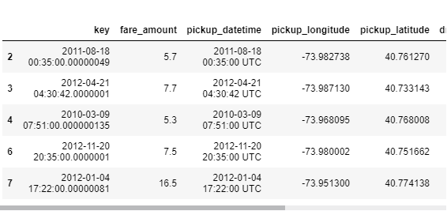

data.describe()

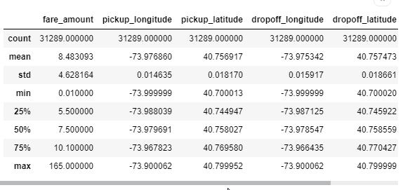
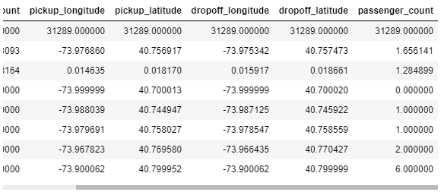

Question 1
Here is the code to plot the partial dependence plot for pickup_longitude. Run the following cell.

from matplotlib import pyplot as plt
from pdpbox import pdp, get_dataset, info_plots

feat_name = 'pickup_longitude'
pdp_dist = pdp.pdp_isolate(model=first_model, dataset=val_X, model_features=base_features, feature=feat_name)

pdp.pdp_plot(pdp_dist, feat_name)
plt.show()

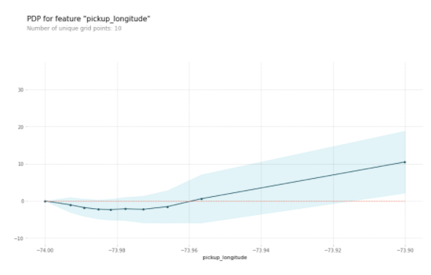
Pourquoi le diagramme de dépendance partielle a-t-il cette forme en U ?
Votre explication suggère-t-elle la forme à laquelle il faut s'attendre dans les diagrammes de dépendance partielle pour les autres caractéristiques ?
Créez tous les autres diagrammes de dépendance partielle dans une boucle en fourchette ci-dessous (en copiant les lignes appropriées du code ci-dessus).

for feat_name in base_features:
pdp_dist = pdp.pdp_isolate(model=first_model, dataset=val_X, model_features=base_features, feature=feat_name)

pdp.pdp_plot(pdp_dist, feat_name)
plt.show()

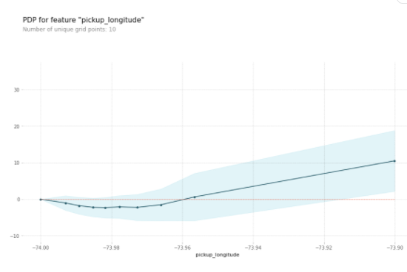
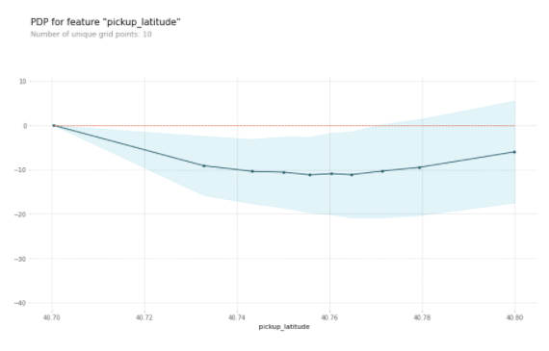

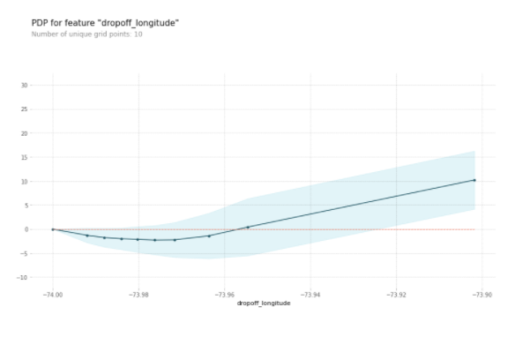
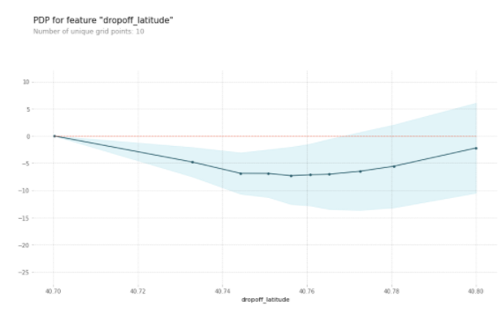

Do the shapes match your expectations for what shapes they would have? Can you explain the shape now that you've seen them?
Uncomment the following line to check your intuition.
Les formes correspondent-elles à vos attentes quant aux formes qu'elles auraient ? Pouvez-vous expliquer la forme maintenant que vous les avez vues ?
Décommentez la ligne suivante pour vérifier votre intuition.

Solution:
The code is

for feat_name in base_features:
pdp_dist = pdp.pdp_isolate(model=first_model, dataset=val_X,
model_features=base_features, feature=feat_name)
pdp.pdp_plot(pdp_dist, feat_name)
plt.show()

We have a sense from the permutation importance results that distance is the most important determinant of taxi fare.
This model didn't include distance measures (like absolute change in latitude or longitude) as features, so coordinate features (like pickup_longitude) capture the effect of distance. Being picked up near the center of the longitude values lowers predicted fares on average, because it means shorter trips (on average).
For the same reason, we see the general U-shape in all our partial dependence plots.

Nous avons le sentiment, d'après les résultats de l'importance de la permutation, que la distance est le facteur déterminant le plus important du prix du taxi.
Ce modèle n'incluait pas les mesures de distance (comme le changement absolu de latitude ou de longitude) en tant que caractéristiques, donc les caractéristiques de coordonnées (comme la pickup_longitude) capturent l'effet de la distance. Le fait d'être ramassé près du centre des valeurs de longitude fait baisser les tarifs prévus en moyenne, car cela signifie des trajets plus courts (en moyenne).
Pour la même raison, nous voyons la forme générale en U dans tous nos graphiques de dépendance partielle.

Question 2
Now you will run a 2D partial dependence plot. As a reminder, here is the code from the tutorial.

inter1 = pdp.pdp_interact(model=my_model, dataset=val_X, model_features=feature_names, features=['Goal Scored', 'Distance Covered (Kms)'])

pdp.pdp_interact_plot(pdp_interact_out=inter1, feature_names=['Goal Scored', 'Distance Covered (Kms)'], plot_type='contour')
plt.show()

Create a 2D plot for the features pickup_longitude and dropoff_longitude.
Plot it appropriately?
What do you expect it to look like?

# Add your code here
inter1 = pdp.pdp_interact(model=first_model, dataset=val_X, model_features=base_features, features=['pickup_longitude', 'dropoff_longitude'])

pdp.pdp_interact_plot(pdp_interact_out=inter1, feature_names=['pickup_longitude', 'dropoff_longitude'], plot_type='contour')
plt.show()

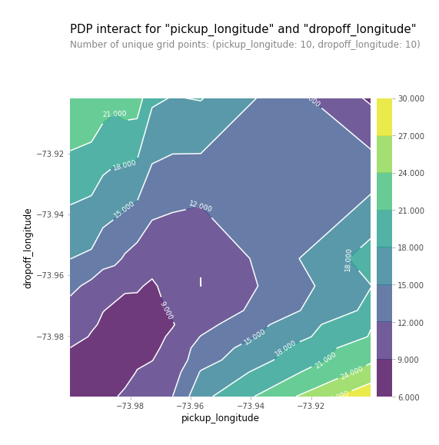
Uncomment the line below to see the solution and explanation for how one might reason about the plot shape.

Solution: You should expect the plot to have contours running along a diagonal. We see that to some extent, though there are interesting caveats.
We expect the diagonal contours because these are pairs of values where the pickup and dropoff longitudes are nearby, indicating shorter trips (controlling for other factors).
As you get further from the central diagonal, we should expect prices to increase as the distances between the pickup and dropoff longitudes also increase.
The surprising feature is that prices increase as you go further to the upper-right of this graph, even staying near that 45-degree line.
This could be worth further investigation, though the effect of moving to the upper right of this graph is small compared to moving away from that 45-degree line.

The code you need to create the desired plot is:

fnames = ['pickup_longitude', 'dropoff_longitude']
longitudes_partial_plot = pdp.pdp_interact(model=first_model, dataset=val_X,
model_features=base_features, features=fnames)
pdp.pdp_interact_plot(pdp_interact_out=longitudes_partial_plot,
feature_names=fnames, plot_type='contour')
plt.show()

Il faut s'attendre à ce que l'intrigue ait des contours en diagonale. Nous le constatons dans une certaine mesure, bien qu'il y ait des mises en garde intéressantes.

Nous nous attendons à des contours diagonaux car il s'agit de paires de valeurs où les longitudes de ramassage et de chute sont proches, ce qui indique des trajets plus courts (en tenant compte d'autres facteurs).

Plus on s'éloigne de la diagonale centrale, plus les prix devraient augmenter, car les distances entre les longitudes de ramassage et de descente augmentent également.

Ce qui est surprenant, c'est que les prix augmentent à mesure que l'on s'éloigne de la partie supérieure droite de ce graphique, même en restant près de cette ligne à 45 degrés.

Cela pourrait mériter une étude plus approfondie, bien que l'effet d'un déplacement vers la partie supérieure droite de ce graphique soit faible par rapport à un éloignement de cette ligne à 45 degrés.
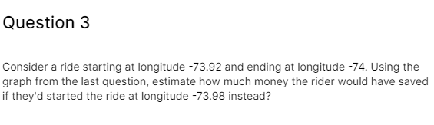
savings_from_shorter_trip = 25.000-10.000
Hint: First find the vertical level corresponding to -74 dropoff longitude. Then read off the horizontal values you are switching between. Use the white contour lines to orient yourself on what values you are near. You can round to the nearest integer rather than stressing about the exact cost to the nearest penny

Correct:

The price decreases froms lightly more than 24 to slightly more than $9.

Question 4
In the PDP's you've seen so far, location features have primarily served as a proxy to capture distance traveled. In the permutation importance lessons, you added the features abs_lon_change and abs_lat_change as a more direct measure of distance.
Create these features again here. You only need to fill in the top two lines. Then run the following cell.
After you run it, identify the most important difference between this partial dependence plot and the one you got without absolute value features. The code to generate the PDP without absolute value features is at the top of this code cell.
# This is the PDP for pickup_longitude without the absolute difference features. Included here to help compare it to the new PDP you create
feat_name = 'pickup_longitude'
pdp_dist_original = pdp.pdp_isolate(model=first_model, dataset=val_X, model_features=base_features, feature=feat_name)

pdp.pdp_plot(pdp_dist_original, feat_name)
plt.show()

# create new features
data['abs_lon_change'] = abs(data.dropoff_longitude - data.pickup_longitude)
data['abs_lat_change'] = abs(data.dropoff_latitude - data.pickup_latitude)

features_2 = ['pickup_longitude',
'pickup_latitude',
'dropoff_longitude',
'dropoff_latitude',
'abs_lat_change',
'abs_lon_change']

X = data[features_2]
new_train_X, new_val_X, new_train_y, new_val_y = train_test_split(X, y, random_state=1)
second_model = RandomForestRegressor(n_estimators=30, random_state=1).fit(new_train_X, new_train_y)

feat_name = 'pickup_longitude'
pdp_dist = pdp.pdp_isolate(model=second_model, dataset=new_val_X, model_features=features_2, feature=feat_name)

pdp.pdp_plot(pdp_dist, feat_name)
plt.show()
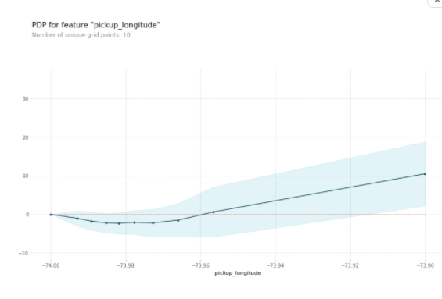
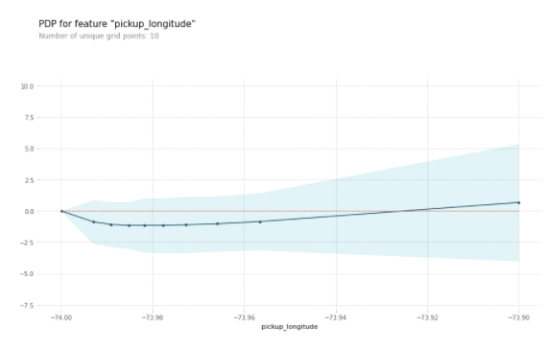
Correct:
The biggest difference is that the partial dependence plot became much smaller. The the lowest vertical value is about 15??????ℎ?ℎ??ℎ???????????????????ℎ?????ℎ???,?ℎ??????ℎ???????????????????????15belowthehighestverticalvalueinthetopchart,whereasthisdifferenceisonlyabout3 in the chart you just created. In other words, once you control for absolute distance traveled, the pickup_longitude has only a very small impact on predictions.
# create new features
data['abs_lon_change'] = abs(data.dropoff_longitude - data.pickup_longitude)
data['abs_lat_change'] = abs(data.dropoff_latitude - data.pickup_latitude)

La plus grande différence est que le diagramme de dépendance partielle est devenu beaucoup plus petit. La valeur verticale la plus basse se situe à environ 15 𝑏𝑒𝑙𝑜𝑤 𝑡ℎ𝑒 ℎ𝑖𝑔ℎ𝑒𝑠𝑡 𝑣𝑒𝑟𝑡𝑖𝑐𝑎𝑙 𝑣𝑎𝑙𝑢𝑒 𝑖𝑛 𝑡ℎ𝑒 𝑡𝑜𝑝 𝑐ℎ𝑎𝑟𝑡, 𝑤ℎ𝑒𝑟𝑒 𝑎𝑠 𝑡ℎ𝑖𝑠 𝑑𝑖𝑓𝑓𝑒𝑟𝑒𝑛𝑐𝑒 𝑖𝑠 𝑜𝑛𝑙𝑦 𝑎𝑏𝑜𝑢𝑡 3 dans le graphique que vous venez de créer. En d'autres termes, une fois que vous contrôlez la distance absolue parcourue, la pickup_longitude n'a qu'un très faible impact sur les prédictions.

Question 5
Consider a scenario where you have only 2 predictive features, which we will call feat_A and feat_B. Both features have minimum values of -1 and maximum values of 1. The partial dependence plot for feat_A increases steeply over its whole range, whereas the partial dependence plot for feature B increases at a slower rate (less steeply) over its whole range.
Does this guarantee that feat_A will have a higher permutation importance than feat_B. Why or why not?
After you've thought about it, uncomment the line below for the solution.
Imaginez un scénario dans lequel vous ne disposez que de deux caractéristiques prédictives, que nous appellerons feat_A et feat_B. La courbe de dépendance partielle de feat_A augmente fortement sur toute sa plage, tandis que la courbe de dépendance partielle de la caractéristique B augmente à un rythme plus lent (moins fortement) sur toute sa plage.

Est-ce que cela garantit que feat_A aura une importance de permutation plus élevée que feat_B. Pourquoi ou pourquoi pas ?

Après réflexion, décommentez la ligne ci-dessous pour la solution.

Solution: No. This doesn't guarantee feat_a is more important. For example, feat_a could have a big effect in the cases where it varies, but could have a single value 99% of the time. In that case, permuting feat_a wouldn't matter much, since most values would be unchanged.

Solution : Non. Cela ne garantit pas que feat_a est plus important. Par exemple, feat_a pourrait avoir un effet important dans les cas où il varie, mais pourrait avoir une valeur unique 99% du temps. Dans ce cas, la permutation de feat_a n'aurait pas beaucoup d'importance, puisque la plupart des valeurs resteraient inchangées.

Question 6
The code cell below does the following:
- Creates two features, X1 and X2, having random values in the range [-2, 2].
- Creates a target variable y, which is always 1.
- Trains a RandomForestRegressor model to predict y given X1 and X2.
- Creates a PDP plot for X1 and a scatter plot of X1 vs. y.
Do you have a prediction about what the PDP plot will look like? Run the cell to find out.
Modify the initialization of y so that our PDP plot has a positive slope in the range [-1,1], and a negative slope everywhere else. (Note: you should only modify the creation of y, leaving X1, X2, and my_model unchanged.)

La cellule de code ci-dessous fait ce qui suit :

Crée deux caractéristiques, X1 et X2, ayant des valeurs aléatoires dans l'intervalle [-2, 2].
Crée une variable cible y, qui est toujours égale à 1.
Forme un modèle RandomForestRegressor pour prédire y étant donné X1 et X2.
Crée un diagramme PDP pour X1 et un diagramme de dispersion de X1 par rapport à y.
Avez-vous une prédiction de ce à quoi ressemblera le diagramme PDP ? Lancez la cellule pour le savoir.

Modifiez l'initialisation de y pour que notre graphique PDP ait une pente positive dans la plage [-1,1], et une pente négative partout ailleurs. (Remarque : vous ne devez modifier que la création de y, en laissant X1, X2 et mon_modèle inchangés).

import numpy as np
from numpy.random import rand

n_samples = 20000

# Create array holding predictive feature
X1 = 4 * rand(n_samples) - 2
X2 = 4 * rand(n_samples) - 2
# Create y. you should have X1 and X2 in the expression for y
# y = np.ones(n_samples)
y = -2 * X1 * (X1<-1) + X1 - 2 * X1 * (X1>1) - X2

# create dataframe because pdp_isolate expects a dataFrame as an argument
my_df = pd.DataFrame({'X1': X1, 'X2': X2, 'y': y})
predictors_df = my_df.drop(['y'], axis=1)

my_model = RandomForestRegressor(n_estimators=30, random_state=1).fit(predictors_df, my_df.y)

pdp_dist = pdp.pdp_isolate(model=my_model, dataset=my_df, model_features=['X1', 'X2'], feature='X1')

# visualize your results
pdp.pdp_plot(pdp_dist, 'X1')
plt.show()
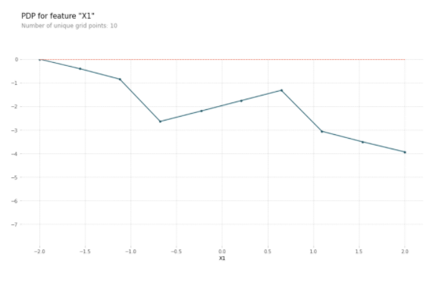
Hint: Consider explicitly using terms that include mathematical expressions like (X1 < -1)
Solution:

# There are many possible solutions.
# One example expression for y is.
y = -2 * X1 * (X1<-1) + X1 - 2 * X1 * (X1>1) - X2
# You don't need any more changes

Question 7
Create a dataset with 2 features and a target, such that the pdp of the first feature is flat, but its permutation importance is high. We will use a RandomForest for the model.
Note: You only need to supply the lines that create the variables X1, X2 and y. The code to build the model and calculate insights is provided.

import eli5
from eli5.sklearn import PermutationImportance

n_samples = 20000

# Create array holding predictive feature
X1 = 4 * rand(n_samples) - 2
X2 = 4 * rand(n_samples) - 2

# Create y. you should have X1 and X2 in the expression for y
y = X1 * X2

# create dataframe because pdp_isolate expects a dataFrame as an argument
my_df = pd.DataFrame({'X1': X1, 'X2': X2, 'y': y})
predictors_df = my_df.drop(['y'], axis=1)

my_model = RandomForestRegressor(n_estimators=30, random_state=8).fit(predictors_df, my_df.y)

pdp_dist = pdp.pdp_isolate(model=my_model, dataset=my_df, model_features=['X1', 'X2'], feature='X1')
pdp.pdp_plot(pdp_dist, 'X1')
plt.show()

perm = PermutationImportance(my_model).fit(predictors_df, my_df.y)

# Check your answer
q_7.check()

# show the weights for the permutation importance you just calculated
eli5.show_weights(perm, feature_names = ['X1', 'X2'])

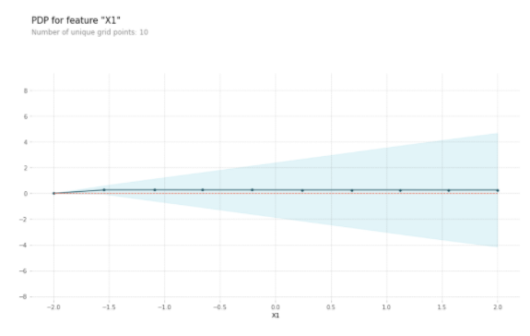
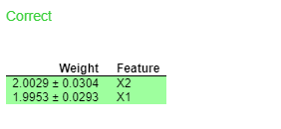
Hint: You need for X1 to affect the prediction in order to have it affect permutation importance. But the average effect needs to be 0 to satisfy the PDP requirement. Achieve this by creating an interaction, so the effect of X1 depends on the value of X2 and vice-versa.
Solution:

# Create array holding predictive feature
X1 = 4 * rand(n_samples) - 2
X2 = 4 * rand(n_samples) - 2
# Create y. you should have X in the expression for y
y = X1 * X2

# Aside from these lines, use the code provided

4. SHAP Values

4.1 COURS

Introduction
You've seen (and used) techniques to extract general insights from a machine learning model. But what if you want to break down how the model works for an individual prediction?
SHAP Values (an acronym from SHapley Additive exPlanations) break down a prediction to show the impact of each feature. Where could you use this?
- A model says a bank shouldn't loan someone money, and the bank is legally required to explain the basis for each loan rejection
- A healthcare provider wants to identify what factors are driving each patient's risk of some disease so they can directly address those risk factors with targeted health interventions
You'll use SHAP Values to explain individual predictions in this lesson. In the next lesson, you'll see how these can be aggregated into powerful model-level insights.

Vous avez vu (et utilisé) des techniques permettant d'extraire des informations générales d'un modèle d'apprentissage machine. Mais que faire si vous voulez décomposer le fonctionnement du modèle pour une prédiction individuelle ?

Les valeurs SHAP (acronyme de SHapley Additive exPlanations) décomposent une prédiction pour montrer l'impact de chaque caractéristique. Où pourriez-vous utiliser cela ?
Un modèle indique qu'une banque ne doit pas prêter de l'argent à quelqu'un et que la banque est légalement tenue d'expliquer les raisons de chaque refus de prêt
Un prestataire de soins de santé souhaite identifier les facteurs qui déterminent le risque de maladie de chaque patient afin de pouvoir y remédier directement par des interventions sanitaires ciblées
Dans cette leçon, vous utiliserez les valeurs SHAP pour expliquer les prédictions individuelles. Dans la leçon suivante, vous verrez comment celles-ci peuvent être regroupées en de puissants aperçus au niveau du modèle.

How They Work
SHAP values interpret the impact of having a certain value for a given feature in comparison to the prediction we'd make if that feature took some baseline value.
An example is helpful, and we'll continue the soccer/football example from the permutation importance and partial dependence plots lessons.
In these tutorials, we predicted whether a team would have a player win the Man of the Match award.
We could ask:
- How much was a prediction driven by the fact that the team scored 3 goals?
But it's easier to give a concrete, numeric answer if we restate this as:
- How much was a prediction driven by the fact that the team scored 3 goals, instead of some baseline number of goals.
Of course, each team has many features. So if we answer this question for number of goals, we could repeat the process for all other features.
SHAP values do this in a way that guarantees a nice property. Specifically, you decompose a prediction with the following equation:
sum(SHAP values for all features) = pred_for_team - pred_for_baseline_values
That is, the SHAP values of all features sum up to explain why my prediction was different from the baseline. This allows us to decompose a prediction in a graph like this:

Les valeurs SHAP interprètent l'impact d'avoir une certaine valeur pour une caractéristique donnée par rapport à la prédiction que nous ferions si cette caractéristique prenait une certaine valeur de base.

Un exemple est utile, et nous allons poursuivre l'exemple du football/football à partir des leçons sur l'importance de la permutation et la dépendance partielle des tracés.

Dans ces tutoriels, nous avons prédit si une équipe aurait un joueur qui gagnerait le titre d'homme du match.

Nous pourrions demander :

Dans quelle mesure une prédiction était-elle motivée par le fait que l'équipe a marqué 3 buts ?
Mais il est plus facile de donner une réponse concrète et numérique si nous reformulons cela comme suit :

Dans quelle mesure la prédiction était-elle motivée par le fait que l'équipe a marqué 3 buts, au lieu d'un nombre de buts de base.
Bien sûr, chaque équipe a de nombreuses caractéristiques. Donc, si nous répondons à cette question pour le nombre de buts, nous pourrions répéter le processus pour toutes les autres caractéristiques.

Les valeurs SHAP font cela de manière à garantir une belle propriété. Plus précisément, vous décomposez une prédiction avec l'équation suivante :

sum(valeurs SHAP pour toutes les caractéristiques) = pred_for_team - pred_for_baseline_values

Autrement dit, les valeurs SHAP de toutes les caractéristiques se résument à expliquer pourquoi ma prédiction était différente de la ligne de base. Cela nous permet de décomposer une prédiction dans un graphique comme celui-ci :

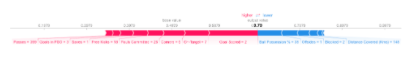
How do you interpret this?
We predicted 0.7, whereas the base_value is 0.4979. Feature values causing increased predictions are in pink, and their visual size shows the magnitude of the feature's effect. Feature values decreasing the prediction are in blue. The biggest impact comes from Goal Scored being 2. Though the ball possession value has a meaningful effect decreasing the prediction.
If you subtract the length of the blue bars from the length of the pink bars, it equals the distance from the base value to the output.
There is some complexity to the technique, to ensure that the baseline plus the sum of individual effects adds up to the prediction (which isn't as straightforward as it sounds). We won't go into that detail here, since it isn't critical for using the technique. This blog post has a longer theoretical explanation.

Comment interprétez-vous cela ?

Nous avions prévu 0,7, alors que la valeur_de_base est de 0,4979. Les valeurs des caractéristiques qui entraînent une augmentation des prédictions sont en rose, et leur taille visuelle montre l'ampleur de l'effet de la caractéristique. Les valeurs des éléments qui diminuent la prédiction sont en bleu. L'impact le plus important vient du fait que l'objectif marqué est de 2. Bien que la valeur de possession du ballon ait un effet significatif en diminuant la prédiction.

Si vous soustrayez la longueur des barres bleues de la longueur des barres roses, cela équivaut à la distance entre la valeur de base et la sortie.

La technique est assez complexe pour que la ligne de base plus la somme des effets individuels s'additionnent pour donner la prédiction (ce qui n'est pas aussi simple qu'il n'y paraît). Nous n'entrerons pas dans les détails ici, car ce n'est pas essentiel pour l'utilisation de la technique. Cet article de blog a une explication théorique plus longue.

Code to Calculate SHAP Values
We calculate SHAP values using the wonderful Shap library.
For this example, we'll reuse the model you've already seen with the Soccer data.
import pandas as pd
from sklearn.model_selection import train_test_split
from sklearn.ensemble import RandomForestClassifier

data = pd.read_csv('../input/fifa-2018-match-statistics/FIFA 2018 Statistics.csv')
y = (data['Man of the Match'] == "Yes") # Convert from string "Yes"/"No" to binary
feature_names = [i for i in data.columns if data[i].dtype in [np.int64, np.int64]]
X = data[feature_names]
train_X, val_X, train_y, val_y = train_test_split(X, y, random_state=1)
my_model = RandomForestClassifier(random_state=0).fit(train_X, train_y)

We will look at SHAP values for a single row of the dataset (we arbitrarily chose row 5). For context, we'll look at the raw predictions before looking at the SHAP values.

Nous allons examiner les valeurs SHAP pour une seule ligne de l'ensemble de données (nous avons arbitrairement choisi la ligne 5). Pour le contexte, nous examinerons les prédictions brutes avant d'examiner les valeurs SHAP.

row_to_show = 5
data_for_prediction = val_X.iloc[row_to_show] # use 1 row of data here. Could use multiple rows if desired
data_for_prediction_array = data_for_prediction.values.reshape(1, -1)

my_model.predict_proba(data_for_prediction_array)
Out[2]:
array([[0.29, 0.71]])
The team is 70% likely to have a player win the award.
Now, we'll move onto the code to get SHAP values for that single prediction.

L'équipe a 70 % de chances de voir un joueur remporter le prix.

Maintenant, nous allons passer au code pour obtenir les valeurs SHAP pour cette seule prédiction.

import shap # package used to calculate Shap values

# Create object that can calculate shap values
explainer = shap.TreeExplainer(my_model)

# Calculate Shap values
shap_values = explainer.shap_values(data_for_prediction)
The shap_values object above is a list with two arrays. The first array is the SHAP values for a negative outcome (don't win the award), and the second array is the list of SHAP values for the positive outcome (wins the award). We typically think about predictions in terms of the prediction of a positive outcome, so we'll pull out SHAP values for positive outcomes (pulling out shap_values[1]).
It's cumbersome to review raw arrays, but the shap package has a nice way to visualize the results.

L'objet shap_values ci-dessus est une liste avec deux tableaux. Le premier tableau est la liste des valeurs SHAP pour un résultat négatif (ne gagne pas le prix), et le second tableau est la liste des valeurs SHAP pour un résultat positif (gagne le prix). Nous considérons généralement les prédictions en termes de prédiction d'un résultat positif, nous allons donc extraire les valeurs SHAP pour les résultats positifs (en extrayant shap_values[1]).

Il est difficile d'examiner des tableaux bruts, mais le module SHAP permet de visualiser les résultats.
shap.initjs()
shap.force_plot(explainer.expected_value[1], shap_values[1], data_for_prediction)
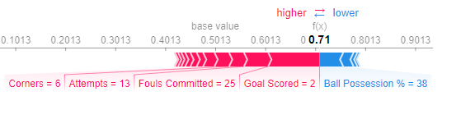
If you look carefully at the code where we created the SHAP values, you'll notice we reference Trees in shap.TreeExplainer(my_model). But the SHAP package has explainers for every type of model.
- shap.DeepExplainer works with Deep Learning models.
- shap.KernelExplainer works with all models, though it is slower than other Explainers and it offers an approximation rather than exact Shap values.
Here is an example using KernelExplainer to get similar results. The results aren't identical because KernelExplainer gives an approximate result. But the results tell the same story.

Si vous regardez attentivement le code dans lequel nous avons créé les valeurs SHAP, vous remarquerez que nous faisons référence aux arbres dans shap.TreeExplainer(my_model). Mais le paquet SHAP contient des explications pour chaque type de modèle.

shap.DeepExplainer fonctionne avec les modèles Deep Learning.
shap.KernelExplainer fonctionne avec tous les modèles, bien qu'il soit plus lent que les autres Explorateurs et qu'il offre une approximation plutôt que des valeurs de Shap exactes.
Voici un exemple d'utilisation de KernelExplainer pour obtenir des résultats similaires. Les résultats ne sont pas identiques car KernelExplainer donne un résultat approximatif. Mais les résultats racontent la même histoire.

# use Kernel SHAP to explain test set predictions
k_explainer = shap.KernelExplainer(my_model.predict_proba, train_X)
k_shap_values = k_explainer.shap_values(data_for_prediction)
shap.force_plot(k_explainer.expected_value[1], k_shap_values[1], data_for_prediction)

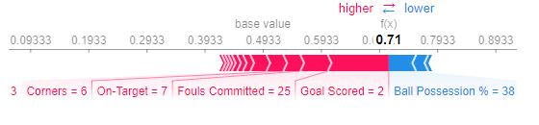

4.2 EXERCICES

Set Up
At this point, you have enough tools to put together compelling solutions to real-world problems. You will ned to pick the right techniques for each part of the following data science scenario. Along the way, you'll use SHAP values along with your other insights tools.
The questions below give you feedback on your work by using some checking code. Run the following cell to set up our feedback system.

The Scenario
A hospital has struggled with "readmissions," where they release a patient before the patient has recovered enough, and the patient returns with health complications.
The hospital wants your help identifying patients at highest risk of being readmitted. Doctors (rather than your model) will make the final decision about when to release each patient; but they hope your model will highlight issues the doctors should consider when releasing a patient.
The hospital has given you relevant patient medical information. Here is a list of columns in the data:

Le scénario
Un hôpital s'est battu avec les "réadmissions", où ils libèrent un patient avant que celui-ci n'ait suffisamment récupéré, et le patient revient avec des complications de santé.

L'hôpital souhaite que vous l'aidiez à identifier les patients qui risquent le plus d'être réadmis. Ce sont les médecins (plutôt que votre modèle) qui prendront la décision finale quant au moment de libérer chaque patient ; mais ils espèrent que votre modèle mettra en évidence les questions que les médecins doivent prendre en compte lorsqu'ils libèrent un patient.

L'hôpital vous a fourni des informations médicales pertinentes sur le patient. Voici une liste des colonnes de ces données :

import pandas as pd
data = pd.read_csv('../input/hospital-readmissions/train.csv')
data.columns

Here are some quick hints at interpreting the field names:
- Your prediction target is readmitted
- Columns with the word diag indicate the diagnostic code of the illness or illnesses the patient was admitted with. For example, diag_1_428 means the doctor said their first illness diagnosis is number "428". What illness does 428 correspond to? You could look it up in a codebook, but without more medical background it wouldn't mean anything to you anyway.
- A column names like glimepiride_No mean the patient did not have the medicine glimepiride. If this feature had a value of False, then the patient did take the drug glimepiride
- Features whose names begin with medical_specialty describe the specialty of the doctor seeing the patient. The values in these fields are all True or False.

Voici quelques conseils rapides pour interpréter les noms des champs :

Votre cible de prédiction est réadmise
Les colonnes contenant le mot "diag" indiquent le code de diagnostic de la ou des maladies pour lesquelles le patient a été admis. Par exemple, diag_1_428 signifie que le médecin a dit que le premier diagnostic de maladie est le numéro "428". À quelle maladie correspond le numéro 428 ? Vous pourriez le chercher dans un livre de codes, mais sans plus de connaissances médicales, cela ne vous dirait rien de toute façon.
Le nom d'une colonne comme glimepiride_No signifie que le patient n'avait pas le médicament glimepiride. Si cette caractéristique avait une valeur de Faux, alors le patient a bien pris le médicament glimepiride
Les caractéristiques dont le nom commence par medical_specialty décrivent la spécialité du médecin qui voit le patient. Les valeurs de ces champs sont toutes Vrai ou Faux.

Your Code Library
As you write code to work through this scenario, these code snippets from previous tutorials may be useful. You'll still need to modify them, but we've copied them here to save you from having to look them up.
Calculate and show permutation importance:

Votre bibliothèque de codes
Au moment où vous écrivez le code pour travailler sur ce scénario, ces extraits de code des didacticiels précédents peuvent être utiles. Vous devrez encore les modifier, mais nous les avons copiés ici pour vous éviter d'avoir à les consulter.

Calculer et montrer l'importance de la permutation :

import eli5
from eli5.sklearn import PermutationImportance

perm = PermutationImportance(my_model, random_state=1).fit(val_X, val_y)
eli5.show_weights(perm, feature_names = val_X.columns.tolist())

Calculate and show partial dependence plot:

Calculer et afficher le diagramme de dépendance partielle :

from matplotlib import pyplot as plt
from pdpbox import pdp, get_dataset, info_plots

# Create the data that we will plot
pdp_goals = pdp.pdp_isolate(model=my_model, dataset=val_X, model_features=feature_names, feature='Goal Scored')

# plot it
pdp.pdp_plot(pdp_goals, 'Goal Scored')
plt.show()

Calculate and show Shap Values for One Prediction:
Calculer et afficher les valeurs de forme pour une prédiction :

import shap # package used to calculate Shap values

data_for_prediction = val_X.iloc[0,:] # use 1 row of data here. Could use multiple rows if desired

# Create object that can calculate shap values
explainer = shap.TreeExplainer(my_model)
shap_values = explainer.shap_values(data_for_prediction)
shap.initjs()
shap.force_plot(explainer.expected_value[0], shap_values[0], data_for_prediction)

Step 1
You have built a simple model, but the doctors say they don't know how to evaluate a model, and they'd like you to show them some evidence the model is doing something in line with their medical intuition. Create any graphics or tables that will show them a quick overview of what the model is doing?
They are very busy. So they want you to condense your model overview into just 1 or 2 graphics, rather than a long string of graphics.
We'll start after the point where you've built a basic model. Just run the following cell to build the model called my_model.
Étape 1
Vous avez construit un modèle simple, mais les médecins disent qu'ils ne savent pas comment évaluer un modèle, et ils aimeraient que vous leur montriez des preuves que le modèle fait quelque chose en accord avec leur intuition médicale. Créez des graphiques ou des tableaux qui leur donneront un aperçu rapide de ce que fait le modèle ?

Ils sont très occupés. Ils veulent donc que vous condensiez votre aperçu du modèle en un ou deux graphiques seulement, plutôt qu'une longue série de graphiques.

Nous commencerons après le point où vous avez construit un modèle de base. Il suffit de lancer la cellule suivante pour construire le modèle appelé my_model.

import pandas as pd
from sklearn.ensemble import RandomForestClassifier
from sklearn.model_selection import train_test_split

data = pd.read_csv('../input/hospital-readmissions/train.csv')

y = data.readmitted

base_features = [c for c in data.columns if c != "readmitted"]

X = data[base_features]

train_X, val_X, train_y, val_y = train_test_split(X, y, random_state=1)
my_model = RandomForestClassifier(n_estimators=30, random_state=1).fit(train_X, train_y)

Now use the following cell to create the materials for the doctors.

# Your code here
# Use permutation importance as a succinct model summary
# A measure of model performance on validation data would be useful here too

import eli5
from eli5.sklearn import PermutationImportance

perm = PermutationImportance(my_model, random_state=1).fit(val_X, val_y)
eli5.show_weights(perm, feature_names = val_X.columns.tolist())

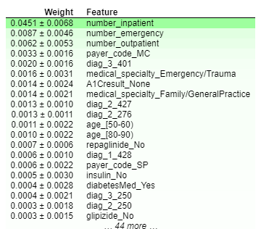

If you'd like to discuss your approach or see what others have done, we have a discussion forum here.

Step 2
It appears number_inpatient is a really important feature. The doctors would like to know more about that. Create a graph for them that shows how num_inpatient affects the model's predictions.
Étape 2
Il semble que number_inpatient soit une caractéristique très importante. Les médecins aimeraient en savoir plus à ce sujet. Créez pour eux un graphique qui montre comment num_inpatient affecte les prédictions du modèle.

# PDP for number_inpatient feature

from matplotlib import pyplot as plt
from pdpbox import pdp, get_dataset, info_plots

feature_name = 'number_inpatient'
# Create the data that we will plot
my_pdp = pdp.pdp_isolate(model=my_model, dataset=val_X, model_features=val_X.columns, feature=feature_name)

# plot it
pdp.pdp_plot(my_pdp, feature_name)
plt.show()

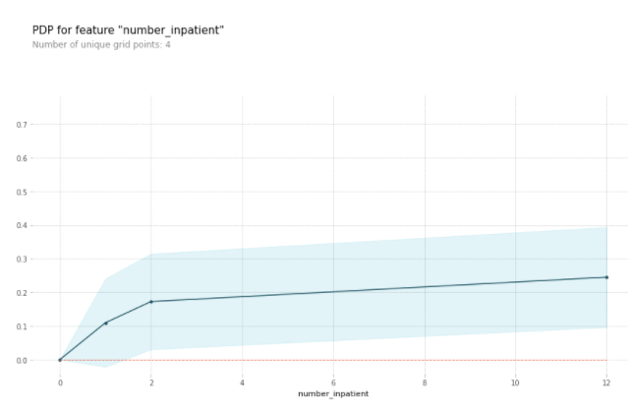
Solution:

# PDP for number_inpatient feature

from matplotlib import pyplot as plt
from pdpbox import pdp, get_dataset, info_plots

feature_name = 'number_inpatient'
# Create the data that we will plot
my_pdp = pdp.pdp_isolate(model=my_model, dataset=val_X, model_features=val_X.columns, feature=feature_name)

# plot it
pdp.pdp_plot(my_pdp, feature_name)
plt.show()

Step 3
The doctors think it's a good sign that increasing the number of inpatient procedures leads to increased predictions. But they can't tell from this plot whether that change in the plot is big or small. They'd like you to create something similar for time_in_hospital to see how that compares.

Étape 3
Les médecins pensent que c'est un bon signe que l'augmentation du nombre de procédures d'hospitalisation entraîne une augmentation des prévisions. Mais ils ne peuvent pas dire à partir de ce graphique si ce changement est important ou non. Ils aimeraient que vous créiez quelque chose de similaire pour le temps passé à l'hôpital afin de voir comment cela se compare.

Solution:
The results are very different. Specifically time in hospital has a much smaller effect. Code below:

Les résultats sont très différents. Plus précisément, le temps passé à l'hôpital a un effet beaucoup plus faible. Code ci-dessous :

from matplotlib import pyplot as plt
from pdpbox import pdp, get_dataset, info_plots

feature_name = 'time_in_hospital'
# Create the data that we will plot
my_pdp = pdp.pdp_isolate(model=my_model, dataset=val_X, model_features=val_X.columns, feature=feature_name)

# plot it
pdp.pdp_plot(my_pdp, feature_name)
plt.show()
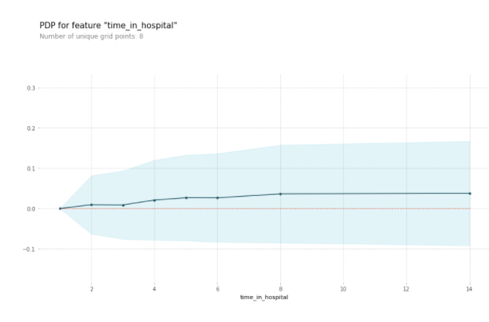

Step 4
Woah! It seems like time_in_hospital doesn't matter at all. The difference between the lowest value on the partial dependence plot and the highest value is about 5%.
If that is what your model concluded, the doctors will believe it. But it seems so low. Could the data be wrong, or is your model doing something more complex than they expect?
They'd like you to show them the raw readmission rate for each value of time_in_hospital to see how it compares to the partial dependence plot.
- Make that plot.
- Are the results similar or different?

Étape 4
Woah ! Il semble que le temps passé à l'hôpital n'ait aucune importance. La différence entre la valeur la plus basse sur le graphique de la dépendance partielle et la valeur la plus élevée est d'environ 5%.

Si c'est ce que votre modèle a conclu, les médecins le croiront. Mais cela semble si faible. Les données peuvent-elles être erronées, ou votre modèle fait-il quelque chose de plus complexe que ce qu'ils attendent ?

Ils aimeraient que vous leur montriez le taux de réadmission brut pour chaque valeur de temps_dans_l'hôpital pour voir comment il se compare au graphique de la dépendance partielle.

Faites ce graphique.
Les résultats sont-ils similaires ou différents ?

Hint: This requires a groupby (from pandas) on the raw data, rather than using a model

Solution:

# A simple pandas groupby showing the average readmission rate for each time_in_hospital.

# Do concat to keep validation data separate, rather than using all original data
all_train = pd.concat([train_X, train_y], axis=1)

all_train.groupby(['time_in_hospital']).mean().readmitted.plot()
plt.show()
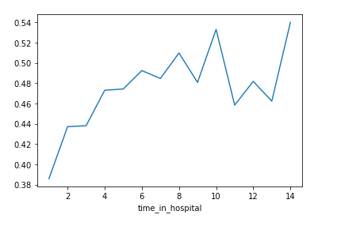
Hint: This requires a groupby (from pandas) on the raw data, rather than using a model

Solution:

# A simple pandas groupby showing the average readmission rate for each time_in_hospital.

# Do concat to keep validation data separate, rather than using all original data
all_train = pd.concat([train_X, train_y], axis=1)

all_train.groupby(['time_in_hospital']).mean().readmitted.plot()
plt.show()

Step 5
Now the doctors are convinced you have the right data, and the model overview looked reasonable. It's time to turn this into a finished product they can use. Specifically, the hospital wants you to create a function patient_risk_factors that does the following
- Takes a single row with patient data (of the same format you as your raw data)
- Creates a visualization showing what features of that patient increased their risk of readmission, what features decreased it, and how much those features mattered.
It's not important to show every feature with every miniscule impact on the readmission risk. It's fine to focus on only the most important features for that patient.

Étape 5
Les médecins sont maintenant convaincus que vous disposez des bonnes données, et la vue d'ensemble du modèle semblait raisonnable. Il est temps de transformer cela en un produit fini qu'ils pourront utiliser. Plus précisément, l'hôpital souhaite que vous créiez une fonction "facteurs de risque du patient" qui

Prend une seule rangée avec les données des patients (du même format que vos données brutes)
Crée une visualisation montrant quelles caractéristiques de ce patient ont augmenté son risque de réadmission, quelles caractéristiques l'ont diminué et dans quelle mesure ces caractéristiques ont eu de l'importance.
Il n'est pas important de montrer chaque caractéristique ayant un impact minime sur le risque de réadmission. Il est bon de se concentrer uniquement sur les caractéristiques les plus importantes pour ce patient.

Hint: Here's the time to use SHAP values

Solution:

# Use SHAP values to show the effect of each feature of a given patient

import shap # package used to calculate Shap values

sample_data_for_prediction = val_X.iloc[0].astype(float) # to test function

def patient_risk_factors(model, patient_data):
# Create object that can calculate shap values
explainer = shap.TreeExplainer(model)
shap_values = explainer.shap_values(patient_data)
shap.initjs()
return shap.force_plot(explainer.expected_value[1], shap_values[1], patient_data)
patient_risk_factors(my_model, sample_data_for_prediction)

5. Advanced Uses of SHAP Values

5.1 COURS

Recap
We started by learning about permutation importance and partial dependence plots for an overview of what the model has learned.
We then learned about SHAP values to break down the components of individual predictions.
Now we'll expand on SHAP values, seeing how aggregating many SHAP values can give more detailed alternatives to permutation importance and partial dependence plots.

Nous avons commencé par nous renseigner sur l'importance de la permutation et les tracés de dépendance partielle pour avoir une vue d'ensemble de ce que le modèle a appris.
Nous nous sommes ensuite renseignés sur les valeurs SHAP pour décomposer les composantes des prévisions individuelles.
Nous allons maintenant nous pencher sur les valeurs SHAP, pour voir comment l'agrégation de nombreuses valeurs SHAP peut donner des alternatives plus détaillées aux diagrammes d'importance de la permutation et de dépendance partielle.

SHAP Values Review
Shap values show how much a given feature changed our prediction (compared to if we made that prediction at some baseline value of that feature).
For example, consider an ultra-simple model:
y=4∗x1+2∗x2y=4∗x1+2∗x2
If x1x1 takes the value 2, instead of a baseline value of 0, then our SHAP value for x1x1 would be 8 (from 4 times 2).
These are harder to calculate with the sophisticated models we use in practice. But through some algorithmic cleverness, Shap values allow us to decompose any prediction into the sum of effects of each feature value, yielding a graph like this:
Les valeurs de forme indiquent dans quelle mesure une caractéristique donnée a modifié notre prévision (par rapport à une valeur de base de cette caractéristique).
Par exemple, considérons un modèle ultra simple :
y=4∗x1+2∗x2
Si x1 prend la valeur 2, au lieu d'une valeur de base de 0, alors notre valeur SHAP pour x1 serait de 8 (de 4 fois 2).
Ces valeurs sont plus difficiles à calculer avec les modèles sophistiqués que nous utilisons dans la pratique. Mais grâce à une certaine habileté algorithmique, les valeurs de Shap nous permettent de décomposer toute prédiction en la somme des effets de chaque valeur de caractéristique, ce qui donne un graphique comme celui-ci :
In addition to this nice breakdown for each prediction, the Shap library offers great visualizations of groups of Shap values. We will focus on two of these visualizations. These visualizations have conceptual similarities to permutation importance and partial dependence plots. So multiple threads from the previous exercises will come together here.

En plus de cette belle ventilation pour chaque prédiction, la bibliothèque Shap offre de superbes visualisations de groupes de valeurs Shap. Nous allons nous concentrer sur deux de ces visualisations. Ces visualisations présentent des similitudes conceptuelles avec les diagrammes d'importance de permutation et de dépendance partielle. Ainsi, plusieurs fils des exercices précédents seront réunis ici.

Summary Plots
Permutation importance is great because it created simple numeric measures to see which features mattered to a model. This helped us make comparisons between features easily, and you can present the resulting graphs to non-technical audiences.
But it doesn't tell you how each features matter. If a feature has medium permutation importance, that could mean it has
- a large effect for a few predictions, but no effect in general, or
- a medium effect for all predictions.
SHAP summary plots give us a birds-eye view of feature importance and what is driving it. We'll walk through an example plot for the soccer data:

L'importance de la permutation est grande car elle a créé des mesures numériques simples pour voir quelles caractéristiques sont importantes pour un modèle. Cela nous a permis de faire facilement des comparaisons entre les caractéristiques et vous pouvez présenter les graphiques résultants à un public non technique.

Mais cela ne vous dit pas en quoi chaque caractéristique est importante. Si une caractéristique a une importance de permutation moyenne, cela pourrait signifier qu'elle a

un effet important pour quelques prédictions, mais aucun effet en général, ou
un effet moyen pour toutes les prévisions.
Les graphiques récapitulatifs de SHAP nous donnent une vue d'ensemble de l'importance des caractéristiques et de ce qui les motive. Nous allons passer en revue un exemple de graphique pour les données sur le football :

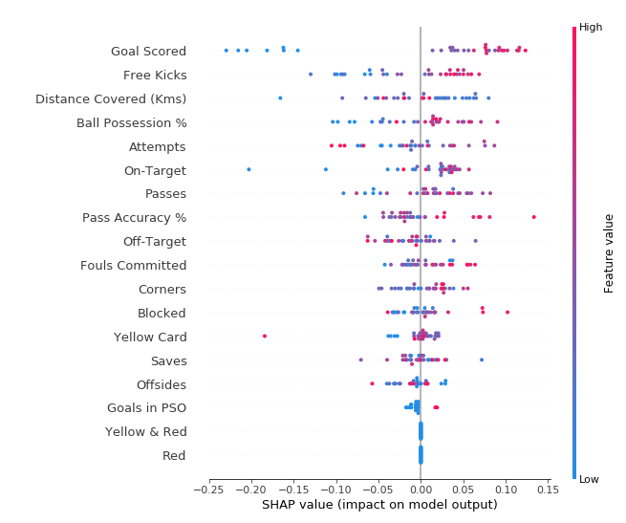
This plot is made of many dots. Each dot has three characteristics:
- Vertical location shows what feature it is depicting
- Color shows whether that feature was high or low for that row of the dataset
- Horizontal location shows whether the effect of that value caused a higher or lower prediction.
For example, the point in the upper left was for a team that scored few goals, reducing the prediction by 0.25.
Some things you should be able to easily pick out:
- The model ignored the Red and Yellow & Red features.
- Usually Yellow Card doesn't affect the prediction, but there is an extreme case where a high value caused a much lower prediction.
- High values of Goal scored caused higher predictions, and low values caused low predictions
If you look for long enough, there's a lot of information in this graph. You'll face some questions to test how you read them in the exercise.

Cette intrigue est faite de nombreux points. Chaque point a trois caractéristiques :

La position verticale indique la caractéristique qu'il représente
La couleur indique si cette caractéristique était élevée ou faible pour cette ligne de l'ensemble de données
La localisation horizontale montre si l'effet de cette valeur a entraîné une prédiction plus ou moins élevée.
Par exemple, le point en haut à gauche était pour une équipe qui a marqué peu de buts, réduisant la prédiction de 0,25.

Vous devriez pouvoir choisir facilement certains éléments :

Le modèle a ignoré les caractéristiques Rouge et Jaune & Rouge.
En général, le carton jaune n'affecte pas la prédiction, mais il existe un cas extrême où une valeur élevée a entraîné une prédiction beaucoup plus faible.
Des valeurs élevées de But marqué ont entraîné des prédictions plus élevées, et des valeurs faibles ont entraîné des prédictions faibles
Si vous cherchez assez longtemps, vous trouverez beaucoup d'informations dans ce graphique. Vous devrez répondre à quelques questions pour tester votre lecture dans l'exercice.

Summary Plots in Code
You have already seen the code to load the soccer/football data:
import pandas as pd
from sklearn.model_selection import train_test_split
from sklearn.ensemble import RandomForestClassifier

data = pd.read_csv('../input/fifa-2018-match-statistics/FIFA 2018 Statistics.csv')
y = (data['Man of the Match'] == "Yes") # Convert from string "Yes"/"No" to binary
feature_names = [i for i in data.columns if data[i].dtype in [np.int64, np.int64]]
X = data[feature_names]
train_X, val_X, train_y, val_y = train_test_split(X, y, random_state=1)
my_model = RandomForestClassifier(random_state=0).fit(train_X, train_y)
We get the SHAP values for all validation data with the following code. It is short enough that we explain it in the comments.
In [2]:
import shap # package used to calculate Shap values

# Create object that can calculate shap values
explainer = shap.TreeExplainer(my_model)

# calculate shap values. This is what we will plot.
# Calculate shap_values for all of val_X rather than a single row, to have more data for plot.
shap_values = explainer.shap_values(val_X)

# Make plot. Index of [1] is explained in text below.
shap.summary_plot(shap_values[1], val_X)
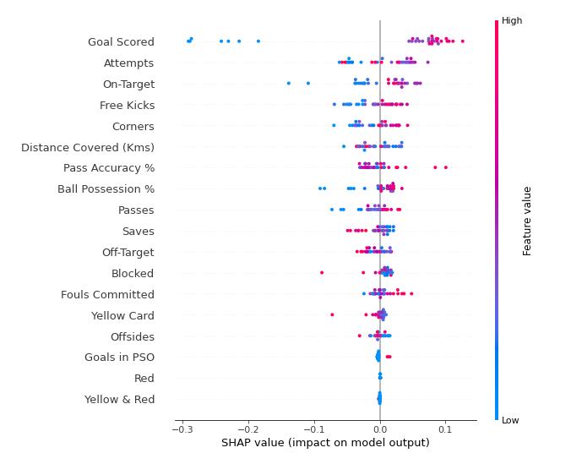
The code isn't too complex. But there are a few caveats.
- When plotting, we call shap_values[1]. For classification problems, there is a separate array of SHAP values for each possible outcome. In this case, we index in to get the SHAP values for the prediction of "True".
- Calculating SHAP values can be slow. It isn't a problem here, because this dataset is small. But you'll want to be careful when running these to plot with reasonably sized datasets. The exception is when using an xgboost model, which SHAP has some optimizations for and which is thus much faster.
This provides a great overview of the model, but we might want to delve into a single feature. That's where SHAP dependence contribution plots come into play.

Le code n'est pas trop complexe. Mais il y a quelques réserves.

Lors du traçage, nous appelons les valeurs de forme [1]. Pour les problèmes de classification, il existe un tableau séparé de valeurs SHAP pour chaque résultat possible. Dans ce cas, nous indexons pour obtenir les valeurs SHAP pour la prédiction de "True".
Le calcul des valeurs SHAP peut être lent. Ce n'est pas un problème ici, car cet ensemble de données est petit. Mais vous devrez être prudent lorsque vous les utiliserez pour tracer des graphiques avec des ensembles de données de taille raisonnable. L'exception est l'utilisation d'un modèle xgboost, pour lequel SHAP a quelques optimisations et qui est donc beaucoup plus rapide.
Cela donne une bonne vue d'ensemble du modèle, mais nous pourrions vouloir approfondir une seule caractéristique. C'est là qu'entrent en jeu les diagrammes de contribution à la dépendance de SHAP.

SHAP Dependence Contribution Plots
We've previously used Partial Dependence Plots to show how a single feature impacts predictions. These are insightful and relevant for many real-world use cases. Plus, with a little effort, they can be explained to a non-technical audience.
But there's a lot they don't show. For instance, what is the distribution of effects? Is the effect of having a certain value pretty constant, or does it vary a lot depending on the values of other feaures. SHAP dependence contribution plots provide a similar insight to PDP's, but they add a lot more detail.

Nous avons déjà utilisé des diagrammes de dépendance partielle pour montrer l'impact d'une caractéristique unique sur les prévisions. Ces graphiques sont perspicaces et pertinents pour de nombreux cas d'utilisation dans le monde réel. De plus, avec un peu d'effort, elles peuvent être expliquées à un public non technique.

Mais il y a beaucoup de choses qu'elles ne montrent pas. Par exemple, quelle est la répartition des effets ? L'effet d'avoir une certaine valeur est-il assez constant, ou varie-t-il beaucoup en fonction des valeurs d'autres éléments ? Les diagrammes de contribution à la dépendance des SHAP fournissent un aperçu similaire à celui des PDP, mais ils ajoutent beaucoup plus de détails.

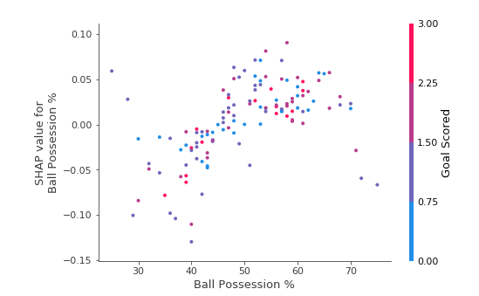
Start by focusing on the shape, and we'll come back to color in a minute. Each dot represents a row of the data. The horizontal location is the actual value from the dataset, and the vertical location shows what having that value did to the prediction. The fact this slopes upward says that the more you possess the ball, the higher the model's prediction is for winning the Man of the Match award.
The spread suggests that other features must interact with Ball Possession %. For example, here we have highlighted two points with similar ball possession values. That value caused one prediction to increase, and it caused the other prediction to decrease.

Commencez par vous concentrer sur la forme, et nous reviendrons sur la couleur dans une minute. Chaque point représente une ligne de données. L'emplacement horizontal est la valeur réelle de l'ensemble de données, et l'emplacement vertical montre ce que le fait d'avoir cette valeur a fait à la prédiction. Le fait que cette position soit ascendante indique que plus vous possédez la balle, plus la prédiction du modèle est élevée pour gagner le prix de l'homme du match.

L'écart suggère que d'autres caractéristiques doivent interagir avec le pourcentage de possession de la balle. Par exemple, nous avons ici mis en évidence deux points ayant des valeurs de possession de balle similaires. Cette valeur a fait augmenter une prédiction et a fait diminuer l'autre prédiction.

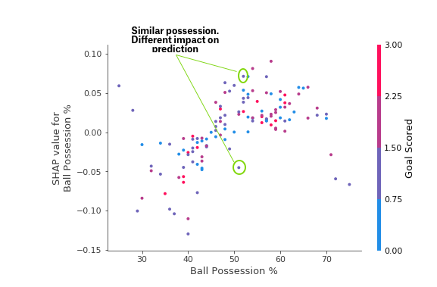
For comparison, a simple linear regression would produce plots that are perfect lines, without this spread.
This suggests we delve into the interactions, and the plots include color coding to help do that. While the primary trend is upward, you can visually inspect whether that varies by dot color.
Consider the following very narrow example for concreteness.

À titre de comparaison, une simple régression linéaire produirait des tracés qui sont des lignes parfaites, sans cet écart.

Cela suggère d'étudier les interactions, et les graphiques comprennent un code couleur pour y parvenir. Si la tendance principale est à la hausse, vous pouvez vérifier visuellement si elle varie en fonction de la couleur des points.

Considérons l'exemple très étroit suivant pour le concret.

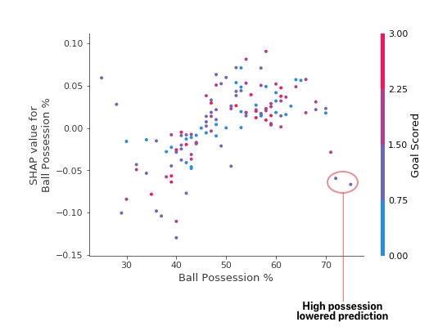
These two points stand out spatially as being far away from the upward trend. They are both colored purple, indicating the team scored one goal. You can interpret this to say In general, having the ball increases a team's chance of having their player win the award. But if they only score one goal, that trend reverses and the award judges may penalize them for having the ball so much if they score that little.
Outside of those few outliers, the interaction indicated by color isn't very dramatic here. But sometimes it will jump out at you.

Ces deux points se distinguent spatialement comme étant éloignés de la tendance à la hausse. Ils sont tous deux de couleur violette, ce qui indique que l'équipe a marqué un but. Vous pouvez interpréter cela comme suit En général, le fait d'avoir le ballon augmente les chances d'une équipe de voir son joueur remporter le prix. Mais s'ils ne marquent qu'un seul but, la tendance s'inverse et les juges de la récompense peuvent les pénaliser pour avoir autant le ballon s'ils marquent si peu.

En dehors de ces quelques valeurs aberrantes, l'interaction indiquée par la couleur n'est pas très spectaculaire ici. Mais parfois, elle vous sautera aux yeux.

Dependence Contribution Plots in Code
We get the dependence contribution plot with the following code. The only line that's different from the summary_plot is the last line.
Nous obtenons le tracé de la contribution de dépendance avec le code suivant. La seule ligne qui diffère de la parcelle summary_plot est la dernière ligne.
import shap # package used to calculate Shap values

# Create object that can calculate shap values
explainer = shap.TreeExplainer(my_model)

# calculate shap values. This is what we will plot.
shap_values = explainer.shap_values(X)

# make plot.
shap.dependence_plot('Ball Possession %', shap_values[1], X, interaction_index="Goal Scored")
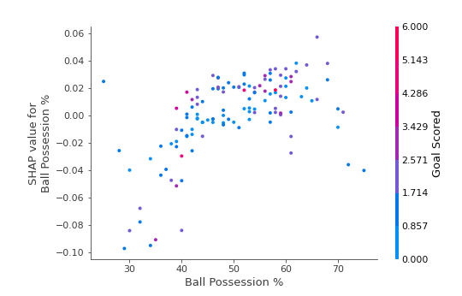
If you don't supply an argument for interaction_index, Shapley uses some logic to pick one that may be interesting.
This didn't require writing a lot of code. But the trick with these techniques is in thinking critically about the results rather than writing code itself.

Si vous ne fournissez pas d'argument pour interaction_index, Shapley utilise une certaine logique pour en choisir un qui pourrait être intéressant.

Cela n'a pas nécessité l'écriture de beaucoup de code. Mais l'astuce de ces techniques consiste à réfléchir de manière critique aux résultats plutôt qu'à écrire le code lui-même.

5.2 EXERCICES

Set Up
We have again provided code to do the basic loading, review and model-building. Run the cell below to set everything up:

import numpy as np
import pandas as pd
from sklearn.ensemble import RandomForestRegressor
from sklearn.model_selection import train_test_split
import shap

import pandas as pd
from sklearn.ensemble import RandomForestClassifier
from sklearn.model_selection import train_test_split

data = pd.read_csv('../input/hospital-readmissions/train.csv')
y = data.readmitted
base_features = ['number_inpatient', 'num_medications', 'number_diagnoses', 'num_lab_procedures',
'num_procedures', 'time_in_hospital', 'number_outpatient', 'number_emergency',
'gender_Female', 'payer_code_?', 'medical_specialty_?', 'diag_1_428', 'diag_1_414',
'diabetesMed_Yes', 'A1Cresult_None']

# Some versions of shap package error when mixing bools and numerics
X = data[base_features].astype(float)

train_X, val_X, train_y, val_y = train_test_split(X, y, random_state=1)

# For speed, we will calculate shap values on smaller subset of the validation data
small_val_X = val_X.iloc[:150]
my_model = RandomForestClassifier(n_estimators=30, random_state=1).fit(train_X, train_y)

data.describe()
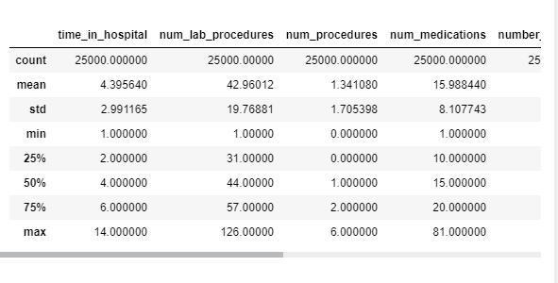

The first few questions require examining the distribution of effects for each feature, rather than just an average effect for each feature. Run the following cell for a summary plot of the shap_values for readmission. It will take about 20 seconds to run.

Les premières questions nécessitent d'examiner la distribution des effets pour chaque élément, plutôt que de se contenter d'un effet moyen pour chaque élément. Lancez la cellule suivante pour obtenir un graphique récapitulatif des valeurs de forme pour la réadmission. L'exécution prendra environ 20 secondes.

explainer = shap.TreeExplainer(my_model)
shap_values = explainer.shap_values(small_val_X)

shap.summary_plot(shap_values[1], small_val_X)
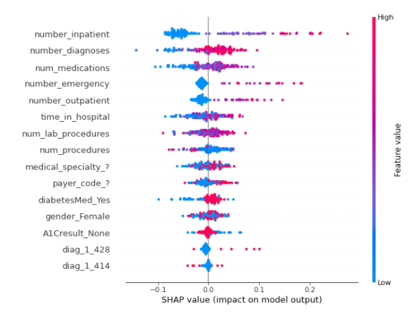

Question 1
Which of the following features has a bigger range of effects on predictions (i.e. larger difference between most positive and most negative effect)
- diag_1_428 or
- payer_code_?

Question 1
Laquelle des caractéristiques suivantes a le plus grand nombre d'effets sur les prévisions (c'est-à-dire une plus grande différence entre l'effet le plus positif et le plus négatif)

diag_1_428 ou
payer_code_ ?

# set following variable to 'diag_1_428' or 'payer_code_?'
feature_with_bigger_range_of_effects = 'diag_1_428'

Solution:

# the range of diag_1_428 is wider, largely due to the few points on the far right.
feature_with_bigger_range_of_effects = 'diag_1_428'

Question 2
Do you believe the range of effects sizes (distance between smallest effect and largest effect) is a good indication of which feature will have a higher permutation importance? Why or why not?
If the range of effect sizes measures something different from permutation importance: which is a better answer for the question "Which of these two features does the model say is more important for us to understand when discussing readmission risks in the population?"
Run the following line after you've decided your answer.

Question 2
Pensez-vous que la gamme des tailles d'effets (distance entre le plus petit effet et le plus grand effet) est une bonne indication de la caractéristique qui aura une plus grande importance de permutation ? Pourquoi ou pourquoi pas ?

Si la gamme des tailles d'effet mesure quelque chose de différent de l'importance de la permutation : quelle est la meilleure réponse à la question "Laquelle de ces deux caractéristiques le modèle dit-il qu'il est le plus important pour nous de comprendre lorsque nous discutons des risques de réadmission dans la population ?

Passez la ligne suivante après avoir décidé de votre réponse.

Solution: No. The width of the effects range is not a reasonable approximation to permutation importance. For that matter, the width of the range doesn't map well to any intuitive sense of "importance" because it can be determined by just a few outliers. However if all dots on the graph are widely spread from each other, that is a reasonable indication that permutation importance is high. Because the range of effects is so sensitive to outliers, permutation importance is a better measure of what's generally important to the model.

Solution : Non. La largeur de la gamme d'effets n'est pas une approximation raisonnable de l'importance de la permutation. D'ailleurs, la largeur de la plage ne correspond pas bien à un sens intuitif de l'"importance" car elle peut être déterminée par quelques valeurs aberrantes seulement. Cependant, si tous les points du graphique sont très éloignés les uns des autres, cela indique raisonnablement que l'importance de la permutation est élevée. La gamme des effets étant très sensible aux valeurs aberrantes, l'importance de la permutation est une meilleure mesure de ce qui est généralement important pour le modèle.

Question 3
Both diag_1_428 and payer_code_? are binary variables, taking values of 0 or 1.
From the graph, which do you think would typically have a bigger impact on predicted readmission risk:
- Changing diag_1_428 from 0 to 1
- Changing payer_code_? from 0 to 1
To save you scrolling, we have included a cell below to plot the graph again (this one runs quickly).

shap.summary_plot(shap_values[1], small_val_X)

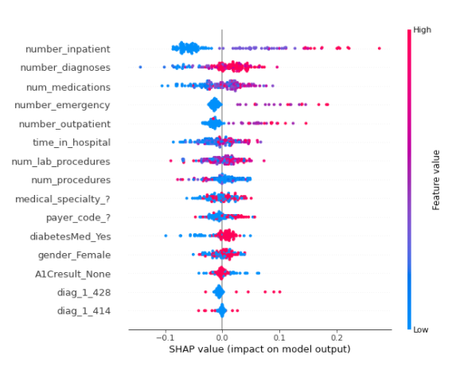

Solution: While most SHAP values of diag_1_428 are small, the few pink dots (high values of the variable, corresponding to people with that diagnosis) have large SHAP values. In other words, the pink dots for this variable are far from 0, and making someone have the higher (pink) value would increase their readmission risk significantly. In real-world terms, this diagnosis is rare, but poses a larger risk for people who have it. In contrast, payer_code_? has many values of both blue and pink, and both have SHAP values that differ meaningfully from 0. But changing payer_code_? from 0 (blue) to 1 (pink) is likely to have a smaller impact than changing diag_1_428.

Alors que la plupart des valeurs SHAP de diag_1_428 sont petites, les quelques points roses (valeurs élevées de la variable, correspondant à des personnes ayant ce diagnostic) ont de grandes valeurs SHAP. En d'autres termes, les points roses pour cette variable sont loin de 0, et le fait de faire en sorte qu'une personne ait la valeur la plus élevée (rose) augmenterait considérablement son risque de réadmission. Dans le monde réel, ce diagnostic est rare, mais représente un risque plus important pour les personnes qui en sont atteintes.
En revanche, payer_code_ ? a de nombreuses valeurs de bleu et de rose, et les deux ont des valeurs SHAP qui diffèrent significativement de 0. Mais changer payer_code_ ? de 0 (bleu) à 1 (rose) aura probablement un impact plus faible que changer diag_1_428.

Question 4
Some features (like number_inpatient) have reasonably clear separation between the blue and pink dots. Other variables like num_lab_procedures have blue and pink dots jumbled together, even though the SHAP values (or impacts on prediction) aren't all 0.
What do you think you learn from the fact that num_lab_procedures has blue and pink dots jumbled together? Once you have your answer, run the line below to verify your solution.

Certaines caractéristiques (comme number_inpatient) ont une séparation assez nette entre les points bleus et roses. D'autres variables comme num_lab_procedures ont des points bleus et roses mélangés, même si les valeurs SHAP (ou impacts sur la prédiction) ne sont pas toutes à 0.

Que pensez-vous apprendre du fait que num_lab_procedures comporte des points bleus et roses mélangés ? Une fois que vous avez votre réponse, exécutez la ligne ci-dessous pour vérifier votre solution.

Solution: The jumbling suggests that sometimes increasing that feature leads to higher predictions, and other times it leads to a lower prediction. Said another way, both high and low values of the feature can have both positive and negative effects on the prediction. The most likely explanation for this "jumbling" of effects is that the variable (in this case num_lab_procedures) has an interaction effect with other variables. For example, there may be some diagnoses for which it is good to have many lab procedures, and other diagnoses where suggests increased risk. We don't yet know what other feature is interacting with num_lab_procedures though we could investigate that with SHAP contribution dependence plots.

Solution : Le mélange suggère que parfois, l'augmentation de cette caractéristique entraîne des prévisions plus élevées, et d'autres fois, une prévision plus faible. Autrement dit, les valeurs élevées et faibles de la caractéristique peuvent avoir des effets positifs et négatifs sur la prédiction. L'explication la plus probable de ce "mélange" d'effets est que la variable (dans ce cas num_lab_procedures) a un effet d'interaction avec d'autres variables. Par exemple, il peut y avoir des diagnostics pour lesquels il est bon d'avoir de nombreuses procédures de laboratoire, et d'autres diagnostics qui suggèrent un risque accru. Nous ne savons pas encore quelle autre caractéristique interagit avec num_lab_procedures, mais nous pourrions l'étudier à l'aide des diagrammes de dépendance de la contribution du SHAP.

Question 5
Consider the following SHAP contribution dependence plot.
The x-axis shows feature_of_interest and the points are colored based on other_feature.

Is there an interaction between feature_of_interest and other_feature?
If so, does feature_of_interest have a more positive impact on predictions when other_feature is high or when other_feature is low?
Run the following code when you are ready for the answer.

Solution: First, recall that the SHAP vaue is an estimate of the impact of a given feature on the prediction. So, if the dots trend from upper left to lower right, that means low values of feature_of_interest cause higher predictions.
Returning to this graph:
feature_of_interest slopes downward for high values of other_feature. To see this, focus your eye on the pink dots (where other_feature is high) and imagine a best-fit line through those pink dots. It slopes down, suggesting that the prediction goes down as feature_of_interest increases.
Now focus your eye on the blue dots, and imagine a best fit line through those dots. It is generally pretty flat, possibly even curving up on the right side of the graph. So increasing feature_of_interest has a more positive impact on predictions when other_feature is high.

Solution : Tout d'abord, il faut rappeler que le SHAP vaue est une estimation de l'impact d'une caractéristique donnée sur la prévision. Ainsi, si les points ont une tendance de haut en bas à gauche, cela signifie que des valeurs faibles d'une caractéristique d'intérêt entraînent des prévisions plus élevées.

Revenons à ce graphique :

feature_of_interest est en pente descendante pour les valeurs élevées de other_feature. Pour le constater, concentrez-vous sur les points roses (là où other_feature est élevé) et imaginez une ligne de meilleure qualité à travers ces points roses. Cette ligne est en pente descendante, ce qui suggère que la prédiction diminue au fur et à mesure que la valeur de la caractéristique "d'intérêt" augmente.

Maintenant, concentrez-vous sur les points bleus et imaginez la ligne la mieux adaptée à travers ces points. Cette ligne est généralement assez plate, et peut même se courber vers le haut sur le côté droit du graphique. Ainsi, l'augmentation de la caractéristique d'intérêt a un impact plus positif sur les prévisions lorsque l'autre caractéristique est élevée.

Question 6
Review the summary plot for the readmission data by running the following cell:

Both num_medications and num_lab_procedures share that jumbling of pink and blue dots.
Aside from num_medications having effects of greater magnitude (both more positive and more negative), it's hard to see a meaningful difference between how these two features affect readmission risk. Create the SHAP dependence contribution plots for each variable, and describe what you think is different between how these two variables affect predictions.
As a reminder, here is the code you previously saw to create this type of plot.

shap.dependence_plot(feature_of_interest, shap_values[1], val_X)
And recall that your validation data is called small_val_X.

Les procédures num_medications et num_lab_procedures ont en commun ce mélange de points roses et bleus.

Outre le fait que num_medications a des effets plus importants (à la fois plus positifs et plus négatifs), il est difficile de voir une différence significative entre la manière dont ces deux caractéristiques affectent le risque de réadmission. Créez les diagrammes de contribution de dépendance SHAP pour chaque variable et décrivez ce qui, selon vous, est différent entre la façon dont ces deux variables affectent les prévisions.

Pour rappel, voici le code que vous avez vu précédemment pour créer ce type de graphique.

# Your code here
shap.dependence_plot('num_medications', shap_values[1], small_val_X)

shap.dependence_plot('num_lab_procedures', shap_values[1], small_val_X)

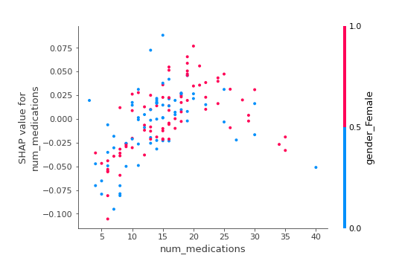
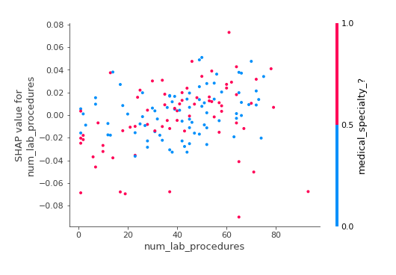
Solution: Here is the code:
shap.dependence_plot('num_lab_procedures', shap_values[1], small_val_X)
shap.dependence_plot('num_medications', shap_values[1], small_val_X)
. Loosely speaking, num_lab_procedures looks like a cloud with little disernible pattern. It does not slope steeply up nor down at any point. It's hard to say we've learned much from that plot. At the same time, the values are not all very close to 0. So the model seems to think this is a relevant feature. One potential next step would be to explore more by coloring it with different other features to search for an interaction.
On the other hand, num_medications clearly slopes up until a value of about 20, and then it turns back down. Without more medical background, this seems a surprising phenomenon... You could do some exploration to see whether these patients have unusual values for other features too. But a good next step would be to discuss this phenomenon with domain experts (in this case, the doctors).

En gros, num_lab_procedures ressemble à un nuage avec un petit motif disernible. Il ne présente aucune pente raide, ni vers le haut, ni vers le bas, en aucun point. Il est difficile de dire que nous avons beaucoup appris de cette intrigue. En même temps, les valeurs ne sont pas toutes très proches de 0. Le modèle semble donc penser que c'est une caractéristique pertinente. Une prochaine étape potentielle serait d'explorer davantage en le colorant avec différentes autres caractéristiques pour rechercher une interaction.

D'autre part, num_medications monte clairement jusqu'à une valeur d'environ 20, puis redescend. Sans plus d'antécédents médicaux, ce phénomène semble surprenant... Vous pourriez faire quelques recherches pour voir si ces patients ont des valeurs inhabituelles pour d'autres caractéristiques également. Mais une bonne étape suivante consisterait à discuter de ce phénomène avec des experts du domaine (dans ce cas, les médecins).

Congratulations
That's it! Machine learning models should not feel like black boxes any more, because you have the tools to inspect them and understand what they learn about the world.
This is an excellent skill for debugging models, building trust, and learning insights to make better decisions. These techniques have revolutionized how I do data science, and I hope they do the same for you.
Real data science involves an element of exploration. I hope you find an interesting dataset to try these techniques on (Kaggle has a lot of free datasets to try out). If you learn something interesting about the world, share your work in this forum. I'm excited to see what you do with your new skills.

Félicitations
C'est tout ! Les modèles d'apprentissage machine ne doivent plus ressembler à des boîtes noires, car vous avez les outils pour les inspecter et comprendre ce qu'ils apprennent sur le monde.

C'est une excellente compétence pour déboguer les modèles, établir la confiance et apprendre à prendre de meilleures décisions. Ces techniques ont révolutionné ma façon de faire de la science des données, et j'espère qu'elles feront de même pour vous.

La vraie science des données implique un élément d'exploration. J'espère que vous trouverez un ensemble de données intéressant pour essayer ces techniques (Kaggle a beaucoup d'ensembles de données gratuits à essayer). Si vous apprenez quelque chose d'intéressant sur le monde, partagez votre travail dans ce forum. Je suis impatient de voir ce que vous ferez de vos nouvelles compétences.

