Sommaire
Intro to SQL 3
1. Getting Starded With SQL and BigQuery 3
1.1 COURS 3
Introduction 3
Your first BigQuery commands 3
Table schema 5
Disclaimer 7
1.2 EXERCICES 8
Introduction 8
Exercises 8
1) Count tables in the dataset 8
2) Explore the table schema 8
3) Create a crime map 10
2. Select, From & WHere 12
2.1 COURS 12
Introduction 12
WHERE ... 12
SELECT ... FROM 13
Example: What are all the U.S. cities in the OpenAQ dataset? 13
Submitting the query to the dataset 14
More queries 15
Q&A: Notes on formatting 16
Question: What's up with the triple quotation marks (""")? 16
Question: Do you need to capitalize SELECT and FROM? 16
Working with big datasets 16
2.2 EXERCICES 19
Introduction 19
Exercises 20
1) Units of measurement 20
2) High air quality 21
3. Group by, having & count 24
3.1 COURS 24
Introduction 24
GROUP BY 24
COUNT() 25
GROUP BY 25
GROUP BY ... HAVING 26
Example: Which Hacker News comments generated the most discussion? 26
Aliasing and other improvements 28
Note on using GROUP BY 29
3.2 EXERCICES 31
Introduction 31
Exercises 31
1) Prolific commenters 31
2) Deleted comments 32
4. Order by 34
4.1 COURS 34
Introduction 34
ORDER BY 34
Dates 35
EXTRACT 35
Example: Which day of the week has the most fatal motor accidents? 36
4.2 EXERCICES 39
Introduction 39
Exercises 43
1) Government expenditure on education 43
2) Identify interesting codes to explore 44
5. As & With 47
5.1 COURS 47
Introduction 47
AS 47
WITH ... AS 48
Example: How many Bitcoin transactions are made per month? 49
5.2 EXERCICES 52
Introduction 52
Exercises 52
1) Find the data 52
2) Peek at the data 53
3) Determine when this data is from 53
4) Dive slightly deeper 55
5) Write the query 56
6. Joining Data 59
6.1 COURS 59
Introduction 59
Example 59
JOIN 62
Example: How many files are covered by each type of software license? 63
6.2 EXERCICES 66
Introduction 66
Exercises 66
1) Explore the data 66
2) Review relevant tables 67
3) Selecting the right questions 69
4) Your first join 70
5) Answer the question 72
6) Building a more generally useful service 73
Congratulations! 74

Intro to SQL
Learn SQL for working with databases, using Google BigQuery to scale to massive datasets.

1. Getting Starded With SQL and BigQuery

1.1 COURS

Introduction
Structured Query Language, or SQL, is the programming language used with databases, and it is an important skill for any data scientist. In this course, you'll build your SQL skills using BigQuery, a web service that lets you apply SQL to huge datasets.
In this lesson, you'll learn the basics of accessing and examining BigQuery datasets. After you have a handle on these basics, we'll come back to build your SQL skills.

Your first BigQuery commands
To use BigQuery, we'll import the Python package below:
In [1]:
from google.cloud import bigquery
The first step in the workflow is to create a Client object. As you'll soon see, this Client object will play a central role in retrieving information from BigQuery datasets.
In [2]:
# Create a "Client" object
client = bigquery.Client()
Using Kaggle's public dataset BigQuery integration.
We'll work with a dataset of posts on Hacker News, a website focusing on computer science and cybersecurity news.
In BigQuery, each dataset is contained in a corresponding project. In this case, our hacker_news dataset is contained in the bigquery-public-data project. To access the dataset,
- We begin by constructing a reference to the dataset with the dataset() method.
- Next, we use the get_dataset() method, along with the reference we just constructed, to fetch the dataset.
In [3]:
# Construct a reference to the "hacker_news" dataset
dataset_ref = client.dataset("hacker_news", project="bigquery-public-data")

# API request - fetch the dataset
dataset = client.get_dataset(dataset_ref)
Every dataset is just a collection of tables. You can think of a dataset as a spreadsheet file containing multiple tables, all composed of rows and columns.
We use the list_tables() method to list the tables in the dataset.
In [4]:
# List all the tables in the "hacker_news" dataset
tables = list(client.list_tables(dataset))

# Print names of all tables in the dataset (there are four!)
for table in tables:
print(table.table_id)
comments
full
full_201510
stories
Similar to how we fetched a dataset, we can fetch a table. In the code cell below, we fetch the full table in the hacker_news dataset.
In [5]:
# Construct a reference to the "full" table
table_ref = dataset_ref.table("full")

# API request - fetch the table
table = client.get_table(table_ref)
In the next section, you'll explore the contents of this table in more detail. For now, take the time to use the image below to consolidate what you've learned so far.

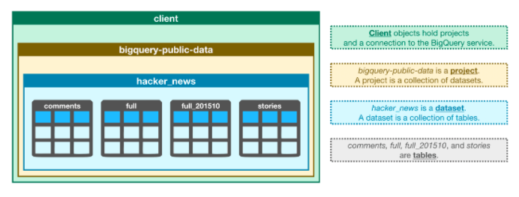
Table schema
The structure of a table is called its schema. We need to understand a table's schema to effectively pull out the data we want.
In this example, we'll investigate the full table that we fetched above.
In [6]:
# Print information on all the columns in the "full" table in the "hacker_news" dataset
table.schema
Out[6]:
[SchemaField('title', 'STRING', 'NULLABLE', 'Story title', ()),
SchemaField('url', 'STRING', 'NULLABLE', 'Story url', ()),
SchemaField('text', 'STRING', 'NULLABLE', 'Story or comment text', ()),
SchemaField('dead', 'BOOLEAN', 'NULLABLE', 'Is dead?', ()),
SchemaField('by', 'STRING', 'NULLABLE', "The username of the item's author.", ()),
SchemaField('score', 'INTEGER', 'NULLABLE', 'Story score', ()),
SchemaField('time', 'INTEGER', 'NULLABLE', 'Unix time', ()),
SchemaField('timestamp', 'TIMESTAMP', 'NULLABLE', 'Timestamp for the unix time', ()),
SchemaField('type', 'STRING', 'NULLABLE', 'Type of details (comment, comment_ranking, poll, story, job, pollopt)', ()),
SchemaField('id', 'INTEGER', 'NULLABLE', "The item's unique id.", ()),
SchemaField('parent', 'INTEGER', 'NULLABLE', 'Parent comment ID', ()),
SchemaField('descendants', 'INTEGER', 'NULLABLE', 'Number of story or poll descendants', ()),
SchemaField('ranking', 'INTEGER', 'NULLABLE', 'Comment ranking', ()),
SchemaField('deleted', 'BOOLEAN', 'NULLABLE', 'Is deleted?', ())]
Each SchemaField tells us about a specific column (which we also refer to as a field). In order, the information is:
- The name of the column
- The field type (or datatype) in the column
- The mode of the column ('NULLABLE' means that a column allows NULL values, and is the default)
- A description of the data in that column
The first field has the SchemaField:
SchemaField('by', 'string', 'NULLABLE', "The username of the item's author.",())
This tells us:
- the field (or column) is called by,
- the data in this field is strings,
- NULL values are allowed, and
- it contains the usernames corresponding to each item's author.
We can use the list_rows() method to check just the first five lines of of the full table to make sure this is right. (Sometimes databases have outdated descriptions, so it's good to check.) This returns a BigQuery RowIterator object that can quickly be converted to a pandas DataFrame with the to_dataframe() method.
In [7]:
# Preview the first five lines of the "full" table
client.list_rows(table, max_results=5).to_dataframe()
Out[7]:
 | title | url | text | dead | by | score | time | timestamp | type | id | parent | descendants | ranking | deleted
0 | None | None | None | None | None | None | 1391699272 | 2014-02-06 15:07:52+00:00 | story | 7190711 | NaN | None | None | True
1 | None | None | Please elaborate how his divorce is either ill... | None | bauerd | None | 1527013360 | 2018-05-22 18:22:40+00:00 | comment | 17128187 | 17128167.0 | None | None | None
2 | None | None | If it's the difference between shipping and no... | None | cheald | None | 1326079846 | 2012-01-09 03:30:46+00:00 | comment | 3441358 | 3441154.0 | None | None | None
3 | None | None | I believe that political biases are blinding y... | None | learc83 | None | 1314393283 | 2011-08-26 21:14:43+00:00 | comment | 2929994 | 2929910.0 | None | None | None
4 | None | None | Relevant The Onion: <a href="https:&#x2F;&#x2F... | None | Taylor_OD | None | 1551482279 | 2019-03-01 23:17:59+00:00 | comment | 19286260 | 19285865.0 | None | None | None
The list_rows() method will also let us look at just the information in a specific column. If we want to see the first five entries in the by column, for example, we can do that!
In [8]:
# Preview the first five entries in the "by" column of the "full" table
client.list_rows(table, selected_fields=table.schema[:1], max_results=5).to_dataframe()
Out[8]:
 | title
0 | None
1 | None
2 | None
3 | None
4 | None

Disclaimer
Before we go into the coding exercise, a quick disclaimer for those who already know some SQL:
Each Kaggle user can scan 5TB every 30 days for free. Once you hit that limit, you'll have to wait for it to reset.
The commands you've seen so far won't demand a meaningful fraction of that limit. But some BiqQuery datasets are huge. So, if you already know SQL, wait to run SELECT queries until you've seen how to use your allotment effectively. If you are like most people reading this, you don't know how to write these queries yet, so you don't need to worry about this disclaimer.

1.2 EXERCICES

Introduction
The first test of your new data exploration skills uses data describing crime in the city of Chicago.
Before you get started, run the following cell. It sets up the automated feedback system to review your answers.

Use the next code cell to fetch the dataset.

Exercises

1) Count tables in the dataset
How many tables are in the Chicago Crime dataset?

# List all the tables in the "chicago_crime" dataset
tables = list(client.list_tables(dataset))

# Print number of tables in the dataset
print(len(tables)

1

num_tables = 1

Hint: Use the list_tables() method to get a list of the tables in the dataset.
Solution:

# List all the tables in the "chicago_crime" dataset
tables = list(client.list_tables(dataset))

# Print number of tables in the dataset
print(len(tables))

num_tables = 1

2) Explore the table schema
How many columns in the crime table have TIMESTAMP data?
# Construct a reference to the "full" table
table_ref_crime = dataset_ref.table("crime")

# API request - fetch the table
table_crime = client.get_table(table_ref_crime)

# info de la table
print(table_crime.schema)

[SchemaField('unique_key', 'INTEGER', 'REQUIRED', 'Unique identifier for the record.', ()), SchemaField('case_number', 'STRING', 'NULLABLE', 'The Chicago Police Department RD Number (Records Division Number), which is unique to the incident.', ()), SchemaField('date', 'TIMESTAMP', 'NULLABLE', 'Date when the incident occurred. this is sometimes a best estimate.', ()), SchemaField('block', 'STRING', 'NULLABLE', 'The partially redacted address where the incident occurred, placing it on the same block as the actual address.', ()), SchemaField('iucr', 'STRING', 'NULLABLE', 'The Illinois Unifrom Crime Reporting code. This is directly linked to the Primary Type and Description. See the list of IUCR codes at https://data.cityofchicago.org/d/c7ck-438e.', ()), SchemaField('primary_type', 'STRING', 'NULLABLE', 'The primary description of the IUCR code.', ()), SchemaField('description', 'STRING', 'NULLABLE', 'The secondary description of the IUCR code, a subcategory of the primary description.', ()), SchemaField('location_description', 'STRING', 'NULLABLE', 'Description of the location where the incident occurred.', ()), SchemaField('arrest', 'BOOLEAN', 'NULLABLE', 'Indicates whether an arrest was made.', ()), SchemaField('domestic', 'BOOLEAN', 'NULLABLE', 'Indicates whether the incident was domestic-related as defined by the Illinois Domestic Violence Act.', ()), SchemaField('beat', 'INTEGER', 'NULLABLE', 'Indicates the beat where the incident occurred. A beat is the smallest police geographic area – each beat has a dedicated police beat car. Three to five beats make up a police sector, and three sectors make up a police district. The Chicago Police Department has 22 police districts. See the beats at https://data.cityofchicago.org/d/aerh-rz74.', ()), SchemaField('district', 'INTEGER', 'NULLABLE', 'Indicates the police district where the incident occurred. See the districts at https://data.cityofchicago.org/d/fthy-xz3r.', ()), SchemaField('ward', 'INTEGER', 'NULLABLE', 'The ward (City Council district) where the incident occurred. See the wards at https://data.cityofchicago.org/d/sp34-6z76.', ()), SchemaField('community_area', 'INTEGER', 'NULLABLE', 'Indicates the community area where the incident occurred. Chicago has 77 community areas. See the community areas at https://data.cityofchicago.org/d/cauq-8yn6.', ()), SchemaField('fbi_code', 'STRING', 'NULLABLE', "Indicates the crime classification as outlined in the FBI's National Incident-Based Reporting System (NIBRS). See the Chicago Police Department listing of these classifications at http://gis.chicagopolice.org/clearmap_crime_sums/crime_types.html.", ()), SchemaField('x_coordinate', 'FLOAT', 'NULLABLE', 'The x coordinate of the location where the incident occurred in State Plane Illinois East NAD 1983 projection. This location is shifted from the actual location for partial redaction but falls on the same block.', ()), SchemaField('y_coordinate', 'FLOAT', 'NULLABLE', 'The y coordinate of the location where the incident occurred in State Plane Illinois East NAD 1983 projection. This location is shifted from the actual location for partial redaction but falls on the same block.', ()), SchemaField('year', 'INTEGER', 'NULLABLE', 'Year the incident occurred.', ()), SchemaField('updated_on', 'TIMESTAMP', 'NULLABLE', 'Date and time the record was last updated.', ()), SchemaField('latitude', 'FLOAT', 'NULLABLE', 'The latitude of the location where the incident occurred. This location is shifted from the actual location for partial redaction but falls on the same block.', ()), SchemaField('longitude', 'FLOAT', 'NULLABLE', 'The longitude of the location where the incident occurred. This location is shifted from the actual location for partial redaction but falls on the same block.', ()), SchemaField('location', 'STRING', 'NULLABLE', 'The location where the incident occurred in a format that allows for creation of maps and other geographic operations on this data portal. This location is shifted from the actual location for partial redaction but falls on the same block.', ())]

num_timestamp_fields = 2

Hint: Begin by fetching the crime table. Then take a look at the table schema, and check the field type of each column. How many times does 'TIMESTAMP' appear?
Solution:

# Construct a reference to the "crime" table
table_ref = dataset_ref.table("crime")

# API request - fetch the table
table = client.get_table(table_ref)

# Print information on all the columns in the "crime" table in the "chicago_crime" dataset
print(table.schema)

num_timestamp_fields = 2

3) Create a crime map
If you wanted to create a map with a dot at the location of each crime, what are the names of the two fields you likely need to pull out of the crime table to plot the crimes on a map?

fields_for_plotting = ['latitude', 'longitude']

Hint: Look at the table schema. There are a couple options, but two of the fields are things commonly used to plot on maps. Both are 'FLOAT' types. Use quotes around the field names in your answer.
Solution:
fields_for_plotting = ['latitude', 'longitude']

Thinking about the question above, there are a few columns that appear to have geographic data. Look at a few values (with the list_rows() command) to see if you can determine their relationship. Two columns will still be hard to interpret. But it should be obvious how the location column relates to latitude and longitude.

client.list_rows(table_crime, max_results=5).to_dataframe()

unique_key | case_number | date | block | iucr | primary_type | description | location_description | arrest | domestic | ... | ward | community_area | fbi_code | x_coordinate | y_coordinate | year | updated_on | latitude | longitude | location
0 | 11644437 | JC211452 | 2018-12-28 18:55:00+00:00 | 055XX S PULASKI RD | 1122 | DECEPTIVE PRACTICE | COUNTERFEIT CHECK | CURRENCY EXCHANGE | True | False | ... | 13 | 62 | 10 | None | None | 2018 | 2019-07-18 16:10:15+00:00 | None | None | None
1 | 6014311 | HP119430 | 2006-06-01 03:00:00+00:00 | 041XX W 57TH ST | 0281 | CRIM SEXUAL ASSAULT | NON-AGGRAVATED | RESIDENCE | True | False | ... | 13 | 62 | 02 | None | None | 2006 | 2015-08-17 15:03:40+00:00 | None | None | None
2 | 7410194 | HS212618 | 2003-12-01 13:00:00+00:00 | 106XX S AVENUE O | 0842 | THEFT | AGG: FINANCIAL ID THEFT | RESIDENCE | False | False | ... | 10 | 52 | 06 | None | None | 2003 | 2015-08-17 15:03:40+00:00 | None | None | None
3 | 10481874 | HZ221648 | 2010-03-25 12:00:00+00:00 | 100XX S AVENUE L | 1154 | DECEPTIVE PRACTICE | FINANCIAL IDENTITY THEFT $300 AND UNDER | RESIDENCE | False | False | ... | 10 | 52 | 11 | None | None | 2010 | 2016-04-12 15:48:52+00:00 | None | None | None
4 | 2297390 | HH569779 | 2002-08-09 22:15:00+00:00 | 032XX E 134TH ST | 2022 | NARCOTICS | POSS: COCAINE | STREET | True | False | ... | 10 | 55 | 18 | None | None | 2002 | 2015-08-17 15:03:40+00:00 | None | None | None
5 rows × 22 columns

==> block contient le nom de la rue.

2. Select, From & WHere

2.1 COURS

Introduction
Now that you know how to access and examine a dataset, you're ready to write your first SQL query! As you'll soon see, SQL queries will help you sort through a massive dataset, to retrieve only the information that you need.
We'll begin by using the keywords SELECT, FROM, and WHERE to get data from specific columns based on conditions you specify.
For clarity, we'll work with a small imaginary dataset pet_records which contains just one table, called pets.

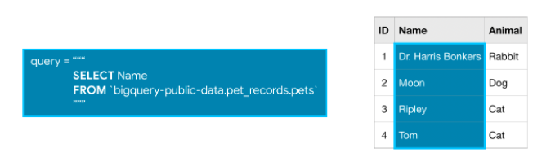
Note that when writing an SQL query, the argument we pass to FROM is not in single or double quotation marks (' or "). It is in backticks (`).

WHERE ...
BigQuery datasets are large, so you'll usually want to return only the rows meeting specific conditions. You can do this using the WHERE clause.
The query below returns the entries from the Name column that are in rows where the Animal column has the text 'Cat'.
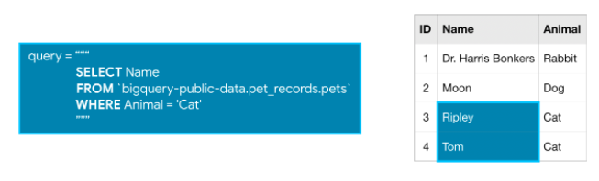

SELECT ... FROM
The most basic SQL query selects a single column from a single table. To do this,
- specify the column you want after the word SELECT, and then
- specify the table after the word FROM.
For instance, to select the Name column (from the pets table in the pet_records database in the bigquery-public-data project), our query would appear as follows:

Example: What are all the U.S. cities in the OpenAQ dataset?
Now that you've got the basics down, let's work through an example with a real dataset. We'll use an OpenAQ dataset about air quality.
First, we'll set up everything we need to run queries and take a quick peek at what tables are in our database. (Since you learned how to do this in the previous tutorial, we have hidden the code. But if you'd like to take a peek, you need only click on the "Code" button below.)
Code
Using Kaggle's public dataset BigQuery integration.
global_air_quality
The dataset contains only one table, called global_air_quality. We'll fetch the table and take a peek at the first few rows to see what sort of data it contains. (Again, we have hidden the code. To take a peek, click on the "Code" button below.)
Code
Out[2]:
 | location | city | country | pollutant | value | timestamp | unit | source_name | latitude | longitude | averaged_over_in_hours
0 | BTM Layout, Bengaluru - KSPCB | Bengaluru | IN | co | 910.00 | 2018-02-22 03:00:00+00:00 | µg/m³ | CPCB | 12.912811 | 77.60922 | 0.25
1 | BTM Layout, Bengaluru - KSPCB | Bengaluru | IN | no2 | 131.87 | 2018-02-22 03:00:00+00:00 | µg/m³ | CPCB | 12.912811 | 77.60922 | 0.25
2 | BTM Layout, Bengaluru - KSPCB | Bengaluru | IN | o3 | 15.57 | 2018-02-22 03:00:00+00:00 | µg/m³ | CPCB | 12.912811 | 77.60922 | 0.25
3 | BTM Layout, Bengaluru - KSPCB | Bengaluru | IN | pm25 | 45.62 | 2018-02-22 03:00:00+00:00 | µg/m³ | CPCB | 12.912811 | 77.60922 | 0.25
4 | BTM Layout, Bengaluru - KSPCB | Bengaluru | IN | so2 | 4.49 | 2018-02-22 03:00:00+00:00 | µg/m³ | CPCB | 12.912811 | 77.60922 | 0.25
Everything looks good! So, let's put together a query. Say we want to select all the values from the city column that are in rows where the country column is 'US' (for "United States").
In [3]:
# Query to select all the items from the "city" column where the "country" column is 'US'
query = """
SELECT city
FROM `bigquery-public-data.openaq.global_air_quality`
WHERE country = 'US'
"""
Take the time now to ensure that this query lines up with what you learned above.

Submitting the query to the dataset
We're ready to use this query to get information from the OpenAQ dataset. As in the previous tutorial, the first step is to create a Client object.
In [4]:
# Create a "Client" object
client = bigquery.Client()
Using Kaggle's public dataset BigQuery integration.
We begin by setting up the query with the query() method. We run the method with the default parameters, but this method also allows us to specify more complicated settings that you can read about in the documentation. We'll revisit this later.
In [5]:
# Set up the query
query_job = client.query(query)
Next, we run the query and convert the results to a pandas DataFrame.
In [6]:
# API request - run the query, and return a pandas DataFrame
us_cities = query_job.to_dataframe()
Now we've got a pandas DataFrame called us_cities, which we can use like any other DataFrame.
In [7]:
# What five cities have the most measurements?
us_cities.city.value_counts().head()
Out[7]:
Phoenix-Mesa-Scottsdale 88
Houston 82
Los Angeles-Long Beach-Santa Ana 68
Riverside-San Bernardino-Ontario 60
New York-Northern New Jersey-Long Island 60
Name: city, dtype: int64

More queries
If you want multiple columns, you can select them with a comma between the names:
In [8]:
query = """
SELECT city, country
FROM `bigquery-public-data.openaq.global_air_quality`
WHERE country = 'US'
"""
You can select all columns with a * like this:
In [9]:
query = """
SELECT *
FROM `bigquery-public-data.openaq.global_air_quality`
WHERE country = 'US'
"""

Q&A: Notes on formatting
The formatting of the SQL query might feel unfamiliar. If you have any questions, you can ask in the comments section at the bottom of this page. Here are answers to two common questions:

Question: What's up with the triple quotation marks (""")?
Answer: These tell Python that everything inside them is a single string, even though we have line breaks in it. The line breaks aren't necessary, but they make it easier to read your query.

Question: Do you need to capitalize SELECT and FROM?
Answer: No, SQL doesn't care about capitalization. However, it's customary to capitalize your SQL commands, and it makes your queries a bit easier to read.

Working with big datasets
BigQuery datasets can be huge. We allow you to do a lot of computation for free, but everyone has some limit.
Each Kaggle user can scan 5TB every 30 days for free. Once you hit that limit, you'll have to wait for it to reset.
The biggest dataset currently on Kaggle is 3TB, so you can go through your 30-day limit in a couple queries if you aren't careful.
Don't worry though: we'll teach you how to avoid scanning too much data at once, so that you don't run over your limit.
To begin,you can estimate the size of any query before running it. Here is an example using the (very large!) Hacker News dataset. To see how much data a query will scan, we create a QueryJobConfig object and set the dry_run parameter to True.
In [10]:
# Query to get the score column from every row where the type column has value "job"
query = """
SELECT score, title
FROM `bigquery-public-data.hacker_news.full`
WHERE type = "job"
"""

# Create a QueryJobConfig object to estimate size of query without running it
dry_run_config = bigquery.QueryJobConfig(dry_run=True)

# API request - dry run query to estimate costs
dry_run_query_job = client.query(query, job_config=dry_run_config)

print("This query will process {} bytes.".format(dry_run_query_job.total_bytes_processed))
This query will process 429036722 bytes.
You can also specify a parameter when running the query to limit how much data you are willing to scan. Here's an example with a low limit.
In [11]:
# Only run the query if it's less than 1 MB
ONE_MB = 1000*1000
safe_config = bigquery.QueryJobConfig(maximum_bytes_billed=ONE_MB)

# Set up the query (will only run if it's less than 1 MB)
safe_query_job = client.query(query, job_config=safe_config)

# API request - try to run the query, and return a pandas DataFrame
safe_query_job.to_dataframe()
---------------------------------------------------------------------------
InternalServerError Traceback (most recent call last)
<ipython-input-11-3ffb41147547> in <module>
7
8 # API request - try to run the query, and return a pandas DataFrame
----> 9 safe_query_job.to_dataframe()

/opt/conda/lib/python3.7/site-packages/google/cloud/bigquery/job.py in to_dataframe(self, bqstorage_client, dtypes, progress_bar_type)
2925 ValueError: If the `pandas` library cannot be imported.
2926 """
-> 2927 return self.result().to_dataframe(
2928 bqstorage_client=bqstorage_client,
2929 dtypes=dtypes,

/opt/conda/lib/python3.7/site-packages/google/cloud/bigquery/job.py in result(self, timeout, retry)
2857 not complete in the given timeout.
2858 """
-> 2859 super(QueryJob, self).result(timeout=timeout)
2860 # Return an iterator instead of returning the job.
2861 if not self._query_results:

/opt/conda/lib/python3.7/site-packages/google/cloud/bigquery/job.py in result(self, timeout, retry)
730 self._begin(retry=retry)
731 # TODO: modify PollingFuture so it can pass a retry argument to done().
--> 732 return super(_AsyncJob, self).result(timeout=timeout)
733
734 def cancelled(self):

/opt/conda/lib/python3.7/site-packages/google/api_core/future/polling.py in result(self, timeout)
128 # pylint: disable=raising-bad-type
129 # Pylint doesn't recognize that this is valid in this case.
--> 130 raise self._exception
131
132 return self._result

InternalServerError: 500 Query exceeded limit for bytes billed: 1000000. 429916160 or higher required.
In this case, the query was cancelled, because the limit of 1 MB was exceeded. However, we can increase the limit to run the query successfully!
In [12]:
# Only run the query if it's less than 1 GB
ONE_GB = 1000*1000*1000
safe_config = bigquery.QueryJobConfig(maximum_bytes_billed=ONE_GB)

# Set up the query (will only run if it's less than 1 GB)
safe_query_job = client.query(query, job_config=safe_config)

# API request - try to run the query, and return a pandas DataFrame
job_post_scores = safe_query_job.to_dataframe()

# Print average score for job posts
job_post_scores.score.mean()
Out[12]:
1.874250078939059

2.2 EXERCICES

Introduction
Try writing some SELECT statements of your own to explore a large dataset of air pollution measurements.

The code cell below fetches the global_air_quality table from the openaq dataset. We also preview the first five rows of the table
from google.cloud import bigquery

# Create a "Client" object
client = bigquery.Client()

# Construct a reference to the "openaq" dataset
dataset_ref = client.dataset("openaq", project="bigquery-public-data")

# API request - fetch the dataset
dataset = client.get_dataset(dataset_ref)

# Construct a reference to the "global_air_quality" table
table_ref = dataset_ref.table("global_air_quality")

# API request - fetch the table
table = client.get_table(table_ref)

# Preview the first five lines of the "global_air_quality" table
client.list_rows(table, max_results=5).to_dataframe()

Using Kaggle's public dataset BigQuery integration.
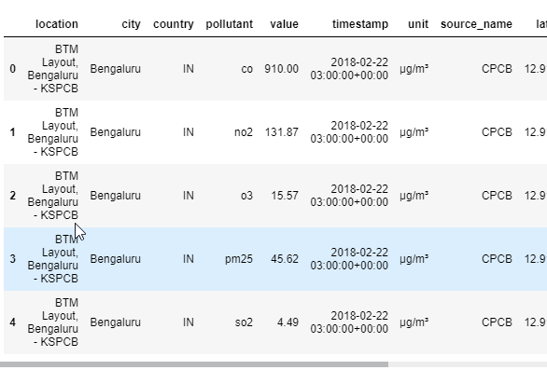
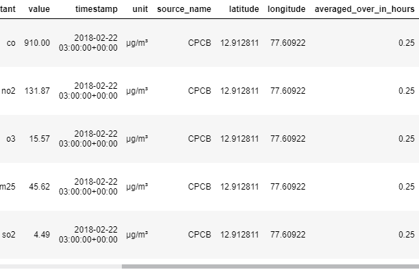

Exercises

1) Units of measurement
Which countries have reported pollution levels in units of "ppm"? In the code cell below, set first_query to an SQL query that pulls the appropriate entries from the country column.
In case it's useful to see an example query, here's some code from the tutorial:
query = """
SELECT city
FROM `bigquery-public-data.openaq.global_air_quality`
WHERE country = 'US'
"""

# Query to select countries with units of "ppm"
first_query = """
SELECT DISTINCT country
FROM `bigquery-public-data.openaq.global_air_quality`
WHERE unit = "ppm"
"""

# Set up the query (cancel the query if it would use too much of
# your quota, with the limit set to 10 GB)
safe_config = bigquery.QueryJobConfig(maximum_bytes_billed=10**10)
first_query_job = client.query(first_query, job_config=safe_config)

# API request - run the query, and return a pandas DataFrame
first_results = first_query_job.to_dataframe()

# View top few rows of results
print(first_results.head())

country
0 US
1 CL
2 AU
3 BM
4 MX

Solution:

first_query = """
SELECT country
FROM `bigquery-public-data.openaq.global_air_quality`
WHERE unit = "ppm"
"""

# Or to get each country just once, you could use
first_query = """
SELECT DISTINCT country
FROM `bigquery-public-data.openaq.global_air_quality`
WHERE unit = "ppm"
"""

2) High air quality
Which pollution levels were reported to be exactly 0?
- Set zero_pollution_query to select all columns of the rows where the value column is 0.
- Set zero_pollution_results to a pandas DataFrame containing the query results.

# Query to select all columns where pollution levels are exactly 0
zero_pollution_query = """
SELECT *
FROM `bigquery-public-data.openaq.global_air_quality`
WHERE value = 0
"""
# Set up the query
safe_config = bigquery.QueryJobConfig(maximum_bytes_billed=10**10)
query_job = client.query(zero_pollution_query, job_config=safe_config)

# API request - run the query and return a pandas DataFrame
zero_pollution_results = query_job.to_dataframe()

location city country pollutant \
0 Victoria Memorial - WBSPCB Kolkata IN pm25
1 Rabindra Bharati University, Kolkata - WBSPCB Kolkata IN so2
2 Zamość ul. Hrubieszowska 69A Zamość PL no2
3 Końskie, MOBILNA Końskie PL pm10
4 Końskie, MOBILNA Końskie PL pm25

value timestamp unit source_name latitude longitude \
0 0.0 2017-10-16 20:45:00+00:00 µg/m³ CPCB 22.572645 88.363890
1 0.0 2017-10-28 14:30:00+00:00 µg/mSolution:

zero_pollution_query = """
SELECT *
FROM `bigquery-public-data.openaq.global_air_quality`
WHERE value = 0
"""

safe_config = bigquery.QueryJobConfig(maximum_bytes_billed=10**10)
query_job = client.query(zero_pollution_query, job_config=safe_config)

zero_pollution_results = query_job.to_dataframe()

That query wasn't too complicated, and it got the data you want. But these SELECT queries don't organizing data in a way that answers the most interesting questions. For that, we'll need the GROUP BY command.
If you know how to use groupby() in pandas, this is similar. But BigQuery works quickly with far larger datasets.
Fortunately, that's next.
³ CPCB 22.627874 88.380400
2 0.0 2020-05-19 05:00:00+00:00 µg/m³ GIOS 50.716630 23.290247
3 0.0 2018-12-21 13:00:00+00:00 µg/m³ GIOS 51.189526 20.408892
4 0.0 2018-12-21 13:00:00+00:00 µg/m³ GIOS 51.189526 20.408892

averaged_over_in_hours
0 0.25
1 0.25
2 NaN
3 NaN
4 NaN

3. Group by, having & count

3.1 COURS

Introduction
Now that you can select raw data, you're ready to learn how to group your data and count things within those groups. This can help you answer questions like:
- How many of each kind of fruit has our store sold?
- How many species of animal has the vet office treated?
To do this, you'll learn about three new techniques: GROUP BY, HAVING and COUNT(). Once again, we'll use this made-up table of information on pets.
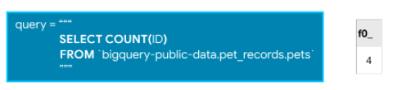
COUNT() is an example of an aggregate function, which takes many values and returns one. (Other examples of aggregate functions include SUM(), AVG(), MIN(), and MAX().) As you'll notice in the picture above, aggregate functions introduce strange column names (like f0__). Later in this tutorial, you'll learn how to change the name to something more descriptive.

GROUP BY
GROUP BY takes the name of one or more columns, and treats all rows with the same value in that column as a single group when you apply aggregate functions like COUNT().
For example, say we want to know how many of each type of animal we have in the pets table. We can use GROUP BY to group together rows that have the same value in the Animal column, while using COUNT() to find out how many ID's we have in each group.
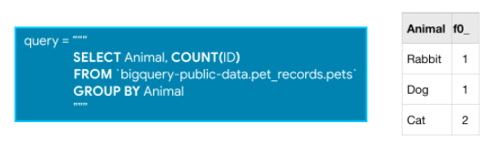

COUNT()
COUNT(), as you may have guessed from the name, returns a count of things. If you pass it the name of a column, it will return the number of entries in that column.
For instance, if we SELECT the COUNT() of the ID column in the pets table, it will return 4, because there are 4 ID's in the table.
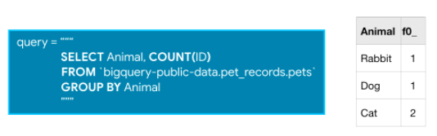
COUNT() is an example of an aggregate function, which takes many values and returns one. (Other examples of aggregate functions include SUM(), AVG(), MIN(), and MAX().) As you'll notice in the picture above, aggregate functions introduce strange column names (like f0__). Later in this tutorial, you'll learn how to change the name to something more descriptive.

GROUP BY
GROUP BY takes the name of one or more columns, and treats all rows with the same value in that column as a single group when you apply aggregate functions like COUNT().
For example, say we want to know how many of each type of animal we have in the pets table. We can use GROUP BY to group together rows that have the same value in the Animal column, while using COUNT() to find out how many ID's we have in each group.
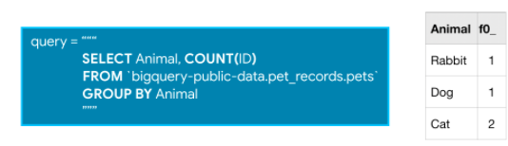
It returns a table with three rows (one for each distinct animal). We can see that the pets table contains 1 rabbit, 1 dog, and 2 cats.

GROUP BY ... HAVING
HAVING is used in combination with GROUP BY to ignore groups that don't meet certain criteria.
So this query, for example, will only include groups that have more than one ID in them.

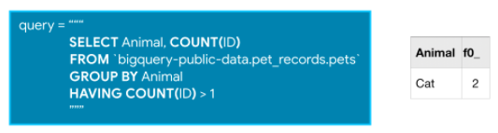
Since only one group meets the specified criterion, the query will return a table with only one row.

Example: Which Hacker News comments generated the most discussion?
Ready to see an example on a real dataset? The Hacker News dataset contains information on stories and comments from the Hacker News social networking site.
We'll work with the comments table and begin by printing the first few rows. (We have hidden the corresponding code. To take a peek, click on the "Code" button below.)
Code
Using Kaggle's public dataset BigQuery integration.
Out[1]:
 | id | by | author | time | time_ts | text | parent | deleted | dead | ranking
0 | 2701393 | 5l | 5l | 1309184881 | 2011-06-27 14:28:01+00:00 | And the glazier who fixed all the broken windo... | 2701243 | None | None | 0
1 | 5811403 | 99 | 99 | 1370234048 | 2013-06-03 04:34:08+00:00 | Does canada have the equivalent of H1B/Green c... | 5804452 | None | None | 0
2 | 21623 | AF | AF | 1178992400 | 2007-05-12 17:53:20+00:00 | Speaking of Rails, there are other options in ... | 21611 | None | None | 0
3 | 10159727 | EA | EA | 1441206574 | 2015-09-02 15:09:34+00:00 | Humans and large livestock (and maybe even pet... | 10159396 | None | None | 0
4 | 2988424 | Iv | Iv | 1315853580 | 2011-09-12 18:53:00+00:00 | I must say I reacted in the same way when I re... | 2988179 | None | None | 0
Let's use the table to see which comments generated the most replies. Since:
- the parent column indicates the comment that was replied to, and
- the id column has the unique ID used to identify each comment,
we can GROUP BY the parent column and COUNT() the id column in order to figure out the number of comments that were made as responses to a specific comment. (This might not make sense immediately -- take your time here to ensure that everything is clear!)
Furthermore, since we're only interested in popular comments, we'll look at comments with more than ten replies. So, we'll only return groups HAVING more than ten ID's.
In [2]:
# Query to select comments that received more than 10 replies
query_popular = """
SELECT parent, COUNT(id)
FROM `bigquery-public-data.hacker_news.comments`
GROUP BY parent
HAVING COUNT(id) > 10
"""
Now that our query is ready, let's run it and store the results in a pandas DataFrame:
In [3]:
# Set up the query (cancel the query if it would use too much of
# your quota, with the limit set to 10 GB)
safe_config = bigquery.QueryJobConfig(maximum_bytes_billed=10**10)
query_job = client.query(query_popular, job_config=safe_config)

# API request - run the query, and convert the results to a pandas DataFrame
popular_comments = query_job.to_dataframe()

# Print the first five rows of the DataFrame
popular_comments.head()
Out[3]:
 | parent | f0_
0 | 6855145 | 39
1 | 3495062 | 38
2 | 6969401 | 48
3 | 4349650 | 44
4 | 9162566 | 41
Each row in the popular_comments DataFrame corresponds to a comment that received more than ten replies. For instance, the comment with ID 801208 received 56 replies.

Aliasing and other improvements
A couple hints to make your queries even better:
- The column resulting from COUNT(id) was called f0__. That's not a very descriptive name. You can change the name by adding AS NumPosts after you specify the aggregation. This is called aliasing, and it will be covered in more detail in an upcoming lesson.
- If you are ever unsure what to put inside the COUNT() function, you can do COUNT(1) to count the rows in each group. Most people find it especially readable, because we know it's not focusing on other columns. It also scans less data than if supplied column names (making it faster and using less of your data access quota).
Using these tricks, we can rewrite our query:
In [4]:
# Improved version of earlier query, now with aliasing & improved readability
query_improved = """
SELECT parent, COUNT(1) AS NumPosts
FROM `bigquery-public-data.hacker_news.comments`
GROUP BY parent
HAVING COUNT(1) > 10
"""

safe_config = bigquery.QueryJobConfig(maximum_bytes_billed=10**10)
query_job = client.query(query_improved, job_config=safe_config)

# API request - run the query, and convert the results to a pandas DataFrame
improved_df = query_job.to_dataframe()

# Print the first five rows of the DataFrame
improved_df.head()
Out[4]:
 | parent | NumPosts
0 | 6683866 | 39
1 | 6627329 | 46
2 | 3476843 | 49
3 | 7234010 | 48
4 | 2932956 | 76
Now you have the data you want, and it has descriptive names. That's good style.

Note on using GROUP BY
Note that because it tells SQL how to apply aggregate functions (like COUNT()), it doesn't make sense to use GROUP BY without an aggregate function. Similarly, if you have any GROUP BY clause, then all variables must be passed to either a
- GROUP BY command, or
- an aggregation function.
Consider the query below:
In [5]:
query_good = """
SELECT parent, COUNT(id)
FROM `bigquery-public-data.hacker_news.comments`
GROUP BY parent
"""
Note that there are two variables: parent and id.
- parent was passed to a GROUP BY command (in GROUP BY parent), and
- id was passed to an aggregate function (in COUNT(id)).
And this query won't work, because the author column isn't passed to an aggregate function or a GROUP BY clause:
In [6]:
query_bad = """
SELECT author, parent, COUNT(id)
FROM `bigquery-public-data.hacker_news.comments`
GROUP BY parent
"""
If make this error, you'll get the error message SELECT list expression references column (column's name) which is neither grouped nor aggregated at.

3.2 EXERCICES

Introduction
Queries with GROUP BY can be powerful. There are many small things that can trip you up (like the order of the clauses), but it will start to feel natural once you've done it a few times. Here, you'll write queries using GROUP BY to answer questions from the Hacker News dataset.
Before you get started, run the following cell to set everything up:

The code cell below fetches the comments table from the hacker_news dataset. We also preview the first five rows of the table.

from google.cloud import bigquery

# Create a "Client" object
client = bigquery.Client()

# Construct a reference to the "hacker_news" dataset
dataset_ref = client.dataset("hacker_news", project="bigquery-public-data")

# API request - fetch the dataset
dataset = client.get_dataset(dataset_ref)

# Construct a reference to the "comments" table
table_ref = dataset_ref.table("comments")

# API request - fetch the table
table = client.get_table(table_ref)

# Preview the first five lines of the "comments" table
client.list_rows(table, max_results=5).to_dataframe()

Exercises

1) Prolific commenters
Hacker News would like to send awards to everyone who has written more than 10,000 posts. Write a query that returns all authors with more than 10,000 posts as well as their post counts. Call the column with post counts NumPosts.
In case sample query is helpful, here is a query you saw in the tutorial to answer a similar question:
query = """
SELECT parent, COUNT(1) AS NumPosts
FROM `bigquery-public-data.hacker_news.comments`
GROUP BY parent
HAVING COUNT(1) > 10
"""

# Query to select prolific commenters and post counts
prolific_commenters_query = """
SELECT author, COUNT(1) AS NumPosts
FROM `bigquery-public-data.hacker_news.comments`
GROUP BY author
HAVING COUNT(1) > 10000
"""

# Set up the query (cancel the query if it would use too much of
# your quota, with the limit set to 1 GB)
safe_config = bigquery.QueryJobConfig(maximum_bytes_billed=10**10)
query_job = client.query(prolific_commenters_query, job_config=safe_config)

# API request - run the query, and return a pandas DataFrame
prolific_commenters = query_job.to_dataframe()

# View top few rows of results
print(prolific_commenters.head())

author NumPosts
# 0 eru 10448
# 1 rbanffy 10557
# 2 dragonwriter 10723
# 3 None 227736
# 4 DanBC 12902

Solution:

prolific_commenters_query = """
SELECT author, COUNT(1) AS NumPosts
FROM `bigquery-public-data.hacker_news.comments`
GROUP BY author
HAVING COUNT(1) > 10000
"""

2) Deleted comments
How many comments have been deleted? (If a comment was deleted, the deleted column in the comments table will have the value True.)

# Query to determine how many posts were deleted
deleted_posts_query = """
SELECT COUNT(1) AS num_deleted_posts
FROM `bigquery-public-data.hacker_news.comments`
WHERE deleted = True
"""

# Set up the query
query_job = client.query(deleted_posts_query)

# API request - run the query, and return a pandas DataFrame
deleted_posts = query_job.to_dataframe()

# View results
print(deleted_posts)

num_deleted_posts
0 227736

num_deleted_posts = 227736

Solution:

# Query to determine how many posts were deleted
deleted_posts_query = """
SELECT COUNT(1) AS num_deleted_posts
FROM `bigquery-public-data.hacker_news.comments`
WHERE deleted = True
"""

# Set up the query
query_job = client.query(deleted_posts_query)

# API request - run the query, and return a pandas DataFrame
deleted_posts = query_job.to_dataframe()

# View results
print(deleted_posts)

num_deleted_posts = 227736

4. Order by

4.1 COURS

Introduction
So far, you've learned how to use several SQL clauses. For instance, you know how to use SELECT to pull specific columns from a table, along with WHERE to pull rows that meet specified criteria. You also know how to use aggregate functions like COUNT(), along with GROUP BY to treat multiple rows as a single group.
Now you'll learn how to change the order of your results using the ORDER BY clause, and you'll explore a popular use case by applying ordering to dates. To illustrate what you'll learn in this tutorial, we'll work with a slightly modified version of our familiar pets table.

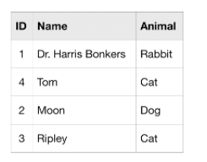
ORDER BY
ORDER BY is usually the last clause in your query, and it sorts the results returned by the rest of your query.
Notice that the rows are not ordered by the ID column. We can quickly remedy this with the query below.
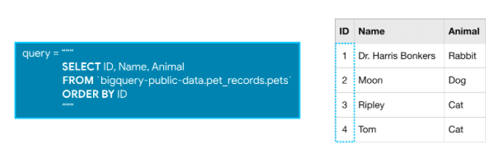
The ORDER BY clause also works for columns containing text, where the results show up in alphabetical order.

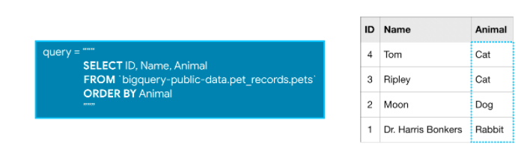
You can reverse the order using the DESC argument (short for 'descending'). The next query sorts the table by the Animal column, where the values that are last in alphabetic order are returned first.

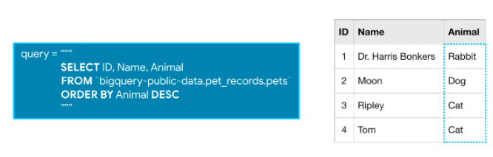
Dates
Next, we'll talk about dates, because they come up very frequently in real-world databases. There are two ways that dates can be stored in BigQuery: as a DATE or as a DATETIME.
The DATE format has the year first, then the month, and then the day. It looks like this:
YYYY-[M]M-[D]D
- YYYY: Four-digit year
- [M]M: One or two digit month
- [D]D: One or two digit day
So 2019-01-10 is interpreted as January 10, 2019.
The DATETIME format is like the date format ... but with time added at the end.

EXTRACT
Often you'll want to look at part of a date, like the year or the day. You can do this with EXTRACT. We'll illustrate this with a slightly different table, called pets_with_date.
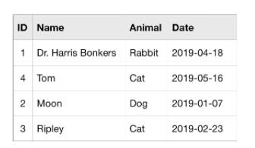
The query below returns two columns, where column Day contains the day corresponding to each entry the Date column from the pets_with_date table:
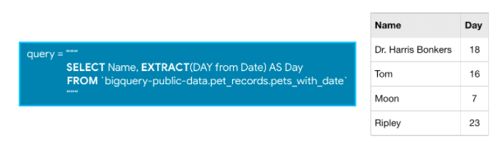
SQL is very smart about dates, and we can ask for information beyond just extracting part of the cell. For example, this query returns one column with just the week in the year (between 1 and 53) for each date in the Date column:
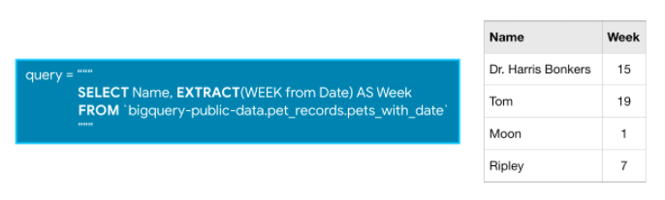
You can find all the functions you can use with dates in BigQuery in this documentation under "Date and time functions".

Example: Which day of the week has the most fatal motor accidents?
Let's use the US Traffic Fatality Records database, which contains information on traffic accidents in the US where at least one person died.
We'll investigate the accident_2015 table. Here is a view of the first few rows. (We have hidden the corresponding code. To take a peek, click on the "Code" button below.)

Using Kaggle's public dataset BigQuery integration.
Out[1]:
 | state_number | state_name | consecutive_number | number_of_vehicle_forms_submitted_all | number_of_motor_vehicles_in_transport_mvit | number_of_parked_working_vehicles | number_of_forms_submitted_for_persons_not_in_motor_vehicles | number_of_persons_not_in_motor_vehicles_in_transport_mvit | number_of_persons_in_motor_vehicles_in_transport_mvit | number_of_forms_submitted_for_persons_in_motor_vehicles | ... | minute_of_ems_arrival_at_hospital | related_factors_crash_level_1 | related_factors_crash_level_1_name | related_factors_crash_level_2 | related_factors_crash_level_2_name | related_factors_crash_level_3 | related_factors_crash_level_3_name | number_of_fatalities | number_of_drunk_drivers | timestamp_of_crash
0 | 19 | Iowa | 190204 | 1 | 1 | 0 | 0 | 0 | 1 | 1 | ... | 2 | 0 | None | 0 | None | 0 | None | 1 | 1 | 2015-09-11 20:20:00+00:00
1 | 19 | Iowa | 190233 | 1 | 1 | 0 | 0 | 0 | 1 | 1 | ... | 88 | 0 | None | 0 | None | 0 | None | 1 | 1 | 2015-11-01 00:30:00+00:00
2 | 19 | Iowa | 190179 | 1 | 1 | 0 | 0 | 0 | 2 | 2 | ... | 1 | 0 | None | 0 | None | 0 | None | 1 | 0 | 2015-05-04 16:18:00+00:00
3 | 19 | Iowa | 190248 | 1 | 1 | 0 | 0 | 0 | 4 | 4 | ... | 99 | 0 | None | 0 | None | 0 | None | 2 | 0 | 2015-11-17 12:26:00+00:00
4 | 19 | Iowa | 190231 | 1 | 1 | 0 | 0 | 0 | 1 | 1 | ... | 88 | 0 | None | 0 | None | 0 | None | 1 | 0 | 2015-10-31 04:49:00+00:00
5 rows × 70 columns
Let's use the table to determine how the number of accidents varies with the day of the week. Since:
- the consecutive_number column contains a unique ID for each accident, and
- the timestamp_of_crash column contains the date of the accident in DATETIME format,
we can:
- EXTRACT the day of the week (as day_of_week in the query below) from the timestamp_of_crash column, and
- GROUP BY the day of the week, before we COUNT the consecutive_number column to determine the number of accidents for each day of the week.
Then we sort the table with an ORDER BY clause, so the days with the most accidents are returned first.
In [2]:
# Query to find out the number of accidents for each day of the week
query = """
SELECT COUNT(consecutive_number) AS num_accidents,
EXTRACT(DAYOFWEEK FROM timestamp_of_crash) AS day_of_week
FROM `bigquery-public-data.nhtsa_traffic_fatalities.accident_2015`
GROUP BY day_of_week
ORDER BY num_accidents DESC
"""
As usual, we run it as follows:
In [3]:
# Set up the query (cancel the query if it would use too much of
# your quota, with the limit set to 1 GB)
safe_config = bigquery.QueryJobConfig(maximum_bytes_billed=10**9)
query_job = client.query(query, job_config=safe_config)

# API request - run the query, and convert the results to a pandas DataFrame
accidents_by_day = query_job.to_dataframe()

# Print the DataFrame
accidents_by_day
Out[3]:
 | num_accidents | day_of_week
0 | 5659 | 7
1 | 5298 | 1
2 | 4916 | 6
3 | 4460 | 5
4 | 4182 | 4
5 | 4038 | 2
6 | 3985 | 3
Notice that the data is sorted by the num_accidents column, where the days with more traffic accidents appear first.
To map the numbers returned for the day_of_week column to the actual day, you might consult the BigQuery documentation on the DAYOFWEEK function. It says that it returns "an integer between 1 (Sunday) and 7 (Saturday), inclusively". So, in 2015, most fatal motor accidents in the US occured on Sunday and Saturday, while the fewest happened on Tuesday.

4.2 EXERCICES

Introduction
You've built up your SQL skills enough that the remaining hands-on exercises will use different datasets than you see in the explanations. If you need to get to know a new dataset, you can run a couple of SELECT queries to extract and review the data you need.
The next exercises are also more challenging than what you've done so far. Don't worry, you are ready for it!

The World Bank has made tons of interesting education data available through BigQuery. Run the following cell to see the first few rows of the international_education table from the world_bank_intl_education dataset.

from google.cloud import bigquery

# Create a "Client" object
client = bigquery.Client()

# Construct a reference to the "world_bank_intl_education" dataset
dataset_ref = client.dataset("world_bank_intl_education", project="bigquery-public-data")

# API request - fetch the dataset
dataset = client.get_dataset(dataset_ref)

# Construct a reference to the "international_education" table
table_ref = dataset_ref.table("international_education")

# API request - fetch the table
table = client.get_table(table_ref)

# Preview the first five lines of the "international_education" table
client.list_rows(table, max_results=5).to_dataframe()

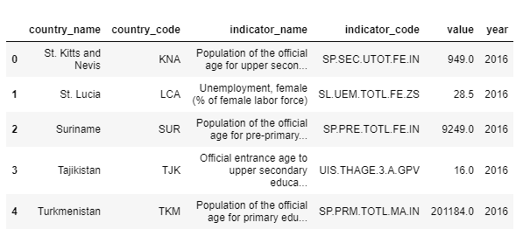
Using Kaggle's public dataset BigQuery integration.

Exercises
The value in the indicator_code column describes what type of data is shown in a given row.
One interesting indicator code is SE.XPD.TOTL.GD.ZS, which corresponds to "Government expenditure on education as % of GDP (%)".

1) Government expenditure on education
Which countries spend the largest fraction of GDP on education?
To answer this question, consider only the rows in the dataset corresponding to indicator code SE.XPD.TOTL.GD.ZS, and write a query that returns the average value in the value column for each country in the dataset between the years 2010-2017 (including 2010 and 2017 in the average).
Requirements:
- Your results should have the country name rather than the country code. You will have one row for each country.
- The aggregate function for average is AVG(). Use the name avg_ed_spending_pct for the column created by this aggregation.
- Order the results so the countries that spend the largest fraction of GDP on education show up first.
In case it's useful to see a sample query, here's a query you saw in the tutorial (using a different dataset):
# Query to find out the number of accidents for each day of the week
query = """
SELECT COUNT(consecutive_number) AS num_accidents,
EXTRACT(DAYOFWEEK FROM timestamp_of_crash) AS day_of_week
FROM `bigquery-public-data.nhtsa_traffic_fatalities.accident_2015`
GROUP BY day_of_week
ORDER BY num_accidents DESC
"""

# Your code goes here
country_spend_pct_query = """
SELECT country_name, AVG(value) AS avg_ed_spending_pct
FROM `bigquery-public-data.world_bank_intl_education.international_education`
WHERE indicator_code = 'SE.XPD.TOTL.GD.ZS' and year >= 2010 and year <= 2017
GROUP BY country_name
ORDER BY avg_ed_spending_pct DESC
"""

# Set up the query (cancel the query if it would use too much of
# your quota, with the limit set to 1 GB)
safe_config = bigquery.QueryJobConfig(maximum_bytes_billed=10**10)
country_spend_pct_query_job = client.query(country_spend_pct_query, job_config=safe_config)

# API request - run the query, and return a pandas DataFrame
country_spending_results = country_spend_pct_query_job.to_dataframe()

# View top few rows of results
print(country_spending_results.head())

country_name avg_ed_spending_pct
0 Cuba 12.837270
1 Micronesia, Fed. Sts. 12.467750
2 Solomon Islands 10.001080
3 Moldova 8.372153
4 Namibia 8.349610

Hint: The part before FROM should be SELECT country_name, AVG(value) AS avg_ed_spending_pct.
Solution:

country_spend_pct_query = """
SELECT country_name, AVG(value) AS avg_ed_spending_pct
FROM `bigquery-public-data.world_bank_intl_education.international_education`
WHERE indicator_code = 'SE.XPD.TOTL.GD.ZS' and year >= 2010 and year <= 2017
GROUP BY country_name
ORDER BY avg_ed_spending_pct DESC
"""

2) Identify interesting codes to explore
The last question started by telling you to focus on rows with the code SE.XPD.TOTL.GD.ZS. But how would you find more interesting indicator codes to explore?
There are 1000s of codes in the dataset, so it would be time consuming to review them all. But many codes are available for only a few countries. When browsing the options for different codes, you might restrict yourself to codes that are reported by many countries.
Write a query below that selects the indicator code and indicator name for all codes with at least 175 rows in the year 2016.
Requirements:
- You should have one row for each indicator code.
- The columns in your results should be called indicator_code, indicator_name, and num_rows.
- Only select codes with 175 or more rows in the raw database (exactly 175 rows would be included).
- To get both the indicator_code and indicator_name in your resulting DataFrame, you need to include both in your SELECT statement (in addition to a COUNT() aggregation). This requires you to include both in your GROUP BY clause.
- Order from results most frequent to least frequent.

# Your code goes here
code_count_query = """
SELECT indicator_code, indicator_name, COUNT(1) AS num_rows
FROM `bigquery-public-data.world_bank_intl_education.international_education`
WHERE year = 2016
GROUP BY indicator_name, indicator_code
HAVING COUNT(1) >= 175
ORDER BY COUNT(1) DESC
"""

# Set up the query
safe_config = bigquery.QueryJobConfig(maximum_bytes_billed=10**10)
code_count_query_job = client.query(code_count_query, job_config=safe_config)

# API request - run the query, and return a pandas DataFrame
code_count_results = code_count_query_job.to_dataframe()

# View top few rows of results
print(code_count_results.head())

indicator_code indicator_name num_rows
0 SP.POP.TOTL Population, total 232
1 SP.POP.GROW Population growth (annual %) 232
2 IT.NET.USER.P2 Internet users (per 100 people) 223
3 SP.POP.TOTL.FE.ZS Population, female (% of total) 213
4 SP.POP.0014.TO.ZS Population, ages 0-14 (% of total) 213

Hint: The part before FROM is SELECT indicator_code, indicator_name, COUNT(1) AS num_rows.
Solution:

code_count_query = """
SELECT indicator_code, indicator_name, COUNT(1) AS num_rows
FROM `bigquery-public-data.world_bank_intl_education.international_education`
WHERE year = 2016
GROUP BY indicator_name, indicator_code
HAVING COUNT(1) >= 175
ORDER BY COUNT(1) DESC
"""

5. As & With

5.1 COURS

Introduction
With all that you've learned, your SQL queries are getting pretty long, which can make them hard understand (and debug).
You are about to learn how to use AS and WITH to tidy up your queries and make them easier to read.
Along the way, we'll use the familiar pets table, but now it includes the ages of the animals.

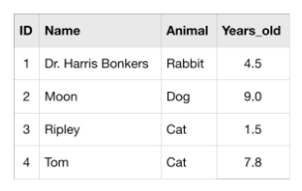
AS
You learned in an earlier tutorial how to use AS to rename the columns generated by your queries, which is also known as aliasing. This is similar to how Python uses as for aliasing when doing imports like import pandas as pd or import seaborn as sns.
To use AS in SQL, insert it right after the column you select. Here's an example of a query without an AS clause:
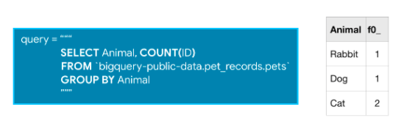
And here's an example of the same query, but with AS.
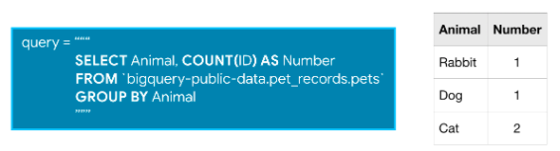
These queries return the same information, but in the second query the column returned by the COUNT() function will be called Number, rather than the default name of f0__.

WITH ... AS
On its own, AS is a convenient way to clean up the data returned by your query. It's even more powerful when combined with WITH in what's called a "common table expression".
A common table expression (or CTE) is a temporary table that you return within your query. CTEs are helpful for splitting your queries into readable chunks, and you can write queries against them.
For instance, you might want to use the pets table to ask questions about older animals in particular. So you can start by creating a CTE which only contains information about animals more than five years old like this:
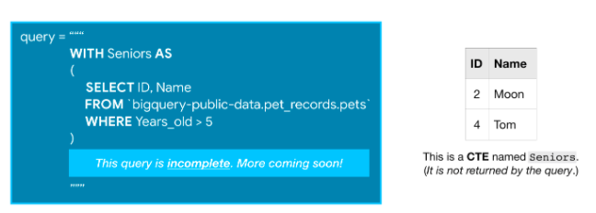
While this incomplete query above won't return anything, it creates a CTE that we can then refer to (as Seniors) while writing the rest of the query.
We can finish the query by pulling the information that we want from the CTE. The complete query below first creates the CTE, and then returns all of the IDs from it.
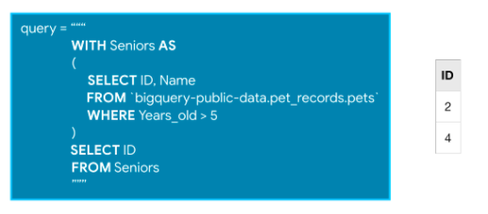
You could do this without a CTE, but if this were the first part of a very long query, removing the CTE would make it much harder to follow.
Also, it's important to note that CTEs only exist inside the query where you create them, and you can't reference them in later queries. So, any query that uses a CTE is always broken into two parts: (1) first, we create the CTE, and then (2) we write a query that uses the CTE.

Example: How many Bitcoin transactions are made per month?
We're going to use a CTE to find out how many Bitcoin transactions were made each day for the entire timespan of a bitcoin transaction dataset.
We'll investigate the transactions table. Here is a view of the first few rows. (The corresponding code is hidden, but you can un-hide it by clicking on the "Code" button below.)
Code
Using Kaggle's public dataset BigQuery integration.
Out[1]:
 | hash | size | virtual_size | version | lock_time | block_hash | block_number | block_timestamp | block_timestamp_month | input_count | output_count | input_value | output_value | is_coinbase | fee | inputs | outputs
0 | aaac8b454e079237b8509c422b8a0ebd95e3eca5944b95... | 137 | 137 | 1 | 0 | 000000000000000000d6cdda66edb65e8969566ca65fe3... | 484015 | 2017-09-07 13:43:30+00:00 | 2017-09-01 | 0 | 1 | None | 1266641901 | True | 0 | [] | [{'index': 0, 'script_asm': 'OP_DUP OP_HASH160...
1 | 8505c4277a8da0450cb6fd345b409a87218e09987c7e92... | 193 | 166 | 1 | 0 | 000000000000000000427219aa8b931acb167f582e9b9c... | 485083 | 2017-09-13 19:30:26+00:00 | 2017-09-01 | 0 | 2 | None | 1367011480 | True | 0 | [] | [{'index': 0, 'script_asm': 'OP_HASH160 6dffc0...
2 | d1a2060a08e8cd54480de8a0aac761b8667c175a7de08e... | 213 | 186 | 1 | 0 | 000000000000000000d5ed15beb3085719e8f1b95f2924... | 485005 | 2017-09-13 10:25:46+00:00 | 2017-09-01 | 0 | 2 | None | 1255484937 | True | 0 | [] | [{'index': 0, 'script_asm': 'OP_DUP OP_HASH160...
3 | 2fba35aaba056d4028d512c0fb134ff41d2d5c504fc7a1... | 213 | 186 | 1 | 0 | 0000000000000000009fd230518a5b3d50ebcd5120a844... | 486934 | 2017-09-25 17:28:19+00:00 | 2017-09-01 | 0 | 2 | None | 1431309437 | True | 0 | [] | [{'index': 0, 'script_asm': 'OP_DUP OP_HASH160...
4 | 630af30aa1ade3de86df071d35b6eb28e0590cf7e0bcaa... | 217 | 190 | 1 | 0 | 000000000000000000841e1fa84e8e5abdfa000936524c... | 483854 | 2017-09-06 16:06:09+00:00 | 2017-09-01 | 0 | 2 | None | 1530785512 | True | 0 | [] | [{'index': 0, 'script_asm': 'OP_DUP OP_HASH160...
Since the block_timestamp column contains the date of each transaction in DATETIME format, we'll convert these into DATE format using the DATE() command.
We do that using a CTE, and then the next part of the query counts the number of transactions for each date and sorts the table so that earlier dates appear first.
In [2]:
# Query to select the number of transactions per date, sorted by date
query_with_CTE = """
WITH time AS
(
SELECT DATE(block_timestamp) AS trans_date
FROM `bigquery-public-data.crypto_bitcoin.transactions`
)
SELECT COUNT(1) AS transactions,
trans_date
FROM time
GROUP BY trans_date
ORDER BY trans_date
"""

# Set up the query (cancel the query if it would use too much of
# your quota, with the limit set to 10 GB)
safe_config = bigquery.QueryJobConfig(maximum_bytes_billed=10**10)
query_job = client.query(query_with_CTE, job_config=safe_config)

# API request - run the query, and convert the results to a pandas DataFrame
transactions_by_date = query_job.to_dataframe()

# Print the first five rows
transactions_by_date.head()
Out[2]:
 | transactions | trans_date
0 | 1 | 2009-01-03
1 | 14 | 2009-01-09
2 | 61 | 2009-01-10
3 | 93 | 2009-01-11
4 | 101 | 2009-01-12
Since they're returned sorted, we can easily plot the raw results to show us the number of Bitcoin transactions per day over the whole timespan of this dataset.
In [3]:
transactions_by_date.set_index('trans_date').plot()
Out[3]:
<matplotlib.axes._subplots.AxesSubplot at 0x7f75b1d636d0>

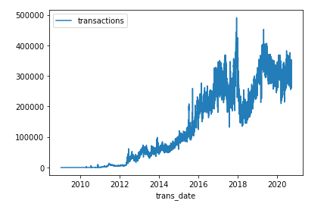
As you can see, common table expressions (CTEs) let you shift a lot of your data cleaning into SQL. That's an especially good thing in the case of BigQuery, because it is vastly faster than doing the work in Pandas.

5.2 EXERCICES

Introduction
You are getting to the point where you can own an analysis from beginning to end. So you'll do more data exploration in this exercise than you've done before. Before you get started, run the following set-up code as usual.

You'll work with a dataset about taxi trips in the city of Chicago. Run the cell below to fetch the chicago_taxi_trips dataset.

from google.cloud import bigquery

# Create a "Client" object
client = bigquery.Client()

# Construct a reference to the "chicago_taxi_trips" dataset
dataset_ref = client.dataset("chicago_taxi_trips", project="bigquery-public-data")

# API request - fetch the dataset
dataset = client.get_dataset(dataset_ref)

Using Kaggle's public dataset BigQuery integration.

Exercises
You are curious how much slower traffic moves when traffic volume is high. This involves a few steps.

1) Find the data
Before you can access the data, you need to find the table name with the data.
Hint: Tab completion is helpful whenever you can't remember a command. Type client. and then hit the tab key. Don't forget the period before hitting tab.

# List all the tables in the dataset
tables = list(client.list_tables(dataset))

# Print names of all tables in the dataset (there is only one!)
for table in tables:
print(table.table_id)

table_name = 'taxi_trips'

# Write the table name as a string below
table_name = 'taxi_trips'

Solution:

# List all the tables in the dataset
tables = list(client.list_tables(dataset))

# Print names of all tables in the dataset (there is only one!)
for table in tables:
print(table.table_id)

table_name = 'taxi_trips'

2) Peek at the data
Use the next code cell to peek at the top few rows of the data. Inspect the data and see if any issues with data quality are immediately obvious.

# Construct a reference to the "taxi_trips" table
table_ref = dataset_ref.table("taxi_trips")

# API request - fetch the table
table = client.get_table(table_ref)

# Preview the first five lines of the "taxi_trips" table
client.list_rows(table, max_results=5).to_dataframe()

Solution: You can see the data by calling:
# Construct a reference to the "taxi_trips" table
table_ref = dataset_ref.table("taxi_trips")

# API request - fetch the table
table = client.get_table(table_ref)

# Preview the first five lines of the "taxi_trips" table
client.list_rows(table, max_results=5).to_dataframe()
Some trips in the top few rows have trip_seconds or trip_miles values of 0. Other location fields have values of None. That is a problem if we want to use those fields.

3) Determine when this data is from
If the data is sufficiently old, we might be careful before assuming the data is still relevant to traffic patterns today. Write a query that counts the number of trips in each year.
Your results should have two columns:
- year - the year of the trips
- num_trips - the number of trips in that year
Hints:
- When using GROUP BY and ORDER BY, you should refer to the columns by the alias year that you set at the top of the SELECT query.
- The SQL code to SELECT the year from trip_start_timestamp is SELECT EXTRACT(YEAR FROM trip_start_timestamp)
- The FROM field can be a little tricky until you are used to it. The format is:
  - A backick (the symbol `).
  - The project name. In this case it is bigquery-public-data.
  - A period.
  - The dataset name. In this case, it is chicago_taxi_trips.
  - A period.
  - The table name. You used this as your answer in 1) Find the data.
  - A backtick (the symbol `).

rides_per_year_query = """
SELECT EXTRACT(YEAR FROM trip_start_timestamp) AS year,
COUNT(1) AS num_trips
FROM `bigquery-public-data.chicago_taxi_trips.taxi_trips`
GROUP BY year
ORDER BY year
"""

# Set up the query (cancel the query if it would use too much of
# your quota)
safe_config = bigquery.QueryJobConfig(maximum_bytes_billed=10**10)
rides_per_year_query_job = client.query(rides_per_year_query, job_config=safe_config)

# API request - run the query, and return a pandas DataFrame
rides_per_year_result = rides_per_year_query_job.to_dataframe()

# View results
print(rides_per_year_result)

year num_trips
0 2013 27217716
1 2014 37395436
2 2015 32385875
3 2016 31759339
4 2017 24988003
5 2018 20732088
6 2019 16477365
7 2020 3419510

Hint: Start your query with SELECT EXTRACT(YEAR FROM trip_start_timestamp) AS year, COUNT(1) AS num_trips.
Solution:

rides_per_year_query = """
SELECT EXTRACT(YEAR FROM trip_start_timestamp) AS year,
COUNT(1) AS num_trips
FROM `bigquery-public-data.chicago_taxi_trips.taxi_trips`
GROUP BY year
ORDER BY year
"""

# Set up the query (cancel the query if it would use too much of
# your quota)
safe_config = bigquery.QueryJobConfig(maximum_bytes_billed=10**10)
rides_per_year_query_job = client.query(rides_per_year_query, job_config=safe_config)

# API request - run the query, and return a pandas DataFrame
rides_per_year_result = rides_per_year_query_job.to_dataframe()

4) Dive slightly deeper
You'd like to take a closer look at rides from 2017. Copy the query you used above in rides_per_year_query into the cell below for rides_per_month_query. Then modify it in two ways:
- Use a WHERE clause to limit the query to data from 2017.
- Modify the query to extract the month rather than the year.

rides_per_month_query = """
SELECT EXTRACT(MONTH FROM trip_start_timestamp) AS month,
COUNT(1) AS num_trips
FROM `bigquery-public-data.chicago_taxi_trips.taxi_trips`
WHERE EXTRACT(YEAR FROM trip_start_timestamp) = 2017
GROUP BY month
ORDER BY month
"""

# Set up the query (cancel the query if it would use too much of
# your quota)
safe_config = bigquery.QueryJobConfig(maximum_bytes_billed=10**10)
rides_per_month_query_job = client.query(rides_per_month_query, job_config=safe_config)

# API request - run the query, and return a pandas DataFrame
rides_per_month_result = rides_per_month_query_job.to_dataframe()

# View results
print(rides_per_month_result)1 2014 37395436
7 2020 3419510

month num_trips
0 1 1972071
1 2 1909802
2 3 2362105
3 4 2194702
4 5 2323386
5 6 2324472
6 7 2054299
7 8 2079861
8 9 1950631
9 10 2141197
10 11 1907997
11 12 1767480

Hint: Start your query with SELECT EXTRACT(MONTH FROM trip_start_timestamp) AS month, COUNT(1) AS num_trips.
Solution:

rides_per_month_query = """
SELECT EXTRACT(MONTH FROM trip_start_timestamp) AS month,
COUNT(1) AS num_trips
FROM `bigquery-public-data.chicago_taxi_trips.taxi_trips`
WHERE EXTRACT(YEAR FROM trip_start_timestamp) = 2017
GROUP BY month
ORDER BY month
"""

# Set up the query (cancel the query if it would use too much of
# your quota)
safe_config = bigquery.QueryJobConfig(maximum_bytes_billed=10**10)
rides_per_month_query_job = client.query(rides_per_month_query, job_config=safe_config)

# API request - run the query, and return a pandas DataFrame
rides_per_month_result = rides_per_month_query_job.to_dataframe()

5) Write the query
It's time to step up the sophistication of your queries. Write a query that shows, for each hour of the day in the dataset, the corresponding number of trips and average speed.
Your results should have three columns:
- hour_of_day - sort by this column, which holds the result of extracting the hour from trip_start_timestamp.
- num_trips - the count of the total number of trips in each hour of the day (e.g. how many trips were started between 6AM and 7AM, independent of which day it occurred on).
- avg_mph - the average speed, measured in miles per hour, for trips that started in that hour of the day. Average speed in miles per hour is calculated as 3600 * SUM(trip_miles) / SUM(trip_seconds). (The value 3600 is used to convert from seconds to hours.)
Restrict your query to data meeting the following criteria:
- a trip_start_timestamp between 2017-01-01 and 2017-07-01
- trip_seconds > 0 and trip_miles > 0
You will use a common table expression (CTE) to select just the relevant rides. Because this dataset is very big, this CTE should select only the columns you'll need to create the final output (though you won't actually create those in the CTE -- instead you'll create those in the later SELECT statement below the CTE).
This is a much harder query than anything you've written so far. Good luck!
speeds_query = """
WITH RelevantRides AS
(
SELECT EXTRACT(HOUR FROM trip_start_timestamp) AS hour_of_day,
trip_miles,
trip_seconds
FROM `bigquery-public-data.chicago_taxi_trips.taxi_trips`
WHERE trip_start_timestamp > '2017-01-01' AND
trip_start_timestamp < '2017-07-01' AND
trip_seconds > 0 AND
trip_miles > 0
)
SELECT hour_of_day,
COUNT(1) AS num_trips,
3600 * SUM(trip_miles) / SUM(trip_seconds) AS avg_mph
FROM RelevantRides
GROUP BY hour_of_day
ORDER BY hour_of_day
"""

# Set up the query (cancel the query if it would use too much of
# your quota)
safe_config = bigquery.QueryJobConfig(maximum_bytes_billed=10**10)
speeds_query_job = client.query(speeds_query, job_config=safe_config)

# API request - run the query, and return a pandas DataFrame
speeds_result = speeds_query_job.to_dataframe()

# View results
print(speeds_result)

hour_of_day num_trips avg_mph
0 0 319339 20.230524
1 1 266529 18.937621
2 2 210147 18.777070
3 3 159668 20.158048
4 4 122183 26.736014
5 5 119312 30.769172
6 6 182738 24.588313
7 7 358406 17.735967
8 8 541775 15.079892
9 9 565548 16.543882
10 10 525120 18.539614
11 11 594603 18.928379
12 12 622324 17.838745
13 13 630181 17.671089
14 14 622465 16.974239
15 15 640430 15.688418
16 16 701435 14.283888
17 17 756627 12.462955
18 18 768251 13.646810
19 19 701064 16.642882
20 20 598614 19.536777
21 21 552726 20.433874
22 22 501095 19.531374
23 23 399587 19.877046

6. Joining Data

6.1 COURS

Introduction
You have the tools to obtain data from a single table in whatever format you want it. But what if the data you want is spread across multiple tables?
That's where JOIN comes in! JOIN is incredibly important in practical SQL workflows. So let's get started.

Example
We'll use our imaginary pets table, which has three columns:
- ID - ID number for the pet
- Name - name of the pet
- Animal - type of animal
We'll also add another table, called owners. This table also has three columns:
- ID - ID number for the owner (different from the ID number for the pet)
- Name - name of the owner
- Pet_ID - ID number for the pet that belongs to the owner (which matches the ID number for the pet in the pets table)
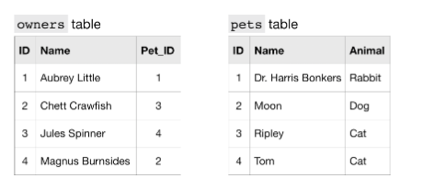
To get information that applies to a certain pet, we match the ID column in the pets table to the Pet_ID column in the owners table.
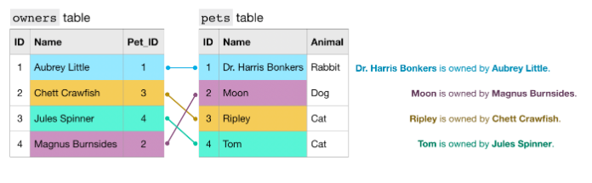
For example,
- the pets table shows that Dr. Harris Bonkers is the pet with ID 1.
- The owners table shows that Aubrey Little is the owner of the pet with ID 1.
Putting these two facts together, Dr. Harris Bonkers is owned by Aubrey Little.
Fortunately, we don't have to do this by hand to figure out which owner goes with which pet. In the next section, you'll learn how to use JOIN to create a new table combining information from the pets and owners tables.

JOIN
Using JOIN, we can write a query to create a table with just two columns: the name of the pet and the name of the owner.
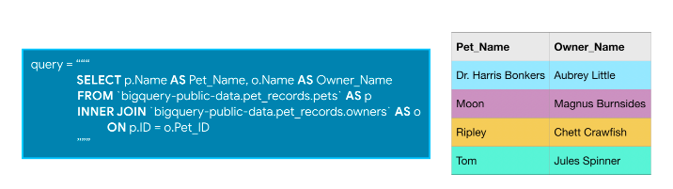
We combine information from both tables by matching rows where the ID column in the pets table matches the Pet_ID column in the owners table.
In the query, ON determines which column in each table to use to combine the tables. Notice that since the ID column exists in both tables, we have to clarify which one to use. We use p.ID to refer to the ID column from the pets table, and o.Pet_ID refers to the Pet_ID column from the owners table.
In general, when you're joining tables, it's a good habit to specify which table each of your columns comes from. That way, you don't have to pull up the schema every time you go back to read the query.
The type of JOIN we're using today is called an INNER JOIN. That means that a row will only be put in the final output table if the value in the columns you're using to combine them shows up in both the tables you're joining. For example, if Tom's ID number of 4 didn't exist in the pets table, we would only get 3 rows back from this query. There are other types of JOIN, but an INNER JOIN is very widely used, so it's a good one to start with.

Example: How many files are covered by each type of software license?
GitHub is the most popular place to collaborate on software projects. A GitHub repository (or repo) is a collection of files associated with a specific project.
Most repos on GitHub are shared under a specific legal license, which determines the legal restrictions on how they are used. For our example, we're going to look at how many different files have been released under each license.
We'll work with two tables in the database. The first table is the licenses table, which provides the name of each GitHub repo (in the repo_name column) and its corresponding license. Here's a view of the first five rows.
Code
Using Kaggle's public dataset BigQuery integration.
Out[1]:
 | repo_name | license
0 | Altai-man/perl6-Compress-Bzip2-Raw | artistic-2.0
1 | morisbartyno/buildnew_andro_6.0 | artistic-2.0
2 | dagolden/ack2 | artistic-2.0
3 | reepblue/SourceSDKContent | artistic-2.0
4 | pynk/PYNK-show- | artistic-2.0
The second table is the sample_files table, which provides, among other information, the GitHub repo that each file belongs to (in the repo_name column). The first several rows of this table are printed below.
Code
Out[2]:
 | repo_name | ref | path | mode | id | symlink_target
0 | git/git | refs/heads/master | RelNotes | 40960 | 62615ffa4e97803da96aefbc798ab50f949a8db7 | Documentation/RelNotes/2.10.0.txt
1 | np/ling | refs/heads/master | tests/success/plug_compose.t/plug_compose.ll | 40960 | 0c1605e4b447158085656487dc477f7670c4bac1 | ../../../fixtures/all/plug_compose.ll
2 | np/ling | refs/heads/master | fixtures/strict-par-success/parallel_assoc_lef... | 40960 | b59bff84ec03d12fabd3b51a27ed7e39a180097e | ../all/parallel_assoc_left.ll
3 | np/ling | refs/heads/master | fixtures/sequence/parallel_assoc_2tensor2_left.ll | 40960 | f29523e3fb65702d99478e429eac6f801f32152b | ../all/parallel_assoc_2tensor2_left.ll
4 | np/ling | refs/heads/master | fixtures/success/my_dual.ll | 40960 | 38a3af095088f90dfc956cb990e893909c3ab286 | ../all/my_dual.ll
Next, we write a query that uses information in both tables to determine how many files are released in each license.
In [3]:
# Query to determine the number of files per license, sorted by number of files
query = """
SELECT L.license, COUNT(1) AS number_of_files
FROM `bigquery-public-data.github_repos.sample_files` AS sf
INNER JOIN `bigquery-public-data.github_repos.licenses` AS L
ON sf.repo_name = L.repo_name
GROUP BY L.license
ORDER BY number_of_files DESC
"""

# Set up the query (cancel the query if it would use too much of
# your quota, with the limit set to 10 GB)
safe_config = bigquery.QueryJobConfig(maximum_bytes_billed=10**10)
query_job = client.query(query, job_config=safe_config)

# API request - run the query, and convert the results to a pandas DataFrame
file_count_by_license = query_job.to_dataframe()
It's a big query, and so we'll investigate each piece separately.
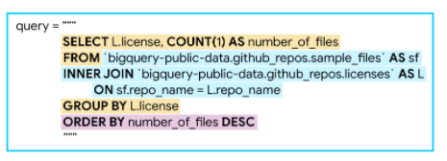
We'll begin with the JOIN (highlighted in blue above). This specifies the sources of data and how to join them. We use ON to specify that we combine the tables by matching the values in the repo_name columns in the tables.
Next, we'll talk about SELECT and GROUP BY (highlighted in yellow). The GROUP BY breaks the data into a different group for each license, before we COUNT the number of rows in the sample_files table that corresponds to each license. (Remember that you can count the number of rows with COUNT(1).)
Finally, the ORDER BY (highlighted in purple) sorts the results so that licenses with more files appear first.
It was a big query, but it gave us a nice table summarizing how many files have been committed under each license:
In [4]:
# Print the DataFrame
file_count_by_license
Out[4]:
 | license | number_of_files
0 | mit | 20432437
1 | gpl-2.0 | 16866825
2 | apache-2.0 | 7114007
3 | gpl-3.0 | 4936479
4 | bsd-3-clause | 2926576
5 | agpl-3.0 | 1293773
6 | lgpl-2.1 | 793054
7 | bsd-2-clause | 694767
8 | lgpl-3.0 | 564433
9 | mpl-2.0 | 473078
10 | cc0-1.0 | 405925
11 | epl-1.0 | 320203
12 | unlicense | 208912
13 | artistic-2.0 | 148414
14 | isc | 117709
You'll use JOIN clauses a lot and get very efficient with them as you get some practice.

6.2 EXERCICES

Introduction
Stack Overflow is a widely beloved question and answer site for technical questions. You'll probably use it yourself as you keep using SQL (or any programming language).
Their data is publicly available. What cool things do you think it would be useful for?
Here's one idea: You could set up a service that identifies the Stack Overflow users who have demonstrated expertise with a specific technology by answering related questions about it, so someone could hire those experts for in-depth help.
In this exercise, you'll write the SQL queries that might serve as the foundation for this type of service.
As usual, run the following cell to set up our feedback system before moving on.

Run the next cell to fetch the stackoverflow dataset.

# Create a "Client" object
client = bigquery.Client()

# Construct a reference to the "stackoverflow" dataset
dataset_ref = client.dataset("stackoverflow", project="bigquery-public-data")

# API request - fetch the dataset
dataset = client.get_dataset(dataset_ref)

Exercises

1) Explore the data
Before writing queries or JOIN clauses, you'll want to see what tables are available.
Hint: Tab completion is helpful whenever you can't remember a command. Type client. and then hit the tab key. Don't forget the period before hitting tab.

# Get a list of available tables
tables = list(client.list_tables(dataset))
list_of_tables = [table.table_id for table in tables]

# Print your answer
print(list_of_tables)

['badges', 'comments', 'post_history', 'post_links', 'posts_answers', 'posts_moderator_nomination', 'posts_orphaned_tag_wiki', 'posts_privilege_wiki', 'posts_questions', 'posts_tag_wiki', 'posts_tag_wiki_excerpt', 'posts_wiki_placeholder', 'stackoverflow_posts', 'tags', 'users', 'votes']

Solution:

# Get a list of available tables
tables = list(client.list_tables(dataset))
list_of_tables = [table.table_id for table in tables]

2) Review relevant tables
If you are interested in people who answer questions on a given topic, the posts_answers table is a natural place to look. Run the following cell, and look at the output.

# Construct a reference to the "posts_answers" table
answers_table_ref = dataset_ref.table("posts_answers")

# API request - fetch the table
answers_table = client.get_table(answers_table_ref)

# Preview the first five lines of the "posts_answers" table
client.list_rows(answers_table, max_results=5).to_dataframe()

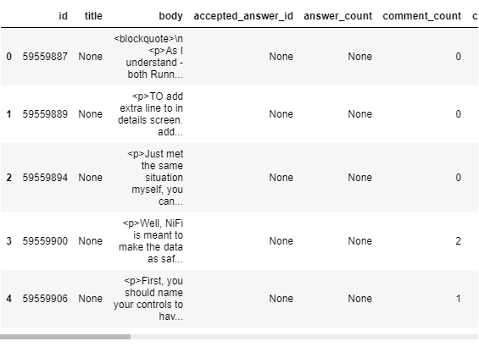
It isn't clear yet how to find users who answered questions on any given topic. But posts_answers has a parent_id column. If you are familiar with the Stack Overflow site, you might figure out that the parent_id is the question each post is answering.
Look at posts_questions using the cell below.

# Construct a reference to the "posts_questions" table
questions_table_ref = dataset_ref.table("posts_questions")

# API request - fetch the table
questions_table = client.get_table(questions_table_ref)

# Preview the first five lines of the "posts_questions" table
client.list_rows(questions_table, max_results=5).to_dataframe()

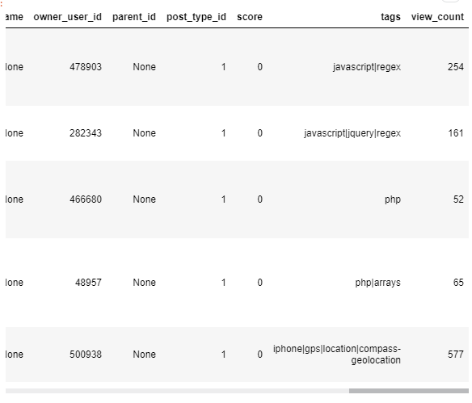
Are there any fields that identify what topic or technology each question is about? If so, how could you find the IDs of users who answered questions about a specific topic?
Think about it, and then check the solution by running the code in the next cell.

Solution: posts_questions has a column called tags which lists the topics/technologies each question is about.
posts_answers has a column called parent_id which identifies the ID of the question each answer is responding to. posts_answers also has an owner_user_id column which specifies the ID of the user who answered the question.
You can join these two tables to:
- determine the tags for each answer, and then
- select the owner_user_id of the answers on the desired tag.
This is exactly what you will do over the next few questions.

3) Selecting the right questions
A lot of this data is text.
We'll explore one last technique in this course which you can apply to this text.
A WHERE clause can limit your results to rows with certain text using the LIKE feature. For example, to select just the third row of the pets table from the tutorial, we could use the query in the picture below.
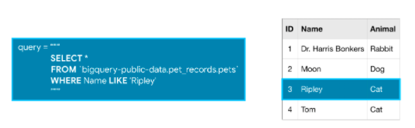
You can also use % as a "wildcard" for any number of characters. So you can also get the third row with:
query = """
SELECT *
FROM `bigquery-public-data.pet_records.pets`
WHERE Name LIKE '%ipl%'
"""
Try this yourself. Write a query that selects the id, title and owner_user_id columns from the posts_questions table.
- Restrict the results to rows that contain the word "bigquery" in the tags column.
- Include rows where there is other text in addition to the word "bigquery" (e.g., if a row has a tag "bigquery-sql", your results should include that too).

# Your code here
questions_query = """
SELECT id, title, owner_user_id
FROM `bigquery-public-data.stackoverflow.posts_questions`
WHERE tags LIKE '%bigquery%'
"""

# Set up the query (cancel the query if it would use too much of
# your quota, with the limit set to 1 GB)
safe_config = bigquery.QueryJobConfig(maximum_bytes_billed=10**10)
questions_query_job = client.query(questions_query, job_config=safe_config)

# API request - run the query, and return a pandas DataFrame
questions_results = questions_query_job.to_dataframe()

# Preview results
print(questions_results.head())

id title owner_user_id
0 4702789 How to Analyze and Query big chunks of data 435951.0
1 63628724 Will the Firebase BigQuery export still work i... 7590610.0
2 63758052 Scheduled query stopped writing to table in Bi... 13961038.0
3 63716014 Inconsistent delay in firebase analytics event... 858350.0
4 63604155 Dynamic Project names in BigQuery Procedures 10739327.0

Hint: Your WHERE clause should be WHERE tags LIKE '%bigquery%'.
Solution:

questions_query = """
SELECT id, title, owner_user_id
FROM `bigquery-public-data.stackoverflow.posts_questions`
WHERE tags LIKE '%bigquery%'
"""

# Set up the query (cancel the query if it would use too much of
# your quota, with the limit set to 1 GB)
safe_config = bigquery.QueryJobConfig(maximum_bytes_billed=10**10)
questions_query_job = client.query(questions_query, job_config=safe_config)

# API request - run the query, and return a pandas DataFrame
questions_results = questions_query_job.to_dataframe()

4) Your first join
Now that you have a query to select questions on any given topic (in this case, you chose "bigquery"), you can find the answers to those questions with a JOIN.
Write a query that returns the id, body and owner_user_id columns from the posts_answers table for answers to "bigquery"-related questions.
- You should have one row in your results for each answer to a question that has "bigquery" in the tags.
- Remember you can get the tags for a question from the tags column in the posts_questions table.
Here's a reminder of what a JOIN looked like in the tutorial:
query = """
SELECT p.Name AS Pet_Name, o.Name AS Owner_Name
FROM `bigquery-public-data.pet_records.pets` as p
INNER JOIN `bigquery-public-data.pet_records.owners` as o
ON p.ID = o.Pet_ID
"""
It may be useful to scroll up and review the first several rows of the posts_answers and posts_questions tables.

# Your code here
answers_query = """
SELECT a.id, a.body, a.owner_user_id
FROM `bigquery-public-data.stackoverflow.posts_questions` AS q
INNER JOIN `bigquery-public-data.stackoverflow.posts_answers` AS a
ON q.id = a.parent_id
WHERE q.tags LIKE '%bigquery%'
"""

# Set up the query (cancel the query if it would use too much of
# your quota, with the limit set to 1 GB)
safe_config = bigquery.QueryJobConfig(maximum_bytes_billed=10**10)
answers_query_job = client.query(answers_query, job_config=safe_config)

# API request - run the query, and return a pandas DataFrame
answers_results = answers_query_job.to_dataframe()

# Preview results
print(answers_results.head())

id body owner_user_id
0 61365135 <p>import os\nfrom google.cloud.bigquery.clien... 6016731.0
1 61366305 <p>As other answers were to hard for me I made... 10187000.0
2 61389343 <p>I decided to poll with the command line gcl... 4355203.0
3 61394597 <p>I did as SANN3 taught me, like a following:... 1332841.0
4 61402047 <p>You can pass the schema explicitly and set ... 4334376.0

Hint: Do an INNER JOIN between bigquery-public-data.stackoverflow.posts_questions and bigquery-public-data.stackoverflow.posts_answers.
Give post_questions an alias of q, and use a as an alias for posts_answers. The ON part of your join is q.id = a.parent_id.
Solution:

answers_query = """
SELECT a.id, a.body, a.owner_user_id
FROM `bigquery-public-data.stackoverflow.posts_questions` AS q
INNER JOIN `bigquery-public-data.stackoverflow.posts_answers` AS a
ON q.id = a.parent_id
WHERE q.tags LIKE '%bigquery%'
"""

# Set up the query (cancel the query if it would use too much of
# your quota, with the limit set to 1 GB)
safe_config = bigquery.QueryJobConfig(maximum_bytes_billed=10**10)
answers_query_job = client.query(answers_query, job_config=safe_config)

# API request - run the query, and return a pandas DataFrame
answers_results = answers_query_job.to_dataframe()

5) Answer the question
You have the merge you need. But you want a list of users who have answered many questions... which requires more work beyond your previous result.
Write a new query that has a single row for each user who answered at least one question with a tag that includes the string "bigquery". Your results should have two columns:
- user_id - contains the owner_user_id column from the posts_answers table
- number_of_answers - contains the number of answers the user has written to "bigquery"-related questions

# Your code here
bigquery_experts_query = """
SELECT a.owner_user_id AS user_id, COUNT(1) AS number_of_answers
FROM `bigquery-public-data.stackoverflow.posts_questions` AS q
INNER JOIN `bigquery-public-data.stackoverflow.posts_answers` AS a
ON q.id = a.parent_Id
WHERE q.tags LIKE '%bigquery%'
GROUP BY a.owner_user_id
"""

# Set up the query (cancel the query if it would use too much of
# your quota, with the limit set to 1 GB)
safe_config = bigquery.QueryJobConfig(maximum_bytes_billed=10**10)
bigquery_experts_query_job = client.query(bigquery_experts_query, job_config=safe_config)

# API request - run the query, and return a pandas DataFrame
bigquery_experts_results = bigquery_experts_query_job.to_dataframe()

# Preview results
print(bigquery_experts_results.head())

user_id number_of_answers
0 4502697.0 1
1 2514521.0 1
2 7041871.0 5
3 2877278.0 260
4 4821960.0 1

Hint: Start with SELECT a.owner_user_id AS user_id, COUNT(1) AS number_of_answers
Solution:

bigquery_experts_query = """
SELECT a.owner_user_id AS user_id, COUNT(1) AS number_of_answers
FROM `bigquery-public-data.stackoverflow.posts_questions` AS q
INNER JOIN `bigquery-public-data.stackoverflow.posts_answers` AS a
ON q.id = a.parent_Id
WHERE q.tags LIKE '%bigquery%'
GROUP BY a.owner_user_id
"""

# Set up the query (cancel the query if it would use too much of
# your quota, with the limit set to 1 GB)
safe_config = bigquery.QueryJobConfig(maximum_bytes_billed=10**10)
bigquery_experts_query_job = client.query(bigquery_experts_query, job_config=safe_config)

# API request - run the query, and return a pandas DataFrame
bigquery_experts_results = bigquery_experts_query_job.to_dataframe()

6) Building a more generally useful service
How could you convert what you've done to a general function a website could call on the backend to get experts on any topic?
Think about it and then check the solution below.

Solution:

def expert_finder(topic, client):
'''
Returns a DataFrame with the user IDs who have written Stack Overflow answers on a topic.

Inputs:
topic: A string with the topic of interest
client: A Client object that specifies the connection to the Stack Overflow dataset

Outputs:
results: A DataFrame with columns for user_id and number_of_answers. Follows similar logic to bigquery_experts_results shown above.
'''
my_query = """
SELECT a.owner_user_id AS user_id, COUNT(1) AS number_of_answers
FROM `bigquery-public-data.stackoverflow.posts_questions` AS q
INNER JOIN `bigquery-public-data.stackoverflow.posts_answers` AS a
ON q.id = a.parent_Id
WHERE q.tags like '%{topic}%'
GROUP BY a.owner_user_id
"""

# Set up the query (a real service would have good error handling for
# queries that scan too much data)
safe_config = bigquery.QueryJobConfig(maximum_bytes_billed=10**10)
my_query_job = client.query(my_query, job_config=safe_config)

# API request - run the query, and return a pandas DataFrame
results = my_query_job.to_dataframe()

return results

Congratulations!
You know all the key components to use BigQuery and SQL effectively. Your SQL skills are sufficient to unlock many of the world's largest datasets.

