Sommaire
Intro to Machine Learning 3
1. How models works 3
1.1 COURS 3
Introduction 3
Improving the Decision Tree 4
Continue 5
2. BASIC DATA EXPLORATION 6
2.1 COURS 6
Using Pandas to Get Familiar With Your Data 6
Interpreting Data Description 7
2.2 EXERCICES 8
Step 1: Loading Data 8
Step 2: Review The Data 8
Think About Your Data 9
3. YOUR FIRST MACHINE LEARNING MODEL 10
3.1 COURS 10
Selecting Data for Modeling 10
Selecting The Prediction Target 10
Choosing "Features" 11
Building Your Model 12
3.2 EXERCICES 14
Step 1: Specify Prediction Target 14
Step 2: Create X 14
Review Data 14
Step 3: Specify and Fit Model 15
Step 4: Make Predictions 15
Think About Your Results 15
4. MODEL VALIDATION 16
4.1 COURS 16
What is Model Validation 16
The Problem with "In-Sample" Scores 17
Coding It 17
Wow! 18
4.2 EXERCICES 19
Step 1: Split Your Data 19
Step 2: Specify and Fit the Model 19
Step 3: Make Predictions with Validation data 20
Step 4: Calculate the Mean Absolute Error in Validation Data 20
5. UNDERFITTING AND OVEFITTING 21
5.1 COURS 21
Experimenting With Different Models 21
Example 22
Conclusion 23
5.2 EXERCICES 24
Step 1: Compare Different Tree Sizes 24
Step 2: Fit Model Using All Data 24
6. RANDOM FORESTS 25
6.1 COURS 25
Introduction 25
Example 25
Conclusion 25
6.2 EXERCICES 27
Step 1: Use a Random Forest 27
7. MACHINE LEARNING COMPETITIONS 29
7.1 COURS 29
7.2 EXERCICES 30
Introduction 30
Creating a Model For the Competition 31
Make Predictions 31
Test Your Work 32
Continuing Your Progress 33
Other Courses 33
8. BONUS – INTRO TO AUTOML 35
8.1 COURS 35
Introduction 35
Automated machine learning (AutoML) 35
Code 36
8.2 EXERCICES 39
9. BONUS – GETTING STARTED WITH TITANIC 40
9.1 COURS 40
9.2 EXERCICES 41

Intro to Machine Learning
Learn the core ideas in machine learning, and build your first models.

1. How models works

1.1 COURS

Introduction
We'll start with an overview of how machine learning models work and how they are used. This may feel basic if you've done statistical modeling or machine learning before. Don't worry, we will progress to building powerful models soon.
This micro-course will have you build models as you go through following scenario:
Your cousin has made millions of dollars speculating on real estate. He's offered to become business partners with you because of your interest in data science. He'll supply the money, and you'll supply models that predict how much various houses are worth.
You ask your cousin how he's predicted real estate values in the past. and he says it is just intuition. But more questioning reveals that he's identified price patterns from houses he has seen in the past, and he uses those patterns to make predictions for new houses he is considering.
Machine learning works the same way. We'll start with a model called the Decision Tree. There are fancier models that give more accurate predictions. But decision trees are easy to understand, and they are the basic building block for some of the best models in data science.
For simplicity, we'll start with the simplest possible decision tree.

It divides houses into only two categories. The predicted price for any house under consideration is the historical average price of houses in the same category.
We use data to decide how to break the houses into two groups, and then again to determine the predicted price in each group. This step of capturing patterns from data is called fitting or training the model. The data used to fit the model is called the training data.
The details of how the model is fit (e.g. how to split up the data) is complex enough that we will save it for later. After the model has been fit, you can apply it to new data to predict prices of additional homes.

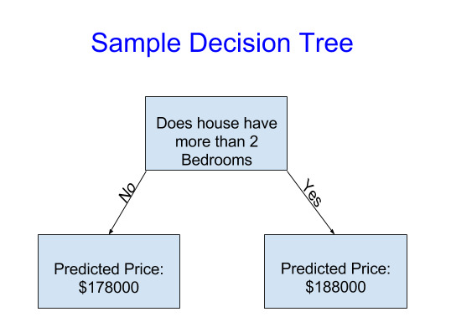
Improving the Decision Tree
Which of the following two decisions trees is more likely to result from fitting the real estate training data?
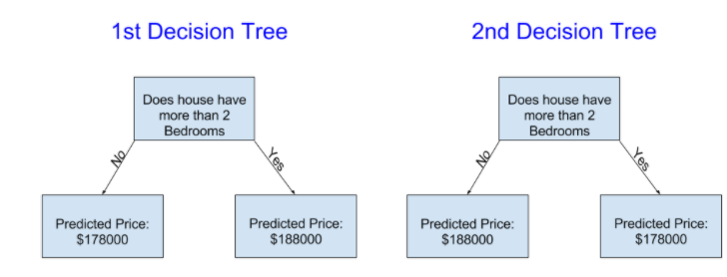
The decision tree on the left (Decision Tree 1) probably makes more sense, because it captures the reality that houses with more bedrooms tend to sell at higher prices than houses with fewer bedrooms. The biggest shortcoming of this model is that it doesn't capture most factors affecting home price, like number of bathrooms, lot size, location, etc.
You can capture more factors using a tree that has more "splits." These are called "deeper" trees. A decision tree that also considers the total size of each house's lot might look like this:

You predict the price of any house by tracing through the decision tree, always picking the path corresponding to that house's characteristics. The predicted price for the house is at the bottom of the tree. The point at the bottom where we make a prediction is called aleaf.
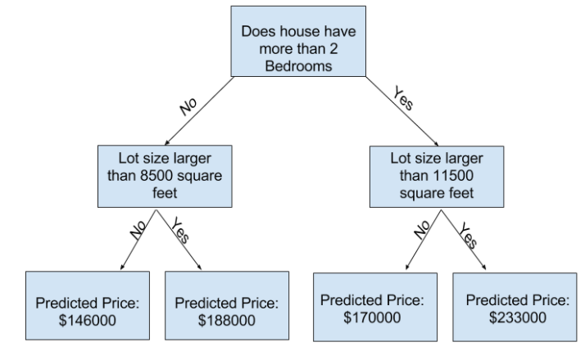
The splits and values at the leaves will be determined by the data, so it's time for you to check out the data you will be working with.

Continue
Let's get more specific. It's time toExamine Your Data.

2. BASIC DATA EXPLORATION

2.1 COURS

Using Pandas to Get Familiar With Your Data
The first step in any machine learning project is familiarize yourself with the data. You'll use the Pandas library for this. Pandas is the primary tool data scientists use for exploring and manipulating data. Most people abbreviate pandas in their code aspd. We do this with the command
In[1]:
import pandas as pd
The most important part of the Pandas library is the DataFrame. A DataFrame holds the type of data you might think of as a table. This is similar to a sheet in Excel, or a table in a SQL database.
Pandas has powerful methods for most things you'll want to do with this type of data.
As an example, we'll look at data about home prices in Melbourne, Australia. In the hands-on exercises, you will apply the same processes to a new dataset, which has home prices in Iowa.
The example (Melbourne) data is at the file path../input/melbourne-housing-snapshot/melb_data.csv.
We load and explore the data with the following commands:
In[2]:
# save filepath to variable for easier access
melbourne_file_path = '../input/melbourne-housing-snapshot/melb_data.csv'
# read the data and store data in DataFrame titled melbourne_data
melbourne_data = pd.read_csv(melbourne_file_path)
# print a summary of the data in Melbourne data
melbourne_data.describe()
Out[2]:
 | Rooms | Price | Distance | Postcode | Bedroom2 | Bathroom | Car | Landsize | BuildingArea | YearBuilt | Lattitude | Longtitude | Propertycount
count | 13580.000000 | 1.358000e+04 | 13580.000000 | 13580.000000 | 13580.000000 | 13580.000000 | 13518.000000 | 13580.000000 | 7130.000000 | 8205.000000 | 13580.000000 | 13580.000000 | 13580.000000
mean | 2.937997 | 1.075684e+06 | 10.137776 | 3105.301915 | 2.914728 | 1.534242 | 1.610075 | 558.416127 | 151.967650 | 1964.684217 | -37.809203 | 144.995216 | 7454.417378
std | 0.955748 | 6.393107e+05 | 5.868725 | 90.676964 | 0.965921 | 0.691712 | 0.962634 | 3990.669241 | 541.014538 | 37.273762 | 0.079260 | 0.103916 | 4378.581772
min | 1.000000 | 8.500000e+04 | 0.000000 | 3000.000000 | 0.000000 | 0.000000 | 0.000000 | 0.000000 | 0.000000 | 1196.000000 | -38.182550 | 144.431810 | 249.000000
25% | 2.000000 | 6.500000e+05 | 6.100000 | 3044.000000 | 2.000000 | 1.000000 | 1.000000 | 177.000000 | 93.000000 | 1940.000000 | -37.856822 | 144.929600 | 4380.000000
50% | 3.000000 | 9.030000e+05 | 9.200000 | 3084.000000 | 3.000000 | 1.000000 | 2.000000 | 440.000000 | 126.000000 | 1970.000000 | -37.802355 | 145.000100 | 6555.000000
75% | 3.000000 | 1.330000e+06 | 13.000000 | 3148.000000 | 3.000000 | 2.000000 | 2.000000 | 651.000000 | 174.000000 | 1999.000000 | -37.756400 | 145.058305 | 10331.000000
max | 10.000000 | 9.000000e+06 | 48.100000 | 3977.000000 | 20.000000 | 8.000000 | 10.000000 | 433014.000000 | 44515.000000 | 2018.000000 | -37.408530 | 145.526350 | 21650.000000

Interpreting Data Description
The results show 8 numbers for each column in your original dataset. The first number, the count, shows how many rows have non-missing values.
Missing values arise for many reasons. For example, the size of the 2nd bedroom wouldn't be collected when surveying a 1 bedroom house. We'll come back to the topic of missing data.
The second value is the mean, which is the average. Under that,s td is the standard deviation, which measures how numerically spread out the values are.
To interpret the min, 25%, 50%, 75% and maxvalues, imagine sorting each column from lowest to highest value. The first (smallest) value is the min. If you go a quarter way through the list, you'll find a number that is bigger than 25% of the values and smaller than 75% of the values. That is the25%value (pronounced "25th percentile"). The 50th and 75th percentiles are defined analogously, and the max is the largest number.

2.2 EXERCICES
This exercise will test your ability to read a data file and understand statistics about the data.
In later exercises, you will apply techniques to filter the data, build a machine learning model, and iteratively improve your model.
The course examples use data from Melbourne. To ensure you can apply these techniques on your own, you will have to apply them to a new dataset (with house prices from Iowa).

Step 1: Loading Data
Read the Iowa data file into a Pandas DataFrame called home_data.

# Path of the file to read
iowa_file_path = '../input/home-data-for-ml-course/train.csv'

# Fill in the line below to read the file into a variable home_data
home_data = pd.read_csv(iowa_file_path)

Step 2: Review The Data
Use the command you learned to view summary statistics of the data. Then fill in variables to answer the following questions

# Print summary statistics in next line
home_data.describe()
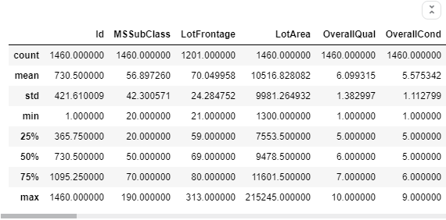
# What is the average lot size (rounded to nearest integer)?
home_data['LotArea'].describe()

round(home_data['LotArea'].mean())
avg_lot_size = 10517

# As of today, how old is the newest home (current year - the date in which it was built)
2020-home_data['YearBuilt'].max()
newest_home_age = 10

# Checks your answers
step_2.check()

Solution:
# using data read from home_data.describe()
avg_lot_size = 10517
newest_home_age = 8

Think About Your Data
The newest house in your data isn't that new. A few potential explanations for this:
- They haven't built new houses where this data was collected.
- The data was collected a long time ago. Houses built after the data publication wouldn't show up.
If the reason is explanation #1 above, does that affect your trust in the model you build with this data? What about if it is reason #2?
How could you dig into the data to see which explanation is more plausible?
Check out this discussion thread to see what others think or to add your ideas.

3. YOUR FIRST MACHINE LEARNING MODEL

3.1 COURS

Selecting Data for Modeling
Your dataset had too many variables to wrap your head around, or even to print out nicely. How can you pare down this overwhelming amount of data to something you can understand?
We'll start by picking a few variables using our intuition. Later courses will show you statistical techniques to automatically prioritize variables.
To choose variables/columns, we'll need to see a list of all columns in the dataset. That is done with the columns property of the DataFrame (the bottom line of code below).
In[1]:
import pandas as pd

melbourne_file_path = '../input/melbourne-housing-snapshot/melb_data.csv'
melbourne_data = pd.read_csv(melbourne_file_path)
melbourne_data.columns
Out[1]:
Index(['Suburb', 'Address', 'Rooms', 'Type', 'Price', 'Method', 'SellerG',
'Date', 'Distance', 'Postcode', 'Bedroom2', 'Bathroom', 'Car',
'Landsize', 'BuildingArea', 'YearBuilt', 'CouncilArea', 'Lattitude',
'Longtitude', 'Regionname', 'Propertycount'],
dtype='object')
In[2]:
# The Melbourne data has some missing values (some houses for which some variables weren't recorded.)
# We'll learn to handle missing values in a later tutorial.
# Your Iowa data doesn't have missing values in the columns you use.
# So we will take the simplest option for now, and drop houses from our data.
# Don't worry about this much for now, though the code is:

# dropna drops missing values (think of na as "not available")
melbourne_data = melbourne_data.dropna(axis=0)
There are many ways to select a subset of your data. The Pandas Micro-Course covers these in more depth, but we will focus on two approaches for now.
- Dot notation, which we use to select the "prediction target"
- Selecting with a column list, which we use to select the "features"

Selecting The Prediction Target
You can pull out a variable with dot-notation. This single column is stored in a Series, which is broadly like a DataFrame with only a single column of data.
We'll use the dot notation to select the column we want to predict, which is called the prediction target. By convention, the prediction target is calledy. So the code we need to save the house prices in the Melbourne data is
In[3]:
y = melbourne_data.Price

Choosing "Features"
The columns that are inputted into our model (and later used to make predictions) are called "features." In our case, those would be the columns used to determine the home price. Sometimes, you will use all columns except the target as features. Other times you'll be better off with fewer features.
For now, we'll build a model with only a few features. Later on you'll see how to iterate and compare models built with different features.
We select multiple features by providing a list of column names inside brackets. Each item in that list should be a string (with quotes).
Here is an example:
In[4]:
melbourne_features = ['Rooms', 'Bathroom', 'Landsize', 'Lattitude', 'Longtitude']
By convention, this data is called X.
In[5]:
X = melbourne_data[melbourne_features]
Let's quickly review the data we'll be using to predict house prices using thedescribemethod and theheadmethod, which shows the top few rows.
In[6]:
X.describe()
Out[6]:
 | Rooms | Bathroom | Landsize | Lattitude | Longtitude
count | 6196.000000 | 6196.000000 | 6196.000000 | 6196.000000 | 6196.000000
mean | 2.931407 | 1.576340 | 471.006940 | -37.807904 | 144.990201
std | 0.971079 | 0.711362 | 897.449881 | 0.075850 | 0.099165
min | 1.000000 | 1.000000 | 0.000000 | -38.164920 | 144.542370
25% | 2.000000 | 1.000000 | 152.000000 | -37.855438 | 144.926198
50% | 3.000000 | 1.000000 | 373.000000 | -37.802250 | 144.995800
75% | 4.000000 | 2.000000 | 628.000000 | -37.758200 | 145.052700
max | 8.000000 | 8.000000 | 37000.000000 | -37.457090 | 145.526350
In[7]:
X.head()
Out[7]:
 | Rooms | Bathroom | Landsize | Lattitude | Longtitude
1 | 2 | 1.0 | 156.0 | -37.8079 | 144.9934
2 | 3 | 2.0 | 134.0 | -37.8093 | 144.9944
4 | 4 | 1.0 | 120.0 | -37.8072 | 144.9941
6 | 3 | 2.0 | 245.0 | -37.8024 | 144.9993
7 | 2 | 1.0 | 256.0 | -37.8060 | 144.9954
Visually checking your data with these commands is an important part of a data scientist's job. You'll frequently find surprises in the dataset that deserve further inspection.

Building Your Model
You will use thes cikit-learn library to create your models. When coding, this library is written as sklearn, as you will see in the sample code. Scikit-learn is easily the most popular library for modeling the types of data typically stored in DataFrames.
The steps to building and using a model are:
- Define :What type of model will it be? A decision tree? Some other type of model? Some other parameters of the model type are specified too.
- Fit :Capture patterns from provided data. This is the heart of modeling.
- Predict :Just what it sounds like
- Evaluate : Determine how accurate the model's predictions are.
Here is an example of defining a decision tree model with scikit-learn and fitting it with the features and target variable.
In[8]:
from sklearn.tree import DecisionTreeRegressor

# Define model. Specify a number for random_state to ensure same results each run
melbourne_model = DecisionTreeRegressor(random_state=1)

# Fit model
melbourne_model.fit(X, y)
Out[8]:
DecisionTreeRegressor(random_state=1)
Many machine learning models allow some randomness in model training. Specifying a number forrandom_stateensures you get the same results in each run. This is considered a good practice. You use any number, and model quality won't depend meaningfully on exactly what value you choose.
We now have a fitted model that we can use to make predictions.
In practice, you'll want to make predictions for new houses coming on the market rather than the houses we already have prices for. But we'll make predictions for the first few rows of the training data to see how the predict function works.
In[9]:
print("Making predictions for the following 5 houses:")
print(X.head())
print("The predictions are")
print(melbourne_model.predict(X.head()))
Making predictions for the following 5 houses:
Rooms Bathroom Landsize Lattitude Longtitude
1 2 1.0 156.0 -37.8079 144.9934
2 3 2.0 134.0 -37.8093 144.9944
4 4 1.0 120.0 -37.8072 144.9941
6 3 2.0 245.0 -37.8024 144.9993
7 2 1.0 256.0 -37.8060 144.9954
The predictions are
[1035000. 1465000. 1600000. 1876000. 1636000.]

3.2 EXERCICES

# Code you have previously used to load data
import pandas as pd

# Path of the file to read
iowa_file_path = '../input/home-data-for-ml-course/train.csv'

home_data = pd.read_csv(iowa_file_path)

Step 1: Specify Prediction Target
Select the target variable, which corresponds to the sales price. Save this to a new variable called y. You'll need to print a list of the columns to find the name of the column you need.
# print the list of columns in the dataset to find the name of the prediction target
home_data.columns

y = home_data.SalePrice

Step 2: Create X
Now you will create a DataFrame called X holding the predictive features.
Since you want only some columns from the original data, you'll first create a list with the names of the columns you want in X.
You'll use just the following columns in the list (you can copy and paste the whole list to save some typing, though you'll still need to add quotes):
* LotArea
* YearBuilt
* 1stFlrSF
* 2ndFlrSF
* FullBath
* BedroomAbvGr
* TotRmsAbvGrd
After you've created that list of features, use it to create the DataFrame that you'll use to fit the model.

# Create the list of features below
feature_names = ["LotArea", "YearBuilt", "1stFlrSF", "2ndFlrSF",
"FullBath", "BedroomAbvGr", "TotRmsAbvGrd"]

# Select data corresponding to features in feature_names
X = home_data[feature_names]

Review Data
Before building a model, take a quick look at X to verify it looks sensible

# Review data
# print description or statistics from X
print(X.describe())

# print the top few lines
print(X.head())

Step 3: Specify and Fit Model
Create a DecisionTreeRegressor and save it iowa_model. Ensure you've done the relevant import from sklearn to run this command.
Then fit the model you just created using the data in X and y that you saved above.

from sklearn.tree import DecisionTreeRegressor
#specify the model.
#For model reproducibility, set a numeric value for random_state when specifying the model
iowa_model = DecisionTreeRegressor(random_state=1)

# Fit the model
iowa_model.fit(X, y)

Step 4: Make Predictions
Make predictions with the model's predict command using X as the data. Save the results to a variable called predictions.

predictions = iowa_model.predict(X)
print(predictions)

Think About Your Results
Use the head method to compare the top few predictions to the actual home values (in y) for those same homes. Anything surprising?

print(y.head())
print(predictions)
for i in range(5):
print('Maison : ',i, ' - Prix réel : ', y[i],
'Prix prédit :', predictions[i])

Maison : 1 - Prix réel : 181500 Prix prédit : 181500.0

4. MODEL VALIDATION

4.1 COURS
You've built a model. But how good is it?
In this lesson, you will learn to use model validation to measure the quality of your model. Measuring model quality is the key to iteratively improving your models.

What is Model Validation
You'll want to evaluate almost every model you ever build. In most (though not all) applications, the relevant measure of model quality is predictive accuracy. In other words, will the model's predictions be close to what actually happens.
Many people make a huge mistake when measuring predictive accuracy. They make predictions with their training data and compare those predictions to the target values in the training data. You'll see the problem with this approach and how to solve it in a moment, but let's think about how we'd do this first.
You'd first need to summarize the model quality into an understandable way. If you compare predicted and actual home values for 10,000 houses, you'll likely find mix of good and bad predictions. Looking through a list of 10,000 predicted and actual values would be pointless. We need to summarize this into a single metric.
There are many metrics for summarizing model quality, but we'll start with one called Mean Absolute Error (also called MAE). Let's break down this metric starting with the last word, error.
The prediction error for each house is:
error=actual−predicted
So, if a house cost $150,000 and you predicted it would cost $100,000 the error is $50,000.
With the MAE metric, we take the absolute value of each error. This converts each error to a positive number. We then take the average of those absolute errors. This is our measure of model quality. In plain English, it can be said as
On average, our predictions are off by about X.
To calculate MAE, we first need a model. That is built in a hidden cell below, which you can review by clicking the code button.
Output
Code
Once we have a model, here is how we calculate the mean absolute error:
In [2]:
from sklearn.metrics import mean_absolute_error

predicted_home_prices = melbourne_model.predict(X)
mean_absolute_error(y, predicted_home_prices)
Out[2]:
434.71594577146544

The Problem with "In-Sample" Scores
The measure we just computed can be called an "in-sample" score. We used a single "sample" of houses for both building the model and evaluating it. Here's why this is bad.
Imagine that, in the large real estate market, door color is unrelated to home price.
However, in the sample of data you used to build the model, all homes with green doors were very expensive. The model's job is to find patterns that predict home prices, so it will see this pattern, and it will always predict high prices for homes with green doors.
Since this pattern was derived from the training data, the model will appear accurate in the training data.
But if this pattern doesn't hold when the model sees new data, the model would be very inaccurate when used in practice.
Since models' practical value come from making predictions on new data, we measure performance on data that wasn't used to build the model. The most straightforward way to do this is to exclude some data from the model-building process, and then use those to test the model's accuracy on data it hasn't seen before. This data is called validation data.

Coding It
The scikit-learn library has a function train_test_split to break up the data into two pieces. We'll use some of that data as training data to fit the model, and we'll use the other data as validation data to calculate mean_absolute_error.
Here is the code:
In [3]:
from sklearn.model_selection import train_test_split

# split data into training and validation data, for both features and target
# The split is based on a random number generator. Supplying a numeric value to
# the random_state argument guarantees we get the same split every time we
# run this script.
train_X, val_X, train_y, val_y = train_test_split(X, y, random_state = 0)
# Define model
melbourne_model = DecisionTreeRegressor()
# Fit model
melbourne_model.fit(train_X, train_y)

# get predicted prices on validation data
val_predictions = melbourne_model.predict(val_X)
print(mean_absolute_error(val_y, val_predictions))
263007.8766946417

Wow!
Your mean absolute error for the in-sample data was about 500 dollars. Out-of-sample it is more than 250,000 dollars.
This is the difference between a model that is almost exactly right, and one that is unusable for most practical purposes. As a point of reference, the average home value in the validation data is 1.1 million dollars. So the error in new data is about a quarter of the average home value.
There are many ways to improve this model, such as experimenting to find better features or different model types.

4.2 EXERCICES

import pandas as pd
from sklearn.tree import DecisionTreeRegressor

# Path of the file to read
iowa_file_path = '../input/home-data-for-ml-course/train.csv'

home_data = pd.read_csv(iowa_file_path)
y = home_data.SalePrice
feature_columns = ['LotArea', 'YearBuilt', '1stFlrSF', '2ndFlrSF', 'FullBath', 'BedroomAbvGr', 'TotRmsAbvGrd']
X = home_data[feature_columns]

# Specify Model
iowa_model = DecisionTreeRegressor()
# Fit Model
iowa_model.fit(X, y)

print("First in-sample predictions:", iowa_model.predict(X.head()))
print("Actual target values for those homes:", y.head().tolist())

Step 1: Split Your Data
Use the train_test_split function to split up your data.
Give it the argument random_state=1 so the check functions know what to expect when verifying your code.
Recall, your features are loaded in the DataFrame X and your target is loaded in y.

# Import the train_test_split function and uncomment
from sklearn.model_selection import train_test_split

# fill in and uncomment
train_X, val_X, train_y, val_y = train_test_split(X, y, random_state=1)

Step 2: Specify and Fit the Model
Create a DecisionTreeRegressor model and fit it to the relevant data. Set random_state to 1 again when creating the model.

# You imported DecisionTreeRegressor in your last exercise
# and that code has been copied to the setup code above. So, no need to
from sklearn.tree import DecisionTreeRegressor

# Specify the model
iowa_model = DecisionTreeRegressor(random_state=1)

# Fit iowa_model with the training data.
iowa_model.fit(train_X, train_y)

Step 3: Make Predictions with Validation data
# Predict with all validation observations
val_predictions = iowa_model.predict(val_X)

Inspect your predictions and actual values from validation data.

Step 4: Calculate the Mean Absolute Error in Validation Data
from sklearn.metrics import mean_absolute_error
val_mae = mean_absolute_error(val_predictions, val_y)

# uncomment following line to see the validation_mae
print(val_mae)

Is that MAE good? There isn't a general rule for what values are good that applies across applications. But you'll see how to use (and improve) this number in the next step.

Non ==> il faut améliorer le programme

5. UNDERFITTING AND OVEFITTING

5.1 COURS
At the end of this step, you will understand the concepts of underfitting and overfitting, and you will be able to apply these ideas to make your models more accurate.

Experimenting With Different Models
Now that you have a reliable way to measure model accuracy, you can experiment with alternative models and see which gives the best predictions. But what alternatives do you have for models?
You can see in scikit-learn's documentation that the decision tree model has many options (more than you'll want or need for a long time). The most important options determine the tree's depth. Recall from the first lesson in this micro-course that a tree's depth is a measure of how many splits it makes before coming to a prediction. This is a relatively shallow tree
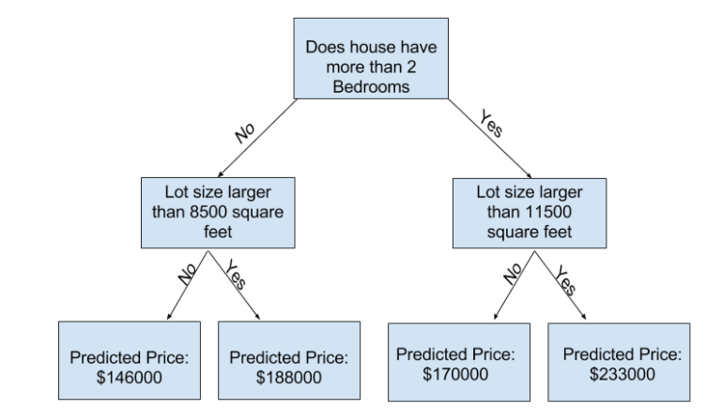
In practice, it's not uncommon for a tree to have 10 splits between the top level (all houses) and a leaf. As the tree gets deeper, the dataset gets sliced up into leaves with fewer houses. If a tree only had 1 split, it divides the data into 2 groups. If each group is split again, we would get 4 groups of houses. Splitting each of those again would create 8 groups. If we keep doubling the number of groups by adding more splits at each level, we'll have 210210 groups of houses by the time we get to the 10th level. That's 1024 leaves.
When we divide the houses amongst many leaves, we also have fewer houses in each leaf. Leaves with very few houses will make predictions that are quite close to those homes' actual values, but they may make very unreliable predictions for new data (because each prediction is based on only a few houses).
This is a phenomenon called overfitting, where a model matches the training data almost perfectly, but does poorly in validation and other new data. On the flip side, if we make our tree very shallow, it doesn't divide up the houses into very distinct groups.
At an extreme, if a tree divides houses into only 2 or 4, each group still has a wide variety of houses. Resulting predictions may be far off for most houses, even in the training data (and it will be bad in validation too for the same reason). When a model fails to capture important distinctions and patterns in the data, so it performs poorly even in training data, that is called underfitting.
Since we care about accuracy on new data, which we estimate from our validation data, we want to find the sweet spot between underfitting and overfitting. Visually, we want the low point of the (red) validation curve in

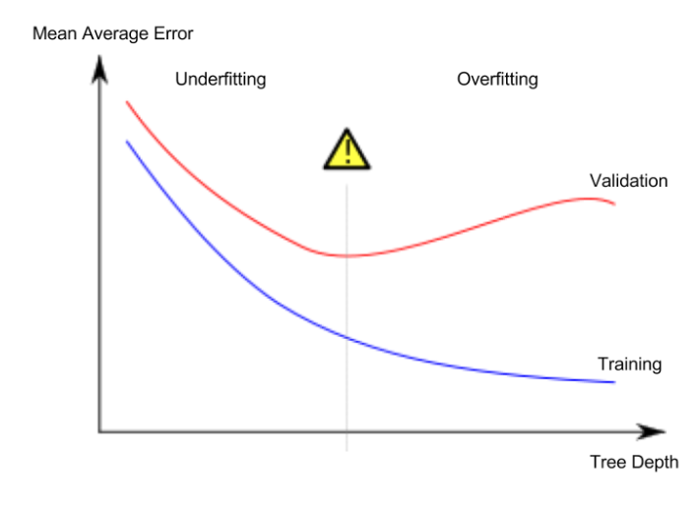
Example
There are a few alternatives for controlling the tree depth, and many allow for some routes through the tree to have greater depth than other routes. But the max_leaf_nodes argument provides a very sensible way to control overfitting vs underfitting. The more leaves we allow the model to make, the more we move from the underfitting area in the above graph to the overfitting area.
We can use a utility function to help compare MAE scores from different values for max_leaf_nodes:
In [1]:
from sklearn.metrics import mean_absolute_error
from sklearn.tree import DecisionTreeRegressor

def get_mae(max_leaf_nodes, train_X, val_X, train_y, val_y):
model = DecisionTreeRegressor(max_leaf_nodes=max_leaf_nodes, random_state=0)
model.fit(train_X, train_y)
preds_val = model.predict(val_X)
mae = mean_absolute_error(val_y, preds_val)
return(mae)
The data is loaded into train_X, val_X, train_y and val_y using the code you've already seen (and which you've already written).
Code
We can use a for-loop to compare the accuracy of models built with different values for max_leaf_nodes.
In [3]:
# compare MAE with differing values of max_leaf_nodes
for max_leaf_nodes in [5, 50, 500, 5000]:
my_mae = get_mae(max_leaf_nodes, train_X, val_X, train_y, val_y)
print("Max leaf nodes: %d \t\t Mean Absolute Error: %d" %(max_leaf_nodes, my_mae))
Max leaf nodes: 5 Mean Absolute Error: 347380
Max leaf nodes: 50 Mean Absolute Error: 258171
Max leaf nodes: 500 Mean Absolute Error: 243495
Max leaf nodes: 5000 Mean Absolute Error: 254983
Of the options listed, 500 is the optimal number of leaves.

Conclusion
Here's the takeaway: Models can suffer from either:
- Overfitting: capturing spurious patterns that won't recur in the future, leading to less accurate predictions, or
- Underfitting: failing to capture relevant patterns, again leading to less accurate predictions.
We use validation data, which isn't used in model training, to measure a candidate model's accuracy. This lets us try many candidate models and keep the best one.

5.2 EXERCICES
You could write the function get_mae yourself. For now, we'll supply it. This is the same function you read about in the previous lesson. Just run the cell below.

def get_mae(max_leaf_nodes, train_X, val_X, train_y, val_y):
model = DecisionTreeRegressor(max_leaf_nodes=max_leaf_nodes, random_state=0)
model.fit(train_X, train_y)
preds_val = model.predict(val_X)
mae = mean_absolute_error(val_y, preds_val)
return(mae)

Step 1: Compare Different Tree Sizes
Write a loop that tries the following values for max_leaf_nodes from a set of possible values.
Call the get_mae function on each value of max_leaf_nodes. Store the output in some way that allows you to select the value of max_leaf_nodes that gives the most accurate model on your data.

candidate_max_leaf_nodes = [5, 25, 50, 100, 250, 500]
# Write loop to find the ideal tree size from candidate_max_leaf_nodes
scores = {leaf_size: get_mae(leaf_size, train_X, val_X, train_y, val_y) for leaf_size in candidate_max_leaf_nodes}

# Store the best value of max_leaf_nodes (it will be either 5, 25, 50, 100, 250 or 500)
best_tree_size = min(scores, key=scores.get)

Step 2: Fit Model Using All Data
You know the best tree size. If you were going to deploy this model in practice, you would make it even more accurate by using all of the data and keeping that tree size. That is, you don't need to hold out the validation data now that you've made all your modeling decisions.

# Fill in argument to make optimal size and uncomment
final_model = DecisionTreeRegressor(max_leaf_nodes=best_tree_size, random_state=1)

# fit the final model and uncomment the next two lines
final_model.fit(X,y)

6. RANDOM FORESTS

6.1 COURS

Introduction
Decision trees leave you with a difficult decision. A deep tree with lots of leaves will overfit because each prediction is coming from historical data from only the few houses at its leaf. But a shallow tree with few leaves will perform poorly because it fails to capture as many distinctions in the raw data.
Even today's most sophisticated modeling techniques face this tension between underfitting and overfitting. But, many models have clever ideas that can lead to better performance. We'll look at the random forest as an example.
The random forest uses many trees, and it makes a prediction by averaging the predictions of each component tree. It generally has much better predictive accuracy than a single decision tree and it works well with default parameters. If you keep modeling, you can learn more models with even better performance, but many of those are sensitive to getting the right parameters.

Example
You've already seen the code to load the data a few times. At the end of data-loading, we have the following variables:
- train_X
- val_X
- train_y
- val_y
Code
We build a random forest model similarly to how we built a decision tree in scikit-learn - this time using the RandomForestRegressor class instead of DecisionTreeRegressor.
In [2]:
from sklearn.ensemble import RandomForestRegressor
from sklearn.metrics import mean_absolute_error

forest_model = RandomForestRegressor(random_state=1)
forest_model.fit(train_X, train_y)
melb_preds = forest_model.predict(val_X)
print(mean_absolute_error(val_y, melb_preds))
191669.7536453626

Conclusion
There is likely room for further improvement, but this is a big improvement over the best decision tree error of 250,000. There are parameters which allow you to change the performance of the Random Forest much as we changed the maximum depth of the single decision tree. But one of the best features of Random Forest models is that they generally work reasonably even without this tuning.

6.2 EXERCICES

import pandas as pd
from sklearn.metrics import mean_absolute_error
from sklearn.model_selection import train_test_split
from sklearn.tree import DecisionTreeRegressor

# Path of the file to read
iowa_file_path = '../input/home-data-for-ml-course/train.csv'

home_data = pd.read_csv(iowa_file_path)
# Create target object and call it y
y = home_data.SalePrice
# Create X
features = ['LotArea', 'YearBuilt', '1stFlrSF', '2ndFlrSF', 'FullBath', 'BedroomAbvGr', 'TotRmsAbvGrd']
X = home_data[features]

# Split into validation and training data
train_X, val_X, train_y, val_y = train_test_split(X, y, random_state=1)

# Specify Model
iowa_model = DecisionTreeRegressor(random_state=1)
# Fit Model
iowa_model.fit(train_X, train_y)

# Make validation predictions and calculate mean absolute error
val_predictions = iowa_model.predict(val_X)
val_mae = mean_absolute_error(val_predictions, val_y)
print("Validation MAE when not specifying max_leaf_nodes: {:,.0f}".format(val_mae))

# Using best value for max_leaf_nodes
iowa_model = DecisionTreeRegressor(max_leaf_nodes=100, random_state=1)
iowa_model.fit(train_X, train_y)
val_predictions = iowa_model.predict(val_X)
val_mae = mean_absolute_error(val_predictions, val_y)
print("Validation MAE for best value of max_leaf_nodes: {:,.0f}".format(val_mae))

Data science isn't always this easy. But replacing the decision tree with a Random Forest is going to be an easy win.

Step 1: Use a Random Forest

# Define the model. Set random_state to 1
rf_model = RandomForestRegressor(random_state=1)

# fit your model
rf_model.fit(train_X, train_y)

# Calculate the mean absolute error of your Random Forest model on the validation data
rf_y_pred = rf_model.predict(val_X)
rf_val_mae = mean_absolute_error(val_y, rf_y_pred)

print("Validation MAE for Random Forest Model: {}".format(rf_val_mae))

7. MACHINE LEARNING COMPETITIONS

7.1 COURS
Machine learning competitions are a great way to improve your data science skills and measure your progress.
In the next exercise, you will create and submit predictions for the House Prices Competition for Kaggle Learn Users.



7.2 EXERCICES

Introduction
In this exercise, you will create and submit predictions for a Kaggle competition. You can then improve your model (e.g. by adding features) to improve and see how you stack up to others taking this course.
The steps in this notebook are:
- Build a Random Forest model with all of your data (X and y).
- Read in the "test" data, which doesn't include values for the target. Predict home values in the test data with your Random Forest model.
- Submit those predictions to the competition and see your score.
- Optionally, come back to see if you can improve your model by adding features or changing your model. Then you can resubmit to see how that stacks up on the competition leaderboard.

# Code you have previously used to load data
import pandas as pd
from sklearn.ensemble import RandomForestRegressor
from sklearn.metrics import mean_absolute_error
from sklearn.model_selection import train_test_split
from sklearn.tree import DecisionTreeRegressor

# Set up code checking
import os
if not os.path.exists("../input/train.csv"):
os.symlink("../input/home-data-for-ml-course/train.csv", "../input/train.csv")
os.symlink("../input/home-data-for-ml-course/test.csv", "../input/test.csv")
from learntools.core import binder
binder.bind(globals())
from learntools.machine_learning.ex7 import *

# Path of the file to read. We changed the directory structure to simplify submitting to a competition
iowa_file_path = '../input/train.csv'

home_data = pd.read_csv(iowa_file_path)
# Create target object and call it y
y = home_data.SalePrice
# Create X
features = ['LotArea', 'YearBuilt', '1stFlrSF', '2ndFlrSF', 'FullBath', 'BedroomAbvGr', 'TotRmsAbvGrd']
X = home_data[features]

# Split into validation and training data
train_X, val_X, train_y, val_y = train_test_split(X, y, random_state=1)

# Specify Model
iowa_model = DecisionTreeRegressor(random_state=1)
# Fit Model
iowa_model.fit(train_X, train_y)

# Make validation predictions and calculate mean absolute error
val_predictions = iowa_model.predict(val_X)
val_mae = mean_absolute_error(val_predictions, val_y)
print("Validation MAE when not specifying max_leaf_nodes: {:,.0f}".format(val_mae))

# Using best value for max_leaf_nodes
iowa_model = DecisionTreeRegressor(max_leaf_nodes=100, random_state=1)
iowa_model.fit(train_X, train_y)
val_predictions = iowa_model.predict(val_X)
val_mae = mean_absolute_error(val_predictions, val_y)
print("Validation MAE for best value of max_leaf_nodes: {:,.0f}".format(val_mae))

# Define the model. Set random_state to 1
rf_model = RandomForestRegressor(random_state=1)
rf_model.fit(train_X, train_y)
rf_val_predictions = rf_model.predict(val_X)
rf_val_mae = mean_absolute_error(rf_val_predictions, val_y)

print("Validation MAE for Random Forest Model: {:,.0f}".format(rf_val_mae))

Validation MAE when not specifying max_leaf_nodes: 29,653
Validation MAE for best value of max_leaf_nodes: 27,283
Validation MAE for Random Forest Model: 21,857

Creating a Model For the Competition
Build a Random Forest model and train it on all of X and y.

# To improve accuracy, create a new Random Forest model which you will train on all training data
rf_model_on_full_data = RandomForestRegressor()

# fit rf_model_on_full_data on all data from the training data
rf_model_on_full_data.fit(X, y)

RandomForestRegressor()

Make Predictions
Read the file of "test" data. And apply your model to make predictions
# path to file you will use for predictions
test_data_path = '../input/test.csv'

# read test data file using pandas
test_data = pd.read_csv(test_data_path)

# create test_X which comes from test_data but includes only the columns you used for prediction.
# The list of columns is stored in a variable called features
test_X = test_data[features]

# make predictions which we will submit.
test_preds = rf_model.predict(test_X)

# The lines below shows how to save predictions in format used for competition scoring
# Just uncomment them.

output = pd.DataFrame({'Id': test_data.Id,
'SalePrice': test_preds})
output.to_csv('submission.csv', index=False)

Solution:
# In previous code cell
rf_model_on_full_data = RandomForestRegressor()
rf_model_on_full_data.fit(X, y)

# Then in last code cell
test_data_path = '../input/home-data-for-ml-course/test.csv'
test_data = pd.read_csv(test_data_path)
test_X = test_data[features]
test_preds = rf_model_on_full_data.predict(test_X)

output = pd.DataFrame({'Id': test_data.Id,
'SalePrice': test_preds})
output.to_csv('submission.csv', index=False)

Test Your Work
To test your results, you'll need to join the competition (if you haven't already). So open a new window by clicking on this link. Then click on the Join Competition button.

Next, follow the instructions below:
- Begin by clicking on the blue Save Version button in the top right corner of the window. This will generate a pop-up window.
- Ensure that the Save and Run All option is selected, and then click on the blue Save button.
- This generates a window in the bottom left corner of the notebook. After it has finished running, click on the number to the right of the Save Version button. This pulls up a list of versions on the right of the screen. Click on the ellipsis (...) to the right of the most recent version, and select Open in Viewer. This brings you into view mode of the same page. You will need to scroll down to get back to these instructions.
- Click on the Output tab on the right of the screen. Then, click on the blue Submit button to submit your results to the leaderboard.
You have now successfully submitted to the competition!
If you want to keep working to improve your performance, select the blue Edit button in the top right of the screen. Then you can change your code and repeat the process. There's a lot of room to improve, and you will climb up the leaderboard as you work.

Continuing Your Progress
There are many ways to improve your model, and experimenting is a great way to learn at this point.
The best way to improve your model is to add features. Look at the list of columns and think about what might affect home prices. Some features will cause errors because of issues like missing values or non-numeric data types.
The Intermediate Machine Learning course will teach you how to handle these types of features. You will also learn to use xgboost, a technique giving even better accuracy than Random Forest.

Other Courses
The Pandas course will give you the data manipulation skills to quickly go from conceptual idea to implementation in your data science projects.
You are also ready for the Deep Learning course, where you will build models with better-than-human level performance at computer vision tasks.

8. BONUS – INTRO TO AUTOML

8.1 COURS

Introduction
When applying machine learning to real-world data, there are a lot of steps involved in the process -- starting with collecting the data and ending with generating predictions. (We work with the seven steps of machine learning, as defined by Yufeng Guo here.)
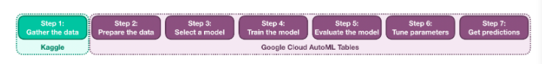
It all begins with Step 1: Gather the data. In industry, there are important considerations you need to take into account when building a dataset, such as target leakage. When participating in a Kaggle competition, this step is already completed for you.
In the Intro to Machine Learning and the Intermediate Machine Learning courses, you can learn how to:
- Step 2: Prepare the data - Deal with missing values and categorical data. (Feature engineering is covered in a separate course.)
- Step 4: Train the model - Fit decision trees and random forests to patterns in training data.
- Step 5: Evaluate the model - Use a validation set to assess how well a trained model performs on unseen data.
- Step 6: Tune parameters - Tune parameters to get better performance from XGBoost models.
- Step 7: Get predictions - Generate predictions with a trained model and submit your results to a Kaggle competition.
That leaves Step 3: Select a model. There are a lot of different types of models. Which one should you select for your problem? When you're just getting started, the best option is just to try everything and build your own intuition - there aren't any universally accepted rules. There are also many useful Kaggle notebooks (like this one) where you can see how and when other Kagglers used different models.
Mastering the machine learning process involves a lot of time and practice. While you're still learning, you can turn to automated machine learning (AutoML) tools to generate intelligent predictions.

Automated machine learning (AutoML)
In this notebook, you'll learn how to use Google Cloud AutoML Tables to automate the machine learning process. While Kaggle has already taken care of the data collection, AutoML Tables will take care of all remaining steps.
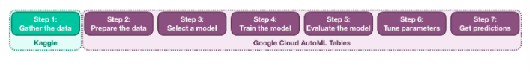
AutoML Tables is a paid service. In the exercise that follows this tutorial, we'll show you how to claim $300 of free credits that you can use to train your own models!
Note: This lesson is optional. It is not required to complete the Intro to Machine Learning course.

Code
We'll work with data from the New York City Taxi Fare Prediction competition. In this competition, we want you to predict the fare amount (inclusive of tolls) for a taxi ride in New York City, given the pickup and dropoff locations, number of passengers, and the pickup date and time.
To do this, we'll use a Python class that calls on AutoML Tables. To use this code, you need only define the following variables:
- PROJECT_ID - The name of your Google Cloud project. All of the work that you'll do in Google Cloud is organized in "projects".
- BUCKET_NAME - The name of your Google Cloud storage bucket. In order to work with AutoML, we'll need to create a storage bucket, where we'll upload the Kaggle dataset.
- DATASET_DISPLAY_NAME - The name of your dataset.
- TRAIN_FILEPATH - The filepath for the training data (train.csv file) from the competition.
- TEST_FILEPATH - The filepath for the test data (test.csv file) from the competition.
- TARGET_COLUMN - The name of the column in your training data that contains the values you'd like to predict.
- ID_COLUMN - The name of the column containing IDs.
- MODEL_DISPLAY_NAME - The name of your model.
- TRAIN_BUDGET - How long you want your model to train (use 1000 for 1 hour, 2000 for 2 hours, and so on).
All of these variables will make more sense when you run your own code in the following exercise!
Code
In [2]:
PROJECT_ID = 'kaggle-playground-170215'
BUCKET_NAME = 'automl-tutorial-alexis'

DATASET_DISPLAY_NAME = 'taxi_fare_dataset'
TRAIN_FILEPATH = "../working/train_small.csv"
TEST_FILEPATH = "../input/new-york-city-taxi-fare-prediction/test.csv"

TARGET_COLUMN = 'fare_amount'
ID_COLUMN = 'key'

MODEL_DISPLAY_NAME = 'tutorial_model'
TRAIN_BUDGET = 4000

# Import the class defining the wrapper
from automl_tables_wrapper import AutoMLTablesWrapper

# Create an instance of the wrapper
amw = AutoMLTablesWrapper(project_id=PROJECT_ID,
bucket_name=BUCKET_NAME,
dataset_display_name=DATASET_DISPLAY_NAME,
train_filepath=TRAIN_FILEPATH,
test_filepath=TEST_FILEPATH,
target_column=TARGET_COLUMN,
id_column=ID_COLUMN,
model_display_name=MODEL_DISPLAY_NAME,
train_budget=TRAIN_BUDGET)
Preparing clients ...
Clients successfully created!
GCS bucket found.
File train.csv uploaded to train.csv.
File test.csv uploaded to test.csv.
Dataset found.
Set target column.
Set columns to nullable.
Ready to train model.
Next, we train a model and use it to generate predictions on the test dataset.
In [3]:
# Create and train the model
amw.train_model()

# Get predictions
amw.get_predictions()
Training model ...
Finished training model.
Getting predictions ...
Submission ready for download!
After completing these steps, we have a file that we can submit to the competition! In the code cell below, we load this submission file and view the first several rows.
In [4]:
submission_df = pd.read_csv("../working/submission.csv")
submission_df.head()
Out[4]:
 | key | fare_amount
0 | 2014-06-23 00:16:00.00000036 | 7.327863
1 | 2013-09-25 22:00:00.0000002 | 18.338501
2 | 2010-06-16 18:41:54.0000002 | 7.675639
3 | 2011-06-01 07:37:00.0000006 | 27.225105
4 | 2012-11-20 21:54:00.000000221 | 19.386213
And how well does it perform? Well, the competition provides a starter notebook with a simple linear model that predicts a fare amount based on the distance between the pickup and dropoff locations. This approach outperforms that notebook, and it ranks better than roughly half of the total submissions to the competition.

8.2 EXERCICES

9. BONUS – GETTING STARTED WITH TITANIC

9.1 COURS

9.2 EXERCICES

