Sommaire
Data Visualization 4
1. Hello, Seaborn 4
1.1 COURS 4
Welcome to Data Visualization! 4
Your coding environment 4
Set up the notebook 5
Load the data 5
Comments 6
Executable code 6
Examine the data 7
Plot the data 8
What's next? 8
1.2 EXERCICES 9
Step 1: Explore the feedback system 9
Step 2: Load the data 10
Step 3: Plot the data 11
2. Line Charts 13
2.1 COURS 13
Set up the notebook 13
Select a dataset 13
Load the data 14
Examine the data 14
Plot the data 16
Plot a subset of the data 17
What's next? 19
2.2 EXERCICES 20
Scenario 20
Step 1: Load the data 20
Step 2: Review the data 21
Step 3: Convince the museum board 22
Step 4: Assess seasonality 24
Part A 24
Part B 25
3. Bar Charts and Heatmaps 27
3.1 COURS 27
Set up the notebook 27
Select a dataset 27
Load the data 28
Examine the data 28
Bar chart 29
Heatmap 30
What's next? 32
3.2 EXERCICES 33
Scenario 33
Setup 33
Step 1: Load the data 33
Step 2: Review the data 34
Step 3: Which platform is best? 36
Part A 36
Part B 37
Step 4: All possible combinations! 38
Part A 38
Part B 40
4. Scatter Plots 41
4.1 COURS 41
Load and examine the data 41
Scatter plots 41
Color-coded scatter plots 43
What's next? 45
4.2 EXERCICES 46
Scenario 46
Setup 46
Step 1: Load the Data 46
Step 2: Review the data 46
Step 3: The role of sugar 48
Part A 48
Part B 48
Step 4: Take a closer look 49
Part A 49
Part B 49
Step 5: Chocolate! 50
Step 6: Investigate chocolate 50
Part A 50
Part B 51
Step 7: Everybody loves chocolate. 52
Part A 52
Part B 52
5. Distributions 54
5.1 COURS 54
Set up the notebook 54
Select a dataset 54
Load and examine the data 54
Histograms 55
Density plots 56
2D KDE plots 56
Color-coded plots 57
What's next? 59
5.2 EXERCICES 60
Scenario 60
Setup 60
Step 1: Load the data 60
Step 2: Review the data 61
Step 3: Investigating differences 62
Part A 62
Part B 63
Step 4: A very useful column 64
Part A 64
Part B 64
6. Choosing Plot Types and Custom Styles 66
6.1 COURS 66
What have you learned? 66
Changing styles with seaborn 67
What's next? 69
6.2 EXERCICES 70
Setup 70
Try out seaborn styles 70
7. Final Project 72
7.1 COURS 72
Kaggle Datasets 72
Use your own dataset 73
What's next? 73
7.2 EXERCICES 74
Setup 74
Step 1: Attach a dataset to the notebook 74
Step 2: Specify the filepath 75
Step 3: Load the data 76
Step 4: Visualize the data 76
8. Creating Your Own Notebook 78
8.1 COURS 78
Workflow 78

Data Visualization
Make great data visualizations. A great way to see the power of coding!

1. Hello, Seaborn

1.1 COURS

Welcome to Data Visualization!
In this hands-on micro-course, you'll learn how to take your data visualizations to the next level with seaborn, a powerful but easy-to-use data visualization tool. To use seaborn, you'll also learn a bit about how to write code in Python, a popular programming language. That said,
- the micro-course is aimed at those with no prior programming experience, and
- each chart uses short and simple code, making seaborn much faster and easier to use than many other data visualization tools (such as Excel, for instance).
So, if you've never written a line of code, and you want to learn the bare minimum to start making faster, more attractive plots today, you're in the right place! To take a peek at some of the charts you'll make, check out the figures below.

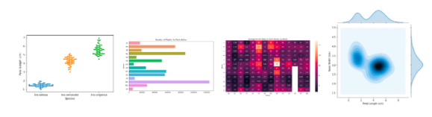
Your coding environment
Take the time now to scroll quickly up and down this page. You'll notice that there are a lot of different types of information, including:
- text (like the text you're reading right now!),
- code (which is always contained inside a gray box called a code cell), and
- code output (or the printed result from running code that always appears immediately below the corresponding code).
We refer to these pages as Jupyter notebooks (or, often just notebooks), and we'll work with them throughout the mini-course. Another example of a notebook can be found in the image below.
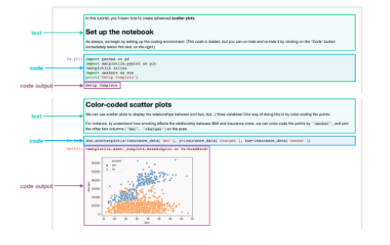
In the notebook you're reading now, we've already run all of the code for you. Soon, you will work with a notebook that allows you to write and run your own code!

Set up the notebook
There are a few lines of code that you'll need to run at the top of every notebook to set up your coding environment. It's not important to understand these lines of code now, and so we won't go into the details just yet. (Notice that it returns as output: Setup Complete.)
In [1]:
import pandas as pd
pd.plotting.register_matplotlib_converters()
import matplotlib.pyplot as plt
%matplotlib inline
import seaborn as sns
print("Setup Complete")
Setup Complete

Load the data
In this notebook, we'll work with a dataset of historical FIFA rankings for six countries: Argentina (ARG), Brazil (BRA), Spain (ESP), France (FRA), Germany (GER), and Italy (ITA). The dataset is stored as a CSV file (short for comma-separated values file. Opening the CSV file in Excel shows a row for each date, along with a column for each country.
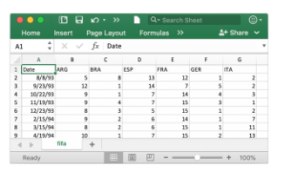
To load the data into the notebook, we'll use two distinct steps, implemented in the code cell below as follows:
- begin by specifying the location (or filepath) where the dataset can be accessed, and then
- use the filepath to load the contents of the dataset into the notebook.
In [2]:
# Path of the file to read
fifa_filepath = "../input/fifa.csv"

# Read the file into a variable fifa_data
fifa_data = pd.read_csv(fifa_filepath, index_col="Date", parse_dates=True)
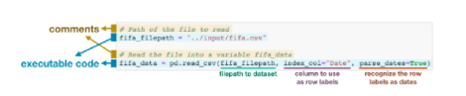
Note that the code cell above has four different lines.

Comments
Two of the lines are preceded by a pound sign (#) and contain text that appears faded and italicized.
Both of these lines are completely ignored by the computer when the code is run, and they only appear here so that any human who reads the code can quickly understand it. We refer to these two lines as comments, and it's good practice to include them to make sure that your code is readily interpretable.

Executable code
The other two lines are executable code, or code that is run by the computer (in this case, to find and load the dataset).
The first line sets the value of fifa_filepath to the location where the dataset can be accessed. In this case, we've provided the filepath for you (in quotation marks). Note that the comment immediately above this line of executable code provides a quick description of what it does!
The second line sets the value of fifa_data to contain all of the information in the dataset. This is done with pd.read_csv. It is immediately followed by three different pieces of text (underlined in the image above) that are enclosed in parentheses and separated by commas. These are used to customize the behavior when the dataset is loaded into the notebook:
- fifa_filepath - The filepath for the dataset always needs to be provided first.
- index_col="Date" - When we load the dataset, we want each entry in the first column to denote a different row. To do this, we set the value of index_col to the name of the first column ("Date", found in cell A1 of the file when it's opened in Excel).
- parse_dates=True - This tells the notebook to understand the each row label as a date (as opposed to a number or other text with a different meaning).
These details will make more sense soon, when you have a chance to load your own dataset in a hands-on exercise.
For now, it's important to remember that the end result of running both lines of code is that we can now access the dataset from the notebook by using fifa_data.
By the way, you might have noticed that these lines of code don't have any output (whereas the lines of code you ran earlier in the notebook returned Setup Complete as output). This is expected behavior -- not all code will return output, and this code is a prime example!

Examine the data
Now, we'll take a quick look at the dataset in fifa_data, to make sure that it loaded properly.
We print the first five rows of the dataset by writing one line of code as follows:
- begin with the variable containing the dataset (in this case, fifa_data), and then
- follow it with .head().
You can see this in the line of code below.
In [3]:
# Print the first 5 rows of the data
fifa_data.head()
Out[3]:
 | ARG | BRA | ESP | FRA | GER | ITA
Date
1993-08-08 | 5.0 | 8.0 | 13.0 | 12.0 | 1.0 | 2.0
1993-09-23 | 12.0 | 1.0 | 14.0 | 7.0 | 5.0 | 2.0
1993-10-22 | 9.0 | 1.0 | 7.0 | 14.0 | 4.0 | 3.0
1993-11-19 | 9.0 | 4.0 | 7.0 | 15.0 | 3.0 | 1.0
1993-12-23 | 8.0 | 3.0 | 5.0 | 15.0 | 1.0 | 2.0
Check now that the first five rows agree with the image of the dataset (from when we saw what it would look like in Excel) above.

Plot the data
In this micro-course, you'll learn about many different plot types. In many cases, you'll only need one line of code to make a chart!
For a sneak peak at what you'll learn, check out the code below that generates a line chart.
In [4]:
# Set the width and height of the figure
plt.figure(figsize=(16,6))

# Line chart showing how FIFA rankings evolved over time
sns.lineplot(data=fifa_data)
Out[4]:
<matplotlib.axes._subplots.AxesSubplot at 0x7f85ec3769d0>
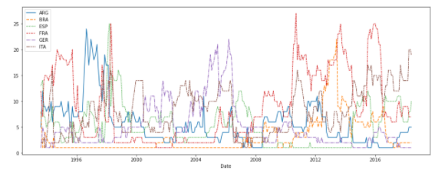
This code shouldn't make sense just yet, and you'll learn more about it in the upcoming tutorials. For now, continue to your first exercise, where you'll get a chance to experiment with the coding environment yourself!

What's next?
Write your first lines of code in the first coding exercise!

1.2 EXERCICES

In this exercise, you will write your first lines of code and learn how to use the coding environment for the micro-course!

The code cell below imports and configures the Python libraries that you need to complete the exercise.
Click on the cell and run it.

import pandas as pd
pd.plotting.register_matplotlib_converters()
import matplotlib.pyplot as plt
%matplotlib inline
import seaborn as sns

The code you just ran sets up the system to give you feedback on your work. You'll learn more about the feedback system in the next step.

Step 1: Explore the feedback system
Each exercise lets you test your new skills with a real-world dataset. Along the way, you'll receive feedback on your work. You'll see if your answer is right, get customized hints, and see the official solution (_if you'd like to take a look!_).
To explore the feedback system, we'll start with a simple example of a coding problem. Follow the following steps in order:
- Run the code cell below without making any edits. It will show the following output:
Check: When you've updated the starter code, check() will tell you whether your code is correct. You need to update the code that creates variable one
This means you need to change the code to set the variable one to something other than the blank provided below (____).
- Replace the underline with a 2, so that the line of code appears as one = 2. Then, run the code cell. This should return the following output:
Incorrect: Incorrect value for one: 2
This means we still have the wrong answer to the question.
- Now, change the 2 to 1, so that the line of code appears as one = 1. Then, run the code cell. The answer should be marked as Correct. You have now completed this problem!

# Fill in the line below
one = 1

n this exercise, you were responsible for filling in the line of code that sets the value of variable one. Don't edit the code that checks your answer. You'll need to run the lines of code like step_1.check() and step_2.check() just as they are provided.
This problem was relatively straightforward, but for more difficult problems, you may like to receive a hint or view the official solution. Run the code cell below now to receive both for this problem.

Hint: How many moons does Earth have?

Solution:
one = 1

Step 2: Load the data
You are ready to get started with some data visualization! You'll begin by loading the dataset from the previous tutorial.
The code you need is already provided in the cell below. Just run that cell. If it shows Correct result, you're ready to move on!

fifa_filepath = "../input/fifa.csv"

# Read the file into a variable fifa_data
fifa_data = pd.read_csv(fifa_filepath, index_col="Date", parse_dates=True)

Next, recall the difference between comments and executable code:
- Comments are preceded by a pound sign (#) and contain text that appear faded and italicized. They are completely ignored by the computer when the code is run.
- Executable code is code that is run by the computer.
In the code cell below, every line is a comment:

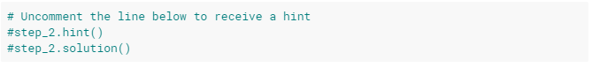
If you run the code cell below without making any changes, it won't return any output. Try this now!

# Uncomment the line below to receive a hint
step_2.hint()
# Uncomment the line below to see the solution
step_2.solution()

Hint: Use pd.read_csv, and follow it with three pieces of text that are enclosed in parentheses and separated by commas. (1) The filepath for the dataset is provided in fifa_filepath. (2) Use the "Date" column to label the rows. (3) Make sure that the row labels are recognized as dates.
Solution:
fifa_data = pd.read_csv(fifa_filepath, index_col="Date", parse_dates=True)

Next, remove the pound sign before step_2.hint() so that the code cell above appears as follows:
# Uncomment the line below to receive a hint
step_2.hint()
#step_2.solution()
When we remove the pound sign before a line of code, we say we uncomment the line. This turns the comment into a line of executable code that is run by the computer. Run the code cell now, which should return the Hint as output.
Finally, uncomment the line to see the solution, so the code cell appears as follows:
# Uncomment the line below to receive a hint
step_2.hint()
step_2.solution()
Then, run the code cell. You should receive both a Hint and the Solution.
If at any point you're having trouble with coming up with the correct answer to a problem, you are welcome to obtain either a hint or the solution before completing the cell. (So, you don't need to get a Correct result before running the code that gives you a Hint or the Solution.)

Step 3: Plot the data
Now that the data is loaded into the notebook, you're ready to visualize it!
Run the next code cell without changes to make a line chart. The code may not make sense yet - you'll learn all about it in the next tutorial!

# Set the width and height of the figure
plt.figure(figsize=(16,6))

# Line chart showing how FIFA rankings evolved over time
sns.lineplot(data=fifa_data)

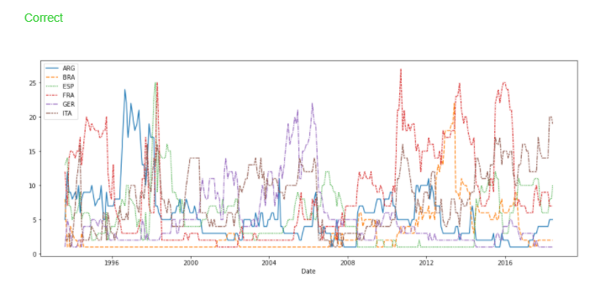
Some questions won't require you to write any code. Instead, you'll interpret visualizations.
As an example, consider the question: Considering only the years represented in the dataset, which countries spent at least 5 consecutive years in the #1 ranked spot?
To receive a Hint, uncomment the line below, and run the code cell.

Hint: Which lines stay at least five consecutive years at the bottom of the chart?

Once you have an answer, check the Solution to get credit for completing the problem and to ensure your interpretation is right.
Solution: The only country that meets this criterion is Brazil (code: BRA), as it maintains the highest ranking in 1996-2000. Other countries do spend some time in the number 1 spot, but Brazil is the only country that maintains it for at least five consecutive years.

Congratulations - you have completed your first coding exercise!

2. Line Charts

2.1 COURS

Now that you are familiar with the coding environment, it's time to learn how to make your own charts!
In this tutorial, you'll learn just enough Python to create professional looking line charts. Then, in the following exercise, you'll put your new skills to work with a real-world dataset.

Set up the notebook
We begin by setting up the coding environment. (This code is hidden, but you can un-hide it by clicking on the "Code" button immediately below this text, on the right.)
Output
Code

Select a dataset
The dataset for this tutorial tracks global daily streams on the music streaming service Spotify. We focus on five popular songs from 2017 and 2018:
- "Shape of You", by Ed Sheeran (link)
- "Despacito", by Luis Fonzi (link)
- "Something Just Like This", by The Chainsmokers and Coldplay (link)
- "HUMBLE.", by Kendrick Lamar (link)
- "Unforgettable", by French Montana (link)
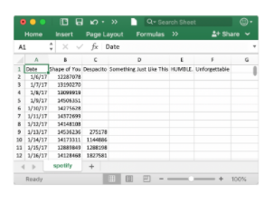
Notice that the first date that appears is January 6, 2017, corresponding to the release date of "The Shape of You", by Ed Sheeran. And, using the table, you can see that "The Shape of You" was streamed 12,287,078 times globally on the day of its release. Notice that the other songs have missing values in the first row, because they weren't released until later!

Load the data
As you learned in the previous tutorial, we load the dataset using the pd.read_csv command.
In [2]:
# Path of the file to read
spotify_filepath = "../input/spotify.csv"

# Read the file into a variable spotify_data
spotify_data = pd.read_csv(spotify_filepath, index_col="Date", parse_dates=True)
The end result of running both lines of code above is that we can now access the dataset by using spotify_data.

Examine the data
We can print the first five rows of the dataset by using the head command that you learned about in the previous tutorial.
In [3]:
# Print the first 5 rows of the data
spotify_data.head()
Out[3]:
 | Shape of You | Despacito | Something Just Like This | HUMBLE. | Unforgettable
Date
2017-01-06 | 12287078 | NaN | NaN | NaN | NaN
2017-01-07 | 13190270 | NaN | NaN | NaN | NaN
2017-01-08 | 13099919 | NaN | NaN | NaN | NaN
2017-01-09 | 14506351 | NaN | NaN | NaN | NaN
2017-01-10 | 14275628 | NaN | NaN | NaN | NaN
Check now that the first five rows agree with the image of the dataset (from when we saw what it would look like in Excel) above.
Empty entries will appear as NaN, which is short for "Not a Number".
We can also take a look at the last five rows of the data by making only one small change (where .head() becomes .tail()):
In [4]:
# Print the last five rows of the data
spotify_data.tail()
Out[4]:
 | Shape of You | Despacito | Something Just Like This | HUMBLE. | Unforgettable
Date
2018-01-05 | 4492978 | 3450315.0 | 2408365.0 | 2685857.0 | 2869783.0
2018-01-06 | 4416476 | 3394284.0 | 2188035.0 | 2559044.0 | 2743748.0
2018-01-07 | 4009104 | 3020789.0 | 1908129.0 | 2350985.0 | 2441045.0
2018-01-08 | 4135505 | 2755266.0 | 2023251.0 | 2523265.0 | 2622693.0
2018-01-09 | 4168506 | 2791601.0 | 2058016.0 | 2727678.0 | 2627334.0
Thankfully, everything looks about right, with millions of daily global streams for each song, and we can proceed to plotting the data!

Plot the data
Now that the dataset is loaded into the notebook, we need only one line of code to make a line chart!
In [5]:
# Line chart showing daily global streams of each song
sns.lineplot(data=spotify_data)
Out[5]:
<matplotlib.axes._subplots.AxesSubplot at 0x7ff15932bbd0>
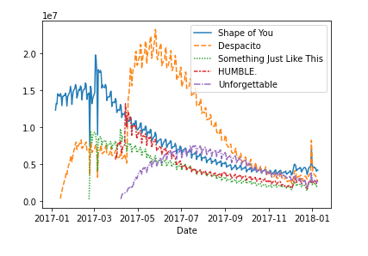
As you can see above, the line of code is relatively short and has two main components:
- sns.lineplot tells the notebook that we want to create a line chart.
  - Every command that you learn about in this course will start with sns, which indicates that the command comes from the seaborn package. For instance, we use sns.lineplot to make line charts. Soon, you'll learn that we use sns.barplot and sns.heatmap to make bar charts and heatmaps, respectively.
- data=spotify_data selects the data that will be used to create the chart.
Note that you will always use this same format when you create a line chart, and the only thing that changes with a new dataset is the name of the dataset. So, if you were working with a different dataset named financial_data, for instance, the line of code would appear as follows:
sns.lineplot(data=financial_data)
Sometimes there are additional details we'd like to modify, like the size of the figure and the title of the chart. Each of these options can easily be set with a single line of code.
In [6]:
# Set the width and height of the figure
plt.figure(figsize=(14,6))

# Add title
plt.title("Daily Global Streams of Popular Songs in 2017-2018")

# Line chart showing daily global streams of each song
sns.lineplot(data=spotify_data)
Out[6]:
<matplotlib.axes._subplots.AxesSubplot at 0x7ff15805d310>
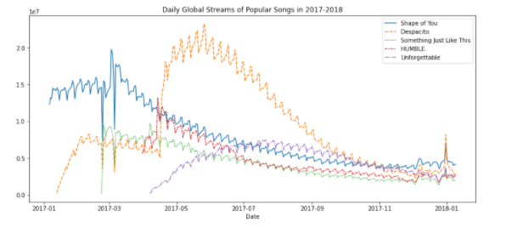
The first line of code sets the size of the figure to 14 inches (in width) by 6 inches (in height). To set the size of any figure, you need only copy the same line of code as it appears. Then, if you'd like to use a custom size, change the provided values of 14 and 6 to the desired width and height.
The second line of code sets the title of the figure. Note that the title must always be enclosed in quotation marks ("...")!

Plot a subset of the data
So far, you've learned how to plot a line for every column in the dataset. In this section, you'll learn how to plot a subset of the columns.
We'll begin by printing the names of all columns. This is done with one line of code and can be adapted for any dataset by just swapping out the name of the dataset (in this case, spotify_data).
In [7]:
list(spotify_data.columns)
Out[7]:
['Shape of You',
'Despacito',
'Something Just Like This',
'HUMBLE.',
'Unforgettable']
In the next code cell, we plot the lines corresponding to the first two columns in the dataset.
In [8]:
# Set the width and height of the figure
plt.figure(figsize=(14,6))

# Add title
plt.title("Daily Global Streams of Popular Songs in 2017-2018")

# Line chart showing daily global streams of 'Shape of You'
sns.lineplot(data=spotify_data['Shape of You'], label="Shape of You")

# Line chart showing daily global streams of 'Despacito'
sns.lineplot(data=spotify_data['Despacito'], label="Despacito")

# Add label for horizontal axis
plt.xlabel("Date")
Out[8]:
Text(0.5, 0, 'Date')
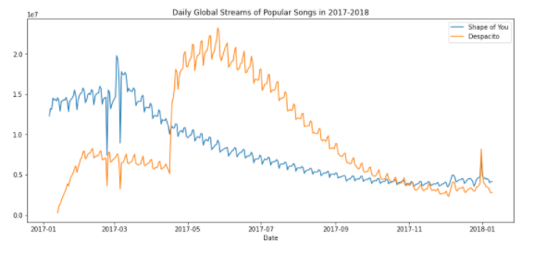
The first two lines of code set the title and size of the figure (and should look very familiar!).
The next two lines each add a line to the line chart. For instance, consider the first one, which adds the line for "Shape of You":
# Line chart showing daily global streams of 'Shape of You'
sns.lineplot(data=spotify_data['Shape of You'], label="Shape of You")
This line looks really similar to the code we used when we plotted every line in the dataset, but it has a few key differences:
- Instead of setting data=spotify_data, we set data=spotify_data['Shape of You']. In general, to plot only a single column, we use this format with putting the name of the column in single quotes and enclosing it in square brackets. (To make sure that you correctly specify the name of the column, you can print the list of all column names using the command you learned above.)
- We also add label="Shape of You" to make the line appear in the legend and set its corresponding label.
The final line of code modifies the label for the horizontal axis (or x-axis), where the desired label is placed in quotation marks ("...").

What's next?
Put your new skills to work in a coding exercise!

2.2 EXERCICES
In this exercise, you will use your new knowledge to propose a solution to a real-world scenario. To succeed, you will need to import data into Python, answer questions using the data, and generate line charts to understand patterns in the data.

Scenario
You have recently been hired to manage the museums in the City of Los Angeles. Your first project focuses on the four museums pictured in the images below.

You will leverage data from the Los Angeles Data Portal that tracks monthly visitors to each museum.
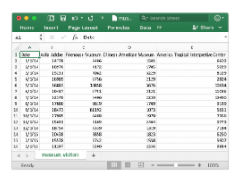
Setup
Run the next cell to import and configure the Python libraries that you need to complete the exercise.

pd.plotting.register_matplotlib_converters()
import matplotlib.pyplot as plt
%matplotlib inline
import seaborn as sns

Step 1: Load the data
Your first assignment is to read the LA Museum Visitors data file into museum_data. Note that:
- The filepath to the dataset is stored as museum_filepath. Please do not change the provided value of the filepath.
- The name of the column to use as row labels is "Date". (This can be seen in cell A1 when the file is opened in Excel.)
To help with this, you may find it useful to revisit some relevant code from the tutorial, which we have pasted below:
# Path of the file to read
spotify_filepath = "../input/spotify.csv"

# Read the file into a variable spotify_data
spotify_data = pd.read_csv(spotify_filepath, index_col="Date", parse_dates=True)
The code you need to write now looks very similar!
# Path of the file to read
museum_filepath = "../input/museum_visitors.csv"

# Fill in the line below to read the file into a variable museum_data
museum_data = pd.read_csv(museum_filepath, index_col="Date", parse_dates=True)

Hint: Use pd.read_csv, and follow it with three pieces of text that are enclosed in parentheses and separated by commas. (1) The filepath for the dataset is provided in museum_filepath. (2) Use the "Date" column to label the rows. (3) Make sure that the row labels are recognized as dates.
Solution:
museum_data = pd.read_csv(museum_filepath, index_col="Date", parse_dates=True)

Step 2: Review the data
Use a Python command to print the last 5 rows of the data.

# Print the last five rows of the data
museum_data.tail()

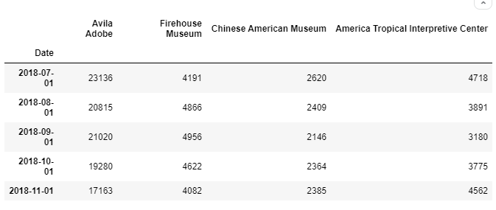
The last row (for 2018-11-01) tracks the number of visitors to each museum in November 2018, the next-to-last row (for 2018-10-01) tracks the number of visitors to each museum in October 2018, and so on.
Use the last 5 rows of the data to answer the questions below.
# Fill in the line below: How many visitors did the Chinese American Museum
# receive in July 2018?
ca_museum_jul18 = 2620

# Fill in the line below: In October 2018, how many more visitors did Avila
# Adobe receive than the Firehouse Museum?
avila_oct18 = 19280

Hint: Use the tail() command that you learned about in the tutorial to print the last five rows. After printing the last five rows, the number of visitors in July 2018 for each museum can be found in the row marked 2018-07-01, and the number of visitors in October 2018 for each museum can be found in the row marked 2018-10-01.
Solution:
# Print the last five rows of the data
museum_data.tail()
# How many visitors did the Chinese American Museum
# receive in July 2018?
ca_museum_jul18 = 2620
# In October 2018, how many more visitors did Avila
# Adobe receive than the Firehouse Museum?
avila_oct18 = 19280

Step 3: Convince the museum board
The Firehouse Museum claims they ran an event in 2014 that brought an incredible number of visitors, and that they should get extra budget to run a similar event again. The other museums think these types of events aren't that important, and budgets should be split purely based on recent visitors on an average day.
To show the museum board how the event compared to regular traffic at each museum, create a line chart that shows how the number of visitors to each museum evolved over time. Your figure should have four lines (one for each museum).
(Optional) Note: If you have some prior experience with plotting figures in Python, you might be familiar with the plt.show() command. If you decide to use this command, please place it after the line of code that checks your answer (in this case, place it after step_3.check() below) -- otherwise, the checking code will return an error!

# Line chart showing the number of visitors to each museum over time
# Set the width and height of the figure
plt.figure(figsize=(12,6))
# Line chart showing the number of visitors to each museum over time
sns.lineplot(data=museum_data)
# Add title
plt.title("Monthly Visitors to Los Angeles City Museums")

# Check your answer
step_3.check()

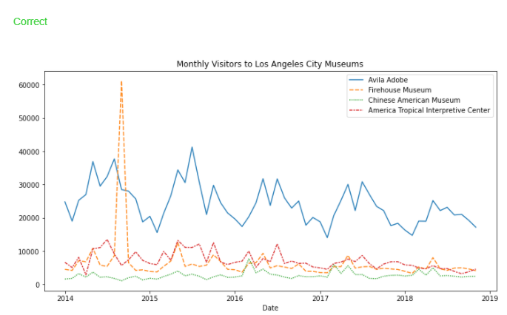
Hint: Use sns.lineplot, and plot one line for each museum in museum_data. (_You can do this in a single line of code!_)
Solution:
# Set the width and height of the figure
plt.figure(figsize=(12,6))
# Line chart showing the number of visitors to each museum over time
sns.lineplot(data=museum_data)
# Add title
plt.title("Monthly Visitors to Los Angeles City Museums")

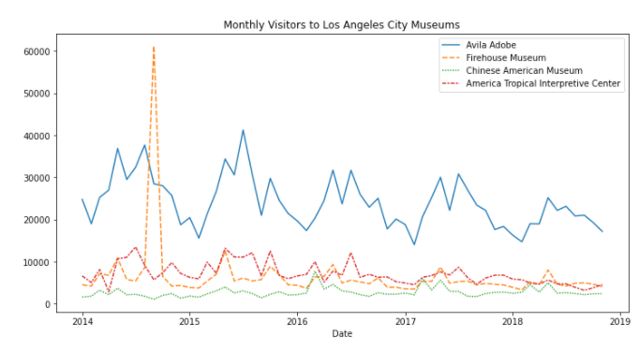

Step 4: Assess seasonality
When meeting with the employees at Avila Adobe, you hear that one major pain point is that the number of museum visitors varies greatly with the seasons, with low seasons (when the employees are perfectly staffed and happy) and also high seasons (when the employees are understaffed and stressed). You realize that if you can predict these high and low seasons, you can plan ahead to hire some additional seasonal employees to help out with the extra work.

Part A
Create a line chart that shows how the number of visitors to Avila Adobe has evolved over time. (_If your code returns an error, the first thing that you should check is that you've spelled the name of the column correctly! You must write the name of the column exactly as it appears in the dataset._)

# Line plot showing the number of visitors to Avila Adobe over time
# Set the width and height of the figure
plt.figure(figsize=(12,6))

# Line chart showing the number of visitors to each museum over time
sns.lineplot(data=museum_data['Avila Adobe'])

# Add title
plt.title('Monthly Visitors to Los Angeles City Museum AvilaAdobe')

plt.show()

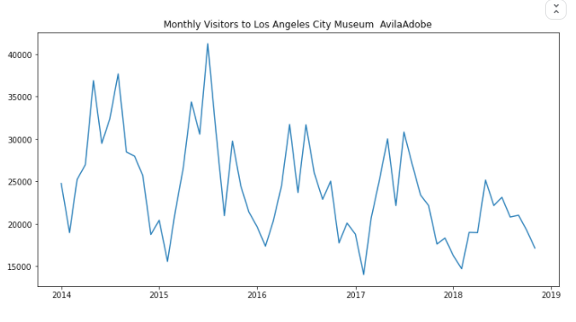

Hint: Use sns.lineplot to plot the 'Avila Adobe' column in museum_data. (_If you like, use label= to add the line to the legend, but this is not necessary!_)
Solution:
# Set the width and height of the figure
plt.figure(figsize=(12,6))
# Add title
plt.title("Monthly Visitors to Avila Adobe")
# Line chart showing the number of visitors to Avila Adobe over time
sns.lineplot(data=museum_data['Avila Adobe'])
# Add label for horizontal axis
plt.xlabel("Date")

Part B
Does Avila Adobe get more visitors:
- in September-February (in LA, the fall and winter months), or
- in March-August (in LA, the spring and summer)?
Using this information, when should the museum staff additional seasonal employees?

Hint: Look at the early part of each year (around January). Does the line chart dip to low values or reach relatively high values?

Solution: The line chart generally dips to relatively low values around the early part of each year (in December and January), and reaches its highest values in the middle of the year (especially around May and June). Thus, Avila Adobe usually gets more visitors in March-August (or the spring and summer months). With this in mind, Avila Adobe could definitely benefit from hiring more seasonal employees to help with the extra work in March-August (the spring and summer)!

3. Bar Charts and Heatmaps

3.1 COURS
Now that you can create your own line charts, it's time to learn about more chart types!
By the way, if this is your first experience with writing code in Python, you should be very proud of all that you have accomplished so far, because it's never easy to learn a completely new skill! If you stick with the micro-course, you'll notice that everything will only get easier (while the charts you'll build will get more impressive!), since the code is pretty similar for all of the charts. Like any skill, coding becomes natural over time, and with repetition.
In this tutorial, you'll learn about bar charts and heatmaps.

Set up the notebook
As always, we begin by setting up the coding environment. (This code is hidden, but you can un-hide it by clicking on the "Code" button immediately below this text, on the right.)
Output
Code

Select a dataset
In this tutorial, we'll work with a dataset from the US Department of Transportation that tracks flight delays.
Opening this CSV file in Excel shows a row for each month (where 1 = January, 2 = February, etc) and a column for each airline code.
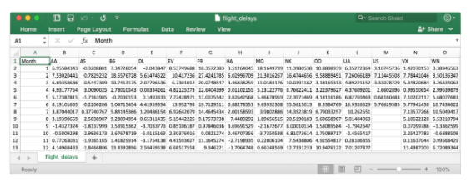
Each entry shows the average arrival delay (in minutes) for a different airline and month (all in year 2015). Negative entries denote flights that (on average) tended to arrive early. For instance, the average American Airlines flight (airline code: AA) in January arrived roughly 7 minutes late, and the average Alaska Airlines flight (airline code: AS) in April arrived roughly 3 minutes early.

Load the data
As before, we load the dataset using the pd.read_csv command.
In [2]:
# Path of the file to read
flight_filepath = "../input/flight_delays.csv"

# Read the file into a variable flight_data
flight_data = pd.read_csv(flight_filepath, index_col="Month")
You may notice that the code is slightly shorter than what we used in the previous tutorial. In this case, since the row labels (from the 'Month' column) don't correspond to dates, we don't add parse_dates=True in the parentheses. But, we keep the first two pieces of text as before, to provide both:
- the filepath for the dataset (in this case, flight_filepath), and
- the name of the column that will be used to index the rows (in this case, index_col="Month").

Examine the data
Since the dataset is small, we can easily print all of its contents. This is done by writing a single line of code with just the name of the dataset.
In [3]:
# Print the data
flight_data

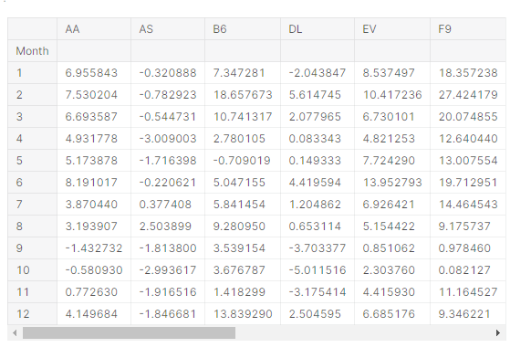

Bar chart
Say we'd like to create a bar chart showing the average arrival delay for Spirit Airlines (airline code: NK) flights, by month.
In [4]:
# Set the width and height of the figure
plt.figure(figsize=(10,6))

# Add title
plt.title("Average Arrival Delay for Spirit Airlines Flights, by Month")

# Bar chart showing average arrival delay for Spirit Airlines flights by month
sns.barplot(x=flight_data.index, y=flight_data['NK'])

# Add label for vertical axis
plt.ylabel("Arrival delay (in minutes)")
Out[4]:
Text(0, 0.5, 'Arrival delay (in minutes)')
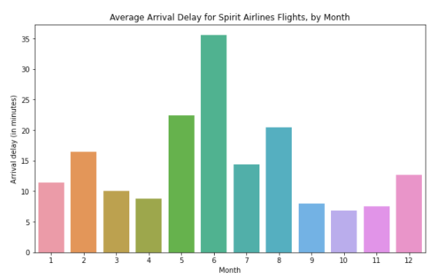
The commands for customizing the text (title and vertical axis label) and size of the figure are familiar from the previous tutorial. The code that creates the bar chart is new:
# Bar chart showing average arrival delay for Spirit Airlines flights by month
sns.barplot(x=flight_data.index, y=flight_data['NK'])
It has three main components:
- sns.barplot - This tells the notebook that we want to create a bar chart.
  - Remember that sns refers to the seaborn package, and all of the commands that you use to create charts in this course will start with this prefix.
- x=flight_data.index - This determines what to use on the horizontal axis. In this case, we have selected the column that indexes the rows (in this case, the column containing the months).
- y=flight_data['NK'] - This sets the column in the data that will be used to determine the height of each bar. In this case, we select the 'NK' column.
Important Note: You must select the indexing column with flight_data.index, and it is not possible to use flight_data['Month'] (which will return an error). This is because when we loaded the dataset, the "Month" column was used to index the rows. We always have to use this special notation to select the indexing column.

Heatmap
We have one more plot type to learn about: heatmaps!
In the code cell below, we create a heatmap to quickly visualize patterns in flight_data. Each cell is color-coded according to its corresponding value.
In [5]:
# Set the width and height of the figure
plt.figure(figsize=(14,7))

# Add title
plt.title("Average Arrival Delay for Each Airline, by Month")

# Heatmap showing average arrival delay for each airline by month
sns.heatmap(data=flight_data, annot=True)

# Add label for horizontal axis
plt.xlabel("Airline")
Out[5]:
Text(0.5, 42.0, 'Airline')
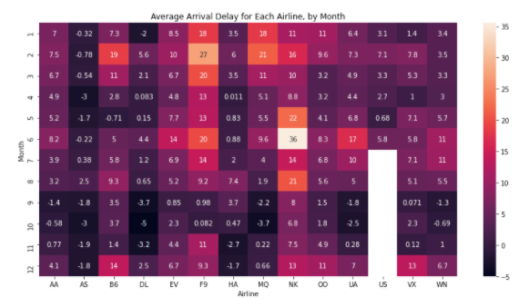
The relevant code to create the heatmap is as follows:
# Heatmap showing average arrival delay for each airline by month
sns.heatmap(data=flight_data, annot=True)
This code has three main components:
- sns.heatmap - This tells the notebook that we want to create a heatmap.
- data=flight_data - This tells the notebook to use all of the entries in flight_data to create the heatmap.
- annot=True - This ensures that the values for each cell appear on the chart. (Leaving this out removes the numbers from each of the cells!)
What patterns can you detect in the table? For instance, if you look closely, the months toward the end of the year (especially months 9-11) appear relatively dark for all airlines. This suggests that airlines are better (on average) at keeping schedule during these months!

What's next?
Create your own visualizations with a coding exercise!

3.2 EXERCICES

In this exercise, you will use your new knowledge to propose a solution to a real-world scenario. To succeed, you will need to import data into Python, answer questions using the data, and generate bar charts and heatmaps to understand patterns in the data.

Scenario
You've recently decided to create your very own video game! As an avid reader of IGN Game Reviews, you hear about all of the most recent game releases, along with the ranking they've received from experts, ranging from 0 (_Disaster_) to 10 (_Masterpiece_).

You're interested in using IGN reviews to guide the design of your upcoming game. Thankfully, someone has summarized the rankings in a really useful CSV file that you can use to guide your analysis.

Setup
Run the next cell to import and configure the Python libraries that you need to complete the exercise.

import pandas as pd
pd.plotting.register_matplotlib_converters()
import matplotlib.pyplot as plt
%matplotlib inline
import seaborn as sns

Step 1: Load the data
Read the IGN data file into ign_data. Use the "Platform" column to label the rows.
# Path of the file to read
ign_filepath = "../input/ign_scores.csv"

# Fill in the line below to read the file into a variable ign_data
ign_data = pd.read_csv(ign_filepath, index_col='Platform')

Hint: Use pd.read_csv, and follow it with two pieces of text that are enclosed in parentheses and separated by commas. (1) The filepath for the dataset is provided in ign_filepath. (2) Use the "Platform" column to label the rows.
Solution:
ign_data = pd.read_csv(ign_filepath, index_col="Platform")

Step 2: Review the data
Use a Python command to print the entire dataset.

# Print the data
ign_data

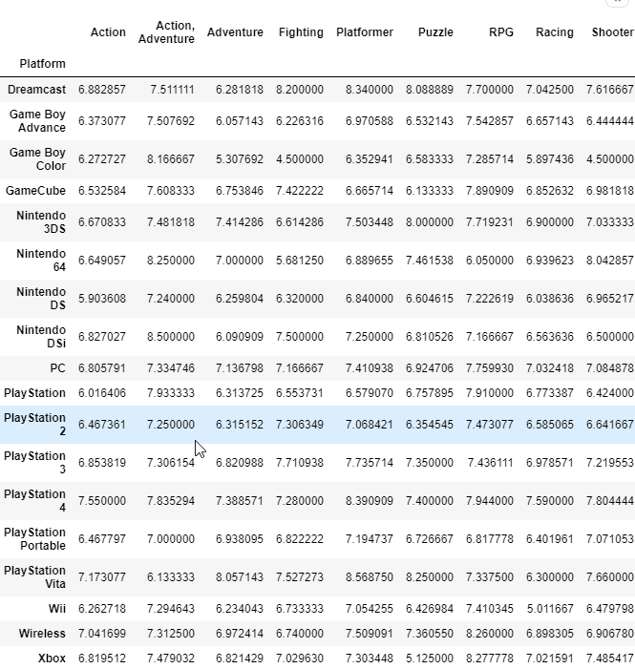

The dataset that you've just printed shows the average score, by platform and genre. Use the data to answer the questions below.

# Fill in the line below: What is the highest average score received by PC games,
# for any platform?
high_score = 7.759930313588848

# Fill in the line below: On the Playstation Vita platform, which genre has the
# lowest average score? Please provide the name of the column, and put your answer
# in single quotes (e.g., 'Action', 'Adventure', 'Fighting', etc.)
worst_genre = 'Simulation'

Hint: Use ign_data to print the entire dataset. After printing the dataset, each row corresponds to a different platform, and each genre has its own column. The entries contain the average score for each combination of genre and platform.
Solution:
# Print the data
ign_data
# What is the highest average score received by PC games, for any platform?
high_score = 7.759930
# On the Playstation Vita platform, which genre has the
# lowest average score? Please provide the name of the column, and put your answer
# in single quotes (e.g., 'Action', 'Adventure', 'Fighting', etc.)
worst_genre = 'Simulation'

Step 3: Which platform is best?
Since you can remember, your favorite video game has been Mario Kart Wii, a racing game released for the Wii platform in 2008. And, IGN agrees with you that it is a great game -- their rating for this game is a whopping 8.9! Inspired by the success of this game, you're considering creating your very own racing game for the Wii platform.

Part A
Create a bar chart that shows the average score for racing games, for each platform. Your chart should have one bar for each platform.

# Bar chart showing average score for racing games by platform
# Set the width and height of the figure
plt.figure(figsize=(10,6))

# Add title
plt.title('Average score for racing games by platform')

# Bar chart showing average score for racing games by platform
sns.barplot(x=ign_data['Racing'], y=ign_data.index)

# Add label for vertical axis
plt.xlabel('Plateform')

# Add label for vertical axis
plt.ylabel('Courses')

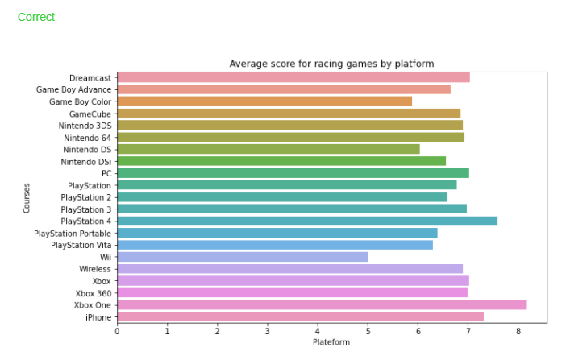

Hint: Use sns.barplot and the 'Racing' column of ign_data.
Solution:
# Set the width and height of the figure
plt.figure(figsize=(8, 6))
# Bar chart showing average score for racing games by platform
sns.barplot(x=ign_data['Racing'], y=ign_data.index)
# Add label for horizontal axis
plt.xlabel("")
# Add label for vertical axis
plt.title("Average Score for Racing Games, by Platform"

Part B
Based on the bar chart, do you expect a racing game for the Wii platform to receive a high rating? If not, what gaming platform seems to be the best alternative?

Hint: Check the length of the bar corresponding to the Wii platform. Does it appear to be longer than the other bars? If so, you should expect a Wii game to perform well!

Solution: Based on the data, we should not expect a racing game for the Wii platform to receive a high rating. In fact, on average, racing games for Wii score lower than any other platform. Xbox One seems to be the best alternative, since it has the highest average ratings.

Step 4: All possible combinations!
Eventually, you decide against creating a racing game for Wii, but you're still committed to creating your own video game! Since your gaming interests are pretty broad (_... you generally love most video games_), you decide to use the IGN data to inform your new choice of genre and platform.

Part A
Use the data to create a heatmap of average score by genre and platform.

# Heatmap showing average game score by platform and genre

# Set the width and height of the figure
plt.figure(figsize=(10,10))

# Add title
plt.title('Score moyen par genre de jeux vidéo')

# Heatmap showing average arrival delay for each airline by month
sns.heatmap(data=ign_data, annot=True)

# Add label for horizontal axis
plt.xlabel('Genres')

# Add label for horizontal axis
plt.ylabel('Plateformes')

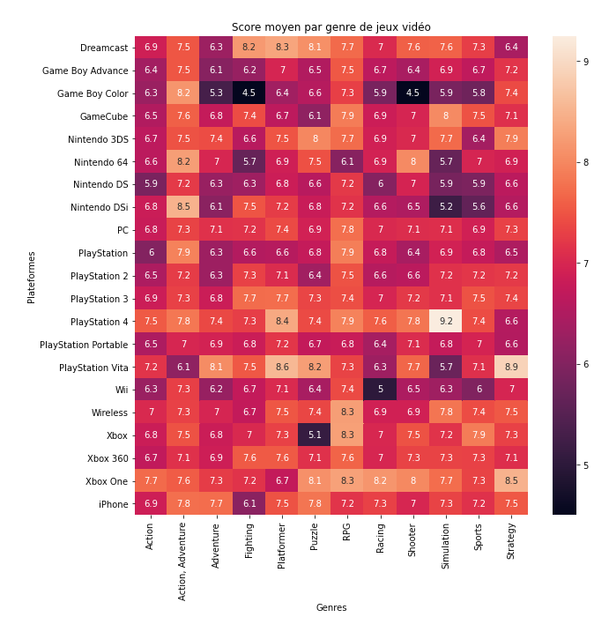
Hint: Use sns.heatmap.
Solution:
# Set the width and height of the figure
plt.figure(figsize=(10,10))
# Heatmap showing average game score by platform and genre
sns.heatmap(ign_data, annot=True)
# Add label for horizontal axis
plt.xlabel("Genre")
# Add label for vertical axis
plt.title("Average Game Score, by Platform and Genre")

Part B
Which combination of genre and platform receives the highest average ratings? Which combination receives the lowest average rankings?

Hint: To find the highest average ratings, look for the largest numbers (or lightest boxes) in the heatmap. To find the lowest average ratings, find the smallest numbers (or darkest boxes).

Solution: Simulation games for Playstation 4 receive the highest average ratings (9.2). Shooting and Fighting games for Game Boy Color receive the lowest average rankings (4.5).

4. Scatter Plots

4.1 COURS
In this tutorial, you'll learn how to create advanced scatter plots.

Load and examine the data
We'll work with a (synthetic) dataset of insurance charges, to see if we can understand why some customers pay more than others.
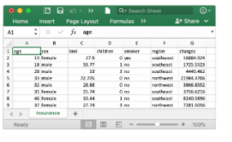
If you like, you can read more about the dataset here.
In [2]:
# Path of the file to read
insurance_filepath = "../input/insurance.csv"

# Read the file into a variable insurance_data
insurance_data = pd.read_csv(insurance_filepath)
As always, we check that the dataset loaded properly by printing the first five rows.
In [3]:
insurance_data.head()
Out[3]:
 | age | sex | bmi | children | smoker | region | charges
0 | 19 | female | 27.900 | 0 | yes | southwest | 16884.92400
1 | 18 | male | 33.770 | 1 | no | southeast | 1725.55230
2 | 28 | male | 33.000 | 3 | no | southeast | 4449.46200
3 | 33 | male | 22.705 | 0 | no | northwest | 21984.47061
4 | 32 | male | 28.880 | 0 | no | northwest | 3866.85520

Scatter plots
To create a simple scatter plot, we use the sns.scatterplot command and specify the values for:
- the horizontal x-axis (x=insurance_data['bmi']), and
- the vertical y-axis (y=insurance_data['charges']).
In [4]:
sns.scatterplot(x=insurance_data['bmi'], y=insurance_data['charges'])
Out[4]:
<matplotlib.axes._subplots.AxesSubplot at 0x7fc446212490>
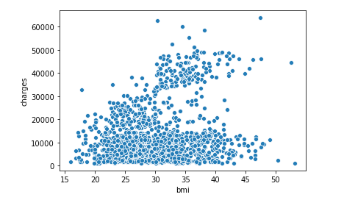

The scatterplot above suggests that body mass index (BMI) and insurance charges are positively correlated, where customers with higher BMI typically also tend to pay more in insurance costs. (This pattern makes sense, since high BMI is typically associated with higher risk of chronic disease.)
To double-check the strength of this relationship, you might like to add a regression line, or the line that best fits the data. We do this by changing the command to sns.regplot.
In [5]:
sns.regplot(x=insurance_data['bmi'], y=insurance_data['charges'])
Out[5]:
<matplotlib.axes._subplots.AxesSubplot at 0x7fc443fd9390>
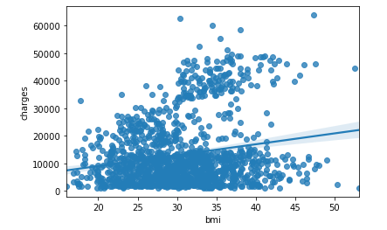

Color-coded scatter plots
We can use scatter plots to display the relationships between (not two, but...) three variables! One way of doing this is by color-coding the points.
For instance, to understand how smoking affects the relationship between BMI and insurance costs, we can color-code the points by 'smoker', and plot the other two columns ('bmi', 'charges') on the axes.
In [6]:
sns.scatterplot(x=insurance_data['bmi'], y=insurance_data['charges'], hue=insurance_data['smoker'])
Out[6]:
<matplotlib.axes._subplots.AxesSubplot at 0x7fc4436d8790>
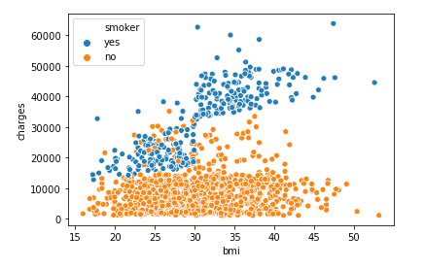
This scatter plot shows that while nonsmokers to tend to pay slightly more with increasing BMI, smokers pay MUCH more.
To further emphasize this fact, we can use the sns.lmplot command to add two regression lines, corresponding to smokers and nonsmokers. (You'll notice that the regression line for smokers has a much steeper slope, relative to the line for nonsmokers!)
In [7]:
sns.lmplot(x="bmi", y="charges", hue="smoker", data=insurance_data)
Out[7]:
<seaborn.axisgrid.FacetGrid at 0x7fc4436cb3d0>

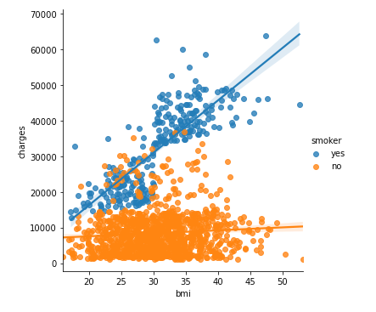
The sns.lmplot command above works slightly differently than the commands you have learned about so far:
- Instead of setting x=insurance_data['bmi'] to select the 'bmi' column in insurance_data, we set x="bmi" to specify the name of the column only.
- Similarly, y="charges" and hue="smoker" also contain the names of columns.
- We specify the dataset with data=insurance_data.
Finally, there's one more plot that you'll learn about, that might look slightly different from how you're used to seeing scatter plots. Usually, we use scatter plots to highlight the relationship between two continuous variables (like "bmi" and "charges"). However, we can adapt the design of the scatter plot to feature a categorical variable (like "smoker") on one of the main axes. We'll refer to this plot type as a categorical scatter plot, and we build it with the sns.swarmplot command.
In [8]:
sns.swarmplot(x=insurance_data['smoker'],
y=insurance_data['charges'])
Out[8]:
<matplotlib.axes._subplots.AxesSubplot at 0x7fc441da1d50>
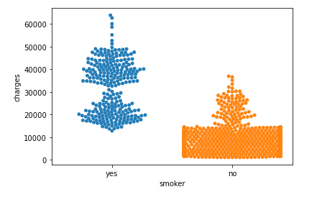
Among other things, this plot shows us that:
- on average, non-smokers are charged less than smokers, and
- the customers who pay the most are smokers; whereas the customers who pay the least are non-smokers.

What's next?
Apply your new skills to solve a real-world scenario with a coding exercise!

4.2 EXERCICES

In this exercise, you will use your new knowledge to propose a solution to a real-world scenario. To succeed, you will need to import data into Python, answer questions using the data, and generate scatter plots to understand patterns in the data.

Scenario
You work for a major candy producer, and your goal is to write a report that your company can use to guide the design of its next product. Soon after starting your research, you stumble across this very interesting dataset containing results from a fun survey to crowdsource favorite candies.

Setup
Run the next cell to import and configure the Python libraries that you need to complete the exercise.

import pandas as pd
pd.plotting.register_matplotlib_converters()
import matplotlib.pyplot as plt
%matplotlib inline
import seaborn as sns

Step 1: Load the Data
Read the candy data file into candy_data. Use the "id" column to label the rows.

# Path of the file to read
candy_filepath = "../input/candy.csv"

# Fill in the line below to read the file into a variable candy_data
candy_data = pd.read_csv(candy_filepath, index_col='id')

Hint: Use pd.read_csv, and follow it with two pieces of text that are enclosed in parentheses and separated by commas. (1) The filepath for the dataset is provided in candy_filepath. (2) Use the "id" column to label the rows.
Solution:
candy_data = pd.read_csv(candy_filepath, index_col="id")

Step 2: Review the data
Use a Python command to print the first five rows of the data.

# Print the first five rows of the data
candy_data.head()

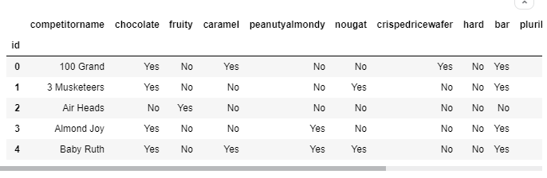
The dataset contains 83 rows, where each corresponds to a different candy bar. There are 13 columns:
- 'competitorname' contains the name of the candy bar.
- the next 9 columns (from 'chocolate' to 'pluribus') describe the candy. For instance, rows with chocolate candies have "Yes" in the 'chocolate' column (and candies without chocolate have "No" in the same column).
- 'sugarpercent' provides some indication of the amount of sugar, where higher values signify higher sugar content.
- 'pricepercent' shows the price per unit, relative to the other candies in the dataset.
- 'winpercent' is calculated from the survey results; higher values indicate that the candy was more popular with survey respondents.
Use the first five rows of the data to answer the questions below.

# Fill in the line below: Which candy was more popular with survey respondents:
# '3 Musketeers' or 'Almond Joy'? (Please enclose your answer in single quotes.)
more_popular = '3 Musketeers'

# Fill in the line below: Which candy has higher sugar content: 'Air Heads'
# or 'Baby Ruth'? (Please enclose your answer in single quotes.)
more_sugar = 'Air Heads'

Hint: Use the head() command to print the first 5 rows. After printing the first 5 rows, each row corresponds to a different candy. The 'winpercent' column indicates the popularity of the candy. The 'sugarpercent' column has the amount of sugar in the candy.
Solution:
# Print the first five rows of the data
candy_data.head()
# Which candy was more popular with survey respondents:
# '3 Musketeers' or 'Almond Joy'?
more_popular = '3 Musketeers'
# Which candy has higher sugar content: 'Air Heads'
# or 'Baby Ruth'?
more_sugar = 'Air Heads'

Step 3: The role of sugar
Do people tend to prefer candies with higher sugar content?

Part A
Create a scatter plot that shows the relationship between 'sugarpercent' (on the horizontal x-axis) and 'winpercent' (on the vertical y-axis). Don't add a regression line just yet -- you'll do that in the next step!

# Scatter plot showing the relationship between 'sugarpercent' and 'winpercent'
sns.scatterplot(x=candy_data['sugarpercent'], y=candy_data['winpercent'])

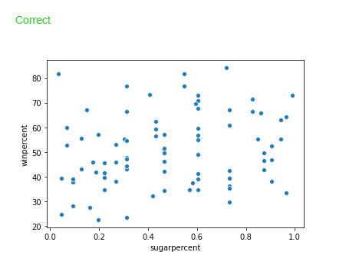
Hint: Use sns.scatterplot, and set the variables for the x-axis and y-axis by using x= and y=, respectively.
Solution:
# Scatter plot showing the relationship between 'sugarpercent' and 'winpercent'
sns.scatterplot(x=candy_data['sugarpercent'], y=candy_data['winpercent'])

Part B
Does the scatter plot show a strong correlation between the two variables? If so, are candies with more sugar relatively more or less popular with the survey respondents?

Hint: Compare candies with higher sugar content (on the right side of the chart) to candies with lower sugar content (on the left side of the chart). Is one group clearly more popular than the other?

Solution: The scatter plot does not show a strong correlation between the two variables. Since there is no clear relationship between the two variables, this tells us that sugar content does not play a strong role in candy popularity.

Step 4: Take a closer look

Part A
Create the same scatter plot you created in Step 3, but now with a regression line!

# Scatter plot w/ regression line showing the relationship between
# 'sugarpercent' and 'winpercent'
sns.regplot(x=candy_data['sugarpercent'], y=candy_data['winpercent'])

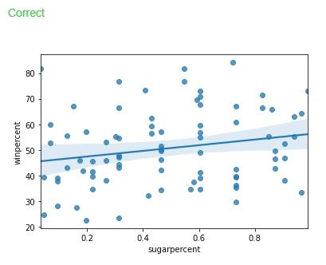
Hint: Use sns.regplot, and set the variables for the x-axis and y-axis by using x= and y=, respectively.
Solution:
# Scatter plot w/ regression line showing the relationship between 'sugarpercent' and 'winpercent'
sns.regplot(x=candy_data['sugarpercent'], y=candy_data['winpercent'])

Part B
According to the plot above, is there a slight correlation between 'winpercent' and 'sugarpercent'? What does this tell you about the candy that people tend to prefer?

Hint: Does the regression line have a positive or negative slope?

Solution: Since the regression line has a slightly positive slope, this tells us that there is a slightly positive correlation between 'winpercent' and 'sugarpercent'. Thus, people have a slight preference for candies containing relatively more sugar.

Step 5: Chocolate!
In the code cell below, create a scatter plot to show the relationship between 'pricepercent' (on the horizontal x-axis) and 'winpercent' (on the vertical y-axis). Use the 'chocolate' column to color-code the points. Don't add any regression lines just yet -- you'll do that in the next step!

Hint: Use sns.scatterplot, and set the variables for the x-axis, y-axis, and color of the points by using x=, y=, and hue=, respectively.
Solution:
# Scatter plot showing the relationship between 'pricepercent', 'winpercent', and 'chocolate'
sns.scatterplot(x=candy_data['pricepercent'], y=candy_data['winpercent'], hue=candy_data['chocolate'])

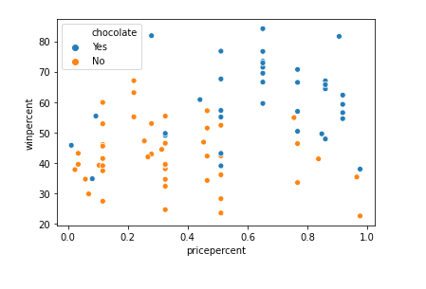
Step 6: Investigate chocolate

Part A
Create the same scatter plot you created in Step 5, but now with two regression lines, corresponding to (1) chocolate candies and (2) candies without chocolate.

# Color-coded scatter plot w/ regression lines
sns.lmplot(x="pricepercent", y="winpercent", hue="chocolate", data=candy_data)

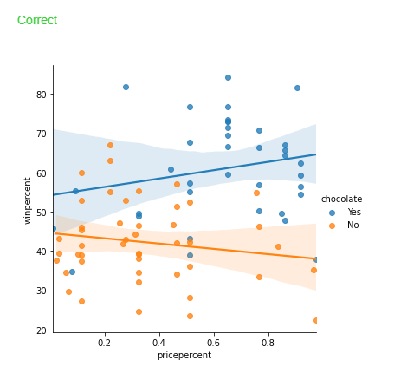
Hint: Use sns.lmplot, and set the variables for the x-axis, y-axis, color of the points, and the dataset by using x=, y=, hue=, and data=, respectively.
Solution:
# Color-coded scatter plot w/ regression lines
sns.lmplot(x="pricepercent", y="winpercent", hue="chocolate", data=candy_data)

Part B
Using the regression lines, what conclusions can you draw about the effects of chocolate and price on candy popularity?

Hint: Look at each regression line - do you notice a positive or negative slope?

Solution: We'll begin with the regression line for chocolate candies. Since this line has a slightly positive slope, we can say that more expensive chocolate candies tend to be more popular (than relatively cheaper chocolate candies). Likewise, since the regression line for candies without chocolate has a negative slope, we can say that if candies don't contain chocolate, they tend to be more popular when they are cheaper. One important note, however, is that the dataset is quite small -- so we shouldn't invest too much trust in these patterns! To inspire more confidence in the results, we should add more candies to the dataset.

Step 7: Everybody loves chocolate.

Part A
Create a categorical scatter plot to highlight the relationship between 'chocolate' and 'winpercent'. Put 'chocolate' on the (horizontal) x-axis, and 'winpercent' on the (vertical) y-axis.

# Scatter plot showing the relationship between 'chocolate' and 'winpercent'
sns.swarmplot(x=candy_data['chocolate'],
y=candy_data['winpercent'])

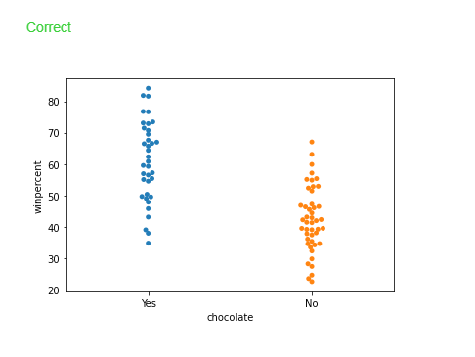
Hint: Use sns.swarmplot, and set the variables for the x-axis and y-axis by using x= and y=, respectively.
Solution:
# Scatter plot showing the relationship between 'chocolate' and 'winpercent'
sns.swarmplot(x=candy_data['chocolate'], y=candy_data['winpercent'])

Part B
You decide to dedicate a section of your report to the fact that chocolate candies tend to be more popular than candies without chocolate. Which plot is more appropriate to tell this story: the plot from Step 6, or the plot from Step 7?

Hint: Which plot communicates more information? In general, it's good practice to use the simplest plot that tells the entire story of interest.

Solution: In this case, the categorical scatter plot from Step 7 is the more appropriate plot. While both plots tell the desired story, the plot from Step 6 conveys far more information that could distract from the main point.

5. Distributions

5.1 COURS
In this tutorial you'll learn all about histograms and density plots.

Set up the notebook
As always, we begin by setting up the coding environment. (This code is hidden, but you can un-hide it by clicking on the "Code" button immediately below this text, on the right.)
Output
Code

Select a dataset
We'll work with a dataset of 150 different flowers, or 50 each from three different species of iris (Iris setosa, Iris versicolor, and Iris virginica).
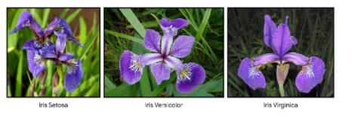

Load and examine the data
Each row in the dataset corresponds to a different flower. There are four measurements: the sepal length and width, along with the petal length and width. We also keep track of the corresponding species.
In [2]:
# Path of the file to read
iris_filepath = "../input/iris.csv"

# Read the file into a variable iris_data
iris_data = pd.read_csv(iris_filepath, index_col="Id")

# Print the first 5 rows of the data
iris_data.head()
Out[2]:
 | Sepal Length (cm) | Sepal Width (cm) | Petal Length (cm) | Petal Width (cm) | Species
Id
1 | 5.1 | 3.5 | 1.4 | 0.2 | Iris-setosa
2 | 4.9 | 3.0 | 1.4 | 0.2 | Iris-setosa
3 | 4.7 | 3.2 | 1.3 | 0.2 | Iris-setosa
4 | 4.6 | 3.1 | 1.5 | 0.2 | Iris-setosa
5 | 5.0 | 3.6 | 1.4 | 0.2 | Iris-setosa

Histograms
Say we would like to create a histogram to see how petal length varies in iris flowers. We can do this with the sns.distplot command.
In [3]:
# Histogram
sns.distplot(a=iris_data['Petal Length (cm)'], kde=False)
Out[3]:
<matplotlib.axes._subplots.AxesSubplot at 0x7f3dde14d610>
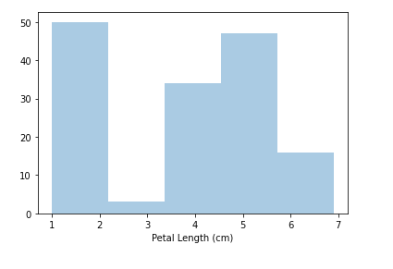
We customize the behavior of the command with two additional pieces of information:
- a= chooses the column we'd like to plot (in this case, we chose 'Petal Length (cm)').
- kde=False is something we'll always provide when creating a histogram, as leaving it out will create a slightly different plot.

Density plots
The next type of plot is a kernel density estimate (KDE) plot. In case you're not familiar with KDE plots, you can think of it as a smoothed histogram.
To make a KDE plot, we use the sns.kdeplot command. Setting shade=True colors the area below the curve (and data= has identical functionality as when we made the histogram above).
In [4]:
# KDE plot
sns.kdeplot(data=iris_data['Petal Length (cm)'], shade=True)
Out[4]:
<matplotlib.axes._subplots.AxesSubplot at 0x7f3dde0156d0>
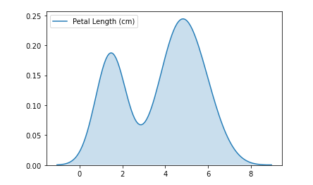

2D KDE plots
We're not restricted to a single column when creating a KDE plot. We can create a two-dimensional (2D) KDE plot with the sns.jointplot command.
In the plot below, the color-coding shows us how likely we are to see different combinations of sepal width and petal length, where darker parts of the figure are more likely.
In [5]:
# 2D KDE plot
sns.jointplot(x=iris_data['Petal Length (cm)'], y=iris_data['Sepal Width (cm)'], kind="kde")
Out[5]:
<seaborn.axisgrid.JointGrid at 0x7f3dddea1190>
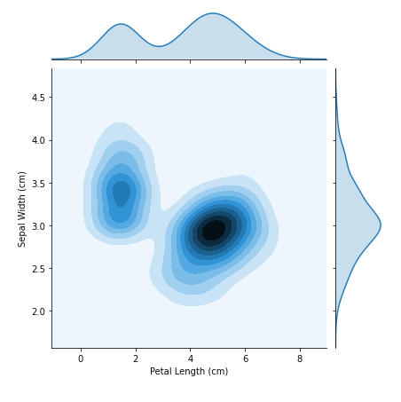
Note that in addition to the 2D KDE plot in the center,
- the curve at the top of the figure is a KDE plot for the data on the x-axis (in this case, iris_data['Petal Length (cm)']), and
- the curve on the right of the figure is a KDE plot for the data on the y-axis (in this case, iris_data['Sepal Width (cm)']).

Color-coded plots
For the next part of the tutorial, we'll create plots to understand differences between the species. To accomplish this, we begin by breaking the dataset into three separate files, with one for each species.
In [6]:
# Paths of the files to read
iris_set_filepath = "../input/iris_setosa.csv"
iris_ver_filepath = "../input/iris_versicolor.csv"
iris_vir_filepath = "../input/iris_virginica.csv"

# Read the files into variables
iris_set_data = pd.read_csv(iris_set_filepath, index_col="Id")
iris_ver_data = pd.read_csv(iris_ver_filepath, index_col="Id")
iris_vir_data = pd.read_csv(iris_vir_filepath, index_col="Id")

# Print the first 5 rows of the Iris versicolor data
iris_ver_data.head()
Out[6]:
 | Sepal Length (cm) | Sepal Width (cm) | Petal Length (cm) | Petal Width (cm) | Species
Id
51 | 7.0 | 3.2 | 4.7 | 1.4 | Iris-versicolor
52 | 6.4 | 3.2 | 4.5 | 1.5 | Iris-versicolor
53 | 6.9 | 3.1 | 4.9 | 1.5 | Iris-versicolor
54 | 5.5 | 2.3 | 4.0 | 1.3 | Iris-versicolor
55 | 6.5 | 2.8 | 4.6 | 1.5 | Iris-versicolor
In the code cell below, we create a different histogram for each species by using the sns.distplot command (as above) three times. We use label= to set how each histogram will appear in the legend.
In [7]:
# Histograms for each species
sns.distplot(a=iris_set_data['Petal Length (cm)'], label="Iris-setosa", kde=False)
sns.distplot(a=iris_ver_data['Petal Length (cm)'], label="Iris-versicolor", kde=False)
sns.distplot(a=iris_vir_data['Petal Length (cm)'], label="Iris-virginica", kde=False)

# Add title
plt.title("Histogram of Petal Lengths, by Species")

# Force legend to appear
plt.legend()
Out[7]:
<matplotlib.legend.Legend at 0x7f3ddde51410>
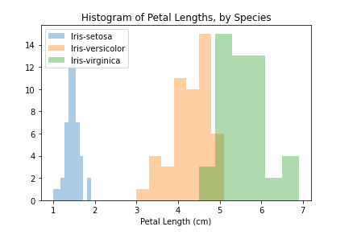
In this case, the legend does not automatically appear on the plot. To force it to show (for any plot type), we can always use plt.legend().
We can also create a KDE plot for each species by using sns.kdeplot (as above). Again, label= is used to set the values in the legend.
In [8]:
# KDE plots for each species
sns.kdeplot(data=iris_set_data['Petal Length (cm)'], label="Iris-setosa", shade=True)
sns.kdeplot(data=iris_ver_data['Petal Length (cm)'], label="Iris-versicolor", shade=True)
sns.kdeplot(data=iris_vir_data['Petal Length (cm)'], label="Iris-virginica", shade=True)

# Add title
plt.title("Distribution of Petal Lengths, by Species")
Out[8]:
Text(0.5, 1.0, 'Distribution of Petal Lengths, by Species')
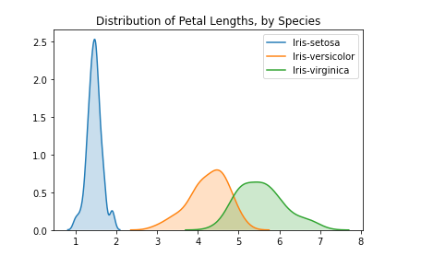
One interesting pattern that can be seen in plots is that the plants seem to belong to one of two groups, where Iris versicolor and Iris virginica seem to have similar values for petal length, while Iris setosa belongs in a category all by itself.
In fact, according to this dataset, we might even be able to classify any iris plant as Iris setosa (as opposed to Iris versicolor or Iris virginica) just by looking at the petal length: if the petal length of an iris flower is less than 2 cm, it's most likely to be Iris setosa!

What's next?
Put your new skills to work in a coding exercise!

5.2 EXERCICES

In this exercise, you will use your new knowledge to propose a solution to a real-world scenario. To succeed, you will need to import data into Python, answer questions using the data, and generate histograms and density plots to understand patterns in the data.

Scenario
You'll work with a real-world dataset containing information collected from microscopic images of breast cancer tumors, similar to the image below.

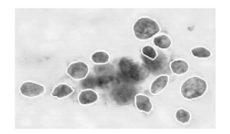
Each tumor has been labeled as either benign (_noncancerous_) or malignant (_cancerous_).
To learn more about how this kind of data is used to create intelligent algorithms to classify tumors in medical settings, watch the short video at this link!

Setup
Run the next cell to import and configure the Python libraries that you need to complete the exercise.

import pandas as pd
pd.plotting.register_matplotlib_converters()
import matplotlib.pyplot as plt
%matplotlib inline
import seaborn as sns

Step 1: Load the data
In this step, you will load two data files.
- Load the data file corresponding to benign tumors into a DataFrame called cancer_b_data. The corresponding filepath is cancer_b_filepath. Use the "Id" column to label the rows.
- Load the data file corresponding to malignant tumors into a DataFrame called cancer_m_data. The corresponding filepath is cancer_m_filepath. Use the "Id" column to label the rows.

# Paths of the files to read
cancer_b_filepath = "../input/cancer_b.csv"
cancer_m_filepath = "../input/cancer_m.csv"

# Fill in the line below to read the (benign) file into a variable cancer_b_data
cancer_b_data = pd.read_csv(cancer_b_filepath, index_col='Id')

# Fill in the line below to read the (malignant) file into a variable cancer_m_data
cancer_m_data = pd.read_csv(cancer_m_filepath, index_col='Id')

Hint: Use pd.read_csv, and follow it with two pieces of text that are enclosed in parentheses and separated by commas. (1) The filepath for the dataset is provided in either cancer_b_filepath or cancer_m_filepath. (2) Use the "Id" column to label the rows.
Solution:

cancer_b_data = pd.read_csv(cancer_b_filepath, index_col="Id")
cancer_m_data = pd.read_csv(cancer_m_filepath, index_col="Id")

Step 2: Review the data
Use a Python command to print the first 5 rows of the data for benign tumors.

# Print the first five rows of the (benign) data
cancer_b_data.head()

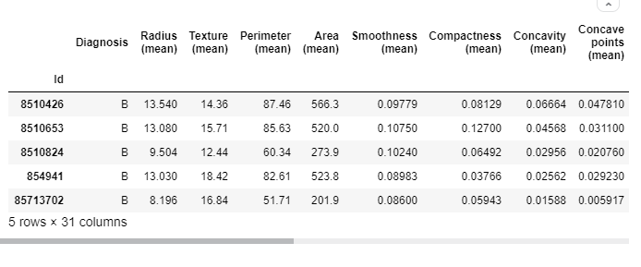
Use a Python command to print the first 5 rows of the data for malignant tumors.

# Print the first five rows of the (malignant) data
cancer_m_data.head()

In the datasets, each row corresponds to a different image. Each dataset has 31 different columns, corresponding to:
- 1 column ('Diagnosis') that classifies tumors as either benign (which appears in the dataset as B) or malignant (M), and
- 30 columns containing different measurements collected from the images.
Use the first 5 rows of the data (for benign and malignant tumors) to answer the questions below.

# Fill in the line below: In the first five rows of the data for benign tumors, what is the
# largest value for 'Perimeter (mean)'?
max_perim = 87.46

# Fill in the line below: What is the value for 'Radius (mean)' for the tumor with Id 842517?
mean_radius = 20.57

Hint: Use the head() command to print the first 5 rows. After printing the first 5 rows, each row corresponds to a different tumor ID. The 'Perimeter (mean)' column is the fourth column in the dataset. The 'Radius (mean)' column is the second column.
Solution:
# Print the first five rows of the (benign) data
cancer_b_data.head()
# Print the first five rows of the (malignant) data
cancer_m_data.head()
# In the first five rows of the data for benign tumors, what is the
# largest value for 'Perimeter (mean)'?
max_perim = 87.46
# What is the value for 'Radius (mean)' for the tumor with Id 842517?
mean_radius = 20.57

Step 3: Investigating differences
+ Code+ Markdown
arrow_upwardarrow_downwarddeleteunfold_lessmore_vert

Part A
Use the code cell below to create two histograms that show the distribution in values for 'Area (mean)' for both benign and malignant tumors. (_To permit easy comparison, create a single figure containing both histograms in the code cell below._)

# Histograms for benign and maligant tumors
sns.distplot(a=cancer_b_data['Area (mean)'], label="Cancers bégnins", kde=False)
sns.distplot(a=cancer_m_data['Area (mean)'], label="Cancers malins", kde=False)

# Add title
plt.title("Histogram of Cancers")

# Force legend to appear
plt.legend()

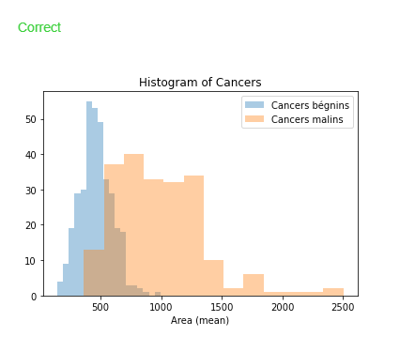
Hint: Use sns.distplot, and set the data and legend label by using a= and label=, respectively. Set kde=False. You will need to write two lines of code, corresponding to cancer_m_data and cancer_b_data.
Solution:
# Histograms for benign and maligant tumors
sns.distplot(a=cancer_b_data['Area (mean)'], label="Benign", kde=False)
sns.distplot(a=cancer_m_data['Area (mean)'], label="Malignant", kde=False)
plt.legend()

Part B
A researcher approaches you for help with identifying how the 'Area (mean)' column can be used to understand the difference between benign and malignant tumors. Based on the histograms above,
- Do malignant tumors have higher or lower values for 'Area (mean)' (relative to benign tumors), on average?
- Which tumor type seems to have a larger range of potential values?

Hint: Does the histogram for malignant tumors appear mostly to the left or to the right of the histogram for benign tumors? Which histogram appears wider?

Solution: Malignant tumors have higher values for 'Area (mean)', on average. Malignant tumors have a larger range of potential values.

Step 4: A very useful column

Part A
Use the code cell below to create two KDE plots that show the distribution in values for 'Radius (worst)' for both benign and malignant tumors. (_To permit easy comparison, create a single figure containing both KDE plots in the code cell below._)

# KDE plots for benign and malignant tumors
sns.kdeplot(data=cancer_b_data['Radius (worst)'], label="Cancers bénins",
shade=True)
sns.kdeplot(data=cancer_m_data['Radius (worst)'], label="Cancers malins",
shade=True)

# Add title
plt.title("Distribution of Radius (worst)")

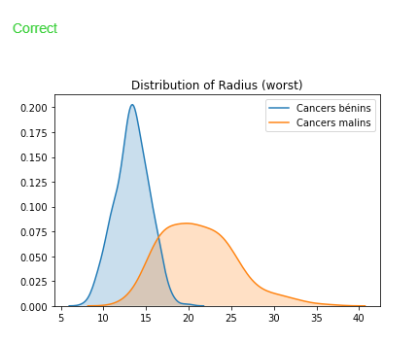
Hint: Use sns.kdeplot, and specify the data and label by using data= and label=, respectively. You will need to write two lines of code, corresponding to cancer_m_data and cancer_b_data.
Solution:
# KDE plots for benign and malignant tumors
sns.kdeplot(data=cancer_b_data['Radius (worst)'], shade=True, label="Benign")
sns.kdeplot(data=cancer_m_data['Radius (worst)'], shade=True, label="Malignant")

Part B
A hospital has recently started using an algorithm that can diagnose tumors with high accuracy. Given a tumor with a value for 'Radius (worst)' of 25, do you think the algorithm is more likely to classify the tumor as benign or malignant?

Hint: Take a look at the KDE plots, and use the legend to tell the difference between malignant and benign tumors. Around a value of 25, which curve appears higher?

Solution: The algorithm is more likely to classify the tumor as malignant. This is because the curve for malignant tumors is much higher than the curve for benign tumors around a value of 25 -- and an algorithm that gets high accuracy is likely to make decisions based on this pattern in the data.

6. Choosing Plot Types and Custom Styles

6.1 COURS

In this micro-course, you've learned how to create many different chart types. Now, you'll organize your knowledge, before learning some quick commands that you can use to change the style of your charts.

What have you learned?
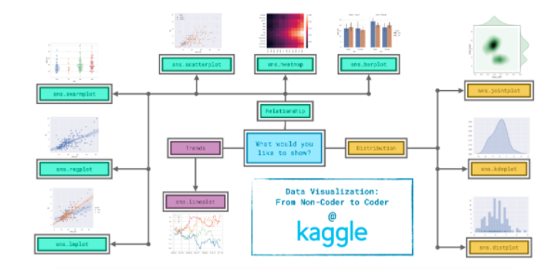
Since it's not always easy to decide how to best tell the story behind your data, we've broken the chart types into three broad categories to help with this.
- Trends - A trend is defined as a pattern of change.
  - sns.lineplot - Line charts are best to show trends over a period of time, and multiple lines can be used to show trends in more than one group.
- Relationship - There are many different chart types that you can use to understand relationships between variables in your data.
  - sns.barplot - Bar charts are useful for comparing quantities corresponding to different groups.
  - sns.heatmap - Heatmaps can be used to find color-coded patterns in tables of numbers.
  - sns.scatterplot - Scatter plots show the relationship between two continuous variables; if color-coded, we can also show the relationship with a third categorical variable.
  - sns.regplot - Including a regression line in the scatter plot makes it easier to see any linear relationship between two variables.
  - sns.lmplot - This command is useful for drawing multiple regression lines, if the scatter plot contains multiple, color-coded groups.
  - sns.swarmplot - Categorical scatter plots show the relationship between a continuous variable and a categorical variable.
- Distribution - We visualize distributions to show the possible values that we can expect to see in a variable, along with how likely they are.
  - sns.distplot - Histograms show the distribution of a single numerical variable.
  - sns.kdeplot - KDE plots (or 2D KDE plots) show an estimated, smooth distribution of a single numerical variable (or two numerical variables).
  - sns.jointplot - This command is useful for simultaneously displaying a 2D KDE plot with the corresponding KDE plots for each individual variable.

Changing styles with seaborn
All of the commands have provided a nice, default style to each of the plots. However, you may find it useful to customize how your plots look, and thankfully, this can be accomplished by just adding one more line of code!
As always, we need to begin by setting up the coding environment. (This code is hidden, but you can un-hide it by clicking on the "Code" button immediately below this text, on the right.)
Output
Code
We'll work with the same code that we used to create a line chart in a previous tutorial. The code below loads the dataset and creates the chart.
In [2]:
# Path of the file to read
spotify_filepath = "../input/spotify.csv"

# Read the file into a variable spotify_data
spotify_data = pd.read_csv(spotify_filepath, index_col="Date", parse_dates=True)

# Line chart
plt.figure(figsize=(12,6))
sns.lineplot(data=spotify_data)
Out[2]:
<matplotlib.axes._subplots.AxesSubplot at 0x7f0d8a072d10>
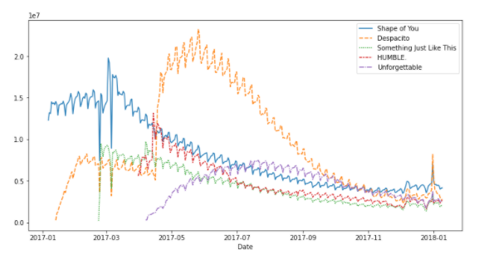
We can quickly change the style of the figure to a different theme with only a single line of code.
In [3]:
# Change the style of the figure to the "dark" theme
sns.set_style("dark")

# Line chart
plt.figure(figsize=(12,6))
sns.lineplot(data=spotify_data)
Out[3]:
<matplotlib.axes._subplots.AxesSubplot at 0x7f0d8980e990>
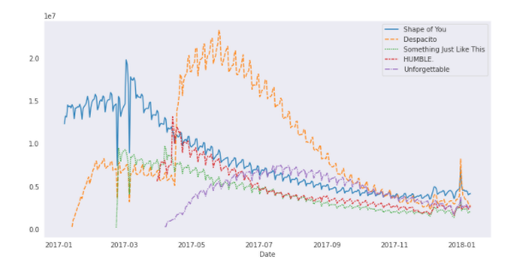
Seaborn has five different themes: (1)"darkgrid", (2)"whitegrid", (3)"dark", (4)"white", and (5)"ticks", and you need only use a command similar to the one in the code cell above (with the chosen theme filled in) to change it.
In the upcoming exercise, you'll experiment with these themes to see which one you like most!

What's next?
Explore seaborn styles in a quick coding exercise!

6.2 EXERCICES

In this exercise, you'll explore different chart styles, to see which color combinations and fonts you like best!

Setup
Run the next cell to import and configure the Python libraries that you need to complete the exercise.

import pandas as pd
pd.plotting.register_matplotlib_converters()
import matplotlib.pyplot as plt
%matplotlib inline
import seaborn as sns

You'll work with a chart from the previous tutorial. Run the next cell to load the data.

Try out seaborn styles
Run the command below to try out the "dark" theme.

# Change the style of the figure
sns.set_style("dark")

# Line chart
plt.figure(figsize=(12,6))
sns.lineplot(data=spotify_data)

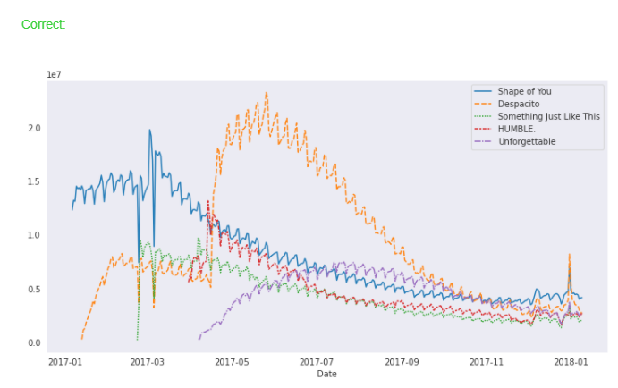

Now, try out different themes by amending the first line of code and running the code cell again. Remember the list of available themes:
- "darkgrid"
- "whitegrid"
- "dark"
- "white"
- "ticks"
This notebook is your playground -- feel free to experiment as little or as much you wish here! The exercise is marked as complete after you run every code cell in the notebook at least once.

7. Final Project

7.1 COURS
So far, you have worked with datasets that we have provided for you. In this tutorial, you'll learn how to use your own datasets. Then, in the following exercise, you'll design and create your own data visualizations.
You'll learn all about Kaggle Datasets, a tool that you can use to store your own datasets and quickly access tens of thousands of publicly available data sources.

Kaggle Datasets
You can access Kaggle Datasets by visiting the link below:
https://www.kaggle.com/datasets
The link will bring you to a webpage with a long list of datasets that you can use in your own projects.

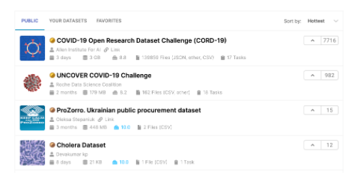

Note that the list of datasets that you see will likely look different from what's shown in the screenshot above, since many new datasets are uploaded every day! There are many different file types on Kaggle Datasets, including CSV files, but also more exotic file types such as JSON, SQLite, and BigQuery. We'll be careful to select a dataset with at least one CSV file, since that is the file type we have been working with in this course.
To search for a specific dataset, use the search bar at the top of the screen. Say, for instance, you'd like to work with a dataset about comic book characters. Begin by typing "comic" in the search window.
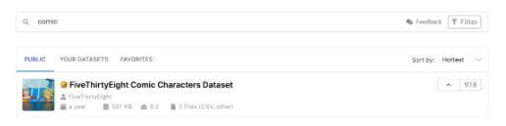
Then, find the FiveThirtyEight Comic Characters Dataset. Note that the dataset contains 3 files, including a CSV file that we can use.
Then, click on the dataset to select it. This will bring you to a webpage that describes the dataset.

Scroll down to see the list of files in the dataset under Data Explorer, on the left of the window. The dataset contains three files: (1) README.md, (2) dc-wikia-data.csv, and (3) marvel-wikia-data.csv. The first file is selected as default. Click on one of the CSV files instead to see a quick preview of the file.
Take the time now to explore the other tabs on the page; for instance, check out the Discussion tab to see what others have to say about the dataset.

Use your own dataset
In the following exercise, you'll work with any CSV dataset of your choosing. As you learned above, Kaggle Datasets contains a large collection of datasets that you can use. If you'd prefer to work with your own dataset, you'll need to first upload it to Kaggle Datasets.
To learn more about how to do that, please watch the video below!
If you're not familiar with CSV file types, note that the Kaggle Datasets platform will automatically convert any tabular data that you have to a CSV file. So, feel free to upload something like a Google spreadsheet or an Excel worksheet, and it will be transformed to a CSV file for you!

What's next?
Visualize any dataset of your choosing in a coding exercise!

7.2 EXERCICES

Now it's time for you to demonstrate your new skills with a project of your own!
In this exercise, you will work with a dataset of your choosing. Once you've selected a dataset, you'll design and create your own plot to tell interesting stories behind the data!

Setup
Run the next cell to import and configure the Python libraries that you need to complete the exercise.
mport pandas as pd
pd.plotting.register_matplotlib_converters()
import matplotlib.pyplot as plt
%matplotlib inline
import seaborn as sns

Step 1: Attach a dataset to the notebook
Begin by selecting a CSV dataset from Kaggle Datasets. If you're unsure how to do this or would like to work with your own data, please revisit the instructions in the previous tutorial.
Once you have selected a dataset, click on the [+ Add Data] option in the top right corner. This will generate a pop-up window that you can use to search for your chosen dataset.

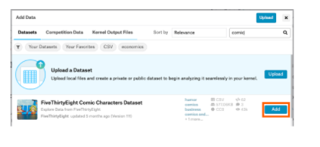
Once you have found the dataset, click on the [Add] button to attach it to the notebook. You can check that it was successful by looking at the Data dropdown menu to the right of the notebook -- look for an input folder containing a subfolder that matches the name of the dataset.
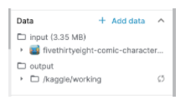
You can click on the carat to the left of the name of the dataset to double-check that it contains a CSV file. For instance, the image below shows that the example dataset contains two CSV files: (1) dc-wikia-data.csv, and (2) marvel-wikia-data.csv.

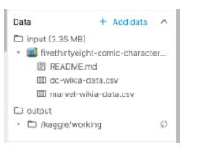
Once you've uploaded a dataset with a CSV file, run the code cell below without changes to receive credit for your work!

Step 2: Specify the filepath
Now that the dataset is attached to the notebook, you can find its filepath. To do this, begin by clicking on the CSV file you'd like to use. This will open the CSV file in a tab below the notebook. You can find the filepath towards the top of this new tab.
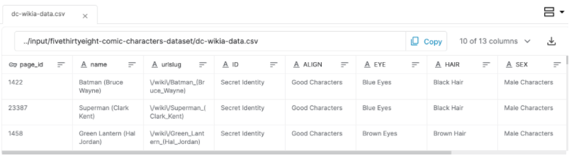
After you find the filepath corresponding to your dataset, fill it in as the value for my_filepath in the code cell below, and run the code cell to check that you've provided a valid filepath. For instance, in the case of this example dataset, we would set
my_filepath = "../input/fivethirtyeight-comic-characters-dataset/dc-wikia-data.csv"
Note that you must enclose the filepath in quotation marks; otherwise, the code will return an error.
Once you've entered the filepath, you can close the tab below the notebook by clicking on the [X] at the top of the tab.

# Fill in the line below: Specify the path of the CSV file to read
my_filepath = '../input/fivethirtyeight-comic-characters-dataset/marvel-wikia-data.csv/marvel-wikia-data.csv'

Step 3: Load the data
Use the next code cell to load your data file into my_data. Use the filepath that you specified in the previous step.

# Fill in the line below: Read the file into a variable my_data
my_data = pd.read_csv(comic_filepath, index_col='page_id')

# Print the first five rows of the data
my_data.head()

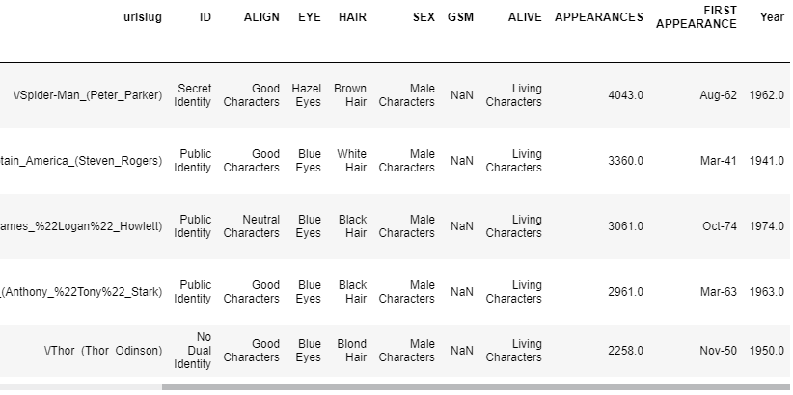

Step 4: Visualize the data
Use the next code cell to create a figure that tells a story behind your dataset. You can use any chart type (_line chart, bar chart, heatmap, etc_) of your choosing!

# Create a plot
sns.scatterplot(x=comic_data['Year'], y=comic_data['APPEARANCES'])
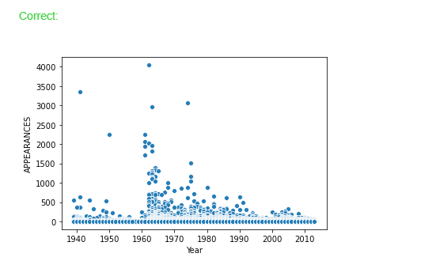

8. Creating Your Own Notebook

8.1 COURS

Congratulations for making it to the end of the micro-course!
In this final tutorial, you'll learn an efficient workflow that you can use to continue creating your own stunning data visualizations on the Kaggle website.

Workflow
Begin by navigating to the site for Kaggle Notebooks:
https://www.kaggle.com/kernels
Then, in the top right corner, click on [New Notebook].


This opens a pop-up window.

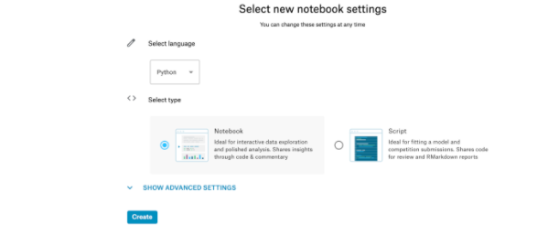
Then, click on [Create]. (Don't change the default settings: so, "Python" should appear under "Select language", and you should have "Notebook" selected under "Select type".)
This opens a notebook with some default code. Please erase this code, and replace it with the code in the cell below. (This is the same code that you used in all of the exercises to set up your Python environment.)
import pandas as pd
pd.plotting.register_matplotlib_converters()
import matplotlib.pyplot as plt
%matplotlib inline
import seaborn as sns
print("Setup Complete")
Setup Complete

The next step is to attach a dataset, before writing code to visualize it. (You learned how to do that in the previous tutorial.)
Then, once you have generated a figure, you need only save it as an image file that you can easily add to your presentations!

