**INTRODUCTION TO CLOUD**

### Welcome

### Welcome to Introduction to Cloud

[Music]

Welcome to introduction to cloud

computing, the first in the series of

four courses designed to give you the

foundational skills you need to be a

cloud practitioner. Today cloud

represents a huge market, one that is

continuing to grow at an unprecedented

scale. Enormous computational power, once

considered a prerogative of large

enterprises, is now available at the

fingertips of even the smallest of

businesses and individual developers,

thanks to Cloud.

Moreover, the Cloud makes all this

computational power highly affordable

with pay-as-you-go economics. If you look

at some of the key emerging technologies

of our times, such as artificial

intelligence, the Internet of Things,

Blockchain and Analytics, all of these

technologies work with massive amounts

of data and need huge storage space and

computational power in order to work -

making cloud possibly the only viable

platform for these technologies. This

course will introduce you to the core

concepts of cloud computing - from its

essential characteristics to the

different service and deployment models,

cloud architecture, security and

monitoring, emerging technologies

supported by the cloud, and career

opportunities available in the domain.

The course is designed for everyone - it

doesn't matter if you have a background

in cloud technologies. Whether you're an

IT person looking to upscale or explore

this domain, a fresh graduate looking to

make a career in cloud technologies, or

an IT decision-maker, this course will

equip you with what you need to get

started. With just the public cloud

service market expected to grow to 331.2

billion by 2022, it's a

time to be in the cloud computing

industry. Today there are more open

positions in cloud than the number of

skilled people available. And the sheer

growth of the cloud market makes it an

exciting and dependable career prospect

for the coming times. So, congratulations

on embarking on this exciting journey.

And good luck!

#### Learning Objectives

After completing this course, you will be able to:

* Define cloud computing and explain its essential characteristics, evolution, and business case for cloud adoption
* Explain how some of the emerging technologies, such as the Internet of Things, Artificial Intelligence, Blockchain, and Analytics, are being supported by the cloud
* Define the cloud service models (IaaS, PaaS, SaaS) and deployment models(Public, Private, Hybrid)
* Describe the concepts and components of cloud infrastructure such as virtualization, virtual machines, bare metal servers, and containers
* Explain different cloud storage models including Direct Attached, File, Block, Object Storage, and CDNs
* Explain emergent trends  related to cloud computing including Hybrid Multicloud, Microservices, Serverless computing, Cloud Native, DevOps, and Application Modernization
* Describe the concepts in cloud security and how organizations in different industries are benefiting from cloud
* List the job roles and career opportunities available in cloud computing
* Create an account on a IBM Cloud platform and deploy a cloud service

Après avoir suivi ce cours, vous serez en mesure de

* Définir l'informatique en nuage et expliquer ses caractéristiques essentielles, son évolution et les arguments économiques en faveur de son adoption
* Expliquer comment certaines des technologies émergentes, telles que l'Internet des objets, l'intelligence artificielle, la chaîne de blocage et l'analyse, sont soutenues par le nuage
* Définir les modèles de services dans le nuage (IaaS, PaaS, SaaS) et les modèles de déploiement (public, privé, hybride)
* Décrire les concepts et les composants de l'infrastructure en nuage tels que la virtualisation, les machines virtuelles, les serveurs en métal nu et les conteneurs
* Expliquer les différents modèles de stockage dans le nuage, y compris le Direct Attached, File, Block, Object Storage et CDN
* Expliquer les tendances émergentes liées à l'informatique en nuage, notamment le multicloud hybride, les micro-services, l'informatique sans serveur, le "Cloud Native", le "DevOps" et la modernisation des applications
* Décrire les concepts de la sécurité dans les nuages et la manière dont les organisations de différents secteurs d'activité tirent profit du nuage
* Liste des emplois et des opportunités de carrière disponibles dans le domaine de l'informatique en nuage
* Créer un compte sur une plate-forme IBM Cloud et déployer un service de cloud

### Module 1 - Overview of Cloud Computing

## Module Introduction and Learning Objectives

Module 1 - Introduction

In this module you will learn about the definition and essential characteristics of cloud computing. You will learn about the evolution of cloud computing and the factors that organizations need to consider while creating their cloud strategy. You will become familiar with some key cloud service providers and the services they offer. At the end of the module, you will learn how to create an account on a public cloud platform.

Dans ce module, vous découvrirez la définition et les caractéristiques essentielles de l'informatique en nuage. Vous apprendrez l'évolution du cloud computing et les facteurs que les organisations doivent prendre en compte lors de la création de leur stratégie de cloud computing. Vous vous familiariserez avec certains des principaux fournisseurs de services d'informatique en nuage et les services qu'ils offrent. À la fin du module, vous apprendrez comment créer un compte sur une plateforme publique de cloud computing.

#### Learning Objectives

After completing this module, you will be able to:

* Define cloud computing
* Describe the essential characteristics of cloud computing
* Briefly recount the history and evolution of cloud computing
* Describe the key considerations that organizations can use as a guide while creating their cloud strategy
* Describe the key cloud service providers and their services
* Create an account on a public cloud platform

Après avoir terminé ce module, vous pourrez

* Définir l'informatique en nuage
* Décrire les caractéristiques essentielles du cloud computing
* Racontez brièvement l'histoire et l'évolution du cloud computing
* Décrire les principales considérations que les organisations peuvent utiliser comme guide lors de l'élaboration de leur stratégie d'utilisation du cloud
* Décrivez les principaux fournisseurs de services dans le nuage et leurs services
* Créer un compte sur une plateforme de cloud public

### Definition and Essential Characteristics of Cloud Computing

Cloud computing, also referred to as “the cloud,” is the delivery of on-demand computing

resources—everything from applications to data centers—over the internet on a pay-for-use

basis.

To get a common understanding of cloud computing, let’s start with the US National Institute

of Standards and Technology (NIST’s) definition of cloud computing.

NIST defines cloud computing as a model for enabling convenient, on-demand network access

to a shared pool of configurable computing resources that can be rapidly provisioned

and released with minimal management effort or service provider interaction.

Examples of computing resources include networks, servers, storage, applications, and services.

This cloud model is composed of five essential characteristics, three deployment models,

and three service models.

Let’s start with understanding the five essential characteristics of the cloud—which

include on-demand self-service, broad network access, resource pooling, rapid elasticity,

and measured service.

On-demand Self-service, the 1st characteristic, means that you get access to cloud resources

such as the processing power, storage, and network you need, using a simple interface,

without requiring human interaction with each service provider.

The 2nd characteristic, Broad Network Access, means that cloud computing resources can be

accessed via the network through standard mechanisms and platforms such as mobile phones,

tablets, laptops, and workstations.

The 3rd characteristic, Resource Pooling, is what gives cloud providers economies of

scale, which they pass on to their customers, making cloud cost-efficient.

Using a multi-tenant model, computing resources are pooled to serve multiple consumers; cloud

resources are dynamically assigned and reassigned, according to demand, without customers needing

to concern themselves with the physical location of these resources.

Rapid Elasticity, the 4th characteristic, implies that you can access more resources

when you need them, and scale back when you don’t—because resources are elastically

provisioned and released.

And the 5th characteristic, Measured Service, means that you only pay for what you use or

reserve as you go; if you’re not using resources, you’re not paying.

Resource usage is monitored, measured, and reported transparently based on utilization.

As we see, cloud computing is really about utilizing technology “as a service”—leveraging

remote systems on-demand over the open internet, scaling up and scaling back, and paying for

what you use.

It is a revolution in that it has changed the way the world consumes compute services

by making them more cost-efficient while also making organizations more agile in responding

to changes in their markets.

+

As I mentioned earlier in this talk, the cloud model is composed of five essential characteristics,

three deployment models, and three service models.

We just went over the five essential characteristics.

While we will go into greater depth of the deployment and the service models in the later

videos, let me leave you with a brief overview of these models.

There are three types of cloud deployment models—Public, Private, and Hybrid.

Public cloud is when you leverage cloud services over the open internet on hardware owned by

the cloud provider, but its usage is shared by other companies.

Private cloud means that the cloud infrastructure is provisioned for exclusive use by a single

organization.

It could run on-premises or it could be owned, managed, and operated by a service provider.

And when you use a mix of both public and private clouds, working together seamlessly,

that is classified as the Hybrid model.

Now, let’s look at the three service models that are based on the three layers in a computing

stack - Infrastructure, Platform, and Applications.

These cloud computing models are aptly referred to as Infrastructure as a Service (Iaas),

Platform as a Service (PaaS), and Software as a Service (SaaS).

In an Infrastructure as a Service model, you get access to infrastructure and physical

computing resources such as servers, networking, storage, and data center space - without the

need to manage or operate them.

In a Platform as a Service model, you get access to the platform, that is the hardware

and software tools, usually those needed to develop and deploy applications to users over

the Internet.

Software as a Service is a software licensing and delivery model in which software and applications

are centrally hosted and licensed on a subscription basis, and sometimes also referred to as "on-demand

software."

In the next video, we will go over some of the key evolutions that brings us to what

cloud computing is today.

### History and Evolution of Cloud Computing

Cloud computing is an evolution of technology over time.

The concept of cloud computing dates to the 1950s when large-scale mainframes with high-volume

processing power became available.

In order to make efficient use of the computing power of mainframes, the practice of time

sharing, or resource pooling, evolved.

Using dumb terminals, whose sole purpose was to facilitate access to the mainframes, multiple

users were able to access the same data storage layer and CPU power from any terminal.

In the 1970s, with the release of an operating system called Virtual Machine (VM), it became

possible for mainframes to have multiple virtual systems, or virtual machines, on a single

physical node.

The virtual machine operating system evolved the 1950s application of shared access of

a mainframe by allowing multiple distinct compute environments to exist on the same

physical hardware.

Each virtual machine hosted guest operating systems that behaved as though they had their

own memory, CPU, and hard drives, even though these were shared resources.

Virtualization thus became a technology driver and a huge catalyst for some of the biggest

evolutions in communications and computing.

Even 20 years ago, physical hardware was quite expensive.

With the internet becoming more accessible, and the need to make hardware costs more viable,

servers were virtualized into shared hosting environments, virtual private servers, and

virtual dedicated servers, using the same types of functionality provided by the virtual

machine operating system.

So, for example, if a company needed ‘x’ number of physical systems to run their applications,

they could take one physical node and split it into multiple virtual systems.

This was enabled by hypervisors.

A hypervisor is a small software layer that enables multiple operating systems to run

alongside each other, sharing the same physical computing resources.

A hypervisor also separates the Virtual Machines logically, assigning each its own slice of

the underlying computing power, memory, and storage, preventing the virtual machines from

interfering with each other.

So, if, for example, one operating system suffers a crash or a security compromise,

the others keep working.

As technologies and hypervisors improved and were able to share and deliver resources reliably,

some companies decided to make the cloud’s benefits accessible to users who didn’t

have an abundance of physical servers to create their own cloud computing infrastructure.

Since the servers were already online, the process of spinning up a new instance was

instantaneous.

Users could now order cloud resources they needed from a larger pool of available resources,

and they could pay for them on a per-use basis, also known as Pay-As-You-Go.

This pay-as-you-go or utility computing model became one of the key drivers behind cloud

computing taking off.

The pay-per-use model allowed companies and even individual developers to pay for the

computing resources as and when they used them, just like units of electricity.

This allowed them to switch to a more cash-flow friendly OpEx model from a CapEx model.

This model appealed to all sizes of companies, those who had little or no hardware, and even

those that had lots of hardware, because now, instead of making huge capital expenditures

in hardware, they could pay for compute resources as and when needed.

It also allowed them to scale their workloads during usage peaks, and scale down when usage

subsided.

And this gave rise to modern-day cloud computing.

The impact of the evolution of the cloud has been immense.

In the next training, we will go over some key considerations for cloud adoption.

### Key Considerations for Cloud Computing

Every organization’s transformation journey is unique, and therefore every organization’s

cloud adoption strategy is also unique to them.

Agility, flexibility, and competitiveness are key drivers for moving to the cloud, provided

it is done without creating business disruption or issues related to security, compliance,

and performance.

Let’s look at some key considerations that organizations can use as a guide while working

through their cloud strategy.

The first consideration is infrastructure and workloads.

The cost of building and operating data centers can become astronomical.

On the other hand, low initial costs and pay-as-you-go attributes of cloud computing can add up to

significant cost savings.

Also, a point to consider is that not all workloads may be ready for the cloud, as-is.

The second consideration is around SaaS and development platforms.

Organizations need to consider if paying for application access is a more viable option

than purchasing off-the-shelf software and subsequently investing in upgrades.

Organizations also need to consider speed and productivity—what it means for them

to get a new application up and running in ‘x’ hours on the cloud versus a couple

of weeks, even months on traditional platforms.

And the person-hour cost efficiencies they gain from using cloud dashboards, real-time

statistics, and active analytics.

Lastly, organizations need to consider the impact of making a wrong decision—their

risk exposure.

Is it riskier, for example, for them to invest in the hardware and software or rent by the

hour?

Is it safer for them to work on a 12-month plan to build, write, test, and release the

code if they’re uncertain about adoption?

And is it better for them to “try” something new paying-as-you-go rather than making long-term

decisions based on little or no trial or adoption?

Let’s look at some of the benefits of cloud adoption, categorized broadly into Flexibility,

Efficiency, and Strategic Value.

Cloud gives us flexibility.

Users can scale back or scale up services to fit their needs, customize applications,

and access cloud services from anywhere with an internet connection.

Cloud infrastructure scales on demand to support fluctuating workloads.

Organizations can determine their level of control with as-a-service options.

Users can select from a menu of pre-built tools and features to build a solution that

fits their specific needs.

And Virtual Private Clouds, encryption, and API keys help keep data secure.

Cloud also brings great efficiency.

Enterprise users can get applications to market quickly without worrying about underlying

infrastructure costs or its maintenance.

Cloud-based applications and data are accessible from virtually any internet-connected device.

Hardware failures do not result in data loss because of networked backups.

Cloud computing uses remote resources, saving organizations the cost of servers and other

equipment, and paying on use-basis.

Cloud services give enterprises a competitive advantage by providing the most innovative

technologies available while managing the underlying infrastructure, thus enabling organizations

to focus on their priorities.

While cloud brings great opportunity, it also introduces challenges for business leaders

and IT departments.

Some of these perceived risks include: Data security, associated with loss or unavailability

of data causing business disruption; Governance and sovereignty issues;

Legal, regulatory, and compliance issues; Lack of standardization in how the constantly

evolving technologies integrate and interoperate; Choosing the right deployment and service

models to serve specific needs; Partnering with the right cloud service providers;

Concerns related to business continuity and disaster recovery.

Organizations can no longer think of cloud adoption as something that is to be looked

at in the future.

With the right cloud adoption strategies, technologies, services, and service providers,

these risks can be mitigated.

In the next training, we’re going to look at some of the key cloud service providers

of our times, and the services they offer.

### Key Cloud Service Providers and Their Services

Let’s look at some numbers and predictions that help us see the scale cloud is predicted

to achieve in the coming years.

Gartner predicts: The worldwide public cloud service market

to grow from $182.4 B in 2018 to $331.2 B in 2022, attaining

a compound annual growth rate (CAGR) of 12.6%.

Spending on Infrastructure-as-a-Service to increase from $30.5 B in 2018

to $76.6 B in 2022, growing 27.5% in a year.

Platform-as-a-Service spending to grow from $15.6 B in 2018 to $31.8B

2022, growing 21.8% in a year.

With software investments shifting from cloud-first to cloud-only, spending on Sofware-as-a-Service

is expected to grow from $80 B in 2018 to $143.7 B in 2022.

What is clear is that cloud is accelerating faster than predicted, adoption is high, and

revenues are soaring.

The question for businesses today is no longer “if” they need to adopt the cloud, rather

“what” their cloud adoption strategy should be to best serve their businesses and customers.

Keeping up with this technological wave, and driving it forward, are the Cloud Service

Providers with a wide range of services.

We will now talk about some of the major Cloud Service Providers in alphabetical order.

Alibaba Cloud, also known as Aliyun, while relatively new, is the largest Chinese cloud

computing service provider.

Aliyun provides a comprehensive suite of global cloud computing services to power not just

their customers’ online businesses but also the Alibaba Group’s own e-commerce ecosystem.

It offers a host of products and services such as compute, network, storage, security,

monitoring and managing, communication, analytics, IoT, application development, data migration,

web hosting, and more.

One of the first to enter the cloud computing space, Amazon Web Services, or AWS Cloud,

offers an extensive range of Infrastructure and Platform services to individuals, companies,

and governments on a metered pay-as-you-go basis.

The Amazon Cloud provides a wide range of products, services, and solutions ranging

from Compute, DevOps, Data, Analytics, IoT, Machine Learning, Networking, Content Delivery,

Robotics, Serverless Computing, and much more.

Google Cloud Platform, or GCP, is a suite of cloud computing services, providing Infrastructure,

Platform, and Serverless Computing environments.

Google also uses GCP internally for their end-user products such as Google Search and

YouTube.

Google Cloud includes G Suite with products for communication, productivity, collaboration,

storage, and more.

The Google App Engine is a platform for developing and hosting web applications in Google-managed

data centers, automatically allocating and de-allocating resources to handle demand.

IBM cloud is a full stack cloud platform that spans public, private, and hybrid environments

with products and services covering compute, network, storage, management, security, DevOps,

and databases.

Some of their prominent offerings include their Bare Metal Servers, VMWare, Cloud Paks

for Application Modernization, Virtual Private Cloud, and the suite of emerging technologies

such as AI, IoT, Blockchain, Data and Analytics.

With the acquisition of Red Hat, IBM is also positioning itself as the leading hybrid cloud

provider of our times.

Microsoft Azure is a flexible cloud platform for building, testing, deploying, and managing

applications and services through Microsoft-managed data centers.

With its data centers spread out in many regions, Azure provides a global reach with a local

presence.

It provides Software, Platform, and Infrastructure services supporting Microsoft-specific and

third-party languages, tools, and frameworks.

Oracle Cloud is primarily known for Software as a Service and Database as a Service (also

known as the Oracle Data Cloud).

Oracle’s SaaS offering includes wide-ranging applications such as ERP, SCM, HCM, Marketing,

Sales, and CX running in the cloud.

And the Oracle Data Cloud provides one of the largest cloud-based data management platforms

helping customers personalize their online, offline, and mobile marketing campaigns, for

targeted audiences.

Oracle Cloud also provides some cloud Infrastructure and Platform services.

Salesforce specializes in their Software as a Service offering that focuses on customer

relationship management, supporting businesses to better connect with their customers, partners,

and potential customers.

Salesforce offers multiple cloud services such as Sales Cloud, Service Cloud, and Marketing

Cloud, helping customers track analytics in real-time, customer success and support, customer

complaints, even listening in to customers across social platforms to automatically route

them to appropriate agents for resolution.

SAP is known for Enterprise software and applications such as ERP, CRM, HR, and Finance, running

in the cloud.

There is also an SAP Cloud Platform for building and extending business applications with rapid

innovation cycles in a secure cloud computing environment managed by SAP.

In the next video, we’re going to look at the business case for cloud computing.

## Create an IBM Cloud Account

[Click this link](https://courses.cognitiveclass.ai/assets/courseware/v1/3e0986ec272fee2357f937d3e5f592b4/asset-v1:IBMDeveloperSkillsNetwork+CC0101EN+2020T1+type@asset+block/Lab1-Create_an_IBM_Cloud_Account-v1.pdf) and follow the instrcutions in the .pdf file that opens up in a new browser tab. In case the pdf file does not open in your browser, you can download the file by right clicking on the above link, choose "Save as", and then open it in a pdf viewer like Adobe Acrobat.

### ****Lab: Create an IBM Cloud Account****

#### Lab Objectives:

After completing this lab, you will have signed up for a free account on IBM Cloud.

#### Lab Overview:

IBM Cloud offers numerous cloud resources and services. In this hands-on lab, you will create a Lite account on IBM Cloud. You can subsequently use your IBM Cloud Lite account, in this course or otherwise, to explore the catalog and provision many cloud services at no charge.

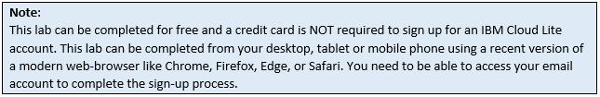

#### About IBM Cloud:

The IBM cloud platform globally deployed across data centers around the world, combines platform as a service (PaaS) with infrastructure as a service (IaaS) to provide an integrated experience. The platform scales and supports both small development teams and organizations, and large enterprise businesses.

The platform is built to support your needs whether it's working only in the public cloud or taking advantage of a multicloud deployment model. IBM Cloud offers a variety of services including Compute, Network, Storage, Management, Security, Databases, Analytics, AI and Cloud Paks.

#### Lab Instructions:

You will perform this lab by completing the following tasks:

        1.   Sign-up

        2.   Confirm

        3.   Login

If you already have an IBM Cloud account, you can skip Tasks 1 and 2 and proceed with Task 3: Login to your IBM Cloud account.

##### Task 1: Sign up for IBM Cloud

        1.   Go to: [Create a free account on IBM Cloud](https://cocl.us/ibmcloud_cc_cc0101en" \t "[object Object])

        2.   In the **Email** box, enter your email address and then click the arrow.

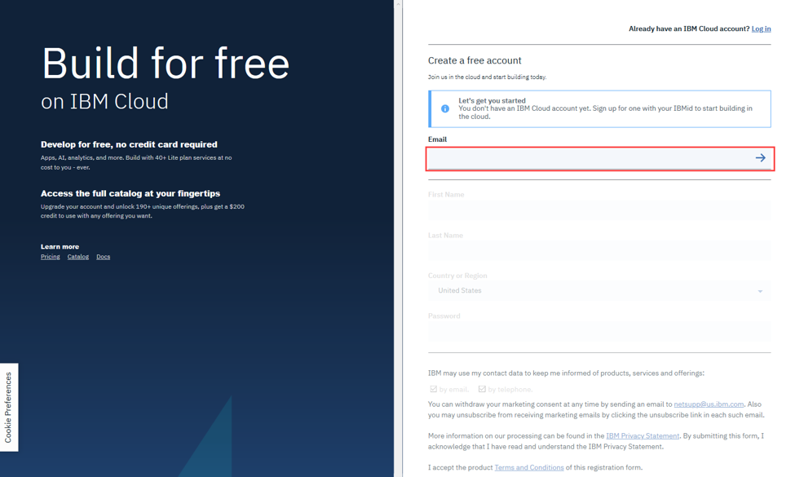

        3.   When your email address is accepted, enter your:

**First Name**, **Last Name**, **Country or Region**, and create a **Password**.

**Note:** To get enhanced benefits, please sign up with your company email address rather than a free email ID like Gmail, Hotmail, etc.

If you would like IBM to contact you for any changes to services or new offerings, then check the box to accept the option to be notified by email.

Then click **Create Account** to create your IBM Cloud account.

##### Task 2: Confirm your email address

        1.   An email is sent to the address that you signed up with.

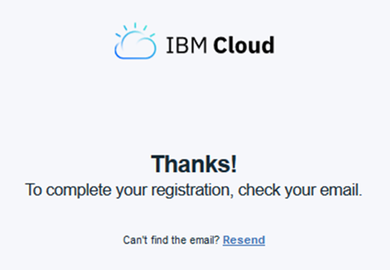

        2.   Check your email, and in the email that was sent to you, click **Confirm Account**.

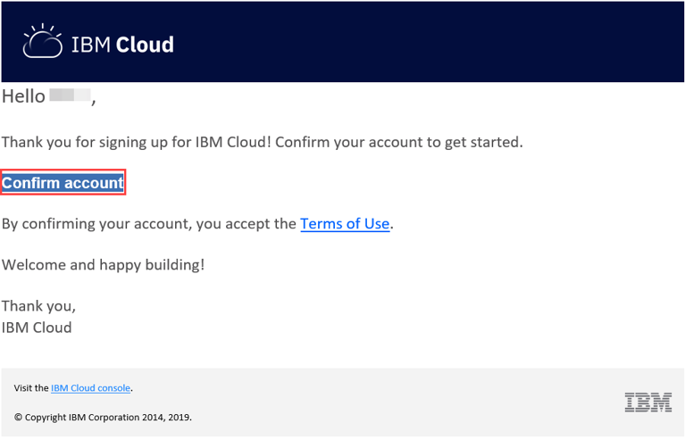

        3.   You will receive notification that your account is confirmed.

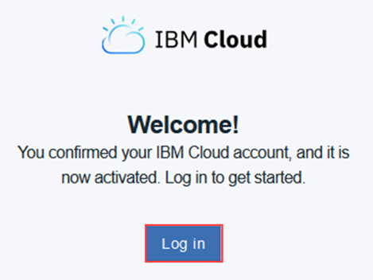

               Click **Log In**, and you will be directed to the IBM Cloud Login Page.

##### Task 3: Login to your IBM Cloud account

        1.   On the [Log in to IBM Cloud](https://cocl.us/ibmcloud_login_cc_cc0101en) page, in the **ID** box, enter your email address and then click **Continue**.

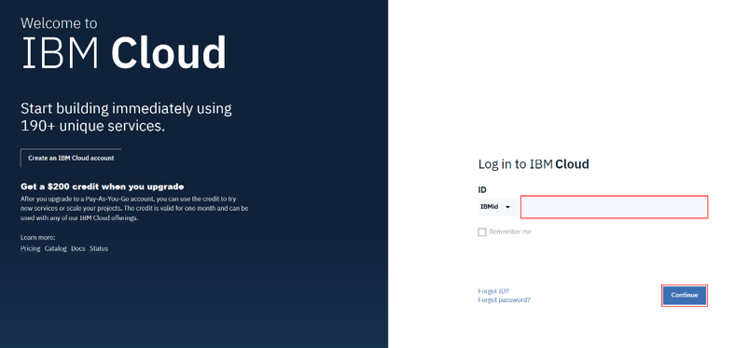

        2.   In the **Password** box, enter your password, and then click **Log in**.

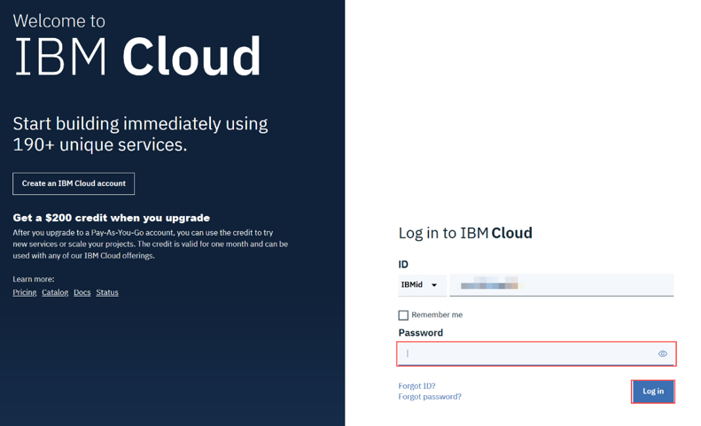

Congratulations!  You can now explore the [IBM Cloud catalog](https://cloud.ibm.com/catalog) and provision various services on cloud.

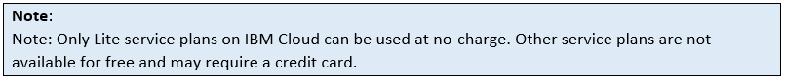

##### Share your progress

Follow us on Twitter and share some of the interesting services you come across on IBM Cloud.

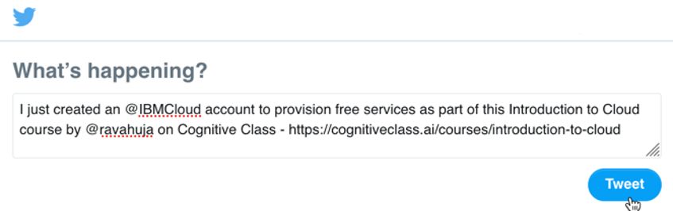

[Click here](https://twitter.com/intent/tweet?text=I%20just%20created%20an%20@IBMCloud%20account%20to%20provision%20free%20services%20as%20part%20of%20this%20Introduction%20to%20Cloud%20course%20by%20@ravahuja%20on%20Cognitive%20Class%20-%20https://cognitiveclass.ai/courses/introduction-to-cloud) to share the above Tweet.

[Follow Rav Ahuja](https://twitter.com/ravahuja)

## Reading: Module 1 Summary

**In this module, you have learned:**

●       Cloud computing is the delivery of on-demand computing resources over the internet on a pay-as-you-go basis; resources are dynamically assigned and reassigned among multiple users and scale up and down in response to users’ needs.

●       The origins of cloud computing can be traced back to the mainframes of the 1950s, with virtualization technologies and hypervisors serving as catalysts for the emergence of modern-day cloud computing.

●       Organizations must consider their business needs, investment viability, and risk capacity in order to create a cloud adoption strategy that delivers desired benefits without causing business disruptions and security, compliance, or performance issues.

●       Cloud adoption is growing faster than predicted. Driving this technological wave are cloud service providers with a host of services ranging from Infrastructure, Platform, and Software services. Some major Cloud providers of our times include AWS, Alibaba Cloud, Google, IBM Cloud, and Microsoft Azure.

Dans ce module, vous avez appris :

● Le cloud computing est la fourniture de ressources informatiques à la demande sur l'internet sur la base d'un paiement à l'utilisation ; les ressources sont affectées et réaffectées dynamiquement entre plusieurs utilisateurs et évoluent en fonction des besoins des utilisateurs.

● Les origines du cloud computing remontent aux ordinateurs centraux des années 1950, les technologies de virtualisation et les hyperviseurs servant de catalyseurs à l'émergence du cloud computing moderne.

● Les organisations doivent tenir compte de leurs besoins commerciaux, de la viabilité de leurs investissements et de leur capacité à prendre des risques afin de créer une stratégie d'adoption du cloud computing qui apporte les avantages souhaités sans causer de perturbations commerciales ni de problèmes de sécurité, de conformité ou de performance.

● L'adoption du cloud computing se développe plus rapidement que prévu. Cette vague technologique est alimentée par les fournisseurs de services dans le nuage, qui proposent toute une gamme de services allant de l'infrastructure à la plate-forme en passant par les logiciels. Parmi les principaux fournisseurs de cloud computing de notre époque, citons AWS, Alibaba Cloud, Google, IBM Cloud et Microsoft Azure.

### Module 2 - Cloud Adoption and Emerging Technologies

## Module Introduction and Learning Objectives

Module 2 - Introduction

In this module, you will learn about the business case for cloud adoption and case studies that demonstrate the results achieved by organizations through cloud adoption. You will also learn about some of the emerging technologies being supported by cloud computing.

Dans ce module, vous découvrirez les arguments économiques en faveur de l'adoption du cloud et des études de cas qui démontrent les résultats obtenus par les organisations grâce à l'adoption du cloud. Vous découvrirez également certaines des technologies émergentes soutenues par l'informatique en nuage.

**Learning Objectives**

After completing this module, you will be able to:

* Describe the business case for cloud adoption and case studies that demonstrate the impact businesses have created by adopting cloud
* Explain how emerging technologies such as the Internet of Things, Artificial Intelligence, Blockchain, and Analytics are being accelerated by the Cloud

Après avoir terminé ce module, vous pourrez

* Décrire le cas commercial de l'adoption du cloud et les études de cas qui démontrent l'impact que les entreprises ont créé en adoptant le cloud
* Expliquer comment les technologies émergentes telles que l'Internet des objets, l'intelligence artificielle, les chaînes de blocage et l'analyse sont accélérées par le Cloud

### Cloud Adoption - No Longer a Choice

Cloud adoption is no longer a thing of the future.

From a single individual to a global multi-billion-dollar enterprise, anybody can access the computing

capacity they need on the cloud.

The lag time from decision to value is no longer a journey of years with high upfront

capital; cloud makes it possible for businesses to experiment, fail, and learn much faster

than ever before, with low risk exposure.

Businesses today have greater freedom to change course than to live with the consequences

of expensive decisions taken in the past.

According to an IBM Institute for Business Value study, more than three-quarters of enterprises

today are using cloud computing to expand into new industries.

74% have adopted cloud to improve customer experience; and 71% use cloud to create enhanced

products and services—while simultaneously downsizing legacy systems and reducing costs.

To remain competitive, businesses need to be able to respond quickly to marketplace

changes, use analytics to understand customer experience, and apply that understanding to

adapt their products and services based on what they learn.

Product lifecycles have shortened, and barriers to entry have become lower.

Today’s enablers for growth, agility, and innovation include:Cognitively-enabled workflows,

Applied exponential technologies such as AI, Automation, IoT, and Blockchain,

Applications that span new and legacy solutions; and

dOpen hybrid and secure Multicloud infrastructures.

The power, scalability, flexibility, and pay-as-you-go economics of cloud provides the foundation

for this transformation.

The International Data Corporation, IDC, predicts that by 2025, the total amount of digital

data created worldwide will rise to 163 zettabytes (where one zettabyte is equivalent to a trillion

gigabytes).

And 30% of this data will be real-time information.

Considering the unprecedented amounts of data being produced daily, and the ability to make

data-driven decisions crucial to any business, cloud computing becomes essential for businesses

to succeed, sustain, and compete in today’s markets.

A cloud strategy, more than just an IT strategy, is the core component of any business strategy

today.

Businesses that haven’t already, or are not currently, integrating cloud into their

business strategy, run the risk of lacking the speed, agility, innovation, and decision-making

capacities needed to be competitive, as also their ability to respond to digital disruption.

In the next video, we’ll look at some case studies that demonstrate the impact businesses

have created by adopting cloud.

### Cloud Adoption - Some Case Studies

In this video, we will look at how some of the leading businesses have transformed the

way they work to provide better customer service, remove barriers to innovation, achieve enterprise

scale, and accelerate growth, using cloud technologies.

Although the case studies we’ll look at are curated from IBM Cloud, similar stories

with dramatic impact to business can be found across the spectrum of companies utilizing

other Cloud Service providers as well.

BETTER CUSTOMER SERVICE: In the highly competitive airline industry,

customer experience is a major point of differentiation, and digital channels are increasingly important.

To become more responsive to customer needs, American Airlines needed a new technology

platform and a new approach to development that would help it deliver digital self-service

tools and customer value more rapidly across its enterprise.

The airline recognized the opportunity to remove the constraints of their existing customer-facing

applications based on monolithic code into cloud-native based microservices architecture

on the cloud.

The results: Faster development and release of new apps.

Improved operational reliability, productivity, and end customer response times.

Cost savings by avoiding existing upgrade costs via migration to the IBM Cloud.

REMOVING BARRIERS TO INNOVATION: As a lean organization with a self-imposed

limit on headcount, UBank excels at finding innovative ways to meet demands.

Continually challenged to find more efficient ways to operate, UBank’s IT team explored

a Platform as a Service (PaaS) cloud development model.

Their need was to give more control to their developers, reduce the need for additional

resources, faster speed to market, and removing barriers in going from an idea to production.

UBank launched new initiatives in an IBM Cloud Platform environment, including a virtual

assistant that incorporates IBM Watson technology to support the bank’s online home loan application.

The results: Faster time to market made possible through

the Cloud Platform framework that streamlines development and empowers product teams.

Foster greater innovation with cloud-based development resources that are quick, easy,

and cost-effective to deploy.

More efficient operations.

DEMAND FOR ENTERPRISE SCALE: Since its inception in 2008, Bitly has journeyed

from a startup that offered intelligent link-shortening technology adopted by users to compress lengthy

URLs for social media posts, to an enterprise product.

Seeking an agile, cost-effective IT infrastructure to support this transition, Bitly started

planning for cloud migration.

Their need was to have a cloud-based model with pay-as-you-go pricing, the ability to

scale up and scale down, a more global presence, and the ability to geodistribute into more

POPs.

And they wanted it to be low-risk.

Bitly migrated to an IBM Cloud environment, establishing a scalable hosting platform for

low-latency delivery to enterprise customers around the world.

The results: 25 billion data-infused links migrated from

one hosting site to Cloud infrastructure with data center locations worldwide.

1 billion user interaction data set stored and managed in a flexible, cost-effective

Cloud Object Storage environment.

Transformed IT operations to scale for growth, control costs and focus valuable resources

on new product development.

ACCELERATING GROWTH: Financial traders demand extreme speed and

availability from trading systems.

Profitability depends on split-second decisions.

As a leading online broker in forex, commodities, equities, cryptocurrencies, indices, and other

financial instruments, ActivTrades enables investors to buy and sell on numerous financial

markets.

Investors need reliable access to accurate market information, combined with the ability

to move rapidly to execute trades.

As its client base grew, ActivTrades wanted to cut latency, accelerate execution, and

streamline the delivery of new functions.

ActivTrades migrated three major trading systems from on-premises infrastructure to IBM Cloud

for VMware solutions, backed by data storage, networking, and security offerings on the

IBM Cloud.

The results: Up to 3X performance boost, helping clients

seize fleeting opportunities for profit.

Security-rich cloud platform with ultra-high availability protects client investments.

Hours, not days to fire up new resources, for faster response to emerging requirements.

In the next video, we’ll look at some of the emerging technologies that are available

on the cloud and the opportunities they bring to businesses.

### Internet of Things in the Cloud

In this new era technologies such as Internet of Things, Big Data, artificial

intelligence, and blockchain are disrupting existing business models and

industries while creating unprecedented opportunities for businesses to

differentiate themselves and create value for their clients. The power, scale,

dynamic nature, and economics of the cloud resources make cloud computing a

key enabler for adoption and evolution of these emerging technologies. In this

video, we will look at how the Internet of Things, or IoT, powered by cloud, is

making a big difference for businesses today. The Internet of Things, or IoT, is a

giant network of connected things and people that have changed much of how we

live our daily lives - from the way we drive, to how we make purchases,

monitoring our personal health, and even how we get energy for our homes. Smart

devices and sensors are continuously tracking and collecting data. For example,

a smart building could have thousands of sensors measuring all kinds of data

related to thermal, optical, structural, and environmental stimuli. An

unprecedented amount of data is being generated, putting a tremendous strain on

the Internet. That is where the cloud comes in, by

connecting the IoT device user to the cloud - be it for device registration,

device identity, storing data, or accessing enterprise data. Data collected

through IoT devices is stored and processed on the cloud since IoT devices

can be in a state of motion, the cloud serves as a collection point in closest

proximity, minimizing the latency in reporting up the data points and

providing a response back to the IoT application.

So, from IOT platforms running entirely on the cloud to the interfaces used by

customers to interact these devices, to the backend analytics

platforms - cloud computing supports and enables IoT. Cloud service providers also

offer specialized IoT services designed to help speed up the development of IoT

solutions. Let's look at a case study that demonstrates the use of the IoT on

the cloud to combat the poaching of endangered rhinos at Welgevonden by

making poaching predictable.

The rhinos have become one of the the key species that is becoming endangered due

to poaching throughout Africa. But now especially in South Africa.

Up until now, poachers have been increasing in numbers, and they become

more militarized with weapons. And so of course we've had to do the same. This is

not sustainable. The only way to do this better, is to bring in technology and

things that they do not have. This endangered species is getting help from

some unexpected friends, the zebra and antelope. They're wearing IoT sensors

connected to the IBM cloud. When poachers enter the area, the animals run for it,

which alerts Rangers who can track their emotions and help stop them before any

harm is done. It's a smart way to help increase the Rhino population and turn

the poachers into the endangered species. In the next video we're going to look at

how artificial intelligence on the cloud is impacting businesses.

### Artificial Intelligence on the Cloud

Making sense of the endless streams of data is where Artificial Intelligence, or AI, comes

in.

Many of the applications where we apply AI today simply wouldn't have been possible without

the scalable, on-demand computing offered by the cloud.

There is a three-way relationship between AI, IoT, and Cloud.

Just as AI consumes the data produced by IoT devices, the IoT devices’ behavior can be

dictated based on responses from AI.

For example, Smart Assistants, a common type of IoT device, continues to learn about the

user’s preferences as usage grows, such as the songs they like, their home temperature

settings, preferred meal times, and over time they anticipate their actions based on the

user’s past history.

So, what we see is a symbiotic relationship between IoT, AI, and Cloud.

IoT delivers the data, AI powers the insights, and both these emerging technologies leverage

cloud’s scalability and processing power to provide value to individuals and businesses

alike.

Let’s look at how the United States Tennis Association, USTA, is using AI on the Cloud

to deliver unique digital experiences to millions of fans around the world.

For two weeks at the end of every summer, tennis fans around the world turn their eyes

to New York city, and the US Open.

Hundreds of thousands onsite, and millions more online.

But where you see tennis, IBM sees data;

the scores and statistics, the sights, the sounds.

IBM integrates and analyzes the data flowing from the court.

And delivers unique digital experiences to more than ten million tennis fans around the

world.

And we do it all in the IBM Cloud.

The IBM Cloud is the digital foundation of the US Open.

It scales rapidly to meet a five thousand percent increase in web traffic.

And it delivers a consistant experience to our fans all around the globe.

And with Watson on the IBM Cloud, we can engage fans in unique ways, year after year.

Slam Tracker analyzes more than twenty-six million historical data points.

It gives fans deep insight into featured matches, and it can see the momentum of a match shifting

in real time.

AI Highlights uses Watson to process thousands of hours of US Open video.

It can hear the cheers of the crowd.

It can see a player celebrating.

And it knows what makes a great tennis highlight.

And this year we're putting the power of AI Highlights into the hands of US players and

coaches.

Watson is analyzing match video,

so coaches can quickly find the footage they need to guide the development of their players.

And if you need to know where to park, find a good burger, or grab the latest US Open

gear, you can find the answers with the Guest Information feature in the US Open app

and mobile web, using Watson.

We work with IBM because they keep us on the cutting edge of the fan experience.

They help us to adopt the latest technology, like Cloud and AI.

And they bring data to life in a way that's accessible and engaging for our fans.

In the next video, we’re going to look at how Blockchain and Analytics on the cloud

are impacting businesses.

### Blockchain and Analytics on the Cloud

Blockchain is a secure, distributed, open technology that can help speed up

processes, lower costs, and build transparency and traceability in

transactional applications. It is an immutable Network allowing members to

view only those transactions that are relevant to them. The more open, diverse,

and distributed the network, the stronger the trust and transparency in the data

and transactions. 85% of businesses today rely on multiple clouds to meet their IT

needs, with more than 70% using more than three. These businesses need to be able

to move applications and data across multiple clouds easily and securely,

leading to the emerging demand to build and manage business applications such as

blockchain for the multi cloud environment. Blockchain and AI, much like

IoT and AI, powered by the cloud, also have a three-way relationship. Where

blockchain technology provides the trusted, decentralized source of truth, AI

powers the analytics and decision-making from the data collected, and cloud

provides globally distributed, scalable, and cost-efficient computing resources

to support both the unprecedented amounts of data being collected and the

processing power required to draw insights from this data. Blockchain

serves to make AI more understandable by recording the data and variables that go

into a decision made in an AI algorithm, leading to greater trust and

transparency in the conclusions and decisions made by these algorithms. Let's

look at how blockchain on the cloud is helping farmers reduce waste at times of

recall by building traceability and transparency in the food supply chain.

For farmers here, this is our life's work. 60% of the nation's lettuce is

grown right here in Salinas. When it comes down to how plants are looked at, I

really relate back to how humans are raised and nurtured. I want to make sure

that everything is safe before it leaves the ranch. But when a recall happens,

perfectly good food goes to waste. You have to take all product off your shelf,

no matter what age, no matter where it came from. And it takes resources to grow

those things. Now we're actually eating into our future food supply. But

we've gotta way around that. With Blockchain technology on the IBM cloud

we're able to track our product within seconds. Giving the consumers instant

access where the product came from, in case there's any recall so we don't

have to take all the food off the shelves.

Having that instant access allows you to reduce the waste. There's a lot of

starving people in this world. I want to be a generation that

fixes that.

Analytics technologies on the cloud leverage the flexibility, scalability, and

computing resources available on the cloud. From tracking trends on social

media to predict future events, to analyzing data to build machine learning

models that can be deployed in cognitive applications, cloud provides the

integrated environment that is required to leverage data for continuous

improvement and accelerated business growth. Let's look at how KONE has

invested in cloud and IoT technologies to power a data analytics and predictive

maintenance solution for city infrastructure used by more than 1

billion people daily. At KONE we manufacture elevators, escalators, auto

walks, and doors All of these devices are streams of data that we are collecting.

In order to process those streams, we need a scalable way of handling the amount

of data that is coming in. And that's where cloud function fits in perfectly.

We handle that data with event-driven architecture. We use functions to persist

that data, and to generate further events on that data, that are then utilized and

consumed by applications, our customers and users. In our analytics

platform, we analyzed the set of data and we generate value predictive in a sense

that we can predict the failure rate to a certain percentage that is about to

happen in the future for our equipment. And this allows us to perform predictive

maintenance. And this is kind of the whole concept that we have behind our

24/7 connected services, which is a promise to our customers. That the

equipment is connected to the cloud and we are monitoring it. And that's where we

generate the real a value for our customers. At the

moment we use almost all aspects of the IBM cloud. We use storage from the cloud.

We use cloud function. We use messaging services. We

use IoT services. So a number of services already in use and platform. And that use

will only grow as our digital footprint in the industry grows.

## Reading: Module 2 Summary

**In this module, you have learned:**

●       The adoption of cloud technologies is enabling enterprises, big and small, to be agile, innovative, and competitive, and to create differentiated customer experiences. The question organizations are asking is not whether they should move to the cloud, rather what strategy they should adopt to move to the cloud.

●       Some case studies that demonstrate the impact businesses have created by adopting cloud

o   American Airlines adopting cloud technologies to deliver customer value rapidly across its enterprise

o   UBank leveraging cloud platform services to give more control to their developers thereby removing barriers to innovation

o   Bitly leveraging the scalability offered by cloud infrastructure for low-latency delivery to its geographically disbursed enterprise customers

o   ActivTrades leveraging the infrastructure, storage, network, and security offerings on the cloud to accelerate execution and delivery of new functions in their online trading systems to their customers

●       Emerging technologies, powered by the cloud, are disrupting existing business models and creating unprecedented opportunities for businesses to grow, innovate, and create value for their customers.

●       Some case studies that demonstrate how the use of emerging technologies on the cloud is creating value for millions around the world.

o   The use of the Internet of Things on the cloud to combat poaching of endangered rhinos in South Africa

o   Artificial Intelligence on the cloud being leveraged to deliver unique digital experiences to millions of fans around the world by the United States Tennis Association

o   Blockchain on the cloud helping farmers reduce waste by building traceability and transparency in the food supply chain

o   The use of data analytics for driving predictive maintenance solutions for a city’s infrastructure by KONE

Dans ce module, vous avez appris :

● L'adoption des technologies dans le nuage permet aux entreprises, grandes et petites, d'être agiles, innovantes et compétitives, et de créer des expériences client différenciées. La question que se posent les entreprises n'est pas de savoir si elles doivent passer au "cloud", mais plutôt quelle stratégie elles doivent adopter pour passer au "cloud".

● Quelques études de cas qui démontrent l'impact que les entreprises ont créé en adoptant le cloud

o American Airlines adopte les technologies de l'informatique dématérialisée pour apporter rapidement une valeur ajoutée à ses clients dans toute l'entreprise

o UBank exploite les services de la plate-forme en nuage pour donner plus de contrôle à ses développeurs, éliminant ainsi les obstacles à l'innovation

o Exploiter légèrement l'évolutivité offerte par l'infrastructure en nuage pour une livraison à faible latence à ses clients entreprises géographiquement dispersés

o ActivTrades exploite l'infrastructure, le stockage, le réseau et les offres de sécurité sur le cloud pour accélérer l'exécution et la livraison de nouvelles fonctions dans leurs systèmes de commerce en ligne à leurs clients

● Les technologies émergentes, alimentées par le cloud, bouleversent les modèles d'entreprise existants et créent des opportunités sans précédent pour les entreprises de croître, d'innover et de créer de la valeur pour leurs clients.

● Quelques études de cas qui démontrent comment l'utilisation des technologies émergentes sur le cloud crée de la valeur pour des millions de personnes dans le monde.

o L'utilisation de l'Internet des objets sur le nuage pour lutter contre le braconnage des rhinocéros menacés en Afrique du Sud

o L'intelligence artificielle sur le cloud est utilisée par la Fédération américaine de tennis pour offrir des expériences numériques uniques à des millions de fans dans le monde entier

o Blockchain on the cloud : aider les agriculteurs à réduire les déchets en renforçant la traçabilité et la transparence de la chaîne d'approvisionnement alimentaire

o L'utilisation de l'analyse de données pour la mise en place de solutions de maintenance prédictive des infrastructures d'une ville par KONE

### Module 3 - Cloud Computing Service and Deployment Models

## Module Introduction and Learning Objectives

Module 3 - Introduction

In this module, you will learn about the different types of service and deployment models of cloud computing.

Dans ce module, vous découvrirez les différents types de services et les modèles de déploiement du cloud computing.

**Learning Objectives**

After completing this module, you will be able to:

* Describe the features, benefits, and use cases for the three main cloud service models—Infrastructure-as-a-Service (IaaS), Platform-as-a-Service (PaaS), and Software-as-a-Service (SaaS
* Describe the features, benefits, and use cases for the three main cloud deployment models—Public, Private, and Hybrid

Après avoir terminé ce module, vous pourrez

* Décrire les caractéristiques, les avantages et les cas d'utilisation des trois principaux modèles de services dans le nuage - Infrastructure-as-a-Service (IaaS), Plate-forme-as-a-Service (PaaS) et Logiciel-as-a-Service (SaaS)
* Décrire les caractéristiques, les avantages et les cas d'utilisation des trois principaux modèles de déploiement du cloud - public, privé et hybride

### Overview of Service Models

In our introductory cloud video we briefly talked about the three service

models available on the cloud. Infrastructure as a Service, Platform as

a Service, and Software as a Service. Before we dive into the details of each

of these service models in the subsequent videos, let's get started with

a quick overview of these models. Hi, I'm Tessa Rhodes, and I'm a designer on IBM

Cloud. So let's start with the foundation here with IaaS. IaaS is a set of compute

networking and storage resources that have been virtualized by a vendor so

that a user can access and configure them any way they want. In design we

have a concept of talking about users, called personas, and the persona for IaaS

is a system admin, or an IT admin. Let's jump up to the top with Software as a

Service that's the easy one. Software as a Service is just software that you

don't have to install on your machine and you don't have to manually update.

And so the user for Software as a Service could be anyone. In fact, if you're

watching this on YouTube right now, then you're a user of Software as a Service.

It's usually charged on a subscription model rather than a one-time license fee.

And that brings us to Platform as a Service. PaaS takes advantage of all the

virtualized resources from Iaas and then just abstracts them away, so the

user doesn't have to worry about managing any of those virtualized

resources. The user for PaaS is not a system admin, usually. It's usually a dev.

At IBM we call this dev, Jane.

That's the name of our persona. And so this whole metaphor, the pyramid metaphor,

is meant to indicate that as you move down, you're increasing complexity in

terms of your knowledge and management of infrastructure resources.

And you're increasing the ease of use.

Another metaphor I use when I'm talking to the designers on my team about PaaS,

is having to do with a car. So in this metaphor IaaS is like leasing

a car. So if you've ever leased a car, you probably did a lot of research, and

you care about the specs of the car and their performance. You care about the

color of the car, what kind of car it is. You're the one driving and you're the one paying

for it. You're also paying for the gas and any tolls or maintenance. With

Platform as a Service in this metaphor, that's more like renting a car. So say

you're on vacation and you just got off at the air Airport and you're going to pick

up your rental car. You don't really care what color it is. You don't even care

about the specs of it, but you're still driving and you're paying for the gas

and any tolls you go through. Software as a Service is again the easiest one. That

one's more like getting a taxi or an uber. So with the taxi or an uber, you

don't care at all about what kind of car it is, what color it is. And in fact,

you're not even the one driving, or paying for gas, or any tolls because

that's baked into the price. So let's see what it means in terms of cloud

computing and its three service models with IaaS the cloud provider manages the

physical resources, data centers, cooling power, Network and security, as well as

computing resources that include servers and storage. With PaaS, the provider, in

addition to the computing resources, also manages the platform infrastructure

which includes the operating systems, development tools, databases, and business

analytics. In the SaaS model, in addition to the infrastructure and the platform

resources, the provider also hosts and manages the applications and data.

In the next video, we'll take a closer look at infrastructure-as-a-service

its features, benefits, and some use cases.

### IaaS - Infrastructure as a Service

In our introductory cloud video, we briefly mentioned the three service models for cloud.

In this video, we will discuss the Infrastructure-as-a-Service model in more detail.

Infrastructure-as-a-Service, commonly referred to as “IaaS,” – or simply “eye-ass”

- is a form of cloud computing that delivers fundamental compute, network, and storage

resources to consumers on-demand, over the internet, on a pay-as-you-go basis.

The cloud provider hosts the infrastructure components traditionally present in an on-premises

data center as well as the virtualization or hypervisor layer.

In an IaaS Cloud environment, customers can create or provision virtual machines (or VMs)

in their choice of Region and Zone available from the Cloud Provider.

These VMs typically come pre-installed the customer’s choice of operating system.

The customers can then deploy middleware, install applications, and run workloads on

these VMs.

They can also and create storage for their workloads and backups.

Cloud providers often provide customers the ability to track and monitor the performance

and usage of their cloud services and manage disaster recovery.

Let’s look at the key components of cloud infrastructure:

Physical data centers: IaaS providers manage large data centers that contain the physical

machines required to power the various layers of abstraction on top of them.

In most IaaS models, end users do not interact directly with the physical infrastructure

but experience it as a service provided to them.

Compute: IaaS providers manage the hypervisors and end-users programmatically provision virtual

instances with desired amounts of compute, memory, and storage resources.

Cloud compute typically comes with supporting services like auto scaling and load balancing

that provide scalability and high performance.

Network: Users get access to networking resources on the cloud through virtualization or programmatically,

through APIs.

Storage: There are three types of cloud data storage: object, file, and block storage.

Object storage is the most common mode of storage in the cloud, given that it is highly

distributed and resilient.

IaaS supports a wide array of use cases.

We’ll look at some typical use cases here.

Organizations today are using cloud infrastructure services to enable their teams to set up test

and development environments faster, helping create new applications more quickly.

By abstracting the low-level components, cloud infrastructure is helping developers focus

more on business logic than infrastructure management.

Business continuity and disaster recovery require a significant amount of technology

and staff investments.

IaaS is helping organizations reduce this cost and make applications and data accessible

as usual during a disaster or outage.

Organizations are using cloud infrastructure to deploy their web applications faster and

also scale infrastructure up and down as demand fluctuates.

Organizations are leveraging the high-performance computing capabilities of cloud infrastructure

to solve complex problems involving millions of variables and calculations, such as climate

and weather predictions and financial modeling.

Mining massive data sets to locate valuable patterns, trends, and associations requires

a huge amount of processing power.

Cloud infrastructure not only provides the required high-performance computing but also

makes it economically viable.

While there are some concerns regarding the lack of transparency in the cloud infrastructure’s

configuration and management and dependency on a third-party for workload availability

and performance Infrastructure-as-a-Service is the fastest growing cloud model today.

In the next video, we will look at Platform-as-a-Service model, its features, benefits, and some use

cases.

### PaaS - Platform as a Service

Platform-as-a-Service, commonly referred to as “PaaS,” is a cloud computing model

that provides customers a complete platform—hardware, software, and infrastructure—to develop,

deploy, manage, and run applications created by them or acquired from a third-party.

The PaaS provider hosts everything—servers, networks, storage, operating system, application

runtimes, APIs, middleware, databases, and other tools—at their data center.

The provider also takes responsibility for the installation, configuration, and operation

of the application infrastructure, leaving the user responsible for only the application

code and its maintenance.

Customers pay for this service on a usage basis and purchase resources on-demand.

With IaaS, the cloud provider offers access to ‘raw’ computing resources, such as

servers, storage, and networking, while the user is responsible for the platform and application

software.

With PaaS, the cloud service provider delivers and manages the entire platform infrastructure,

abstracting users from the lower-level details of the environment.

**(Can bring in the referenced visual here)

Let’s look at some essential characteristics of Platform-as-a-Service:

PaaS clouds are distinguished by the high level of abstraction they provide to the users,

eliminating the complexity of deploying applications, configuring infrastructure, and provisioning

and configuring supporting technologies like load balancers and databases.

PaaS clouds provide services and APIs that help simplify the job of developers in delivering

elastically scalable and highly available cloud applications.

These services typically include a variety of capabilities such as APIs for distributed

caching, queuing and messaging, file and data storage, workload management, user identity,

and analytics, thus eliminating the need to integrate disparate components.

The PaaS runtime environment executes end-user code according to policies set by the application

owner and cloud provider.

Many of the PaaS offerings provide developers with rapid deployment mechanisms, or “push

and run” mechanism, for deploying and running applications.

PaaS offerings support a range of application infrastructure (or middleware) capabilities,

such as application servers, database management systems, business analytics services, mobile

back-end services, integration services, business process management systems, rules engines,

and complex event processing systems.

Such an application infrastructure assists developers by reducing the amount of code

that must be written while expanding the application’s functional capabilities.

The most important use case for PaaS is strategic—build, test, deploy, enhance, and scale applications

rapidly and cost-effectively.

Let’s look at some more use cases for PaaS: API development and management: Organizations

are using PaaS to develop, run, manage, and secure APIs and microservices, which are loosely

coupled, independently deployable components and services.

Internet of Things, or IoT: PaaS clouds support a broad range of application environments,

programming languages, and tools used for IoT deployments.

Business analytics/intelligence: PaaS tools allow organizations to analyze their data

to find business insights that enable more informed business decisions and predictions.

Business Process Management, or BPM: Organizations are using the PaaS cloud to access BPM platform

delivered as a service.

Master data management, or MDM: Organizations are leveraging the PaaS cloud to provide a

single point of reference for critical business data such as information about customer transactions

and analytical data to support decision making.

Let’s look at some advantages of using PaaS: Scalability, made possible because of the

rapid allocation and deallocation of resources with a pay-as-you-use model offered by PaaS.

The APIs, support services, and middleware capabilities that PaaS clouds provide assist

developers in focusing their efforts on application development and testing, resulting in faster

time to market for their products and services.

Middleware capabilities also reduce the amount of code that needs to be written while expanding

the application’s functional capabilities.

Greater agility and innovation because using PaaS platforms means that you can experiment

with multiple operating systems, languages, and tools without having to invest in these

resources.

You can evaluate and prototype ideas with very low risk exposure resulting in faster,

easier, less-risky adoption of a wider range of resources.

Some of the key PaaS offerings available in the market today include AWS Elastic Beanstalk,

Cloud Foundry on IBM Cloud, IBM Cloud Paks, Windows Azure, RedHat OpenShift, Magento Commerce

Cloud, Force.com, and Apache Stratos.

PaaS clouds do come with some risks—risks that all cloud offerings have in general,

such as information security threats and dependency on the service provider’s infrastructure.

Services can get impacted when a service provider’s infrastructure experiences downtime.

Customers also don’t have any direct control over the changes that may take place when

a provider makes changes in its strategy, service offerings, or tools.

But the benefits can far outweigh these risks—PaaS continues to experience strong growth and

is predicted to become the prevailing platform delivery model moving forward.

In the next video, we will look at Software-as-a-Service model, its features, benefits, and some use

cases.

### SaaS - Software as a Service

Software-as-a-Service, “SaaS”, or simply “sass”, is a cloud offering that provides

users with access to a service provider’s cloud-based software.

SaaS providers maintain the servers, databases, and code that constitute an application.

They also manage access to the application, including security, availability, and performance.

Applications reside on a remote cloud network, and users use these applications without having

to maintain and update the infrastructure.

Core business processes supported by SaaS today / include

email and collaboration via offerings such as Microsoft's Office 365 and Google's Gmail,

Customer Relationship Management via services such as NetSuite CRM and Salesforce,

Human Resource Management via services from Workday and SAP SuccessFactors,

financial management, billing and collaboration, and many more.

According to Forrester Research, SaaS has overtaken on-premises solutions in categories

such as human capital management (HCM), customer relationship management (CRM), and collaboration.

Solutions once available with several different deployment options are now SaaS-only.

Let’s look at key characteristics of Software-as-a-Service: SaaS clouds have a multitenant architecture.

Infrastructure and code are maintained centrally and accessed by all users.

SaaS makes it easy for users to manage privileges, monitor data use, and ensure everyone sees

the same information at the same time.

Security, compliance, and maintenance are all part of the offering.

Users can customize applications to fit their business processes with point-and-click ease.

Users can customize the UI to work with their branding guidelines; they can modify data

fields and enable or disable features within the business process.

These customizations are preserved through upgrades.

Users pay for the use of the services via a subscription model.

The use of resources can be scaled easily, depending on service needs.

Key benefits of adopting SaaS: Businesses can directly procure solutions

without upfront capital and assistance from IT, greatly reducing the time from decision

to value from months to days.

SaaS greatly increases workforce productivity and efficiency.

Users can access core business apps from wherever they; they can also buy and deploy apps in

minutes reducing the typical obstacles enterprises have to to test the products they they might

use.

Using SaaS applications, individuals and small enterprises can spread out their software

costs over time.

Let’s look at some use cases for SaaS: Organizations are moving to SaaS for their

core business needs as part of their strategic transformation to reduce on-premises IT infrastructure

and reduce capital expenditure.

Oragnzaitions are leveraging SaaS to avoid the need for ongoing upgrades, maintenance,

and patching, done traditionally by internal IT resources; applications run reliably with

minimal input, for example, email servers and office collaboration and productivity

tools.

Organizations are increasingly opting for SaaS eCommerce Platforms to manage their websites,

marketing, sales, and operations.

With SaaS, organizations are able to take advantage of the resilience and business continuity

of the cloud provider.

Enterprises are now developing SaaS integration platforms (or SIPs) for building additional

SaaS applications, moving SaaS beyond standalone software functionality to a platform for mission-critical

applications.

SaaS does evoke some concerns, as well.

Primary among them being data ownership and data safety.

Security is an important consideration when you’re allowing a third-party to maintain

business-critical data.

And application access relies on a good internet connection—if you’re not connected, you

cannot access the apps.

But the benefits far outweigh the concerns, with SaaS making up the largest segment of

the cloud market today.

### Public Cloud

In our introductory cloud video, we briefly mentioned the three deployment models for

cloud.

In this video, we will discuss the Public Cloud deployment model in more detail.

Deployment models indicate where the infrastructure resides, who owns and manages it, and how

cloud resources and services are made available to users.

The three cloud deployment models include—Public Cloud, Private Cloud, and Hybrid Cloud.

In a public cloud model, users get access to servers, storage, network, security, and

applications as services delivered by cloud service providers over the internet.

Using web consoles and APIs, users can provision the resources and services they need.

The cloud provider owns, manages, provisions, and maintains the infrastructure, renting

it out to customers either for a subscription charge or usage-based fee.

Users don’t own the servers their applications run on or storage their data consumes, or

manage the operations of the servers, or even determine how the platforms are maintained.

In very much the same way that we consume and pay for utilities such as water, electricity,

or gas in our everyday lives, we don’t own any of these cloud resources—we make an

agreement with the service provider, use the resources, and pay for what we use within

a certain period.

Public clouds offer significant cost savings as the provider bears all the capital, operational,

and maintenance expenses for the infrastructure and the facilities they are hosted in.

It makes scalability as easy as requesting more capacity.

However, with a public cloud, the user does not have any control over the computing environment

and is subject to the performance and security of the cloud provider’s infrastructure.

There are several public cloud providers in the market today, such as Amazon Web Services,

Microsoft Azure, IBM Cloud, Google Cloud Platform, and Alibaba Cloud.

While all providers include a common set of core services, such as servers, storage, network,

security, and databases, they also offer a wide spectrum of niche services with varied

payment options.

Let’s talk about some of the characteristics of a public cloud:

A public cloud is a virtualized multi-tenant architecture enabling tenants or users to

share computing resources, residing outside their firewalls.

The cloud providers pool of resources, including infrastructure, platforms, and software, are

NOT dedicated for use by a single tenant or organization.

Resources are distributed on an as-needed basis offered through a variety of subscription

and pay-as-you-go models.

Public clouds have significant benefits; we’ll go over some of these benefits here:

Vast on-demand resources are available, allowing applications to respond seamlessly to fluctuations

in demand.

Considering the large number of users that share the centralized cloud resources on-demand,

the public cloud offers the most significant economies of scale.

The sheer number of server and network resources available on the public cloud means that a

public cloud is highly reliable—if one physical component fails, the service still runs unaffected

on the remaining available components.

It’s also important to note some concerns users have regarding public clouds—key among

them being security and data sovereignty compliance.

Security issues such as data breaches, data loss, account hijacking, insufficient due

diligence, and system and application vulnerability seem to be some of the fears users continue

to have concerning security in the public cloud.

With data being stored in different locations and accessed across national borders, it has

also become increasingly critical for companies to be compliant with data sovereignty regulations

governing the storage, transfer, and security of data.

A service provider’s ability to not just keep up with the regulations, but also the

interpretation of these regulations, is a concern shared by many businesses.

Let’s look at some common use cases for public cloud:

Organizations are increasingly opting to access cloud-based applications and platforms so

their teams can focus on building and testing applications, and reducing time-to-market

for their products and services.

Businesses with fluctuating capacity and resourcing needs are opting for the public cloud.

Organizations are using public cloud computing resources to build secondary infrastructures

for disaster recovery, data protection, and business continuity.

More and more organizations are using cloud storage and data management services for greater

accessibility, easy distribution, and backing up their data.

IT departments are outsourcing the management of less critical and standardized business

platforms and applications to pubic cloud providers.

In the next video, we will look at the private cloud model, its features, benefits, and some

use cases.

### Private Cloud

The National Institute of Standards and Technology defines Private Cloud as cloud infrastructure

provisioned for exclusive use by a single organization comprising multiple consumers,

such as the business units within the organization.

It may be owned, managed, and operated by the organization, a third party, or some combination

of them, and it may exist on or off premises.”

Private cloud platforms can be implemented internally or externally.

When the platform is provisioned over an organization’s internal infrastructure, it runs on-premises

and is owned, managed, and operated by the organization.

When it is provisioned over a cloud provider’s infrastructure, it is owned, managed, and

operated by the service provider.

This external private cloud offering that resides on a cloud service provider’s infrastructure

is called a Virtual Private Cloud, or VPC.

A VPC is a public cloud offering that lets an organization establish its own private

and secure cloud-like computing environment in a logically isolated part of a shared public

cloud.

Using a VPC, organizations can leverage the dynamic scalability, high availability, and

lower cost of ownership of a public cloud, while having the infrastructure and security

tailored to the organization’s unique needs.

Virtual Private Clouds are offered by most Public Cloud providers such as IBM and Amazon.

A private cloud is a virtualized environment modeled to bring in the benefits of a public

cloud platform without the perceived disadvantages of an open and shared public platform.

Users of a private cloud, such as Developers and Business Units in an organization, still

get to leverage benefits such as economies of scale, granular scale, operational efficiencies,

and user self-service, while exercising full control over access, security, and compliances

specific to their organization and business.

Private clouds provide you with The ability to leverage the value of cloud

computing using systems that are directly managed or under perceived control of the

organization’s internal IT.

The ability to better utilize internal computing resources, such as the organization’s existing

investments in hardware and software, thereby reducing costs.

Better scalability through virtualization and “cloud bursting,” i.e., leveraging

public cloud instances for a period of time but returning to the private cloud when the

surge is met.

Controlled access and greater security measures customized to specific organizational needs.

The ability to expand and provision things in a relatively short amount of time, providing

greater agility.

Organizations may choose to opt for private cloud because of various reasons—because

their applications provide a unique competitive advantage, there are security and regulatory

concerns, or because the data is highly sensitive and subject to strict industry or governmental

regulations.

Let’s look at some common use cases for a private cloud:

A private cloud is an opportunity for organizations to modernize and unify their in-house and

legacy applications.

Moving these applications from their dedicated hardware to the cloud also allows them to

leverage the power of the compute resources and multiple services available on the cloud.

Using the private cloud, organizations are integrating data and application services

from their existing applications with public cloud services.

This allows them to leverage their private cloud’s compute capability for the larger

jobs while pulling data into an application on a private cloud to leverage public cloud

services—essentially opening their data centers to work with cloud services.

Application portability is a key feature of cloud platforms.

Using the private cloud gives organizations the flexibility to build applications anywhere,

and move them anywhere, without having to compromise security and compliance in the

process.

Some of the key reasons that may prevent an organization from moving to a public cloud

include security and regulatory concerns, and data sensitivity.

A private cloud offers these organizations the benefits of on-demand enterprise resources

while exercising full control over critical security and compliance issues from within

the environment of their dedicated cloud.

In the next video, we will look at the hybrid cloud model, its features, benefits, and some

use cases.

### Hybrid Cloud

Hybrid cloud is a computing environment that connects an organization’s on-premise private

cloud and third-party public cloud into a single, flexible infrastructure for running

the organization’s applications and workloads.

The mix of public and private cloud resources gives organizations the flexibility to choose

the optimal cloud for each application or workload.

Workloads move freely between the two clouds as needs change.

Organizations can choose to run the sensitive, highly-regulated, and mission-critical applications

or workloads with reasonably constant performance and capacity requirements on private cloud

infrastructure while deploying the less-sensitive and more-dynamic workloads on the public cloud.

With proper integration and orchestration between the public and private clouds, you

can leverage both clouds for the same workload.

For example, you can leverage additional public cloud capacity to accommodate a spike in demand

for a private cloud application (also known as “cloud bursting”).

The key tenets of a hybrid cloud are interoperability, scalability, and portability.

Hybrid cloud is interoperable—which means that the public and private cloud services

can understand each other’s APIs, configuration, data formats, and forms of authentication

and authorization.

When there is a spike in demand, a workload running on the private cloud can leverage

the additional public cloud capacity, making it scalable.

A hybrid cloud is also portable—since you’re no longer locked-in with a specific vendor,

you can move applications and data not just between on-premise and cloud systems, but

also between cloud service providers.

Hybrid is about taking the best of both worlds.

There are 2 common types of hybrid clouds: Hybrid monocloud and Hybrid multicloud.

A hybrid monocloud is a hybrid cloud with one cloud provider, while a hybrid multicloud

is an open standards-based stack that can be deployed on any public cloud infrastructure.

The difference lies in the flexibility that the hybrid multicloud offers organizations

to move workloads and environments from one vendor to another.

There is also a variant of hybrid multicloud, called the composite multicloud, which makes

this flexibility even more granular as it distributes single applications across multiple

providers, allowing you to move application components across cloud services and vendors

as needed.

Hybrid cloud offers significant benefits in areas of security and compliance, scalability

and resilience, resource optimization and cost-saving.

A hybrid cloud lets organizations deploy highly regulated or sensitive workloads in a private

cloud while running the less-sensitive workloads on a public cloud.

Using a hybrid cloud, you can scale up quickly, inexpensively, and even automatically using

the public cloud infrastructure, all without impacting the other workloads running on your

private cloud.

Because you’re not locked-in with a specific vendor and also don’t have to make either-or

decisions between the different cloud models, you can make the most cost-efficient use of

your infrastructure budget.

You can maintain workloads where they are most efficient, spin-up environments using

pay-as-you-go in the public cloud, and rapidly adopt new tools as you need them.

A typical organization will have a range of applications and workloads spread across private,

public, and traditional IT environments.

This represents a range of opportunities for optimization via a hybrid cloud approach.

Let’s look at some increasingly common hybrid cloud use cases:

Software-as-a-Service integration.

Through hybrid integration, organizations are connecting Software-as-a-Service applications

available in the public cloud to their existing public cloud, private cloud, and traditional

IT applications to deliver new solutions.

Data and AI integration.

Organizations today are creating richer and more personal experiences by combining new

data sources on the public cloud—such as weather, social, the Internet of Things, CRM,

and ERP—with existing data and analytics, machine learning, and AI capabilities.

Enhancing legacy apps.

An increasing number of organizations are using public cloud services to upgrade the

user experience of their on-premises applications and deploy them globally to new devices, while

incrementally modernizing their core business systems.

VMware migration.

More and more organizations are “lifting and shifting” their on-premises virtualized

workloads to a public cloud without conversion or modification to reduce their on-premises

data center footprint and position themselves to scale without added capital expense.

## Reading: Module 3 Summary

**In this module, you have learned:**

●       Cloud computing allows us to utilize technology as a service, leveraging remote resources on-demand, on a pay-as-you-model. There are three main service models available on the cloud—Infrastructure-as-a-Service, Platform-as-a-Service (PaaS), and Software-as-a-Service (SaaS).

o   IaaS provides the fundamental compute, network, and storage resources for customers on-demand.

o   PaaS provides customers the hardware, software, and infrastructure to develop, deploy, manage, and run applications created by them or acquired from a third-party.

o   SaaS provides access to users to a service provider’s cloud-based software. Users simply access the applications on Cloud while the Cloud provider maintains the infrastructure, platform, data, application code, security, availability, and performance of the application.

●       Deployment models indicate where the infrastructure resides, who owns and manages it, and how cloud resources and services are made available to users. There are three main deployment models available on the cloud—Public, Private, and Hybrid.

o   In the Public cloud model, the service provider owns, manages, provisions, and maintains the physical infrastructure such as data centers, servers, networking equipment, and storage, with users accessing virtualized compute, networking, and storage resources as services.

o   In the Private cloud model, the provider provisions the cloud infrastructure for exclusive use by a single organization. The private cloud infrastructure can be internal to the organization and run or on-premises. Or, it can be on a public cloud, as in the case of Virtual Private Clouds (VPC) and be owned, managed, and operated by the cloud provider.

o   In the Hybrid cloud model, an organization’s on-premise private cloud and third-party, public cloud is connected as a single, flexible infrastructure leveraging the features and benefits of both Public and Private clouds.

Dans ce module, vous avez appris :

● Le cloud computing nous permet d'utiliser la technologie comme un service, en exploitant des ressources distantes à la demande, sur un modèle de paiement à la carte. Il existe trois principaux modèles de service disponibles sur le cloud : infrastructure en tant que service, plate-forme en tant que service (PaaS) et logiciel en tant que service (SaaS).

o IaaS fournit les ressources fondamentales de calcul, de réseau et de stockage pour les clients à la demande.

o Le PaaS fournit aux clients le matériel, les logiciels et l'infrastructure nécessaires pour développer, déployer, gérer et exécuter des applications créées par eux ou acquises auprès d'un tiers.

o Le SaaS permet aux utilisateurs d'accéder au logiciel en nuage d'un fournisseur de services. Les utilisateurs accèdent simplement aux applications sur le Cloud tandis que le fournisseur de Cloud maintient l'infrastructure, la plate-forme, les données, le code d'application, la sécurité, la disponibilité et la performance de l'application.

● Les modèles de déploiement indiquent où réside l'infrastructure, qui la possède et la gère, et comment les ressources et les services du cloud sont mis à la disposition des utilisateurs. Il y a trois principaux modèles de déploiement disponibles sur le cloud : public, privé et hybride.

o Dans le modèle de cloud public, le fournisseur de services possède, gère, fournit et entretient l'infrastructure physique telle que les centres de données, les serveurs, les équipements de réseau et le stockage, les utilisateurs accédant aux ressources informatiques, de réseau et de stockage virtualisées sous forme de services.

o Dans le modèle de cloud privé, le fournisseur fournit l'infrastructure du cloud pour l'usage exclusif d'une seule organisation. L'infrastructure du nuage privé peut être interne à l'organisation et fonctionner ou être installée sur place. Elle peut également se trouver sur un nuage public, comme dans le cas des nuages privés virtuels (VPC), et être détenue, gérée et exploitée par le fournisseur de services de cloud computing.

o Dans le modèle de cloud hybride, le cloud privé sur site d'une organisation et le cloud public d'un tiers sont connectés comme une infrastructure unique et flexible qui exploite les caractéristiques et les avantages des deux types de cloud, public et privé.

### Module 4 - Components of Cloud Computing

## Module Introduction and Learning Objectives

Module 4 - Introduction

In this module, you will learn about the various components of a cloud computing architecture, such as virtualization, virtual machines, bare metal servers, and the difference between virtual machines and bare metal servers. You will learn how to build a secure cloud networking presence and how container-based technologies work.

Dans ce module, vous découvrirez les différentes composantes d'une architecture de cloud computing, telles que la virtualisation, les machines virtuelles, les serveurs bare metal, et la différence entre les machines virtuelles et les serveurs bare metal. Vous apprendrez comment établir une présence de réseau en nuage sécurisée et comment fonctionnent les technologies basées sur des conteneurs.

**Learning Objectives**

After completing this module, you will be able to:

* Describe the key components of cloud infrastructure
* Explain virtualization
* List the features and benefits of virtual machines
* List the features and benefits of bare metal servers and how they differ from virtual servers
* Describe how to build a secure cloud networking presence
* Explain how contain-based technology works

Après avoir terminé ce module, vous pourrez :

* Décrire les principaux éléments de l'infrastructure en nuage
* Expliquer la virtualisation
* Liste des caractéristiques et avantages des machines virtuelles
* Liste des caractéristiques et avantages des serveurs "bare metal" et de leurs différences avec les serveurs virtuels
* Décrire comment établir une présence sécurisée dans les réseaux en nuage
* Expliquer comment fonctionne la technologie de confinement

### Overview of Cloud Infrastructure

After choosing the cloud service model and the cloud type offered by vendors, customers

need to plan the infrastructure architecture.

The infrastructure layer is the foundation of the cloud.

This layer consists of physical resources that are housed in Regions, Zones and Data

Centers.

A Cloud provider’s IT environment is typically distributed across many Regions around the

world.

A cloud Region, is a geographic area or location where a Cloud provider’s infrastructure

is clustered, and may have names like NA South or US East.

The cloud Regions are isolated from each other so that if one Region was impacted by a natural

disaster like an Earthquake, the Cloud operations in other Regions would keep running.

Each Cloud Region can have multiple Zones (or Availability Zones or AZ for short), which

are typically distinct Data Centers with their own power, cooling and networking resources.

These Zones can have names like DAL-09 or us-east-1.

The isolation of zones improves the cloud’s overall fault tolerance, decreases latency,

and avoids creating a single shared point of failure.

The Availability Zones (and DataCenters within them) are connected to other AZs and regions,

private datacenters and the Internet using very high bandwidth network connectivity.

A cloud Data center is a huge room or a warehouse containing cloud infrastructure.

These data centers contain pods and racks or standardized containers of computing resources

such as servers, as well as storage, and networking equipment - virtually everything that a physical

IT environment has.

Computing Resources: Cloud providers offer several compute options

– Virtual Servers, Bare Metal Servers, and “Serverless” computing resources.

Most of the servers in a cloud datacenter run hypervisors to create virtual servers

or virtual machines (also called VMs for short), that are software-based computers, based on

virtualization technologies.

Other servers in the racks are bare metal servers that are physical servers that aren’t

virtualized.

Customers can provision VMs and Bare Metals servers as and when they need them and run

their workloads on them.

Cloud users can also run their workloads on serverless computing resources, which are

an abstraction layer on top of virtual machines.

We will talk about all three compute options in greater detail in subsequent videos.

Storage: Information and data can consist of files,

code, documents, images, videos, backups, snapshots, and databases and can be stored

in many different types of storage options on the Cloud.

Bare Metal Servers and Virtual Servers are provisioned with default storage in local

drives.

Since these cloud servers can be provisioned and decommissioned by customers on demand

and freed up for use by other users, any information stored in a local drive can be lost when you

delete or decommission a cloud server.

However there are other storage options available on the cloud to persist data that you can

choose depending on factors like how important your data is, how quickly you want to be able

to access it, how often you access it, and how secure you need it to be.

These additional storage options include Block storage, File storage, and Object storage.

Block and file storage modes are commonly used in traditional data centers, but “often

struggle with scale, performance and distributed characteristics of cloud.”

Object storage is the most common mode of storage in the cloud as it’s both highly

distributed and resilient.

We will examine Object Storage and the other storage options in more detail in later videos.

Networking: Networking infrastructure in a cloud datacenter

includes traditional networking hardware like routers and switches, but more importantly

for users of the Cloud, the Cloud providers have Software Defined Networking (or SDN)

options where certain networking resources are virtualized or made available programmatically,

through APIs.

This allows for easier network provisioning, configuration, and management in the cloud.

When servers in the cloud are provisioned, you need to setup their public and private

network interfaces.

The public network interfaces, as the name suggests, connect the servers to the public

internet, whereas the private ones provide connectivity to your other cloud resources

and help keep them secure.

As in the physical IT world, network interfaces in the cloud need to have IP addresses and

subnets either assigned automatically or configured.

In a cloud environment it is even more important to configure which network traffic and users

can access your resources, which can be done by setting up Security Groups and Access Control

Lists (or ACLs).

For further security and isolation of your resources in the cloud, most Cloud providers

provide Virtual Local Area Networks (VLANs), Virtual Private Clouds (VPCs), and Virtual

Private Networks (VPNs).

Some of the traditional hardware appliances such as firewalls, load balancers, gateways

and traffic analyzers can also be virtualized and made available as services in the cloud.

Another networking capability provided by the Cloud Providers is Content Delivery Networks

or CDNs, that distribute content to multiple points throughout the world so users accessing

the content can access it more quickly by getting it from a point nearest to them.

We will learn more about some of these cloud networking options and terminology in subsequent

videos.

Cloud infrastructure is constantly advancing and improving.

In the next video, we explain virtualization and virtual machines.

### Virtualization and Virtual Machines Explained

Hi. My name is Kaleigh Bovey, with the IBM Cloud team and today we're going to be

talking about virtualization. As you know virtualization is a fairly old

technology, but it's still super relevant to building our cloud computing strategy

today. So, first off, what is virtualization? Simply put, virtualization

is the process of creating a software based, or virtual, version of something,

whether that be compute, storage, networking, servers, or applications. And

what makes virtualization feasible, is something called the hypervisor. We're

going to write that here. What a hypervisor is, is it's simply a piece of

software that runs above the physical server, or host. And there are a couple

different types of hypervisors out there. What they do is essentially pull the

resources from the physical server and allocate them to your virtual

environments. There are two main types of hypervisors out there. One being Type 1.

Very simple to remember. And 2, you guessed it, Type 2. So let's start

with Type 1. A Type 1 hypervisor is a hypervisor that

is installed directly on top of the physical server. They're also called

bare-metal hypervisors. So we'll write that up here. Remember these are the most

frequently typed of use hypervisors and they're most secure, they lower the

latency, and these are the ones that you'll see in the market the most. Some

examples would be VMware, ESXi, or Microsoft Hyper-v, or even open-source

KVM. The other type of hypervisor is a Type 2 hypervisor, over here. And what

makes these different is that there is a layer of host OS that sits between the

physical server and the hypervisor. By that nature they are also called, Hosted.

Hhese are a lot less frequent. They're mostly used for end-user virtualization.

You might see some in the market that are called: Oracle, VirtualBox,

or VMware Workstation. Again, they're a lot less frequent. They're a bit more...

They have a higher latency than a Type 1 hypervisor. So once you have your

hypervisor installed, you can build virtual environments, or virtual machines,

or simply put, VMs. So let's spin up some environments.

What makes a VM a VM? A VM is simply a software based computer. They're run like

a physical computer. They have an operating system and applications, and

they're completely independent of one another, but you can run multiple of them

on a hypervisor. And the hypervisor manages the resources that are allocated

to these virtual environments from the physical server. Because they're

independent you can run different operating systems on different virtual

machines. You could run Windows here, or Linux here, or UNIX here for example.

Because they're independent they're also extremely portable. You can move a

virtual machine from one hypervisor to another hypervisor on a completely

different machine almost instantaneously, which gives you a lot of

flexibility and a lot of portability within your environment. So looking at

all of this - this is the core virtualization as a process. So let's

talk about a couple key benefits that you want to take away from this. 1) Cost

savings.

When you think about this and the fact that you can run multiple virtual

environments from one piece of infrastructure, means that you can

drastically reduce your physical infrastructure footprint. This is

consolidation at its core. And the fact that you don't have to maintain nearly

as many servers, run as much electricity, save on maintenance costs, means that you

save on your bottom line at the end of the day. 2) Would

be agility and speed. Like I said, spinning up a virtual machine is

relatively easy and quick - a lot more simple than provisioning an entire new

environment for your developers if they say they want to spin up a new

environment so that they can run a test scenario. Whatever it might be,

virtualization makes that process a lot simpler and quicker. And 3) lowers

your downtime.

Let's say that this host goes out unexpectedly. The fact that you can move

virtual machines from one hypervisor to another, on a different physical server,

means that you have a great backup plan in place. Right? So, if this host goes down

you can simply move your VMs very quickly to another hypervisor on a

machine that is working. Virtualization and VMs are at the center of cloud

computing and provide many benefits. In the next video, we will discuss the types

of virtual machines.

### Types of Virtual Machines

Virtual Machines or VMs are also known as Virtual Servers or Virtual Instances or simply

Instances depending on the cloud provider.

The various cloud providers make VMs available in a variety of configurations and deployment

options to serve different use cases.

When you create a virtual server in the cloud, you specify the Region and Zone or Data Center

you want the server to be provisioned in and the Operating System you want on it.

, You can choose between shared (that is, a multi-tenant) VMs or dedicated (that is,

a single-tenant) VMs.

You can also choose between hourly or monthly billing, and select storage and networking

options for the virtual server.

Now let’s look at a few different types of VMs that can be provisioned in the cloud.

Shared or Public Cloud VMs are provider-managed, multi-tenant deployments that can be provisioned

on-demand with predefined sizes.

Being multi-tenant means that the underlying physical server is virtualized and is shared

across other tenants or users.

To satisfy different workloads, cloud providers offer predefined sizes and configurations

ranging from a single virtual core and a small amount of RAM to multiple virtual cores and

much larger amounts of RAM s.

For example there can be configurations for Compute Intensive workloads, Memory intensive

workloads, or High Performance I/O. Rather than pick from only pre-defined sizes, some

providers also offer custom configurations that allow users to define the number of cores

and RAM and local storage characteristics.

Public VMs are usually priced by the hour (or in some cases even seconds) and configurations

start as low as pennies per hour.

Some providers also let you get monthly VMs, which can result in some cost savings if you

know you will run the VM for at least a month, but if you decide to de-commision the VM in

the middle of the month, you will still be charged for the full month.

Transient or Spot VMs take advantage of unused capacity in a cloud data center.

Cloud providers make this unused capacity available to users at a much lower cost than

regular VMs of similar sizes.

Although the Transient VMs are available at a huge discount, the Cloud provider can choose

to de-provision them at any time and reclaim the resources for provisioning regular, higher-priced,

VMs.

Because you run the risk of losing these VMs when capacity in the data center decreases,

these VMs are great for non-production workloads such as testing and developing applications.

They are also useful for running stateless workloads, testing scalability, or running

big data and high performance computing (HPC) workloads at a low cost.

Reserved virtual server instances allow you to reserve capacity and guarantee resources

for future deployments.

You reserve desired amount of virtual server capacity, provision instances from that capacity

when you need them, and choose a term, such as 1 year or 3 years, for your reserved capacity.

You're guaranteed this capacity within the data center of your choice for the life of

the contract term.

By committing to a longer term, you can also lower your costs compared to hourly or monthly

instances.

This can be useful when you know you require at least a certain level of cloud capacity

for a specific duration.

And if you exceed your reserved capacity, you can always choose to supplement your unplanned

usage and capacity requirements with hourly or monthly VMs.

Note however that not all predefined VMs families or configurations may be available as reserved.

Dedicated hosts offer single-tenant isolation.

This means that only your VMs run on a given host so they can make exclusive use of full

capacity and resources of the underlying hardware.

When provisioning a dedicated host you to specify the data center and POD in which you

want your host placed.

You then assign instances, or virtual machines, to a specific host.

This allows for maximum control over workload placement.

Dedicated hosts are typically used for meeting compliance and regulatory requirements or

meet specific licensing terms.

Virtualization and VMs are at the center of cloud computing and provide many benefits.

In the next video, we will discuss bare metal servers, what they are and what they provide.

### Bare Metal Servers

A bare metal server is a single-tenant, dedicated physical server. In other words, it's dedicated

to a single customer.

The cloud provider actually takes the physical server and plugs it into a rack in a data

center for customers. The cloud provider manages the server up to the operating system (OS),

which means if anything goes wrong with the hardware or rack connection, they will fix

or replace it and then reboot the server. The customer is responsible for administering

and managing everything else on the server.

Bare metal servers are either preconfigured by the cloud provider to meet workload packages

or they can be custom-configured as per customer specifications. This includes the processors,

RAM, hard drives, specialized components, and the OS. Customers can also install their

own OS and can install certain hypervisors that aren't available from the cloud provider,

and thus create their own virtual machines and farms. With bare metal servers you can

also add GPUs, which are designed for accelerating scientific computation, data analytics, and

rendering professional grade virtualized graphics.

Because bare metal servers are physical machines, they take longer to provision than virtual

servers. Pre-configured builds of bare metal can take 20 to 40 minutes to provision and

custom-builds can take around three or four hours, but these provisioning times can vary

by Cloud provider. As Bare Metal servers are dedicated for use by a single client at any

given time, they tend to be more expensive than similarly sized Virtual Machines. Also

note that unlike virtual servers, not all cloud providers provide Bare Metal servers."

Since bare metal servers are fully customizable, they can do what a customer wants in the most

demanding environments. Bare metal servers are dedicated and intended for long term,

high performance use in highly secure and isolated environments. Clients have full access

and control of bare metal servers because there’s no hypervisor required. This means

that they can be scaled up and optimized for high availability as needed.

As there is no sharing underlying server hardware with other customers, Bare metal servers fulfil

the demanding needs of high-performance computing (HPC) and data intense applications that require

“minimal latency-related delays”. These servers also excel in big data analytics applications

and GPU-intensive solutions.

Some workload examples that bare metal servers satisfy are ERP, CRM, AI, Deep Learning, and

virtualization.

If you use any applications that require high degrees of security control or apps that you’ve

typically run in an on-premises environment, then a bare metal server is a good alternative

in the cloud.

When comparing bare metal servers to virtual servers, some of the most important considerations

are found in customer need. Bare metal servers work best for: CPU and I/O intensive workloads,

excel with highest performance and security, satisfy strict compliance requirements, and

offer complete flexibility, control and transparency but come with added management and operational

overhead. Whereas, virtual servers are rapidly provisioned, provide an elastic & scalable

environment, and are low cost to use, however since they share underlying hardware with

other virtual servers, they can be limited in throughput and performance.

### Secure Networking in Cloud

As cloud environments gain greater adoption, and digital data invites rapidly increasing

cybersecurity threats, building secure networks on the cloud is crucial.

Let’s look at how we can build a secure cloud networking presence.

As one might expect, the notion of building a cloud network is not much different from

deploying a network in an on-premises data center.

The main difference stems from the fact, that in the cloud, we use logical instances of

networking elements as opposed to physical devices.

For example, Network Interface Controllers (NICs) would be represented by vNICs in cloud

environments.

In the cloud, networking functions are delivered as a service rather than in the form of rack-mounted

devices.

To create a network in the cloud, one starts by defining the size of the network, or the

IP address range that establishes the boundaries or the cloud network.

Cloud networks are deployed in networking spaces that are logically separated segments

of the networks using options, including Virtual private Cloud (VPC) that in turn can be divided

into smaller segments called subnets.

Logically segmented cloud networks are private carveout of the cloud that offer customers

the security of private clouds and the scalability of public clouds.

Cloud resources, such as VMs or Virtual Server Instances (VSIs), Storage, network connectivity

and load balancers are deployed into subnets.

Using subnets allows users to deploy enterprise applications using the same multi-tier concepts

used in on-premises environments.

Subnets are also the main area where security is implemented in the cloud.

Every subnet is protected by Access Control Lists (ACLS) that serve as a subnet-level

fire wall.

Within the subnet, one could create Security Groups that provide security at the instance

level such as VSIs.

Once you build a subnet, then it is time to add some VSIs and storage to it so that you

could run your applications.

Let’s say you have a 3-tier application that require web access VSIs, applications

tier VSIs and backend database VSIs.

In this case, we would place the web facing VSIs into one Security Group, the Application

VSIs in a second Security Group, while the database VSIs in a third SG.

It goes without saying that the web-facing VISs need Internet access.

A public Gateway instance is added to the network to enable users’ access to the application

in the internet tier.

While public gateways are great for Internet access to the cloud, enterprises are interested

in extending their on-premises resources to the cloud by securely connecting them using

Virtual Private Networks, or VPNs.

When building many subnets and deploying several workloads, it becomes necessary to ensure

that applications continue to be responsive.

That is achieved with Load Balancers that ensure availability of bandwidth for the different

applications.

Enterprises with hybrid cloud environment find using dedicated high-speed connections

between clouds and on-premises resources is a more secured and more efficient way than

public connectivity solutions.

Some cloud service providers offer such connectivity, such as IBM Cloud and its Direct Link solution

that enables extending on-premises resources to the cloud as needed.

Building a cloud network entails creating a set of logical constructs that deliver networking

functionality that is akin to the data center networks that all IT professionals have come

to rely on for securing their environments and ensuring high performing business applications.

In the Next video we’ll look at Containerization technology and why Containers have become

a de-facto element of Cloud Native computing.

### Containers

Containers are an executable unit of

software in which application code is

packaged, along with its libraries and

dependencies, in common ways so that it

can be run anywhere, whether it be on

desktop, traditional IT, or the cloud.

Containers are small, fast, and portable,

and unlike virtual machines, they do not

need to include a guest OS in every

instance and can, instead, simply leverage

the features and resources of the host

OS. In the rest of this video, we will see

how container-based technology really

works. Hi everyone. My name is Sai Vennam

and I'm a developer advocate with IBM.

Today I want to talk about

containerization. Whenever I mention

containers, most people tend to default

to something like Docker or even

Kubernetes these days. But container

technology has actually been around for

quite some time. It's actually back in

2008 that the Linux kernel introduced C

groups, and control groups, that basically

paved the way for all the different

container technologies we see today.

So that includes Docker, but also things

like Cloud Foundry, as well as Rocket and

other container runtimes out there. Let's

get started with an example, and we'll

say that I was a developer. I've

created a node.js application and I want

to push it into production.

We'll take two different form factors to

kind of explain the advantages of

containerization. Let's say that first

we'll talk about VMs, and then we'll talk

about containers.

First things first, let's introduce

some of the things that we've got here.

We've got the hardware itself, just a

big box. We've got the guest, or rather,

the host, operating system, as well as a

hypervisor. Hypervisor is actually what

allows us to spin up VMs.

Let's take a look at this shared pool of

resources with the host OS and

hypervisor. We can assume that some of

these resources have already been

consumed. Next, let's go ahead and take

this .js application and push it in. And

to do that, I need a Linux VM, so let's go

ahead and sketch out that Linux VM.

In this VM there's a few things to note

here. We've got another operating

system, in addition to the host OS, it's

gonna be the guest OS, as well as some

binaries and libraries. That's one of

the things about Linux VMs, that even

though we're working with a really

lightweight application, to create that

Linux VM, we have to put that guest OS in

there, in a set of binaries and libraries.

That really bloats it out. In fact,

I think the smallest node .js VM

that I've seen out there is 400 plus

mega bytes, whereas the node.js

runtime and app itself would be

under 15. So we've got that and

we'll go ahead and let's push that .js

application into it. Just by doing that alone,

we're gonna consume a set of resources.

Next, let's think about scaling this out.

So we'll create two additional

copies of it, and you'll notice that even

though it's the exact same application,

we have to use and deploy that

separate guest OS and libraries every

time. And so we'll do that three times.

And by doing that, essentially, we can

assume that for this particular hardware

we've consumed all of the all of the

resources. There's another thing that

I haven't mentioned here, but this

.js application, I developed it on my

macbook. So when I pushed it into

production to get it going on the VM, and

notice that there were some issues and

incompatibilities. This is the kind

of foundations is big, he

said, she said issue. Where things might

be working on your local machine, and

work great, but when you try to push it

into production, things start to break.

And this really gets in the way of doing

agile DevOps, and continuous integration

and delivery. That's solved when you use

something like containers. There's a

three-step process when kind of doing

anything container related, and then

pushing, or creating, containers. And it

almost always starts with first, some

sort of a manifest. So something that

describes the container itself. In the

Docker world, this would be something

like a Docker file. And in Cloud Foundry,

this would be a manifest Channel. Next,

what you'll do is create the actual

image itself. For the image,

again, if you're working with

something like Docker, that could be

something like a Docker image. If you're

working with Rocket it would be an ACI

or application container image. So

regardless of the different

containerization technologies, this

process stays the same. The last thing

you end up with is an actual container

itself. You know, that contains all of the

runtimes, and libraries, and binaries

needed to run an application. That

application runs on a very similar set

up to the VMS, but what we've got on this

side is, again, a host operating

system. The difference here, instead of a

hypervisor, we're gonna have something

like a runtime engine. So if you're using

Docker this would be the Docker engine

and, you know, different

containerization technologies would have

a different engine.

Regardless, it's something that runs

those containers. Again, we've got this

shared pool of resources, so we can

assume that that alone consumes some set

of resources. Next, let's think about

actually containerizing this technology.

We talked about the three-step

process. We create a docker

file. We build out the image. We push it

to a registry, and we have our container

and we can start pushing this out as

containers. The great thing is, these are

going to be much more lightweight. So

deploying out multiple containers, since

you don't have to worry about a guest OS

this time, you really just have the

libraries, as well as the

the application itself. We've scaled

that out three times, and because we

don't have to duplicate all of those

operating system dependencies and create

bloated VMs, we actually will use less

resources. So use a different color

here... and scaling that out three times, we

still have a good amount of resources

left.

Next, let's say that my coworker decides,

hey, for this .js application, let's take

advantage of a third party -

let's say a cognitive API - to do

something like image recognition.

Let's say that we've got our third

party service, and we want to access that

using maybe a Python application. So he's

created that service that acts as that

third party APIs. And with our node.js

application, we want to access that

Python app, to then access that

service. If we wanted to do this in VMs,

I'm really tempted to basically create a

VM out of both the .js application and the

Python application. Because essentially

that would allow me to continue to use

the VMs that I have. But that's not truly

cloud native, right? Because if I wanted

to scale out the .js, but not the Python

app, I wouldn't be able to if they were

running in the same VM. So to do it in a

truly cloud native way, essentially I

would have to free up some of these

resources. Basically get rid of one of

these VMs, and then deploy the Python

application in it instead. And you know,

that's not ideal. But with the container

based approach what we can do is simply

say, since we're modular, we can say, okay,

just deploy one copy of the Python

application. So we'll go ahead and do

that. There's a different color here. And

that consumes a little bit more

resources. Then with those

those remaining resources, the great

thing about container technology, that

actually becomes shared between all the

processes running. In fact, another

advantage if some of these

container processes aren't actually

utilizing the CPU or memory, all of those

shared resources become accessible for

the other

containers running within

that hardware.

So with container-based technology, we

can truly take advantage of cloud native

based architectures. We talked about

things like portability of the

containers. We talked about how it's

easier to scale them out. And then

overall, with this kind of three-step

process and the way we push containers,

allows for more agile devops and

continuous integration and delivery.

Containers streamline development and

deployment of Cloud Native applications.

In the next lesson, we will cover cloud

storage.

## Reading: Module 4 Summary

**In this module, you have learned:**

●       Cloud infrastructure consists of data centers, storage, networking components, and compute resources.

●       Virtualization is the process of creating a software-based version of physical resources, made possible through the use of hypervisors.

●       A few different types of Virtual Machines can be provisioned on the cloud. These include:

o   Shared or Public Cloud VMs that are provider-managed, multi-tenant deployments that can be provisioned on-demand with predefined sizes

o   Transient or Spot VMs that take advantage of unused capacity in a cloud data center

o   Reserved VMs that allow you to reserve capacity and guarantee resources for future deployments

o   Dedicated hosts that offer single-tenant isolation

●       Bare metal servers are single-tenant physical servers that are dedicated to a single customer. Bare metal servers fulfil the demanding needs of high-performance computing (HPC) and data intense applications and are ideal for applications that have a high degree of security or compliance requirements.

●       Networking capabilities in the cloud are delivered as a service rather than in the form of rack-mounted devices. Cloud resources, such as VMs (or VSIs), storage, network connectivity, and load balancers, are deployed into subnets within Virtual Private Clouds (VPCs). Using private and public subnets allows users to deploy multi-tier enterprise applications securely. Load balancers distribute the traffic and allow applications to be responsive.

●       Containers are an executable unit of software in which application code is packaged, along with its libraries and dependencies, in common ways so that it can be run anywhere—desktops, traditional IT, or the cloud. Containers are lighter weight and consume fewer resources than Virtual Machines - helping streamline the development and deployment of cloud native applications.

Dans ce module, vous avez appris :

● L'infrastructure du nuage se compose de centres de données, de stockage, de composants de réseau et de ressources informatiques.

● La virtualisation est le processus de création d'une version logicielle des ressources physiques, rendue possible grâce à l'utilisation d'hyperviseurs.

● Quelques types différents de machines virtuelles peuvent être mis à disposition sur le cloud. Il s'agit notamment des suivantes :

o les VM partagées ou publiques sur le cloud qui sont des déploiements multi-tenant gérés par le fournisseur et qui peuvent être approvisionnées à la demande avec des tailles prédéfinies

o les VM transitoires ou ponctuelles qui tirent parti de la capacité inutilisée d'un centre de données en nuage

o Les VM réservées qui vous permettent de réserver des capacités et de garantir des ressources pour des déploiements futurs

o Des hôtes dédiés qui offrent un isolement à un seul locataire

● Les serveurs en métal nu sont des serveurs physiques à locataire unique qui sont dédiés à un seul client. Les serveurs en métal nu répondent aux besoins exigeants du calcul haute performance (HPC) et des applications à forte densité de données. Ils sont idéaux pour les applications qui présentent un degré élevé de sécurité ou de conformité.

● Les capacités de mise en réseau dans le nuage sont fournies sous forme de service plutôt que sous forme d'appareils montés en rack. Les ressources du nuage, telles que les VM (ou VSI), le stockage, la connectivité réseau et les répartiteurs de charge, sont déployées en sous-réseaux au sein de nuages privés virtuels (VPC). L'utilisation de sous-réseaux privés et publics permet aux utilisateurs de déployer des applications d'entreprise à plusieurs niveaux en toute sécurité. Les équilibreurs de charge répartissent le trafic et permettent aux applications d'être réactives.

● Les conteneurs sont une unité exécutable de logiciel dans laquelle le code d'application est conditionné, avec ses bibliothèques et ses dépendances, de manière commune afin de pouvoir être exécuté n'importe où - sur des ordinateurs de bureau, dans le cadre de l'informatique traditionnelle ou dans le nuage. Les conteneurs sont plus légers et consomment moins de ressources que les machines virtuelles, ce qui permet de rationaliser le développement et le déploiement des applications natives du cloud.

### Module 5 - Cloud Computing Storage and Content Delivery Networks

## Module Introduction and Learning Objectives

Module 5 - Introduction

In this module, you will learn about the features and differences between the four main types of cloud storage - Direct Attached, File, Block, and Object Storage. You will also learn about the benefits of a Content Delivery Network.

Dans ce module, vous découvrirez les caractéristiques et les différences entre les quatre principaux types de stockage dans le nuage - Direct Attached, File, Block, and Object Storage. Vous découvrirez également les avantages d'un réseau de diffusion de contenu.

**Learning Objectives**

After completing this module, you will be able to:

* Describe and differentiate between the four main types of cloud storage - Direct Attached, File Storage, Block Storage and Object Storage
* Explain the benefits of Content Delivery Networks

Après avoir terminé ce module, vous pourrez :

* Décrire et différencier les quatre principaux types de stockage dans le nuage - Direct Attached, File Storage, Block Storage et Object Storage
* Expliquer les avantages des réseaux de diffusion de contenu

### Basics of Cloud Storage

Cloud storage is where you save data and files in the cloud.

Certain storage must be attached to a compute node before the storage can be accessed, whereas

other storage types can be directly accessed either through the public Internet or a dedicated

private network connection.

Cloud providers host, secure, manage, and maintain the cloud storage and associated

infrastructure to ensure you have access to your data when you need it.

Cloud storage services allow you to scale your capacity as you need so you only pay

for what you provision, usually on a ‘per gigabyte’ basis.

The cost of storage will vary by type but in general, the faster the read / write speed

of the storage, the higher the per gigabyte cost.

Cloud storage is available in four main types – Direct Attached, File Storage, Block Storage

and Object Storage.

Direct Attached storage – sometimes referred to as ‘Local Storage’ - is storage which

is presented directly to a cloud-based server and is effectively either within the host

server chassis or within the same rack.

This storage is fast and normally only used to store a server’s operating system, although

it can have other use cases.The main two reasons why direct attached storage is not so great

for other uses besides to store the operating system is that it’s typically ‘Ephemeral’

– meaning that it only lasts as long at the compute resource it’s attached to – it

cannot be shared with other nodes and while you can use RAID techniques, it’s not as

resilient to failure as other types of storage.

File storage is typically presented to compute nodes as ‘NFS Storage’.

NFS stands for Network File System and means that the storage is connected to compute nodes

over a standard ethernet network.

NFS-mounted storage is common-place but it tends to be slower than either direct-attached

storage or block storage because the data travels over an ethernet network.

It also tends to be lower cost than either direct attached or block storage.

One advantage of File Storage is that it can be mounted or used on multiple servers at

once.

File-based storage is a simple, straightforward approach to data storage and works well for

organizing data in a hierarchical folder structure, that desktop users are familiar with.

Block storage is presented to compute nodes using high-speed fibre connections, which

means that read and write speeds are typically much faster and reliable than with file storage,

making block storage suitable for use with databases and other applications where disk

speed is important.

You typically provision block storage in ‘volumes’, which can then be mounted onto a compute node,

which it then effectively sees as another hard drive.

Volumes can normally only be mounted onto one compute node at a time.

With both File and Block storage, you may also hear the term ‘IOPS’.

IOPS stands for ‘Input/Output Operations Per Second’ and relates to the speed of

the storage or to put it another way, how quickly data can be read from or written to

the storage.

We’ll cover this in a little more detail in a later video.

Persistence is a term that is used when provisioning File or Block storage and relates to what

happens to the storage once the compute node it is attached to is terminated.

If the storage is set to ‘persist’ then it will not be deleted along with the compute

node, meaning that it and its data are preserved and available to mount onto another compute

node, though you will continue to pay for the storage.

You can also, in some cases, set the storage so that it is automatically deleted with the

compute node that it is mounted onto – in this case, as we know, it becomes Ephemeral

Storage.

Here, you will also stop paying for the storage but you will lose any data unless it is backed

up somewhere.

There are several ways to backup data in the cloud but one way to back up both File and

Block storage is to take a Snapshot.

As the term implies, this is a point in time image of the storage.

Snapshots are usually fast to create (they don’t actually write any data, or rather

they create metadata), don’t require downtime and subsequent snapshots record only changes

to the data.

They are great for returning storage to the way it was at a particular snapshot, though

note, they cannot be used to recover individual files.

The fourth kind of storage is Object storage.

This is a different type of storage in so much as it’s not attached to a compute node,

rather it is accessed via an API.

Of all the storage types, Object Storage is by far the cheapest and also the slowest in

terms of read and write speeds, but it is infinite in size to the end user.

Unlike File and Block storage where you provision a certain storage capacity and it fills up

over time, with Object Storage you can keep adding files to it and it never fills up,

you just pay for what you use.

This makes Object Storage a fantastic repository for all sorts of unstructured data types,

large and small, including documents, video, logs, backups, data from IoT, application

binaries and virtual machine images.

In the following videos, there will be more detailed information on the different types

of storage.

Cloud storage provides increased workflow and security.

In the next video we cover file storage.

### File Storage

In this video, we’re going to talk about File Storage in greater detail.

Like direct attached storage, file storage must be attached to a compute node before

it can be accessed and have data stored on it.

However, File Storage can be less expensive, more resilient to failure, and involve lesser

disk management and maintenance for you as the user to do , as compared to direct attached

storage.

You can also provision much larger amounts of File Storage and present it as a disk to

a server.

File storage is mounted from remote storage appliances.

That is, the physical disks are contained in a separate, specialised piece of hardware

and they are then connected to the compute node via the underlying infrastructure in

the datacentre.

These storage appliances are not only extremely resilient to failure, the data is also far

more secure in them as these storage appliances offer services such as encryption in transit

and encryption at rest.

These appliances are all managed by the service provider.

File Storage is mounted to compute nodes via an ethernet network – the same kind of network

that you might receive email or browse the internet over, although this ethernet network

is normally dedicated to the task.

This means it can sometimes be referred to as ‘Network Attached Storage’, ‘Network

File Storage’ or simply ‘NFS.

One of the issues with ethernet networks is that their speed can vary – the more loaded

an ethernet network is, the more likely it becomes that it’s speed or bandwidth will

be affected.

Of course, Cloud Providers build their storage networks to handle very high volumes of traffic

but even so, consistent speed cannot be guaranteed.

Therefore, File storage tends to be used for workloads where consistently high network

speeds are not a requirement.

In terms of workloads, File Storage can typically be mounted onto more than one compute node

at a time, where the mounted disk or volume looks just like another drive on the compute

node.

The ability for File Storage to be mounted to multiple compute nodes at a time make it

an ideal solution where some sort of common storage is required – for example, a departmental

file share, a ‘landing zone’ for incoming files that need to be processed by an application,

or a repository of files that a web service might access.

In these applications, the potential variance in the speed of the connecting network is

not really an issue.

Of course, where cost is an issue, you can use file storage for other applications such

as databases, but the trade-off is speed.

When you provision file storage, one consideration you need to take into account is the IOPS

capacity of the storage.

IOPS stands for Input/Output Operations Per Second and refers to the speed at which the

disks can write and read data (note this is not the speed of the network between the storage

and the compute node).

The higher the IOPS value, the faster the speed of the underlying disk.

A higher IOPS will also normally cost more.

Understanding IOPS is important because if the IOPS value is too low for your application,

the storage can become a bottleneck and cause your application to run slowly.

Alternatively, if the IOPS is too high, you will probably be paying more that you need

to for your storage.

For example, a file share may be mounted on 30 different compute nodes and an application

writes and requests data to and from that share 60 times per minute.

You can average that out to 1 operation per second.

With this simple example, you can see that each application has different IOPS requirements.

In the next video, we’re going to talk more about Block Storage, how it compares with

File Storage, and when you would typically use one over the other.

### Block Storage

In this video, we will discuss Block Storage and how it compares to File Storage in the

Cloud.

Block storage breaks files into chunks (or blocks) of data and Stores each block separately

under a unique address.

Like direct attached storage and file storage, block storage also must be attached to a compute

node before it can be utilized for your workloads.

Block storage, like file storage, can be mounted from remote storage appliances, making it

extremely resilient to failure, and keeping data far more secure in them, on account of

encryption in transit, and encryption at rest services - available on these appliances.

Block storage is mounted as a volume to compute nodes using a dedicated network of fibres,

through which signals move at the speed of light.

These fibre optic networks are more expensive to build than the ethernet ones which deliver

File Storage, which is one reason why Block Storage tends to have a higher price-point.

However, since the traffic is moving faster and with speed consistency, they are perfect

for workloads that need low-latency storage to work effectively.

In terms of workloads, it is important to note that unlike File Storage, which can be

mounted onto 80 computer nodes or more, Block storage is normally mounted onto only one

compute node at a time.

Since these disks run at a consistent high speed, they are perfect for workloads that

need consistently fast storage, such as databases and mail servers.

Block storage is not suitable for workloads where there needs to be some level of disk

sharing between compute nodes.

For block storage, as it is for file storage, you need to take the IOPS capacity of the

storage into account.

Most cloud providers will allow you to specify IOPS characteristics when you provision storage

and, in some cases, adjust the IOPS of your storage as you need, so if the requirements

or usage behaviour of an application changes, you can adjust accordingly.

So, to summarise the commonalities and differences between these two storage types:

Block and File Storage is taken from appliances which are maintained by the service provider.

Both are normally highly available and resilient and will often include data encryption at

rest and in transit.

File storage is attached to compute nodes using an ethernet network, so it is sometimes

called Network attached or NFS Storage.

File storage is very reliable, but the speed of the connecting network can vary, based

on load.

Block storage is attached via a high-speed fibre network, which is very reliable and

consistent.

File storage can be attached to multiple compute nodes at once.

Block storage can only be attached to one node at a time.

File storage is a good choice where file shares are required, where workloads do not require

lightning fast connectivity to storage, or where cost is a factor.

Block storage is a good choice when supporting an application that needs consistent fast

access to disk, such as databases.

Remember to consider the IOPS requirements of the application when provisioning either

file or block storage.

In the next video, we’ll start to look at Object Storage.

### Object Storage Overview

In this video, we’re going to start to understand what Object Storage is, how data is stored

in Object Storage, and how it differs from the more traditional storage types such as

File and Block Storage.

The first thing to note about Object Storage is that you do not connect it to a particular

compute node in order to use it.

Instead, you provision an Object Storage service instance and use an API (or Application Program

Interface) to upload, download, and manage your data.

This means you can directly use Object Storage with anything that can call an API and you

don’t need an underlying compute node.

The second thing to note about Object Storage is that it’s less expensive that other cloud

storage options.

It’s per gigabyte cost is typically a couple of US cents per month and in some cases, even

less, depending on the storage tier used.

More on storage tiers later.

The third and possibly most important thing to note about Object Storage is that it’s

effectively infinite.

With file and block storage, you specify the size of the storage you want in gigabytes

or terabytes and then pay a fee based on the size you provisioned.

With Object Storage, you just consume the storage you need and pay per gigabyte cost

for what you use.

You can keep uploading files and the storage will never run out.

So, when would you use Object Storage?

Well, Object Storage is great for storing large amounts of unstructured data.

By unstructured this means that the data is not stored in any kind of hierarchical folder

or directory structure – Object Storage uses ‘buckets’, and objects are stored

within these buckets in a structurally flat way.

A bucket is a bit like a folder, in the sense that you can give them meaningful names, and

of course have different buckets for different object-types but you cannot place a bucket

within a bucket.

When an object is placed in a bucket, it also has some metadata (data about the data) added

to it, such as an object ID.

This metadata helps applications to both locate and access the object, as well as provide

information on the time that the data was stored or last accessed.

When you create a bucket, you don’t need to provide or define any sizing information—the

bucket will just hold the data that you place inside it and the service provider ensures

that there is sufficient storage capacity available.

Buckets can hold as little as a few bytes of data, right up to multiple petabytes and

you can build up the amount of data stored as slowly or quickly as you like—as well

as shrink it back down again.

The service provider also takes care of resilience and making sure that the Object Storage solution

is highly available.

Some cloud providers offer different types of buckets with different levels of resilience.

For example, they offer buckets which are resilient, but the data is only stored in

one data centre.

This is a good option where data needs to reside in a particular geographical location

or in situations where high availability is less of an issue.

They will then offer buckets which are highly available across regions, where the data is

stored multiple times in different datacentres (or zones) in the same region or even in multiple

regions.

These options usually cost more but they provide both the highest level of resilience as well

as availability for your data.

Object Storage has a very ‘flat’ storage structure, which we’ll explain in the next

lesson.

This data can be anything from text files to audio and video files, from IOT data to

virtual machine images, from backup files to data archives.

Pretty much any data which is static and where fast read and write speeds are not necessary

would make a good fit for object storage.

Object Storage would, however, not be suitable for running operating systems, nor applications

such as databases or anything else where the contents of the files changes.

So, to summarize what we have learned in this lesson:

Object Storage is used to store files—or Objects—which are static.

The data that you can store using Object Storage can be anything from text files to audio and

video files, from IOT data to virtual machine images, from backup files to data archives.

You cannot run operating systems or other applications such as databases using Object

Storage.

Objects are stored in Buckets.

You can have multiple buckets, but you cannot place buckets within buckets.

You do not need to specify a size for a bucket, you can just use as little or as much space

as you need.

Many providers offer different types of buckets with different charges for each.

Some are based on resilience and availability, while others are based on the frequency at

which the objects inside are accessed.

In the next video, we’ll be diving into Object Storage data tiers and Object Storage

APIs.

### Object Storage - Tiers and APIs

In this video, we’re going to look more closely at Object Storage data tiers and Object

Storage APIs.

Object Storage buckets also have storage ‘tiers’ or ‘classes’ associated with them and

these tiers are based on how frequently the data is accessed.

A standard tier bucket is where you would store objects that are frequently accessed.

This tier tends to have the highest per gigabyte cost associated with it.

A ‘vault’ or ‘archive’ tier is where you might store documents that are only accessed

perhaps only once or twice a month or less, and this will be offered at a lower storage

cost, whereas there may also be ‘cold vault’ tier, where you would store data that is typically

accessed only once or twice a year.

This storage often costs just a fraction of a US cent per gigabyte per month.

Often, you can also set up automatic archiving rules for your data, meaning that if an object

isn’t accessed for a period of time, it will automatically be moved to a cheaper storage

tier.

The rule uses some of the object’s metadata to determine when it should be archived.

Note that Object Storage does not come with IOPS options.

Object Storage tends to be very slow in comparison with file or block storage, where downloads

typically take seconds, if not longer, to complete.

Where providers offer ‘cold vault’ buckets, data retrieval from these tiers can sometimes

even take hours because the storage is kept off-line.

If your application needs fast access to files, then Object Storage may not be a good option.

We’ve mentioned that Object Storage is priced per gigabyte used but there can also be other

costs related to retrieval of the data.

These costs are similarly low but access charges can be higher for data that is in vault or

cold vault tiers, so it is important to ensure that the data is in the correct tier, based

on its frequency of access.

Object Storage does not need to be attached to a compute node for you to access it, rather

you access Object Storage through an Application Program Interface, or API.

The most common API for object storage is called the ‘S3’ API, which is a standard

based on the S3 Object Storage offered by AWS.

Many providers offer APIs to their Object Storage which is S3 compatible, which is useful

because it means developers can write code which is able to access multiple vendor’s

Object Storage.

The API itself is an HTTP-based RESTful API or RESTful Web service.

The API call allows applications to manage object storage and buckets as well as PUT

(upload) or GET (download) objects to and from them,

Object storage is not just for new applications but can be used to meet requirements for existing

ones.

It can also be used as an effective solution for backup and disaster recovery as a replacement

for offsite, tape-based solutions, reducing the time to restore data.

Many backup packages now include the ability to back data up into the cloud, using Object

Storage.

Object storage is more efficient than tape backup solutions, which require tapes that

need to be physically loaded into, and removed from, tape drives, and moved off-site for

geographic redundancy.

So, to summarize what we have learned in this lesson:

Object Storage has different tiers, with different charges for each.

Some are based on the frequency at which the objects inside are accessed.

Object Storage is priced per gigabyte of storage used per month, plus some charges for data

retrieval.

Object Storage is much cheaper than file or block storage.

Object Storage is very slow in comparison with File and Block Storage.

You can often create rules which allow the automatic ‘archiving’ of objects to cheaper

tiers when they are infrequently accessed.

Object Storage is accessed using an API.

Many Object Storage providers have an ‘S3 Compatible’ API, which means developers

can create code that will work against multiple-vendors Object Storage solutions

Object storage in the Cloud offeres an effective Backup and Disaster Recovery solution.

In the next video, we will be covering Content Delivery Network (CDN), which is driven by

Object Storage.

### Content Delivery Networks

[Music]

A content delivery network, or CDN, is a

distributed server network that delivers

temporarily stored, or cached, copies of

website content to users, based on the

user's geographic location. A CDN stores

this content in distributed locations

and reduces the distance between your

website visitors, and your website server.

In the rest of the video, we'll learn

more about Content Delivery Networks.

Hi. I'm Ryan Sumner, I'm a Chief Network

Architect with IBM cloud, and today I'm

going to help you answer: what is a

content delivery network? So, in short, a

content delivery network, or CDN, is a

service that accelerates Internet

content delivery. In other words, the

main benefit of a CDN is that it makes

your website faster. Before I get into

describing to you how it accomplishes

that, and some of the other benefits,

first I want to talk to you about some

of the challenges that we have where we

have users all around the world, but we

don't have servers all around the world,

and the experience that those users have

due to that dynamic. I've got a simple

diagram here showing a server hosted

down in Dallas. This is my website. And

then I have users all around the world.

So, in Sidney I might have five.In London

I've got five. New York I might have ten.

LA I might have ten. I've got 30 users

around the world that are accessing my

server and my website down in Dallas.

Let's kind of follow a set of these

users in their journey. Let's look at

their users down in Sydney. They make a

request to the website. They've got an 8,600

mile hike to Dallas, and then an 8,600

mile hike back. The amount of time

that that takes is usually measured and

measured in milliseconds, and just that

round-trip might be about 170

milliseconds. For our users up in London,

that might be about 100

seconds. Our users in New York City

can probably experience about a 40

millisecond round-trip time. And over in

LA, about 30. So as you can see, the

further you're away,

the longer it takes ultimately, the

slower the website will be for you. So

this is where the the CDN comes into

play, and this is how it actually

accomplishes the increase in speed,

which is by reducing the amount of

distance between the user and the

content, or the server providing the

content. What it does by doing that is,

it places these content delivery

network endpoints in as many locations

around the world as possible. And in our

case, we're going to assume we've got one

in just about every location where our

users exist. Now when the user in

Sydney, or London, or New York City, or LA

tries to access some content, it's first

retrieved by the content delivery

network service and then distributed

around the world. So we have a single

request down to the Dallas server. It's

now then distributed all around the

world, and our users in London now

instead of going all the way to Dallas,

they're able to retrieve that content

directly from their closest geographical

location, drastically reducing the amount

of time that it takes to retrieve that

content. As you can see here, it's very

basic how a CDN is able to provide the

benefits to the end-user by reducing

the amount of time that it takes to

deliver the service. But what you're not

seeing here, is an indirect benefit, is

the reduction in the amount of traffic

that actually hits the Dallas server. So

the indirect benefit is that you

actually see a reduction in the load,

or a reduction in the amount of capacity

that you need in Dallas, to serve all

these users. Another indirect benefit

because of there's this much less

validity, and so much less stuff

happening in Dallas, because all these

users are

having to make these trips. And

I'm also not having to communicate with

with users so far away. The Dallas

environment may also see an increase in

uptime. And then lastly, because the users

are not really directly communicating

with the servers down in Dallas,

you have the indirect benefit of an

increase in security through obscurity.

It's pretty basic to understand how a

CDN works in the end to provide a better

benefit to the end user.

## Hands-on Lab: Create an Object Storage Instance and add items

## Lab Overview:

After completing this lab, you will have created an Object Storage instance, a bucket, and added objects to the bucket.

## Lab Objectives:

IBM Cloud offers numerous cloud resources and services. In this hands-on lab, you will use your IBM Cloud Lite account to create an instance of Object Storage, create a bucket to store data, add objects to your bucket, and share objects in your bucket.

You will perform this lab by completing the following tasks:

      I.     Create an Object Storage instance

     II.     Create a Bucket to store data

    III.     Add objects to your bucket

    IV.     Share objects in your bucket

## Prerequisites:

Before you begin this lab, you need an IBM Cloud account. You should have already created this free account in a previous hands-on lab titled:**Create a Cloud Account**by going to <https://cocl.us/ibmcloud_cc_cc0101en> [or https://cloud.ibm.com/registration ].

## Task I: Create an instance of IBM Cloud Object Storage:

1. Go to: <https://cocl.us/objectstorage_cc_cc0101en>

Alternatively, you can Log in to your IBM Cloud account that you created in an earlier lab and open the **IBM Cloud Catalog [**<https://cloud.ibm.com/catalog>].



On the Catalog page, make sure the **Services** tab is selected and then click **Storage and select Object Storage:**

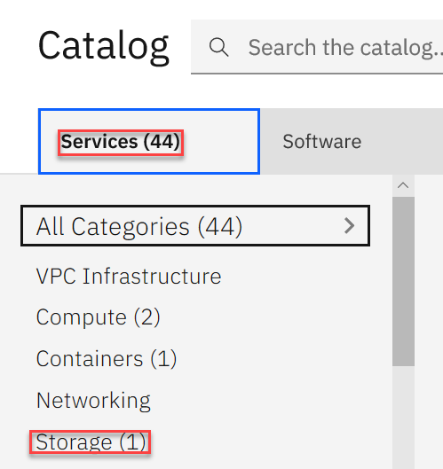

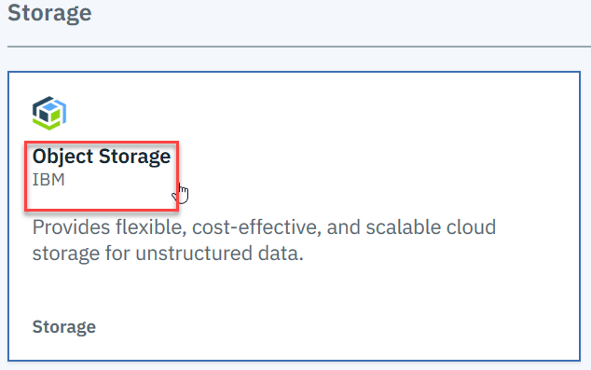

2. On the Cloud Object Storage page, choose the **Lite** plan. You can use the name that is shown in **Service name** or rename it as you want, accept the Default resource group, and then click **Create**.

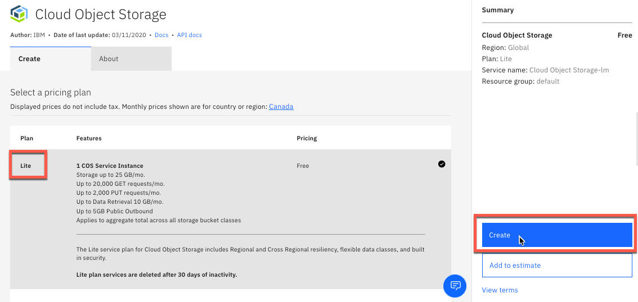

If not already logged in to IBM Cloud, instead of the **Create** button, you will see an option to **Sign up**/**Log in**: at the bottom right:

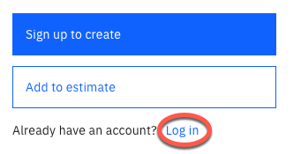

3. Once the Cloud Object Storage instance is created, you will automatically be directed to the **Resource List** page where you can see a list of resources provisioned in your IBM Cloud account. Expand **Storage** in the left column and click the **Cloud Object Storage** instance that you just created.

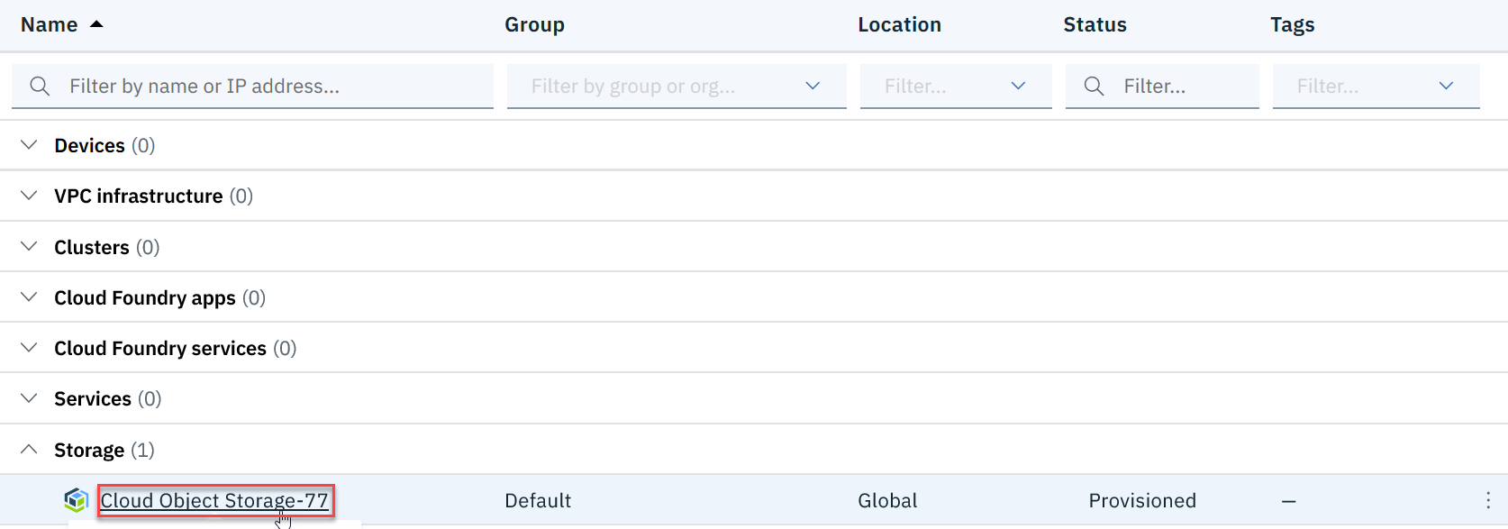

4. The **Cloud Object Storage** page appears for the instance that you just created. Here you can create a bucket and invite users for your Cloud Object Storage instance.

## Task II: Create a Bucket to store your data:

1. On your new Object Storage instance page, click **Create Bucket**.

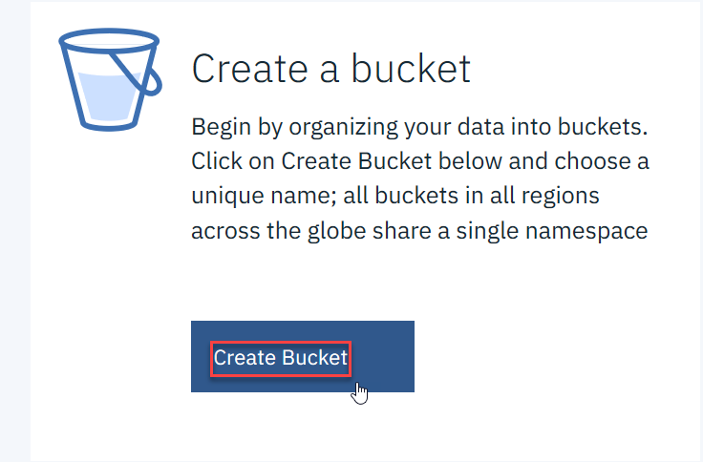

2. On the **Create a bucket** page, you can create a standard bucket. Click **Standard bucket** to create a predefined bucket.

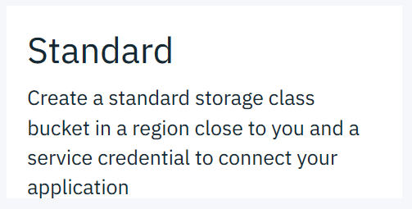

3. Use the pre-assigned name for your bucket or enter your name and review the pre-configured settings and service credentials and click **Next**.

4. The **Bucket details** page appears where you can begin adding objects to the bucket.

## Task III: Add Objects to your Bucket:

1. On the **Bucket details** page, the details for the bucket are displayed. You can add files to your bucket using either drag and drop or upload. After adding files to the bucket, click **Next** to continue.

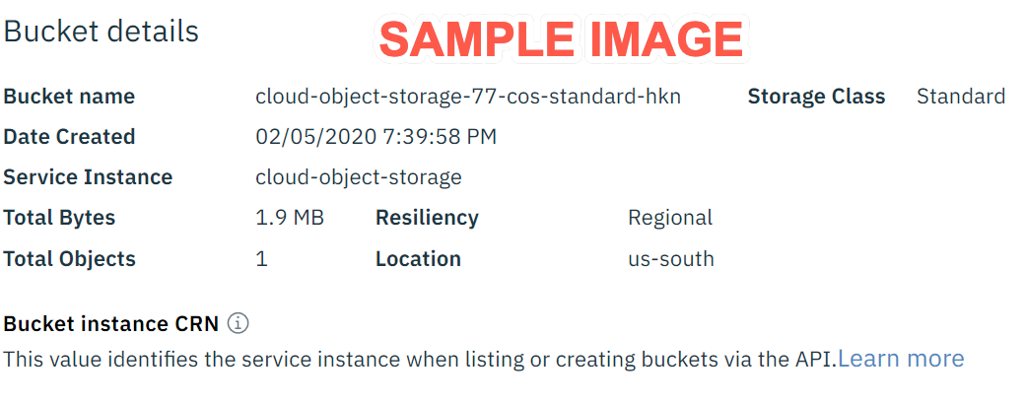

**IMPORTANT:**For learners earning a Certificate, please take and save the screenshot of the bucket details for the Object Storage Bucket YOU just created. You will be required to upload it in the graded assessment that follows.

2. The Summary page provides complete details for the bucket you’ve just created. Click **View Buckets** to see the bucket that you’ve created. You can also click **View Objects** to see the objects that you’ve added to your bucket.





3. On clicking **View Buckets**, the **Resource list** that shows the buckets you’ve created appears. Click the name of the bucket to which you want to add objects.

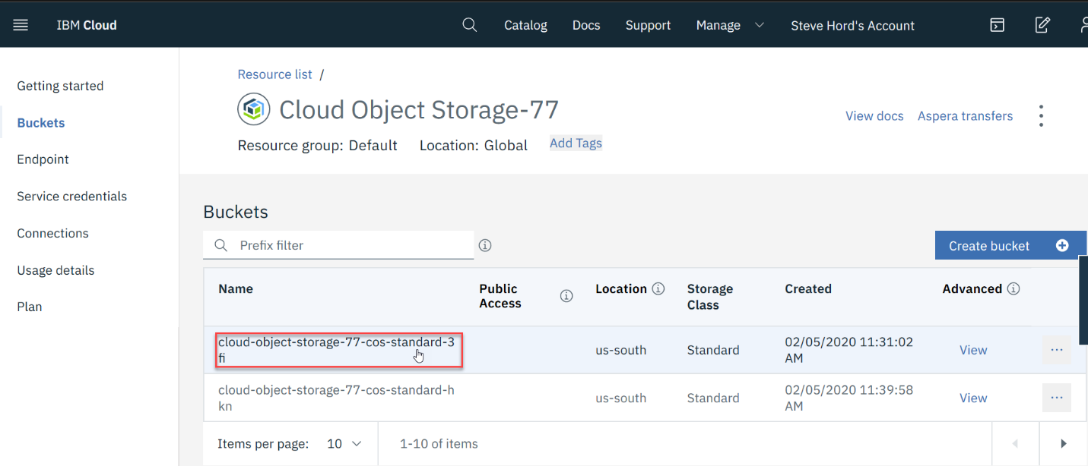

4. The **Objects** page appears where you can click **Upload** and select **Files** or **Folders** from the dropdown. You can also drag and drop files or folders into the space.

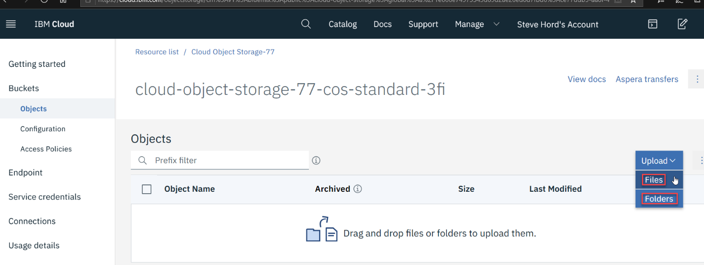

5. When you click **Files** on the dropdown menu, the **Upload files** window appears. The **Object and folder guidelines** are listed at the top of this window. Select **Standard Upload** under **Select transfer type** and then click, **Select files** when you want to add files.

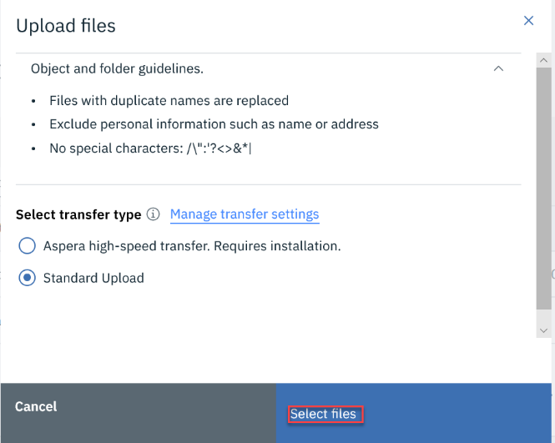

6. For this lab, we’ve provided an Html file that you can use to add to your bucket. Click the link below to download the **index.html** file to your computer.

[Index.html](https://courses.cognitiveclass.ai/asset-v1:IBMDeveloperSkillsNetwork+CC0101EN+2020T1+type@asset+block/index-cc.html)

7. In Windows Explorer, navigate to the Html file you just downloaded. A popup window appears when the file successfully uploads.

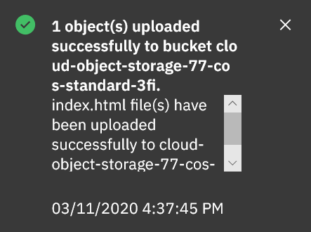

After uploading this file to your bucket, you need to invite other students to your bucket so they can open the Html file and sign it to get credit for completing the lab.

## Task IV: Share Objects in your Bucket:

If you need to share objects in your buckets with other users, you can setup **Access Policies**. You can set access policies for specific users and groups, or you can choose to make certain buckets public so that anyone can access them (e.g., if you want to host static files on your website).

1. In the navigation pane under buckets, click **Access Policies.**

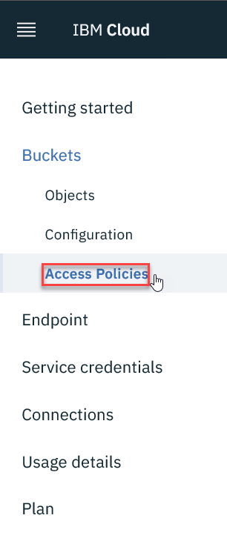

2. On the **Bucket access policies** page, click **Need to Add users?** to add user access for your bucket.  You can select users if they’ve already been added and select roles for this bucket. You can also provide public access for the Html file that you just added to your bucket. Click **Public Access** and notice **Public Access** appears in the **Access group**, and then click **Create access policy**.

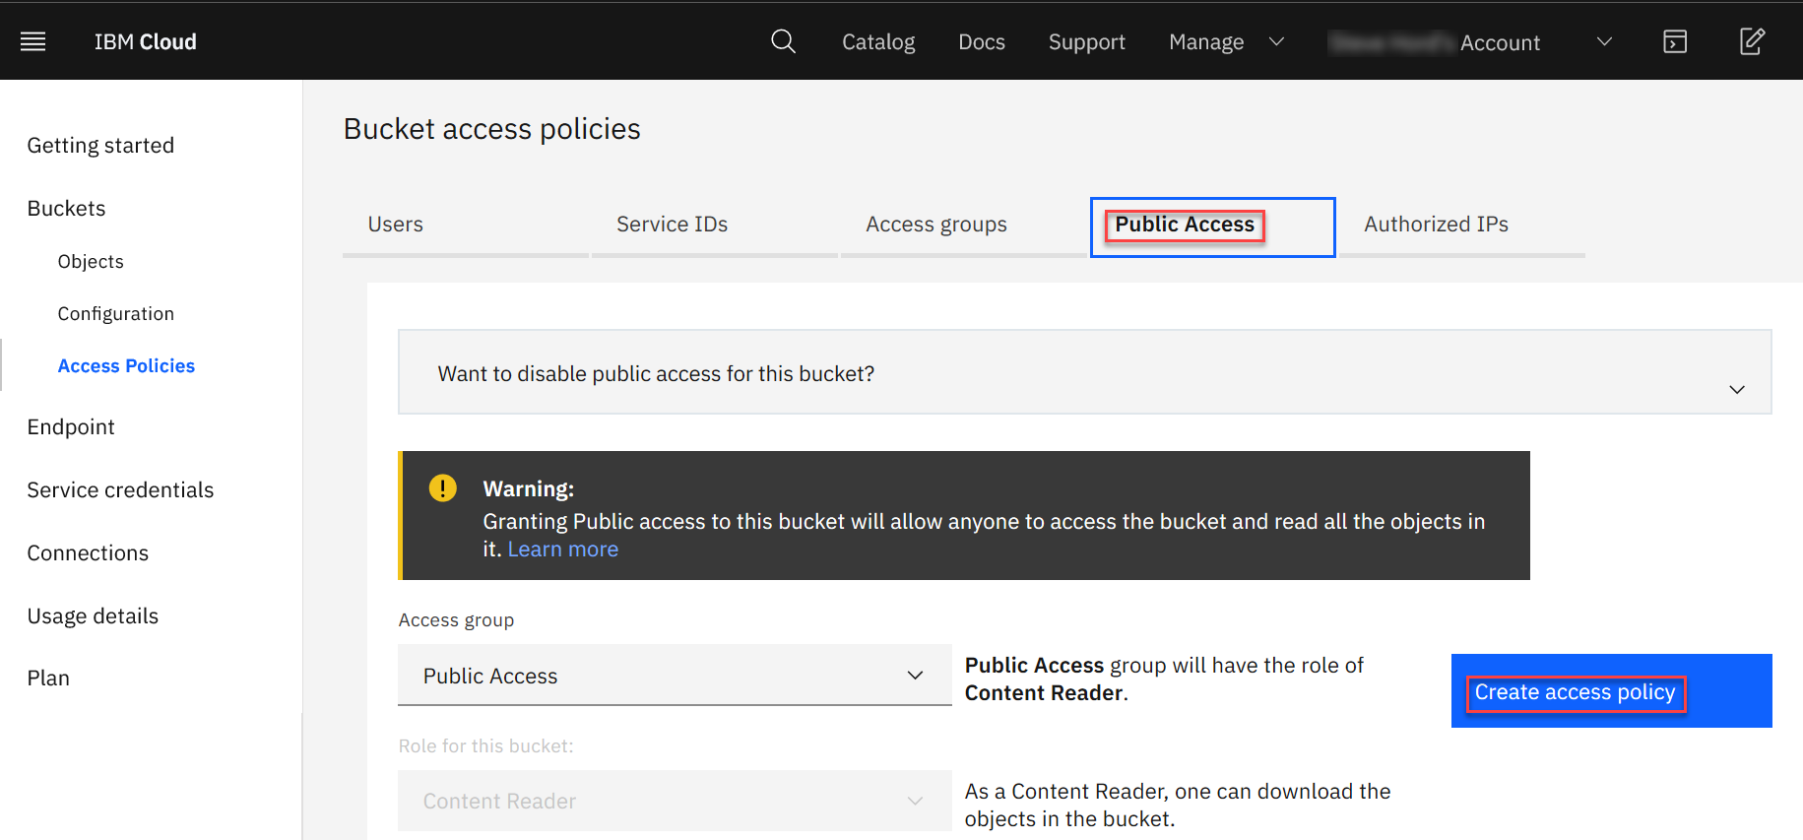

3. When you click on **Public Access**, a popup window appears. Click **Enable** to allow public access.

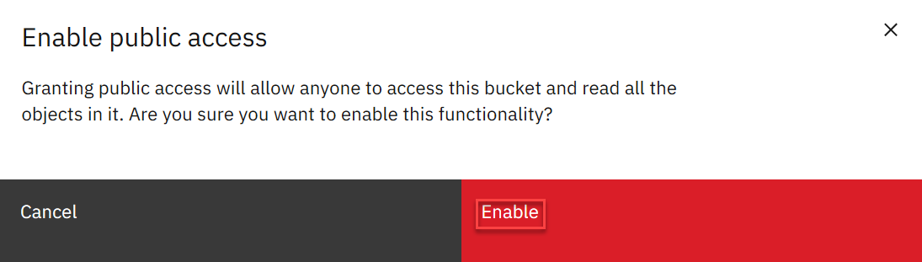

4. Next, a popup window appears that confirms you have provided public access to the Html file.

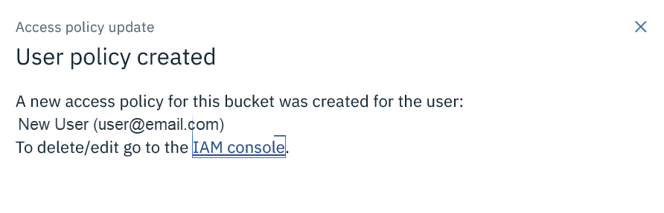

5. Next, click **Objects** in the navigation pane to return to the screen where you can find the URL for the Html file that you loaded to your bucket

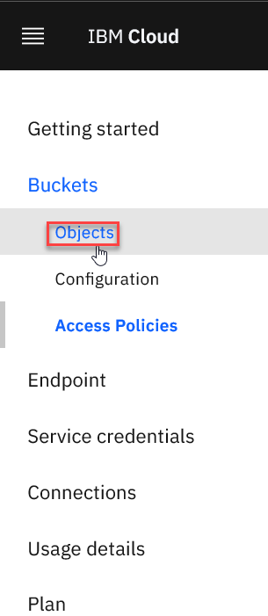

6. On the **Objects** page, click the ellipses (“…”) at the end of the Html file you added to your bucket, and then select **Public URL** from the list.

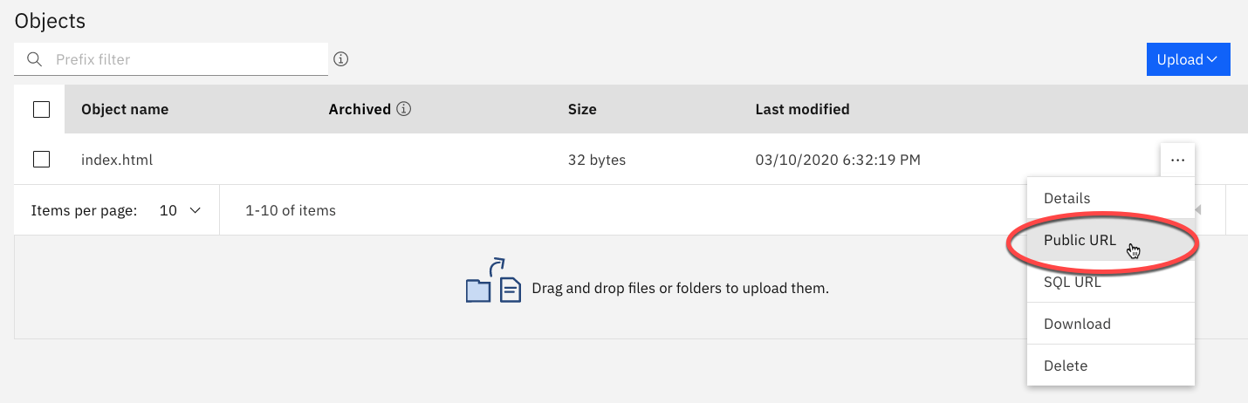

7. The URL for the Html file appears in the next window. Click the **Copy to clipboard** icon to get the URL for the Html file to share this file with others.

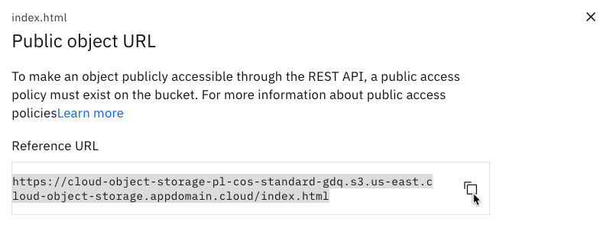

## Reading: Module 5 Summary

**In this module, you have learned:**

* Cloud storage is available in four main types–Direct Attached, File, Block, and Object Storage. These storage types differ in how they can be accessed, the capacity they offer, how much they cost, the types of data they are best suited to store, and their read-write speed.
* Direct Attached (or Local) Storage is storage that is presented directly to a cloud-based server and is effectively either within the host server chassis or within the same rack.
* File Storage is typically presented to compute nodes as a Network File System (NFS), which means that the storage is connected to compute nodes over a standard ethernet network.
* Block Storage is presented to compute nodes using high-speed fibre connections, typically provisioned in volumes, which are mounted onto a compute node.
* Object Storage is accessed via an API and doesn’t need an underlying compute node. Object Storage offers infinite capacity as you can keep adding files to it and just pay for what you use. Compared to the other storage types, object storage is slowest in terms of read and write speeds.
* A Content Delivery Network (CDN is a distributed server network that accelerates internet content delivery by delivering temporarily stored or cached copies of website or media content to users based on their geographic location.

Dans ce module, vous avez appris :

* Le stockage dans le nuage est disponible en quatre types principaux : Direct Attached, File, Block et Object Storage. Ces types de stockage diffèrent par la manière dont ils sont accessibles, la capacité qu'ils offrent, leur coût, les types de données qu'ils sont les mieux adaptés au stockage et leur vitesse de lecture-écriture.
* Le stockage en attachement direct (ou local) est un stockage qui est présenté directement à un serveur basé sur le cloud et qui se trouve effectivement soit dans le châssis du serveur hôte, soit dans le même rack.
* Le stockage de fichiers est généralement présenté aux nœuds de calcul comme un système de fichiers réseau (NFS), ce qui signifie que le stockage est connecté aux nœuds de calcul sur un réseau Ethernet standard.
* Le stockage en bloc est présenté aux nœuds de calcul en utilisant des connexions à fibres optiques à haut débit, généralement fournies en volumes, qui sont montées sur un nœud de calcul.
* Le stockage d'objets est accessible via une API et ne nécessite pas de nœud de calcul sous-jacent. Le stockage d'objets offre une capacité infinie, car vous pouvez y ajouter des fichiers en continu et ne payer que pour ce que vous utilisez. Par rapport aux autres types de stockage, le stockage d'objets est le plus lent en termes de vitesse de lecture et d'écriture.
* Un réseau de diffusion de contenu (CDN) est un réseau de serveurs distribués qui accélère la diffusion de contenu Internet en fournissant aux utilisateurs des copies temporairement stockées ou mises en cache de contenus de sites web ou de médias en fonction de leur situation géographique.

### Module 6 - Emergent Trends, Cloud Native, DevOps and Application Modernization

## Module Introduction and Learning Objectives

Module 6 - Introduction

In this module, you will learn about some of the emergent cloud trends, such as Hybrid Multicloud, Microservices, and Serverless. You will also learn how cloud native applications work, how DevOps helps tackle some of the complexities posed by cloud, and how organizations can modernize their applications for the cloud.

Dans ce module, vous découvrirez certaines des tendances émergentes du cloud, telles que le multicloud hybride, les micro-services et le Serverless. Vous apprendrez également comment fonctionnent les applications natives du cloud, comment DevOps aide à résoudre certaines des complexités posées par le cloud, et comment les organisations peuvent moderniser leurs applications pour le cloud.

**Learning Objectives**

After completing this module, you will be able to:

* Describe the emergent cloud trends such as Hybrid Multicloud, Microservices, and Serverless
* Explain how cloud native applications work
* Explain how DevOps helps tackle some of the complexities posed by cloud
* Describe the benefits of application modernization and how organizations can modernize their applications

Après avoir terminé ce module, vous pourrez :

* Décrire les nouvelles tendances en matière de nuages, telles que le multicloud hybride, les micro-services et le sans serveur
* Expliquer le fonctionnement des applications natives dans le nuage
* Expliquer comment DevOps permet de s'attaquer à certaines des complexités posées par le nuage
* Décrire les avantages de la modernisation des applications et comment les organisations peuvent moderniser leurs applications

## Module Introduction and Learning Objectives

Module 6 - Introduction

In this module, you will learn about some of the emergent cloud trends, such as Hybrid Multicloud, Microservices, and Serverless. You will also learn how cloud native applications work, how DevOps helps tackle some of the complexities posed by cloud, and how organizations can modernize their applications for the cloud.

Dans ce module, vous découvrirez certaines des tendances émergentes du cloud, telles que le multicloud hybride, les micro-services et le Serverless. Vous apprendrez également comment fonctionnent les applications natives du cloud, comment DevOps aide à résoudre certaines des complexités posées par le cloud, et comment les organisations peuvent moderniser leurs applications pour le cloud.

**Learning Objectives**

After completing this module, you will be able to:

* Describe the emergent cloud trends such as Hybrid Multicloud, Microservices, and Serverless
* Explain how cloud native applications work
* Explain how DevOps helps tackle some of the complexities posed by cloud
* Describe the benefits of application modernization and how organizations can modernize their applications

Après avoir terminé ce module, vous pourrez :

* Décrire les nouvelles tendances en matière de nuages, telles que le multicloud hybride, les micro-services et le sans serveur
* Expliquer le fonctionnement des applications natives dans le nuage
* Expliquer comment DevOps permet de s'attaquer à certaines des complexités posées par le nuage
* Décrire les avantages de la modernisation des applications et comment les organisations peuvent moderniser leurs applications

### Hybrid Multicloud

Hybrid Cloud, as we covered in the

previous lesson, is a computing

environment that connects and

organizations on-premise private cloud

and third-party public cloud into a

single infrastructure for running the

organization's applications. Multicloud

is a cloud adoption strategy that

embraces a mix of cloud models from

different service providers -

public, private, and managed - across

infrastructure, platform, or software

services. For example, a business may

consume email as a service from one

provider, a CRM application from another,

and infrastructure from yet another

provider. So, essentially, a Hybrid

Multi-cloud implies you're able to

leverage the best of cloud models and

services across different service

providers, and have your applications and

workloads working seamlessly across

multiple different clouds. In this video

we will look at some use cases for why a

business may want to use a hybrid multi-

cloud approach. In this video I want to

touch on a few of those use cases for

why a business may want to use hybrid or

multicloud. Let's start with the basic

one: cloud scaling. Now most of us are

probably familiar with this, it's one of

the main reasons for adopting the cloud.

Now let's say we have a flower delivery

service that is able to hit a certain

bottom line of users to have on-premise

infrastructure, and it can hit a certain

amount of user load. So, visualizing this

here throughout a calendar year, you can

imagine that their load maybe goes up

and down, and responds to specific

holidays. Now to hit those peaks, they

could scale up their on-premise

architecture, but that's met with upfront

costs and cost of upkeep. Now instead

what they'll do, is take advantage of

cloud that allows them to scale up in

response to that load, and then

automatically deprovision resources when

they no longer need them. This

concept is kind of general to cloud

computing, not just hybrid or multicloud.

That brings me to my next topic. Here

we're gonna be talking about how it can

be used to build a composite cloud.

Essentially this is going to be

applications that are spread across

multiple cloud environments. Back to

the flower delivery service. Let's say

they have on-premise architecture that

allows them to run three major

components of their app. So, let's say

they have the web UI. They have some

billing API's, as well as a rewards

framework. Now let's say that this

service is actually based in EU, and

their European customers are happy. But

for their North American or American

customers, it's best specifically around,

you know, Veterans Day or Thanksgiving,

they're noticing that the system is

bogging down. So they decide to take

advantage of a hybrid cloud or multi-

cloud architecture by composing their

application across multiple cloud

environments. So, they'll take advantage

of data centers in America, and

essentially, they've identified that

although the rewards framework can stay

on Prem in their European side, they want

to move the billing and the UI

capabilities over. They'll move just

those two to a cloud platform of their

choice in a North American or American

datacenter. This allows them to

scale up portions in response to

American holidays, while keeping their EU

portions individually scaled. In this

example the flower delivery service is

able to take advantage of scaling at a

global level by using the hybrid or

multicloud architecture. Next let's talk

about the airline or travel industry.

We can first start with an example of

modernization.

In the past we've seen that

reservation systems may have been

difficult to work with, or you might have

had to call in. But almost all the

airline companies now have a mobile

application. So most of the time, and

we've actually found that, it's about - in

general - not just in the travel industry,

but 80% of all enterprise applications

are actually still on Prem. And that's

likely the case in this industry as well.

So, in this specific example, let's say

they have a reservation system that's

running on prem. But to create new

experiences for their end-users, let's

say they've created a mobile application.

That mobile app, of course, has a mobile

backend that's maybe running in a public

cloud. That in turn works with the

reservation service. So again, the mobile

app can hit the mobile backend, that in

turn works with the reservation

capabilities.

In this case, they've modernized and

new user experiences are possible. But

let's take that a step further. A

source for a lot of dissatisfaction for

users, is whenever their flights are

delayed - so when a flight is delayed, they

may have to rebook new flights. The

solution is almost always the same. The

traveler wants to get to his destination

in the easiest way possible. What

airline industries have been doing is

taking advantage of the cloud to create

maybe a recommendation feature. It

allows them to book new flights as soon

as the delay is recommended, or as soon

as the delay is incurred. That's

going to connect up to that mobile

backend service, allowing users to be

able to book flights through their phone

the second of flight is delayed. This not

only improves the bottom line for the

airline industry, it leads to happier users.

That's one way the modernization has

been done. Next, let's take it even a step

further and talk about data and AI.

For data and AI, the airline industry has

been taking advantage of lots of

historical data. Over the decades that

a company has been around, let's say they

have historical data of when unplanned

maintenance has happened on their

airline. In fact, 30% of all delay time in

the airline industry is actually

when unplanned maintenance happens. By

taking advantage of, let's say, machine

learning or AI capabilities, they could

hook into all of the legacy data that

they have - large volumes - and connect them

up to machine learning and AI

capabilities. This allows airline

industries to take advantage of

predictive analytics and get insights

before errors, or before the unplanned

maintenance ever occurs. This again

improves their bottom line, leading to

happier users and a more efficient

airline industry. Today we talked

about four major use cases for hybrid

and multicloud platforms: cloud

scaling and composite cloud, in the

flower delivery service, as well as

modernize in data and AI for the

airline industry. Another reason for

adopting hybrid multicloud strategy is

to prevent lock-in to a specific vendor's

cloud platform and having flexibility of

being able to move workloads from one

cloud platform to another as the need

arises. In the next video, we will

understand what a microservices

architecture is, its features, benefits,

and use cases.

### Microservices

[Music]

micro-services architecture is an

approach in which a single application

is composed of many loosely coupled and

independently deployable smaller

components or services these services

typically have their own stack running

on their own containers they communicate

with one another over a combination of

api's events streaming and message

brokers for a business what this means

is that application components can be

developed and updated more efficiently

by multiple developers working

independently teams can use different

stacks and runtime environments for

different components components facing

too much load can be scaled

independently reducing the waste and

cost associated with having to scale

entire applications in this video we'll

look at how micro services have shaped

application development and also look at

a use case that illustrates micro

services in action the way developers

work to build applications is changing

in the past software was built as large

monolithic applications where a team of

developers would take months to

construct a large application built on a

common code base these developers would

write every part of the application from

start to finish now after decades of

software development there are vast

amounts of code already out there that

developers can use as the base of an

application meaning they no longer have

to create every line of code from

scratch cloud development platforms

provide developers with an ecosystem of

code that can be easily and securely

integrated into applications now instead

of building one huge application on one

team

developers break into small independent

teams where they write smaller amounts

of code called micro services

microservices break down large

applications into their core functions

for example search recommendations

customer ratings or product catalogs

each is developed independently of one

another yet work together on the cloud

development platform to create a

functioning application a container is

the distribution method for each micro

service meaning it delivers the code

where it needs to go

containers are plug-and-play so if one

micro service isn't working for an

application developers can take it out

and put in a different one without

disrupting how the rest of the app

functions check out micro services in

action with Ron Ron is a soccer fan who

uses an online streaming media service

called dream game last night he missed

watching his team play their crucial

semi final match luckily he can watch

the match tonight on dream game when he

logs in he sees the most popular content

among all dream game users after some

searching he finds the match he's

looking for what he would really like is

to find his game with one click

luckily the dream game development team

is using micro services to develop a

better user experience for viewers like

Ron the first micro service is a Content

catalog housing the millions of games

that Dream game offers the small team of

developers organizes each piece of

content with metadata that describes

them this metadata feeds into a second

micro service the search function which

ensures that Ron's search results are

captured and compared to the dream game

catalog the third micro service

recommendations captures data about the

most popular content among all dream

game users this is what generates the

home page that ron saw when he first

logged in these three micro services are

all in their separate containers ready

to join the application but before they

can work together they have to find one

another they do this by using something

called service discovery which creates a

roadmap for these and many other micro

services to communicate when micro

services find each other they

communicate using an application

programming interface or an API so when

Ron searches for his favorite soccer

team the search micro service is

communicating to the content catalog in

an API about what Ron is looking

for now back to the goal at hand to get

Ron to his soccer game with just one

click

the development team working on the

recommendations micro-service is

updating the code adding an analytics

algorithm using analytics the

recommendations micro-service will

compare Ron's viewing history and

preferences to popular content among

other users including soccer fans and

viewers in Ron's geographical region and

demographic since the developers didn't

need to create the code from scratch

they are able to deploy this new

functionality in a matter of days these

updates happen behind the scenes as the

rest of the micro service containers

function normally the next time Ron

checks dream game instead of just seeing

the most popular or newest content he

sees a personalized playlist that will

continue to refine itself as the system

learns more about his viewing habits and

preferences the result Ron finds his

favorite team's latest game right away

the micro service approach lets

developers quickly innovate applications

in parallel and lets users like Ron

focus on the things that really interest

them and when those interests are

changing and growing faster everyday

micro services help businesses keep up

and grow with their customers

[Music]

in the next video we will talk about

serverless computing its features

benefits and some use cases

### Serverless Computing

Serverless is an approach to computing that offloads responsibility for common infrastructure

management tasks such as scaling, scheduling, patching, and provisioning application stacks

to cloud providers, allowing developers to focus their time and effort on the code and

business logic specific to their applications or process.

Serverless doesn’t mean there are no servers; only that the management of the underlying

physical or virtual servers is removed from their users.

The serverless computing environment allocates resources as needed for the applications.

Let’s look at some key attributes that distinguish serverless computing from other compute models.

The serverless model requires no provisioning of servers, installation of application stacks

and software, or operation of the infrastructure by the developer.

Serverless computing runs code only on-demand on a per-request basis, scaling transparently

with the number of requests being served.

Serverless enables end users to pay only for resources being used, never paying for idle

capacity, which is unlike virtual servers on the cloud—where end users pay for VMs

as long as they are running even if idle.

Effectively, serverless abstracts the infrastructure away from developers.

Code is executed as individual functions where each function runs inside a stateless container.

No prior execution context is required to serve a request; and with each new request,

a new instance of the function is invoked.

Let’s look at a scenario.

You could, for example, have a serverless platform between the front-end of your website

and your storage layer, running individual functions.

The serverless app could be translating text files and storing it in a cloud-based storage

service.

Using the front-end of your website, you send text files to a serverless app; the app creates

translations in different languages, and then stores these translated files in cloud storage,

and sends their links back to you.

Some of the key serverless computing services today include IBM Cloud Functions (which is

based on Apache OpenWhisk), AWS Lamb-da, and Microsoft Azure Functions.

It is important to note that serverless may not be the best fit for all applications or

scenarios.

You need to evaluate application characteristics and ensure that the application is aligned

to serverless architecture patterns.

Applications that qualify for a serverless architecture include some of the following

characteristics: Short-running stateless functions (seconds

or minutes).

Seasonal workloads with varying off-peak and peaks.

Production volumetric data that shows too much idle time.

Event-based processing or asynchronous request processing for implementing use cases.

Microservices that can be built as functions that are stateless.

Serverless architectures are well-suited for use cases around data and event processing,

IoT, microservices, and mobile backends.

Given its inherent and automatic scaling, rapid provisioning, and a pricing model that

does not charge for idle time, supporting microservices architecture has become one

of the most common use cases of serverless computing today.

Serverless is well-suited to working with structured text, audio, image, and video data

around tasks such as data enrichment, transformation, validation and cleansing, PDF processing,

audio normalization, thumbnail generation, and video transcoding.

Parallel tasks such as data search and processing, and genome processing, are also well-suited

to be run on a serverless runtime.

Serverless is also well-suited for working with all sorts of data stream ingestions,

including business data streams, IoT sensor data, log data, and financial market data.

And finally, let’s look at some challenges worth considering about serverless.

Serverless workloads are designed to scale up and down in response to workload, but for

workloads characterized by long-running processes managing a traditional server environment

might be simpler and more cost-effective.

The serverless application architecture can be vendor dependent, and so there is a potential

for vendor lock-in, particularly involving platform capabilities such as authentication,

scaling, monitoring, or configuration management.

Because serverless architectures scale up and down in response to workload, they also

sometimes need to start up from zero to serve a new request.

For certain applications, this delay isn’t much of an impact, but for something like

a low-latency financial application, this delay wouldn’t be acceptable.

### Cloud Native Applications

Simply put, a cloud native application is

an application developed from the outset

to work only in the cloud environment, or

an existing app that has been refactored

and reconfigured with cloud native

principles. A cloud native application

consists of microservices working

together as a whole to comprise an

application, yet each can be

independently scaled and iterated

through automation and orchestration

processes. These microservices are often

packaged in containers, which are

executable units of software in which

the application code is packaged along

with its libraries and dependencies so

that it can be run from anywhere. This

independence enables frequent, iterative

improvement of cloud native applications,

without disrupting the experience of

end-users. Cloud native applications are

unlike traditional, or monolithic

applications, that are built out of one

huge piece of software; applications that

tightly couple the user interface,

business-logic layer, and data layer.

Let's take the example of how a cloud

native application might be used on a

travel website. Each topic covered by the

site - flights, hotels, cars, specials - is its

own microservice. Each microservice may

roll out new features independent of the

other microservices. Specials and

discounts can also scale out

independently. While the travel site is

presented to customers as a whole, each

microservice remains independent and

can be scaled or updated as needed

without affecting other services. Whether

creating a new cloud native application

or modernizing an existing application,

developers adhere to a consistent set of

development principles: Follow the

microservices architecture approach by

breaking applications down to single-

function microservices. Rely on

containers for maximum flexibility,

scalability, and portability.

Adopt Agile methods that speed the

creation and improvement process through

quick iterative updates based on user

feedback. In this video, we'll take a

closer look at the key concepts of cloud

native, its benefits and use cases. Hi. I'm

Andrea Crawford and I'm with IBM Cloud.

Today we're going to talk about cloud

native apps. In the heritage world, we

have our lumpy, monolithic apps. And in

the new world, we have our microservices

living on the cloud. If we take a look at

this diagram here, we see we have cloud

infrastructure. This is your private, your

public, and your enterprise

infrastructure. Cloud native apps apply

to hybrid and multicloud situations. We

also have our scheduling and

orchestration layer. This layer is all

about control planes, like our kubernetes.

We also have our application and data

services layer. This layer is all about

backing services, and being able to

integrate our application code with

existing services that may be available

on other clouds, or even on-premise. We

have our application runtimes, these are

what we're traditionally, or

conventionally, known as middleware. And

over here, well, that's where we have our

cloud native apps. This is the sweet spot

right up here. So our application code is

actually designed, built, and delivered

very differently for cloud native, than

it would be for conventional, monolithic,

lumpy apps over here. Let's talk a

little bit about why cloud native apps

can actually leverage benefits like:

enabling innovation,

business agility, and most importantly -

from a technology perspective - the

commoditization of this solution stack

over here. As time has progressed and

technologies have matured and emerged, a

lot of the services are actually being

refactored lower down in this stack. This

means that core services are starting to

have a lower center of gravity, freeing

up innovation at this level over here.

So, what are our use cases for when to build

a cloud native app? Everything!

Everything that lives in the cloud

should have a cloud native app design

and approach. This means our application

code needs to be instrumented with

things like: standardized logging,

standardized events, and being able to

match those logging and events to a

standard catalog, that multiple microservices

and cloud native apps can use.

The last thing we want to do is have our

development squads have to figure out

what their log and event messages should

be. Let's standardize that, because we

want to be able to commoditize that as

well. We also need to have things like

distributed tracing. When we get over

into the microservices world over here,

we have a lot of moving parts. This means

we're going to need to leverage services

core to the system, like: load balancing,

service discovery, and routing. These are

the kinds of things that are

commoditized in this layer here, with

things like Istio, and with the emergence

of newer projects, like Knative. And so,

if we were to recognize the benefits for

cloud native apps and to sum it all up,

we are all about enterprise and

engineering at scale. In the next video

we'll take a look at DevOps.

### DevOps on the Cloud

Development teams need to design, develop, deliver and run software as reliably and efficiently

as possible.

Operations teams need to identify and resolve problems as soon as possible by monitoring,

predicting failure, managing the environment, and fixing issues.

Combining development and operations with the ability to monitor and analyze and optimize

bottlenecks gives us DevOps—a collaborative approach where business owners and the development,

operations, and quality assurance teams collaborate to continuously deliver software.

A DevOps approach applies agile and lean thinking principles to all stakeholders in an organization

who develop, operate, or benefit from the business’s software systems, including customers,

suppliers, partners.

By extending lean principles across the software supply chain, DevOps capabilities improve

productivity through accelerated customer feedback cycles, unified measurements and

collaboration across an enterprise, and reduced overhead, duplication, and rework.

Using the DevOps approach, developers can produce software in short iterations

on a continuous delivery schedule of new features and bug fixes in rapid cycles;

and businesses can seize market opportunities and reduce time to include customer feedback

in their products.

The DevOps process involves: Continuous Delivery, which is about delivering

small, well-designed, high-quality, increments of software to customers.

Continuous Integration; creating packaged builds of the code changes released as immutable

images; where immutable implies that when modifications are needed, the entire component

is replaced with an upgraded version.

Continuous Deployment, which involves progressing each new packaged build through the deployment

lifecycle as rapidly as possible.

Continuous Monitoring; with tools that help developers understand the performance and

availability of their applications, even before they are deployed to production.

Delivery Pipeline; which is an automated sequence of steps that involves the stages of

Ideation, Coding, Building, Deploying, Managing, and Continuous Improvement; which loops back

to the Ideation phase in the delivery pipeline.

While DevOps can apply to applications anywhere, there is especially a compelling case for

DevOps when it comes to cloud-ready, and cloud-native applications.

DevOps and Cloud share a symbiotic relationship.

With its near limitless compute power and available data and application services, cloud

computing platforms come with their own risks and challenges.

DevOps’ tools, practices, and processes are helping tackle some of the complexities

and challenges posed by the cloud and allowing solutions to be delivered—quickly and reliably.

Let’s look at some core capabilities that DevOps provides to help building and running

applications in the cloud a lot more manageable: DevOps best practices make it possible to

programmatically provision servers, build middleware, install application code, and

fully automate the installation process in a way that is documented, repeatable, verifiable,

and traceable.

Application deployments often involve considerable complexity.

The DevOps’ practices of continuous integration and continuous deployment help create a fully

automated deployment pipeline, which is important all through the application development lifecycle.

Cloud native applications form a complex distributed system with multiple moving parts, independent

tech stacks, and rapid release cycles.

DevOps principles are essential to define how people work together to build, deploy,

and manage applications in a cloud native approach.

With the DevOps best practices of automated provisioning and continuous deployment, developers,

quality professionals, and other stakeholders can test in low-cost, production-like test

environments that were previously not available—enhancing both productivity and quality.

When systems are compromised or struggling to recover from natural disasters, DevOps

best practices make it possible to rebuild these systems quickly and reliably.

DevOps provides a powerful set of principles, practices, and tools to realize the full potential

of cloud-native computing, as well as for modernizing existing applications to leverage

cloud benefits.

In the next video, we’ll learn about application modernization.

### Application Modernization

Many organizations have huge investments

in existing applications that are often

siloed in legacy systems and are very

difficult and expensive to update and

maintain. Modernizing these applications

can unlock great benefits for these

organizations such as accelerating their

digital transformations, enabling them to

take advantage of new technologies and

services, and becoming more responsive to

their customers' needs and changing

market dynamics. Cloud computing is one

of the three main ingredients in

Application Modernization. In the rest of

this video we will see how, and what else

Application Modernization entails. Hi, I'm

Eric Minick, with IBM Cloud, and I want to

talk about application modernization and

three huge transformations that have

been going on together. We've got

three things going on. They're

interrelated, and this is what we're

seeing this change in how we're doing

architecture, infrastructure, and our ways

of working - how we deliver. And if we go

back in time a little bit,

we saw applications that were

very monolithic. They were running on

physical servers And we used waterfall

style development where we'd have long

plans and we'd sa,y okay, this is gonna be

our planning phase, or development phase,

or testing phase, and we could plan out a

year as a project. And that's really what

we've gone away from. So if we look at

how most organizations are working today,

architecturally, they've got some sort

of distributed architecture. It's usually

related to like a service-oriented

architecture; the the big buzzwords a few

years ago. But some sort of distributed

architecture. We have a bunch of web

services. They're talking to each other.

We've got some databases on the backend.

[Music]

And then some front ends that kind of go

through all that. On an infrastructure

level, they're running on some sort of a

virtual machine, alright. So, we said we could

probably do better than having to order

a new server every time we have a new

service.

Let's virtualize this stuff, and we need

a little more density along the way. And

from a way of working,

you know, Agile development - pretty normal -

and then trying to figure out a little

bit of what happens downstream. So this

kind of takes us up to where a lot of

teams are today, but not really where

they're going. And so if we look at, kind

of, that next phase. We're taking another

pass at this service-oriented

architecture, and really shrinking the

sizes of the services, taking advantage

of the more dynamic infrastructure we

have. And we're calling these now

microservices. So we've

got a microservice architecture, very

small, very focused services, moving away

from a lot of the heavyweight XML based

communication we saw in SOA, towards

more rest based communication, things

like that. But same idea; let's keep

breaking into smaller and smaller pieces.

We have more independence of what we

ship. More rigor in saying this service

needs to be independent from another

service, so I can change these things by

themselves. On the infrastructure side -

cloud. It's pretty popular. And this could

be public cloud, this could also be

private cloud. I'm painting with a very

broad brush when I say cloud here.

Then from a delivery, in a way of working,

we could say that DevOps is really key.

And I would include in this, approaches

like site reliability engineering, SRE.

More the ways of working we have today.

Now that that's fine and interesting. But

what do these things have to do with

each other? I'd argue that what we're

really seeing is modernization in how

the applications are delivered, and how

they're built, and what they are.

While you could walk into any large

enterprise today and you'll find someone

who says we are going through a cloud

transformation. You'll often find

somebody says, "yes, I'm in charge of

leading the DevOps transformation." And

you'll walk into enterprise architecture

and they'll say, "yes, we are pushing

microservice architectures." Individuals think

that they're going through three

separate transformations. But they're

really tied. Right? If I'm doing

microservices, and I have new

microservices all the time.

In order to get a new microservice

up and running, I'm over here and I have

to order a new physical server, then

rack and stack it a couple months later.

I'm not gonna get any time to market

benefits. The resilience benefits that

I'm gonna normally look for from

microservices are gonna be modest, at best.

Microservices want cloud

infrastructure. You want to be able to

say, I've got a new microservice. Let me

put it in a container and just run that

container right now and scale that

dynamically. Similarly, cloud really likes

running microservices. The

benefits of being able to dynamically scale are

really cool when you have a lot of small

things that you might need few of, or a

lot of. It's not as interesting when I've

got a monolith that that isn't even

distributed. How do I scale that? I get a

bigger cloud server? Then all of this

is, kind of, baking in this idea of speed

and resiliency. And DevOps brings that

together; the developers who have

always wanted speed, the

operations people who've always wanted

that resiliency. They're going to be

programming that cloud. The

programmable infrastructure the cloud

provides, needs operations people who

understand resiliency, but bring some of

that development skill in. To really

take advantage of these new

infrastructures, the new

architectures, you need these new ways

of working. And you also are gonna say, if

this is going to give me time to market

benefits, I can't be back here,

and say we've got a one-year

project plan that we're just gonna

execute. I need to be able to be more

agile, and adapt in my planning and my

responsiveness to the business. I need to

better wire up my application so they

can be more easily monitored and more

resilient. We have to have the

application in a way that it knows when

one of these services is failing, and we

can spin up another. So this is really,

for me, fascinating - that you walk into

these organizations everywhere, and

they're undergoing these three different

transformations. But they're always doing

them together. And when they don't - it

doesn't quite work. So you've got these

three transformations going on at once.

And you'll hear us talk a lot about

application modernization.

See it written across the top here.

When I think of application

modernization, I think it's just this.

It's this transformation right here;

going from these kind of monoliths, or

service-oriented architectures, to micro-

services, adopting cloud, modernizing our

ways working towards DevOps and SRE.

that's AppMod (AM). It's a really

exciting time. And it's really great when

you're able to go after it in a holistic

fashion.

## Reading: Module 6 Summary

**In this module, you have learned:**

●       Hybrid Multicloud is a cloud adoption strategy that makes it possible for public clouds, private clouds, and on-premises IT to interoperate seamlessly while leveraging the best cloud-based services from different public cloud providers.

●       Microservices architecture is an approach in which an application is built as a collection of loosely coupled and independently deployable components or services, leading to efficient development, maintenance, and upgradation cycles.

●       Serverless Computing is an approach to computing that offloads responsibility for common infrastructure management tasks for application runtimes to cloud providers, allowing developers to focus their time and effort on development and testing, and not have to worry about provisioning, maintaining and scaling compute resources.

●       Cloud native applications are applications that are built or refactored to work in the cloud environment. These applications, developed using DevOps methodologies, consist of microservices packaged in containers that can run in any environment—making it possible to create and update features in quick iterative cycles.

●       DevOps is a collaborative approach that enables development and operations teams to continuously deliver software in quick iterative cycles while reducing overhead, duplication, and rework. DevOps’ tools, practices, and processes help tackle the complexities and challenges posed by the cloud, allowing solutions to be delivered and updated —quickly and reliably.

●       Application Modernization helps organizations accelerate their digital transformation, take advantage of new technologies and services, and become more responsive to changing market dynamics. Cloud computing is one of the key enablers of application modernization.

Dans ce module, vous avez appris :

● Hybrid Multicloud est une stratégie d'adoption du cloud qui permet aux clouds publics, aux clouds privés et aux TI sur site d'interagir de façon transparente tout en tirant parti des meilleurs services basés sur le cloud de différents fournisseurs de cloud publics.

● L'architecture de micro-services est une approche dans laquelle une application est construite comme un ensemble de composants ou de services vaguement couplés et pouvant être déployés de manière indépendante, ce qui permet des cycles de développement, de maintenance et de mise à niveau efficaces.

● L'informatique sans serveur est une approche de l'informatique qui décharge les fournisseurs de cloud computing de la responsabilité des tâches communes de gestion de l'infrastructure pour l'exécution des applications, permettant aux développeurs de concentrer leur temps et leurs efforts sur le développement et les tests, et de ne pas avoir à se soucier de l'approvisionnement, de la maintenance et de la mise à l'échelle des ressources informatiques.

● Les applications natives dans le nuage sont des applications qui sont construites ou refaites pour fonctionner dans l'environnement du nuage. Ces applications, développées selon les méthodologies DevOps, consistent en des micro-services conditionnés dans des conteneurs qui peuvent fonctionner dans n'importe quel environnement, ce qui permet de créer et de mettre à jour des fonctionnalités dans des cycles itératifs rapides.

● DevOps est une approche collaborative qui permet aux équipes de développement et d'exploitation de fournir en permanence des logiciels dans des cycles itératifs rapides tout en réduisant les frais généraux, les doublons et les reprises. Les outils, les pratiques et les processus de DevOps permettent de faire face aux complexités et aux défis posés par le cloud, en permettant de fournir et de mettre à jour des solutions de manière rapide et fiable.

● La modernisation des applications aide les organisations à accélérer leur transformation numérique, à tirer profit des nouvelles technologies et des nouveaux services et à mieux s'adapter à l'évolution de la dynamique du marché. Le cloud computing est l'un des principaux moteurs de la modernisation des applications.

### [Optional] Bonus Module 7 - Cloud Security, Case Studies and Jobs in Cloud Computing

## Module Introduction and Learning Objectives

[Bonus] Module 7 - Introduction

This is an optional module and does not have any graded components.

Il s'agit d'un module optionnel qui ne comporte pas de composantes graduées.

In this module, you will learn about the key concepts and components of cloud security. We will familiarize you with some real-life case studies of business value created through the adoption of cloud technologies. You will also learn about career opportunities and job roles that have emerged in the field of cloud computing.

Dans ce module, vous découvrirez les concepts et les composantes clés de la sécurité dans les nuages. Nous vous familiariserons avec quelques études de cas réels de la valeur commerciale créée par l'adoption des technologies en nuage. Vous découvrirez également les opportunités de carrière et les rôles professionnels qui ont émergé dans le domaine de l'informatique en nuage.

**Learning Objectives**

After completing this module, you will be able to:

* Explain the concepts and components of cloud security
* Describe some of the cloud adoption case studies in different industry verticals
* Describe the job roles and career opportunities in cloud computing

Après avoir terminé ce module, vous pourrez :

* Expliquer les concepts et les composantes de la sécurité dans les nuages
* Décrivez quelques-unes des études de cas sur l'adoption du cloud dans différents secteurs d'activité
* Décrivez les rôles et les opportunités de carrière dans le domaine de l'informatique en nuage

### What is Cloud Security - Part 1

[Music]

Hi, I'm Nataraj Nagaratnam, and I'm from

IBM Cloud. Traditionally when you deploy

an application, you have the entire data

center, the servers that you run - you're

responsible for all of it. In the cloud

model, that's a shared responsibility

between you and the cloud provider. In a

shared responsibility model, you need to

rethink security; on what your

responsibility is, and what cloud

provider's responsibility is. Let's take

platform as a service as an example. When

you look at PaaS, you're building

applications, migrating data to the cloud,

and building applications, running them on

the cloud. So you're responsible for

securing the applications, the workload,

and the data, while the cloud provider is

responsible for managing the security of

the platform - so that it's compliant, it's

secured from the perspective of network,

the platform on down, in terms of

managing the containers, the runtime, and

isolation so that you have your own

space within the platform. Whereas, if you

are adopting and migrating workloads to

the cloud, and you're using

infrastructure as a service, then the

cloud provider manages hypervisor on

down. If you are using virtual servers or

if you are using bare metal, then you can

completely control everything on up, from

the operating system, the virtual servers

that you run, and the data you bring it

on. So it's very important to understand

the adoption model, whether you're

consuming Iaas, or PaaS, or if you're

consuming SaaS -

where the club provider manages all the

applications, and the security of it.

You worry about the data that you bring

in, and plan accordingly. So that's a very

important thing, because it's part of

understanding your responsibility in

ultimately managing the risk and

compliance of the workloads and the data

that you bring to cloud. Now let's talk

about architecture. When you build

applications and migrate applications, or

modernize your apps - let's start with

data with all the risk that you deal

with. And the kind of data matters. Is it

confidential data? Is it public data or

sensitive data, that may deal with

private information? Consider all those

factors and make a secure design around

what your data security architecture

should be. Make sure you have data at

rest encryption so that the data is

always encrypted, whether you use a

database as a service, object store as a

service, or other ways to store data like

block storage. Encryption is for amateurs.

If you think about key management, is for

professionals. So, having more control of

your keys, provide you the ability, in the

context of shared responsibility model,

that you own your data. You have complete

control of your data. As you think

about key management, make sure you have

an approach to think about if you are

bringing confidential data - you want to

bring your own keys. Maybe sensitive data,

you want to keep your own keys, so that

how much control of the keys you have

and the hardware security module in

which the key processing the encryption/

decryption operations happen. More

control you have, more responsibility

that you can take on. So encryption at:

data at rest,

data in motion - as it comes from services

to data stores or applications, so that

as you think about data coming all

the way. Your request and API requests

coming all the way - data in motion.

And in the new world you need to start

thinking about when the application is

actually processing the data, that is

going to be data in this memory. So you

can actually start to protect data using

hardware based technologies where you

can protect in-memory data as well. So

that when it is in use, and in memory by

the applications, you can protect it.

Take a holistic approach to data

protection at rest, in motion, in use, with

full control of your keys. It can be

bring your own keys, or even better, push

the boundary with keep your own keys. The

application that serves the data - it's

not only about which application needs

to have access. Make sure the data access

is only on need by need basis. Do not

open up your data services to the whole

world, be it network access, or everybody to

access the data. Make sure you exactly

know which applications need to access,

or which users need to access the data

to run your cloud applications. From an

application viewpoint, make sure there

are no vulnerabilities in your

application. So scan your applications.

Have an AppSec application security

approach so that you can do dynamic

scanning or static scanning of your

application before you deploy it into

the production. In the cloud native

environment, you are deploying container

images. So you can scan your images. You

can scan it for vulnerabilities before

you deploy, and set your policies so that

you only have secured images in

production any time. If there is any

vulnerability in the new world, you don't

need to patch these systems, you just

spin up a new container and off you go.

That's the beauty of a cloud native

approach; that you have security built in

in every step. At a container level

and the applications that serves the

business logic, you can start to

protect them. Then when you look at the

users coming in, you want to manage

access in terms of who the user is, and

from where they are coming from. So,

identity - you need to make sure who the

user is,

or which service it is, based on the

identity of those services or users, so

that you can maintain access control to your

application or data. And also from the

perspective of network access, you want

to make sure only authorized users can

get in. If there are intruders out

there, you can make sure you set it

up so that they are prevented from

accessing your application and your data

in the cloud - be it through web application

firewalling, network access control, or

distributed denial of

service protection, and have intelligence

built into these network protections as

well. So both identity and network - in

essence, you are protecting your data. You

need to manage access to your apps and

the workload on the data that you have

deployed on the cloud. In the next video,

we will look at security monitoring and

DevOps security.

### What is Cloud Security - Part 2

[Music]

You need to have a continuous security

monitoring so that you know at any point

whether you're compliant - your policies -

you can watch out for threats that you

need to manage. Having an approach and

set of tools to manage security and

compliance posture is very important.

Gaining insights about your posture,

compliance, and threats, so from your

deployment environment you can garner

information. It can be security events,

audit logs, flow logs from network or

system that can be fed in so that you

can figure out what your posture, and

complaints, and threats are. And not only

is it important for you to gain insight,

you need to have actionable intelligence

so that you can start to mediate. You

may figure out there's a vulnerability; a

container image that you have deployed

is vulnerable, so you can remediate

and respin

up a new container. There may be a

particular access from a network that

seems to be coming in from a suspicious

network IP address. You can block that.

Ability to gain visibility and

insights, and having that insight and

turning it into actionable intelligence and

remediating is very important. Let's

talk about DevOps. DevOps is about

development and operations. Traditionally

we think about, okay, there's an

application team that is doing the

design and architecture for building

code, and then you throw it over the wall

for the enterprise security team to

secure it and manage it. That should be

rethought. Fundamentally, it's not just

about dev and ops, but security needs to

be a forethought, not an afterthought.

It should become SecDevOps approach to

the way you build, manage, and run

your applications. You need to embed

security into the entire lifecycle, what

we call shift left. Not only will you manage

security, but shift left through the

entire process. You need to have a secure

design.

So as you plan, as you design and say:

what kind of data am I going to put what

level of classification? What kind of

applications am I building? Is it

container-based? Is it a workload that

I'm migrating? Take that into account along

with what integrations you need to do so

that you can plan it and architect it. Then as

you build it, embed security as part of

that process. Do you have security

aware applications? For example, you may

want to encrypt data, or the sensitive

data. You may want to encrypt the data

from your applications before you even

store it into a data store. So, secure build -

and you manage security. As part of

SecDevOps, you have secure design and

architecture. You pass on that and build

secure applications. And deploy and

manage security in continuous fashion.

Then you have a closed loop so that

whatever you find, you may need to

remediate, or rearchitect your application,

or implement certain things as the threats

landscape evolves. In the next video, we

will look at Identity and Access

Management.

[Music]

### Case Studies in Different Industry Verticals

[Music]

In this video, we will look at some case

studies that demonstrate the use of

cloud computing in real business

scenarios, and the ensuing impact on

these businesses and the customers they

serve. The Weather Company's mission is

to map the atmosphere of the earth. And

based on that, generate the most accurate

and hyperlocal forecasts, which can be

served out to all our consumers and

devices - which number in millions across

the globe. Weather is unpredictable.

We need to be able to spin up and spin

down as fast as weather happens. Our

normal day-to-day load is 30 million

unique users. When we peak into

severe weather, that can go north of 100

million across our products. We

generate forecasts on demand. And our

forecast on demand system is responsible

for generating forecasts at a resolution

of one square kilometer grade. We deliver

forecasts on demand to the tune of 250

billion per day. On the backside of that

is our API platform. That system

operates at the scale about 150,000

requests per second. If our products

don't work, and don't work fast, people's

lives are in danger.

Imagine a hurricane is approaching the East

coast of the United States. As it is

approaching the coast, usage of my

weather data goes up tremendously. It can

go up from anywhere from two times, to

five times. It took us six months to

migrate to IBM Kubernetes from our

previous provider. What we've noticed

is some real efficiencies with DevOps.

It's reduced our workflow in pipeline

by about 80%. With the latest

hurricane, we were able to scale with IBM

cloud very easily, very seamlessly. IBM's

community service allows us to scale as

fast as the weather happens. As we

migrated our web platform to IBM

Cloud Kubernetes services, one of the

biggest advantages is that this is a

managed service... which allows our team

not to have to babysit our system;

enables them to do other work.

With the migration to IBM

Cloud Kubernetes, we've gained the

ability to have automation security

baked in. This was a feature in the

component that was very main for us in

the past.

IBM's security team proactively now

notifies us of any security

vulnerabilities. The tools and the

investment that the company's made, gives

us capabilities that we would have never

had before. It gets us very excited and

it gives our developers and engineers

opportunities to build new things that

they wouldn't have otherwise been able

to do. The global reach that IBM and IBM

Cloud together with our technology, with

our capabilities for forecasting, give us

the ability to extend our products and

services to keep people safe all over

the world.

[Music]

[In-flight announcement: "Good afternoon ladies

and gentlemen. Welcome aboard. Captain speaking.

Anticipating on-time arrival.]

In the scenario where there's a flight

cancellation or some other off-scheduled

operation, we've had a system where we

find new seats and flights availability

for those customers. But I think

oftentimes customers didn't necessarily

know that that was the best option for

them. What we wanted to do was create a

system where they could actually see

alternate options. The goal was to

facilitate a better experience for our

customers on how to get to their

destination, in an automated fashion, on

the channel of their choice. In our

business, hurricanes, storms, are the

natural events that impact our customers

on a fairly regular basis. What happened - and

this is a true story -

the hurricanes hit and nobody said this

is ridiculous. Our customers were being

impacted by the hurricanes immediately.

Why are we mitigating risk of a

traditional rollout, when we have the

power of the Cloud? This is exactly

the scenario that our customers need

this capability for. I think people will now

realize that these kind of activities

and integration are much easier when we

can use cloud technology, and especially

microservices. We can break problems

into much smaller problems. Those get

much easier to wrap your head around and

develop. This is the technology that we

need to be adopting now in order to keep

pace with our customer expectations.

What I loved about my job at Cementos

Pacasmayo, is that it challenged

me every single day. Technology moves so

agile that I have to keep up with it.

What I love is that the company is also

on that same road; driving towards

it's digital transformations. Our

customers are now demanding quicker time

to market and also a more broad

portfolio of products. We need to keep up

and deliver the best service and

the best products that they can get, in

the least amount of time. We implemented

SAP S/4HANA on IBM Cloud since it

brings us a cost-effective

infrastructure. Also, it's quite

scalable. Cementos Pacasmayo is now

turning from a product-driven company, to

a service-driven company. The accounting

area now has real insights in real time

on our financial statements that they didn't

used to have. Also on our supply

chain area, especially on the procurement.

They now have the dashboard that helps

them make decisions right on time.

[Music]

My name is Mukesh Sharma, and I'm the

Senior Manager of IT at Welch Food. Welch

started as an organization

150 years ago, and pretty fast

became the national. We are owned by the

farmers. It's a co-op. And we value the

sweat equity our farmers put into it. So,

that's what drives us every day; that our

farmers are working out on the farms.

And we were working here to make sure the

organization gets the best benefit of

each dollar spent back to them.

Welch's IT is the heart of the business -

all the manufacturing systems, any

manufacturing data which comes in

through different processing ERP systems,

you name it. We started this

journey with the private cloud. Then

at the same time, we have started the

process of asking ourselves on any new

application request, can it be run in the

public cloud? The approach we have taken

is to slowly and steadily start to move

these non mission-critical systems, which

can be done better by somebody else, let

them run outside. Let them spend time on

it, while we spend time on our core

values. Liquid Power is a company that

sells products that when you inject them

into crude oil or gasoline pipelines, it

changes the flow characteristics to such

a point that you can either: one, increase

the flow of those fluids, or secondly, use

less energy to actually push the fluids

down the pipeline. We needed to become a

standalone company under Berkshire

Hathaway, without any experience in

running our own infrastructure, or SAP.

We had to come up with the solution that

was best for our business to operate as

a standalone company. There were many

decisions we had to make. Do we go cloud?

Do we stay on-premise? How do we create

our own infrastructure and back office?

And what's the best decision for us not

only today and now, but in the future

going forward? So, I talked to some CIOs

and IT professionals. If you had a blank

sheet of paper, what would you do? Cloud

or go on-premise?

Without a doubt, all of them say

cloud. This whole process and the

migration to the cloud, is giving what we

believe is a competitive advantage. And

what I really love about having IBM with

SAP on the cloud, is it's scalable. We can

do it much faster, and change in a much

faster time period than we could

otherwise.

### Career Opportunities and Job Roles in Cloud Computing

Cloud computing is a key part of an enterprise’s digital transformation strategy.

As more and more companies are moving critical business processes and applications to a mix

of cloud infrastructures, qualified cloud computing professionals are in high demand.

According to Gartner’s report on the Cloud Services Industry, from a market size of 182.4

Billion USD in 2018 to a projected market size of 331.2 Billion USD in 2022, the market

size and growth of the cloud services industry is at nearly three times the growth of overall

IT services.

That is the scale at which the cloud market is growing.

Employer demand is outpacing the number of qualified candidates available.

Gartner TalentNeuron’s database of more than one billion unique job listings, scores

the hiring scale for jobs requiring cloud computing skills at 78, which means employers

are finding it "difficult" to get the right applicants for open positions in cloud technologies.

There are many specialization areas within this domain.

Here’s a look at some of the common roles available currently:

Cloud Developers, or Cloud Software Engineers, work through all phases of the software development

lifecycle: writing, testing, and maintaining the code.

They work with the front- and back-end of applications, as well as platforms and systems

that their applications run on.

Cloud Developers need to have a mix of technical skills, business knowledge, and experience

with at least one of the major cloud providers.

Technical skill for a Cloud Developer would typically include:

Knowledge of data structures, distributed systems, operating systems, and algorithms.

Experience with databases.

Proficiency in commonly used web application development languages, such as Python, JavaScript,

Java, HTML, and CSS.

Cloud Integration Specialists are responsible for integrating new cloud services, applications

and infrastructure, into the organization’s portfolio of internal systems and existing

cloud services.

These specialists assess the implications and trade-offs between different solutions

as they relate to the integration between external and internal systems, optimize integration

and user-experience, and ensure that performance standards adhere to service level agreements

set with the enterprise.

Cloud Data Engineers are responsible for designing, developing, and deploying scalable data pipelines

and data services.

They look at integrating new data management technologies and software engineering tools

into existing infrastructure.

Their responsibilities include: Understanding existing systems to recommend

automated integration of disparate data sets.

Collaborating with data scientists and researchers to develop predictive models and proofs of

concept.

Promoting best practices that enable teams to accelerate their consumption and understanding

of data.

Improving overall efficiency by introducing new engineering processes and tools.

Cloud Security Engineers provide expertise around the systems and processes needed to

protect the confidentiality, integrity, and availability of an organization’s systems

and application data.

They Determine security requirements.

Plan, implement, and test security systems.

Perform threat simulations to detect possible risks

Recommend innovative technologies that will enhance the security of cloud-based environments.

Cloud Security Engineers need to have deep knowledge of cloud platforms and services,

software design patterns, and DevOps tools and methodologies.

Cloud DevOps Engineers collaborate with development and operations teams to create reliable and

rapid release pipelines for software and updates.

This may typically involve.

Creating custom automation tools.

Building and maintaining configuration and deployment frameworks.

Tracking design bugs and automating the debugging process for developers.

Maintaining and deploying web-based applications.

Monitoring security issues.

Measuring performance against expected business outcomes.

Containerization expertise is increasingly a must-have for DevOps Engineers.

Cloud Solutions Architects work to translate business requirements into application architecture

and design.

Some of the technical skills required for a Cloud Architect role include:

Deep knowledge of cloud platforms and services.

Deep understanding of software design patterns.

Knowledge of DevOps tools and methodologies.

Good understanding of networking.

A high-level understanding of key security concepts.

Solution Architects work closely with Cloud Developers, Networking Specialists, Security

Engineers, Integration Specialists, and DevOps Engineers to architect and design solutions.

There are several resources available for learning cloud technologies, in a variety

of delivery methods, including instructor-led courses, self-paced online courses, online

videos, books, and also technology-focused community forums.

Many cloud providers have dedicated learning portals with extensive resources available

on the complete range of cloud technologies and services they provide.

They offer: learning paths, which make resources available

as per specific career roles.

Hands-on learning labs, with interactive learning resources that can be filtered by role, level,

or product.

Free trials on their suite of products and services.

## Reading: Module 7 Summary

**In this module, you have learned:**

●       Cloud security refers to the policies, technological procedures, services, and solutions designed to secure the enterprise applications and data on cloud against insider threats, data breaches, compliance issues, and organized security threats.

●       Cloud security is a shared responsibility between the cloud provider and the user organization.

●       Security architecture and methods for achieving continuous security need to be embedded through the life cycle of an application to ensure that the application runs on a safe platform, the code is free from vulnerabilities, and the operational risks are understood.

●       There needs to be active monitoring of all connected systems and cloud-based services to maintain visibility of all data exchanges between public, private, and hybrid cloud environments. This ensures that the cloud provides a trusted platform that can securely integrate with your enterprise data centers.

●       Businesses all over the world are realizing tangible benefits from the use of cloud technologies and services.

o   The Weather Company migrating to the cloud to reliably deliver critical weather data at high speed, especially during major weather events such as hurricanes and tornadoes

o   American Airlines using the cloud platform and technologies to deliver digital self-service tools and customer value more rapidly across its enterprise

o   Cementos Pacasmayo achieving operational excellence and insight to help drive strategic transformation and reach new markets using cloud services

o   Welch choosing cloud storage to drive business value from hybrid cloud

o   LiquidPower using cloud-based SAP applications to fuel business growth

●       The market size of the cloud services industry is at nearly three times the growth of overall IT services, escalating the need for qualified cloud computing professionals. Some of the common job roles that are available in this domain include Cloud Software Engineers, Cloud Integration Specialists, Cloud Data Engineers, Cloud Security Engineers, Cloud DevOps Engineers, and Cloud Solution Architects.

Dans ce module, vous avez appris :

● La sécurité dans les nuages fait référence aux politiques, procédures technologiques, services et solutions conçus pour sécuriser les applications et données d'entreprise dans les nuages contre les menaces internes, les violations de données, les problèmes de conformité et les menaces de sécurité organisées.

● La sécurité du cloud est une responsabilité partagée entre le fournisseur de cloud et l'organisation utilisatrice.

● L'architecture de sécurité et les méthodes permettant d'assurer une sécurité continue doivent être intégrées tout au long du cycle de vie d'une application afin de garantir que l'application fonctionne sur une plate-forme sûre, que le code est exempt de vulnérabilités et que les risques opérationnels sont compris.

● Il doit y avoir une surveillance active de tous les systèmes connectés et des services basés sur le cloud afin de maintenir la visibilité de tous les échanges de données entre les environnements cloud publics, privés et hybrides. Cela permet de s'assurer que le nuage fournit une plate-forme de confiance qui peut s'intégrer en toute sécurité aux centres de données de votre entreprise.

● Les entreprises du monde entier tirent des avantages tangibles de l'utilisation des technologies et des services dans le nuage.

o The Weather Company qui migre vers le cloud pour fournir de manière fiable et à grande vitesse des données météorologiques essentielles, notamment lors de phénomènes météorologiques majeurs tels que les ouragans et les tornades

o American Airlines utilise la plate-forme et les technologies du cloud pour fournir plus rapidement des outils numériques en libre-service et une valeur ajoutée pour le client dans toute son entreprise

o Cementos Pacasmayo atteint l'excellence opérationnelle et la perspicacité pour aider à conduire la transformation stratégique et à atteindre de nouveaux marchés en utilisant les services en nuage

o Welch choisit le stockage dans le nuage pour tirer parti de la valeur commerciale du nuage hybride

o LiquidPower utilise des applications SAP basées sur le cloud pour alimenter la croissance des entreprises

● La taille du marché du secteur des services de cloud computing est près de trois fois supérieure à la croissance de l'ensemble des services informatiques, ce qui augmente le besoin de professionnels qualifiés dans ce domaine. Parmi les postes les plus courants dans ce domaine, on trouve les ingénieurs en logiciels de cloud computing, les spécialistes de l'intégration de cloud computing, les ingénieurs en données de cloud computing, les ingénieurs en sécurité de cloud computing, les ingénieurs en développement de cloud computing et les architectes de solutions de cloud computing.