<https://www.youtube.com/watch?v=TqOeMYtOc1w&list=PLblh5JKOoLUK0FLuzwntyYI10UQFUhsY9&index=27>

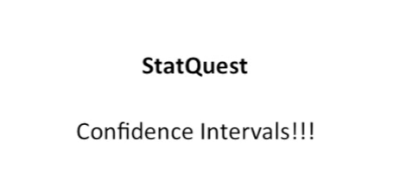

Today's stat quest is all about confidence intervals/

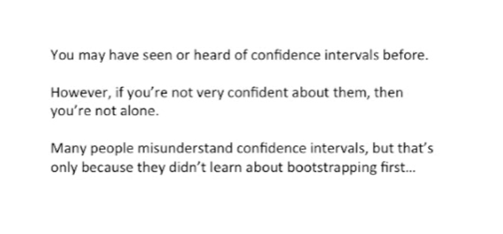

You may have seen or heard of confidence intervals before.

However if you're not very confident about them then you're not alone.

Many people misunderstand confidence intervals but that's only because they didn't learn about bootstrapping.

First now just to clarify there are lots of ways to calculate.

Calculate. center holes and bootstrapping is just one of them but for me it makes it easiest to understand.

But when you see confidence intervals out there in the wild, you're likely to see a different way to calculate them.

Now even though we just did bootstrapping, your brain might be a little cloudy and you may have forgotten what it was all about my brains like that.

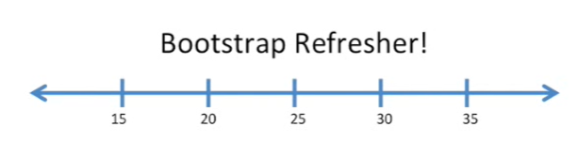

So I totally understand that's why we're gonna do a little bootstrap refresher.

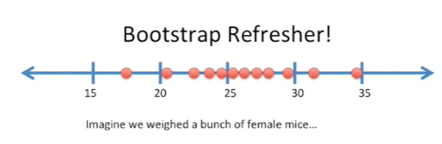

Imagine we wait a bunch of female mice.

In this case we weighed 12 of them we didn't weigh every single female Mouse on the planet just 12.

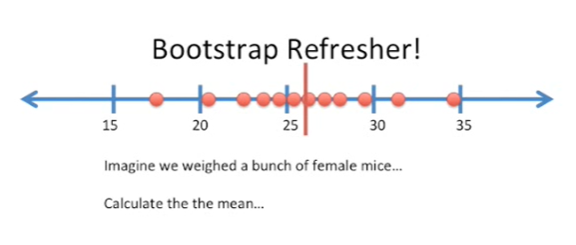

Now we can take these 12 measurements and we can use them to calculate the sample mean.

Now the sample mean is not the mean for all mice the entire planet, it's just the mean of the mice that we sampled.

However we can use bootstrapping.

And the data that we have here to determine what values would be reasonable for the global worldwide mean of all female mice on the planet.

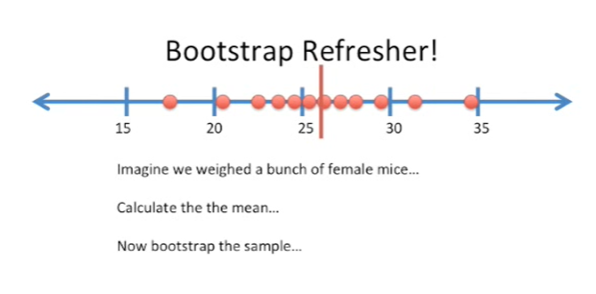

Now that we've calculated the sample mean we can bootstrap the sample.

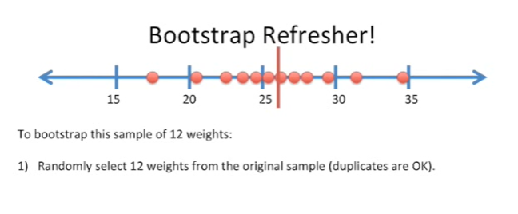

To bootstrap the sample we randomly select 12 weights from the original sample (and duplicates are okay.

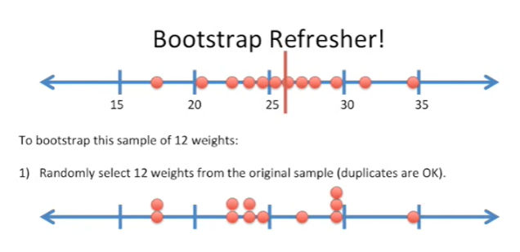

Here's an example of a bootstrap sample.

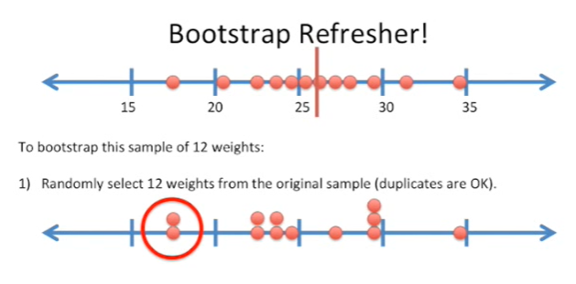

We can see that this measurement on the far left was sampled twice in our bootstrap sample.

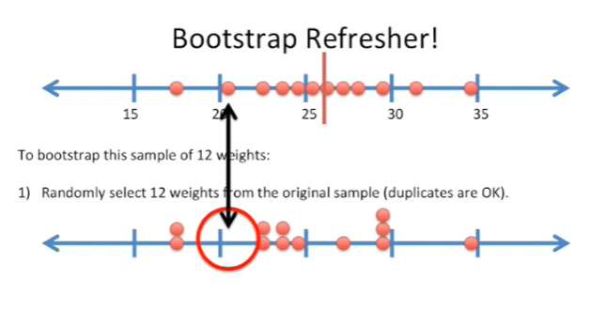

And the measurement to its right wasn't included in our bootstrap sample.

This is called sampling with replacement

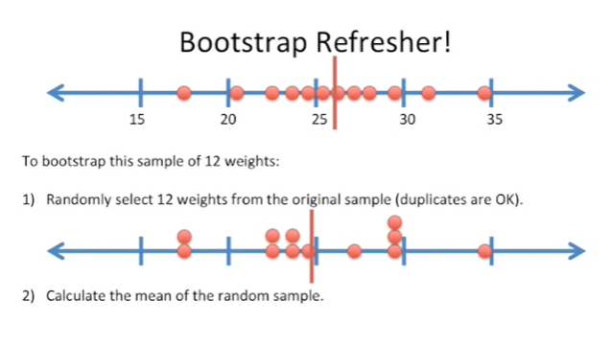

Now we calculate the mean of the random sample.

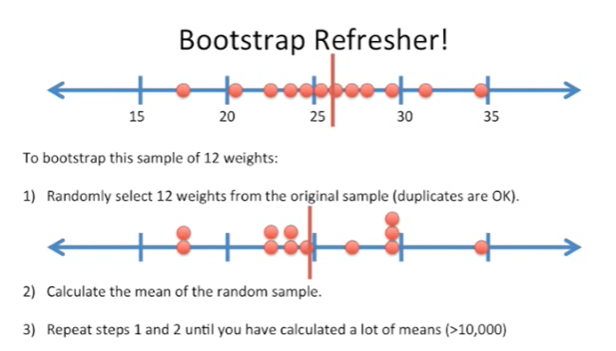

After we've calculated the mean of our first random sample, all we have to do is repeat steps 1 and 2 until we've calculated a lot of means sometimes more than 10,000.

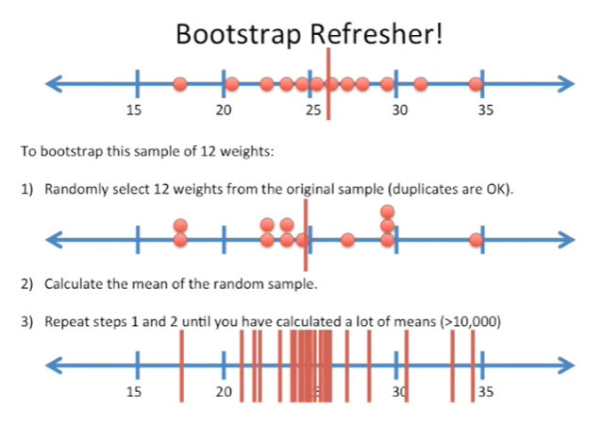

And here's what it looks like when we've calculated a lot of means, it's maybe a little fewer than 10,000, but you get the idea.

Anyway that's all there is to bootstrapping.

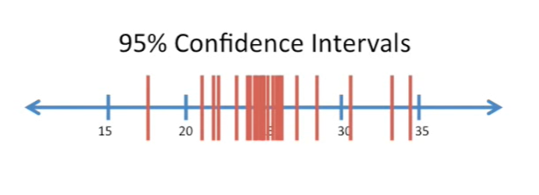

Now let's talk about confidence intervals.

Usually when you see a confidence interval out in the wild, it's called a 95% confidence interval.

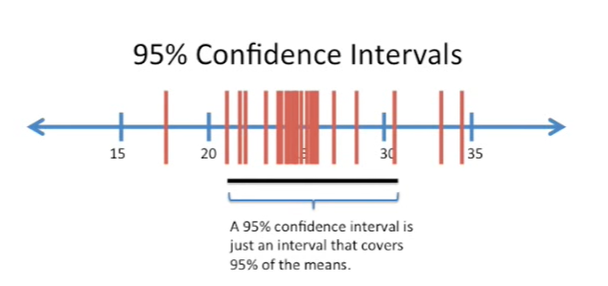

A 95% confidence interval is just an interval that covers 95% of the means.

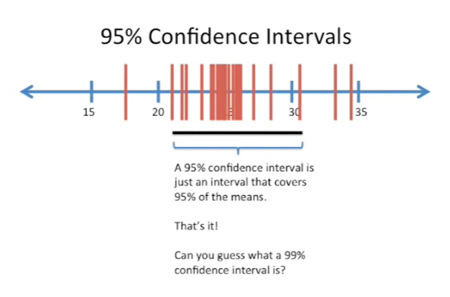

So here we have a black bar that spans 95% of the bootstrapped means that we just calculated.

That's it.

That's all, the confidence interval is nothing more, nothing less.

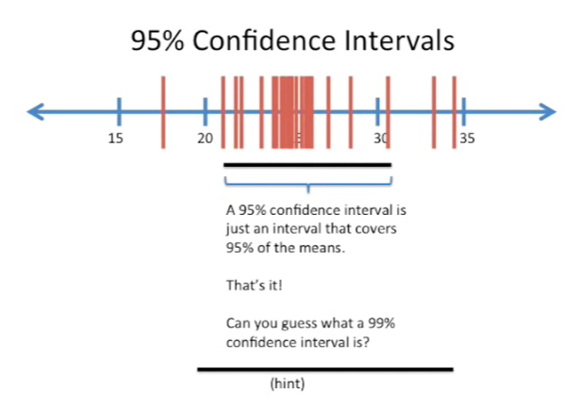

Can you guess what a 99% confidence interval is ?

Here's a hint it's wider than a 95% confidence interval.

Alright I'll tell you it's just an interval that covers 99% of the means that you calculated when you bootstrap to the sample.

Now that we know what confidence intervals are, we might ask why are they useful ?

Well I think confidence intervals are useful because they are statistical tests performed visually.

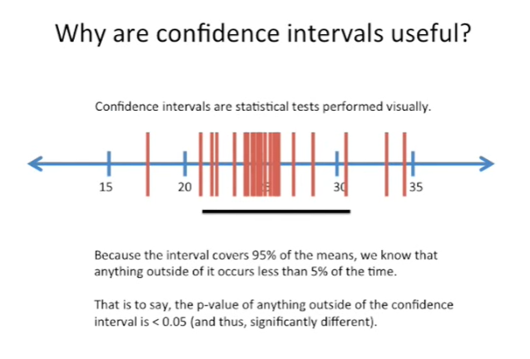

Because the interval covers 95% of the means we know that anything outside of it occurs less than 5% of the time.

That is to say the p-value of anything outside of the confidence interval is less than 0.05 and thus significantly different.

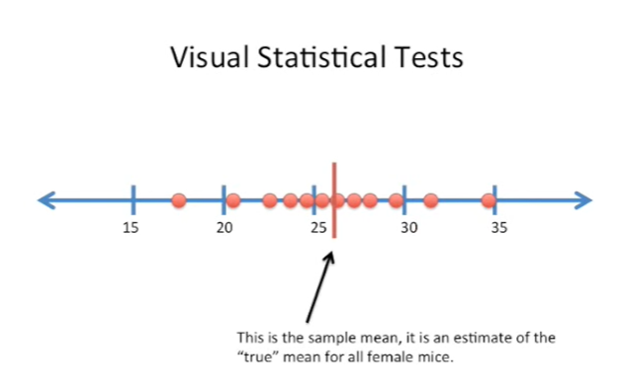

Here's an example of a visual statistical test.

You'll remember we originally calculated the sample mean.

The sample mean is an estimate of the true mean for all female mice.

Well with our confidence interval we can figure out.

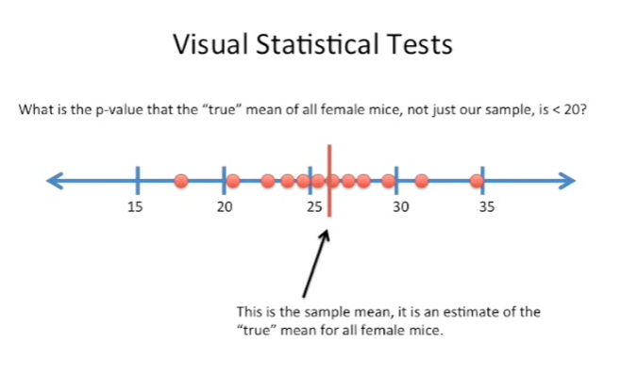

What the p-value is that the true mean of all female mice not just of our sample is less than 20 ?

To perform that test we draw our confidence interval which we know because of bootstrapping or some formula that we use.

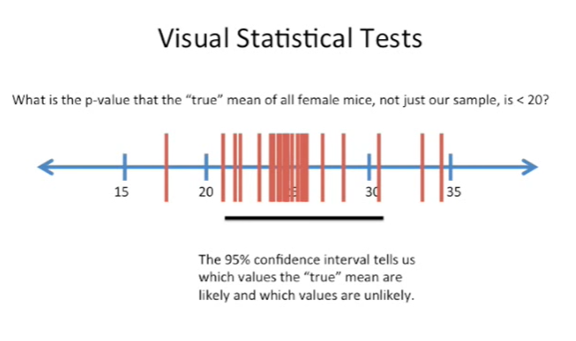

We can see that the area left of 20.

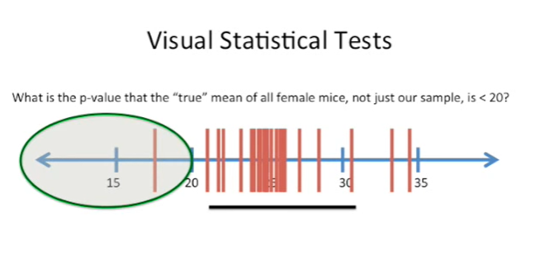

So values less than 20 are outside of our 95% confidence interval.

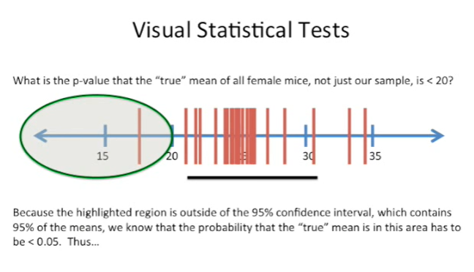

Because the highlighted region is outside of the 95% confidence interval which contains 95% of the means we know that the probability that the true mean is in this area has to be less than 0.05.

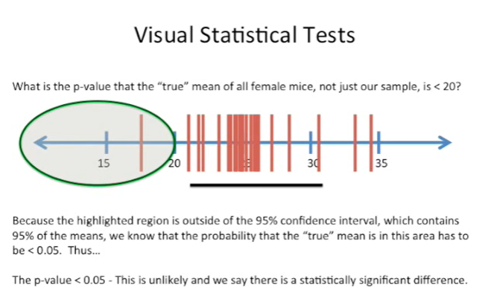

Thus the p-value is less than 0.05 this is unlikely and because of this we can say there's a statistically significant difference between the true mean and any value less than 20.

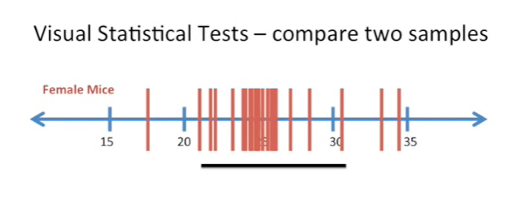

Here's another example of a visual statistical test.

In this case we're going to compare two samples.

Here we've weighed female mice.

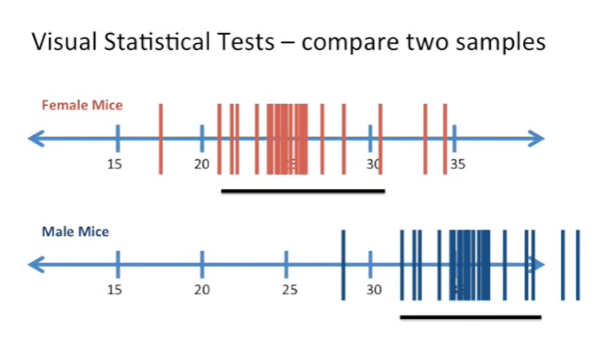

And now we have a sample of male mice.

We've already done the bootstrapping on that sample and here in the figure we just show the means from that bootstrapping.

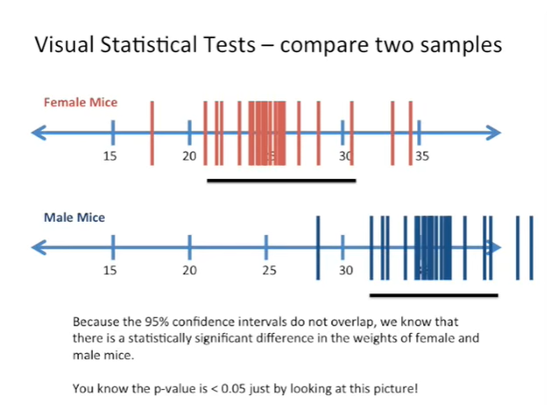

Because the 95% confidence intervals do not overlap we know that there is a statistically significant difference in the weights of female and male mice.

That is to say we know that the p-value is less than 0.05 just by looking at the picture.

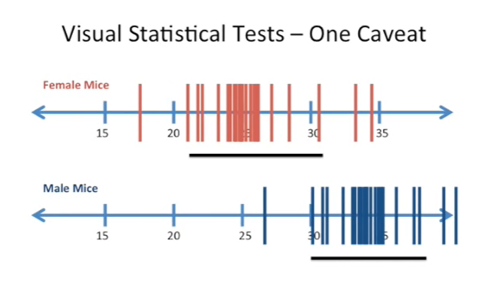

There is one caveat to that and to illustrate that caveat I've shifted the means a little bit over to the left so that now the confidence intervals overlap.

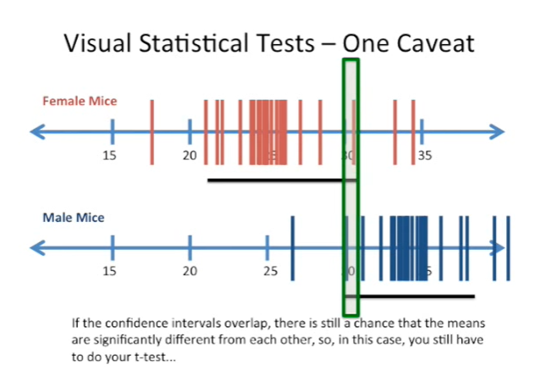

If the confidence intervals overlap, there is still a chance that the means are significantly different from each other. So in this case you still have to do the t-test but when the confidence intervals do not overlap then you can rest assured that there's a statistically significant difference between those two means.