<https://www.youtube.com/watch?v=pYxNSUDSFH4&list=PLblh5JKOoLUK0FLuzwntyYI10UQFUhsY9&index=35>

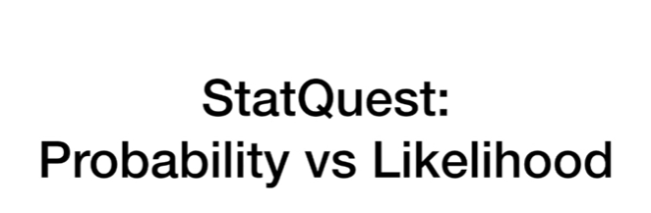

Today we're gonna be talking about the difference between probability and likelihood.

These are two closely related concepts that are very easy to get confused.

Even I mix them up from time to time so enough of this jibber-jabber.

Let's get down to it for me the easiest way to understand the difference between probability and likelihood is.

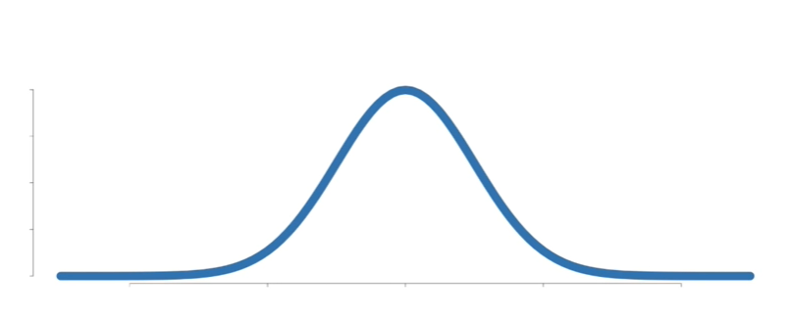

To just see it in pictures.

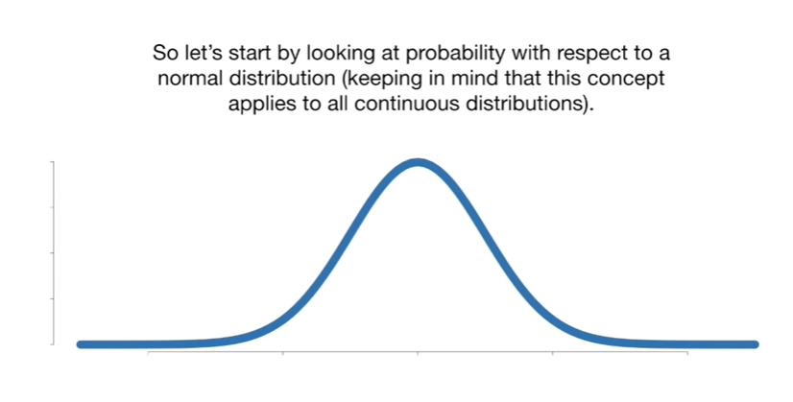

So let's start by looking at probability with respect to a normal distribution keeping in mind that this concept applies to all continuous distributions.

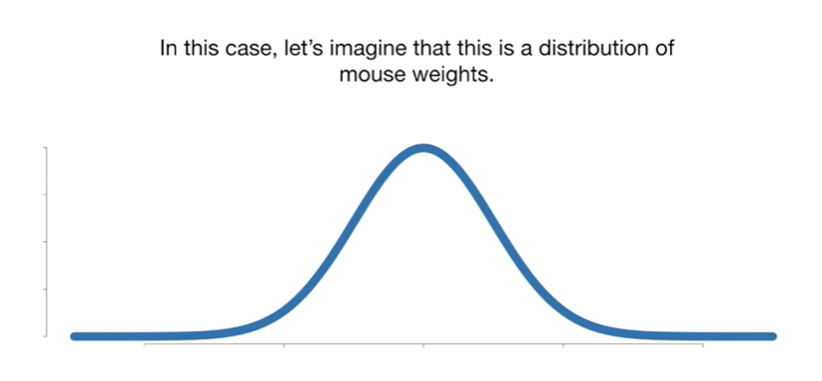

In this case let's imagine that this is a distribution of Mouse weights.

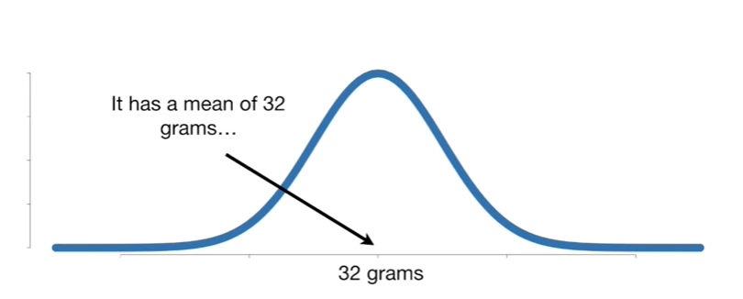

It has a mean of 32 grams

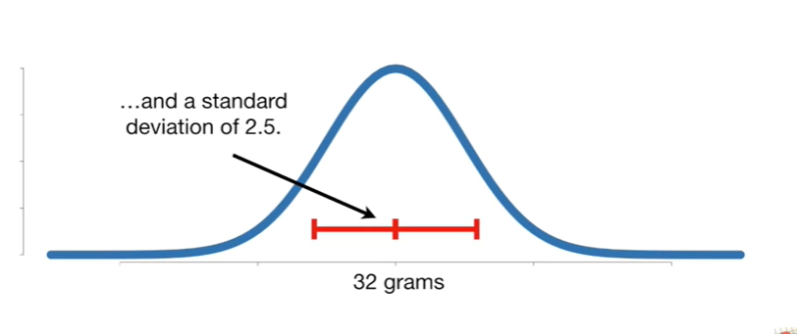

and a standard deviation of 2.5.

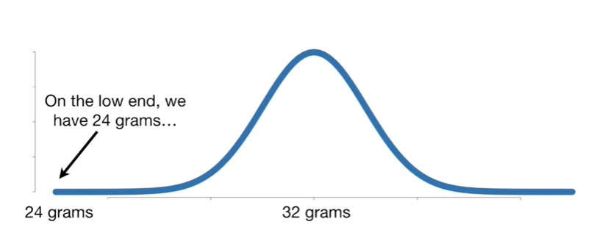

On the low end we have 24 grams

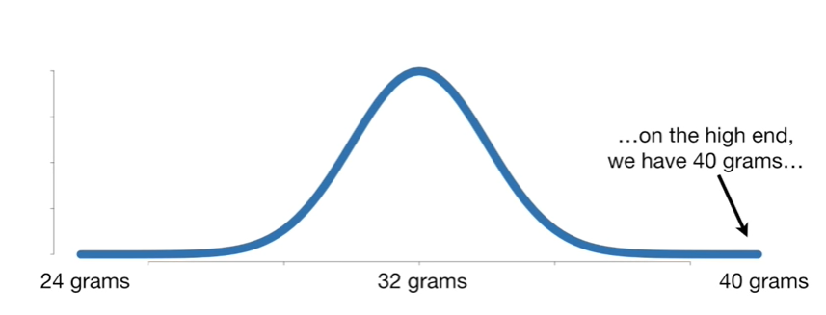

and on the high end we have 40 grams.

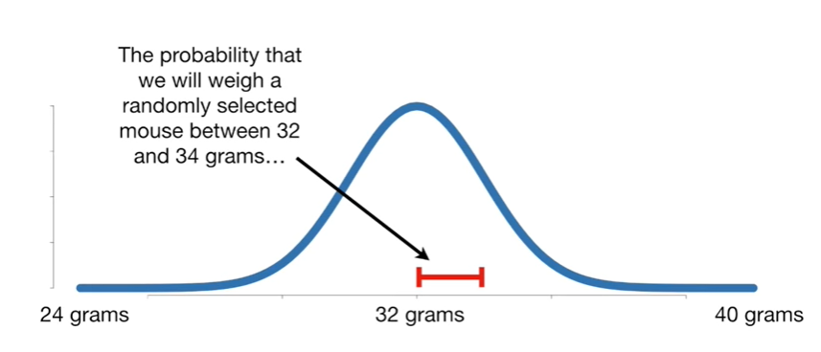

The probability that we will weigh a randomly selected Mouse between 32 and 34 grams

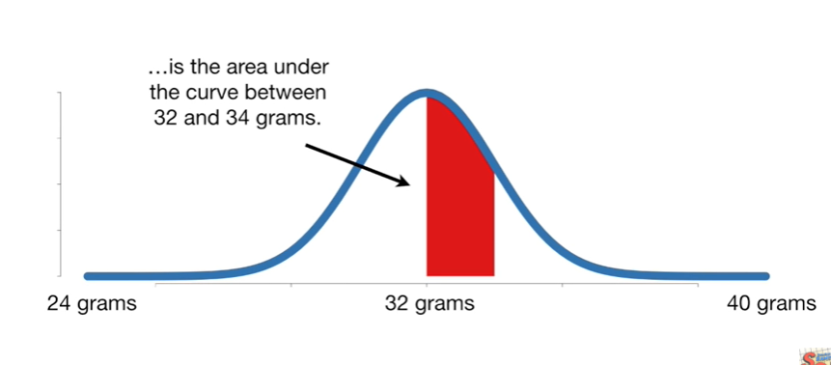

is the area under the curve between 32 and 34 grams.

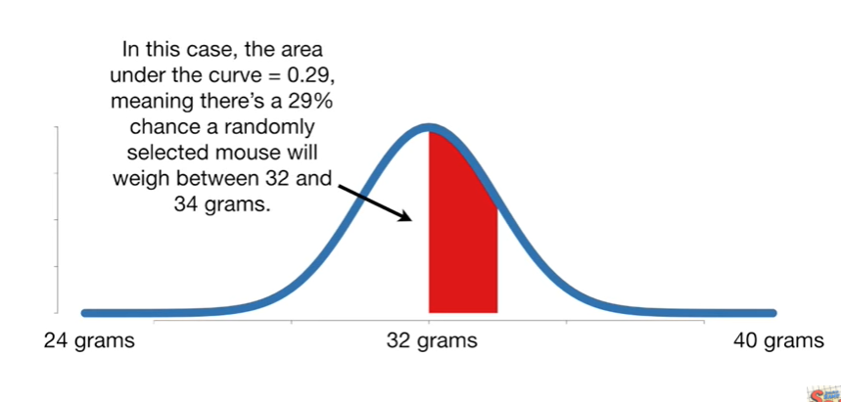

In this case the area under the curve equals zero point 2 9 meaning there's a 29% chance a randomly selected Mouse will weigh between 32 and 34 grams.

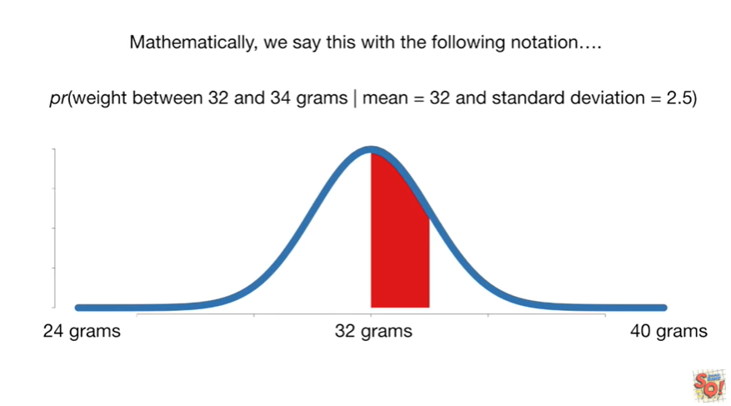

Mathematically we say this with the following notation.

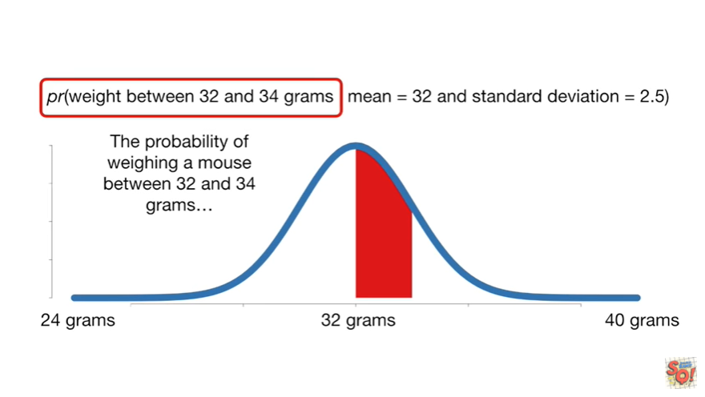

The probability of weighing a mouse between 32 and 34 grams

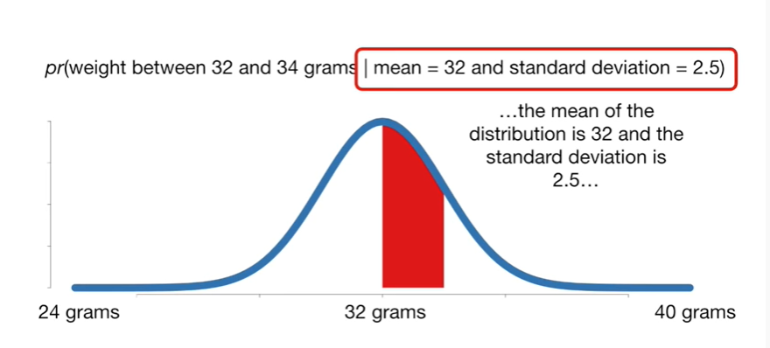

given the mean of the distribution is 32 and the standard deviation is 2.5.

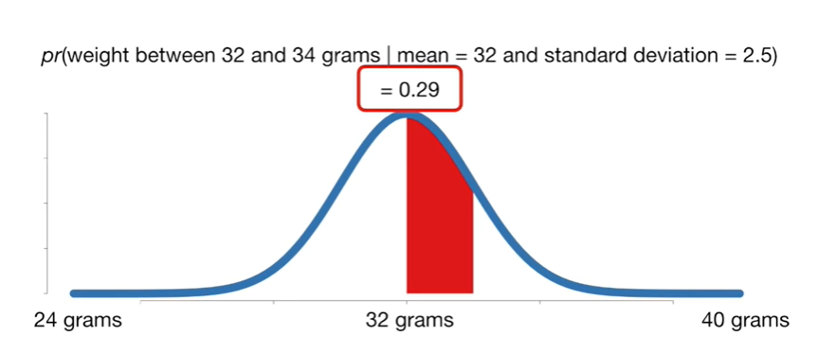

And all this equals zero point two nine.

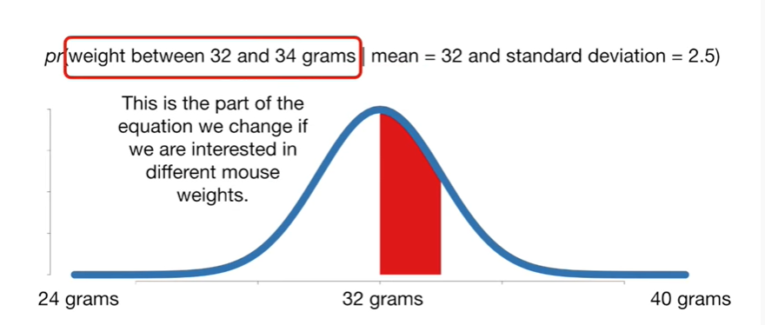

This is the part of the equation we change if we are interested in different Mouse weights.

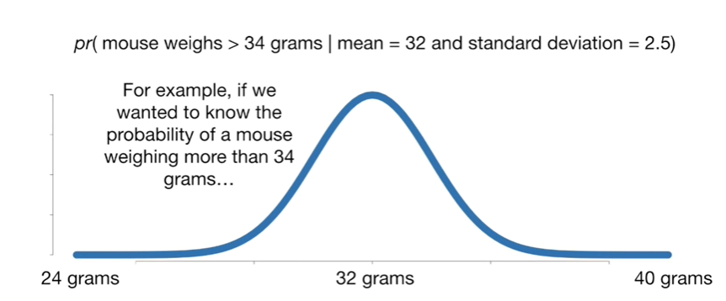

For example if we wanted to know the probability of a mouse weighing more than 34 grams

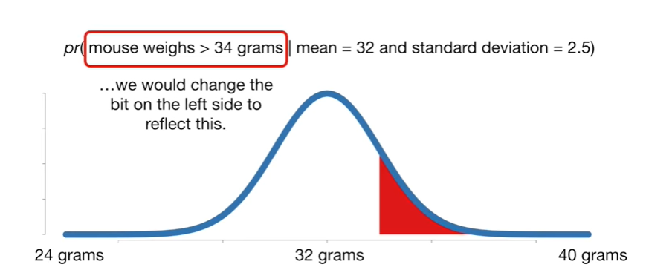

we would change the bit on the left side to reflect this.

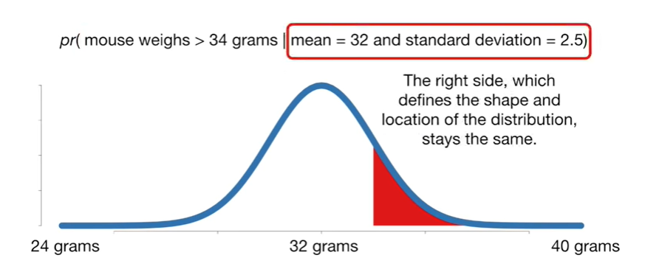

The right side which defines the shape and location of the distribution stays the same.

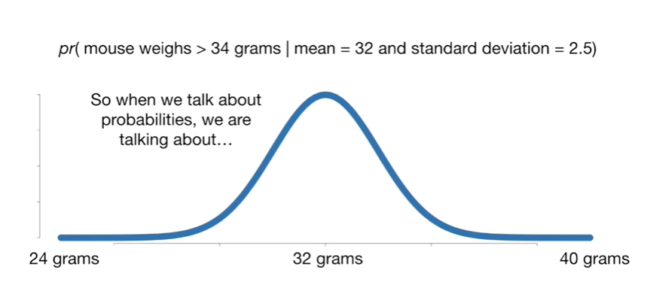

So when we talk about probabilities we are talking about.

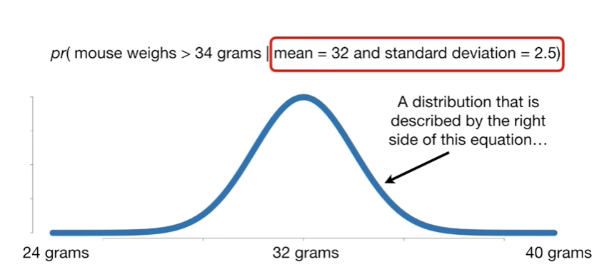

A distribution that's described by the right side of this equation

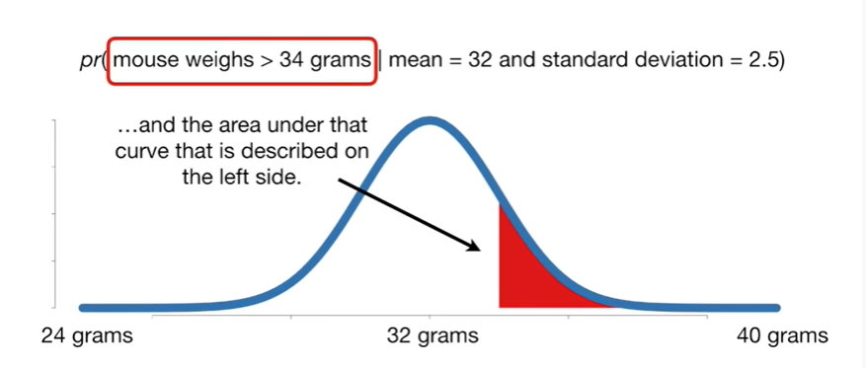

and the area under the curve that is described on the left side.

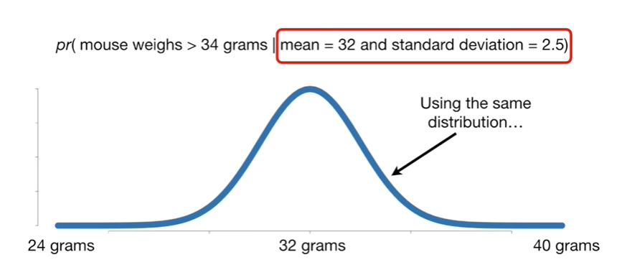

Using the same distribution

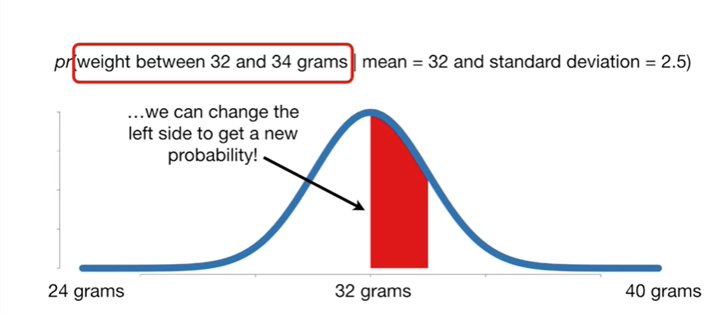

we can change the left side to get a new probability !

BAM !!

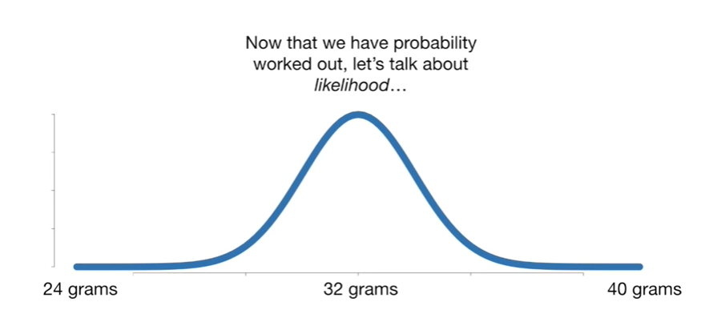

Now that we have probability worked out let's talk about likelihood.

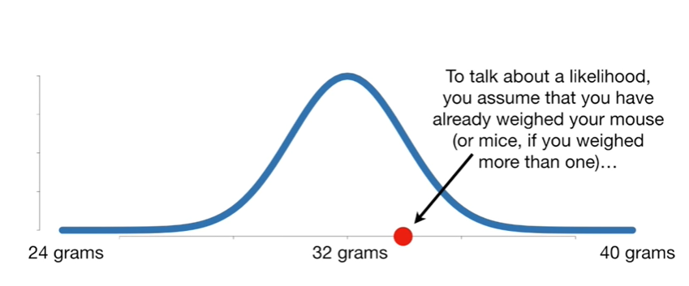

To talk about likelihood you assume that you have already weighed your mouse or mice if you have weighed more than one.

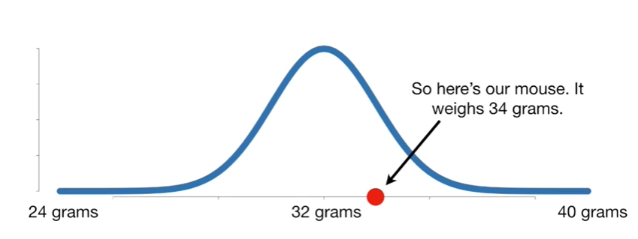

So here's our mouse it weighs 34 grams.

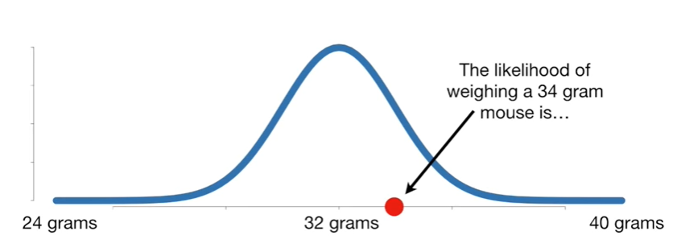

The likelihood of weighing a 34 gram Mouse is

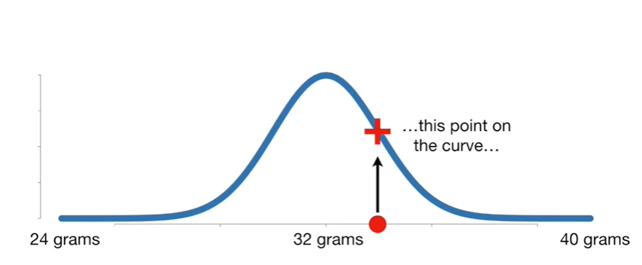

this point on the curve

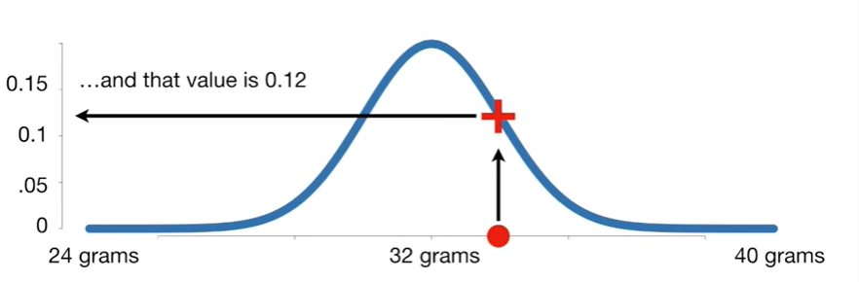

and that value is 0.12.

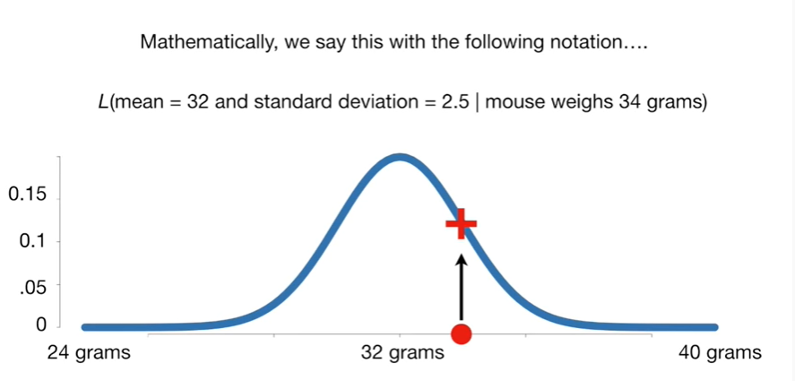

Mathematically we say this with the following notation.

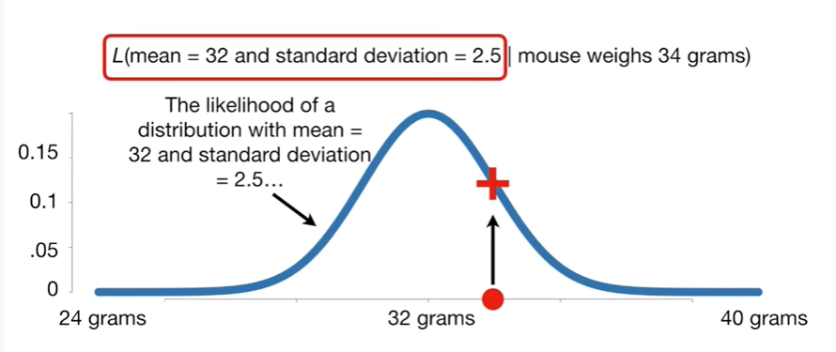

The likelihood of a distribution with mean equals 32 and the standard deviation equals 2.5

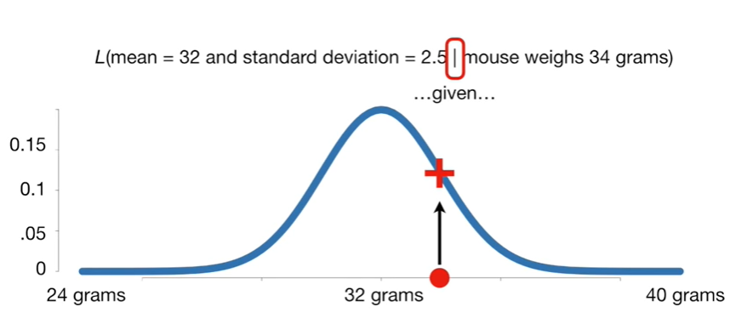

given

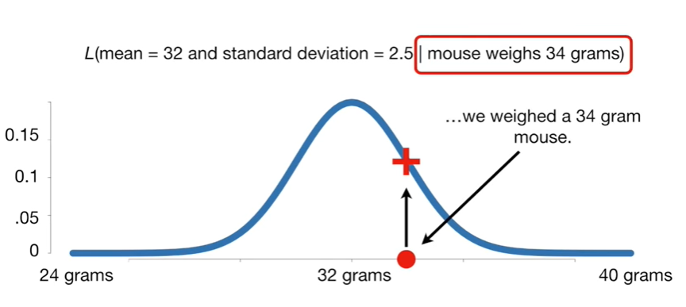

we weighed a 34 gram Mouse

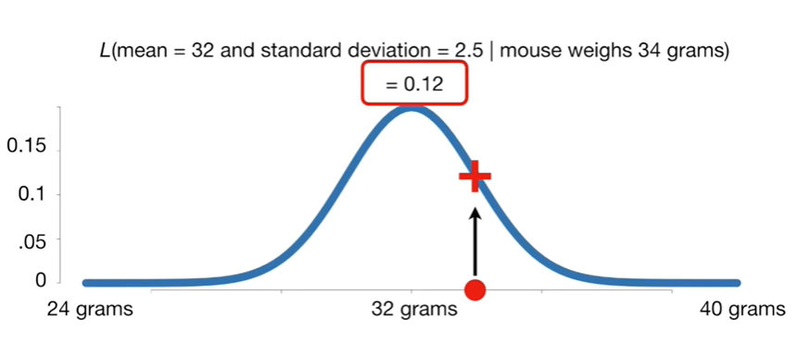

and all that equals 0.12.

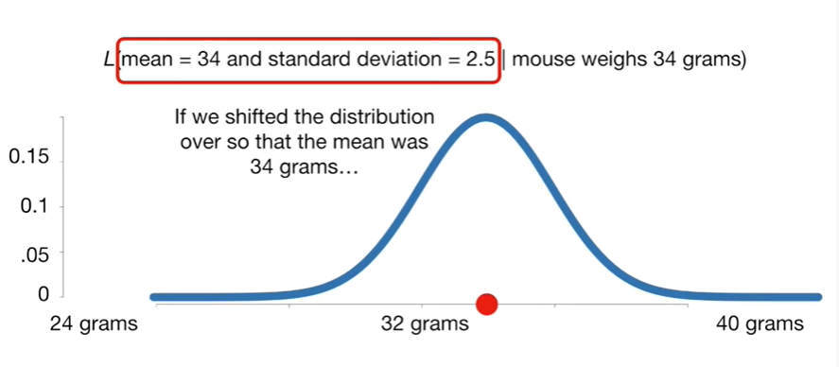

If we shifted the distribution over so that the mean was 34 grams

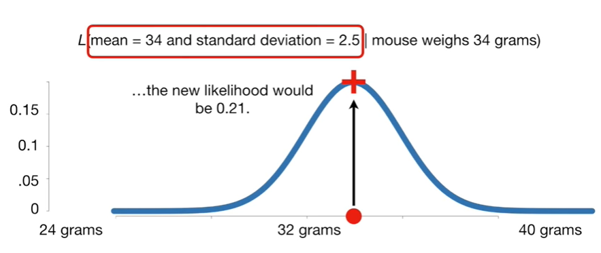

the new likelihood would be zero point two one

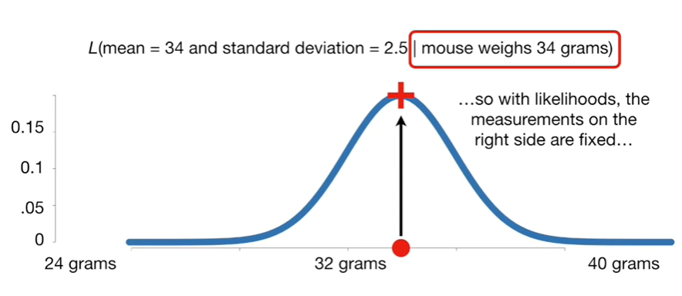

so with likelihoods the measurements on the right side are fixed

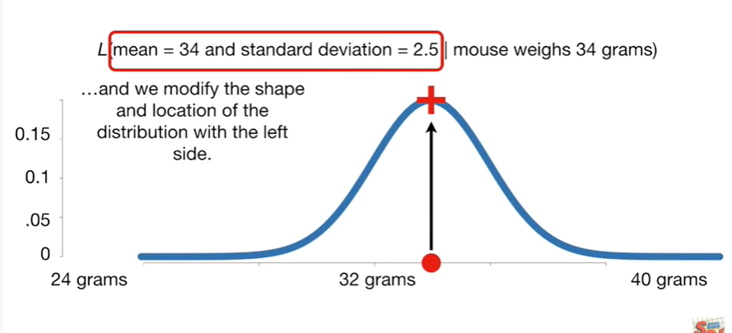

and we modify the shape and location of the distribution with the left side.

Double bam !!!



In summary :

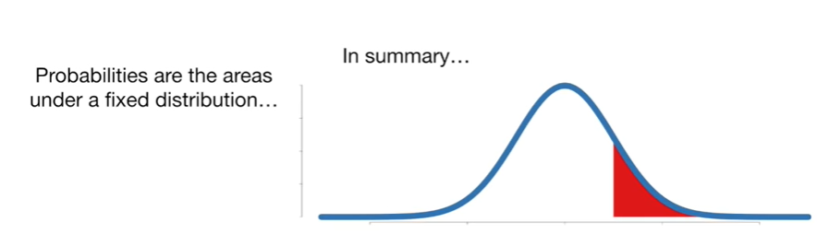

Probabilities are the areas under a fixed distribution

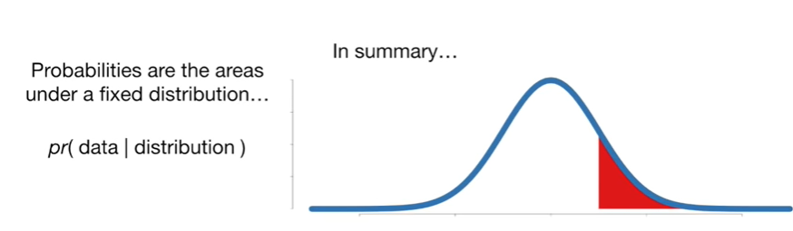

and mathematically we have the probability of data given a distribution

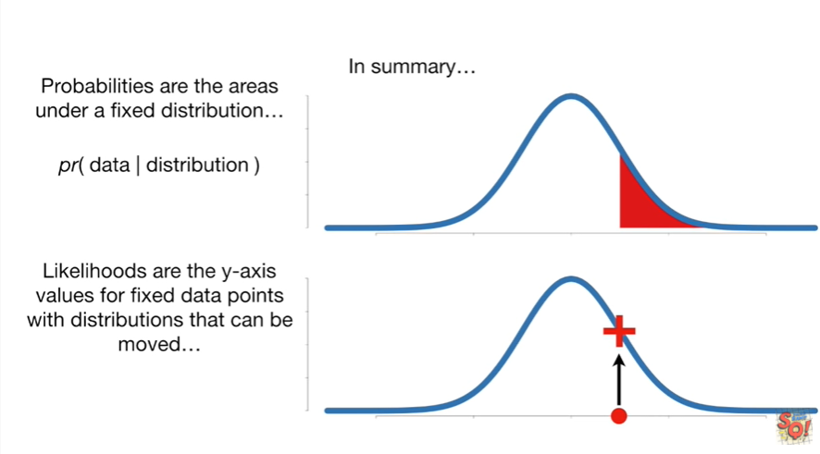

Likelihoods are the y-axis values for fixed data points with distributions that can be moved

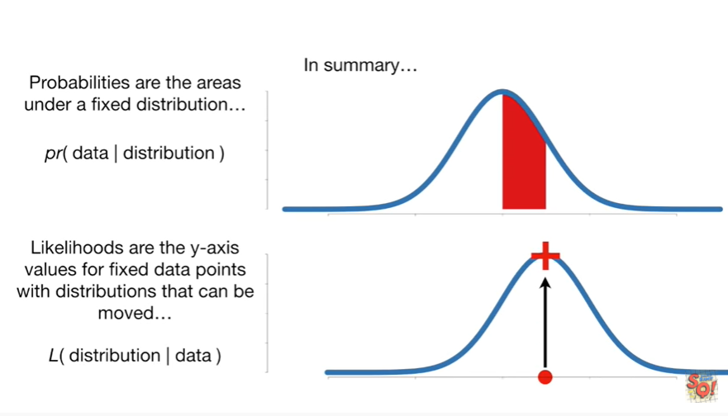

mathematically this is written as the likelihood of a distribution given data.

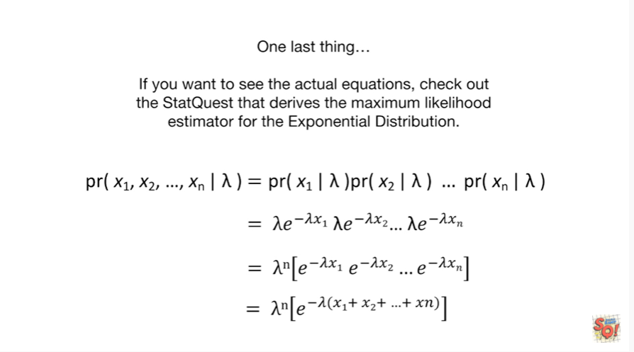

If you want to see the actual equations check out the stat quest that derives the maximum likelihood estimator for the exponential distribution.