<https://www.youtube.com/watch?v=fU2PuYKsr6M&list=PLblh5JKOoLUK0FLuzwntyYI10UQFUhsY9&index=43>

Welcome to stat quest thank you for joining me.

I see in the chat we've got all kinds of people from all over in place we've got Egypt.

I just saw Egypt go by, we've got lots of people from India, we got Poland, Colombia, Brazil, Uruguay, anyways…

Lots of excitement a lot of stuff going on I'm just gonna go ahead and get started because I'm super excited about today.

So BAM !!!

Alright today we're gonna talk about probability and expected values and I'm gonna take off my guitar.

So there BAM !!

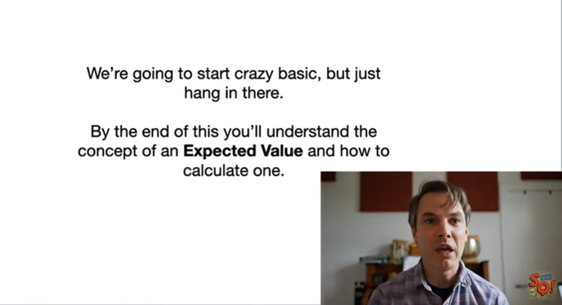

We're gonna start crazy basic but just hang in there.

I know this probability, this intro probability stuff is gonna be, so simple, that is you might get a little bored but whatever we're gonna plow through that stuff found and then we're gonna dive in.

Whoo !!!

I just lost power so I don't know how long I'm gonna last a transformer just exploded somewhere down the street.

So, so we'll see what happens, if I just drop out.

I will try to do this again tomorrow, but for now we'll just keep plowing about through anyways we're gonna start off with simple probability stuff.

And but by the end you're gonna understand the concept of an expected value, and how to calculate one.

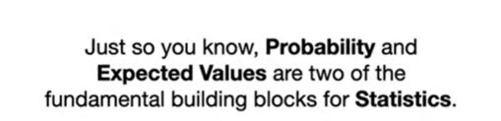

Okay, just so you know, probability and expected values are two of the fundamental building blocks for statistics.

So if you ever try to like figure out why something works, the way it works like, why do we divide the variance by n minus 1.

Instead of in Y is n minus 1 make it unbiased, if you want to understand what kind of Y of Statistics you're gonna run into expected values.

All the time it's sort of like the Gig way to understanding all the all the kind of like mucky things that lurk underneath everything that we do in statistics.

Okay !!



So, with that said, let's take a trip to the magical place called stat land !!!

And if I had chimes, I'd have chimes going okay.

So !

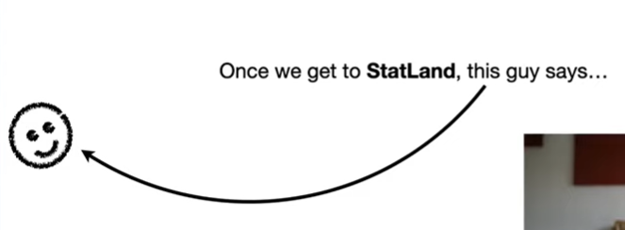

Once we get to stat land, this guy, he's gonna be our friend, our friend in state land, he says

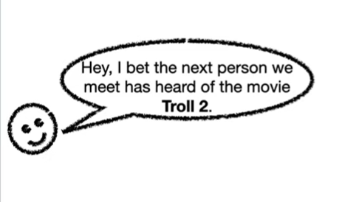

Hey, I bet the next person we meet has heard of the movie troll 2.

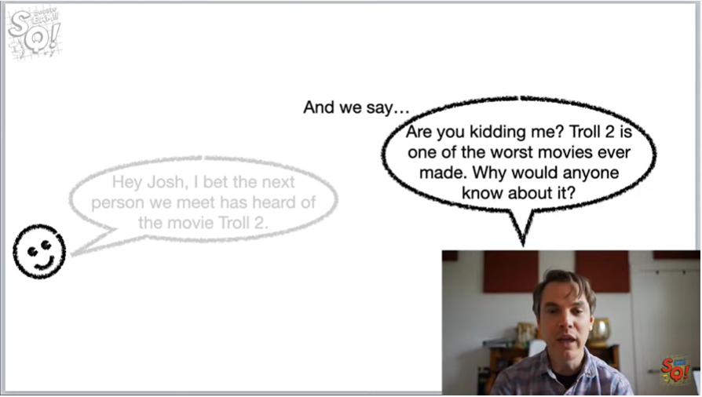

And we say.

Are you kidding me ?

Troll 2 is one of the worst movies ever made.

Why would anyone know about it ?

By the way, I'm talking about the 1990 movie troll 2, that if you look at it, on Rotten Tomatoes.

Tomatoes it is routinely rated as the worst movie.

Ever made so why would anyone know about that movie, anyways our friend says, I bet you $1 that the next person we meet has heard of the movie troll 2.



So we think to ourselves

We go, huh, thinking, thinking, thinking .



Good thing we have just asked everyone in stat land if they've heard of the movie troll 2, and here's the data.

BAM !!!

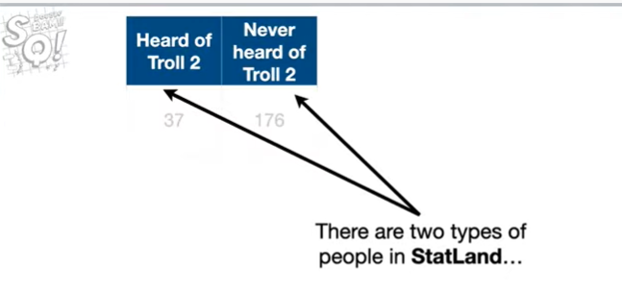

There are two types of people in stat land.

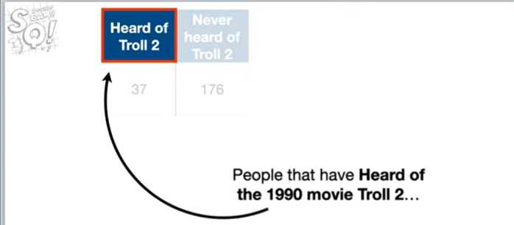

People that have heard of the 1990 terrible movie troll 2

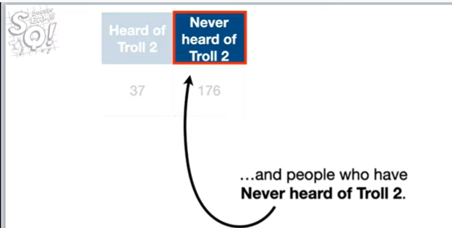

and people who have never heard of troll 2.

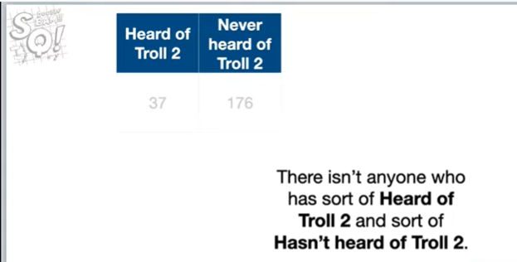

There isn't anyone who sort of heard of troll 2 or sort of hasn't heard of troll 2.

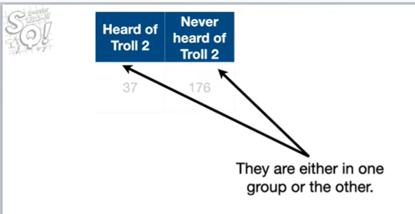

They're either in one group or the other.

Each person is either heard of troll 2 or they have never heard of troll 2, they may not remember that, they've heard of troll 2 but they've heard of it.

Ok !!!

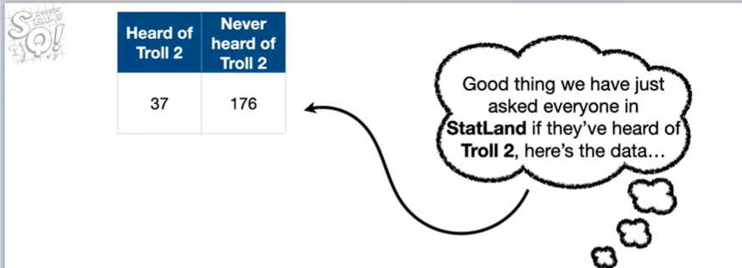

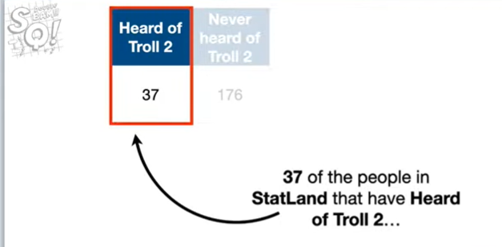

So 37 people in stat land have heard of troll 2.

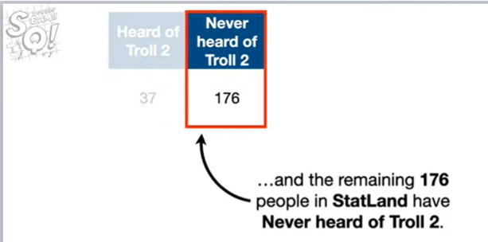

and the remaining 176 people in stat land never heard of Troll 2.

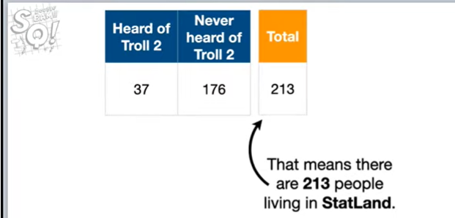

And that means there are 213 people living in stat land.

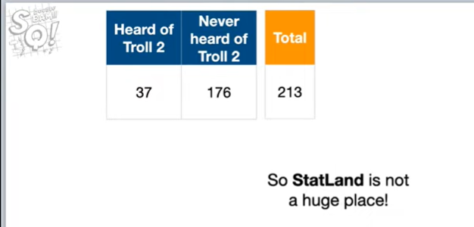

So statLand is not a huge place !

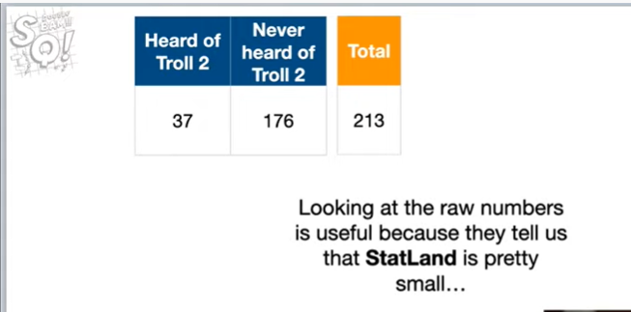

And looking at the raw numbers is useful because they tell us one stat land is pretty small

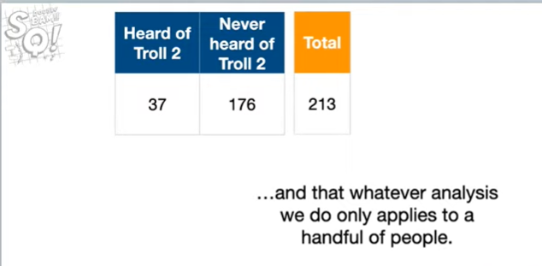

and that whatever analysis we do only applies to a handful of people.

So it's always important to kind of know what what size population we're talking about.

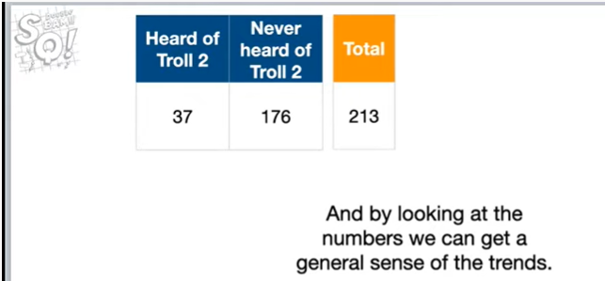

And by looking at the numbers we can get a general sense of the trends.

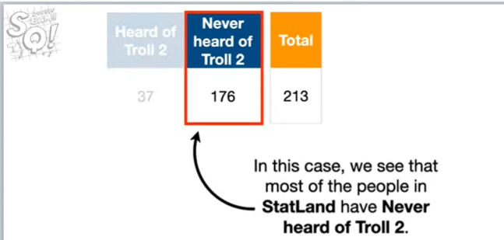

And in this case, we see that most of the people in stat land have never heard of troll 2.

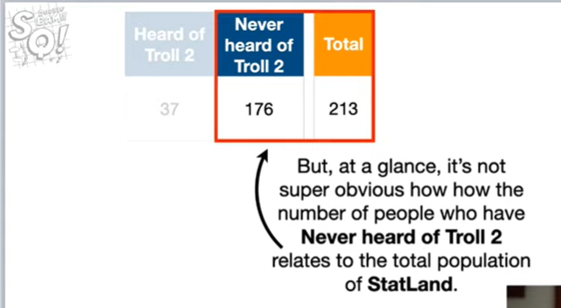

But, at a glance, it's not super obvious how the number of people who have never heard of troll 2 relates to the total population of stat land.

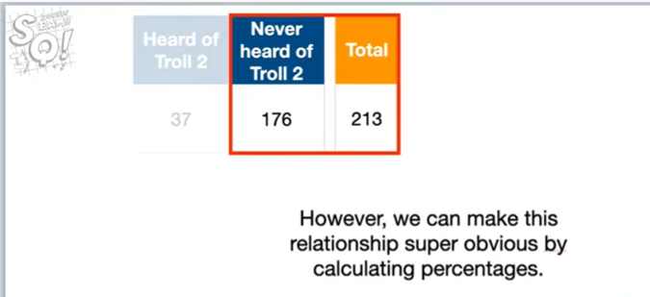

However, we can make this relationship super obvious by calculating percentages.

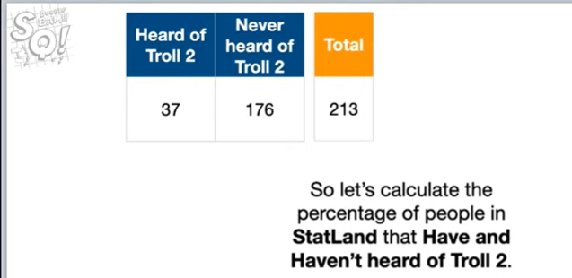

So let's calculate the percentage of people in stat land that have and haven't heard of troll 2.

Actually I've been I've been nosed ichinose oh I've got something well I was gonna say I've got something to show you but let's let's keep going I'll show it to you at the very end okay

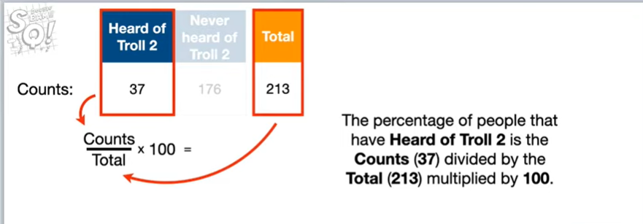

So the percentage of people that have heard of troll 2 is the counts 37th of 37 people have heard of troll 2 divided by the total which is 213 people.

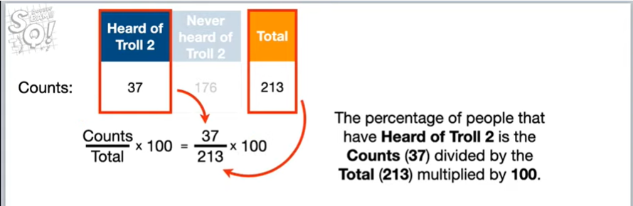

So there's 213 people that live in stat land and then we multiply that fraction by 100, all you guys know this, everybody knows how to calculate percentages and if you don't wow you just learned.

So no big deal !

Either way okay.

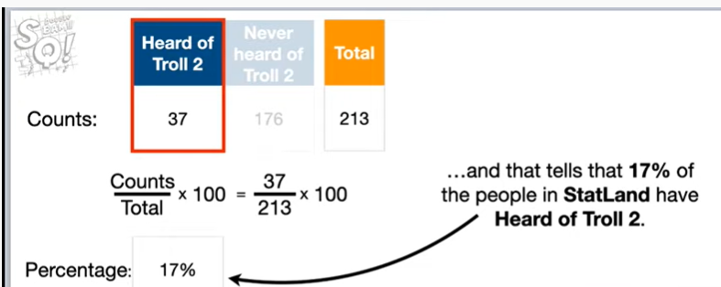

and that tells us that 17 percent of the people and stat land have heard of troll 2.

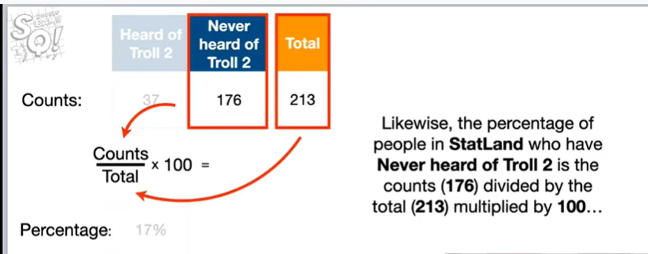

Likewise, the percentage of people in stat land who have never heard of troll 2 is the counts 176

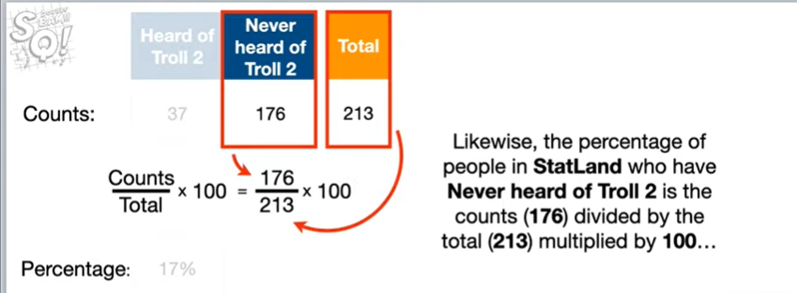

divided by the total 213 multiplied by 100

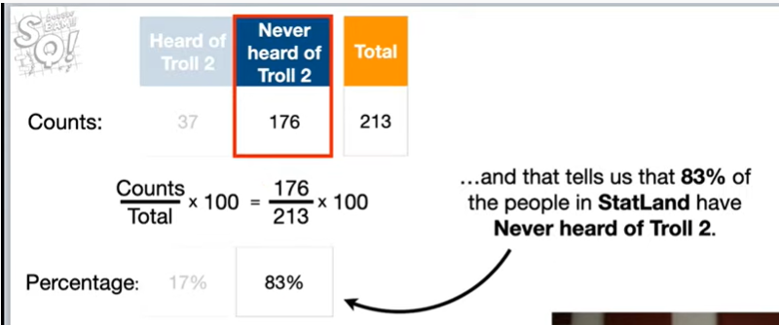

and that gives us 83 percent.

So we see that 83% of the people and stat land have never heard of troll 2.

Okay.

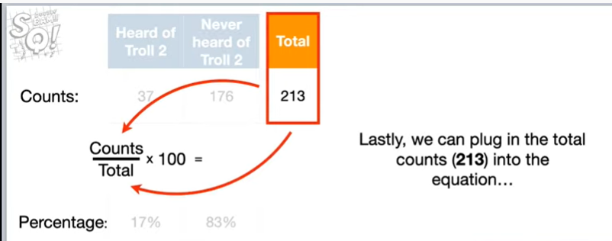

Lastly, we can plug in the total counts 213 into the equation

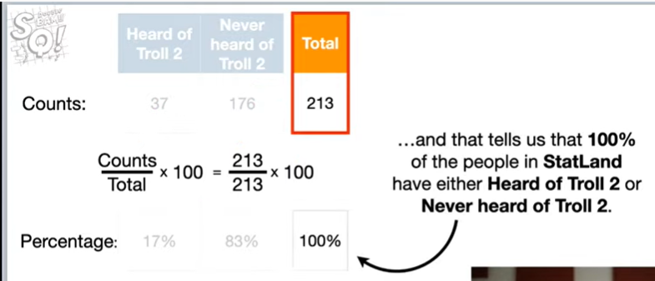

it's just the counts and the total.

And that tells us that 100% of the people have either heard of troll 2 or never heard of troll 2.

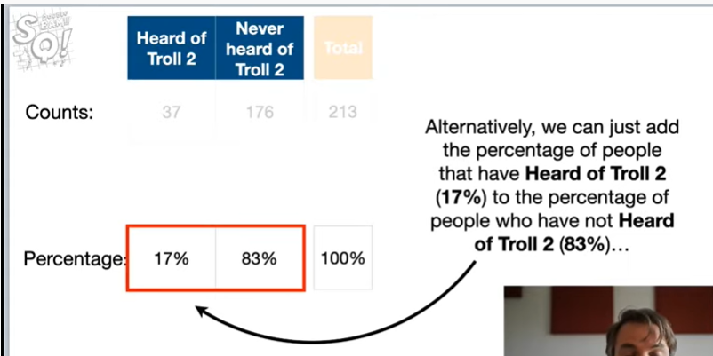

Alternatively, we can just add up the percentage of people that have heard of troll 2 (17 percent) to the percentage of people who have not heard of troll 2 that's 83 percent

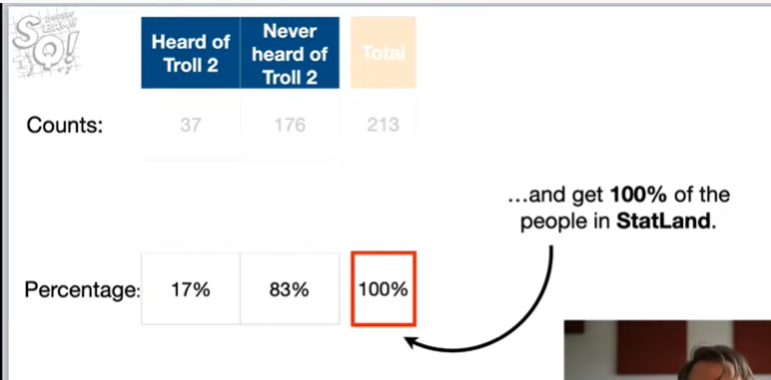

and that should give us a hundred percent of the people in stat line.

Because we said people in the set land are - there's just two types you've either heard of troll 2 or you haven't heard of troll 2 there's no other category so that accounts for 100 percent of the population okay.

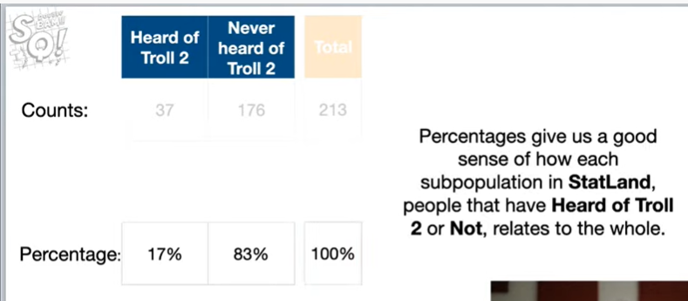

Percentages give us a good sense of how each sub population in stat lamb and by sub population I mean people that have heard of troll 2 or not, relates to the whole.

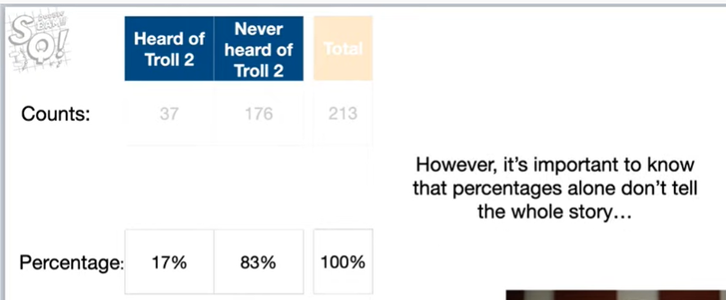

However, it's important to note that percentages alone don't tell the whole story

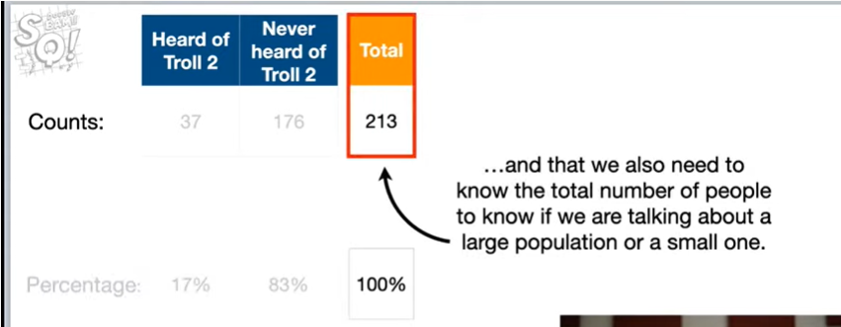

and that we also need to know the total number of people to know if we were talking about a large population or a small one.

So it's nice to know sort of the population size or the number of people were talking about okay.

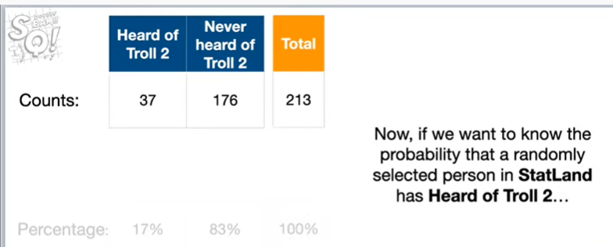

Now, if we wanted to know the probability that a randomly selected person in stat land has heard of troll 2

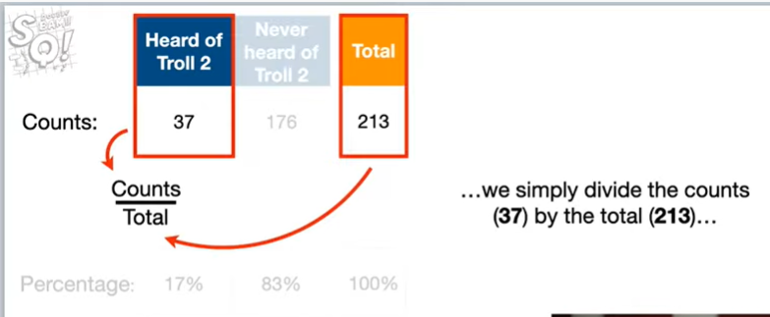

We simply divide the counts 37 by the total to 13 and that gives us zero point one seven.

Now I told you this is going to be basic.

So if you're fading out, don't worry stick with us, it's gonna get kind of cool pretty soon.

Okay

0.17.

What does that mean ?

That means that the probability that someone in stat land has heard of troll 2 is zero point one seven, which is pretty low, which means, we're unlikely to just run into someone randomly.

And they're gonna say, hey, I've heard of troll 2, the probability that a randomly selected person that land has not heard of troll 2 is 0.83.

Which is pretty high and that means and that means that there's a good chance, if we just randomly bump into someone.

That they're gonna say no, I've never heard of that movie, I don't care about that movie.

So, so, that's that's a pretty pretty probable outcome.

Okay.

Lastly, the probability that randomly select a person instantly and that is either heard of troll 2 or not heard of troll 2 is one.

So they're kind of guaranteed to be in one of those two categories.

Now remember that bet our friend wanted to make our friend said.

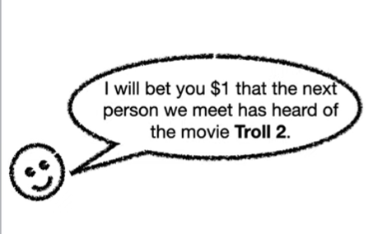

I bet you $1 that the next person we meet has heard of the movie troll 2.

And because we want to know the probability that we will win the bet we're gonna focus on probability.

So let's move the probabilities to the top, so we can focus on them.

Okay.

Now, if the next person we meet has heard of troll 2, then we will lose the bet and that means we will lose $1.

So let's put negative 1.

Here to represent the outcome of losing $1.

If we meet someone who has heard of troll 2, in contrast if the next person has not heard of troll 2 then we will win the bet.

Hooray !!

And that means we will win $1.

So let's put a 1.

Here to represent the outcome of winning $1, if the next person we meet has not heard of troll 2.

So now we see that the probability we will lose $1 is 0.17 and the probability that we will win $1 is 0.83.

In other words the probability we will win $1 is much higher than the probability that we will lose one dollar.

So this looks like a pretty good bet for us to make.

Oh I just said that so it seems like it would be a good idea to accept this bet.

However, even though there's a high probability that we will win the bet.

There's still a low probability that we will lose the bet and no one likes to lose money especially me.

I'm I'm not a betting person so I'm gonna be honest, this example is completely abstract.

Betting is one of those things that some people do for fun, but it stresses me out, so I tend not to bet.

So we say can we make this bet a hundred times or is this just a one-time offer and there I'll be honest the reason why I'm saying this is if we just make the bet once you know we could win or lose.

We either win a dollar or we lose a dollar but if we make this bet a bunch of times.

Maybe on average we'll come up you know ahead no matter what make you know, there's always a small chance, we could lose our honored bets.

In a row but that's a very small chance and so I'd like to know is like what's our chance of sort of like what are we gonna do on average over a hundred bets and our friend says we can make this bet 100 times.

So this is great.

So what we're gonna do is we're gonna we're gonna make this bet a hundred times we're going to ask a hundred people.

Okay !!

And so if we make this bet a hundred times, we will win some and we will lose some but we can use this table to figure out how much we will win and lose.

And that'll give us a sense of like what will happen in the long term how safe is this bet.

Okay, if we make the bet a hundred times we can approximate how many times we will lose by multiplying the probability we will lose 0.17 by 100 and if we do the math we get seventeen.

So that means we expect to lose seventeen times out of 100 bets.

However, just for now humor me and let's not do the math and just know that this this represents the approximate number of times we will lose the bet.

Since each time we lose the bet, we lose one dollar, we can estimate how much money we will lose by multiplying the X the number of times we expect to lose by negative one.

So this whole term represents how much money we expect to lose in 100 bets and if we did the math we'd see that we expect to lose about 17 dollars.

Wha-wha.

Now since we can make the bet 100 times, we can approximate how many times we will win by multiplying the probability we will win zero point eight three by 100.

Again, if we did the math we'd see that we expect to win eighty three times but we're not doing the math quite yet since each time we win the bet we win $1 we can estimate how much money we will win by multiplying the number of times we expect to win by one.

So this whole term represents how much money we expect to win in 100 beds and if we did the math we'd see that we expect to win eighty three dollars if we wanted to find out the total of how much we could expect to win or lose. We can add these two terms together and now when we do all of the math we see that we expect to win approximately 66 dollars after 100 bets.

However, we can also calculate the average amount of money we win per bet by dividing everything by the number of bets 100 doing the math gives us 66 divided by 100 which is 0.66.

So on average we expect to win 66 cents every time we bet note even though I win or lose $1 each time I bet so I don't win or lose 66 cents even though I'm betting $1 and I'm either winning or losing that dollar on average I expect to win 60 cents each time because sometimes I'm gonna lose and sometimes I'm gonna win and so on once you a verge on the wins we get 66 cents each time in statistics lingo 66 cents is the expected value for the bet.

Using statistics notation we would write e of the bat or the expected value of the bet equals zero point six six so that's how you notate that and if we wanted to make it look even more cryptic we would write e of X or the expected value of x equals zero point six six where in this case X represents the bet whether or not someone has heard of troll 2 and I'm using this sort of fancy cryptic terminology because that's what you're gonna see if you pull up the Wikipedia article on any distribution they're gonna say who the expected value they're gonna say e of x equals something and I just want you to know that e of X is really just an average it's a type of average and we're gonna go through a bunch of examples I'm going to see that kind of different ways to do it okay so we're gonna put a of X or the expected value of x over here and we're going to talk about why we left this math so messy because you remember we could have done the math halfway through but I said let's just not do it quite yet and we're gonna we left it messy and now we're gonna talk about why we did that okay since I'm multiplying each probability by the number of bats and I'm dividing by the number of bats 100 all of the values that represent the number of bets cancel out and we are left with the probability that someone in stat land has heard of troll 2 times the outcome negative 1 plus the probability that someone has not heard of troll 2 times the outcome 1 and when we do the math we get the same thing we got before 0.66 because those hundreds just cancel out so of course we're gonna get the same result note because all of the terms for the number of bets cancelled out the expected value simply represents the average of what we would expect if we made this bet a bunch of times now if we made that bet once we will either win $1 or we will lose $1 we won't win or lose 66 cents but if we make it a bunch of times and we just average out the wins and the losses we're gonna get 66 cents every time we do it so that's what this expected value represents note in fancy math notation this expected value is this sum so it's the sum of each outcome X and we'll talk about what X means in a little bit times the probability of observing each outcome X okay so for the first term heard of troll 2 the outcome is negative 1 so x equals negative 1 so that's that's what we're observing is that we've lost some money and the probability of observing the outcome of negative on at the other deserving the loss of money is zero point 1 7 so we multiply those two values together then we add that term to the term for not heard of troll 2 and in this case the outcome is 1 so x equals 1 and the probability of observing the outcome of 1 is zero point 8 3 so we see the probability that x equals 1 is zero point 8 3 okay so now we've seen how the fancy math definition of expected value works so if you if you if you're out there in the wild I usually don't like doing these fancy terminology things but this is one of those things but I will I'm gonna be honest with you expected value for a long time when someone said hey we're just gonna do the expected value I kind of get chills down my spine and I go oh no that's not good and then they would show me this equation I go what does that equation mean I don't know and that would have that would intimidate me so what I'm doing is I'm putting them on the screen to try to like demystify so we're gonna plug in things for X and we're going to plug in stuff for that probability a bunch of times so hopefully by the end of this tech quest you're gonna be real comfortable with this formula you'll be like I get it it's just a way of calculating an average okay BAM okay now imagine our friends saying because it is rare for someone in stat land who have heard of troll 2 I will pay you ten dollars if the next person we meet has heard of the movie troll 2 but if they have not you pay me $1 okay so this is a slightly different bet if they've heard of troll 2 we get a lot we get a bigger payout but it's also rare to find people that have heard of troll 2 so there's a higher likelihood we're gonna have to pay our friend okay so we will win money will we win money or lose money if we can make this bet a bunch of time so what's gonna happen on average say like we could make this bet a hundred times or a thousand times overall are we gonna win money are we gonna lose money so we're gonna calculate the expected value to find out okay this outcome this is the outcome for when someone has heard of troll 2 so that's 10 and the outcome for when someone has not heard of troll 2 holy smokes someone just did a crazy super chat Andre care avail yo holy smokes that's like the superest superjet I've seen in a long time dang ok sorry about that shoutout but I just had to do it totally caught me I see a lot of chat going on in the background and people are using the the triple triple BAM and the special emojis but I had to had to shout that out ok oh where were we and the outcome for when someone has not heard of troll 2 was negative 1 okay when these are the outcomes the expected value is and we're using that fancy notation the sum of each outcome that's x times The Associated probability so the probability that we observe that outcome we'll start by plugging in numbers for heard of troll 2 the outcome is 10 and the probability of observing that outcome is 0 point 1 7 now we add the term for never heard of troll 2 the outcome is negative 1 and the probability of observing that outcome is zero point 8 3 so that's how we plug the numbers into that fancy equation now we just do the math and the expected value is zero point eight seven and that means we expect to make on average eighty seven cents every time we make this bet double BAM okay I've got two more examples I know we've been going pretty long I've got two more examples using a six-sided die this first example is kind of a standard example so if you go to the Wikipedia article on expected values you're gonna see this example but now that you've got a better feel for expected values you're gonna see that example I get it I know how that works okay so the probability so we're imagine we're rolling this die and the probability of landing on any specific side like having five like we have over here in the in the image of the die is 1/6 now if we want to find the expected value or the average value of rolling the die a bunch of times then we need just need to plug in values into the formula for the expected values and I think I skipped a slide or it got deleted somehow but you see that we get out the outcomes are just the the number that length comes up on top of the die so if we roll one the outcome is 1 if we roll a 6 the outcome is 6 so those are the outcomes and we're gonna plug the probabilities and the outcomes into this formula for the expected value so for lands on one the outcome is 1 and the probability of observing a one is 1/6 and that gives us 1 times 1/6 for lands on to the outcome is 2 and the probability of observing a 2 is 1/6 and that gives us 2 times 1/6 so we add that term to our sum and four lands on three we get three times one time 1/6 we add that term to the sum and four lands on four we get four times 1/6 and four lands on five we get five times 1/6 and four lands on six we get six times 1/6 now we just do the math and the expected value for rolling a six-sided die is three point five note there is no side on the die for 3.5 so we will never roll 3.5 exactly but if we take the average of what we get after a bunch of rolls then we expect that average value to be close to 3.5 damn okay one last example and then we're gonna be all done okay here's the new bet this is what our friend says he says I will pay you $100 if you roll a six otherwise you pay me ten dollars this bet means the outcome for rolling a six is 100 because he will pay us $100 and the outcome for rolling anything else is negative 10 so if we roll a 1 we owe this guy our friend nay we owe him 10 dollars so that's the those are our outcomes now what's the expected value all we have to do to find the expected value is plug the outcomes and probabilities of observing the outcomes into the formula so boo boo boo boo boo boo now we just do the math and the expected value for this bet is eight point three in other words if we can bet a bunch of times and not just once if we can bet a bunch of times we will win on average eight dollars and thirty cents each time and that means our friend is the worst gambler ever triple bam um so that is hold on I think that's our last slide we're I try to keep these things to about 30 minutes and we're at 30 minutes however I just want to do a little shout out to smeared you mayn't it she just became a member and that's awesome that's super helpful for me and keeping stat quest alive memberships are doing pretty well we're almost up to 200 the channel members which is really exciting and remember channel members are a way to support me making stack quest videos full-time as a job and the more time I can dedicate to that the more the more time the more videos and more live streams and more stuff you get and I've got some exciting stuff to talk about the last time we talked about how I was working on these Jupiter notebooks for how to do machine learning in Python I've got a bunch of those made and here's the deal what I'm gonna do is I'm gonna start doing umm because everyone's doing zoom these days I'm gonna start doing zoom classes we're gonna do a zoom class where I take you through this Python notebook oh this Jupiter notebook and we're gonna go through how to use XG boost from start to finish we're gonna get some data we're gonna clean that data up we're gonna deal with missing values we're gonna make sure that the data is formatted correctly each type is correct we're gonna do all that then we're gonna do XG boost we're gonna optimize the hyper parameters hyper parameters is just a fun fancy fancy way for things that you just have to tweak by hand but we're gonna call him hyper printer parameters because that makes him sound cool rather than things you tweak by hand and we're gonna tune those and then we're gonna have a finished model and I'm we're gonna start doing those so that's something very exciting to look forward to I'm also working on the study guides PDF study guides and those are gonna be downloadable so lots of exciting things that are going on right now and so I'm excited about stat quest I want to thank all of you guys for tuned in unfortunately I rambled on for way too long today so I'm unable to take questions live but I rest assured I I will save the live stream and I will go through it and I will look at your questions and I'll read through everything and some may end up as a queue for a future stat quest a future live stream or whatever I think we're gonna stick with this probability for a little while I want to do look I'll be honest when I started this out my goal was to do conditional probability and and sort of joint distributions and marginal distributions and kind of talk about these sort of like weird kind of fundamental concepts that have a lot of scary terms associated with them but a really basic and and once we do that we can start heading into bayesian territory then we'll start understanding Bayesian so if that was the goal but when I was just I was just kind of going and all the sudden I was like wham expected values are here let's talk about them because expected values are a big deal and I've been meaning to to cover them because I've got a I've got a stat quest on extraña to explain why the variance equation the way it is why do we divide when we want an unbiased estimate of the variance why do we divide by n minus 1 instead of n where n is the number of observations and it all has to do with expected values and so this is a stepping stone towards answering that question so anyways thank you very much I'm really happy you guys are here it means a ton to me and I'm looking forward to the next stat quest it's gonna be the first Monday in May and I think we're just gonna do them all at noon it's a good time for me and I hope it's a good time for you I know it's not a good time for everybody but these are recorded and so if it's not a good time for you you can always watch it later alright until next time quest on