# Implementation of the linkage between the openENTRANCE scenario explorer and SCOPE-SD

## Workflow

The workflow for the SCOPE-SD model includes the following steps:

* **Downloading data from the OpenENTARNCE scenario explorer and creating a SCOPE-SD input** dataset. For this a script (python) was implemented that creates a connection to the platform, downloads the data, filter them, aggregate or disaggregate (depend on the data) them and convert them to SCOPE-SD input format (excel sheets).
* **Running the model** with the inputs from the database and other inputs.
* **Uploading SCOPE-SD results to the platform**. To prepare the dataset, scripts (Matlab and python) were implemented that converts the SCOPE-SD outputs into the IAMC format, convert the units, aggregate results and checks the nomenclature. Afterwards the results (excel sheet) have to be uploaded manually to openENTRANCE scenario explorer via a browser.

## Downloading and processing data from the openENTRANCE database

For downloading and using the scenario data provided by TU Berlin in the openENTRANCE database the python script “import_scenario_data_openENTRANCE.py” was implemented. The used python packages are the pandas, pyam, nomenclature and xlwings package. The script is structured as follows:

1. Connection to data platform
2. Downloading results of a model, e. g. GENeSYS-MOD 2.9.0-oe
3. Conversion of the units, e. g. EJ/yr to TWh/yr
4. Filtering the data, e. g. scenario, year and variable
5. Checking the iso mapping between the results and SCOPE-SD inputs
6. Write relevant data from the downloaded results into the input excel sheet for SCOPE-SD

If data needs to be disaggregated or aggregated, this will happen in the input excel file

## Uploading results from SCOPE-SD to the openENTRANCE database

For uploading results, the output data form SCOPE-SD (.mat file) has to be converted to the IAMC format (excel sheet). In the first step a Matlab script was implemented, that filters the output data, renames the variables, aggregates results and writes them into an excel file. In a second step a python script reads the result excel sheet, makes the regions compatible to the IAMC format and checks if all variables, units etc. are in line with the nomenclature of the openENTRANCE scenario explorer (IAMC format). After the validation the excel file is manually uploaded to the openENTRANCE scenario explorer via the browser application.

## Data and a screenshots of the log file

The used python scripts and test excel files can be found here <https://github.com/openENTRANCE/linkages>:

* import_scenario_data_openENTRANCE.py
* export_SCOPE_results_openENTRANCE.py
* scope_sd_20201120_test_data.xlsx
* scope_sd_20201120_test_data_validated.xlsx

The screenshot of the log file shows the successful upload to the openENTRANCE data platform of the test data set.

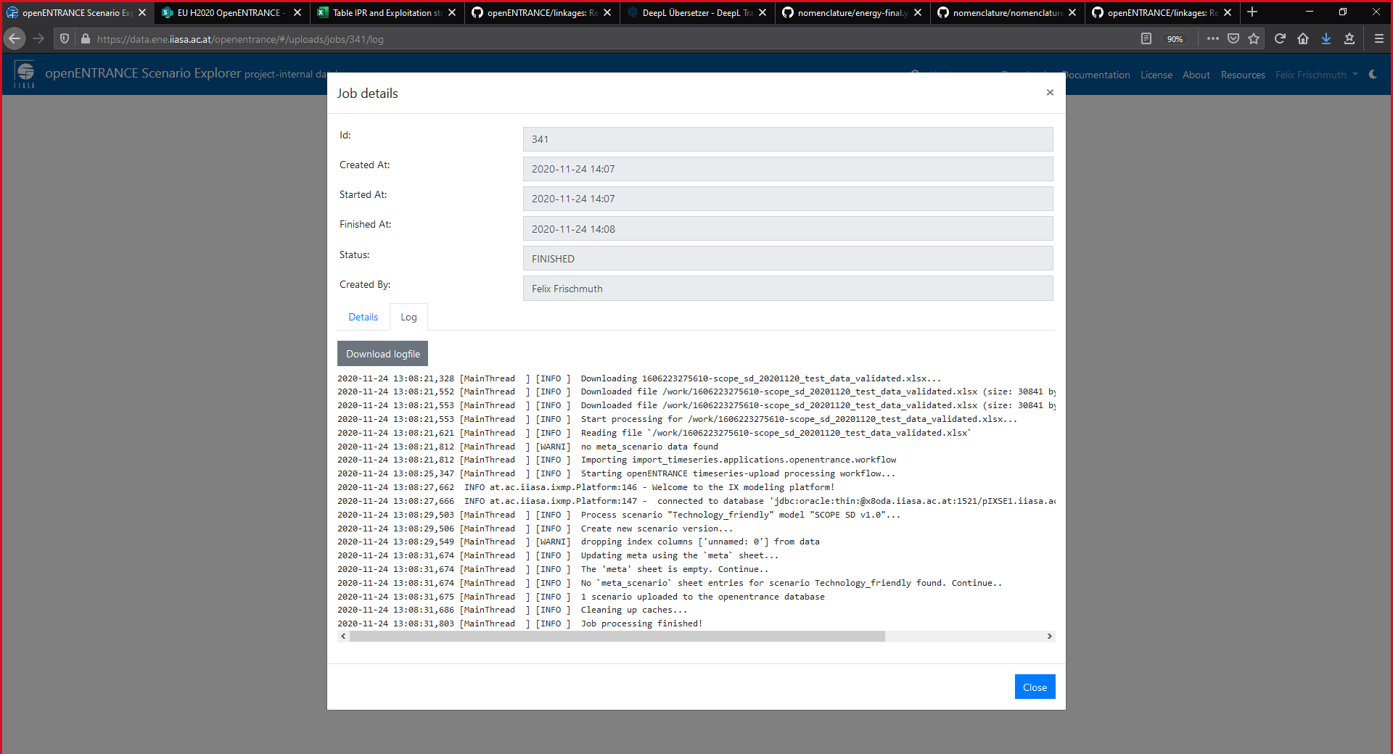

Figure 1: Screenshot of the log file when uploading results to the openENTRANCE scenario explorer