**Linkage of openTEPES to the openENTRANCE Platform (19.11.2020)**

Still missing: unit conversion that’s in line with nomenclature

Code and data available at: <https://pascua.iit.comillas.edu/aramos/openTEPES/index.html>



Showing screenshots of the successful linkages of openTEPES:

1. **Load data from GENeSYS-MOD from IIASA scenario explorer:**

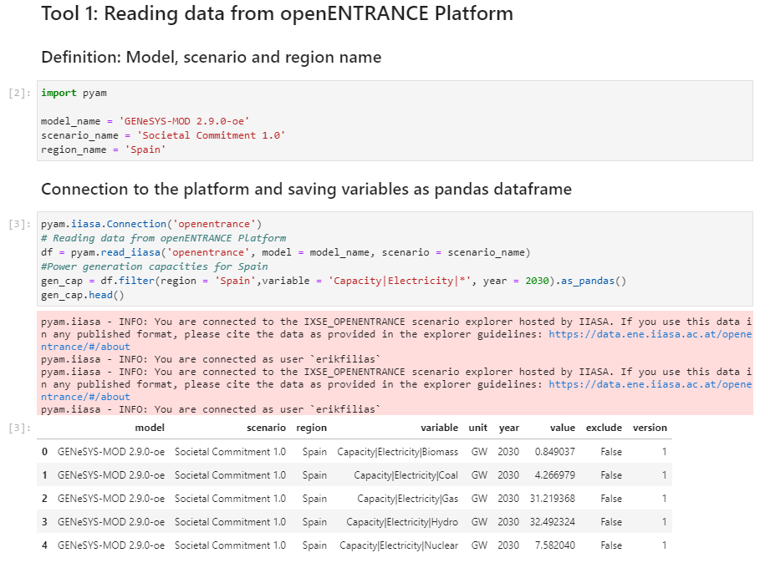

1. **Own data (from Case Study 3 database) can also be downloaded to the program:**

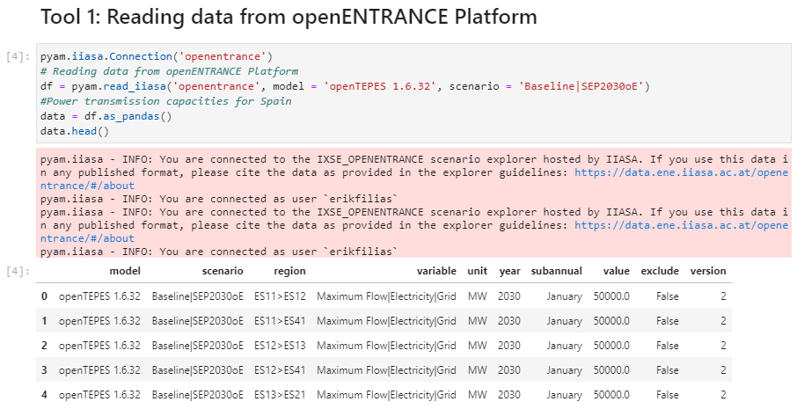

1. **Data transformation to openTEPES format:**

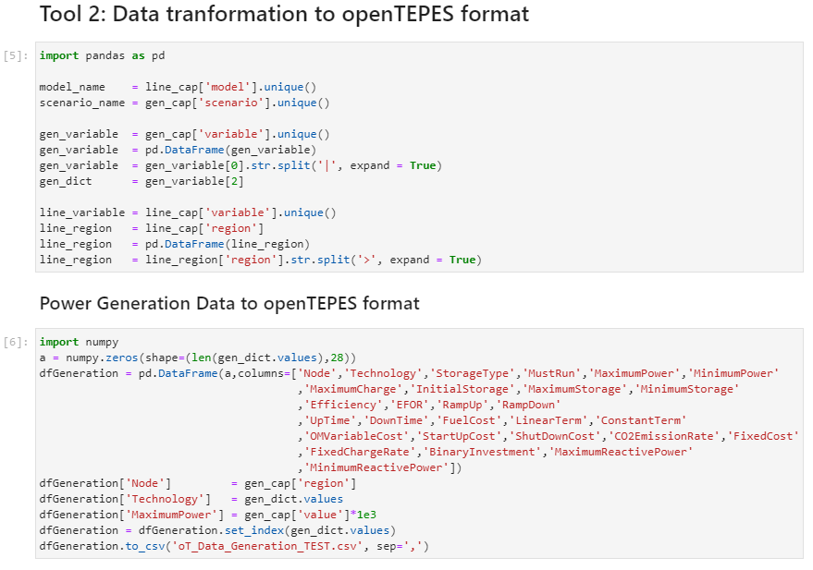

* Write to excel power generation data

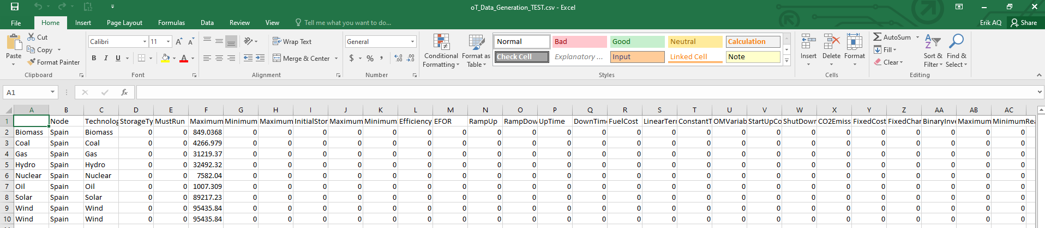

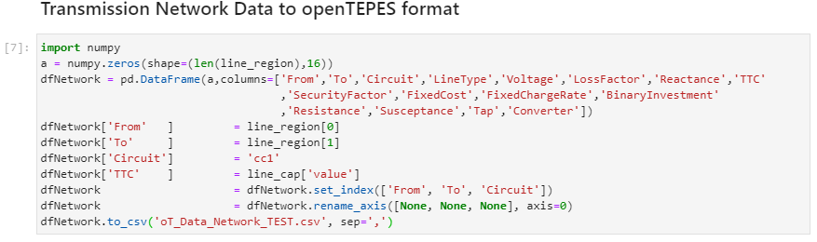

* Write to excel transmission network data

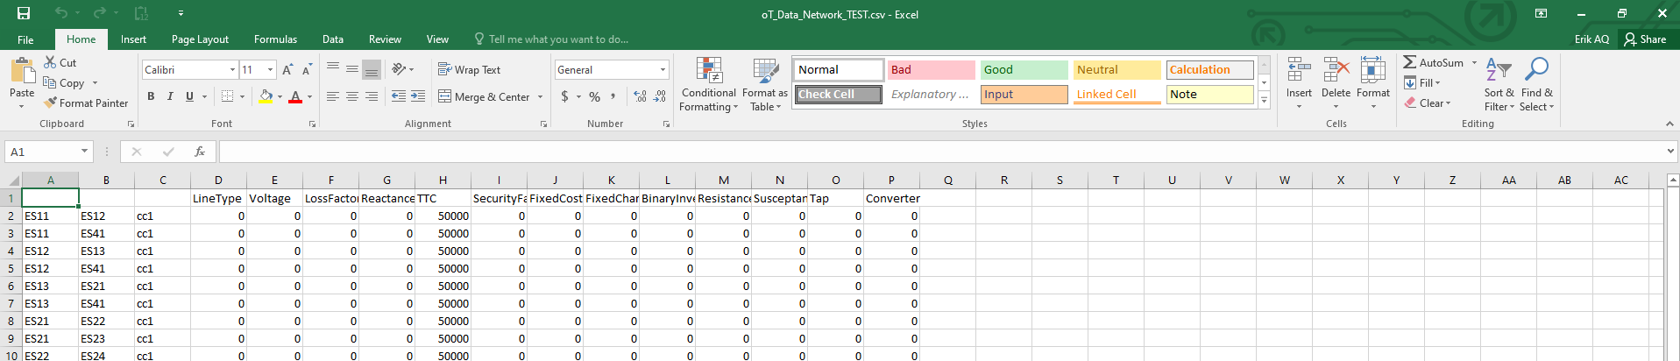

1. **Writing output to IAMC format:**

Use a function to create a *pandas.DataFrame* with the same structure as *pyam.IamDataFrame*

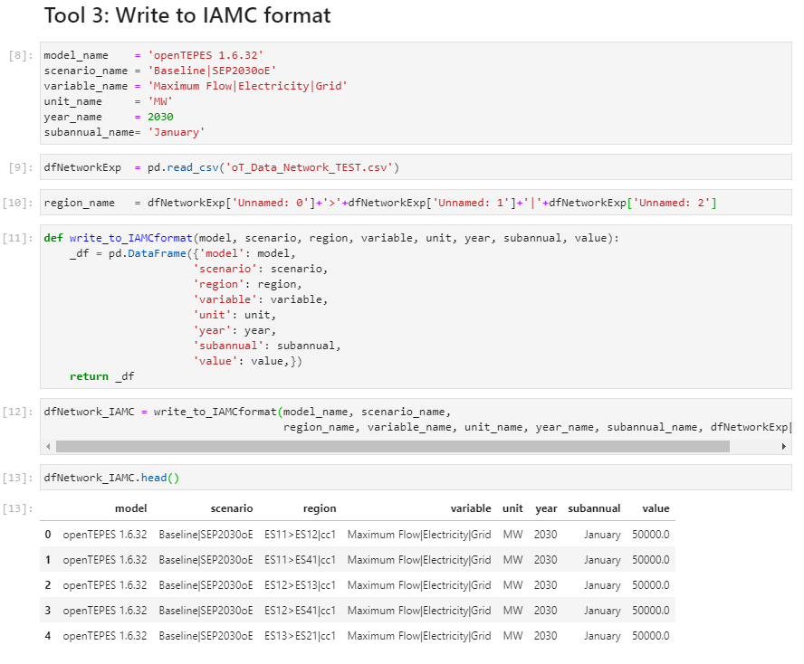

1. **Validating the input files:**

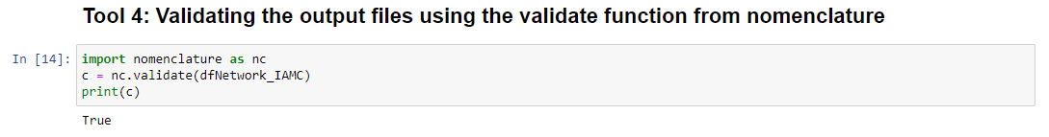

* + Upload to the scenario explorer:

