NEC IR Transceiver

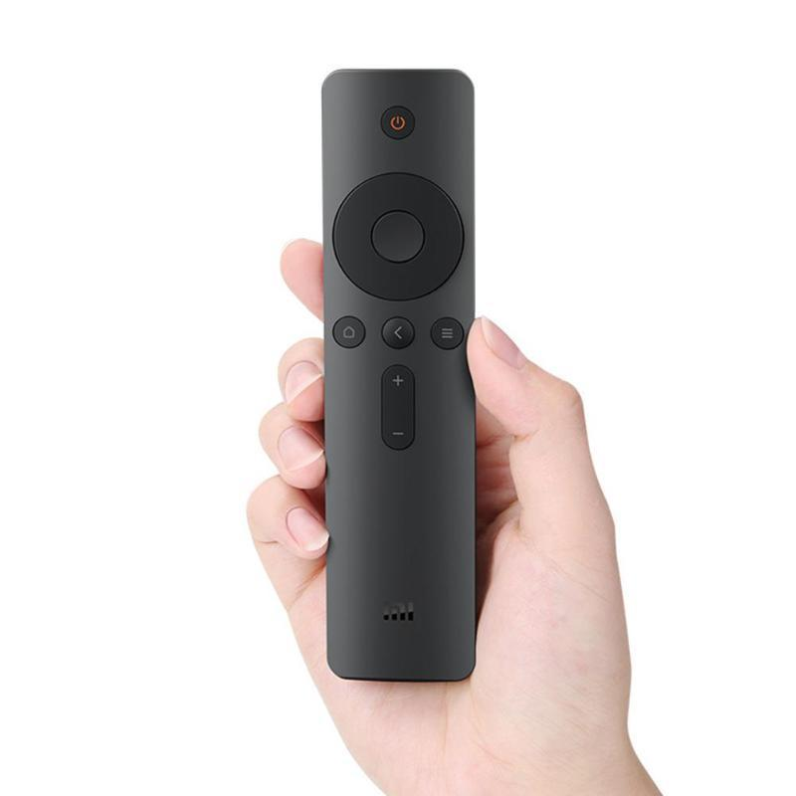

Content

**Geen inhoudsopgavegegevens gevonden.**

# Introduction

Infrared communication is frequently used for televisions and other appliances that require a remote controller. This projects contains a transceiver with an independent transmitter and receiver. Which are able to work separately and even without one of the two drivers. The protocol used is NEC from Sony. This protocol is widely implemented and makes this driver versatile.

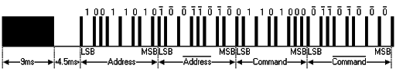

In the picture above there is one of the two NEC variants. This one uses an 8 bit address which is sent inverted as well. In this driver the extended NEC variant is used, which uses a 16 bit address bus for more devices to address. The advantage of the extended variant is that a normal 8 bit address can be represented by just inverting the lower byte.

Before the data is sent, a high burst (9ms) and a low signal (4.5ms) is transmitted. To indicate a beginning of a data packet. Then the address is sent (2x8 bit or 16 bit). Then the command is sent the same like the 8 bit address, with an inverted byte after the original command, to insure that the data is not corrupted. After that one end pulse is sent.

# Transmitter

## Design

The design is made with a Mealy controller and a specific data path. The Data formatter makes a packet to send directly, by concatenating the address with the data and the inverted data. This data is captured in a register after the controller received an available sign. Then the mod32 counter selects which bit is read from the register and that is modulated thru the modulator.

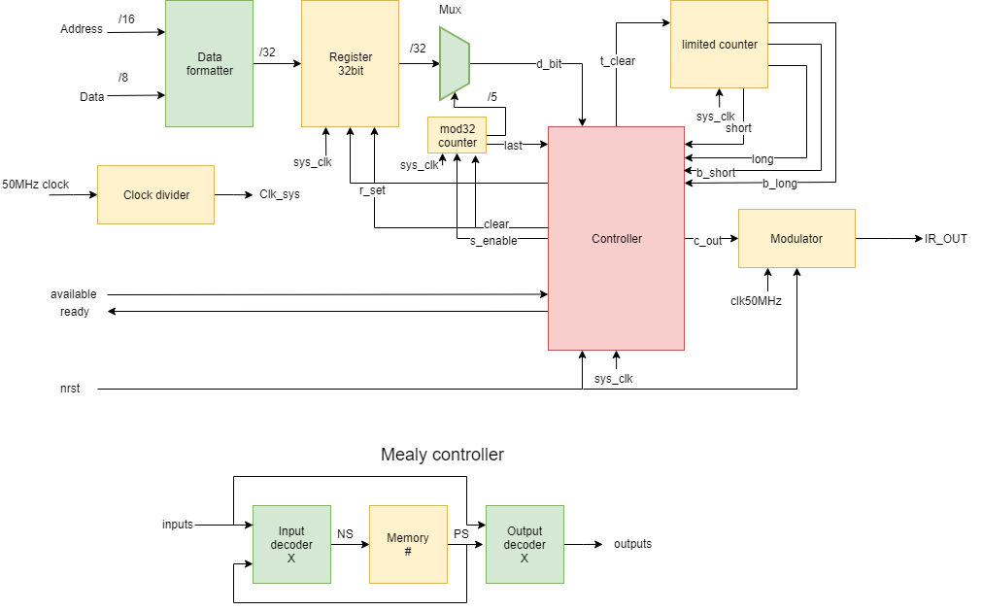

The characters t, s and r are used for:

T = Timer

R = Register

S = Selection

According to this design, there is a matching ASM chart.

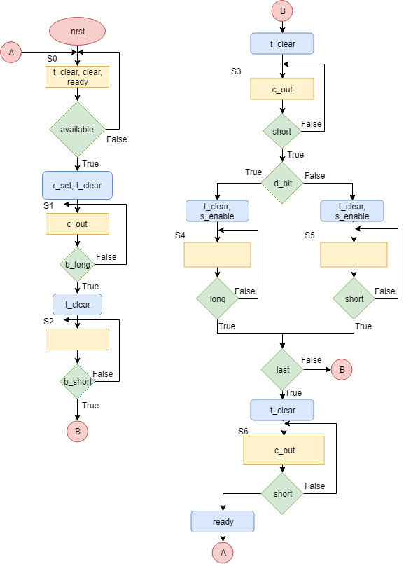

## Simulation

# Receiver