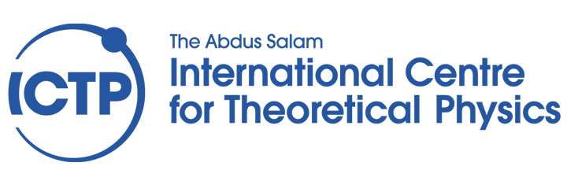

**Postgraduate Diploma in**

**Condensed Matter and Statistical Physics**

**Towards Accurate DeepMD Potentials**

**for Aqueous Interfaces**

**Diploma Thesis**

**CHRISTIAN LOER T. LLEMIT**

**Supervisors**

**ALI HASSANALI**

**CESARE MALOSSO**

**EDWARD DONKOR**

**AUGUST 2024**