ANALYSIS OF A PHYSICS CITATION GRAPH.

This project analyzes how scientific papers get cited and whether their is a predetermined relation between citations or if the relation is completely random.

Part 1:
Provided is a citation graph (CITATION_URL = "http://storage.googleapis.com/codeskulptor-alg/alg_phys-cite.txt"). The provided citation graph is a graph for 27,770 high energy physics theory papers. The graph has 352,768 edges. To analyze the graph, we shall compute the in-degree distribution and normalize the distribution(make the values in the dictionary sum to one). Afterwards, we shall compute the log/log plot of the points in this normalized distribution; this can be done using the matplotlib library (nodes with in-degree zero can be ignored when computing since log(0)=−∞).

Part 2:
Consider the algorithm ER(Erdos-Renyi) for generating random graphs:
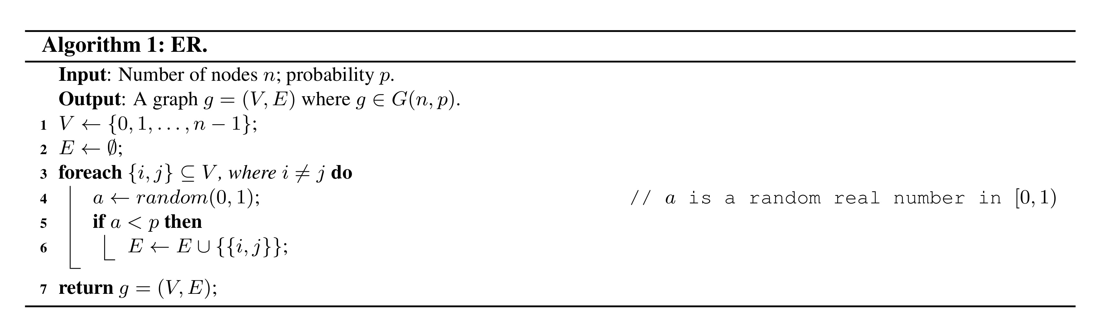
Modify the algorithm to generate random directed graphs: For every ordered pair of distinct nodes (i,j), the modified algorithm adds the directed edge from i to j with probability p.
Consider the shape of the in-degree distribution for an entire ER graph and compare its shape to that of the physics citation graph. To determine the shape, we shall compute several examples of in-degree distributions. Once this shape has been determined, we shall compare this shape to the in-degree distribution for the citation graph. With that, we can answer some of the following points:
- Is the expected value of the in-degree the same for every node in an ER graph? Explain.
- What does the in-degree distribution for an ER graph look like? Describe briefly.
- Does the shape of the in-degree distribution plot for ER look similar to the shape of the in-degree distribution for the citation graph? Provide a short explanation of the similarities or differences.

