電通二乙微處理器實驗 實驗結報

實驗名稱 | 跑馬燈
組別 | 23 | 組員 | 04050715李政憲/ 04050653 簡鋐菖

- 實驗目的
Arduino UNO D1 – D8 分別接到 LED，實作跑馬燈展 示。

- 實驗步驟

- LED 向左及向右執行花色展示

2. 執行自定花色展示: 所有LED亮滅兩次 -> 左移八次 -> 所有LED亮滅兩次 -> 右移八次

3. Arduino 接上一個開關 2. 開關 OFF -> LED 向左及向右執行花色展示 3. 開關 ON -> 執行自定花色展示 * 注意事項: 需完成防彈跳程式碼

注意事項:
* Arduino 燒錄程式時, 會用到 D0 (RX) 及 D1 (TX) 腳位. 請儘量避免使用 D0 及 D1. * 燒錄時, D0 及 D1 不得接電路

程式碼
作業一:
// Pin 13 has an LED connected on most Arduino boards.
// give it a name:
int led[8] = {2,3,4,5,6,7,8,9};
int i,num;
// the setup routine runs once when you press reset:
void setup() {
// initialize the digital pin as an output.
for (i=0;i<8;i++)
{
pinMode(led[i], OUTPUT);
}
}

// the loop routine runs over and over again forever:
void loop() {

for (num=0;num<1;num++){ //左移1次
for (i=7;i>=0;i--){
digitalWrite(led[i], HIGH); // turn the LED on (HIGH is the voltage level)
delay(100); // wait for a second
digitalWrite(led[i], LOW); // turn the LED off by making the voltage LOW
delay(100); // wait for a second
}
}

for (num=0;num<1;num++){ //右移1次
for (i=0;i<8;i++){
digitalWrite(led[i], HIGH); // turn the LED on (HIGH is the voltage level)
delay(100); // wait for a second
digitalWrite(led[i], LOW); // turn the LED off by making the voltage LOW
delay(100); // wait for a second
}
}
}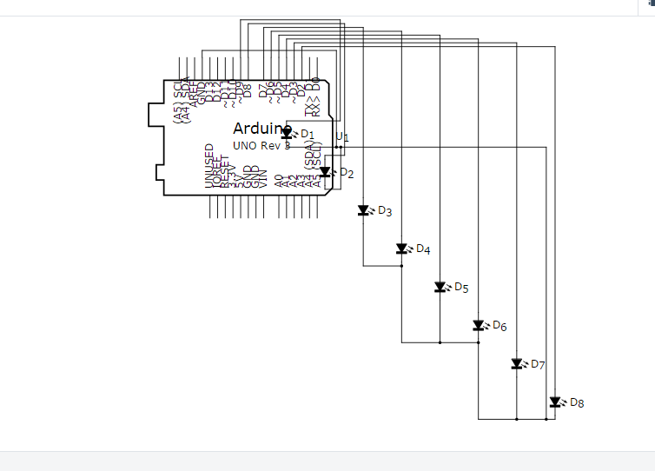

作業二:
// Pin 13 has an LED connected on most Arduino boards.
// give it a name:
int led[8] = {2,3,4,5,6,7,8,9};
int i,num;
// the setup routine runs once when you press reset:
void setup() {
// initialize the digital pin as an output.
for (i=0;i<8;i++)
{
pinMode(led[i], OUTPUT);
}
}

// the loop routine runs over and over again forever:
void loop() {
for (num=0;num<2;num++){ //全亮滅2次
for (i=7;i>=0;i--){
digitalWrite(led[i], HIGH); // turn the LED on (HIGH is the voltage level
}
delay(1000);
for (i=7;i>=0;i--){
digitalWrite(led[i], LOW); // turn the LED on (HIGH is the voltage level
}
delay(1000);
}
for (num=0;num<1;num++){ //左移1次
for (i=7;i>=0;i--){
digitalWrite(led[i], HIGH); // turn the LED on (HIGH is the voltage level)
delay(100); // wait for a second
digitalWrite(led[i], LOW); // turn the LED off by making the voltage LOW
delay(100); // wait for a second
}
}
for (num=0;num<2;num++){ //亮滅2次
for (i=7;i>=0;i--){
digitalWrite(led[i], HIGH); // turn the LED on (HIGH is the voltage level
}
delay(1000);
for (i=7;i>=0;i--){
digitalWrite(led[i], LOW); // turn the LED on (HIGH is the voltage level
}
delay(1000);
}
for (num=0;num<1;num++){ //右移1次
for (i=0;i<8;i++){
digitalWrite(led[i], HIGH); // turn the LED on (HIGH is the voltage level)
delay(100); // wait for a second
digitalWrite(led[i], LOW); // turn the LED off by making the voltage LOW
delay(100); // wait for a second
}
}
}

作業三:
// Pin 13 has an LED connected on most Arduino boards.
// give it a name:
int led[8] = {2,3,4,5,6,7,8,9};
int i,num;
// the setup routine runs once when you press reset:
void setup() {
// initialize the digital pin as an output.
for (i=0;i<8;i++)
{
pinMode(led[i], OUTPUT);
}
pinMode(13,INPUT);
Serial.begin(9600);
for (i=0;i<8;i++)
{
digitalWrite(led[i], LOW);
}
}

// the loop routine runs over and over again forever:
void loop() {

if(digitalRead(13)==0)
{
for (num=0;num<2;num++){ //全亮滅2次
for (i=7;i>=0;i--){
digitalWrite(led[i], HIGH); // turn the LED on (HIGH is the voltage level
}
delay(1000);
for (i=7;i>=0;i--){
digitalWrite(led[i], LOW); // turn the LED on (HIGH is the voltage level
}
delay(1000);
}
for (num=0;num<1;num++){ //左移1次
for (i=7;i>=0;i--){
digitalWrite(led[i], HIGH); // turn the LED on (HIGH is the voltage level)
delay(100); // wait for a second
digitalWrite(led[i], LOW); // turn the LED off by making the voltage LOW
delay(100); // wait for a second
}
}
for (num=0;num<2;num++){ //亮滅2次
for (i=7;i>=0;i--){
digitalWrite(led[i], HIGH); // turn the LED on (HIGH is the voltage level
}
delay(1000);
for (i=7;i>=0;i--){
digitalWrite(led[i], LOW); // turn the LED on (HIGH is the voltage level
}
delay(1000);
}
for (num=0;num<1;num++){ //右移1次
for (i=0;i<8;i++){
digitalWrite(led[i], HIGH); // turn the LED on (HIGH is the voltage level)
delay(100); // wait for a second
digitalWrite(led[i], LOW); // turn the LED off by making the voltage LOW
delay(100); // wait for a second
}
}

for (i=0;i<=7;i++){
if(digitalRead(13)==1)
{
break;
}
else
{
digitalWrite(led[i], HIGH); // turn the LED on (HIGH is the voltage level)
delay(100); // wait for a second
digitalWrite(led[i], LOW); // turn the LED off by making the voltage LOW
delay(100);
// wait for a second
}
}
/* for (num=0;num<2;num++){ //亮滅2次
for (i=7;i>=0;i--){
digitalWrite(led[i], HIGH); // turn the LED on (HIGH is the voltage level
}
delay(1000);
for (i=7;i>=0;i--){
digitalWrite(led[i], LOW); // turn the LED on (HIGH is the voltage level
}
delay(1000);
}*/

for (i=7;i>=0;i--){
if(digitalRead(13)==1)
{
break;
}
else
{
digitalWrite(led[i], HIGH); // turn the LED on (HIGH is the voltage level)
delay(100); // wait for a second
digitalWrite(led[i], LOW); // turn the LED off by making the voltage LOW
delay(100); // wait for a second
}
}

}
else
{
for (num=0;num<1;num++){ //左移1次
for (i=7;i>=0;i--){
digitalWrite(led[i], HIGH); // turn the LED on (HIGH is the voltage level)
delay(100); // wait for a second
digitalWrite(led[i], LOW); // turn the LED off by making the voltage LOW
delay(100); } // wait for a second
}
for (num=0;num<1;num++){ //右移1次
for (i=0;i<8;i++){
digitalWrite(led[i], HIGH); // turn the LED on (HIGH is the voltage level)
delay(100); // wait for a second
digitalWrite(led[i], LOW); // turn the LED off by making the voltage LOW
delay(100); // wait for a second
}
}
}
}

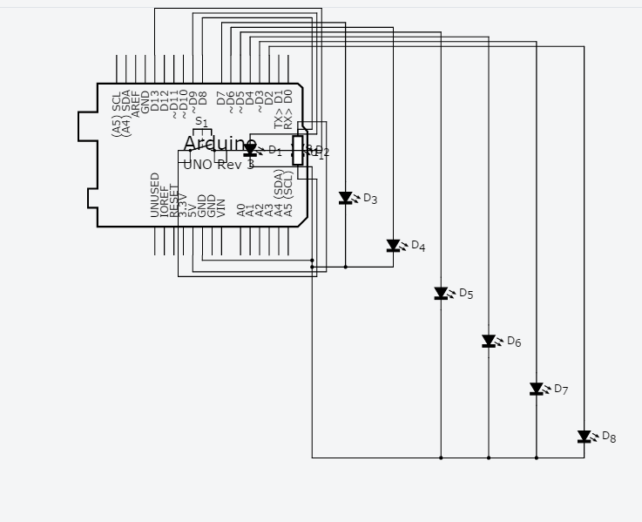
- 實驗結果及分析
實驗一製作簡單的跑馬燈 左移一次、右移一次
實驗二製作為複雜的跑馬燈 閃暗閃暗 右移一次 閃暗閃暗 左移兩次 右移一次
實驗三把實驗一和實驗二作結合 當按下按鈕顯示實驗一，放開則是顯示實驗二

- 心得討論
我們這次做的實驗由簡單轉為複雜，從一開始簡單的指令到後來複雜且困難的程式，並且做按鈕上的結合。
一開始的我們可以說是輕輕鬆鬆，可是當碰上按扭結合這個困難的問題
。我們可以說是絞盡腦汁、費盡心力，索性就在我們想破頭的時候，突然的靈光一閃，有一個新的想法，我們嘗試之後終於成功的把實驗一和實驗二成功的用鈕扣結合。 這次的實驗讓我們非常的有成就感。
修正電路圖

在程式碼裡有電路圖
- 修正程式碼

