1. High-level Architecture Diagram

It is the first time that we use block design to integrate packaged IPs. The basic block diagram and design diagram are shown as following.

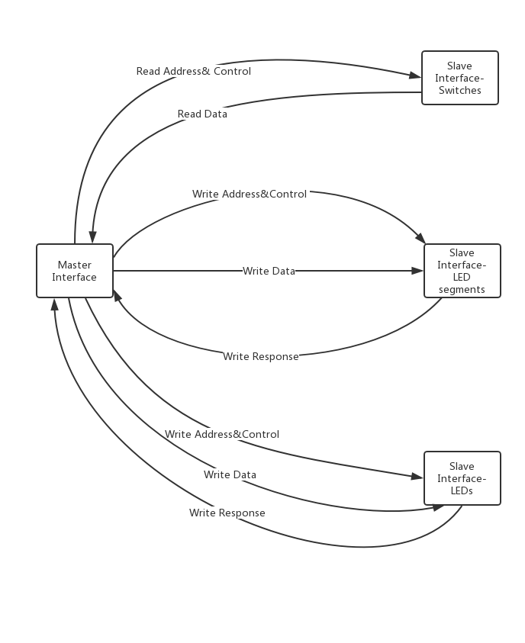

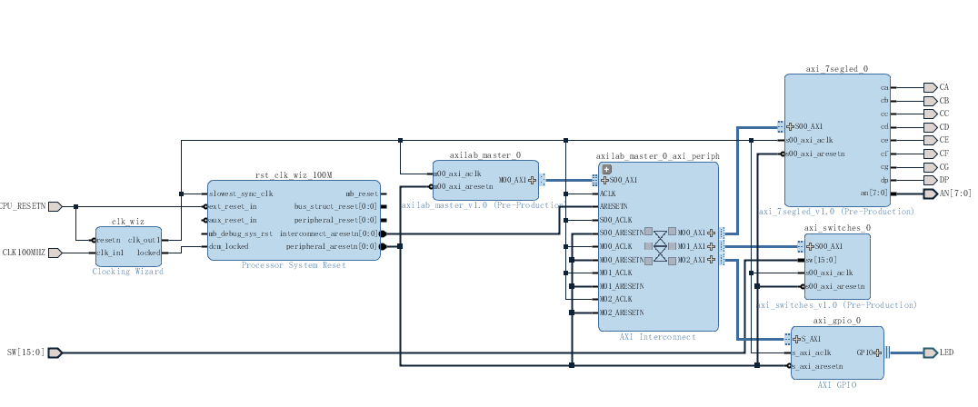

1. Description of Blocks

2.1 AXI Bus Master block

At first, I revised the master top module template **axilab_master_v1_0**, adding three generic parameters of slavers’ base addresses and commenting out three unused ports. Then I changed the generic parameters in the given **axilab_master_v1_0_M00_AXI**, to make them equal to those in top module **axilab_master_v1_0**. All of these revisions are shown in following pictures.

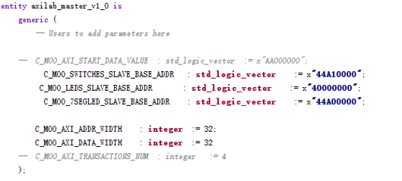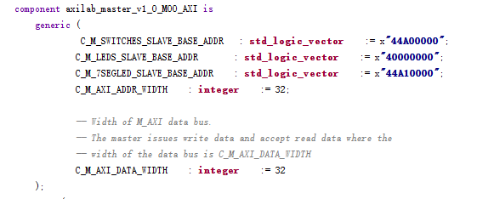

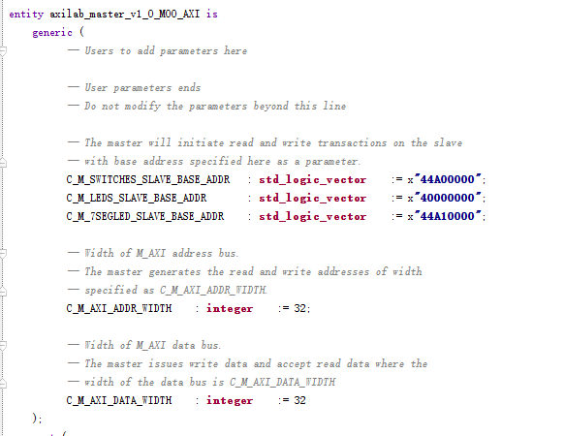

* 1. AXI Bus Switches Slave Block

In this block, we should put data input by switches into AXI bus. This read process requires assigning input data to axi_rdata, when slv_reg_rden is 1. I added two parts of new codes in given skeleton slave module. The first one is **debounce** part:

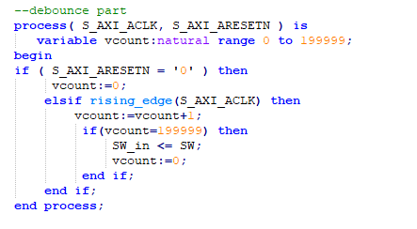

The second one is **read data** part.

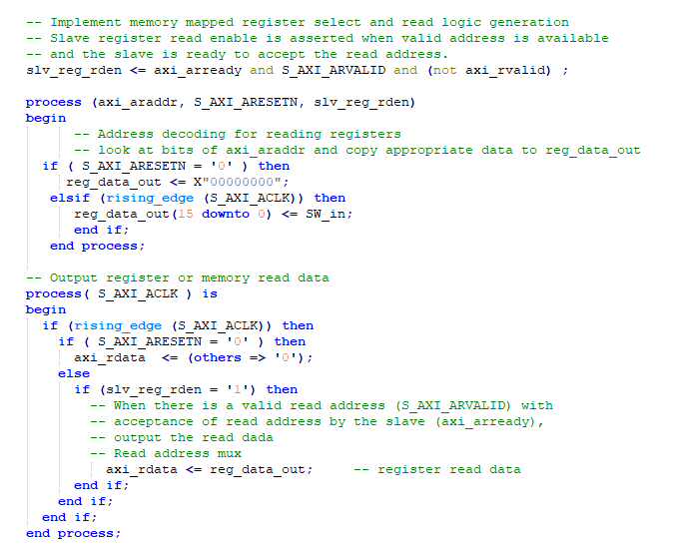

* 1. AXI Bus 7segled Slave Block

In this block, we should assign S_AXI_WDATA from AXI bus to reg_data_in and then write data to output LED segments. I added two parts of new codes in given skeleton slave module. The first one is 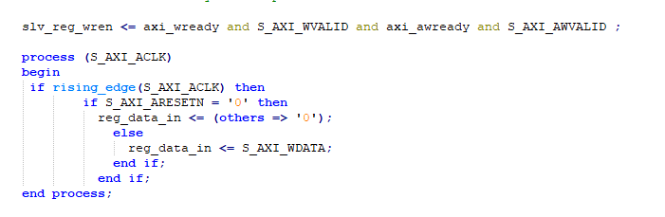

The second one is **data-to-LED** **segments transfer**

