Alfresco Tutorial
In this tutorial we will take you through the process of starting to work with Alfresco, right from the point after it is installed and running.

Logging in for the first time
When Alfresco is installed, it creates an administration user called ‘admin’ with a default password of ‘alfresco’. So, let’s login and we’ll be taken to the Company Home Space (whose location is configurable) as shown in the screen below.

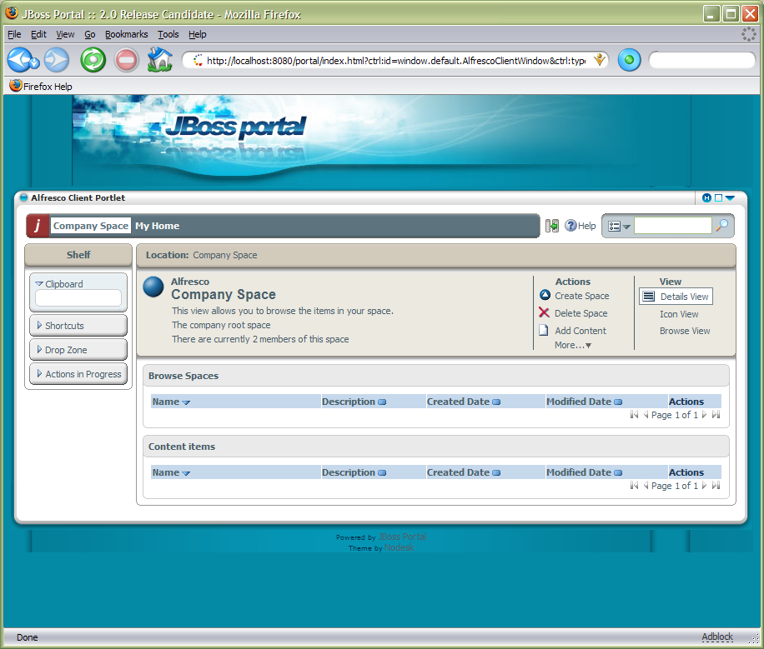

First, a bit of orientation. There are 3 main areas in the Alfresco user interface: a toolbar along the top; the Shelf; and the main working area.

Toolbar
The toolbar contains two main navigation buttons that take you to the Company Space or your Home Space, as well as search and help capabilities.

Shelf
The Shelf contains a number of different features to help working with content, such as the Clipboard.
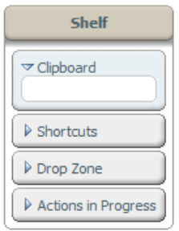

Working Area
The working area will change depending on what information we are looking at or what task we are performing. The top of the working area will always have a navigation breadcrumb that allows us to jump to any part of the breadcrumb path. For information views we will usually have a summary area along with actions or alternative views. These will change depending on what we are looking at and doing, as well as who we are.

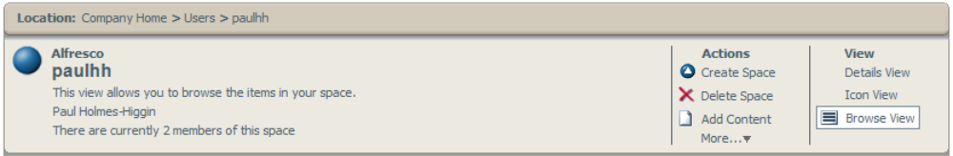

Adding New Users
Before we add some new users and define their own personal working spaces, we need to decide how we are going to organise our repository and where user home spaces live. For this tutorial we are going to put the user homes all in the same location, so we need to create a space to contain them all. We are going to create a space named ‘Users’ in the ‘Company Space’, so since we are in the right place, we just need to select ‘Create Space’ from ‘Actions’ and we will be taken to the Create Space dialog, as below.

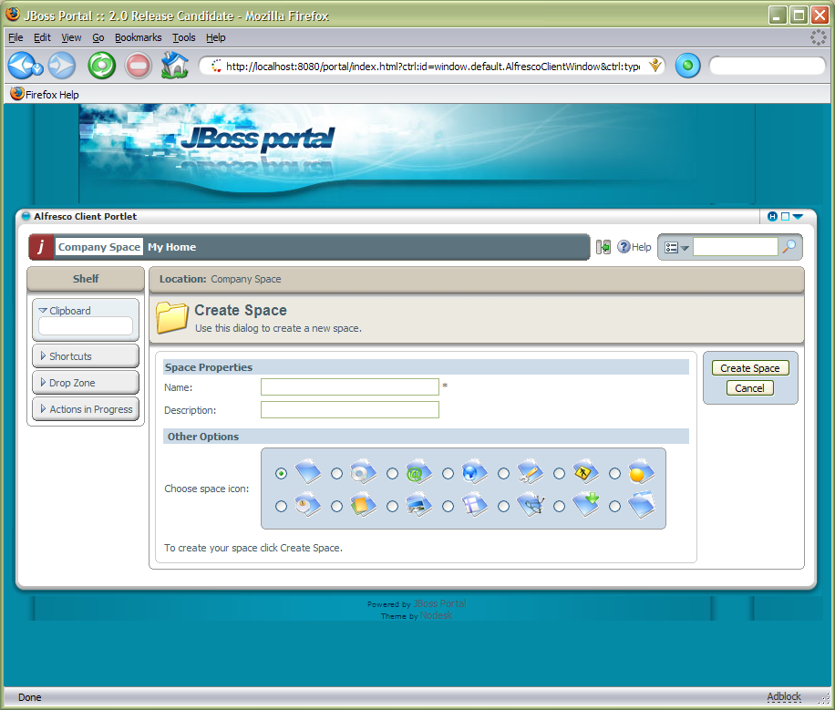

Now fill in ‘Users’ for the Name with any descriptive text in Description, and choose an icon to use for the space, then click ‘Create Space’. We have now created a space.

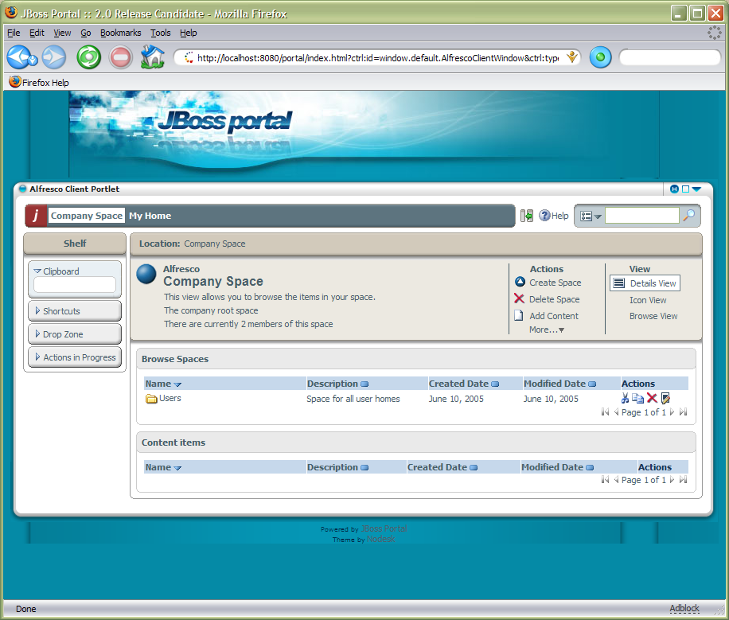

While we are here, create another space named ‘Projects’ that we will come back to later. Next we want to add a new user. As we are logged in as an administrator, there is an action under the Actions ‘More…’ link called ‘Manage Users’ that we need to use.

[Manage User screens]

Creating Content
We can now login as the newly created user. This time, the user is taken to their Home Space, but they can still easily navigate to the Company Space and elsewhere. All the options to create sub-spaces and add content are available. The first thing we are going to do is see how can create web content directly in the browser. From the ‘Action’ menu, select ‘Create Content’ (it may be available from the More popup). A wizard is started that allows you to create new content.

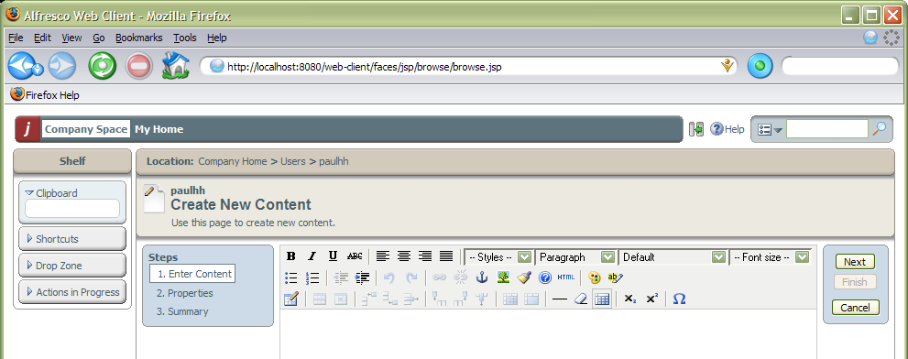

We can now add some HTML content through the WYSIWYG editor. We will add a web page as an example, including text formatting and images.

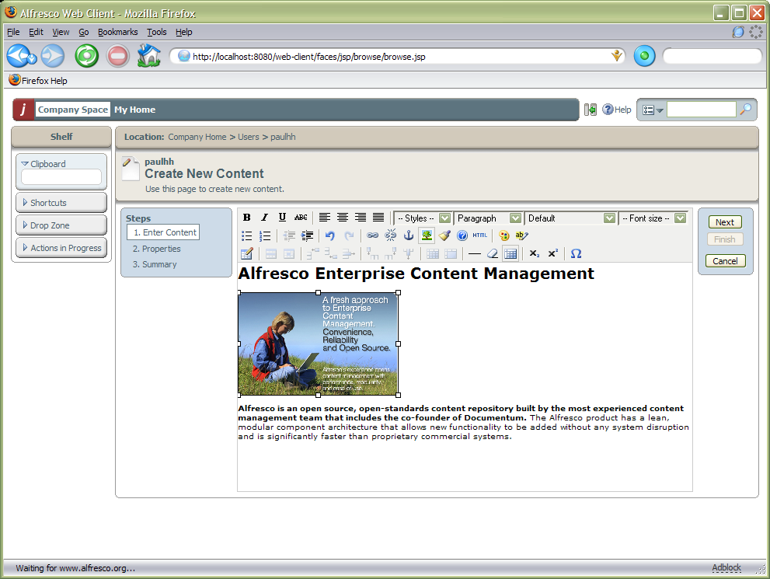

Selecting the ‘Next’ button in the wizard takes us to a step where we can give whatever appropriate properties we want.

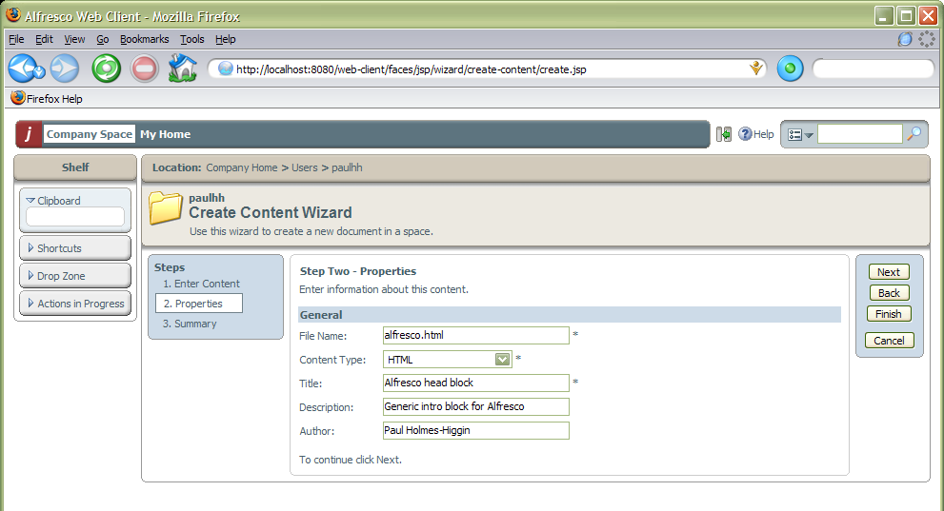

We can now either select ‘Next’ to take us to a summary page of what new content is going to be created, or just select ‘Finish’ now. In all Alfresco wizards, the ‘Finish’ button becomes enabled when there is enough information to complete the task, any additional steps are optional.

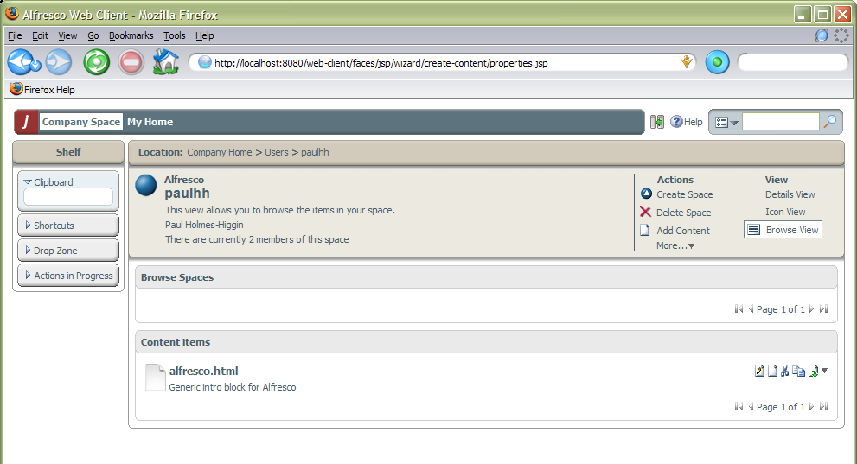

We have now created our first piece of content in the repository! To see the details of the content you can select its name (or the ‘Content Details’ action from the popup menu to the right of the content item.

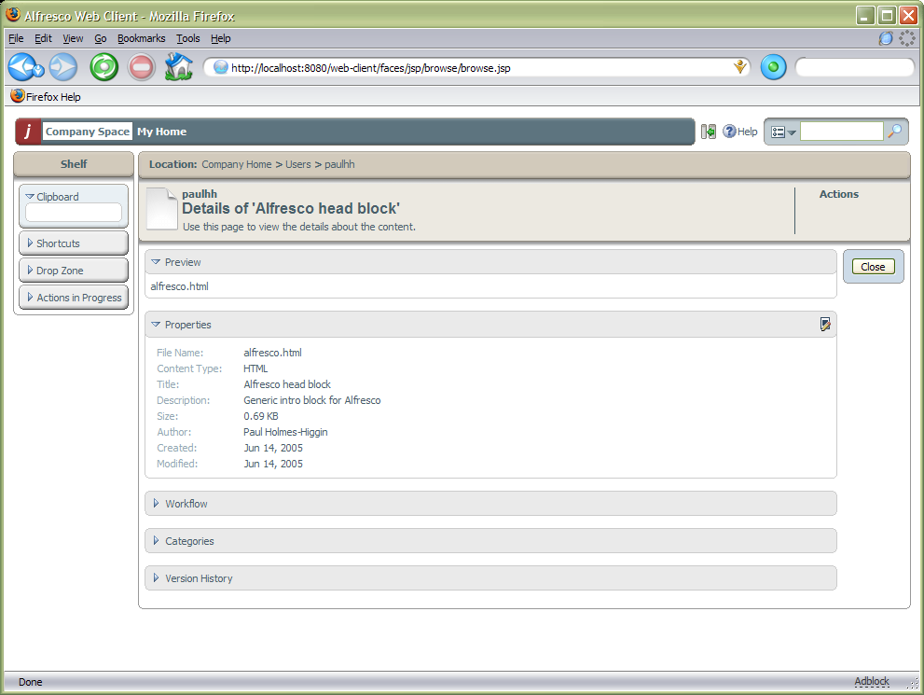

From the content details page, we can change any of the properties by selecting the edit icon for the Properties panel. Selecting the content name in the Preview panel will request the content to be downloaded as a file through the browser. We may also download the content as a file by selecting the content icon rather than the content name in the space browser.

Next, we are going to set up a new project space where we can work with other team members on some content. If we navigate to the Company Space (either from the breadcrumb or the toolbar) and then into the Projects space we created earlier. This time, rather that create sub-spaces all by hand, we are going to use a template space that contains all the standard elements we need. From the space Actions, select ‘Advanced Space Wizard’.

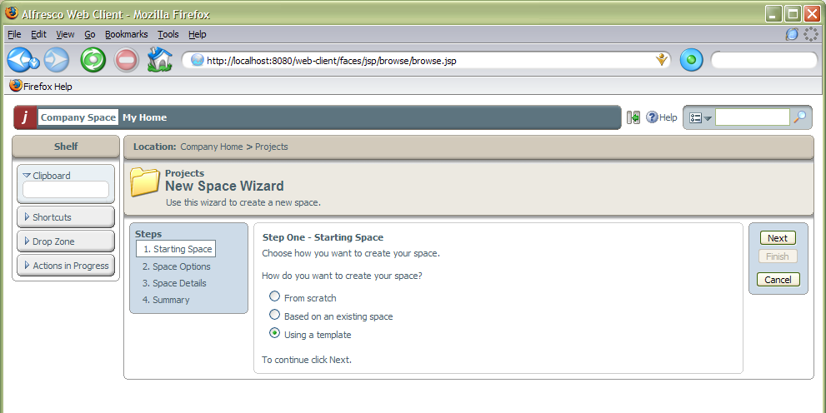

It is possible to create a complete tree of sub-spaces by basing the new space on an existing space or a template. We are going to use a template, so selecting ‘Next’ takes us to a step where we can choose which template and whether we want any template content to be copied as well as any sub-spaces.

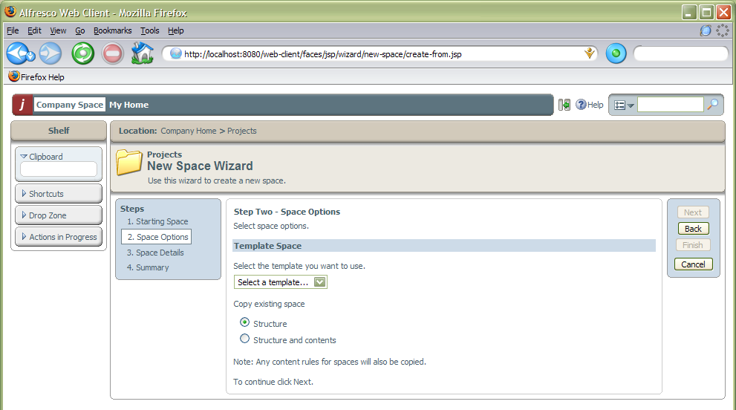

We are going to use the ‘Software Engineering Project’ template, so we choose this and select ‘Next’ to specify the details we want for the new space including its name – in this case ‘Project Voodoo’.

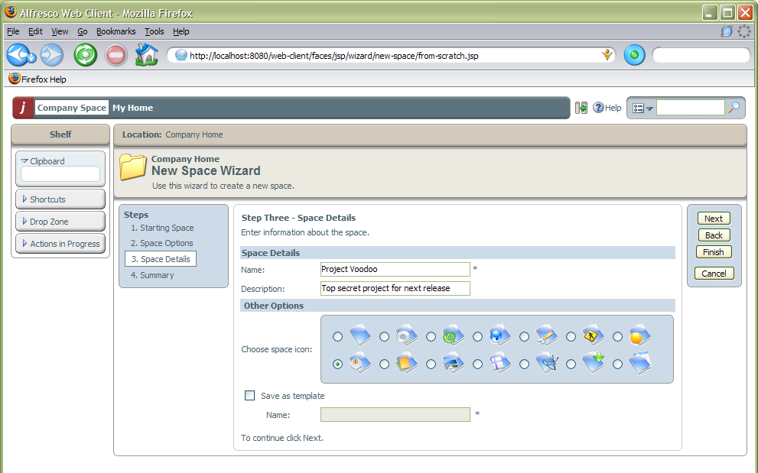

Again, we can select ‘Next’ to go to the summary page or select ‘Finish’ now. We can see that a new space has been created with standard sub-spaces for an engineering project.

[Screen with project space and sub-spaces]

Collaborative Spaces [TBD]
Now that we have created our project workspace, we would like to let other members of the team work there as well. To do this we need to invite them into the project space. Go into the Project Voodoo space and select the ‘Invite Users’ action. If there were any users already invited into the space, then we would see them listed next and be able to change any of their details or remove them.

[Invite People – list – screen]

In this case there are no invited users, so we are going to invite one now by selecting the ‘Add Person’ action. We can then fill in the details of the person we wish to invite and the role they will play in the space.

[Invite Person screen]

Smart Spaces
One of the key features of Alfresco is the ability to define rules

Uploading Content
We have a rough software requirement document that we are going to put in the project space so that other users can collaborate on developing the requirements. So, the first step is to get the current outline document uploaded into the project space. Navigate into the XXX space and then select the ‘Add Content’ action. A wizard to add the document takes us through the steps involved.

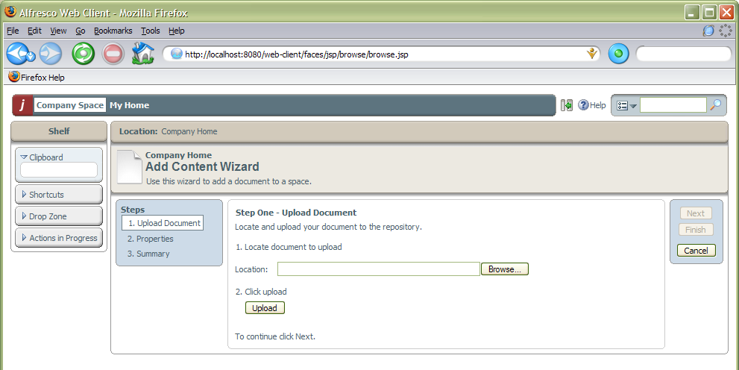

Select the ‘Browse’ button to locate the document to be uploaded, then select ‘Upload’.

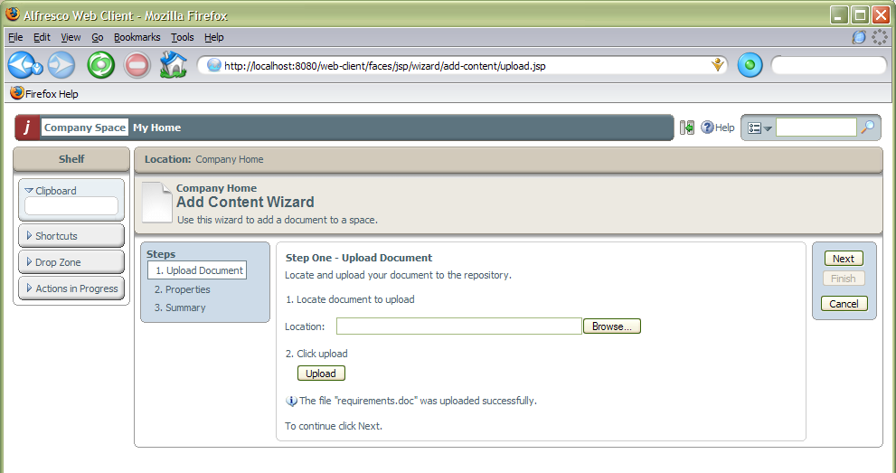

Once the document has been uploaded it is possible to go to the next step in the wizard, which has the same options as we completed for creating the content within the browser earlier.

