Robert Thompson

2/23/2025

IT 230

SNHU

Final Project Part II

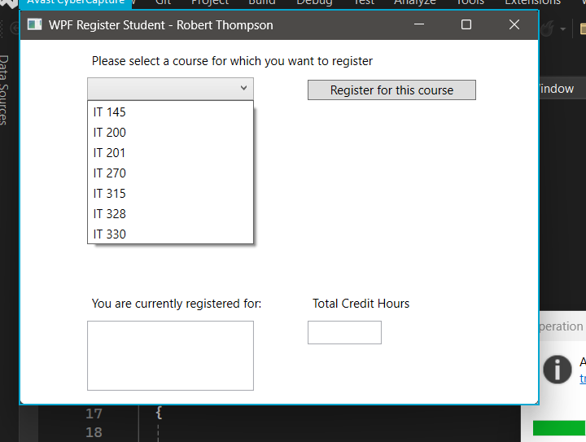

Combo box displays choices and label prompts user to select course.

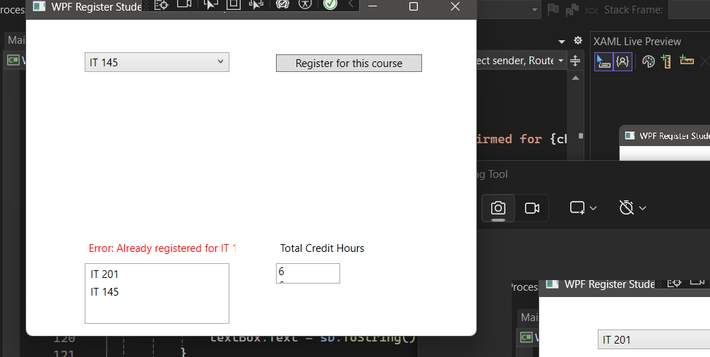

ListBox adds selected courses to list

Error message shown on label if class already registered

Amount of credits displayed in text box

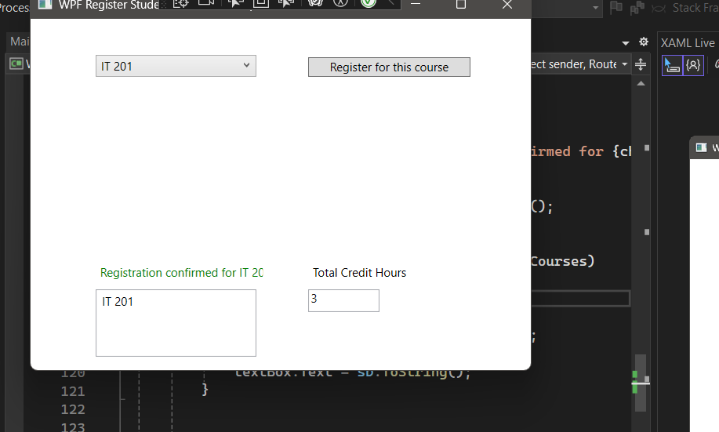

Confirmation label if succesfully registered

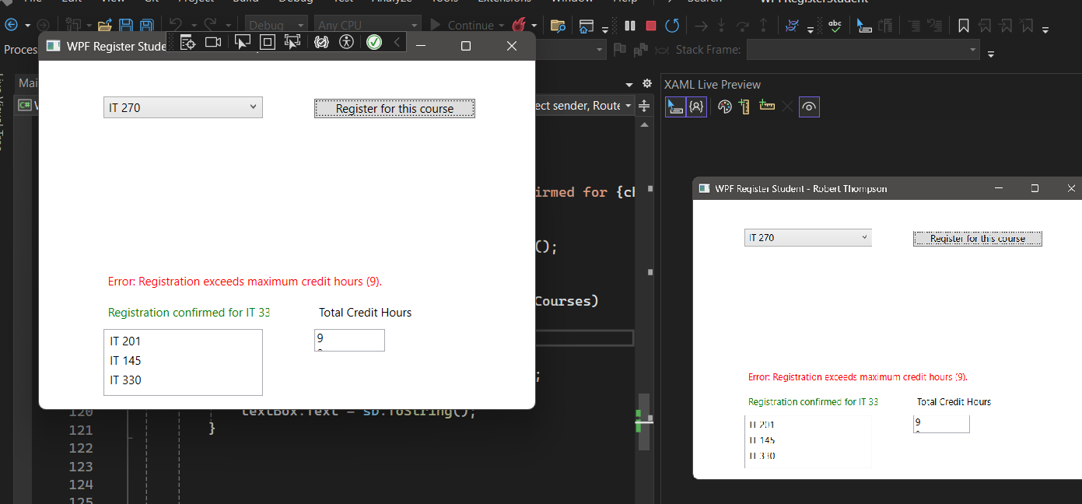Error message label if amount of credits exceeded