LAB02

Q1

data segment
n1 db 12H
n2 db ?
data ends
code segment
assume cs:code, ds:data
MOV AX, data
MOV ds, AX
LEA SI, n1
MOV BX, [SI]
INT 03
code ends
End
data segment
n1 db 12H
n2 db ?
n3 db ?
m1 dw 1273H
m2 dw ?
o1 dd 12341234H
o2 dd ?
data ends
code segment
assume cs:code, ds:data
MOV AX, data
MOV ds, AX
LEA SI, n1
MOV BL, [SI]
MOV n2, BL
MOV BL, ds:[0001h]
MOV n3, BL
MOV AX, m1
MOV m2, AX
MOV BX, word ptr o1
MOV word ptr o2, BX
MOV BX, word ptr 2[o1]
MOV word ptr 2[o2], BX
INT 03
code ends
end

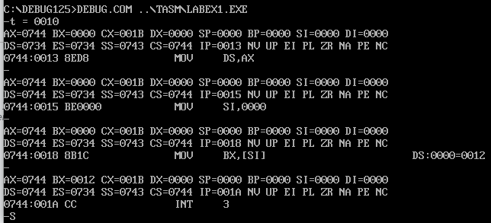

Q2
data segment
n1 dw 1225H
n2 dw 3212H
n3 dw ?
data ends
code segment
assume cs:code, ds:data
MOV AX, data
MOV ds, AX

MOV AX, n1
ADD AX, n2
MOV n3, AX
INT 03
code ends
end

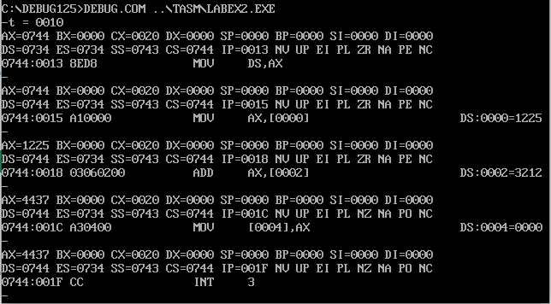
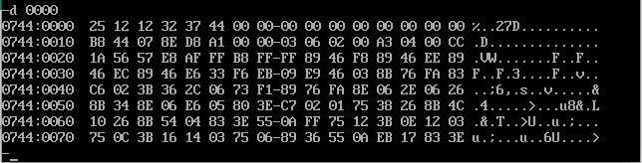

Q3
data segment
n1 dd 11111111H
n2 dd 22222222H
ans dd ?
data ends
code segment
assume cs:code, ds:data
MOV AX, data
MOV ds, AX
MOV AX, word ptr n1
ADD AX, word ptr n2
MOV BX, word ptr 2[n1]
ADC BX, word ptr 2[n2]
MOV word ptr ans, AX
MOV word ptr ans + 2, BX
INT 03
code ends
end

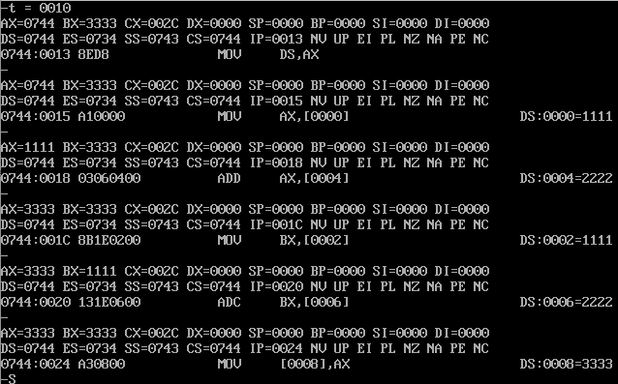
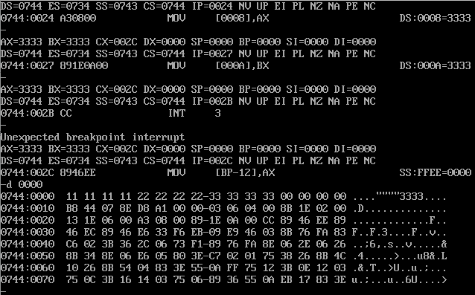

LAB03

1. Program to multiply two unsigned 16-bit numbers.

data segment
num1 dw 0005H
num2 dw 0002H
data ends
code segment
ASSUME ds:data,cs:code
MOV AX, data
MOV ds, AX
MOV AX, num1
MOV BX, num2
MUL BX
INT 03H
code ends
end

2. Program to multiply signed 16-bit numbers.
data segment
num1 dw 0FFFEH
num2 dw 0FFFDH
data ends
code segment
ASSUME ds:data,cs:code
MOV AX, data
MOV ds, AX
MOV AX, num1
MOV BX, num2
IMUL BX
INT 03H
code ends
end

3. Program to divide a 16-bit unsigned/signed number by 16-bit number. The numbers are stored into the data segment.

data segment
num1 dw 0004H
num2 dw 0002H
num3 dw -0006
num4 dw -0002
data ends
code segment
ASSUME ds:data,cs:code
MOV AX, data
MOV ds, AX
MOV AX, num1
MOV BX, num2
DIV BX
MOV AX, num3
MOV BX, num4
CWD
IDIV BX
INT 03H
code ends
end

4. Find the Checksum and verify validity of a 32 bit data.

data segment
num1 dd 22221555H
num2 dd 23221555H
checksum db 00H
data ends
code segment
ASSUME ds:data,cs:code
MOV AX, data
MOV ds, AX
MOV AX, word ptr num1
MOV BX, word ptr num2
XOR AX, BX
JZ skip1
INC checksum
INT 03H
skip1: MOV AX, word ptr 2[num1]
MOV BX, word ptr 2[num2]
XOR AX, BX
JZ end1
INC checksum
end1: INT 03H
code ends

5. Program to copy an array of bytes/words from the variable “SOURCE” to
variable “DEST” which are defined in data segment.
data segment
source db "mfplab"
destination db ?
data ends
code segment
ASSUME ds:data,cs:code
MOV AX, data
MOV ds, AX
MOV SI, offset source
MOV BX, offset destination
MOV CX, 0006H
loop2: MOV DL, [SI]
MOV [BX], DL
INC SI
INC BX
DEC CX
JNZ loop2
INT 03H
code ends
end

6. To sum an array of numbers stored in the data segment.

LAB05
q. 1
data segment
number1 DQ 0000001212121212H
number2 DQ 0000002121212121H
answer DQ ?
data ends
code segment
assume ds:data, cs:code, es:code
MOV AX, data
MOV ds, AX
LEA SI, number1
LEA DI, answer
MOV CX, 3
loop1: MOV AX, word ptr [SI]
MOV BX, word ptr [SI + 8H]
ADD AX, BX
MOV word ptr [DI], AX
ADD SI, 2
ADD DI, 2
LOOP loop1
INT 03H
code ends
end

q2
data segment
stringinput db 20,19 dup(0)
data ends
code segment
assume ds:data, cs:code, es:code
MOV AX, data
MOV ds, AX
MOV es, AX
LEA DX, stringinput
MOV ah, 10
INT 21H
mov cx, 0
MOV CL, byte ptr stringinput
LEA DI, stringinput
ADD DI, 2
MOV ah, 1
int 21h
CLD
repne scasb

JNE not_found
MOV BX, DI
not_found:
INT 03H
code ends
end

q.3
data segment
arr1 DW 1212H, 2323H, 3434H, 4545H
arr2 DW 4 dup(0)
data ends
code segment
assume ds:data, cs:code, es:code
MOV AX, data
MOV ds, AX

LEA SI, arr1
LEA DI, arr2

MOV CX, 4

loop1: MOV AX, word ptr [SI]
MOV word ptr [DI], AX
ADD SI, 2
ADD DI, 2
LOOP loop1

INT 03H
code ends
end
ends
end

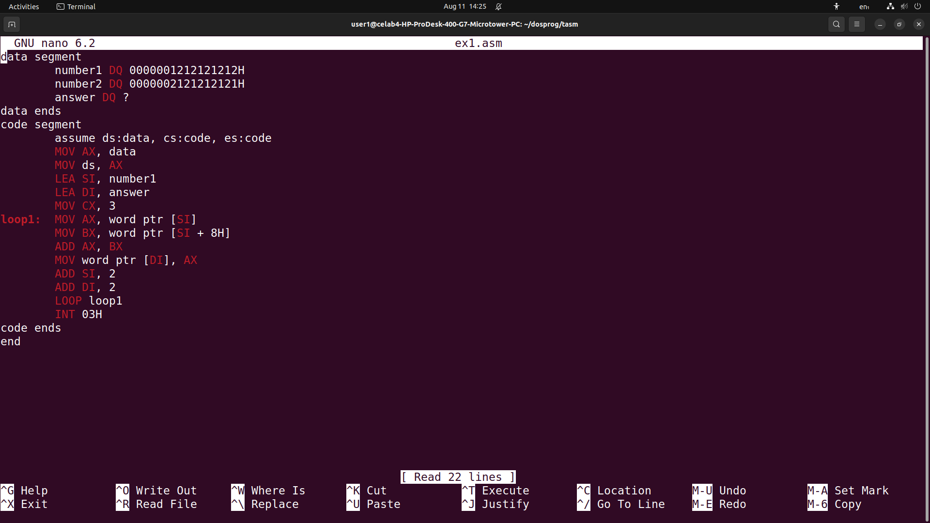
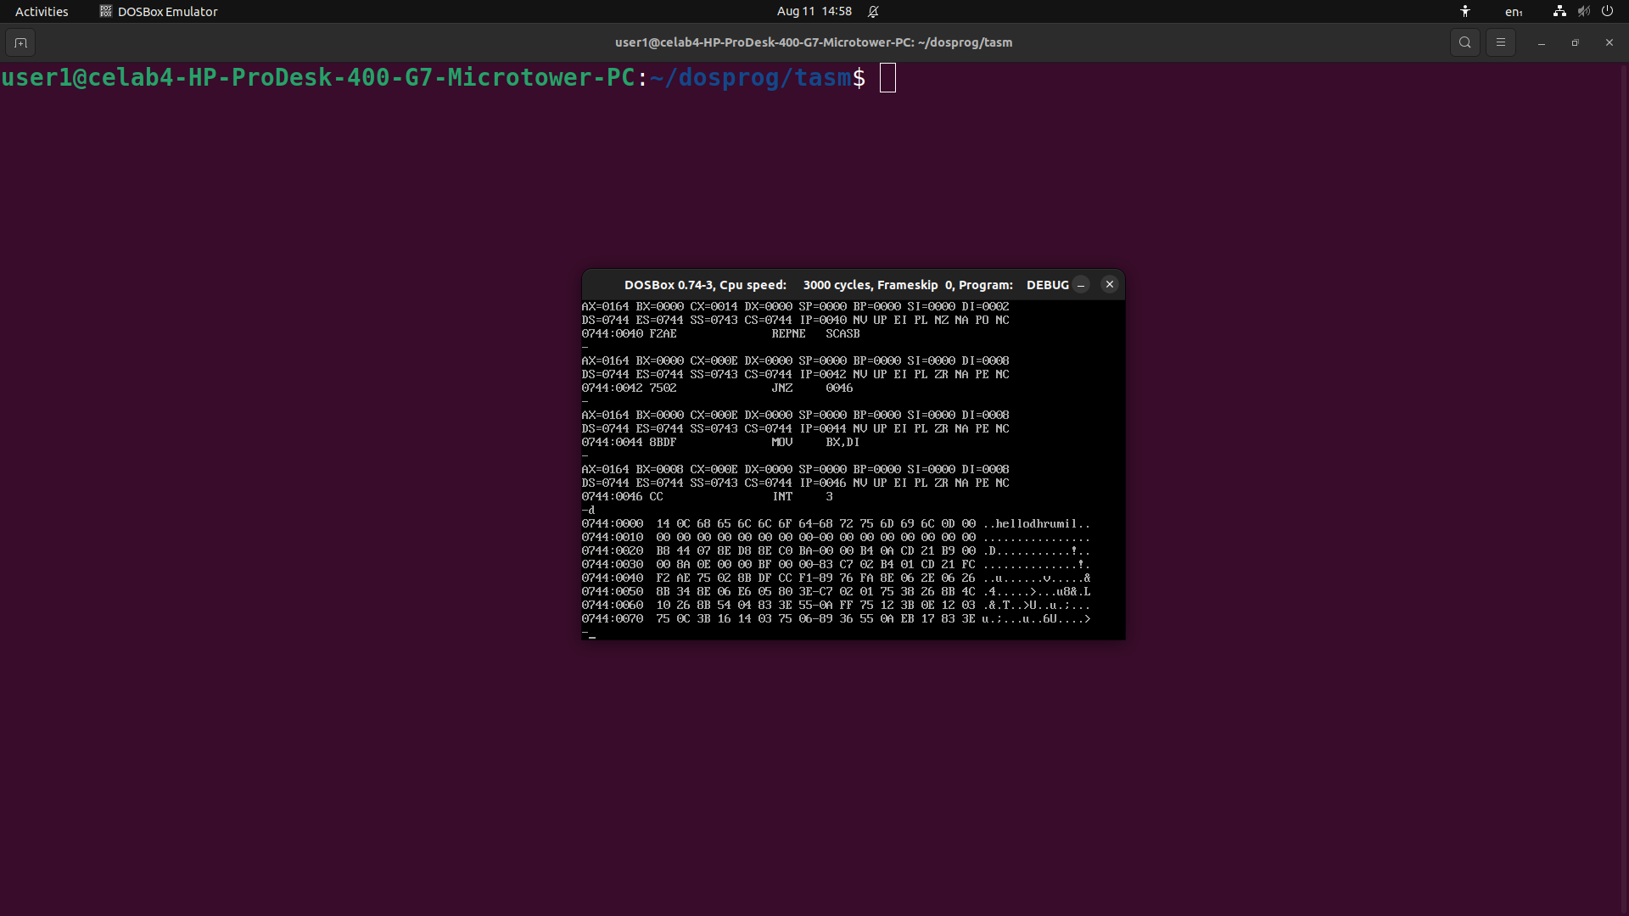

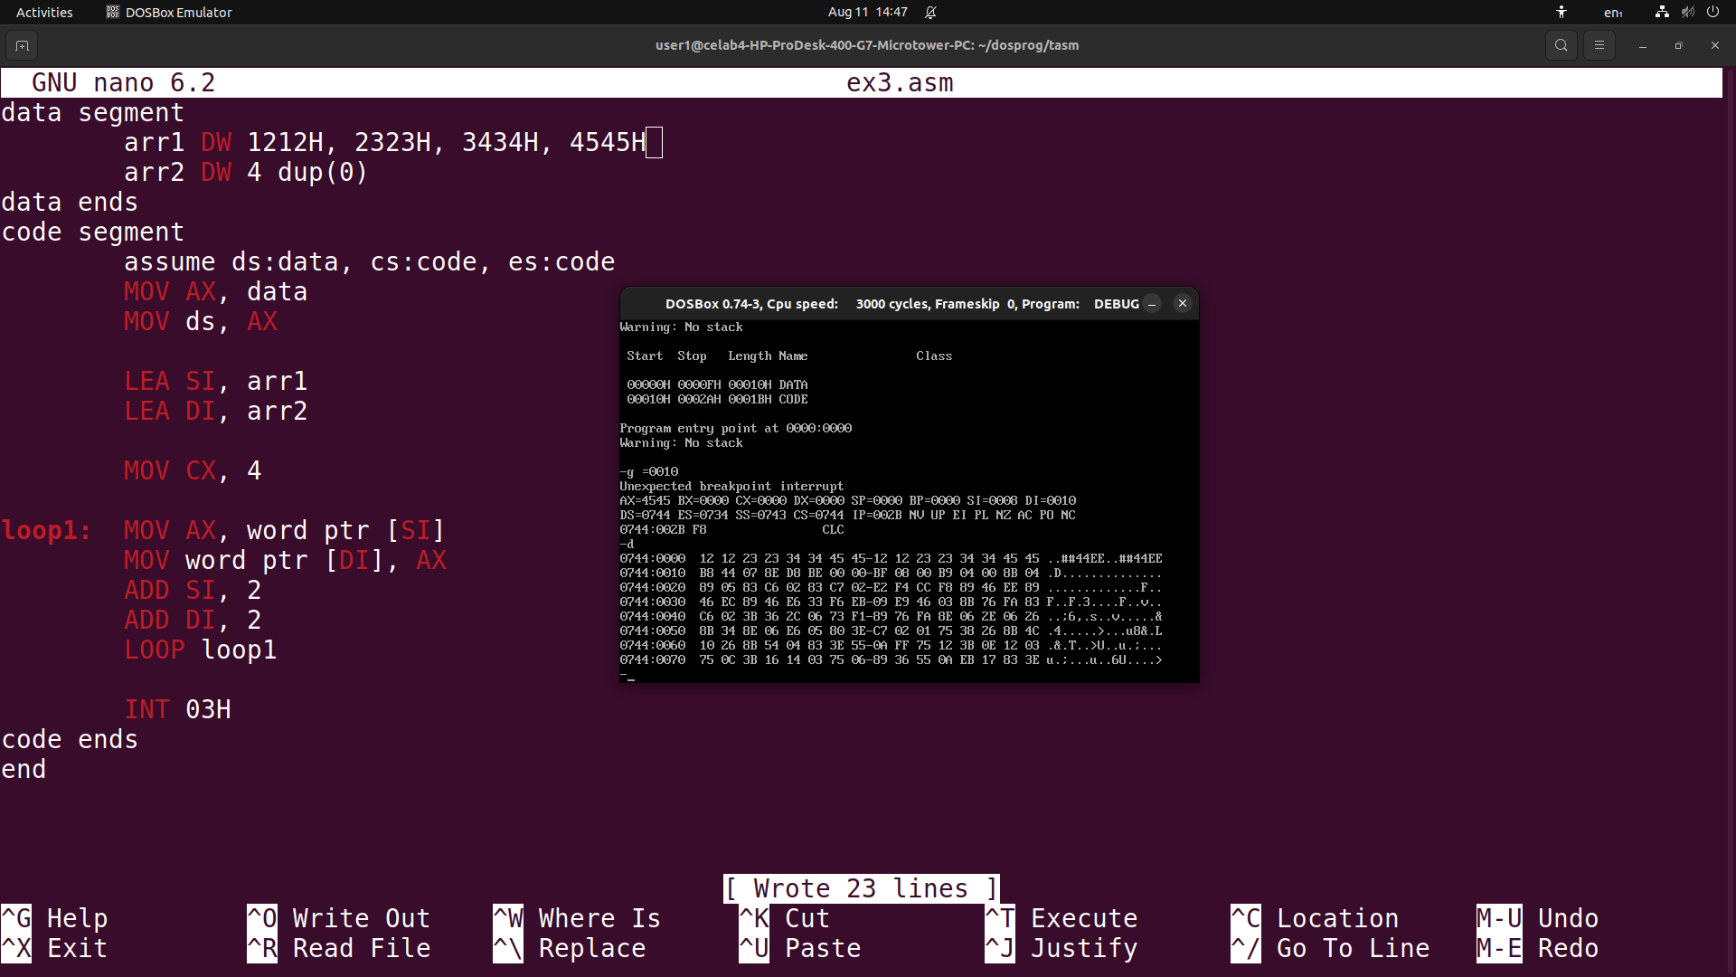
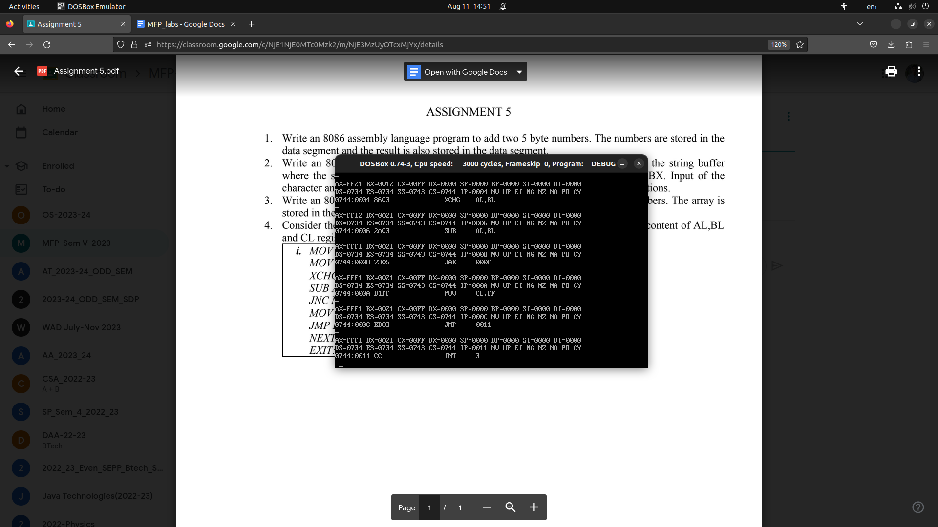
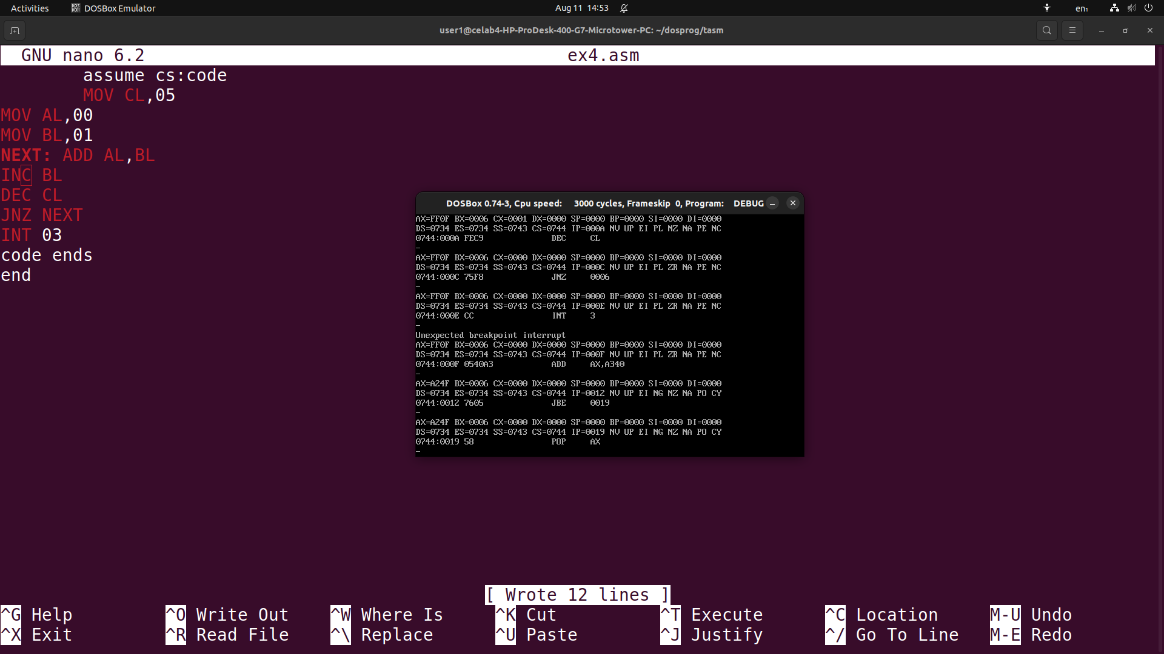

LAB06

ASSIGNMENT 6

1. Write an assembly language to count the number of occurrence of a substring in a given string.
data segment
datastring db "HelloHelloHello"
lendata db ($ - datastring)
searchstring db "Hello"
lensearch db ($-searchstring)
data ends
code segment
assume ds:data, cs:code, es:data
MOV AX, data
MOV ds, AX
MOV es, AX
MOV BH, 0
MOV BL, byte ptr lendata
MOV DH, 0
MOV DL, byte ptr lensearch
SUB BX, DX
ADD BX, 1
LEA SI, datastring
LEA DI, searchstring
LEA SP, datastring
MOV AX, 0
outer: MOV CX, DX
cld
rep cmpsb
JNZ nsame
INC AX
nsame: INC SP
MOV SI, SP
LEA DI, datastring
DEC BX
JNZ outer
INT 03H
code ends
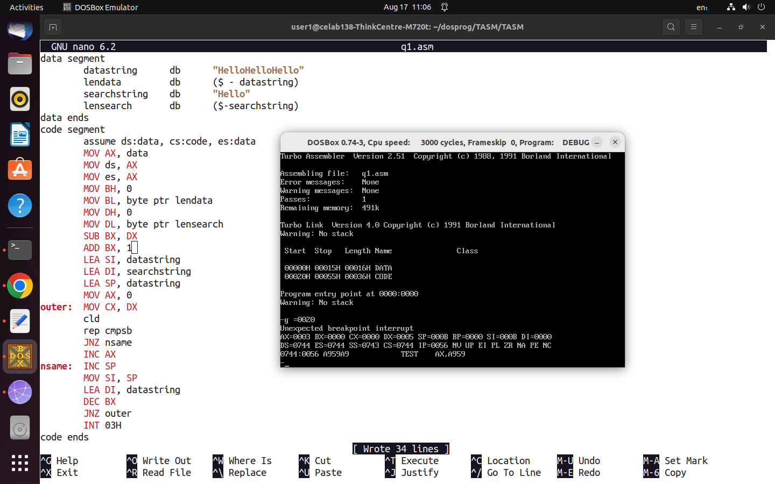
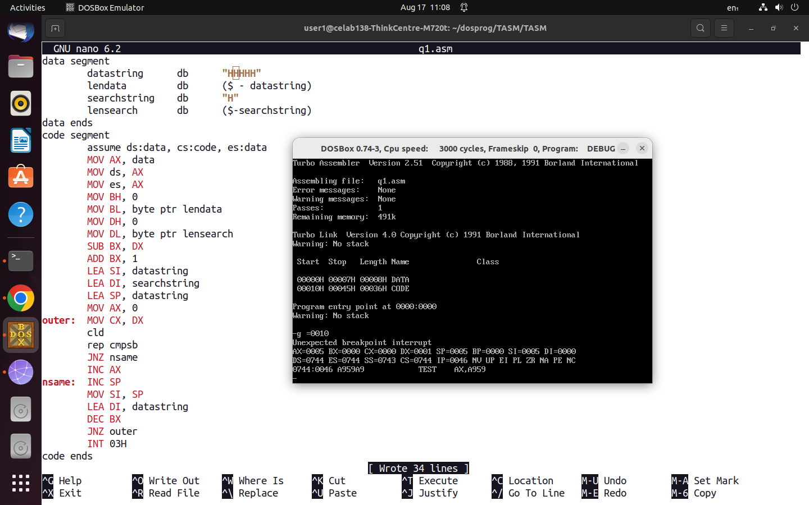
2. In a string “Good Morning”, write a program to replace the substring “Morning” with “Evening”
and display “Good Evening”.
data segment
parentstring db "Good Morning$"
lenparent db ($ - parentstring)
repstring db "Evening$"
lenrep db ($-repstring)
data ends
code segment
assume ds:data, cs:code, es:data
MOV AX, data
MOV ds, AX
MOV es, AX
LEA DI, parentstring
LEA SI, repstring
MOV CH, 0
MOV CL, byte ptr lenrep
ADD DI, 5
CLD
rep movsb

MOV DX, offset parentstring
MOV AH, 9
int 21H
INT 03H
code ends
end

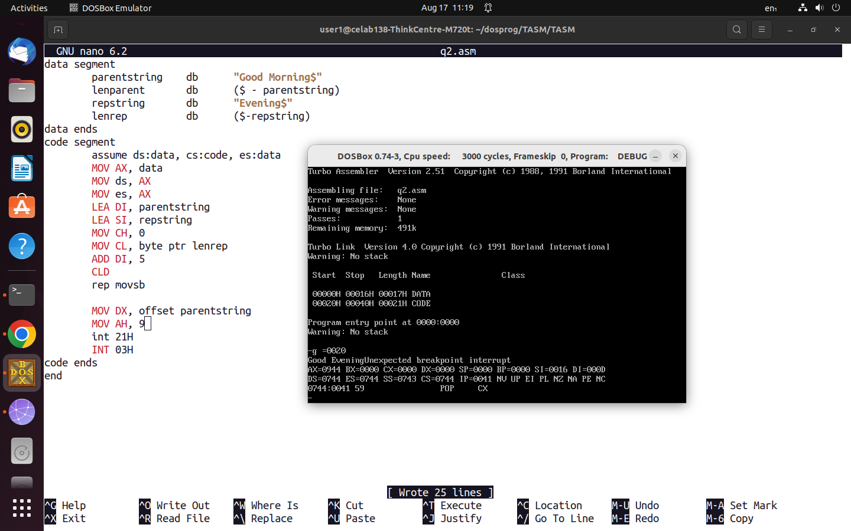
3. Write a program to concatenate two strings STR1 and STR2 and store the result in the string
STR3. Try to input the string through the keyboard.
data segment
str1 db 10,9 dup(0)
str2 db 10,9 dup(0)
str3 db 20 dup(0)
data ends
code segment
assume ds:data, cs:code, es:data
MOV AX, data
MOV ds, AX
MOV es, AX
LEA DX, str1
MOV AH, 10
int 21H
LEA DX, str2
MOV AH, 10
int 21H
LEA SI, 2[str1]
LEA DI, str3
MOV CH, 0
MOV CL, byte ptr 1[str1]

rep movsb

LEA SI, 2[str2]
MOV CL, byte ptr 1[str2]

rep movsb

INT 03H
code ends
end

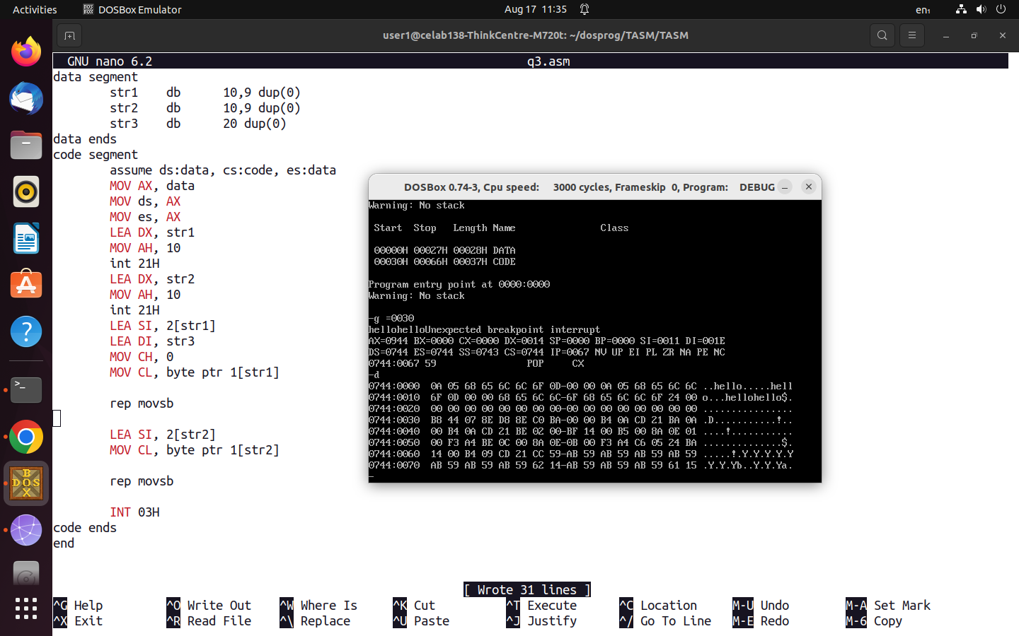

4. Program to enter two strings, Find the characters that match in both the strings, store these
Characters

data segment
str1 db 10,9 dup(0)
str2 db 10,9 dup(0)
samech db 10 dup(0)
data ends
code segment
assume ds:data, cs:code, es:data
MOV AX, data
MOV ds, AX
MOV es, AX
LEA DX, str1
MOV AH, 10
int 21H

LEA DX, str2
MOV AH, 10
int 21H

LEA SI, 2[str1]
LEA DI, 2[str2]
MOV CH, 0
MOV BX, 0
MOV DL, byte ptr 1[str1]
outer:
MOV AL, byte ptr [SI]
repne scasb
JNE nfound
MOV samech[BX], AL
INC BX
nfound:
INC SI
MOV CL, byte ptr 1[str2]
LEA DI, 2[str2]
DEC DL
JNZ outer
INT 03H
code ends
end

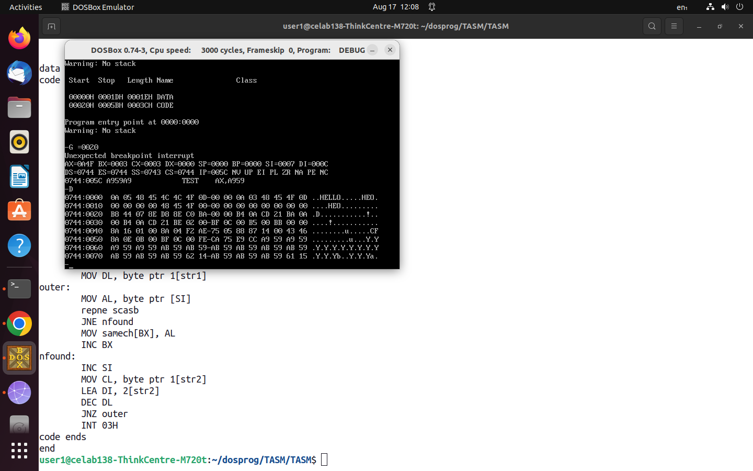
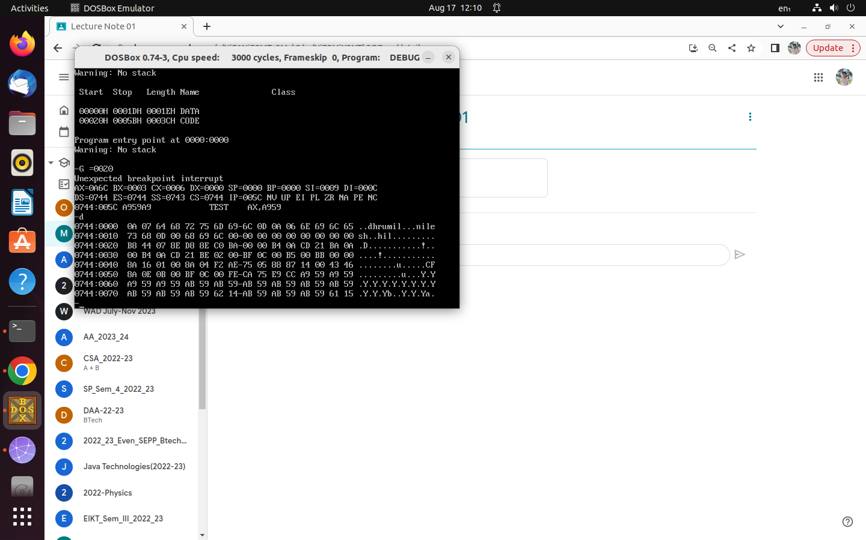

LAB07

1,Write the programs to verify the instructions AAA, AAS, AAM, AAD, DAA and DAS
Instructions.

code segment
; MOV AX, 3135H
; MOV BX, 3136H
; ADD AX, BX
; AAA
; MOV AL, 09H
; MUL BL
; AAM
; MOV AX, 39H
; MOV AX, 24H
; MOV BX, 19H
; ADD AX, BX
; DAA
; SUB AX, BX
; DAS
; MOV AX, 0108H
; MOV BX, 0009H
; MUL BX
; AAM
; AAD
; DIV BL
INT 03H
code ends
end

2. Implement a calculator for single digit numbers, which takes the input through the keyboard
and display the result on the screen.

data segment
op1 db ?
op2 db ?
opr db ?
res dw ?
dol db "$"
nline db 13, 10, "$"
data ends
code segment
ASSUME cs:code, ds:data
MOV AX, data
MOV ds, AX

loop1:
MOV AH, 01H

INT 21H
MOV op1, AL

INT 21H
MOV opr, AL

INT 21H
MOV op2, AL

AND op1, 0FH
AND op2, 0FH
MOV AH, 0
MOV AL, op1

CMP opr, '+'
JNE next1
ADD AL, op2
AAA
JMP exit
next1:
CMP opr, '-'
JNE next2
SUB AL, op2
AAS
JMP exit
next2:
CMP opr, '*'
JNE next3
MUL op2
AAM
JMP exit
next3:
CMP opr, '/'
JNE exit
MOV BL, op2
DIV BL
exit:
OR AX, 3030H
MOV byte ptr 1[res], AL
MOV byte ptr res, AH
MOV AH, 9
LEA DX, nline
INT 21H
MOV DX, offset res
INT 21H
LEA DX, nline
INT 21H
JMP loop1
INT 03H
code ends
end

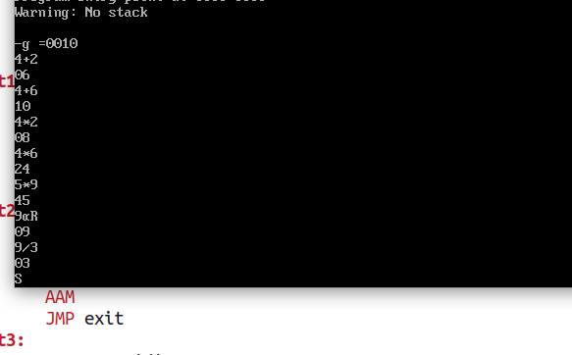

data segment
op1 db ?
op2 db ?
opr db ?
res dw ?
dol db "$"
nline db 13, 10, "$"
data ends
code segment
ASSUME cs:code, ds:data
MOV AX, data
MOV ds, AX

loop1:
MOV AH, 01H

INT 21H
MOV op1, AL

INT 21H
MOV opr, AL

INT 21H
MOV op2, AL

AND op1, 0FH
AND op2, 0FH
MOV AH, 0
MOV AL, op1

CMP opr, '+'
JNE loop1
ADD AL, op2
CMP AL, 9
JC do
LAHF
AND AH, 8
JNE skip
ADD AL, 6
ADD AH, 1

skip:
OR AX, 3030H
MOV byte ptr 1[res], AL
MOV byte ptr res, AH
MOV AH, 9
LEA DX, nline
INT 21H
MOV DX, offset res
INT 21H
LEA DX, nline
INT 21H
JMP loop1
INT 03H
code ends
end

LAB08

i.Write an assembly language program to convert the code of a 2 digit BCD number to hexadecimal and
Viceversa.
data SEGMENT
num_bcd DB 25H
num_hex DB 1AH
ans_hex DB 0
ans_bcd DB 0

data ends
code SEGMENT
ASSUME ds:data, cs:code
MOV AX, data
MOV ds, AX

MOV CL, 4

MOV AH, 0
;for bcd to hex
MOV AL, num_bcd
AND AL, 0FH
ADD ans_hex, AL
MOV AL, num_bcd
SHR AX, CL
MOV CH, 10
MUL CH
ADD ans_hex, AL
;for hex to bcd
MOV CL, num_hex
MOV CH, 0
MOV AL, 0
MOV AH, 1
addanddaa:
ADD AL, AH
DAA
LOOP addanddaa

MOV ans_bcd, AL
INT 03H
code ends
end

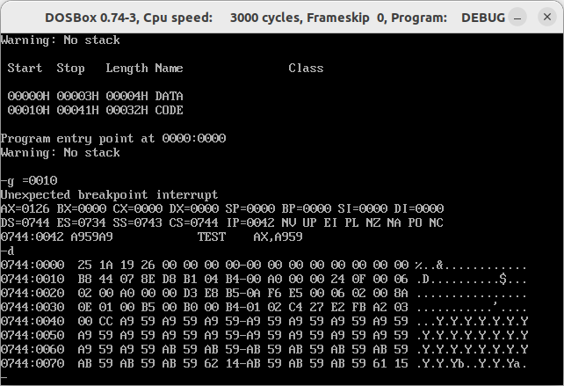

ii. Write an assembly language program to convert a number entered through keyboard to 7 segment
Display.
data segment
table db 3fh, 06h, 5bh, 4fh, 66h, 6dh, 7dh, 07h, 7fh, 6fh
data ends
code segment
ASSUME cs:code, ds:data
MOV AX, data
MOV ds, AX

MOV AH, 1
INT 21H
AND AL, 0FH
LEA BX, table
XLAT
INT 03H
code ends
end

iii. Write an assembly language program to sort an array of words.
data segment
list1 dw 11, 6, 10, 25, 27, 18, 2, 35, 72, 1, 26
data ends
code segment
ASSUME cs:code, ds:data
MOV AX, data
MOV ds, AX

LEA SI, list1
MOV CX, word ptr [SI]
ADD SI, 2
DEC CX
MOV CH, CL

main_loop:
MOV AX, word ptr [SI]
CMP AX, word ptr 2[SI]
JC nswap
MOV BX, AX
MOV AX, word ptr 2[SI]
MOV word ptr [SI], AX
MOV word ptr 2[SI], BX
nswap:
ADD SI, 2
DEC CL
JNZ main_loop
LEA SI, list1
ADD SI, 2
DEC CH
MOV CL, CH
JNZ main_loop

INT 03H
code ends
end

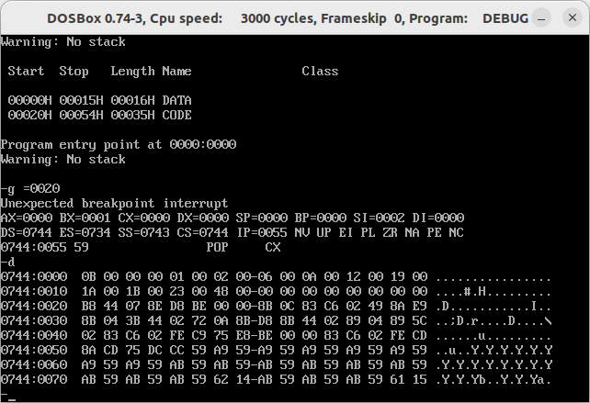

LAB09

Write a program to create a directory and in that create a file and write 10 bytes of data into the file.Create one more file and make a copy of the first file.(i.e Read from the first file and write into the second file.).

data segment
dir_name db "myDir", 0
file_name1 db "myDir\newFile", 0
file_data1 db "hello in file", 0
data_len db ($ - file_data1)
file_hd1 dw ?
file_name2 db "myDir\cpFile",0
file_hd2 dw ?
temp_data db 30 dup(0)
temp_len dw ?
data ends
code segment
assume ds:data, cs:code, es:data
MOV AX, data
MOV ds, AX
MOV es, AX
;creating a dir
LEA DX, dir_name
MOV AH, 39H
INT 21H
;creating a file
LEA DX, file_name1
MOV CX, 0
MOV AH, 3CH
INT 21H
MOV file_hd1, AX
;adding data in file
MOV BX, AX
MOV CX, 0
MOV CL, data_len
LEA DX, file_data1
MOV AH, 40H
INT 21H
;closing one file to save
MOV BX, file_hd1
MOV AH, 3EH
INT 21h
;opening file 1
MOV AL, 2
MOV AH, 3DH
LEA DX, file_name1
INT 21H
;reading data from file1
MOV BX, AX
MOV CX, 30
LEA DX, temp_data
MOV AH, 3FH
INT 21H
MOV temp_len, AX
;closing one file to save
MOV BX, file_hd1
MOV AH, 3EH
INT 21h
;creating another file
LEA DX, file_name2
MOV CX, 0
MOV AH, 3CH
INT 21H
MOV file_hd2, AX
;writing data to file
MOV BX, file_hd2
MOV CX, temp_len
LEA DX, temp_data
MOV AH, 40H
INT 21H
;closing file
MOV BX, file_hd2
MOV AH, 3EH
INT 21h
INT 3
code ends
end

Consider an array(array1) of 20 random numbers ranging between 1 to 4. Write a program to Count the number of 1’s, 2’s, 3’s and 4’s in the array1 and store the result of the count in one more array (array 2) of size 4 elements. At first location of array2 it has to store the count of 1’s, at second location it has to store count of 2’s and so on... 3.

data segment
array1 db 1,1,2,4,2,3,2,3,1,4,2,2,1,2,4,3,2,1,4,1
array2 db 4 dup(0)
data ends
code segment
assume cs:code, ds:data
MOV AX, data
MOV ds, AX
;counting
LEA DI, array2
ADD DI, 3
MOV BL, 4
outerloop:
LEA SI, array1
MOV BH, 0
MOV CX,20
loop1:
CMP BL, byte ptr [SI]
JNE skip
INC BH
skip:
INC SI
LOOP loop1
MOV byte ptr [DI], BH
DEC DI
DEC BL
JNZ outerloop
INT 3
code ends
end

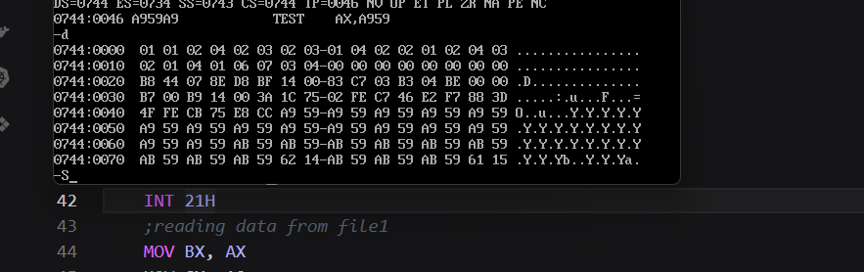

LAB10

1. Write an assembly language to find the LCM of two numbers. (Pass the parameters to the procedure using registers, pointers and stack)
data segment
num1 db 15
num2 db 25
anslcm DW ?
data ends
stack1 SEGMENT STACK
DW 10 dup(0)
stacktop LABEL WORD
stack1 ends

; using direct variables
code segment
assume cs:code, ds:data, ss:stack1
MOV AX, data
MOV ds, AX
MOV AX, stack1
MOV ss, AX
MOV SP, stacktop
CALL find_lcm
INT 3

PROC find_lcm NEAR
MOV BH, num1
MOV BL, num2
MOV CX,2
next:
MOV AX, CX
DIV BH
CMP AH, 0
JNZ skip
MOV AX, CX
DIV BL
CMP AH, 0
JNZ skip
MOV anslcm, CX
RET
skip:
INC CX
CMP CX, 0FFFFH
JNZ next
find_lcm ENDP
code ends
end

; using registers
code segment
assume cs:code, ds:data, ss:stack1
MOV AX, data
MOV ds, AX
MOV AX, stack1
MOV ss, AX
MOV SP, stacktop
MOV AL, num1
MOV AH, num2
CALL find_lcm
MOV anslcm, AX
INT 3

PROC find_lcm NEAR
MOV BH, AH
MOV BL, AL
MOV CX,2
next:
MOV AX, CX
DIV BH
CMP AH, 0
JNZ skip
MOV AX, CX
DIV BL
CMP AH, 0
JNZ skip
MOV AX, CX
RET
skip:
INC CX
CMP CX, 0FFFFH
JNZ next
find_lcm ENDP
code ends
end

;using pointers
code segment
assume cs:code, ds:data, ss:stack1
MOV AX, data
MOV ds, AX
MOV AX, stack1
MOV ss, AX
MOV SP, stacktop
LEA SI, num1
LEA DI, num2
CALL find_lcm
INT 3

PROC find_lcm NEAR
MOV BH, [SI]
MOV BL, [DI]
INC DI
MOV CX,2
next:
MOV AX, CX
DIV BH
CMP AH, 0
JNZ skip
MOV AX, CX
DIV BL
CMP AH, 0
JNZ skip
MOV [DI], CX
RET
skip:
INC CX
CMP CX, 0FFFFH
JNZ next
find_lcm ENDP
code ends
end

;using stack
code segment
assume cs:code, ds:data, ss:stack1
MOV AX, data
MOV ds, AX
MOV AX, stack1
MOV ss, AX
MOV SP, stacktop
MOV AL, num1
MOV AH, num2
PUSH AX
CALL find_lcm
POP AX
MOV anslcm, AX
INT 3

PROC find_lcm NEAR
MOV BH, 2[SP]
MOV BL, 3[SP]
MOV CX,2
next:
MOV AX, CX
DIV BH
CMP AH, 0
JNZ skip
MOV AX, CX
DIV BL
CMP AH, 0
JNZ skip
MOV 2[SP], CX
RET
skip:
INC CX
CMP CX, 0FFFFH
JNZ next
find_lcm ENDP
code ends
end

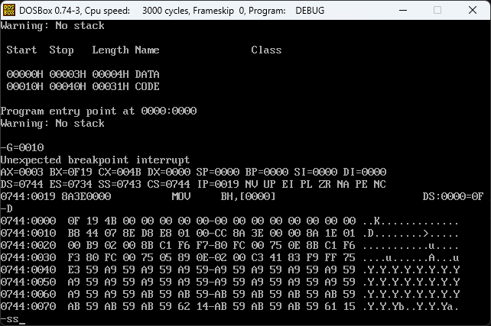
2. Write an assembly language program to convert temperature from Fahrenheit to Celsius. [(F − 32) × 5/9 = °C]
data segment
tempInF dW 86
tempInC dW ?
data ends
stack1 SEGMENT STACK
DW 10 dup(0)
stacktop LABEL WORD
stack1 ends
code segment
assume cs:code, ds:data, ss:stack1
MOV AX, data
MOV ds, AX
MOV AX, stack1
MOV ss, AX
MOV SP, stacktop
CALL convertToF
INT 3

PROC convertToF NEAR
MOV AX, tempInF
MOV BX, 32
SUB AX, BX
MOV BX, 5
MUL BX
MOV BX, 9
DIV BL
MOV tempInC, AX
RET
convertToF ENDP
code ends
end

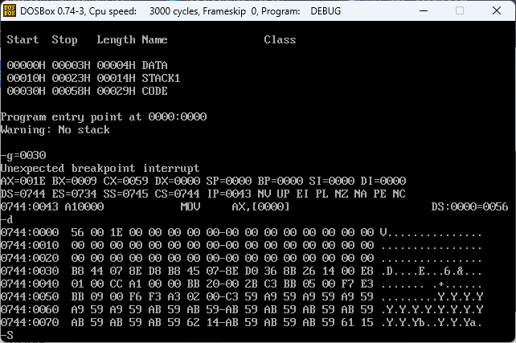

LAB11

1. Write an assembly language program using far procedure to find square root of a perfect square number using procedure.
; procedure for square root

public findsqrt

sqrtt segment
assume cs:sqrtt
findsqrt PROC far
; BX <- number to find square
MOV CX, 0

sqr_loop:
INC CL
CMP CL, AL
JNC end1
MOV AX, BX
DIV CL
CMP AH, 0
JNE sqr_loop
CMP AL, CL
JNE sqr_loop

MOV AX, CX
end1:
RET
;AX <- answer
findsqrt ENDP
sqrtt ends
end

extrn findsqrt:far

data segment
num1 dw 16
num2 dw 25
ans1 db ?
ans2 db ?
data ends
code segment
assume cs: code,ds:data
mov ax,data
mov ds,ax
mov bx, num1
call findsqrt
mov ans1, AL
int 03h
code ends
end

2. Write a program using Macro to add two numbers. Macro should be written in another file.

SUM MACRO a, b
mov ax, a
mov bx, b
add ax, bx
ENDM

INCLUDE ex22.h

data segment
num1 dw 6
num2 dw 9
ans dw ?
data ends
code segment
assume cs:code, ds:data
mov ax, data
mov ds, ax
SUM num1, num2
mov ans, ax

INT 03
code ends
end

3. Write an assembly language to override the overflow interrupt.

data segment
msg db "Overflow Occured",13,10,"$"
data ends

stacks segment
stack dw 40 dup(0)
top label word
stacks ends

code segment
assume cs:code,ds:data,ss:stacks
mov ax,data
mov ds,ax
mov ax,stacks
mov ss,ax
mov sp,top
mov ax,0000
mov es,ax
mov word ptr es:0010h,offset overflow
mov word ptr es:0012h,seg overflow
mov al,100
add al,100
INTO
int 03h

overflow proc near
lea dx, msg
mov ah, 9
int 21h
iret
overflow endp

code ends
end

