**SOFTWARE** **REQUIREMENT** **SPECIFICATION**

**Research Title:** PR| Travel : Travel and Tour Reservation

**Members:** ***Aguilan, Rafael Sebastian*** *(Help with the srs)*

***Bermundo, Carl Vincent*** *(Help in programming and help with the srs)*

***Novicio, Juvy Lyn*** *(Main Programmer, help with the srs)*

***Perez, Ivan Gabriel*** *(Help in programming and help with the srs)*

***Sogelio, Cris Carl*** *(Help with the srs)*

# A. General Description

1. **Background Study**

Travel and Tour web applications or websites gives some sort of convenience to the customers which gives value to their travel spend. They plan and manage travel and trips for the customers. Through this kind of web-application a person can plan and book a travel that is set for a specific period of time and includes specific travel destination, features like pick up and drop service facility, a hotel room or apartment where the travelers can stay during the trip and a travel package may also include a trip itinerary.

Based on the Philippines National Geographic the islands of the Philippines are categorized into three different island groups which is Luzon, Visayas and Mindanao. Luzon is the largest island in the Philippines where Region I, Region II and Cordillera Administrative Region (CAR) is located. These regions include some of the most beautiful provinces and cities in the Philippines like Baguio, Benguet, Ilocos Sur, Ilocos Norte and more. These provinces have some of the most beautiful tourist attractions in the Philippines like beaches, Philippine Heritage and historic cities that are perfect travel destinations and very popular to tourists.

PR Travels, a travel and tour web application will provide the customers ease when they are planning a trip in the selected cities and provinces of Northern Luzon. Where customers will be able to choose a package that is set to a specific travel destination and a specific travel period and the package also includes service and stay facility for the customers.

The developers decided to make a Web Application that will help tourists plan and have a trip without any hassle. Web applications are very popular platform that can be used by a Travel and Tour Agency that can be easily access by the customers when they wanted to book a trip with conveniency and ease.

The main objective of this study was to create a Travel and Tour web application named PR Travels that will provide the tourist market trip fares to selected cities and provinces in Northern Luzon. Web applications are very popular platform that can be used by a Travel and Tour Agency that can be easily access by the customers when they wanted to book a trip with conveniency and ease. The system aims to offer tourist market affordable trip fares around Northern Luzon and promote beautiful tourist destinations in the selected cities and provinces around it.

1. **Similar System Information**

The system main functions are recording such data and information; it can also retrieve and compile information that will help lessen the processing time and has a database to avoid data lose that is the main problem of the organization from the current time and the past.

**Table 1. Technology Gap Analysis**

|  |  |  |  |
| --- | --- | --- | --- |
| **Existing***.*  **Technology** | **Strength** | **Weakness/Gap** | **Proposed Technology** |
| Facebook | It’s a known to everyone and the **most popular social networking site** | -The records for reservation and schedule are still done manually or with the help of other application. | A web-based system which can store data |
| Recording by the used of pen/paper for manual recording | Can retrieve data and store data | Prone to degradation and termite invasion and it takes time to retrieve data. | A web-based system which can store data and retrieve data more faster. |

1. **Users Goal**

The following table describes the identified user characteristics upon their duties and functions of using the system.

**Table 2. User Characteristics**

|  |  |
| --- | --- |
| **User** | **Role** |
| Admin | * Design and maintain the system |
| Super User (Tour Package Provider) | * Login * Adds tour packages * Updates existing tour packages * Manages all the booked tours * Manages all the messages * Sends a response to a message * Views all the accounts * Edits his/her account profile |
| User (Tourist) | * Login * Views all the tour packages * Reserves and books tour packages * Views all of his/her booked tours * Sends a message or feedback to the tour package provider * Views all his/her sent messages * Updates the information on his/her account profile |

1. **User Problem Statement**

The following table lists down what each type of user wants, as defined by the users themselves, as well as the list of what the user needs as defined by the developers.

|  |  |
| --- | --- |
| **User** | **Problems Identified** |
| Tourist | The current process of a tourist in finding and booking a trip to a tourist destination is difficult because the tourist must first browse famous tourist spots in Google or Facebook before searching for great deals for the trip including where the tourist will stay, foods, and who will guide them in their trip. The tourist also can’t see the list of their booked tours. |
| Tour Package Provider | As the provider of tour packages still uses Facebook as one of their plat-form in entertaining their tourist, the process may take some time. Another platform they use is their phone, which they use for calls and text messages. Having these kinds of platforms in accepting requests from a tourist is tricky as the messages are not well-organized. At worst, some providers are still using paper to record the booked tours. |

1. **Use Case Scenario**

|  |  |
| --- | --- |
| Actor | Goal |
| Tourist | Register to the system |
|  | Login to view the system |
|  | Search for the desire tour package |
|  | Book Tour |
|  | Send Messages |
|  | Update Profile |
|  |  |
| Tour Provider admin | Login to view the system |
|  | Add Tour Packages |
|  | View the booked tours |
|  | Confirm the booked tours |
|  | Request Payment |
|  | Respond to messages |

1. Case Scenario for Tourist

|  |  |
| --- | --- |
| Goal | Tourist register and login to the system and booked a tour |
| Primary Actor | Tourist |
| Secondary Actor | Tour Provider admin |
| Scope | Travel and Tours Reservation System |
| Precondition | Tourist is at the registration page |
| Success end condition | Tourist successfully booked a tour |
| Failure end condition | Unsuccessful registration, login and unsuccessful booking of tours |
| Trigger | Tourist login to the application |
| Main Success Scenario | 1. The Tourist registered to the system. |
| 1. Message will appear to verify successful registration. |
| 1. Tourist enters account and password. |
| 1. System verifies the customer account. |
| 1. Tourist view the website content. |
| 1. Tourist search tour packages. |
| 1. Tourist Booked packages. |
| 1. Tourist send message to the admin. |
| Error Scenario | 1. Incomplete Registration |
| 1.1 System will notify if there’s an incomplete data during registration |
| 2. Username or password incorrect |
| 2.1 An alert will show to notify if the username and password is incorrect |
| * 1. Tourist tries again |
| 1. Incomplete or blank message |
| 3.1 System will notify if the message is blank. |
| 3.2 Tourist will try again |
| Variations (alternative scenarios) | 1. Tourist enters for destination. |

1. Case Scenario for Tour Provider admin

|  |  |
| --- | --- |
| Goal | Tour Provider admin login to the system, add new tours package, manage the booked packages, respond to the messages. |
| Primary Actor | Tourist |
| Secondary Actor | Tour Provider admin |
| Scope | Travel and Tours Reservation System |
| Precondition | Tour Provider admin is at the login page |
| Success end condition | Tour Provider admin add tour packages, manages booked tours and respond to messages |
| Failure end condition | Unsuccessful login and unsuccessful adding package |
| Trigger | Tourist login to the application |
| Main Success Scenario | 1. Tour Provider admin enters account and password. |
| 1. System verifies the Tour Provider admin account. |
| 1. Tour Provider admin view the website content. |
| 1. Tour Provider admin add tour packages |
| 1. Tour Provider admin update packages |
| 1. Tour Provider admin managed booked tours. |
| 1. Tour Provider admin request payment |
| 1. Tour Provider admin search messages by type (unread, Read, and all). |
| Error Scenario | 1. Username or password incorrect |
| 1.1 An alert will show to notify if the username and password is incorrect |
| 1.2 Tour Provider admin tries again |
| 1. Incomplete data in updating tour package |
| 2.1 System will notify if the data is incomplete. |
| 2.2 The Tour Provider admin will try again |
| 3. Blank messages |
| 3.1 System will notify if the message is blank. |
| 3.2 Tourist will try again. |
|  |
| Variations (alternative scenarios) | 1. Tour provider search messages through issues. |

1. **General Constraints**

*For the limitation we didn’t include payment method in the system. One of the reason is that we are lack of knowledge, we find difficulties in including it in the system so we choose to not to include it.*

# B. Functional Requirements

## Functions and Features

1. The system is divided into two main functions, Tour Management and Booking Management

1. Tour Management

* The super user and user have the access to this function but the users have limitation they can only view the tour package.
* This function includes adding new tour or trip packages as well as updating necessary information in tours packages
* The users can view all package tours in their account added by the super user.

B. Booking Management

* The super user also has the access with this function the admin can manage booked tours and the users or the tourists can book a tour.

The features of the system include the following:

1. All the information inserted in the system will be stored in the cloud database.

* The data of the users will be stored in a cloud database as well as the tour package tours, booked tours, messages from the tourists and response message from the admin.

1. Email Notification functionality to inform the tourists

* Email Notification should help in informing the tourists about the requesting of payment or if the date of the booked tour was not available and also for the forgot password.
* Given the capability of SQL, this requirement is able to be satisfied

1. The data stored should be able to be manipulated through forms.

* Forms should allow for the addition and updating of items and other data.
* The user of the system not being able to use it appropriately is the sole factor that can be met here. This will be addressed by ensuring that individuals who will be utilizing it are properly trained. D. Different Account type is provided
* For the security of the data • Each account type has a different form depending on the user type.
* Only the admin developer can create account for admin and the users would have to register for them to have an account.

## 2. Use CASE Diagram

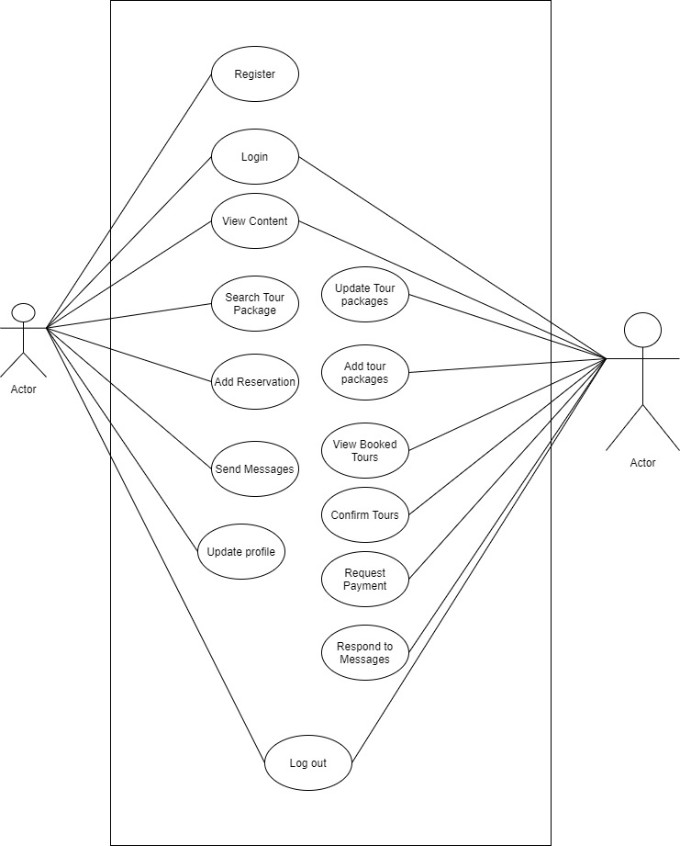

Travel and Tour Reservation

## 3. User Requirements

The PR | Travel: Travel and Tour Reservation has three main types of users: Super admin, Admin and Tourist.

1. **Super Admin (IT Personnel) –** Superadmin are responsible for upkeep, as well as software and database management. They are also responsible for adding and managing Admin, as well as password management, for when a user forgets their password. They are considered as the main user of the system. They are responsible for creation and management of each user.
2. **Admin (Tour Package Provider) –** They are responsible for updating, adding tour packages and managing the booked tours of the tourist.
3. **User (Registered User)–** They are the one who will interact with the application. For creating account, searching and booking tour packages, updating their profile etc.

## 4. Data Dictionary

## Logical Data Model/Data Dictionary

**tblaccounts**

|  |  |  |  |  |
| --- | --- | --- | --- | --- |
| **FIELD** | **DATA TYPE** | **FIELD LENGTH** | **CONSTRAINTS** | **DESCRIPTION** |
| id | INT | 255 | PRIMARY KEY | ID Auto generates |
| firstname | VARCHAR | 255 | NOT NULL | firstname |
| middlename | VARCHAR | 255 | NOT NULL | Password |
| lastname | VARCHAR | 255 | NOT NULL | lastname |
| birthdate | DATE |  | NOT NULL | birthdate |
| contact | VARCHAR | 255 | NOT NULL | contact |
| address | VARCHAR | 255 | NOT NULL | address |
| email | VARCHAR | 255 | NOT NULL | email |
| username | VARCHAR | 255 | NOT NULL | username |
| password | VARCHAR | 255 | NOT NULL | password |
| usertype | VARCHAR | 255 | NOT NULL | usertype |
| secret_q1 | VARCHAR | 255 | NOT NULL | First Secret question |
| secret_q2 | VARCHAR | 255 | NOT NULL | Second Secret Question |
| image | VARCHAR | 255 | NOT NULL | Profile Image |
| created | TIMESTAMP | 6 | NOT NULL | Time created |

**tblbookings**

|  |  |  |  |  |
| --- | --- | --- | --- | --- |
| **FIELD** | **DATA TYPE** | **FIELD LENGTH** | **CONSTRAINTS** | **DESCRIPTION** |
| ID | INT | 255 | PRIMARY KEY | ID Auto generates |
| user_id | INT | 255 | NOT NULL | Id of user |
| Packaged_id | INT | 255 | NOT NULL | Id of packaged |
| from_date | DATE |  | NOT NULL | Starting date |
| To_date | DATE |  | NOT NULL | Ending date |
| adults | INT | 255 | NOT NULL | Number of adults |
| kids | INT | 255 | NOT NULL | Number of kids |
| Total_amounts | INT | 255 | NOT NULL | Total amount |
| Booking_status | VARCHAR | 255 | NOT NULL | Booking status |
| created | TIMESTAMP | 6 | NOT NULL | Time Created |

**tblmessages**

|  |  |  |  |  |
| --- | --- | --- | --- | --- |
| **FIELD** | **DATA TYPE** | **FIELD LENGTH** | **CONSTRAINTS** | **DESCRIPTION** |
| ID | INT | 255 | PRIMARY KEY | ID Auto generate |
| User_id | INT | 255 | NOT NULL | Id of user |
| issue | VARCHAR | 255 | NOT NULL | issue |
| message | VARCHAR | 255 | NOT NULL | Message content |
| response | VARCHAR | 255 | NOT NULL | Response to message |
| Message_status | VARCHAR | 255 | NOT NULL | Message Status |
| created | TIMESTAMP | 255 | NOT NULL | Time Created |

**tblpackages**

|  |  |  |  |  |
| --- | --- | --- | --- | --- |
| **FIELD** | **DATA TYPE** | **FIELD LENGTH** | **CONSTRAINTS** | **DESCRIPTION** |
| ID | INT | 255 | PRIMARY KEY | ID Auto generate |
| Package_name | VARCHAR | 255 | NOT NULL | Package name |
| Packge_location | VARCHAR | 255 | NOT NULL | Package Location |
| Adult_rate | VARCHAR | 255 | NOT NULL | Adult Rate |
| Child_rate | VARCHAR | 255 | NOT NULL | Child Rate |
| Package_inclusion | VARCHAR | 255 | NOT NULL | Package Inclusion |
| Package_exclusion | VARCHAR | 255 | NOT NULL | Package Exclusion |
| Package_details | VARCHAR | 255 | NOT NULL | Package Detaials |
| image | VARCHAR | 255 | NOT NULL | Image |
| created | TIMESTAMP | 6 | NOT NULL | Time Created |

## i. Functional Requirements

1. **Table 1. Functional Requirements for System Administrator**

|  |  |  |
| --- | --- | --- |
| **Functions** | **Type** | **Event** |
| **Log in** | Essential | User enters a valid Email and password. |
| **Manage Superuser** | Essential | Add, update and delete  Superuser. |
| **Manage password** | Essential | Provides new password to Superuser admin Admin incase they forgot their password. |

1. **Table 2. Functional Requirements for Superuser**

|  |  |  |
| --- | --- | --- |
| **Functions** | **Type** | **Event** |
| **Log in** | Essential | User enters a valid Email and password. |
| **Manage Tours** | Essential | Add edit tour Packaged. |
| **Manage Booked tours** | Essential | Accept, reject and request payment for booked tours |

1. **Table 3. Functional Requirements for User**

|  |  |  |
| --- | --- | --- |
| **Functions** | **Type** | **Event** |
| **Log in** | Essential | User enters a valid username and password. |
| **Manage Booked tours** | Essential | Add or cancel his/her booked. |

# C. Non-Functional Requirements

## Interface Requirements

The Website: PR | Travels has a friendly user interface, the combination of a cozy background, colors, and the font style soothe the eyes of the users. The captions and the informations clearly state the message. The navigation bar has also included different linked text and the buttons have their own set of functions.

## Software Interfaces

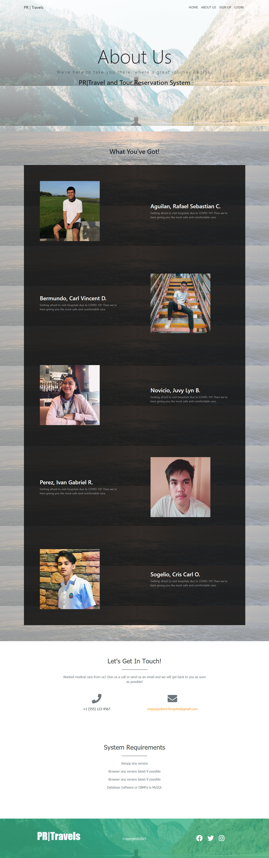

## ii. Communications Interfaces

Online will be the way for the different computers to communicate. All the database will be uploaded using Online communication.

## b. Data Conversion Requirements

The system will automatically upload all the database from the old system to the new and developed system.

## c. Hardware/Software Requirements

Hardware:

* PC – running on MAC, Windows,
* Android/ iOS smartphone
* Web Server
* Router/Switch

Software:

* Web Browser
* Generic Mobile App

## d. Operational Requirements

The users/clients have the authorization to view or access the wesite: PR | Travels and the admin/superuser are the persons responsible for managing the system performance, network security, database, and the management of components and software.

## Security and Privacy

A. Consequences of breach of security:

1. Loss or corruption of data – If the data is lost or being corrupted the system can’t access all the database in the system.
2. Disclosure of secrets or sensitive information – there can be a problem in managing the system and the database.
3. Disclosure of privileged/privacy information about individuals – the admins will check all the data in the database, communicate with the customers, and make sure that if those things happen the customers will be more secure in the system and the database.
4. Corruption of software or introduction of malware, such as viruses – the admin must have to do something to ease that problem, install antiviruses, provide a backup all the time, if-else inquire cybersecurity experts for protection.
5. Physical security. – if any part of the hardware is damaged, the superuser must fix all the issues or else the computer won't function correctly.
6. Password for each account – each account must have its own unique password in order to achieve password security.
7. Admin security – an authorized system and security-related functions must be executed, the admin performs different functions that ordinary users are not authorized to perform.
8. Accounts for each user – each user has their own account as they logged in to the system.
9. Super user is the only person which can view all of the data –special user account has open access to the whole system and can carry out all actions making unrestricted, potentially adverse, system-wide changes.

## ii. Reliability

* Loss of data – loss of data might include the loss of booking and tours total number, and also the customer messages.
* Backlogs will happen – backlogs might lead to customers' dissatisfaction with the service of the system.
* The customers will have to wait for the system to be functional again before they can get in access to the web portal.
* The productivity of the admin will slow down.

**iii. Recoverability**

1. In the event of loss of data, the admin monitors each activity and has prepared a backup in another storage in case of dispossession.
2. In the event of backlogs, the admin guaranteed that every customers’ message (includes uncompleted services) in the message section will have a response as soon as the admin read it and solve the issue immediately.
3. Regarding productivity, the other admins will kick in or will contribute to work once the update is in the process in order for them to finish it in an agile way.

## iv. System Availability

The web portal is available for customers 24 hours a day starting from Monday to Saturday.

**v. Capacity**

The system will be able to hold several amounts of booking and tours in contrast to the quota of the tourist spots and attractions, and the hotel rooms.

## vi. Data Retention

N/A

## vii. Error Handling

developing error, this error occurs during development stage of the system. While logical error is error in the condition of the code

**viii. Validation Rules**

N/A

## ix. Conventions/Standards

N/A

# D. Operational Scenario

**Scenario A: Browsing of the Website**

The customers are free to browse and explore the user interface of the PR | Travels website.

**Scenario B: About Us**

Details of the admin are visible to the customers including the mission and vision of the website.

## Scenario C: Account Creation

In order for the customers to book a tour, the customers must log in to the website first, if the customer doesn’t have an account yet, they must create an account for the validation and notification of the booking.

**Scenario D: Tours Available**

The customers are able to see the different types of tours once they are logged in to the website.

**Scenario E: Booking Confirmation**

After the customers decide to book a tour, they can now check their booked tours for clarification.

**Scenario F: Customers Messages**

The customers can write messages regardless of different purposes and it will be sent to the admins.

**Scenario G: Booking Approval**

The admins will make a decision wheter to approve the pending tour request or decline. And once the decision is made, a message will be sent to the customers’ email regarding the approval.

**Scenario H: Admins’ Response**

The admins can reply to different messages from the customers.

**Scenario I: Admins’ Logout**

# SOFTWARE DEMONSTRATION

The undersigned acknowledge they have reviewed the PR | Travels **Software Product Specification and System Requirements** listed are document and agree with the approach it presents. Any changes to this Requirements Definition will be coordinated with and approved by the undersigned or their designated representatives.

Recommendation:

|  |  |
| --- | --- |
|  | |
| Printed Name Over Signature: |  |