**THE UNITED REPUBLIC OF TANZANIA**

**PRESIDENT’S OFFICE**

**REGIONAL ADMINISTRATION AND LOCAL GOVERNMENT**

**MWANZA CITY**

**JOINT EXAMINATION (NYEGEZI, BUTIMBA AND MKUYUNI WARDS)**

**FORM FOUR PRE - MOCK EXAMINATION-2021**

**031 PHYSICS**

**Time: 3 Hours MAY, 2021**

**INSTRUCTIONS**

1. This paper consists of section A, B and C with total of eleven (11) questions.
2. Answer all questions in section A and B and any two (2) questions in section C.
3. Cell phones are not allowed in the examination room.
4. Non programmable calculator and mathematical table are allowed in the examination room.
5. Where necessary the following constants may be used:

* Acceleration due to gravity g = 10 m/s2
* Specific heat capacity of water = 4200Jkg-1K-1
* Speed of light in air =



* Speed of sound in air =



* Pie (π) = 3.14

**SECTION A (15 Marks)**

Answer **all** questions in this section

1. For each of the items (i) – (x), choose the correct answer among the given alternatives and write its letter beside the item number. **(10 marks @1 mark)**

(i) The diagram below shows series of experiments performed by a student to determine the relative density of a cork that floats in water. Four reading of the spring balance were obtained.

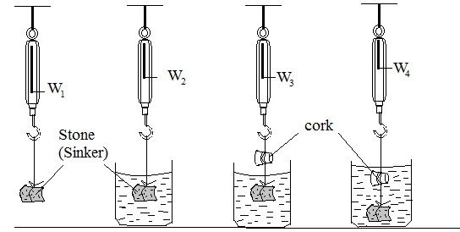

The relative density of the cork is given by;-

A. B. C. D.E.



(ii) Diffusion occurs more quickly in a gas than in a liquid because;-

A. The liquid contains a layer on its surface

B. The gas contain semi-permeable membrane

C. The gas molecules is small in size compared to the liquid molecules

D. The adhesion is large than cohesion in gas compared to that in liquid.

E. The speed of molecules in gas is greater than in liquid.

(iii) In a loading a lorry a man lifts boxes each of weight 100N through a height of 1.5m, if he lifts 4boxes per minute, the average power the man is working is;-

A. 100 B. 10 C. 600 D. 37.5 E. 2250

(iv) In a process of charging by induction in static electricity;-

1. A conductor is rubbed with an insulator
2. A charge is produced by friction
3. Negative and positive charges are separated
4. A positive charge induces a positive charge
5. Electrons are sprayed into an object

(v) A magnetic needle, free to turn in a vertical plane, is suspended first at the earth’s south magnetic pole and then at a point on the magnetic equator. The respective angles between the needle and horizontal are:

A. 0o and 0o B. 70o and 70o  C. 0o and 45o D. 0o and 90o

E. 90o and 0o

(vi) The acceleration of a moving object may be found from

1. The area under its velocity-time graph.
2. The slope of the velocity-time graph.
3. The area under its distance-time graph.
4. The slope of the distance-time graph.
5. The slope of the peak of its distance-time graph.

(vii) Which of these resources of energy is non-renewable?

1. Wave energy B. Bio fuels C. Radiant energy D. Fossil fuel

E. Geothermal energy

(viii) A typist uses a new carbon paper under her top typing paper for making a copy of a letter. When she holds the carbon paper close to a plane mirror, she can read the letter. This is because the mirror;

A. Forms an image the same size as object

B Produces an inverted image

C Produces a laterally image

D Forms a virtual image

E Forms an image behind the mirror.

(ix) Light waves differ from sound waves because;

A. Light is an electromagnetic wave

B. Light wave are long and sound waves are short

C. Interference is obtained with light waves but not with sound waves.

D. The speed of light is independent of the medium in which it travels

E. Sound waves do not travel in water

(x) The layer in the atmosphere where weather phenomena are formed is;-

A. Stratosphere B. Magnetosphere C. Troposphere D. Thermosphere

E. Exosphere

1. Match the items in **List A** with the responses in **List B** by writing the letter of the corresponding response beside the item number in the answer sheet provided.

|  |  |
| --- | --- |
| **LIST A** | **LIST B** |
| 1. Longitudinal wave 2. Reverberation 3. Snell’s law 4. Critical angle 5. Principle of superposition | 1. Sin over Sin 2. Refractive index 3. Water waves 4. Sound wave 5. Angle of incidence for which the angle of refractive is 900 6. Rise and fall of sounds of two vibrating objects 7. The resultant displacement at any point is equal to the sum of displacements of different waves 8. The multiple reflection of sound waves 9. Angle of reflection for which the angle of incidence is 900 |

**SECTION B (60 Marks)**

**Answer all questions from this section**

1. (a) A body dipped in a liquid experiences an upthrust. Explain three factors on which the upthrust depends. **(4.5 marks)**

(b) Two identical free running trolleys are on a smooth horizontal runway. One trolley is at rest and the other approaches it at constant speed of 20m/s.

(i) Use the principle of conservation of momentum find the common speed of two trolleys after the collision. **(3.5 marks)**

(ii) Why the kinetic energies before and after the collision are different? **(2 marks)**

1. (a) A uniform half metre rule is balanced at 15cm mark when a load of 0.4N is hanging at the zero mark. Draw a sketched diagram indicating the arrow of weight of the rule acting through the centre of gravity hence determine the weight of the half metre rule **(5 marks)**

(b) A screw jack has a screw pitch of 5mm and the effort arm of 16cm .

(i) State two forms of energy in which the energy supplied to the screw jack is finally converted to.**(2 marks)**

(ii) Determine the percentage efficiency of this screw jack, if it needs an effort of 30N to lift a load of 750N.**(3 marks)**

1. (a) State one example of the use of a convex mirror and indicate why it is preferred to a plane mirror. **(4 marks)**

(b) An object is set 20cm in front of a lens and the real, inverted, magnified and at great distance image was formed. State the type of the lens used and determine the value of focal length.

**(6 marks)**

1. (a) Describe how a lens camera operates the same as human eye. Give three points. **(6 marks)**

(b) A 42kg refrigerator is placed on the back of a stationary pick-up. The coefficient of static friction between the refrigerator and the pick-up bed is 0.44. At what rate can the pick-up accelerate without the refrigerator sliding off the back? **(4 marks)**

1. (a) The diagram below show a bimetallic thermostat used to regulate a cooler and heater in a class room. It consist a brass of linear expansivity and iron of linear expansivity . To keep the temperature in the room constant, which of the two devices A or B should be the heater? Explain your answer.



**(5 marks)** 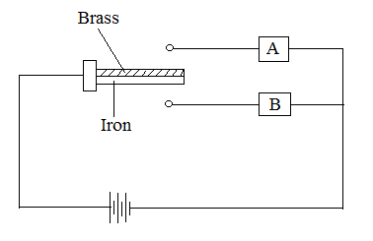

(b) Three beakers are of identical size and shape; one beaker is painted matt black, one is dull white and one is gloss white. The beakers are filled with boiling water.

(i) In which beaker will the water cool most quickly? Give a reason. **(3 marks)**

(ii) State a process in addition to conduction, convection and radiation, by which heat energy will be lost from the beaker. **(2 marks)**

1. (a) A pressure cooker will cook beans faster than an open saucepan. Give explanation on these observations.**(5 marks)**

(b) An insulated cup holds 0.3kg of water at 0oC. 0.2kg of boiling water at standard pressure is poured into the cup. What will be the final temp **(5 marks)**

**SECTION C (25 Marks)**

**Answer two (2) questions from this Section**

1. (a) A boy has a large number of coloured bulbs labeled 240V and 60W, he wishes to use for decoration so that the bulbs operates normally. How many can he connect to a 240V and 5A fuse? **(4 marks)**

(b) You are required to use 3Ω resistor in your electric circuit. Unfortunately there are only 2Ω resistors in School Physics laboratory. How could you design the required resistor from available resistors? **(4.5 marks)**

(c) A figure shows a block diagram of generation and distribution of electricity using a.c generator. Study the diagram then answer the questions that follow.

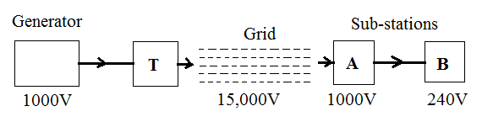

1. What will be the main item of equipment in the sub-stations **A** and **B**? **(1 mark)**
2. If the transformer T has 80 turns on its primary coil how many turns must it have on its secondary coil? **(3 marks)**
3. (a) A piano wire and a turning fork produce different notes at the same time and beats are heard. What could be done on the piano wire in order to emit a note of the same frequency as vibrating fork.(Give three points) **(3 marks)**

(b) A graph below shows a wave emitted by the electromagnetic source. If the velocity of the wave is 12m/s, determine the frequency and the wavelength of the wave.

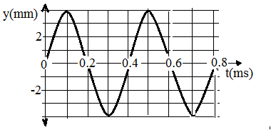

**(5 marks)**

(c) Boats use “sonar” to detect the depth of water in the seas or lakes. A sonar pulse sent out by a boat arrives back after 3seconds. If the speed of sound in water is 1500m/s, how deep is the water **(4.5 marks)**

1. (a) Why some semiconductors called ‘P’ type and other ‘N’ type? **(3 marks)**

(b) Describe, how you will connect the semiconductor diode as forward bias. **(4 marks)**

1. The diagram bellow shows a puzzle box contains two lamps and simple components so that when T1 is connected to the anode lamp L1lights but when terminal T2 is connected to the anode, lamp L2 light. Suggest what the puzzle box is and how the connections are made. **(5.5 marks)**

