**KANDOTO GIRLS SCIENCE SECONDARY SCHOOL**

**ADVANCED MATHEMATICS 02**

**FV PCM MAY 2015**

**ANNUAL EXAMINATION**

Time: 3hrs

**Section A (60 marks)**

***Attempt all questions in this section.***

1. (a) Solve the equation on

 (10 marks)

(b) Solve the inequality

 (05 marks)

1. (a) Show that  (03 marks)

(b) Given  what is  (02 marks)

(c) Solve  (05 marks)

(d) If  prove that  (05 marks)

1. (a) Show whether the following statement is valid or not:

If I study hard, then I will not fail logic. If I do not fail to manage my time, then I will study hard. But I failed logic. Therefore I failed to manage my time.

(b) Le P be ‘He is tall’ and q be ‘He is handsome! Write each of the following statements in symbolic

form using p and q:

1. He is tall and handsome.
2. He is neither tall nor handsome.

(c) (i) Simplify the compound statement  using the algebra laws for logical

expressions an then draw the corresponding network.

(ii) Construct the compound sentences for S1 and S2 having the following truth table and

simplify S1 using the algebraic laws for logical expressions.

|  |  |  |  |  |
| --- | --- | --- | --- | --- |
| P | q | r | S1 | S2 |
| T | T | T | F | T |
| T | T | F | F | F |
| T | F | T | T | F |
| T | F | F | F | F |
| F | T | T | F | T |
| F | T | F | F | F |
| F | F | T | T | F |
| F | F | F | F | F |

(d) Use a truth table to show that the statement  is a self-contradiction.

(15 marks)

1. (a) Draw the graph of 

(b) Express in rectangular Cartesian form

1. 
2. 
3. 

(c) Write in polar form

1. 
2. 
3.  (15 marks)

**Section B (40 marks)**

***Attempt any two questions.***

1. (a) (i) Find the adjoint of 

(ii) Use the adjoint obtained in (a) (i) above to solve the system of equations.



(b) If  is small that  and higher powers may be neglected, obtain a quadratic approximation of



(c) Express  in partial fractions and hence state the first four terms in the series

expansion of 

(d) Write the following series using sigma notation

1. 
2.  (20 marks)
3. (a) Show that 

(b) Find all angles which satisfy the equation 

(c) (i) Show that 

(ii) Using c) (i) express  as a single term of cosine.

(iii) If  and  are the angle of a triangle, verify that



(d) If  and  prove that 

(20 marks)

1. (a) (i) Write a compound proposition corresponding to the electrical network below.

(ii) Construct a simple electrical network equivalent to the complex electrical below.

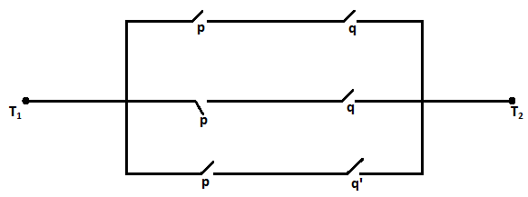

(b) (i) Write the contrapositive, the converse and inverse of the implication “Tanga School team

wins whenever it is sunny”

(ii) Determine the validity of the following argument, “ If  then   therefore ”.

(c) Using the laws of algebra of sets

1. Simplify 
2. Verify that  is a tantology. (20 marks)
3. (a) (i) If  and  are the roots of the quadratic equation  find the value of

 without calculating the values of  and 

(ii) Prove that  is divisible by 3 when 

(b) (i) Find the inverse of matrix  and then show that 

(ii) If  and  find the value of  (20 marks)

*“Logic drives mind to the perfect end”*