Download node js

Node js is the run time environment for the Java Script

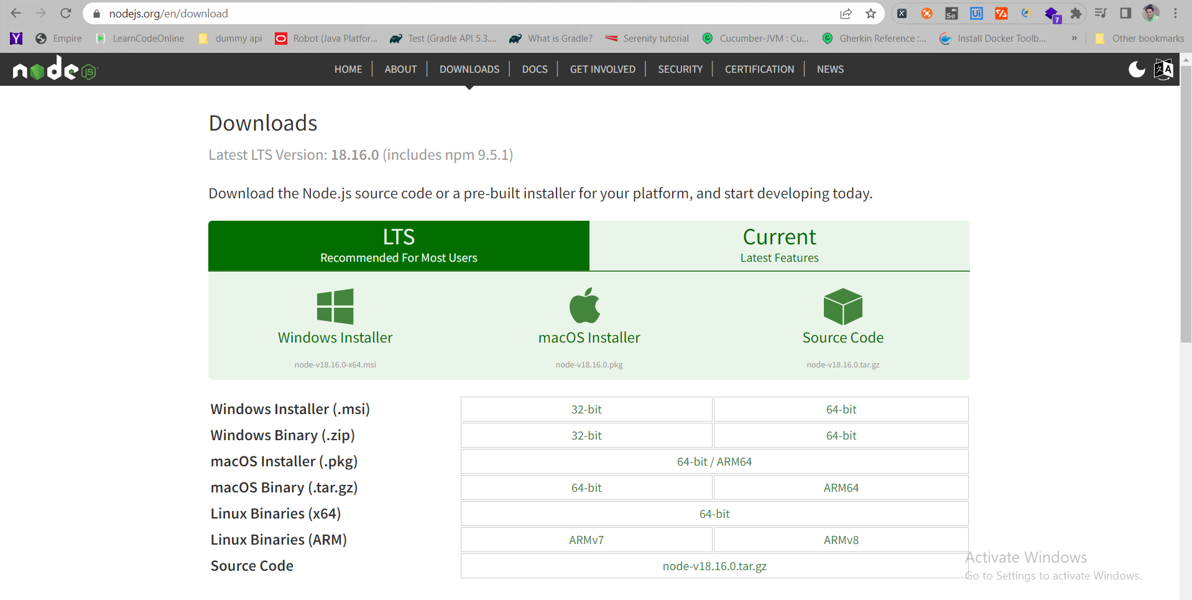

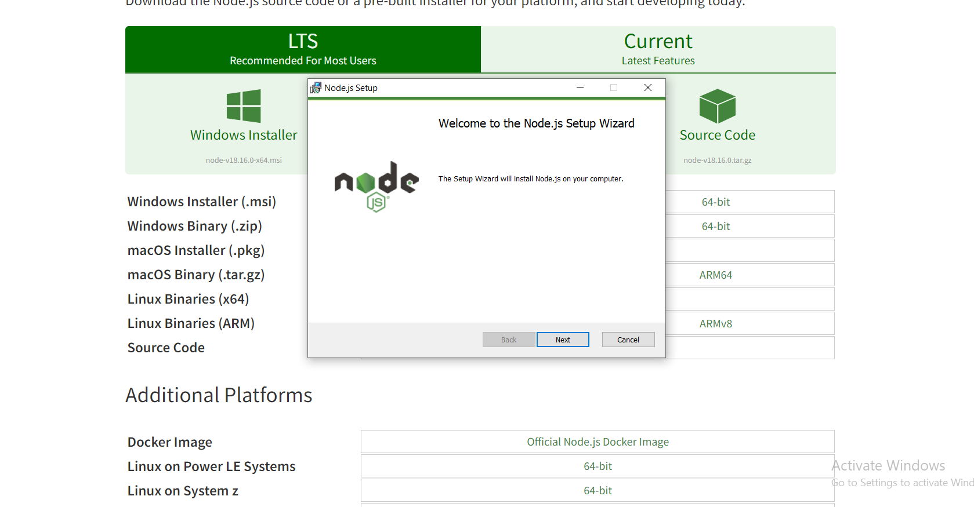

Download the set up

Node js is successfully installed.

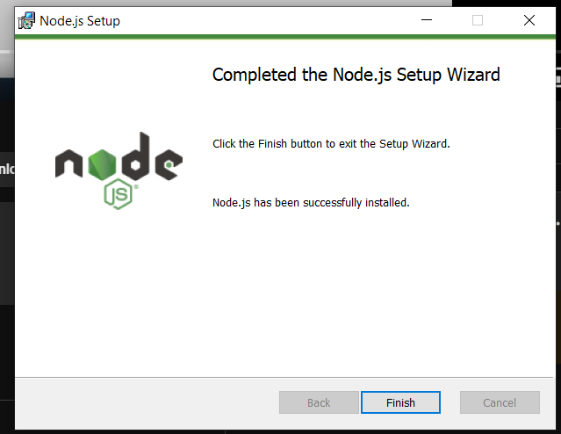

In the system variable – it will automatically set up the path for the node js – program files path.

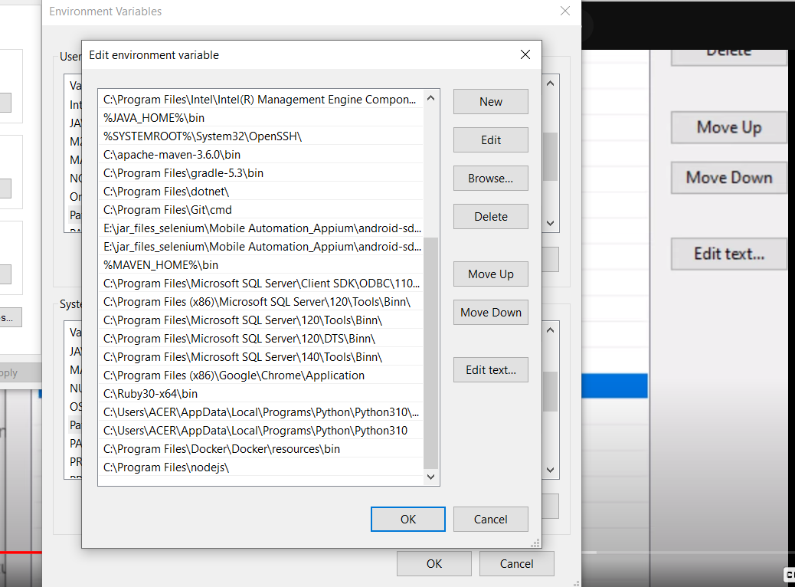

Node js is installed - to check the **version of the node js -version installed**.

To verify check the version of the node js – node -v

To check the node js - help documents

It will open the npm help documents.

To check the node js folder where the node js is installed – we can verify all the node js folders is present

Create a new text file and write the sample Java Script code – and save it with the help of hello.js.

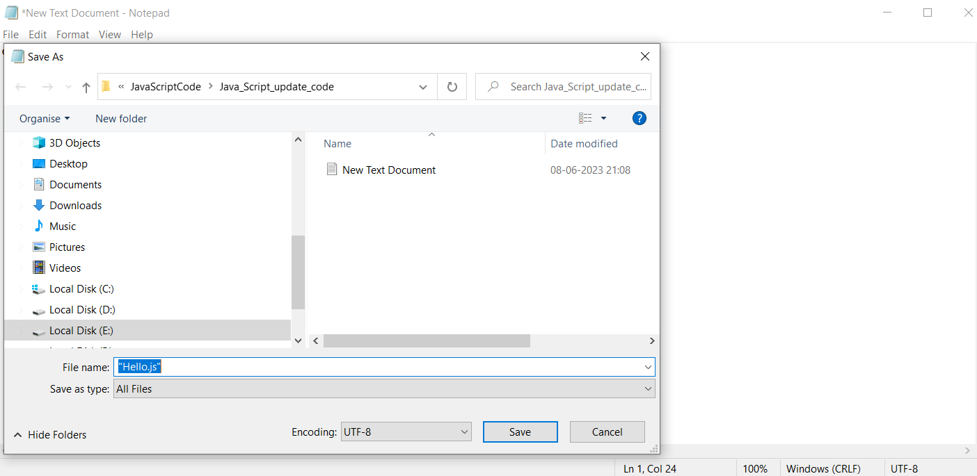

Navigate to the folder path and run the js file with the help of node Hello.js

To execute this code, we don’t need any browser – we can directly execute the Java Script code without the need of any browser, and we can do with the help of node js – which provides the run time environment for running the Java Script code.

Even we can execute the same thing through VS code terminal

We can execute the Java Script code inside the Browser – under the Console tab – just type the java script code

