Java Script – Array definition

In JS – Array is also an object, and an Array can hold different types of Data Types inside it

If we give an index which is not existing inside the array it will throw undefined – it will not throw an exception unlike Java and Python

Index 5 is not existing in the array – in the output it will show as undefined – instead of throwing an exception.

To add new elements inside the java script, use the push method – to add the elements inside the Array which will add the element inside the end of the array.

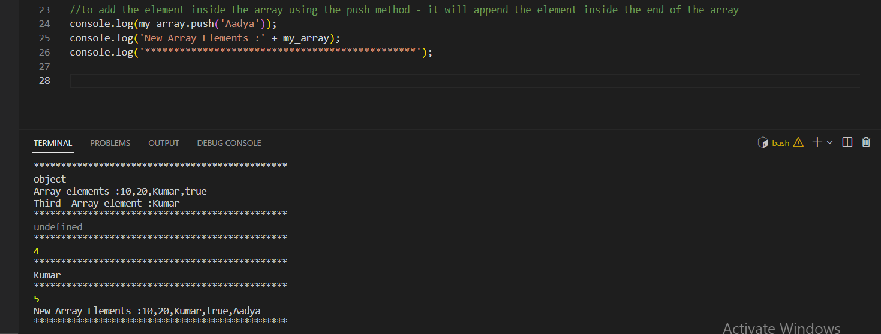

Using the unshift element we can add the elements at the starting of the array.

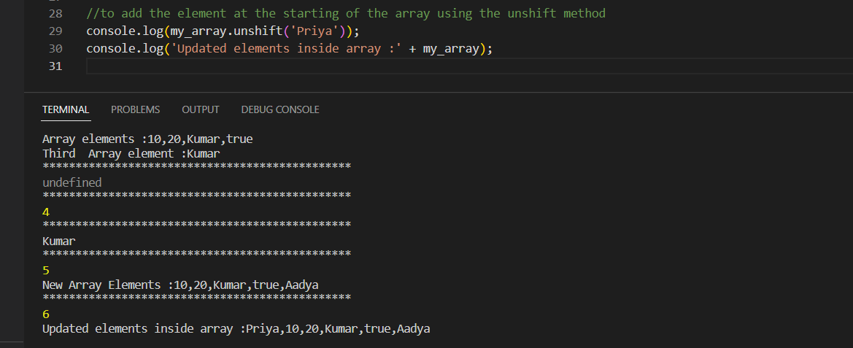

Using the pop , shift method can be used for removing the elements

Use the nested array – by combining two arrays – by using the push method

To retrieve the nested array elements inside the array using the index method

To iterate over the java script using the for loop

