Different data types in Java Script

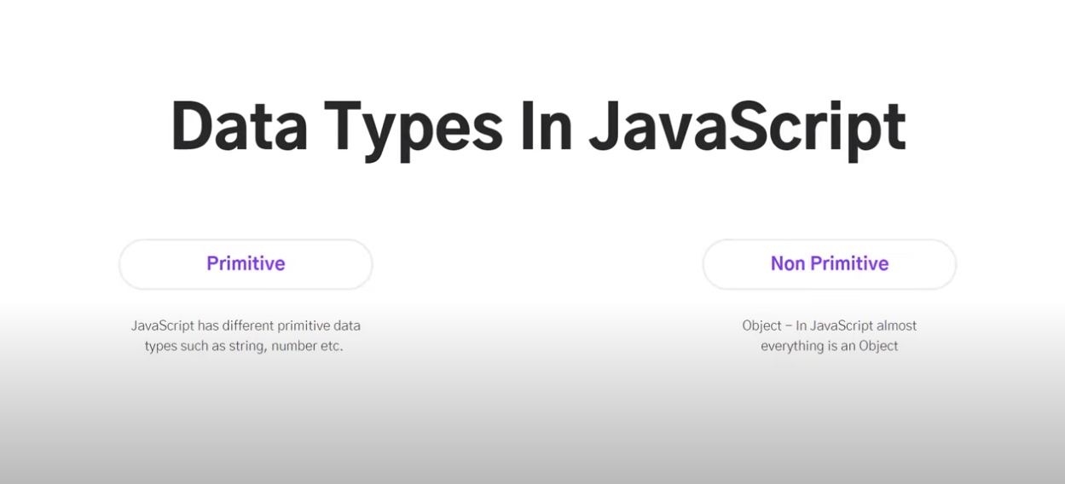

In JavaScript – everything is an Object.

Various types of Primitive Data types in Java Script

Except Null and Undefined all data types are Wrapper Objects

Let assign some variable to a string in JS and with the help of typeOf -we will be able to know which data type the value its holding.

Try to deal with the numbers.

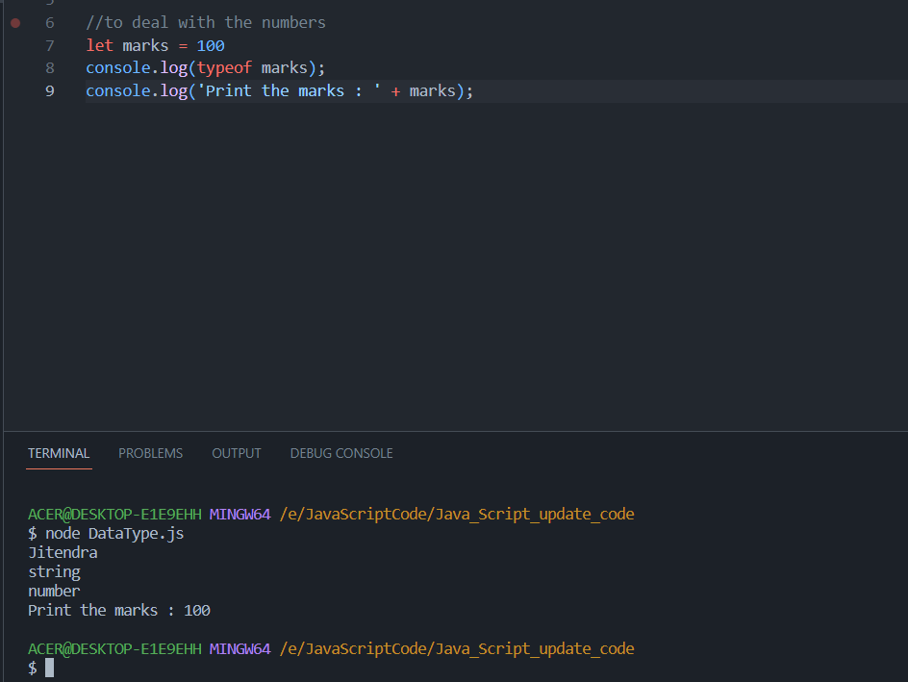

If we give any decimal number, then also it will take as number – in Java Script there is no float, double – everything is treated as number

To verify **the Boolean data type in Java Script**

when we dont declare any value to the string - java script will throw an error named as undefined



Output

Null as Data type in JS – if we assign any value as null , it will give data type as object

Output

Java Script is dynamically typed language – we don’t have to declare the variable type in Java Script

Output: -

//to deal with non-primitive data type – object

Output:-

