JavaScript – let , const and var – data types

//Usage of var key word –

Var keyword – variables can be changed – it can be re declared and updated.

Let keyword – let can be updated but it cannot be re -declared.

Output

Let variables can be updated with new values.

Usage of const keyword – once the variable is declared as const – we cannot update the value again.

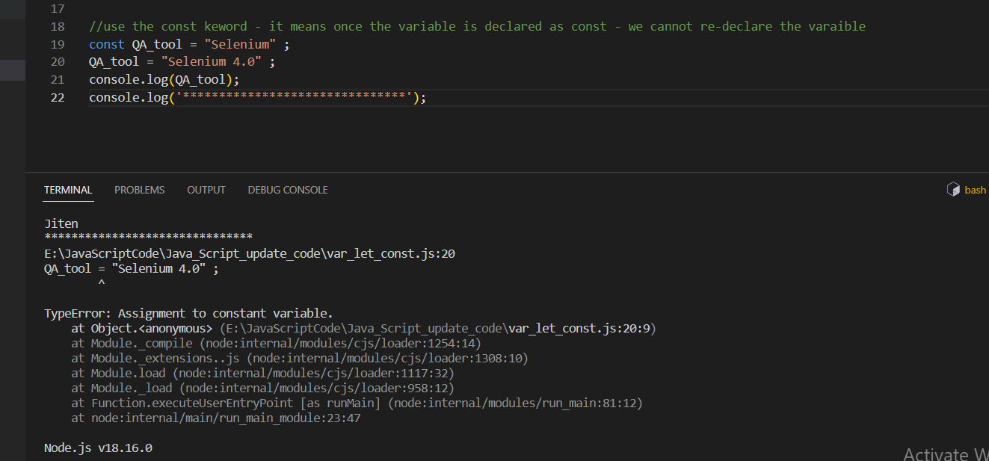

Usage of var keyword with the for loop – var keyword can be accesses outside the loop as it is a global declaration

Usage of let keyword inside the loop – let keyword cannot be accessed outside the loop – it scope is only until the block level – the variable cannot be accessed outside the loop.

Var keyword is global in scope and the variable can be accessed outside the loop

Output: - It will throw an error message

**Usage of const keyword** – const keyword cannot be accessed outside the loop, but the loop counter will only go for first iteration – because the const keyword variable cannot be incremented.

Output

We cannot declare any const variable – const variable has to be initialised.



If we don’t give any value assigned to the let and var variables it will give error as undefined

Output: -

If we use the var keyword inside the block – if block - it will be updated with the latest variable as **var keyword variables can be updated – and if we use the let keyword the let keyword variable cannot be updated.**

If we use the const keyword – const keyword is available inside the block level storage – and if we use the const keyword – the const keyword will show the updated message inside the block and then it will show the message outside the block.

Output

