Java Script – Loop Practice

Various types of Loops In JS

Output : print each number from 0 to 9

Let’s do in decrement way from 10 to 0

Output

Let’s declare the for loop in another way.

Let’s try to iterate over the for loop over the array.

Output

Using the for of loop – to iterate over each element **inside the array.**

Output: -

If we use the for in loop – to iterate over the array it wi**ll print the indexes – this is the difference between the for in loop and for of loop**.

Output

Using the for each loop inside the array to print each element inside the loop

Output

Usage of for of – loop to print each character of the string

Output

Usage of for – in loop to print each object value inside the string.

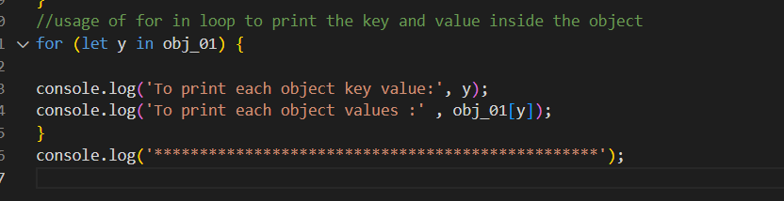

Output

We can run the same Java Script code inside the Browser Console

Usage of while loop **– initialise the value, give the condition inside the while loop and if the condition satisfies come out of the while loop**.

Output

If we use the continue statement inside the loop – condition will not be executed inside the loop, and it will come out of the loop.

If the output value is equal to 6 – it will not print the values inside the loop

Output

Usage of do while loop – where the condition will be executed at least once

Output

